Aj clean korbo data

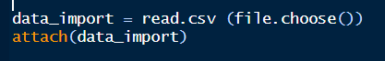

Data import er porei attach kora lagbe alws

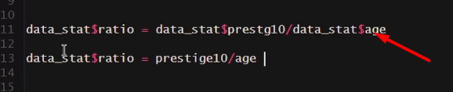

Atatch er subidha hoilo aita korle tmr r alada kore $ diye diye column gula call kora lagbe na. 2nd line er moto tmi direct call korte parba.

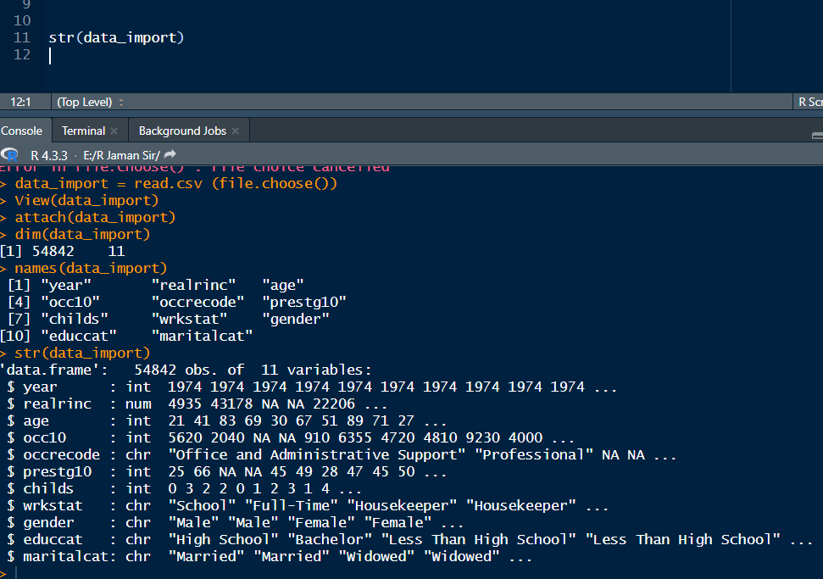

Aita data structure dekhlma je kon column int, konta string.

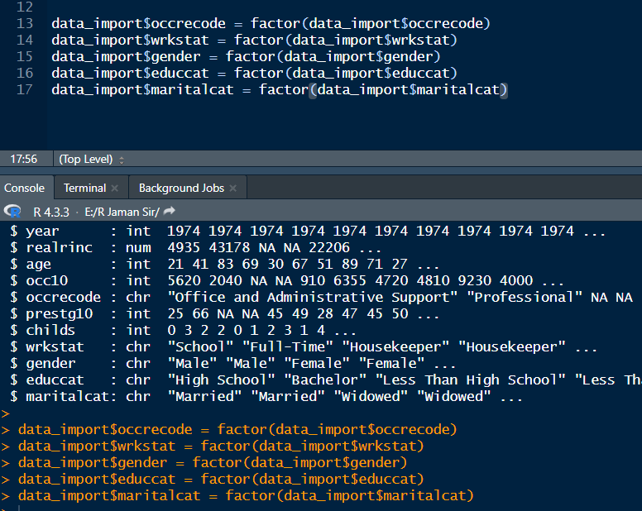

Then aita dibo, aita mane factorized korlam. Char gula ke amon kora lage, so that alada alada bar chart or oder graph dekhaite pari.

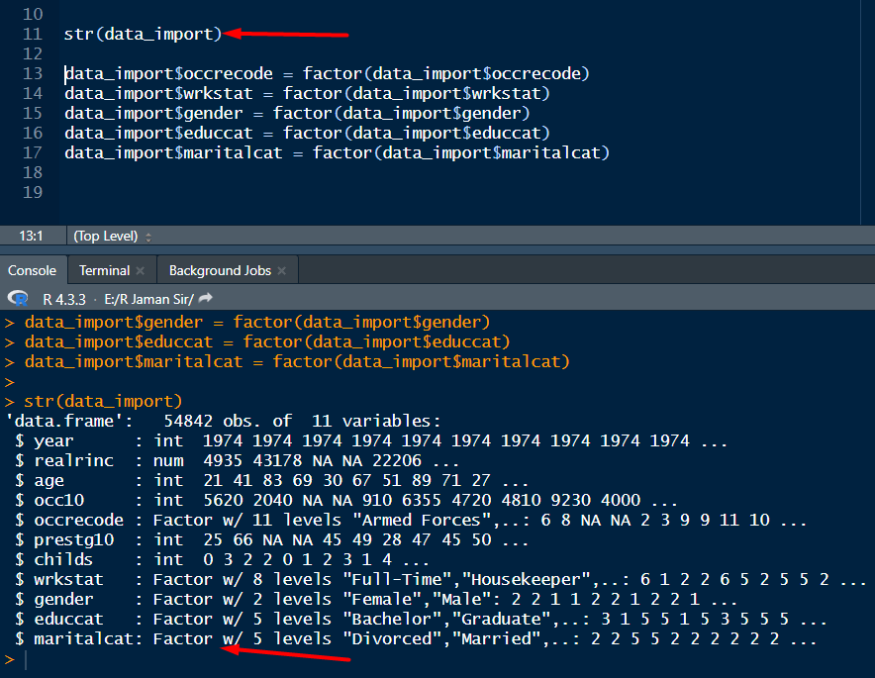

Then abr ghuira state check korle dekhbo je amon char gula factor dekhabe. Dekho je koy type data ache, ta o dekhabe. Marital e 5 ta type data, divorced, married….

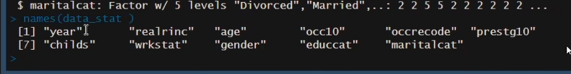

Abr akhon name theke column dekhbo, and kichu jinish bad dibo jegula lagbe na amr. Mane jegula amr jonno irrelevant.

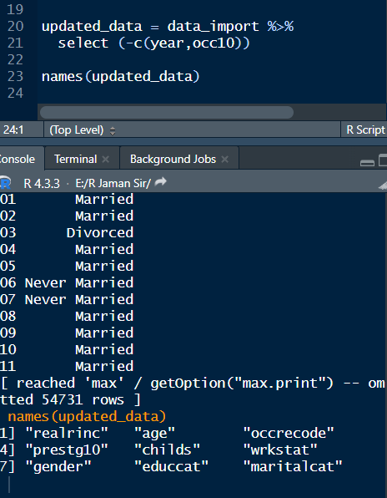

So akhon year and occ10 bad disi. diye abr names ditye check kore dekhlam je bad gese koina. Aivabei column drop kora lage.

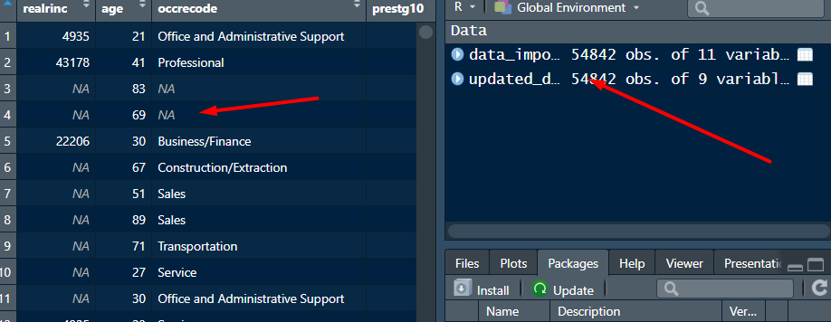

Akhon amon aikhane cloick kore delhbo na ache naki. Aikhane ache, aivbe kaj kora jabe na. either ai na er pura row drop kora lagbe.

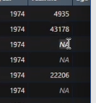

Or na er upor niche je value gula ache, oigular mean diye fill up kora lagbe.

Drop korar age dekha lagbe ki poriman na ache. aikhane 55000 data ache, jodi 5000 e na thake, tahole jodi 5000 drop kori, tahole to mara. Akhon apatoto bad diye dibo. But real kaje ami amr objective onushare bad dibo or rakhbo.

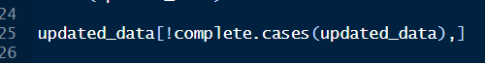

To aita diye na check korbo. Aitar mane hocche kon kon row ten a ache for all column.

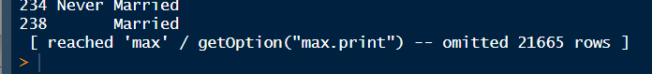

Aikhane 21000 na ache. but aitar output ta guchano na, as onek data aikhane.

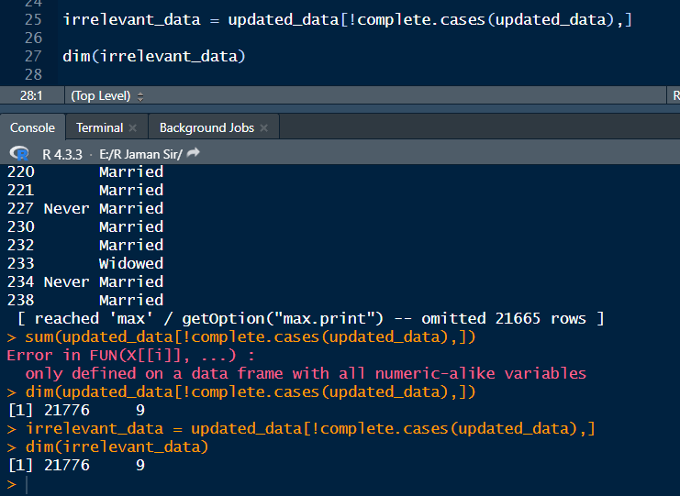

Oitake irrelevant datay dhukailam. Then aitar dim check korlam and dekhlam koto na ache.

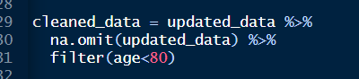

To ami akhon shob na falaya dilam tidyverse diye. And pore dim o check korlam. Sathe 80 age er upore jara ache, tader shoraya dilam.

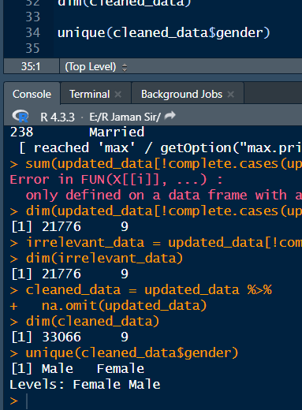

Ami akhon ai column e dekhlam je ki ki unique value ache. 2 er odhik categorical boli. 2 ta thakle binary or dummy boli. Aita dummy or binary, as male and female ache aikjhane only. Apni iphone use koren ki koren na. korle 1, na korle 0. Male 0, female 1. Masters korle 1, na korle 0. Button phon ejara tara1, android jara tara 2, iphone 3.

So ai male female ke convert kore dummy code korbo. Mane akta 0, arekta 1.

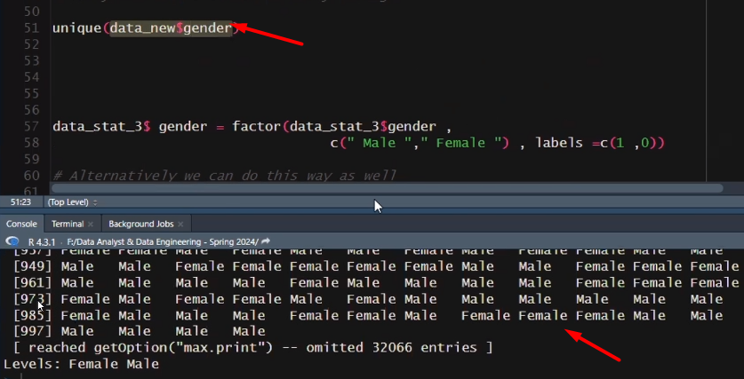

Akhn aikhane click kore male female ber korbo. Aigula 0 1 e convert korbo.

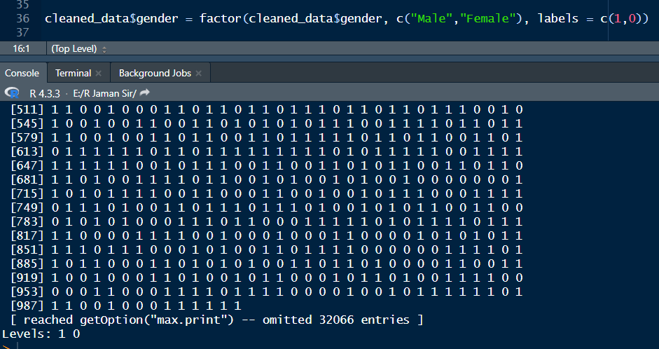

Dekho ami change kore disi.

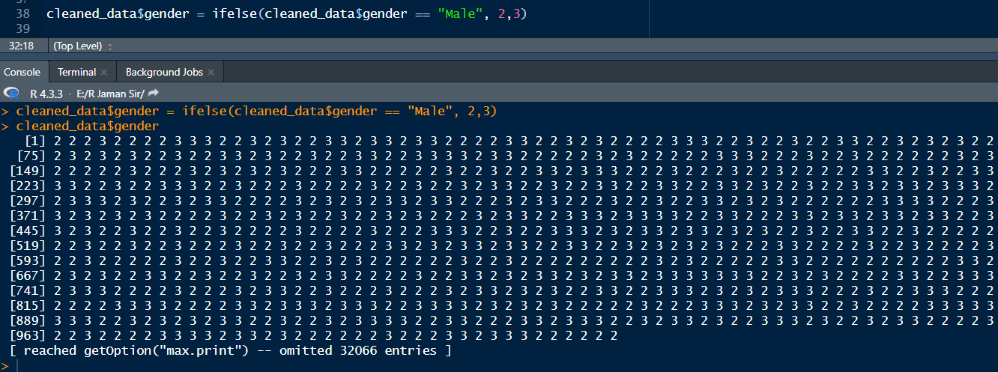

Ai alternative bashay korte bolse. Aita kaj kore na 1st e. aitar jonno upore na.omit abr load kore kora lagbe.

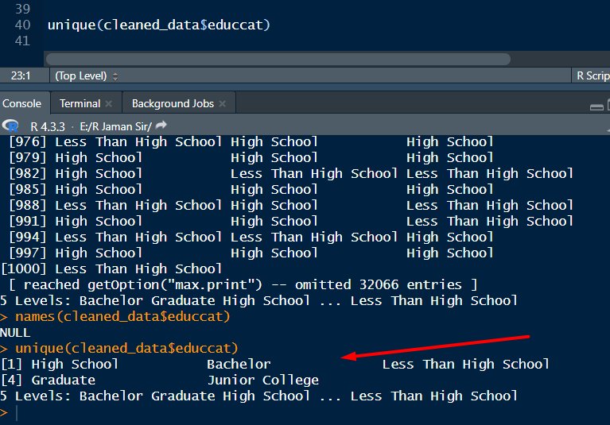

Akhon aikhane dekho 5 ta category ache.

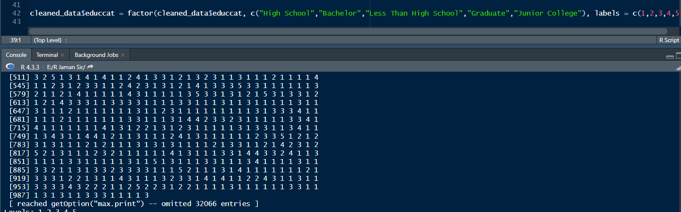

Akhon akdom same to same way te ami 2 er odhik value gula ke 12345 korlam. If else diyeo korsi.

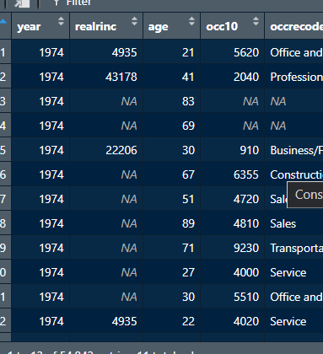

Akhon ami datay jaiya dekhlam je 80 up ache age kichu. Era to r chakri korbe na. so eder bad diye dibo.

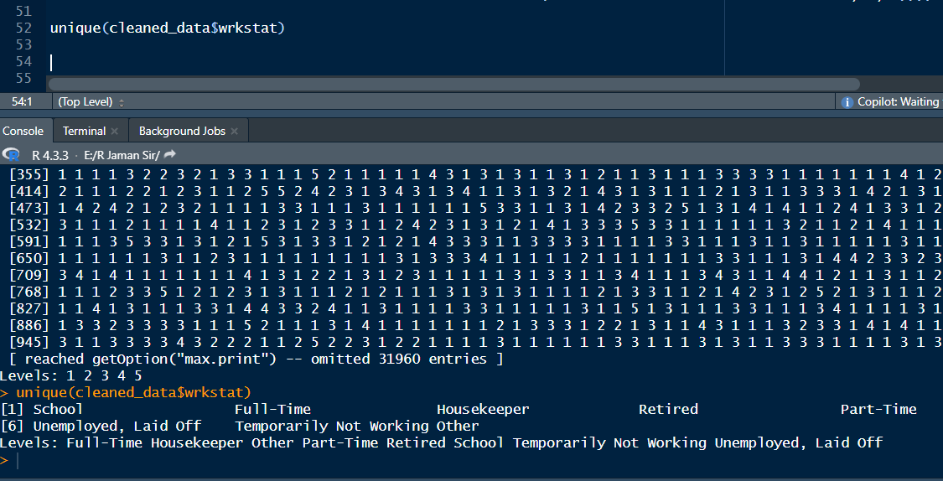

Aikhane dekho 2-3 ta ke akta category banabo. Jemon androia and iphone ke same category te mobile e rakhbo. Masters, post doc, phd ke aksathe kore post grad e rakhbo. Aikhaneo temporarirly not working, retired o kaj kore na.

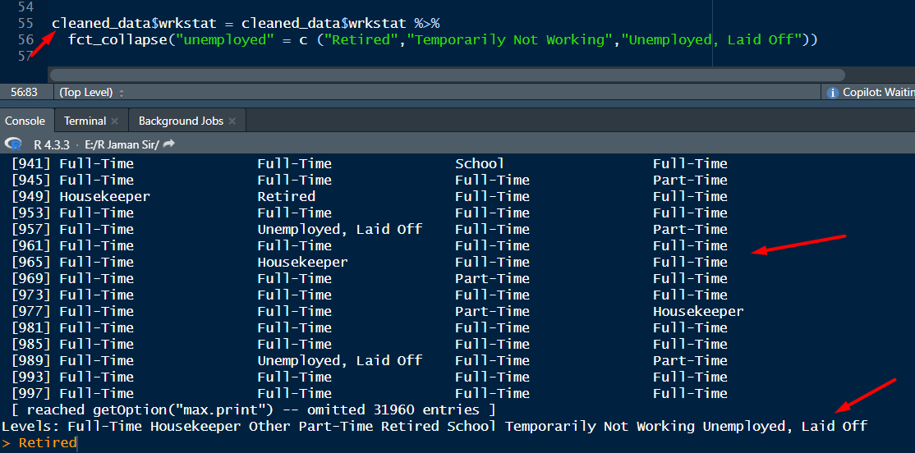

So age aitay check korlam ki ki data, coz unique e dile bujhi na thikvabe. Then oigula shob unemployed name e assign korlam.

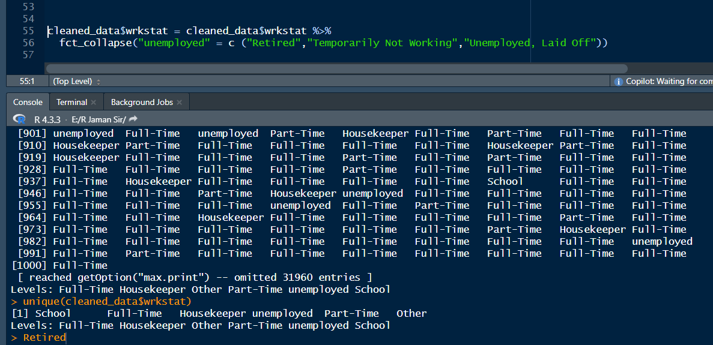

Change er por ki hoise, sheiatao dekho.

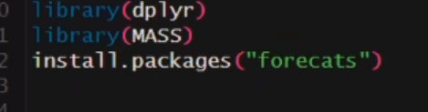

Sir e fct collapse na run korte pairra ai packacge google kore niye asche. But am raita lagei nai.