DATA SCIENCE TOOLBOX PYTHON PROGRAMMING
PROJECT REPORT
Customer Churn Analysis

Submitted by

NAME: Saikat Tunga

DECLARATION

I, Saikat Tunga student of AI (Program name) under AI Discipline at, Alipurduar Government Engineering and Management College, West Bengal, hereby declare that all the information furnished in this project report is based on my own intensive work and is genuine.

Date: 24-09-2026
Name of the student: Saikat Tunga

Table of Contents
- Introduction
- What is EDA?
- Why EDA is Important for Churn Analysis
- Source of Dataset
- Step-by-Step EDA Process
- Dataset Preprocessing
- Univariate Analysis
- Bivariate Analysis
- Correlation Analysis
- Analysis on Dataset
- Conclusion
- Future Scope
- References

1. Introduction
In today’s competitive business environment, customer retention is a critical success factor. One of the major challenges faced by service-oriented businesses, especially in the banking sector, is customer churn. Customer churn refers to when a customer stops doing business with a company. High churn rates can indicate dissatisfaction with services and lead to financial losses.
This project focuses on analyzing a bank customer dataset to identify the key factors that contribute to customer churn. Using exploratory data analysis (EDA), we investigate demographic, behavioral, and financial variables to discover patterns and gain actionable insights. The objective is to help the bank better understand its customers and develop data-driven strategies to reduce churn.

2. What is EDA?
Exploratory Data Analysis (EDA) is the process of analyzing data sets by summarizing their main characteristics. It involves visual methods and statistical techniques that help in discovering trends, patterns, relationships, and anomalies in the dataset. EDA is a crucial step in the data analysis process because it allows analysts to:
- Better understand the structure of the dataset
- Detect missing or incorrect data
- Identify outliers
- Find relationships between variables
EDA provides the foundation for model building and helps in making informed decisions.

3. Why EDA is Important for Churn Analysis
Understanding why customers leave is essential for developing effective retention strategies. EDA helps break down the raw data to reveal patterns related to churn behavior. In this project, EDA allows us to:
- Quantify the churn rate among customers
- Detect customer segments with high churn probability
- Assess the impact of variables like age, balance, credit score, etc.

- Use visualizations to make complex data more interpretable
By conducting EDA, we can move beyond assumptions and base our decisions on real evidence.

4. Source of Dataset
The dataset used in this analysis was sourced from a public dataset often used in churn prediction projects. The data simulates a real-world scenario in a European bank. Each row represents a customer with several features such as credit score, geography, tenure, and balance.
- File Name: Bank_Churn.csv
- Format: CSV (Comma Separated Values)
- Features:
  - CreditScore
  - Geography
  - Gender
  - Age
  - Tenure
  - Balance
  - NumOfProducts
  - HasCrCard
  - IsActiveMember
  - EstimatedSalary
  - Exited (target variable: 1 = churned, 0 = stayed)

5. Step-by-Step EDA Process
- Import Libraries (Pandas, NumPy, Matplotlib, Seaborn, Scipy)
- Load the dataset
- Inspect structure and check for missing values
- Clean and preprocess the data
- Visualize each feature with respect to churn
- Analyze correlations

6. Dataset Preprocessing
Before diving into the analysis, we cleaned and prepared the dataset. The key preprocessing steps included:
- Checking for missing values using df.isnull().sum() which showed none
- Ensuring column names were formatted properly (no trailing spaces)
- Converting data types where required (e.g., integers to floats if needed)
- Removing duplicate entries if found (none in this case)
- Understanding the balance between churned and retained customers

7. Univariate Analysis
Univariate analysis involves examining one variable at a time. For our dataset, we started with:
- Churn Rate (Exited column): We plotted the number of customers who churned vs. who stayed. A pie chart also provided a percentage view.
- Gender: We checked the gender distribution and how it relates to churn.
- Geography: We looked at churn rates across different countries.
- Age: Age distribution helped us understand which age groups are most prone to churn.

8. Bivariate Analysis
In bivariate analysis, we explore the relationship between two variables. For churn prediction, the most useful bivariate comparisons were:
- Tenure vs. Churn: Box plots helped us see if long-term customers were more loyal.
- Number of Products vs. Churn: Customers with fewer products had a higher chance of leaving.
- IsActiveMember vs. Churn: Inactive members were more likely to churn.

9. Correlation Analysis
Correlation analysis helps us understand how numerical features move in relation to each other. We used:
- Heatmap: Shows correlation coefficients for multiple variables at once
- Pearson Correlation: Specifically used to check the relationship between Credit Score and Churn

The heatmap revealed that age and balance had some correlation with churn, while credit score and estimated salary had weaker relationships.

# Correlation Heatmap
corr=df[['CreditScore','Age','Tenure','Balance','NumOfProducts','EstimatedSalary','Exited']].corr()
sns.heatmap(corr, annot=True, cmap='coolwarm')
plt.title("Correlation Matrix")
plt.show()
Heatmap:
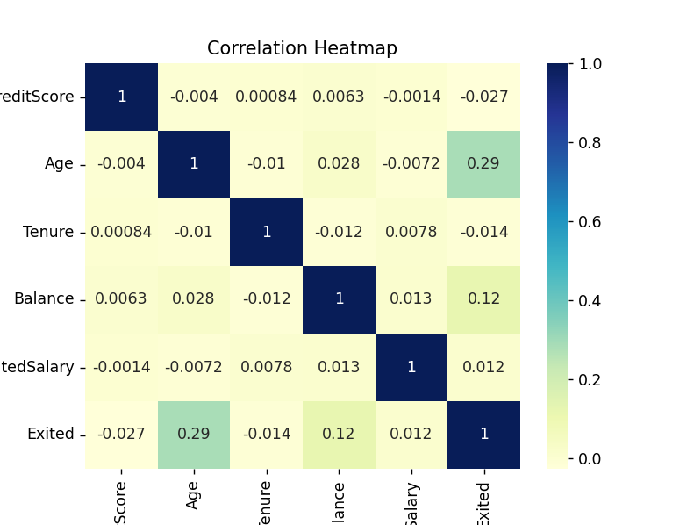

10. Analysis on Dataset
Objective 1: Customer Churn Overview
• Most customers stayed with the bank (Exited = 0).
• Pie chart shows approx. 80% stayed, 20% churned.
Code:
# Bar chart
sns.countplot(x='Exited', data=df,color='brown')
plt.title('Customer Churn Distribution')
plt.show()

# Pie chart
churn_counts = df['Exited'].value_counts()
plt.pie(churn_counts,labels=['Stayed','Churned'], autopct='%1.1f%%',colors=['orange','#66b3ff'])
plt.title('Churn Percentage')
plt.show()

Graph:
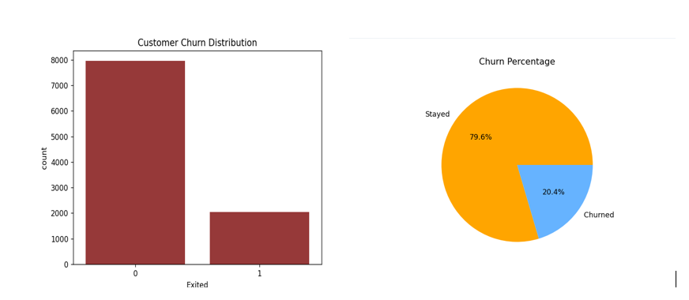

Objective 2: Demographic Impact Analysis
• Gender: Slightly more males churned
• Geography: Customers from Germany had a higher churn rate
• Age: Older customers (40+) churn more
Code:
sns.countplot(x='Gender', hue='Exited', data=df)
plt.title("Gender vs Churn")
plt.show()

sns.countplot(x='Geography', hue='Exited', data=df)
plt.title("Geography vs Churn")
plt.show()

sns.histplot(data=df, x='Age', hue='Exited', bins=20, kde=True)
plt.title("Age Distribution by Churn")
plt.show()

Graph:

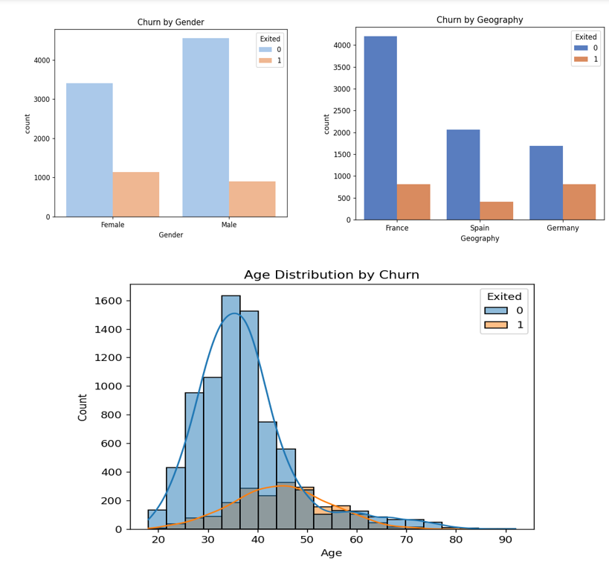

Objective 3: Customer Behavior Insights
• Lower Tenure and fewer Products increase churn risk
• Inactive members churn more
Code:
sns.boxplot(x='Exited', y='Tenure', data=df)
plt.title("Tenure vs Churn")
plt.show()

sns.countplot(x='NumOfProducts', hue='Exited', data=df)
plt.title("Number of Products vs Churn")
plt.show()

sns.countplot(x='IsActiveMember', hue='Exited', data=df)
plt.title("Activity Status vs Churn")
plt.show()

Graph:
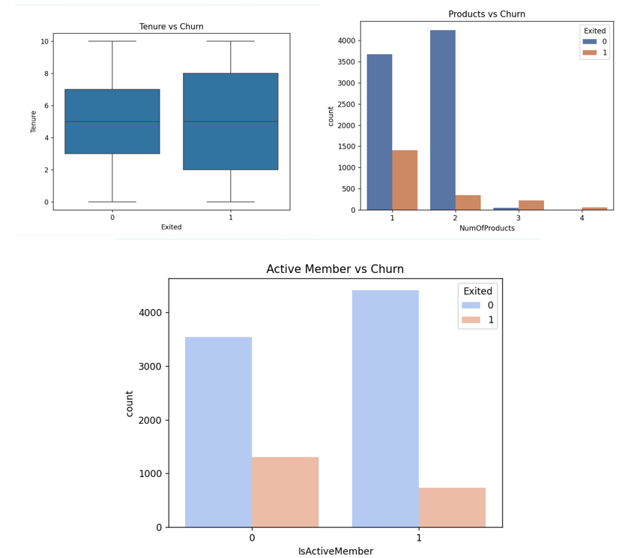

Objective 4: Credit Score and Churn
• Weak negative correlation found between credit score and churn

Pearson Correlation: -0.16
Code:
sns.boxplot(x='Exited', y='CreditScore', data=df)
plt.title("Credit Score vs Churn")
plt.show()

from scipy.stats import pearsonr
credit_corr, _ = pearsonr(df['CreditScore'], df['Exited'])
print(f"Pearson Correlation between Credit Score and Churn: {credit_corr:.2f}")

Graph:
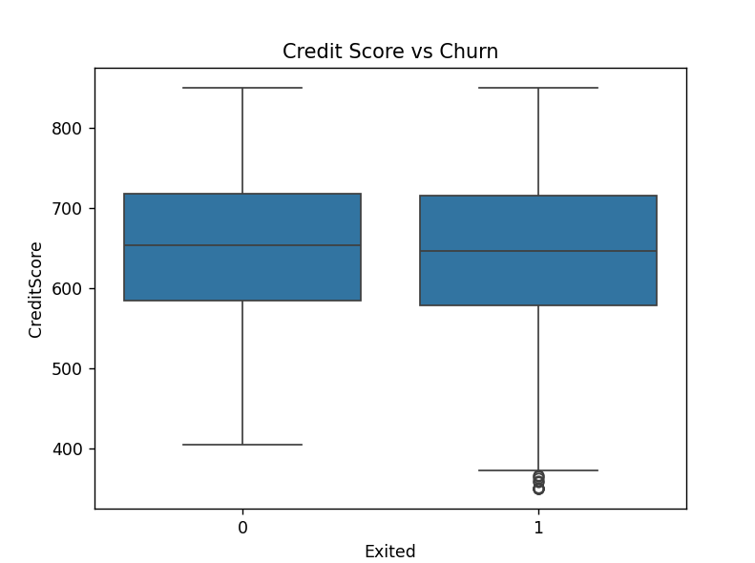

Objective 5: Income & Churn Relationship
• Salary shows little impact on churn
• Balance is higher in churned customers

Code:
sns.boxplot(x='Exited', y='EstimatedSalary', data=df)
plt.title("Estimated Salary vs Churn")
plt.show()

sns.boxplot(x='Exited', y='Balance', data=df)
plt.title("Balance vs Churn")
plt.show()

Graph:

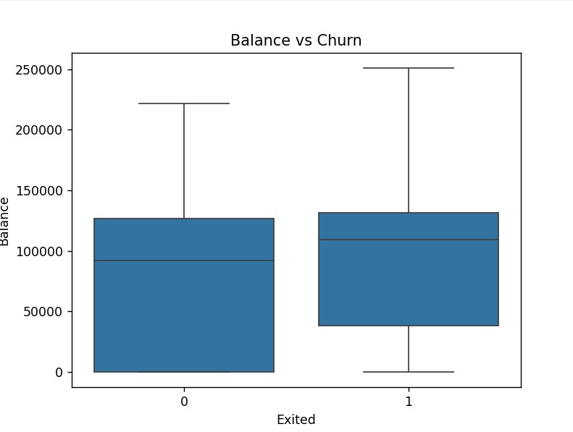

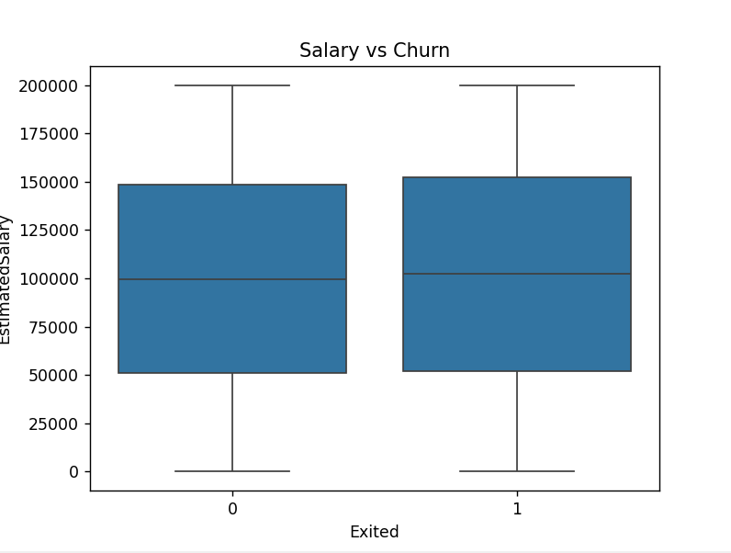

11. Conclusion
Through exploratory data analysis, we identified various factors that influence customer churn in the banking sector. Key findings include:
- High churn among customers aged 40+
- More churn in Germany than other regions
- Behavior-based indicators like tenure, number of products, and activity are strong churn predictors
By understanding these insights, banks can build customer retention strategies, target vulnerable segments, and improve service quality.

12. Future Scope
While EDA provides valuable insights, future steps can enhance this analysis:
- Implement machine learning models (e.g., logistic regression, decision trees) for churn prediction
- Introduce new features like transaction frequency or customer feedback
- Design targeted campaigns to reduce churn and improve satisfaction
- Use clustering to segment customers into risk categories

13. References
- Dataset: Bank_Churn.csv
- Tools Used: Python, Pandas, NumPy, Seaborn, Matplotlib, Scipy
- Concepts: Exploratory Data Analysis, Pearson Correlation, Visualization Techniques

