# INTRODUCTION TO AWS (and Databases)- CSE6331-ASSIG-1

FIRST NAME: SAI KAVYA

LAST NAME: DUKKIPATI

UTA ID: 1000980778

AWS S3:

For uploading file to AWS S3

* Create a user in IAM management console.
* Download credentials (i.e. Access key, Secret key).
* Create a bucket in S3 for the created user through python shell.
* Connect to the bucket and upload the two files.
* Time taken for uploading is calculated using a timer.

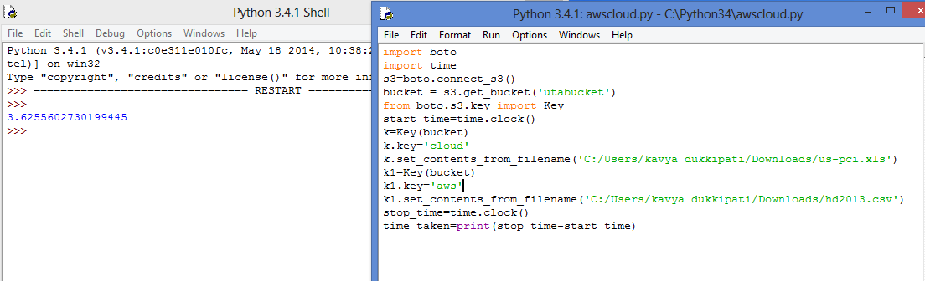

Time taken to upload two files into AWS S3 =3.6255602730199445

AWS RELATIONAL DB

To connect to AWS RDB from local MySQL workbench

* Launch a DB instance.
* Create a security group.
* Set inbound and outbound rules.
* Create tables and load files into the tables.

Time taken for uploading data into AWS RDS

* For HD2013 file – 1.359sec



* For uc-plsi file - 0.141sec



* Create a view for projecting “state names”, “state-incomes”, “number of universities in each state”.

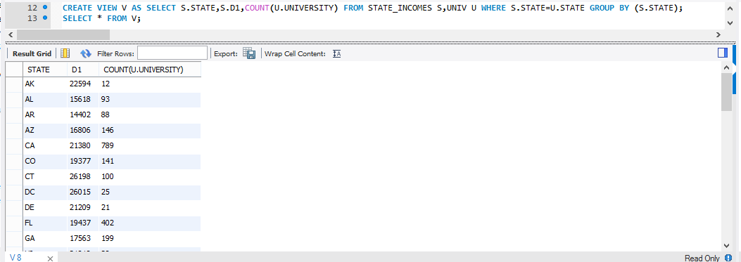

* Plot a graph with the values.

