Application-1:

Implemented an application using 4 services:

* Geolocation
* TWILIO
* Amazon beanstalk
* Amazon cloud front

Developed a web application for finding geographical co-ordinates and integrated it with TWILIO voice and SMS service which directs us to the web application. Deployed this into Amazon beanstalk and Amazon cloud front.

The health of our application in amazon beanstalk turned green after complete environment

Setup.

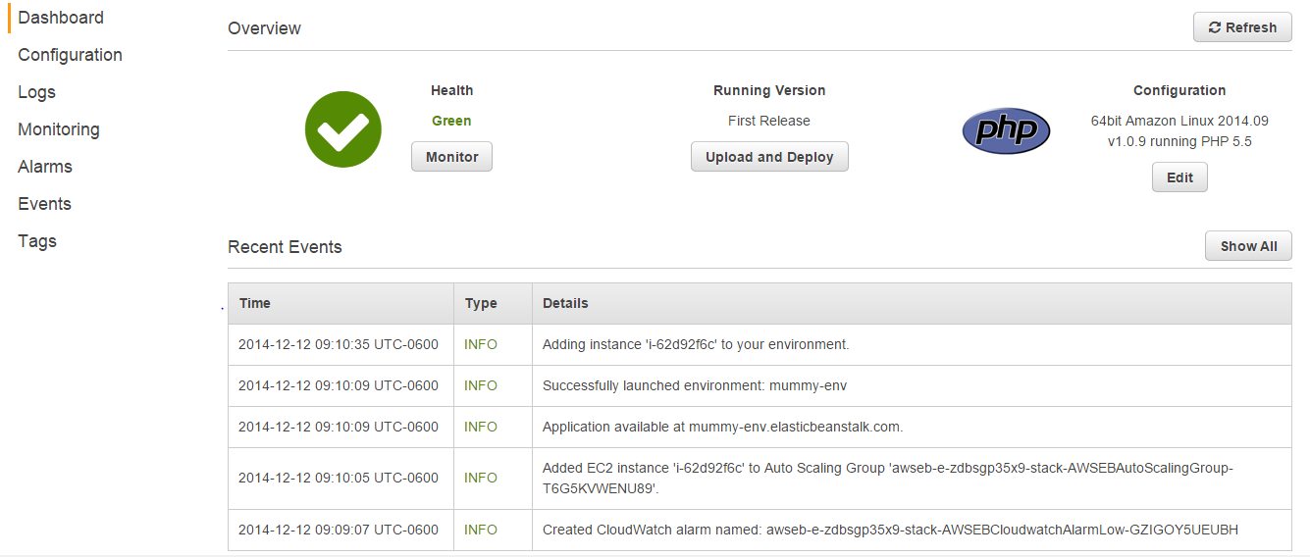

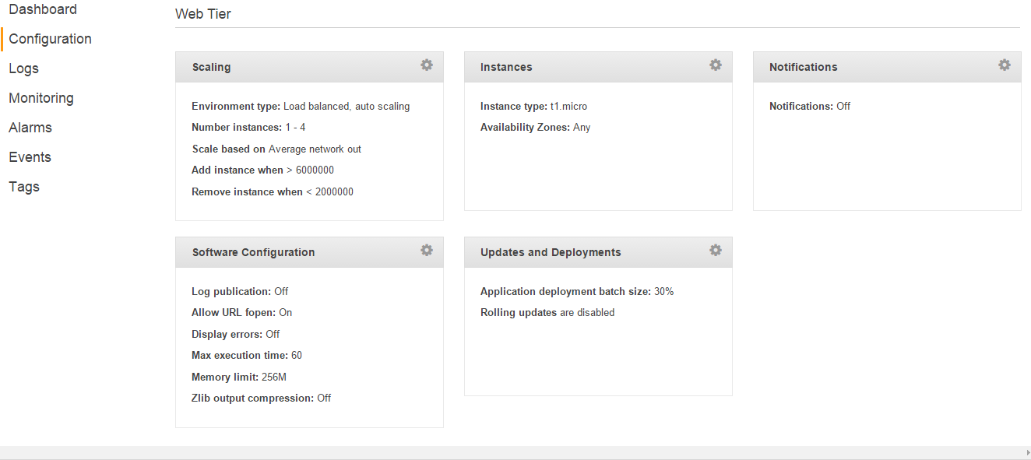

Configurations in amazon beanstalk.

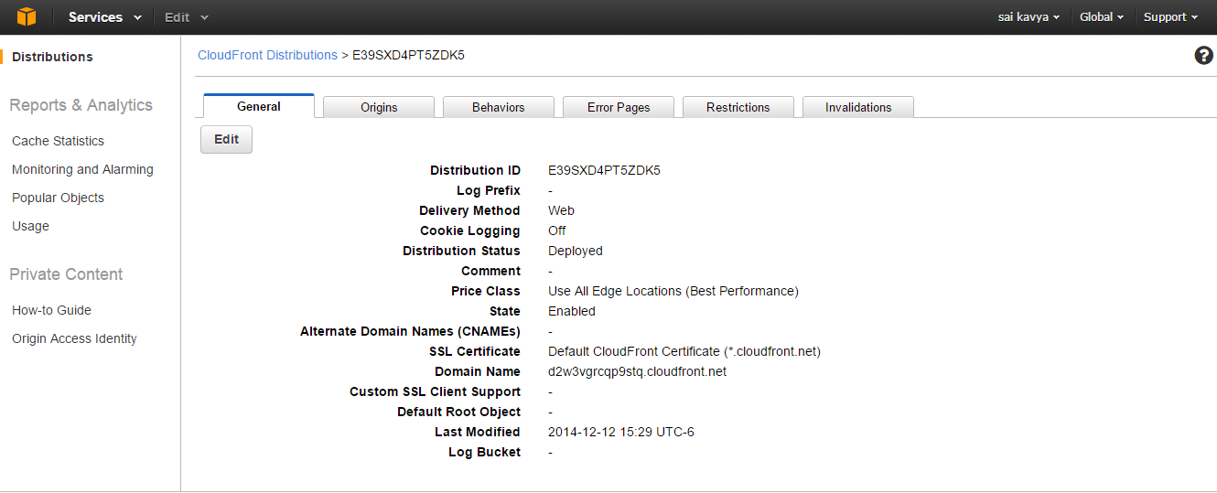

Application uploaded to amazon cloud front.