**NAME:** SAI KAVYA, DUKKIPATI

**UTA ID**: 1000980778

**CSE6311: ASSIGNMENT -5**

1. **Uploading to Google Cloud Storage :**

Command line arguments using “gsutil”:

**Creating a bucket:**

gsutil mb gs://bucket-name

Created Buckets

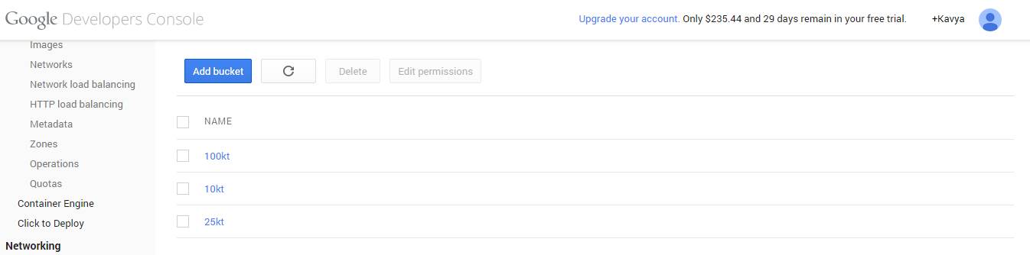

**Uploading file to bucket:**

gsutil cp *.txt gs://bucket-name

Create a folder with text file containing the data set. Go to the folder in command prompt and execute the command for uploading.

Time taken to upload data with 10k tuples =4.34s-0.55s= 3.95s

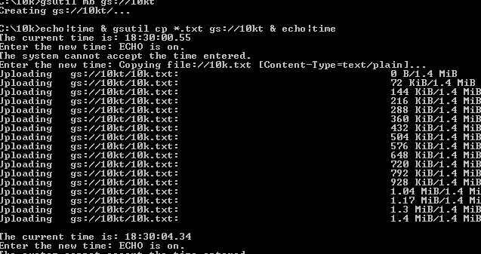

Time taken to upload data with 25k tuples =26.64-19.67s= 6.97s

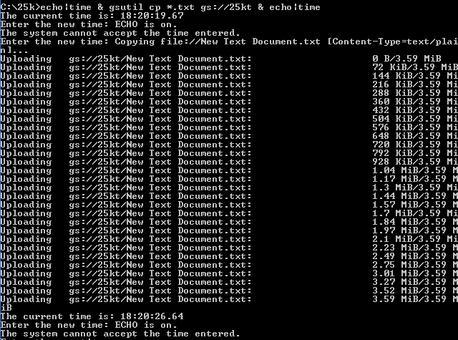

Time taken to upload data with 100k tuples =39.43-29.63s= 9.8s

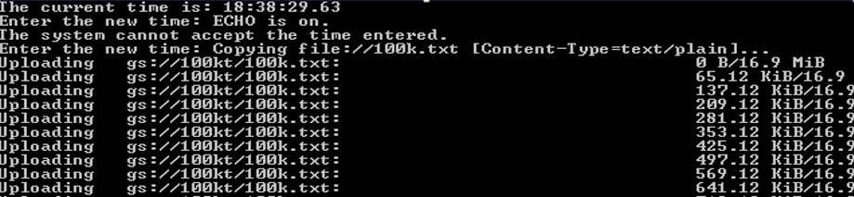

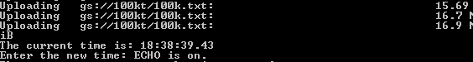

1. **Google Cloud SQL:**

Create an instance in cloud SQL and connect to the instance through local MySQL.

* Created a table.
* Uploaded the file from local computer system to the table.
* Monitored the time taken for uploaded various sizes of data.
* Monitored the time taken to retrieve the data.
* Ran select query on the tables to retrieve data.

1. 10k tuples of data

Time taken for uploading: 3.016s

C:\Users\kavya dukkipati\Pictures\10tupsql.PNG

Time taken for fetching data: 2.031s

C:\Users\kavya dukkipati\Pictures\fetch 10k.PNG

1. 25k tuples of data

Time taken for uploading: 8.671s

C:\Users\kavya dukkipati\Pictures\25tups.PNG

Time taken for fetching data: 6.672

C:\Users\kavya dukkipati\Pictures\25tup fetchs.PNG

1. 100k tuples of data

Time taken for uploading: 41.047s

C:\Users\kavya dukkipati\Pictures\lakhstoree.PNG

Time taken for fetching data: 26.110s

C:\Users\kavya dukkipati\Pictures\100ktup fetch.PNG

As, the number of tuples increases i.e. data load increases delay is experienced for serving the requests. App engine’s Scheduler decides the way to serve app request. When the load increases it will either create a new instance which will consume more time or it may give to any available idle instance. When there are heavy loads i.e. when no idle instances are available app engine had to create new instances which consumes time.

Therefore, the times are symmetrical w.r.t the size of data.

**REFERENCES:**

* + <https://cloud.google.com/storage/docs/gettingstarted-gsutil>
  + <https://cloud.google.com/storage/docs/gsutil_install>
  + <http://superuser.com/questions/15824/easiest-way-to-time-a-command-line-tool>