CSE 5330: Database Systems I

Development of a Public Health Information System

1. a) The ERD of the Public Health Information System

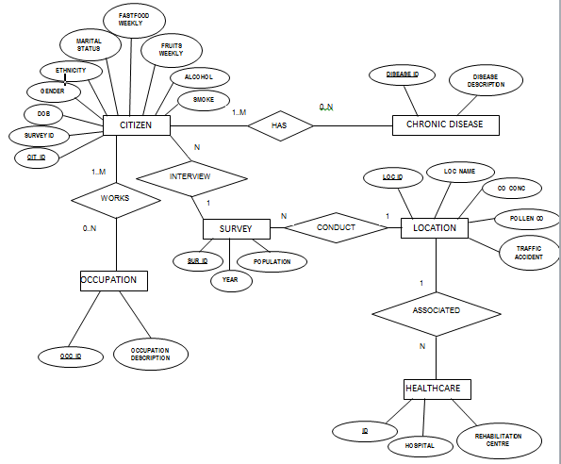

1. b) Description of the transformation of the ERD to relational algorithm

Step1: Mapping of regular entity types

* For each regular entity type E in the ER schema, create a relation R that includes all the simpleattributes of E.
* Choose one of the key attributes of E as primary key for R.
* If the chosen key of E is composite, the set of simple attributes that form it will together form the primary key of R.

There are six regular entity types in population surveillance as shown below:

LOCATION

|  |  |  |  |  |
| --- | --- | --- | --- | --- |
| LOC_ID | LOC_NAME | CO_CONC | POLLEN_CONC | TRAFFIC ACCIDENTS |

HEALTHCARE

|  |  |  |
| --- | --- | --- |
| ID | HOSPITAL | REHABILITATION CENTRE |

SURVEY

|  |  |  |
| --- | --- | --- |
| SUR_ID | YEAR | POPULATION |

CHRONIC_DISEASE

|  |  |
| --- | --- |
| DISEASE_ID | DISEASE DESCRIPTION |

CITIZEN

|  |  |  |  |  |  |  |  |  |
| --- | --- | --- | --- | --- | --- | --- | --- | --- |
| Cit_id | Gender | DOB | Ethnicity | Marital_status | Fastfood_weekly | Fruits_weekly | Alcohol | Smoke |

OCCUPATION

|  |  |
| --- | --- |
| OCC_ID | OCCUPATION DESCRIPTION |

Step2: Mapping of weak entity types

There are no weak entity types in the population surveillance ERD.

Step3: Mapping of Binary 1:1 relationship types

There are no Binary 1:1 relationship types in the population surveillance ERD.

Step4: Mapping of Binary 1:N relationship types

* For each regular binary 1:N relationship type R, identify the relation S that represent the participating entity type *at the N-side* of the relationship type.
* Include as foreign key in S the primary key of the relation T that represents the other entity type participating in R.
* Include any simple attributes of the 1:N relation type as attributes of S.

There are three relations with 1:N relationship scenario as shown below:

1. CITIZEN <---> SURVEY
2. SURVEY <---> LOCATION
3. LOCATION <---> HEALTHCARE

LOCATION

|  |  |  |  |  |
| --- | --- | --- | --- | --- |
| LOC_ID | LOC_NAME | CO_CONC | POLLEN_CONC | TRAFFIC ACCIDENTS |

HEALTHCARE

|  |  |  |  |
| --- | --- | --- | --- |
| ID | HOSPITAL | REHABILITATION CENTRE | LOC_ID |

SURVEY

|  |  |  |  |
| --- | --- | --- | --- |
| SUR_ID | LOC_ID | YEAR | POPULATION |

CITIZEN

|  |  |  |  |  |  |  |  |  |  |
| --- | --- | --- | --- | --- | --- | --- | --- | --- | --- |
| Cit_id | SUR_ID | Gender | DOB | Ethnicity | Marital  Status | Fastfood  weekly | Fruits  weekly | Alcohol | Smoke |

Step5: Mapping of Binary M:N relationship types

* For each regular binary M:N relationship type R, *create a new* relation S to represent R.
* Include as foreign key attributes in S the primary keys of the relations that represent the participating entity types; *their combination will form the primary* key of S.
* Also include any simple attributes of the M:N relationship type (or simple components of composite attributes) as attributes of S.

There are two relations with M:N relationship scenario as shown below:

CITIZEN <--> OCCUPATION

CITIZEN <--> CHRONIC_DISEASE

**LOCATION­­­­**

|  |  |  |  |  |
| --- | --- | --- | --- | --- |
| LOC_ID | LOC_NAME | CO_CONC | POLLEN_­­­­­CONC | TRAFFIC ACCIDENTS |

**HEALTHCARE**

|  |  |  |  |
| --- | --- | --- | --- |
| ID | HOSPITAL | REHABILITATION CENTRE | LOC_ID |

**SURVEY**

|  |  |  |  |
| --- | --- | --- | --- |
| SUR_ID | LOC_ID | YEAR | POPULATION |

**DIS_CIT**

|  |  |
| --- | --- |
| CIT_ID | DIS_ID |

**CHRONIC_DISEASE**

|  |  |
| --- | --- |
| DISEASE DESCRIPTION | DISEASE_ID |

**CITIZEN**

|  |  |  |  |  |  |  |  |  |  |
| --- | --- | --- | --- | --- | --- | --- | --- | --- | --- |
| Cit_id | Sur_id | Gender | DOB | Ethnicity | Marital  Status | Fastfood  weekly | Fruits  weekly | Alcohol | Smoke |

**OCC_CIT**

|  |  |
| --- | --- |
| CIT_ID | OCC_ID |

**OCCUPATION**

|  |  |
| --- | --- |
| OCCUPATION DESCRIPTION | OCC_ID |

Step 6 & Step 7:

The population surveillance ERD does not have multivalued attributes and N-array relationship types.

1. c) The SQL Create code and the relational diagram

CREATE TABLE `disease` (  
  `disease_id` int(11) NOT NULL DEFAULT '0',  
  `disease_description` varchar(45) NOT NULL,  
  PRIMARY KEY (`disease_id`),  
  UNIQUE KEY `disease_description_UNIQUE` (`disease_description`)  
) ENGINE=InnoDB DEFAULT CHARSET=utf8;  
  
CREATE TABLE `location` (  
  `location_id` int(11) NOT NULL DEFAULT '0',  
  `location_name` varchar(45) NOT NULL,  
  PRIMARY KEY (`location_id`),  
  UNIQUE KEY `location_name_UNIQUE` (`location_name`)  
) ENGINE=InnoDB DEFAULT CHARSET=utf8;  
  
CREATE TABLE `occupation` (  
  `occ_id` int(11) NOT NULL DEFAULT '0',  
  `occup_description` varchar(45) NOT NULL,  
  PRIMARY KEY (`occ_id`),  
  UNIQUE KEY `occup_description_UNIQUE` (`occup_description`)  
) ENGINE=InnoDB DEFAULT CHARSET=utf8;  
  
CREATE TABLE `survey` (  
  `sur_id` int(11) NOT NULL DEFAULT '0',  
  `loc_id` int(11) DEFAULT NULL,  
  `year` varchar(45) DEFAULT NULL,  
  `population_m` varchar(45) DEFAULT NULL,  
  PRIMARY KEY (`sur_id`),  
  KEY `loc_id2_idx` (`loc_id`),      
  CONSTRAINT `loc_id2` FOREIGN KEY (`loc_id`) REFERENCES `location` (`location_id`) ON DELETE NO ACTION ON UPDATE NO ACTION  
) ENGINE=InnoDB DEFAULT CHARSET=utf8;  
  
CREATE TABLE `citizen` (  
  `cit_id` int(11) NOT NULL DEFAULT '0',  
  `sur_id` int(11) DEFAULT NULL,  
  `gender` varchar(45) DEFAULT NULL,  
  `dob` date DEFAULT NULL,  
  `ethnicity` varchar(45) DEFAULT NULL,  
  `marital_stat` varchar(45) DEFAULT NULL,  
  `fast_food_weekly` int(11) DEFAULT NULL,  
  `fruits_weekly` int(11) DEFAULT NULL,  
  `alcohol` tinyint(4) DEFAULT NULL,  
  `smoke` tinyint(4) DEFAULT NULL,  
  PRIMARY KEY (`cit_id`),  
  KEY `sur_id_idx` (`sur_id`),  
  CONSTRAINT `sur_id` FOREIGN KEY (`sur_id`) REFERENCES `survey` (`sur_id`) ON DELETE NO ACTION ON UPDATE NO ACTION  
) ENGINE=InnoDB DEFAULT CHARSET=utf8;  
  
CREATE TABLE `dis_cit` (  
  `dis_id` int(11) NOT NULL,  
  `cit_id` int(11) NOT NULL,  
  PRIMARY KEY (`dis_id`,`cit_id`),  
  KEY `cit_id_idx` (`cit_id`),  
  CONSTRAINT `cit_id1` FOREIGN KEY (`cit_id`) REFERENCES `citizen` (`cit_id`) ON DELETE NO ACTION ON UPDATE NO ACTION,  
  CONSTRAINT `dis_id` FOREIGN KEY (`dis_id`) REFERENCES `disease` (`disease_id`) ON DELETE NO ACTION ON UPDATE NO ACTION  
) ENGINE=InnoDB DEFAULT CHARSET=utf8;  
  
CREATE TABLE `healthcare` (  
  `hc_id` int(11) NOT NULL DEFAULT '0',  
  `hc_type` varchar(45) DEFAULT NULL,  
  `loc_id` int(11) DEFAULT NULL,  
  PRIMARY KEY (`hc_id`),  
  KEY `loc_id_idx` (`loc_id`),  
  CONSTRAINT `loc_id1` FOREIGN KEY (`loc_id`) REFERENCES `location` (`location_id`) ON DELETE NO ACTION ON UPDATE NO ACTION  
) ENGINE=InnoDB DEFAULT CHARSET=utf8;  
  
CREATE TABLE `loc_accident` (  
  `loc_id` int(11) DEFAULT NULL,  
  `acc_id` int(11) NOT NULL DEFAULT '0',  
  `acc_type` varchar(45) DEFAULT NULL,  
  PRIMARY KEY (`acc_id`),  
  KEY `loc_id_idx` (`loc_id`),  
  CONSTRAINT `loc_id` FOREIGN KEY (`loc_id`) REFERENCES `location` (`location_id`) ON UPDATE CASCADE  
) ENGINE=InnoDB DEFAULT CHARSET=utf8;  
  
CREATE TABLE `loc_env` (  
  `id` int(11) NOT NULL,  
  `loc_id` int(11) DEFAULT NULL,  
  `year` int(11) DEFAULT NULL,  
  `pollen_conc%` varchar(45) DEFAULT NULL,  
  `co_conc%` varchar(45) DEFAULT NULL,  
  PRIMARY KEY disease (`id`),  
  KEY `loc_id4_idx` (`loc_id`),  
  CONSTRAINT `loc_id4` FOREIGN KEY (`loc_id`) REFERENCES `location` (`location_id`) ON DELETE NO ACTION ON UPDATE NO ACTION) ENGINE=InnoDB DEFAULT CHARSET=utf8;  
  
CREATE TABLE `occ_cit` (  
  `occ_id` int(11) NOT NULL,  
  `cit_id` int(11) NOT NULL,  
  PRIMARY KEY (`occ_id`,`cit_id`),  
  KEY `cit_id_idx` (`cit_id`),  
  CONSTRAINT `cit_id` FOREIGN KEY (`cit_id`) REFERENCES `citizen` (`cit_id`) ON DELETE NO ACTION ON UPDATE NO ACTION,  
  CONSTRAINT `occ_id` FOREIGN KEY (`occ_id`) REFERENCES `occupation` (`occ_id`) ON DELETE NO ACTION ON UPDATE NO ACTION  
) ENGINE=InnoDB DEFAULT CHARSET=utf8;

Relational Diagram:

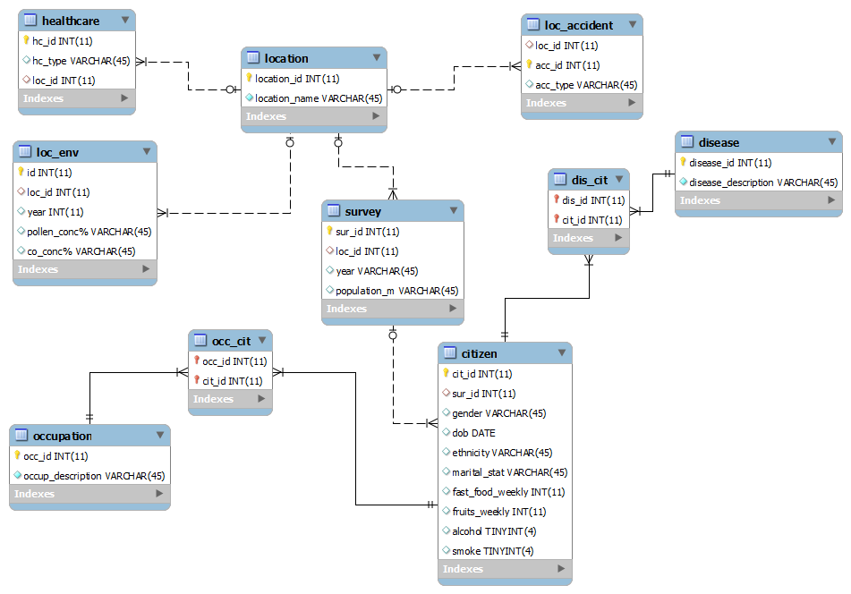

1. d) Insert code present in insertdata.sql
2. e) The SQL code of the queries and screenshots

**Task 4**

**Query 1: The surveyed female population for each town during the year 2012**

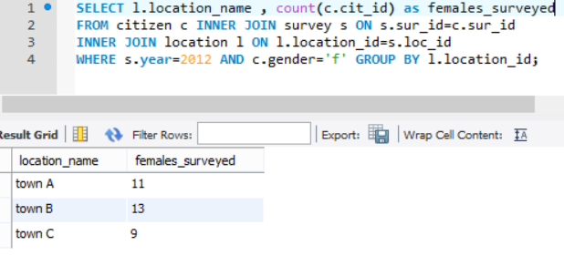**Query 2: Most common accident type for Town A.**

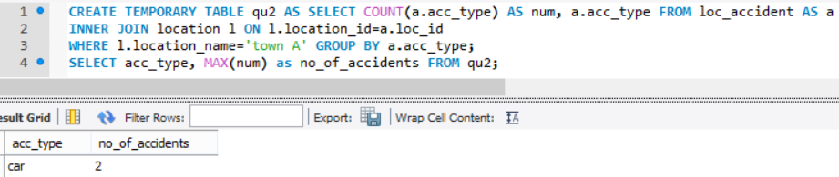

**Query 3: Prevalence of diabetes in Town B for the year 2014**

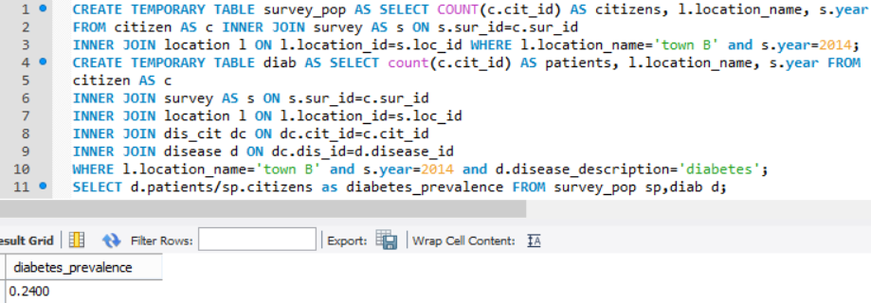

**Query 4: Town with the lowest diabetes prevalence for the year 2012**

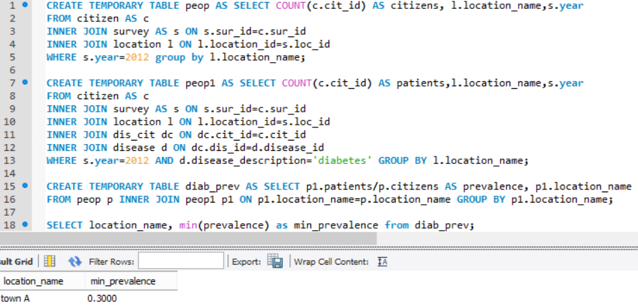**Query 5: The town(s) where no accidents have been reported**

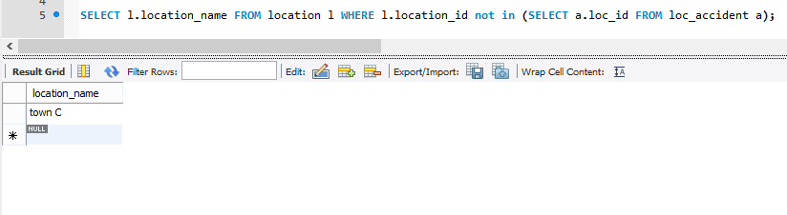

**Query 6: The availability of health resources for Town C for the whole observation period.**

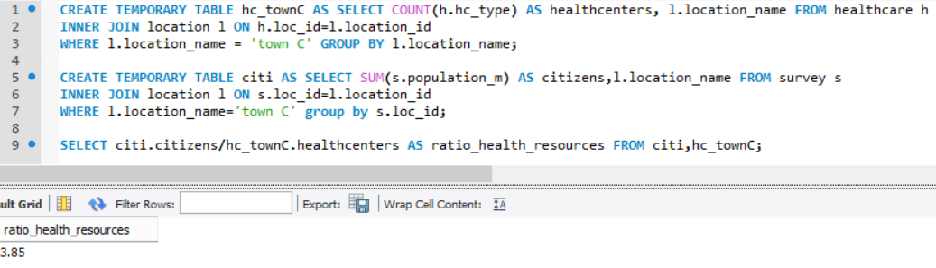**Query 7: The change in the smoking habit between in 2014 compared to 2012, for all towns**

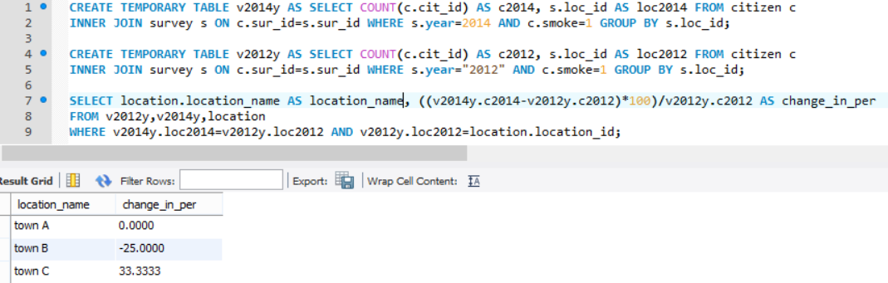

References:

http://www.cvauni.edu.vn/imgupload_dinhkem/file/CSDL/Fundamentals_of_Database_Systems,_6th_Edition.pdf