**SatLog dataset**

PCA+RDPOD

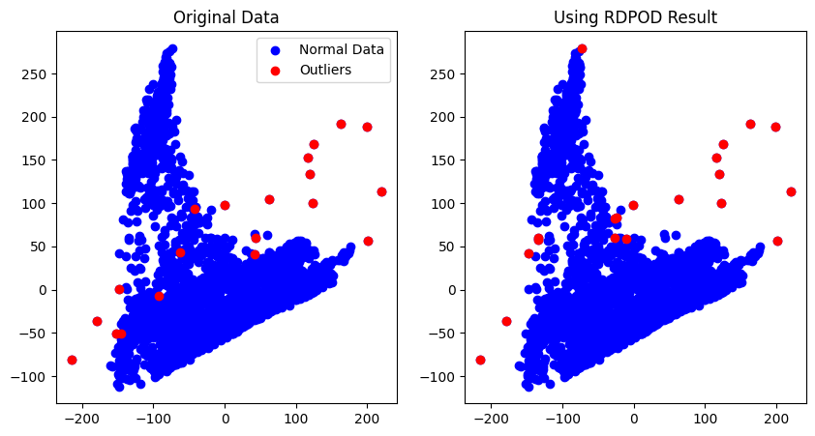

AEC+RDPOD

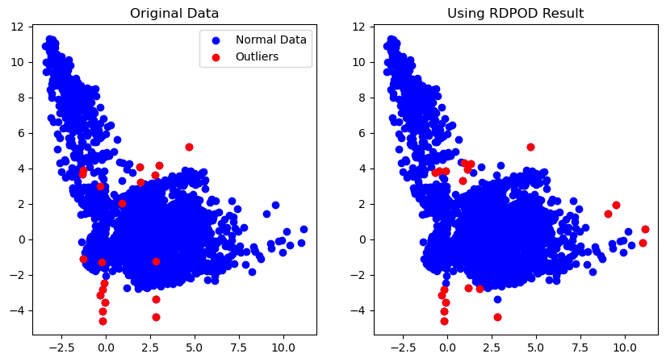

T-SNE +RDPOD

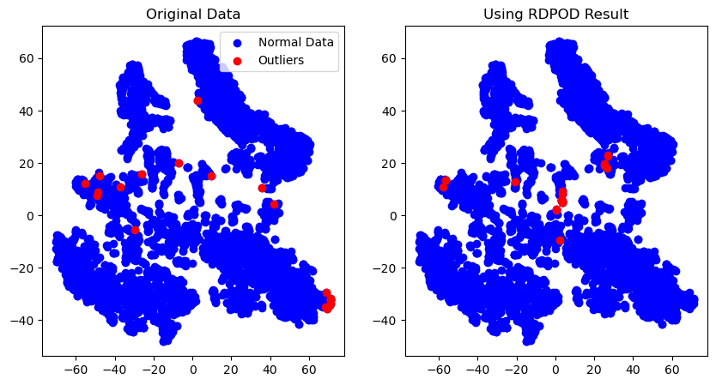

AEC+ELM

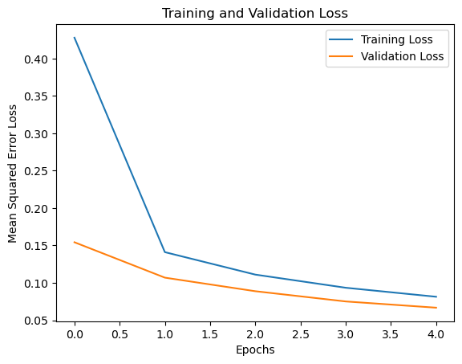

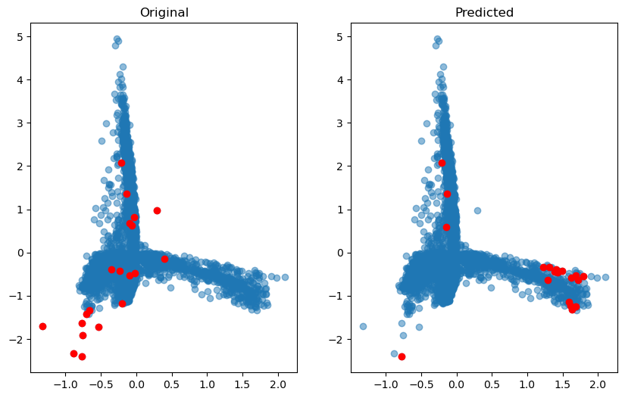

T-SNE + ELM

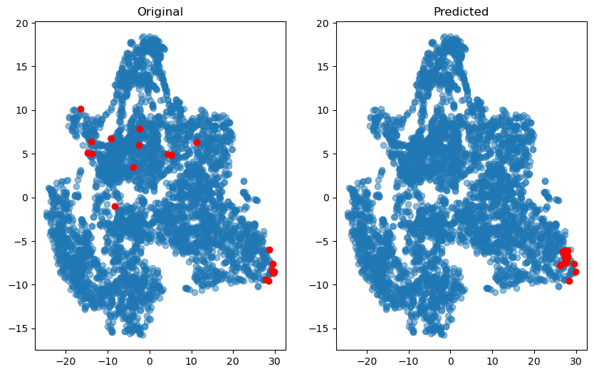

PCA+RDPOD+ELM

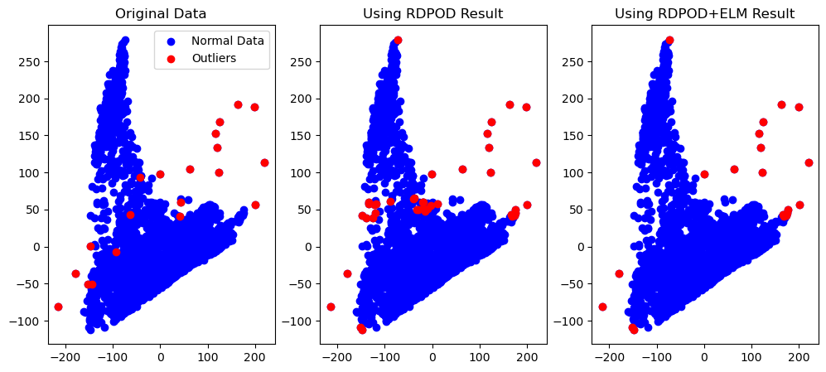

AEC+RDPOD+ELM

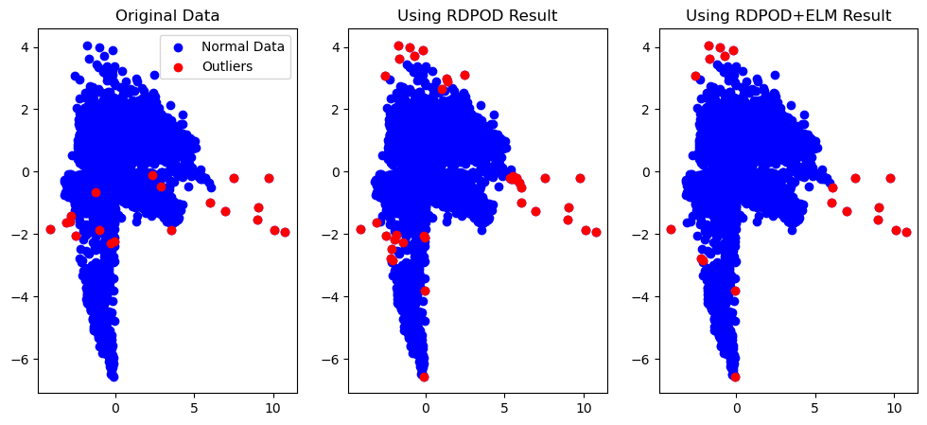

ELM

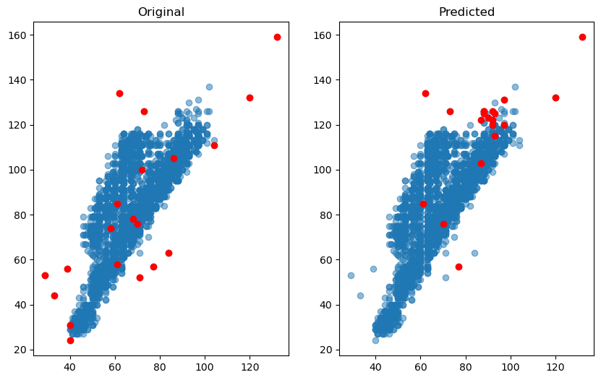

**Breast-Cancer dataset**

PCA+RDPOD:

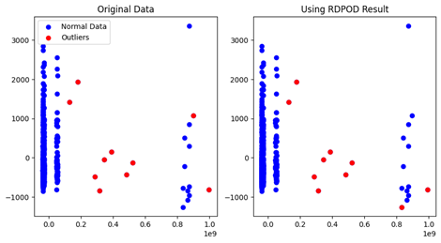

AEC+RDPOD

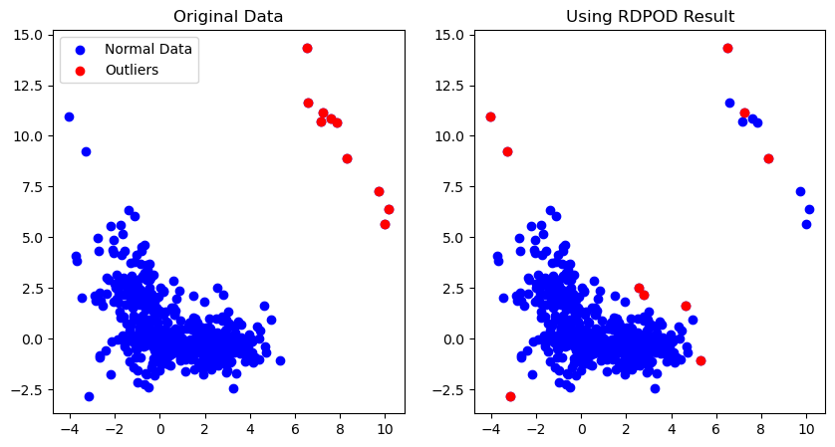

T-SNE +RDPOD

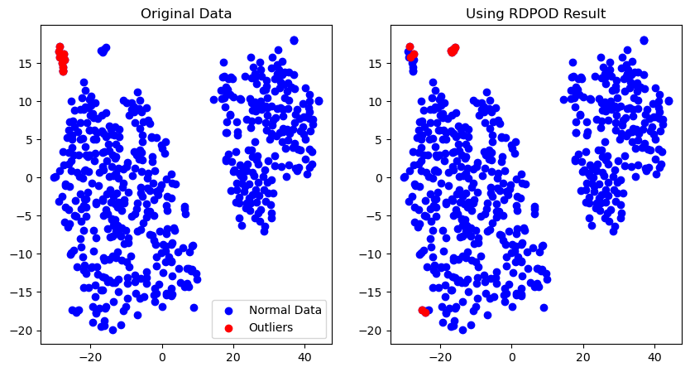

AEC+ELM

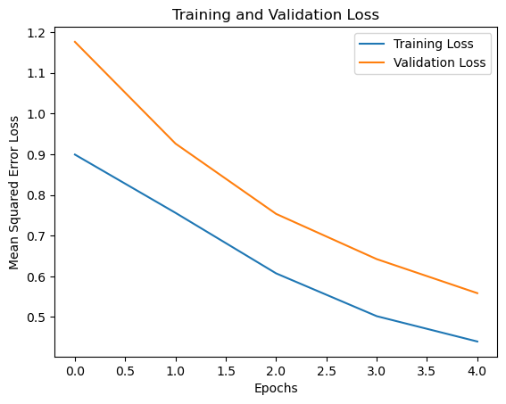

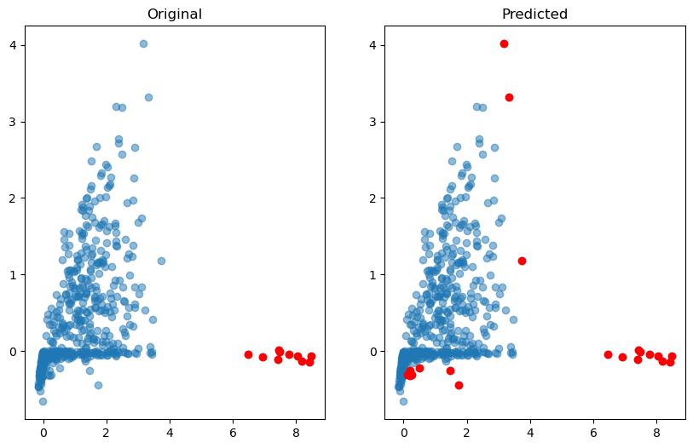

T-SNE + ELM

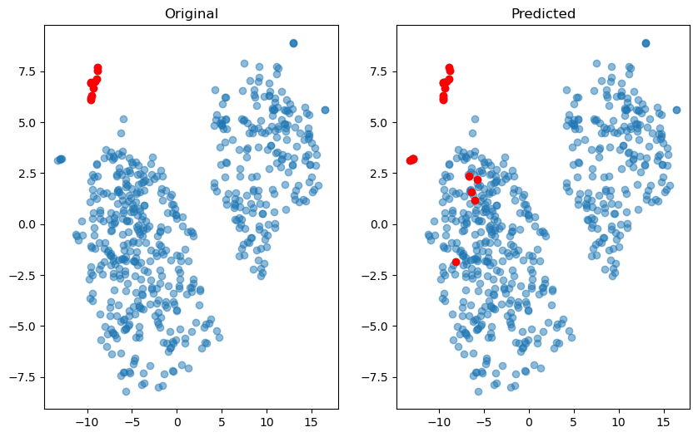

PCA+RDPOD+ELM

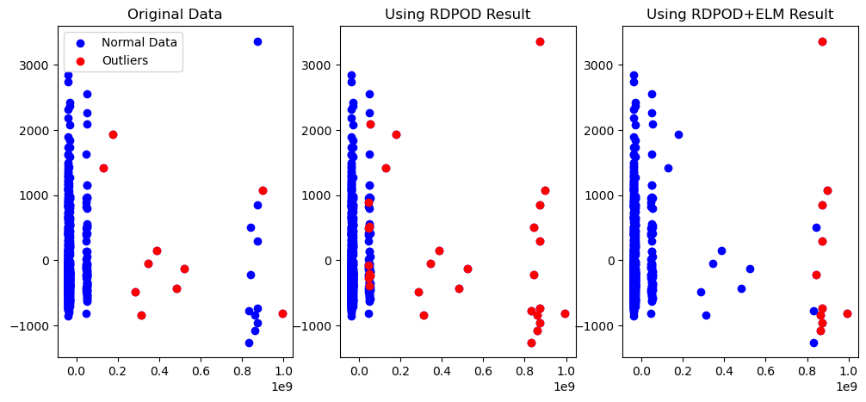

AEC+RDPOD+ELM

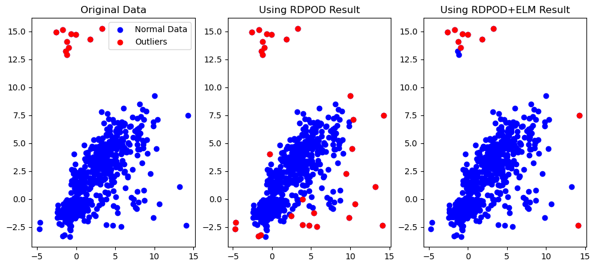

ELM

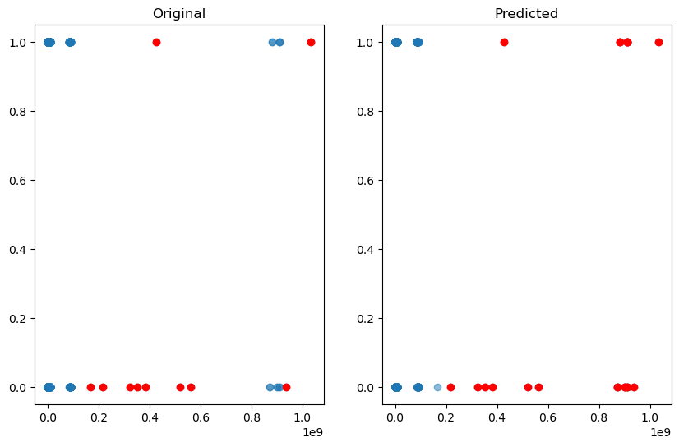

**CovType dataset**

Can’t able to them memory not enough

PCA+RDPOD

AEC+RDPOD

T-SNE +RDPOD

AEC+ELM

T-SNE + ELM

PCA+RDPOD+ELM

AEC+RDPOD+ELM

ELM

**KDD99 dataset**

Can’t able to them memory not enough

PCA+RDPOD

AEC+RDPOD

T-SNE +RDPOD

AEC+ELM

T-SNE + ELM

PCA+RDPOD+ELM

AEC+RDPOD+ELM

ELM