**IOT_Phase 4**

**(Noise Pollution Monitoring)**

**Team Members:**

1. Kishore.M (210621106029)
2. Jedance (2106211060027)
3. Nathanial (210621106036)
4. Edwin Inbaraj (210621106019)

**Introduction:**

A noise monitoring system is designed to capture, analyze, and manage environmental noise levels. It helps measure and control noise pollution in various settings, including urban areas, industrial sites, and public spaces.

**Hardware Components:**

First Code Snippet (MicroPython for ESP8266):

* An analog-to-digital converter (ADC) connected to Pin 2, which is used to read analog data.
* The code snippet reads a value from the ADC and prints it.

Second Code Snippet (MicroPython for ESP32):

* The component information is defined in the JSON configuration provided. Here are the components specified in the JSON configuration:
* An ESP32 development kit (type: "wokwi-esp32-devkit-v1") with the ID "esp."This represents the ESP32 microcontroller.
* A microphone component with the ID "mic." This represents a microphone sensor.

**Software Components:**

* Arduino IDE: The Arduino Integrated Development Environment is used for writing and uploading code to MicroPython for ESP8266 and MicroPython for ESP32.

**System Design:**

ESP8266/ESP32:

Low-cost microcontrollers with Wi-Fi capabilities, ideal for IoT applications.

IoT Connectivity:

Implementing connectivity to transmit noise data to Azure IoT Hub.

**Options include:**

Wi-Fi:

Use onboard Wi-Fi capabilities of microcontrollers.

Cellular:

If remote locations are involved, consider using cellular IoT modules.

LoRa:

For long-range communication in low-power scenarios, LoRaWAN can be suitable.

Power Source:

Deployment scenario, power your IoT device with a suitable power source. This could be a standard power outlet, battery, or energy harvesting solutions for low-power, remote deployments.

Traffic Data Integration :

Incorporate traffic data sources such as traffic cameras, GPS, or traffic flow sensors to obtain information about vehicle counts, speeds, and congestion in the same areas.

Data analytics is crucial for noise monitoring as it helps in extracting valuable insights from the collected noise data.

Alert Response:

Plan for appropriate responses to alerts, such as dispatching noise control teams, notifying residents of possible disturbances, or making real-time traffic management adjustments.

**Simulation Code:**

*#include <LiquidCrystal.h> // include the LiquidCrystal library*

*const int micPin1 = A0; // define the pin for the first microphone*

*const int micPin2 = A1; // define the pin for the second microphone*

*const int micPin3 = A2; // define the pin for the third microphone*

*const int buzzerPin = 9; // define the pin for the buzzer*

*const int ledPin = 6; // define the pin for the LED*

*const int contrast = 50; // define the LCD contrast*

*LiquidCrystal lcd(12, 11, 5, 4, 3, 2); // initialize the LCD display*

*void setup() {*

*pinMode(buzzerPin, OUTPUT); // set the buzzer pin as output*

*pinMode(ledPin, OUTPUT); // set the LED pin as output*

*lcd.begin(16, 2); // initialize the LCD display*

*analogWrite(6,contrast); // set the LCD contrast*

***Serial****.begin(9600); // initialize the serial monitor*

*}*

*void loop() {*

*// read the values from the microphones*

*int micValue1 = analogRead(micPin1);*

*int micValue2 = analogRead(micPin2);*

*int micValue3 = analogRead(micPin3);*

*// calculate the sound levels in dB for each microphone*

*float voltage1 = micValue1 * 5.0 / 1024.0; // convert the first microphone value to voltage (5V reference)*

*float voltage2 = micValue2 * 5.0 / 1024.0; // convert the second microphone value to voltage (5V reference)*

*float voltage3 = micValue3 * 5.0 / 1024.0; // convert the third microphone value to voltage (5V reference)*

*float dB1 = 20 * log10(voltage1/0.0063); // calculate the sound level in dB for the first microphone*

*float dB2 = 20 * log10(voltage2/0.0063); // calculate the sound level in dB for the second microphone*

*float dB3 = 20 * log10(voltage3/0.0063); // calculate the sound level in dB for the third microphone*

*// calculate the average sound level in dB for all microphones*

*float averageDB = (dB1 + dB2 + dB3) / 3;*

*// display the sound level on the LCD display and the serial monitor*

*lcd.setCursor(0, 0); // set the cursor to the first row of the LCD display*

*lcd.print("Sound Level: "); // print the text "Sound Level: " on the LCD display*

*lcd.setCursor(0, 1); // set the cursor to the second row of the LCD display*

*lcd.print(averageDB); // print the average sound level on the LCD display*

***Serial****.print("Sound Level: "); // print the text "Sound Level: " on the serial monitor*

***Serial****.println(averageDB); // print the average sound level on the serial monitor*

*// control the LED and the buzzer based on the sound level*

*if (averageDB > 70) { // if the sound level is higher than 70 dB*

*digitalWrite(ledPin, HIGH); // turn the LED on*

*tone(buzzerPin, 1000, 500); // turn the buzzer on*

*} else { // if the sound level is lower than 70 dB*

*digitalWrite;*

*}*

*}*

**Diagram.json :**

{

  "version": 1,

  "author": "Kishore M",

  "editor": "wokwi",

  "parts": [

    { "type": "wokwi-arduino-uno", "id": "uno", "top": 202.2, "left": 18.6, "attrs": {} },

    { "type": "wokwi-lcd1602", "id": "lcd", "top": 8, "left": 20, "attrs": {} },

    { "type": "wokwi-resistor", "id": "r1", "top": 140, "left": 220, "attrs": { "value": "220" } },

    {

      "type": "wokwi-buzzer",

      "id": "bz1",

      "top": 66.16,

      "left": -72.28,

      "attrs": { "volume": "0.1" }

    },

    {

      "type": "wokwi-led",

      "id": "led1",

      "top": 175.61,

      "left": 339.36,

      "attrs": { "color": "red" }

    },

    {

      "type": "wokwi-led",

      "id": "led2",

      "top": 259.31,

      "left": 341.33,

      "attrs": { "color": "red" }

    },

    {

      "type": "wokwi-led",

      "id": "led3",

      "top": 329.23,

      "left": 345.27,

      "attrs": { "color": "red" }

    }

  ],

  "connections": [

    [ "uno:GND.1", "lcd:VSS", "black", [ "v-51", "*", "h0", "v18" ] ],

    [ "uno:GND.1", "lcd:K", "black", [ "v-51", "*", "h0", "v18" ] ],

    [ "uno:GND.1", "lcd:RW", "black", [ "v-51", "*", "h0", "v18" ] ],

    [ "uno:5V", "lcd:VDD", "red", [ "v16", "h-16" ] ],

    [ "uno:5V", "r1:2", "red", [ "v16", "h-118", "v-244", "h50" ] ],

    [ "r1:1", "lcd:A", "pink", [] ],

    [ "uno:12", "lcd:RS", "green", [ "v-16", "*", "h0", "v20" ] ],

    [ "uno:11", "lcd:E", "green", [ "v-20", "*", "h0", "v20" ] ],

    [ "lcd:D4", "uno:5", "green", [ "v43.53", "h76.86" ] ],

    [ "lcd:D5", "uno:4", "green", [ "v36.63", "h75.24" ] ],

    [ "lcd:D6", "uno:3", "green", [ "v26.79", "h78.54" ] ],

    [ "lcd:D7", "uno:2", "green", [ "v52.39", "h79.87" ] ],

    [ "bz1:2", "uno:9", "red", [ "v36.28", "h220.75" ] ],

    [ "bz1:1", "uno:GND.1", "black", [ "v9.69", "h180.53", "v54.16" ] ],

    [ "led1:A", "uno:A0", "red", [ "v26.92", "h-60.72", "v166.42", "h-77.79" ] ],

    [ "led2:A", "uno:A1", "red", [ "v18.06", "h-50.87", "v108.32", "h-81.73" ] ],

    [ "led3:A", "uno:A2", "red", [ "v67.3", "h-125.71" ] ],

    [ "led3:C", "uno:GND.2", "black", [ "v47.6", "h-169.87" ] ],

    [ "led2:C", "uno:GND.2", "black", [ "v32.84", "h-17.24", "v86.66", "h-147.71" ] ],

    [ "led1:C", "uno:GND.2", "black", [ "v3.29", "h-15.27", "v198.92", "h-150.66" ] ]

  ],

  "dependencies": {}

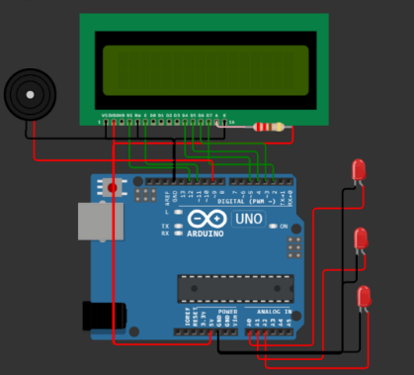**Diagram.json output :**

**Simulation link:**

[**https://wokwi.com/projects/379572007533323265**](https://wokwi.com/projects/379572007533323265)

**Simulation Output:**

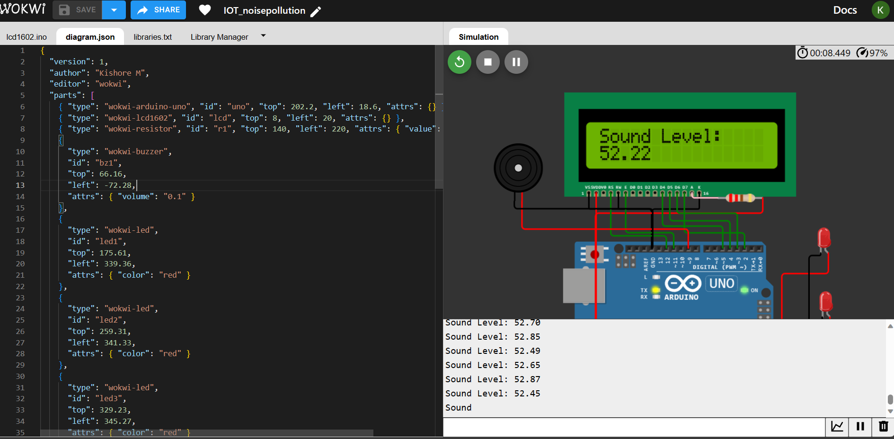

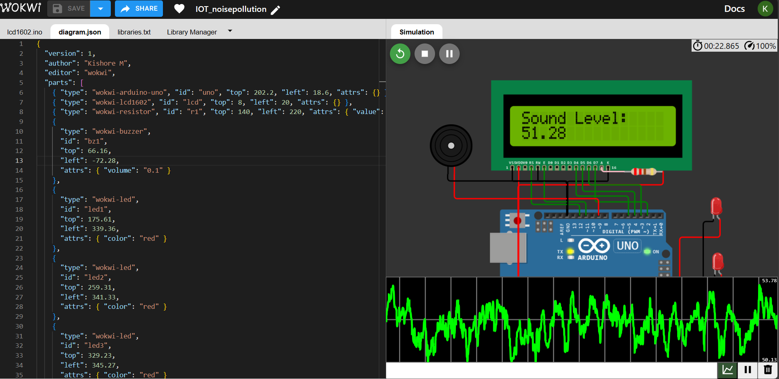

**App for noise monitoring system :**

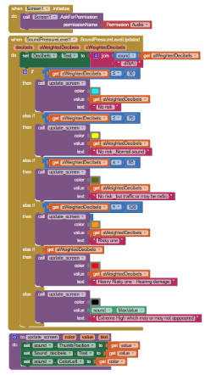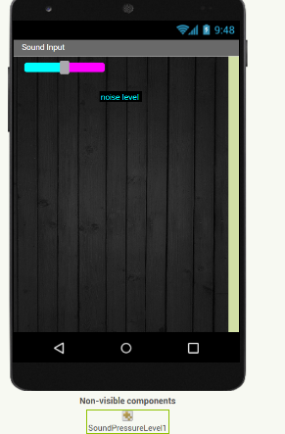

**Conclusion:**

There are several sources of noise such as automobiles, construction works, tools, and industries. Noise Pollution is becoming a serious concern due to the increase in vehicles, heavy industries, power tools, etc. In conclusion, noise pollution monitoring systems play a pivotal role in modern society by providing critical insights into the levels and sources of noise pollution in our environment.