**DML Commands with Constraints –UPDATE, DELETE**

**Aim:**

To perform Data Manipulation Language (DML) Commands such as UPDATE, DELETE in the table.

1.Update the value of student name whose register number is ‘191711342’

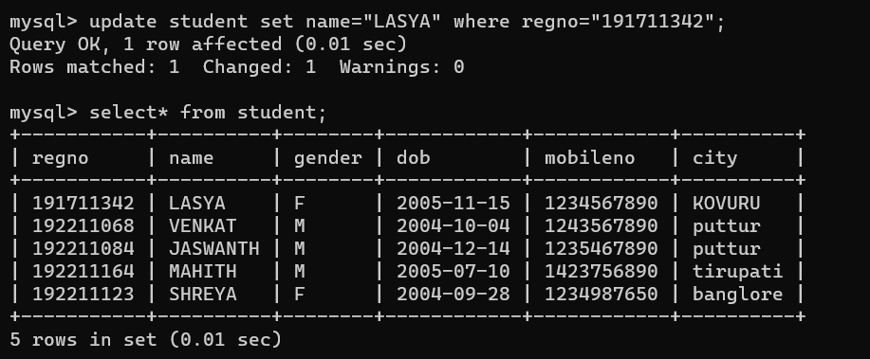

2.Delete the record in the table FACULTY, who resigned her job.

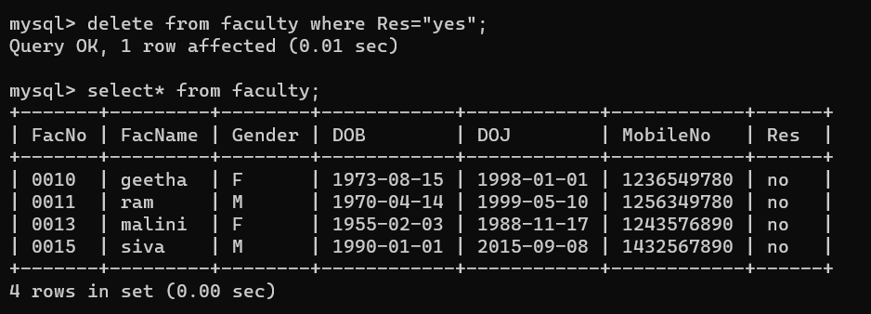

**RESULT**:

Data Manipulation Language (DML) Commands such as INSERT, SELECT, UPDATE, DELETE are performed in the five tables.