**Bank Churn Analysis**

This project analyzes **customer churn** in a bank using **statistical and machine learning techniques**. It includes **univariate analysis, KDE plots, line graphs, normalization, and standardization** to understand customer behavior and improve predictive models.

**Project Structure**

**Installation**

1. Clone the repository:

bash

git clone https://github.com/your-username/Bank_Churn_Analysis.git

1. Install dependencies:

bash

pip install -r requirements.txt

1. Run the Jupyter Notebook:

**Dataset**

The dataset includes customer information such as:

* **Demographics**: Age, gender, location, etc.
* **Financial details**: Credit score, balance, estimated salary.
* **Account details**: Number of products, tenure, and churn status (0 = Stayed, 1 = Left).

**Analysis Overview**

**📊 Univariate Analysis**

* Examining the distribution of **age, balance, credit score**, etc.
* Used **histograms, box plots, and KDE plots** to visualize distributions.

This histogram gives us insights like:

Gender also correlated with churn.

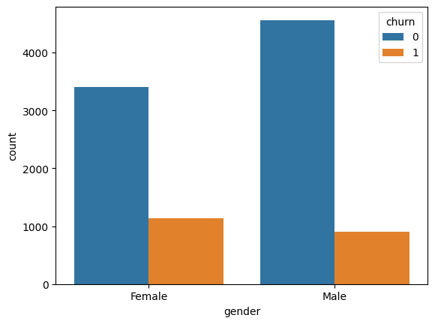

**📈 Line Graphs & KDE Plots**

* **Line graphs** used to track trends in customer churn over different variables.

With this graph, we got insights that

Customers between 40 and 54 years of age are more likely to churn.

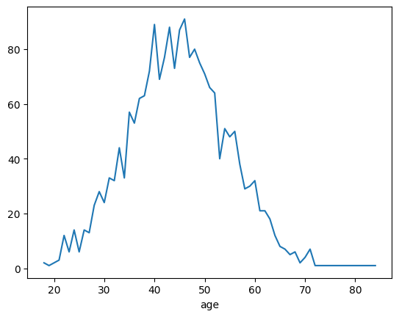

* **KDE (Kernel Density Estimation) plots** visualize the distribution of continuous variables.

With this KDE plot in green line shows that people who are active are aged between 28 – 40

And people brown line customers between 40- 54 (approximately) are more like to churn.

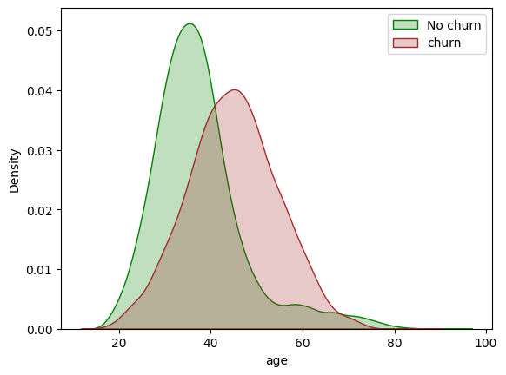

**🔄**

* Customer age element is also correlated to churn as per the insights from the dataset.

**Normalization & Standardization**

* **Normalization (Min-Max Scaling)**:
  + Transforms values between 0 and 1 for models like KNN.
* **Standardization (Z-score Scaling)**:
  + Centers data with a mean of 0 and standard deviation of 1 for models like Logistic Regression.
* Applied these techniques to features like **age, balance, and estimated salary** to improve model performance.

**Results & Insights**

* **Key factors affecting churn**:
  + Customers with **low tenure and high balance** are more likely to leave.
  + Older customers tend to stay longer with the bank.
* **Feature scaling improves model performance**, especially for distance-based algorithms.