Q4 Business Review

Q4 Business Review
Revenue grew across all regions while churn held flat.
Revenue by Month
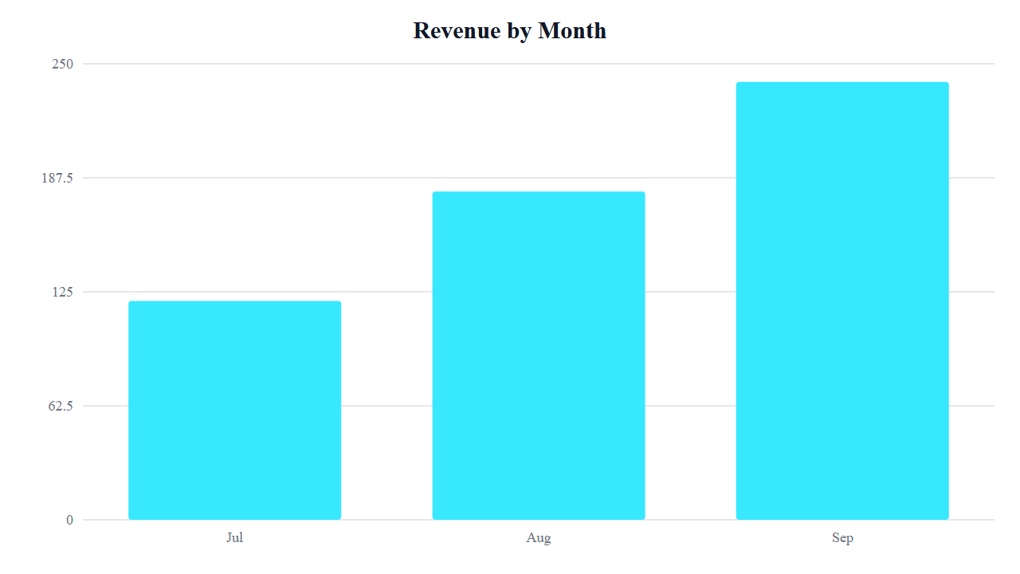
Revenue Mix
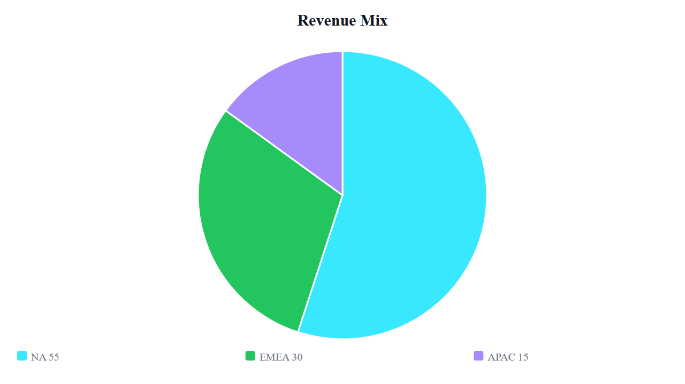
Region | Q4
NA | 1.2M
EMEA | 640K

