**Installation of pymongo module (How to Connect Python with MongoDB)**

Conda activate

pip install pymongo

spyder

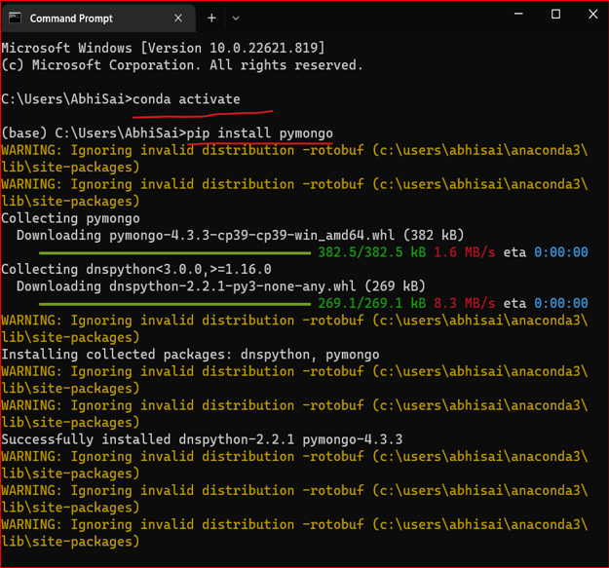

**# IMPORT the installed PYMONGO package**

import pymongo # To interact with db, collections etc

**# Create MongoDB Client**

client = pymongo.MongoClient('mongodb://127.0.0.1:27017/')

# By default whenever we are running MongoDB on local server the IP address is '127.0.0.1 and the PORT is 27017

# we also need to give the protocol i.e mongodb

**# Create a Database 'Employee' and store it in mybd variable**

mydb = client['Employee']

# Until and unless we will not create/add collections in any new databases, it will not show up in Cilent Side i.e mongodb compass interface

**# Start Create One Collection**

information = mydb.employeeinformation

**# Start Creating One Records**

**# All the records that are stored in the collections in the form of JSON documents**

**# So, we need to make JSON type in the form of KEY:VALUE pairs**

record = {

'firstname':'Sid',

'lastname':'Das',

'Department':'Data-Science'

}

**# Insert the above record in the collection named 'employeeinformation'**

**# Using the above Document information**

information.insert_one(record)

**O/P:**

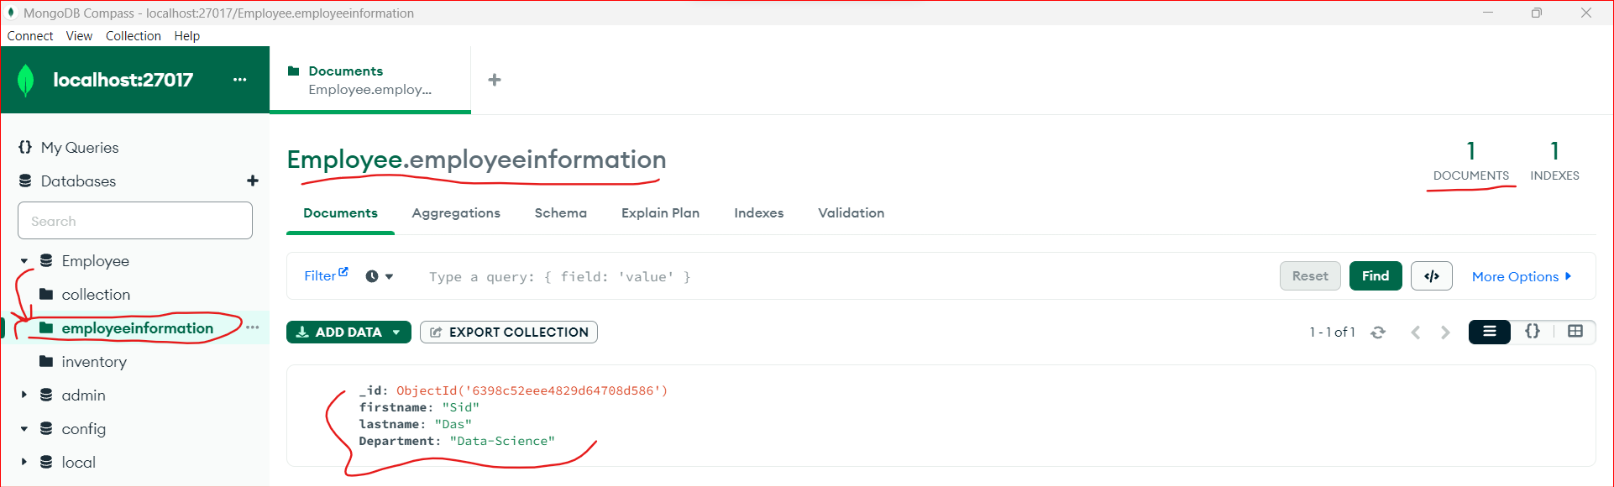

**# To insert multiple Records at once**

**# We need to pass multile list arrays**

record = [{

'firstname':'Sid',

'lastname':'Das',

'Department':'Data-Science'

},{

'firstname':'Sid1',

'lastname':'Das1',

'Department':'Data-Science1'

},{

'firstname':'Sid2',

'lastname':'Das2',

'Department':'Data-Science2'

}]

**# We need to use 'insert_many()' function to insert all the above records**

information.insert_many(record)

**O/P:**

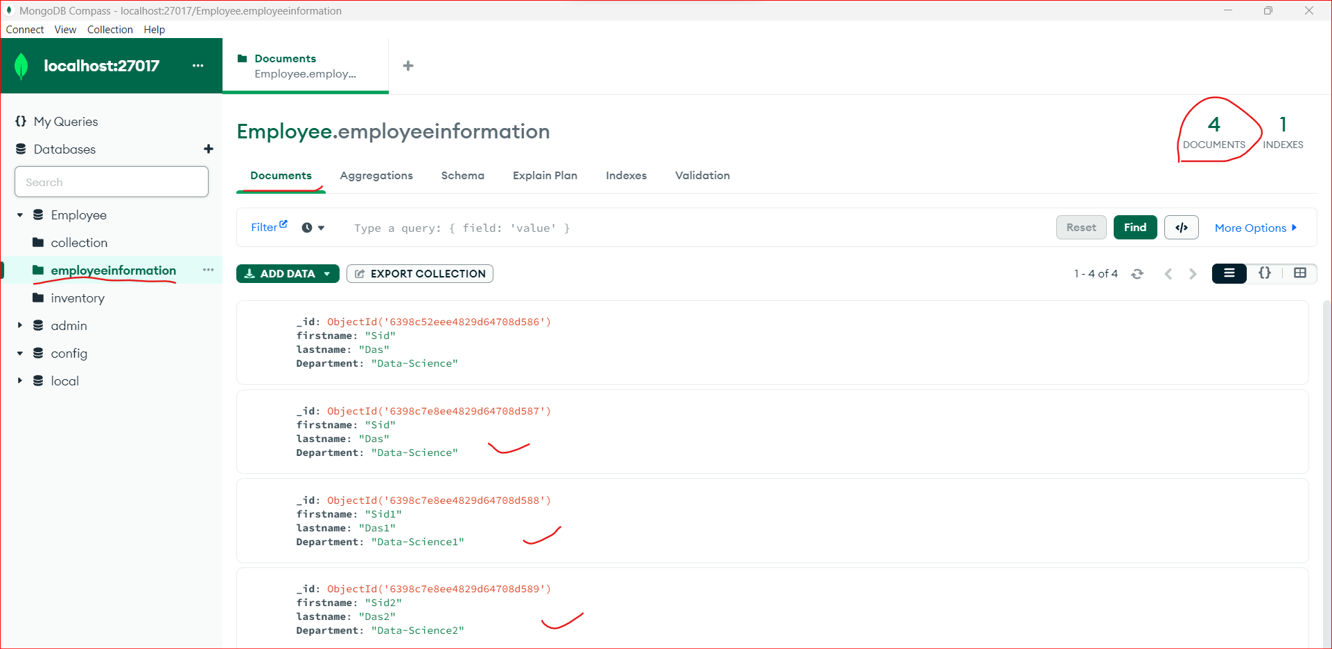

**2nd PART: MongoDB with Python- Querying JSON Documents | Data Science**

**Next section 3rd**