**36. MongoDB Indexes**

**I'll use native MongoDB Shell to demonstrate**

I'll switch to the "forum" database - "use forum". And then perform following - **-> db.posts.getIndexes()**

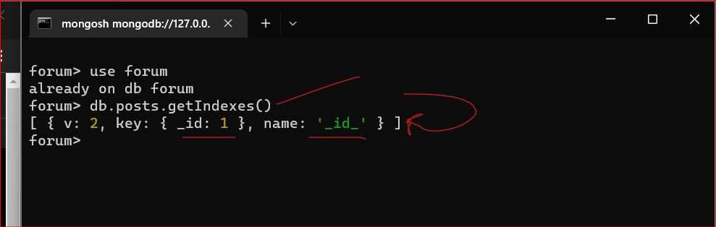

**Above I get array that consists of objects.**

And each object is Index.

In each collection there is default index and this index is created by field "_id". One here means the index is ascending,

name of the Index is here -"_id_"

and namespace is "forum.posts".

This index ensures that if you perform query by "_id"

**Note:**

**To clear the terminal you can use: cls**

* **db.posts.find()**

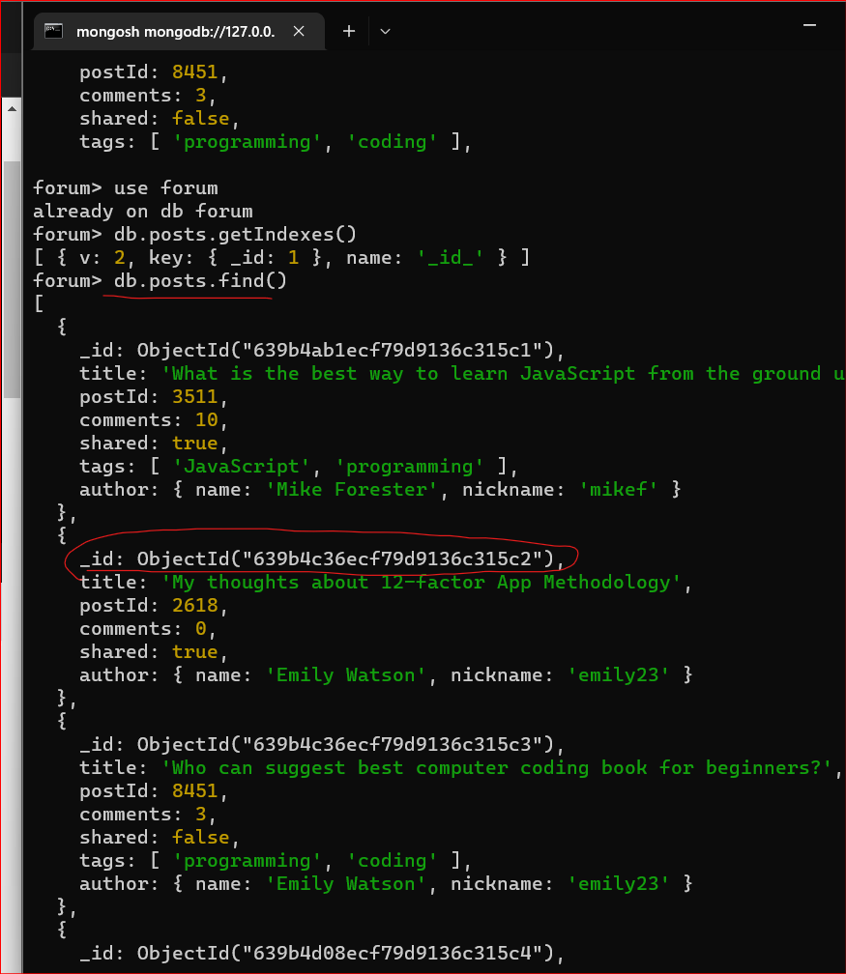

Let’s copy any object line above!

_id: ObjectId("639b4c36ecf79d9136c315c2")

* **db.posts.findOne({“_id”: ObjectId("639b4c36ecf79d9136c315c2")})**

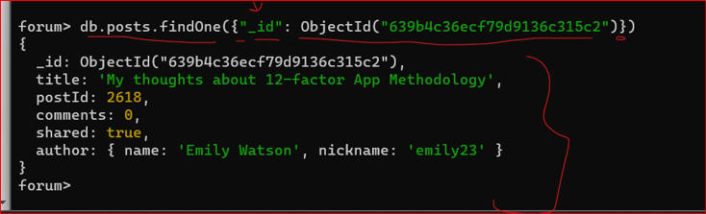

In this case this query was executed using index. This document was found using "_id" index.

You can add to the index other fields if you want and usually indexes are created for the fields that are most often used in the queries.

For example if you use "postId" or "tags" in the queries you need to create corresponding indexes.

**in the next section let's discuss MongoDB utilities**