**37- MongoDB Utilities**

**Mongoexport**

**Mongoimport**

**Mongodump**

**Mongorestore**

**Those utilities are separate applications and they can be used for data management in MongoDB.**

**Mongoexport is used to export specific data from certain collection.**

**Mongoimport is used to import data into the MongoDB database.**

**Mongodump creates dump from the MongoDB database**

**mongorestore is used to restore data from the MongoDB dump.**

Let me show you mongoexport and mongodump in action.

In order to demonstrate this I will use Terminal window.

**Please note**

Those utilities are separate applications and you don't need to open mongo shell in order to use them.

I will go to the Terminal and change directory to the desktop.

Then I'll use mongoexport utility.

**mongoexport**

And now I I'll pass several arguments to it.

"-d" specifies name of the database. In our case it is "forum".

"-c" - name of the collection. It is "posts".

"-o" defines name of the file where this export data will be written to.

And name of the file will be just "posts.txt". And let's execute.

<https://www.mongodb.com/community/forums/t/mongoexport-is-not-recognized-as-an-internal-or-external-command/129304>

**Need to Download the above Tools Externally 54MB**

[**https://www.mongodb.com/try/download/database-tools**](https://www.mongodb.com/try/download/database-tools)

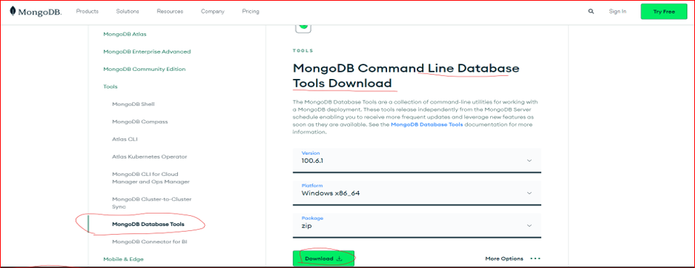

**These are the files:**

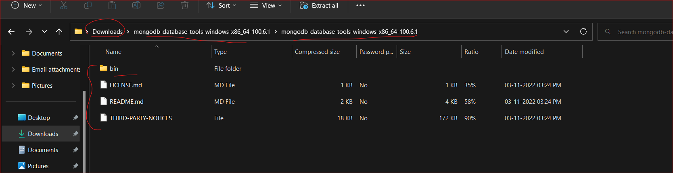

**And copy the downloaded files in**

**C:\Program Files\MongoDB\Tools\bin**

**Add new folder: “Tools” and paste the files**

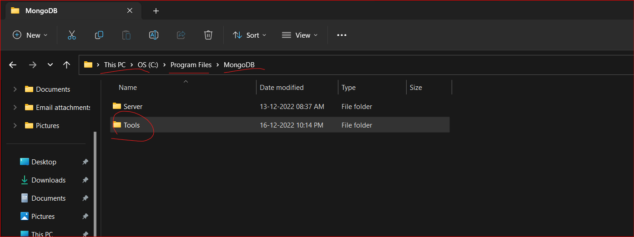

**In Order to execute the tools from command prompt in any directory we need to add the Path to System Environment variable**

[**https://www.mongodb.com/docs/database-tools/installation/installation-windows/#installation**](https://www.mongodb.com/docs/database-tools/installation/installation-windows/#installation)

**Make the DB Tools available in your PATH.**

**You may wish to make the Database Tools available in your system's PATH environment variable, which allows referencing each tool directly on the command prompt by name, without needing to specify its full path, or first navigating to its parent directory.**

**Once you've installed the Database Tools, follow the instructions below to add the install directory to your system's PATH environment variable.:**

1. **Open the Control Panel.**
2. **In the System and Security category, click System.**
3. **Click Advanced system settings. The System Properties modal displays.**
4. **Click Environment Variables.**
5. **In the System variables section, select Path and click Edit. The Edit environment variable modal displays.**
6. **Click New and add the filepath to the location where you installed the Database Tools.**
7. **Click OK to confirm your changes. On each other modal, click OK to confirm your changes.**

**Once set, you can run any of the Database Tools directly from your command prompt. Consult the**

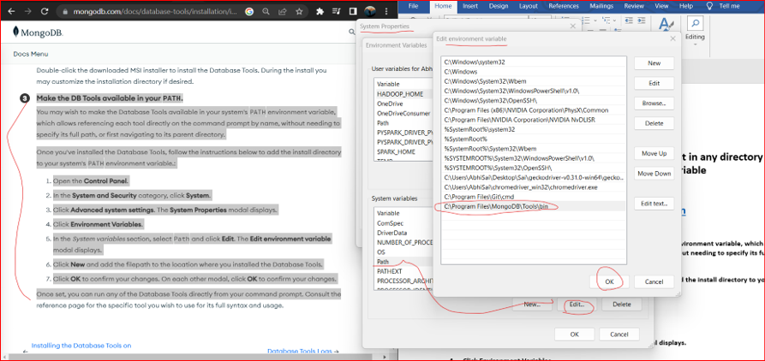

**Now Open New CMD terminal:**

**Save the data using**

**Mongoexport utility**

* **mongoexport -d forum -c posts -o posts.txt**

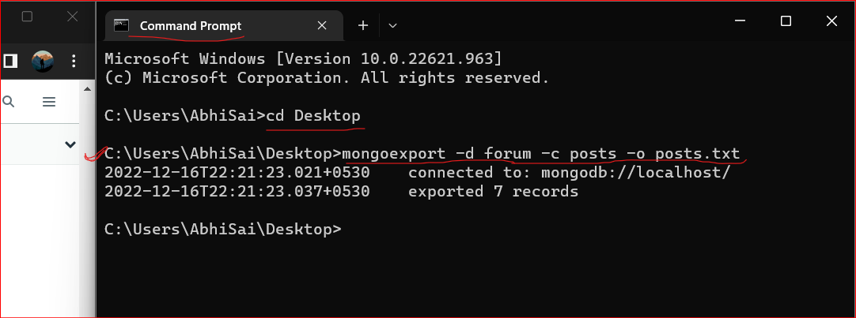

**Output: (posts data saved in desktop without any errors!)**

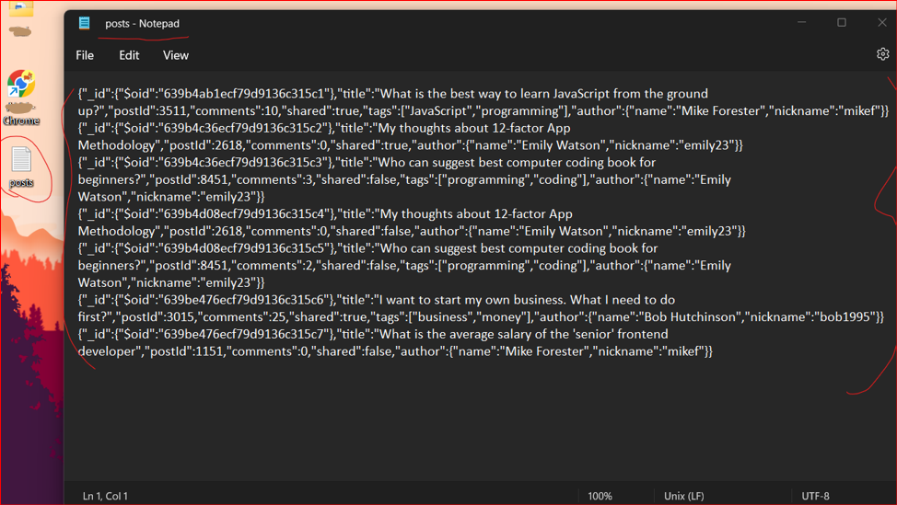

**This application has successfully connected to the localhost and has exported 7 records.**

You may notice that instead of "ObjectID" - "$oid" is used to represent "ObjectID" type.

why this format is used here?

* Answer is simple. Document was exported as JSON object not as Extended JSON object and
* now this document fully conforms to JSON standard.

Let's now use

* **mongodump utility**

It will create dump of our entire database.

Just mongodump and (Enter)

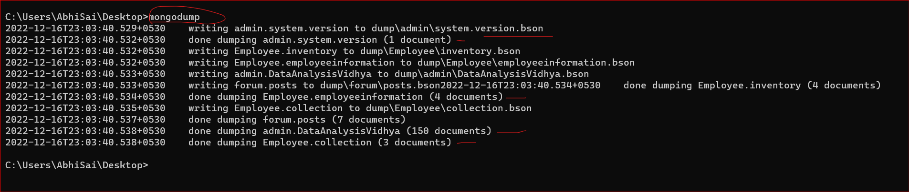

**Output:**

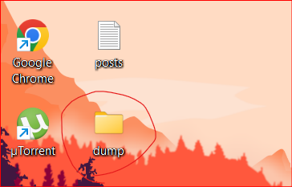

**You see that 3 collections were automatically dumped.**

**"admin.system.version" and inside admin we have: Admin.DataAnalysisVidhya**

**"forum.posts"**

**“Employee.collection”**

Let's open up this folder. And you will see here two folders.

"admin", ‘Employee’ and "forum".

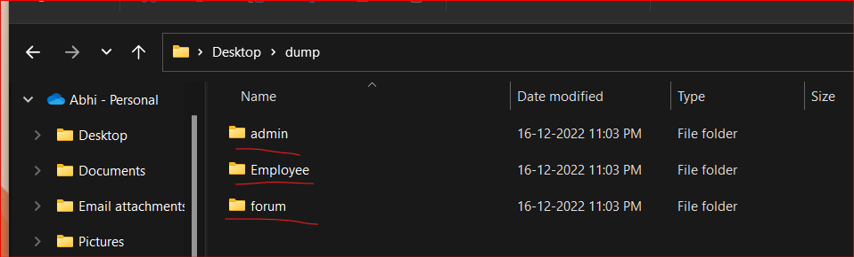

Let me expand "forum"/ And you see here "posts.bson" and "posts.metadata.json"

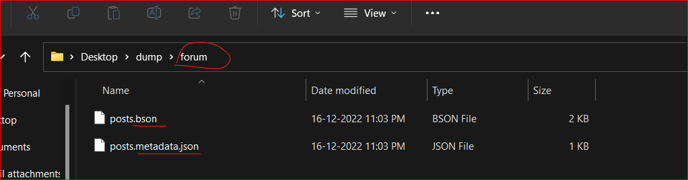

And if I'll expand "admin" database I'll see similar structure - ".bson" file and ".metadata.json" file.

**What is stored in those files?**

* In the ".bson" file data from the collection is stored in the BSON format, in the binary format.
* And ".metadata.json" file contains information about Indexes.

**Let's try to open this BSON file.**

And I'll use special utility for this called "hexdump".

Let me open new Terminal window.

And here I'll use "hexdump" utility and pass name of the file called "posts.bson".

**Error:**

'hexdump' is not recognized as an internal or external command, operable program or batch file.

And here you will see binary data from the BSON file.

And this output is just sequence of the ASCII codes in the hexadecimal format.

Remember that we have discussed this in the previous section.

add here one more option "-C"and (Enter)

And here on the right you'll see attempt to parse this sequence of the ASCII codes.

And you can read some parts of our documents.

"What is the best way to learn JavaScript from the ground up?" and so on.

And now you already know that those ASCII codes contain also information about values types.

For example here you see "title" that is a string. And here this "02" represents string value type and so on. That is a BSON format.

**In the next Section let's discuss MongoDB Replica** Sets.