**38 - What is MongoDB Replica Set?**

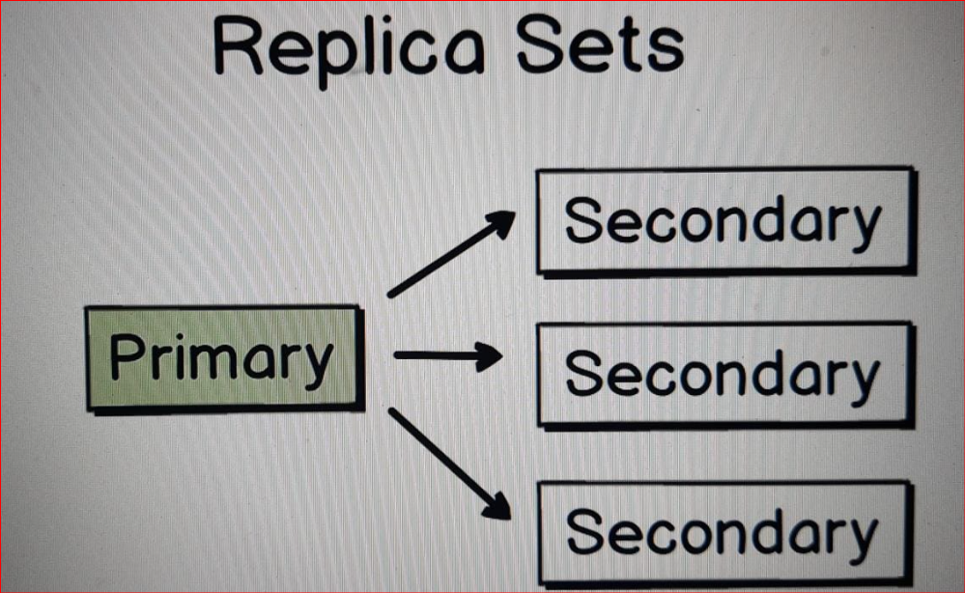

In this section we have used standalone MongoDB installation on the local computer.

And of course such kind of setup isn't suitable for production needs.

**If you want to use MongoDB in production you must setup MongoDB Replica Set.**

* Replica Set consist of several MongoDB servers and I have never seen production database that consists just of one server.
* In each Replica Set there is always only one primary server. And all others are secondary.
* And you can make changes only on the primary server.
* example update one of the documents, then this update is automatically propagated to all secondary servers. Or in other words it is replicated from primary to secondary.

That is the process in the Replica Set.

* If primary server fails then secondary servers will elect new primary server and one of the secondary servers will become primary.

**If you want to perform write operation you must do it on the primary server.**

But if you want to read data from the database, perform for example aggregation request or simple "find" query, then you can read from any of the server - either from primary or secondary.

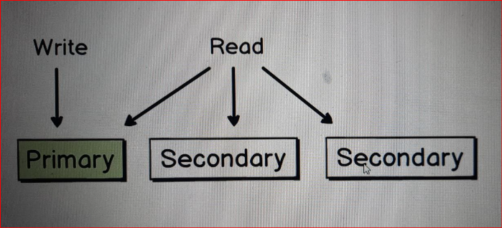

Remember that at the beginning of the section I have shown you example of the MongoDB Atlas setup.

Here it is. Here is my Cluster and Cluster consists of three servers.

And you see here tags – Secondary, Primary and Secondary.

**MongoDB Atlas:**

Choose SHARED Cluster of AWS

usrname: and pwd:

ip:

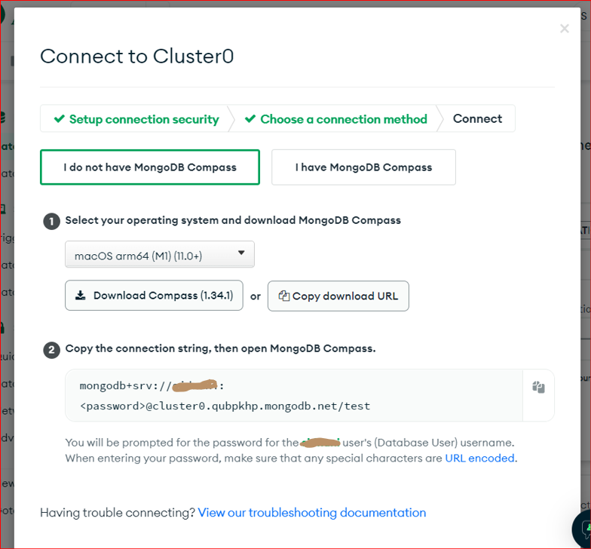

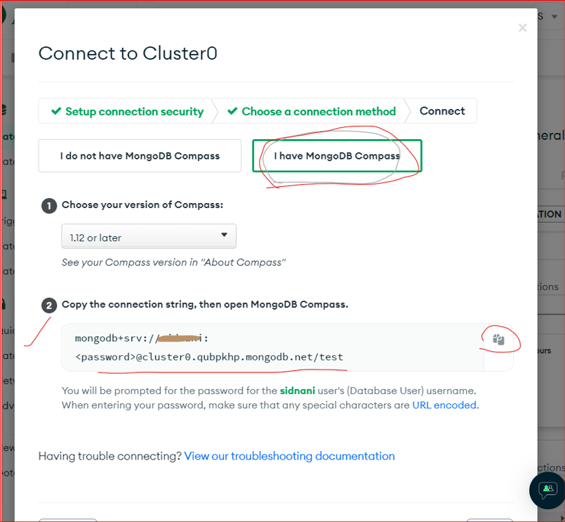

COPY the Connection STRING

mongodb+srv://sidnani:<password>@cluster0.qubpkhp.mongodb.net/test

Open your MongoDB Compass:

* New Connection:

Paste the above LINK in the box and Edit your password

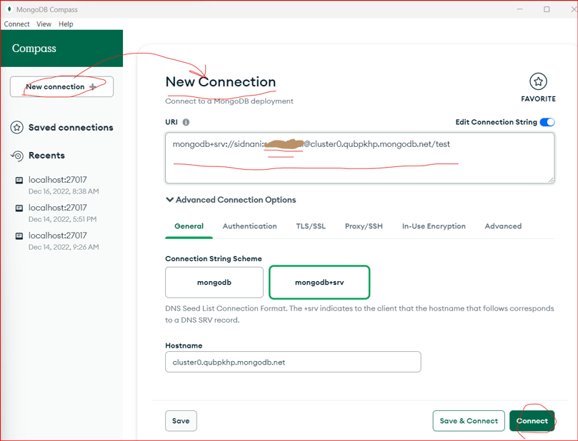

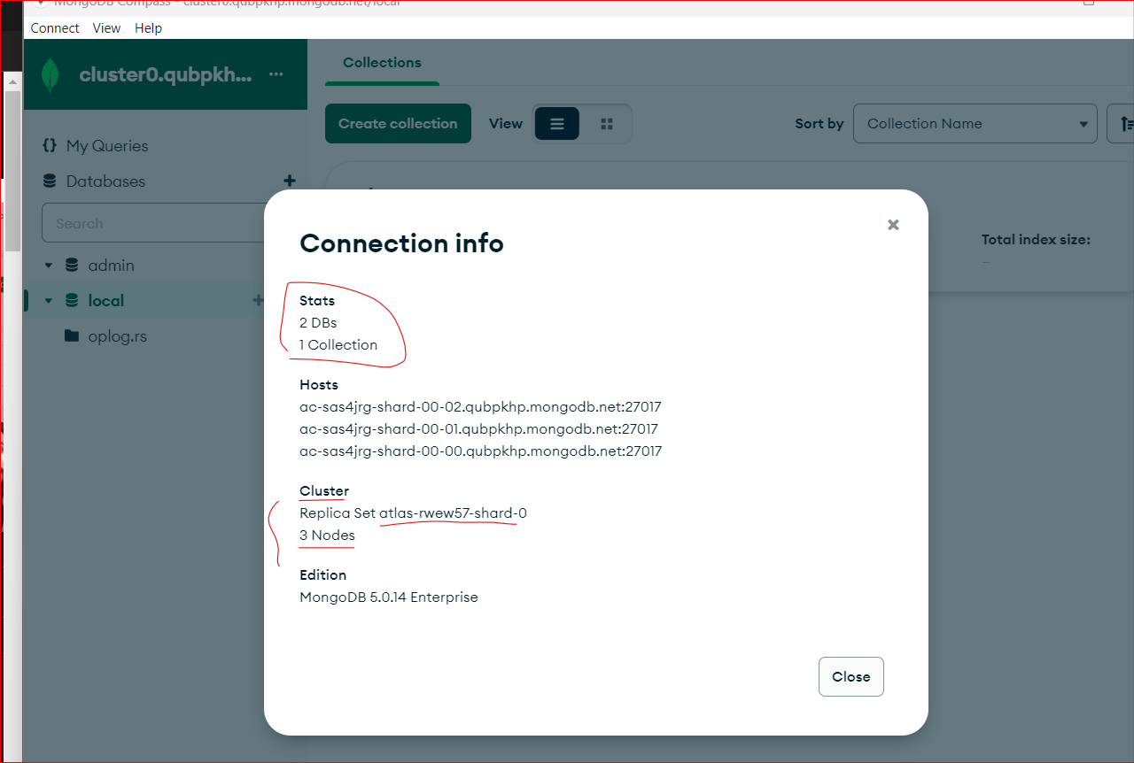

It means that I have in the cluster three servers combined in a Replica Set and one of the servers, this one, is primary.

If this server will fail, then one of those two secondary servers will become automatically primary.

Now if I perform any read operations I can read from any of those servers.

But if I want to change data, then I will do that only on the primary server.

And this information will be automatically replicated to all secondary servers.

That is the process in the MongoDB Replica Set.

And in the next section, let's talk about MongoDB drivers.

**MongoDB Drivers:**

In this section, we have used native MongoDB Shell and MongoDB Shell embedded into the Mongo 3T (Robo 3T)

But if you want to use MongoDB in full stack or backend applications, you should consider using MongoDB drivers.

And there are many different MongoDB drivers available.

* There are drivers for BHP for not just for CSR, C++, for Java, for Python, and so on.

Those drivers are used for same operations that we briefly discussed in the schools.

I mean, for create, read, update and delete operations.

If you use one of those programming languages or platforms, you should install one would-be driver

and connect it with your MongoDB database

**40 - Section Summary**

In this section, you have learned basics of MongoDB, MongoDB architecture.

We talked about MongoDB, and MongoDB server.

We discussed what is a database, what is collection, what is a document?

We talked about Jason, BSON and Extended Jason formats.

We discussed different BSON types such as object I.D., date and so on.

We performed different CRUD operations.

We inserted documents into the collection. We have edited them.

We found different documents using certain Query operators.

We have the little documents and we discussed some advanced MongoDB features.

I wish you all good luck.