**6. Create Table and Columns (INSERT INTO)**

**Create Table: Select Create a TABLE**

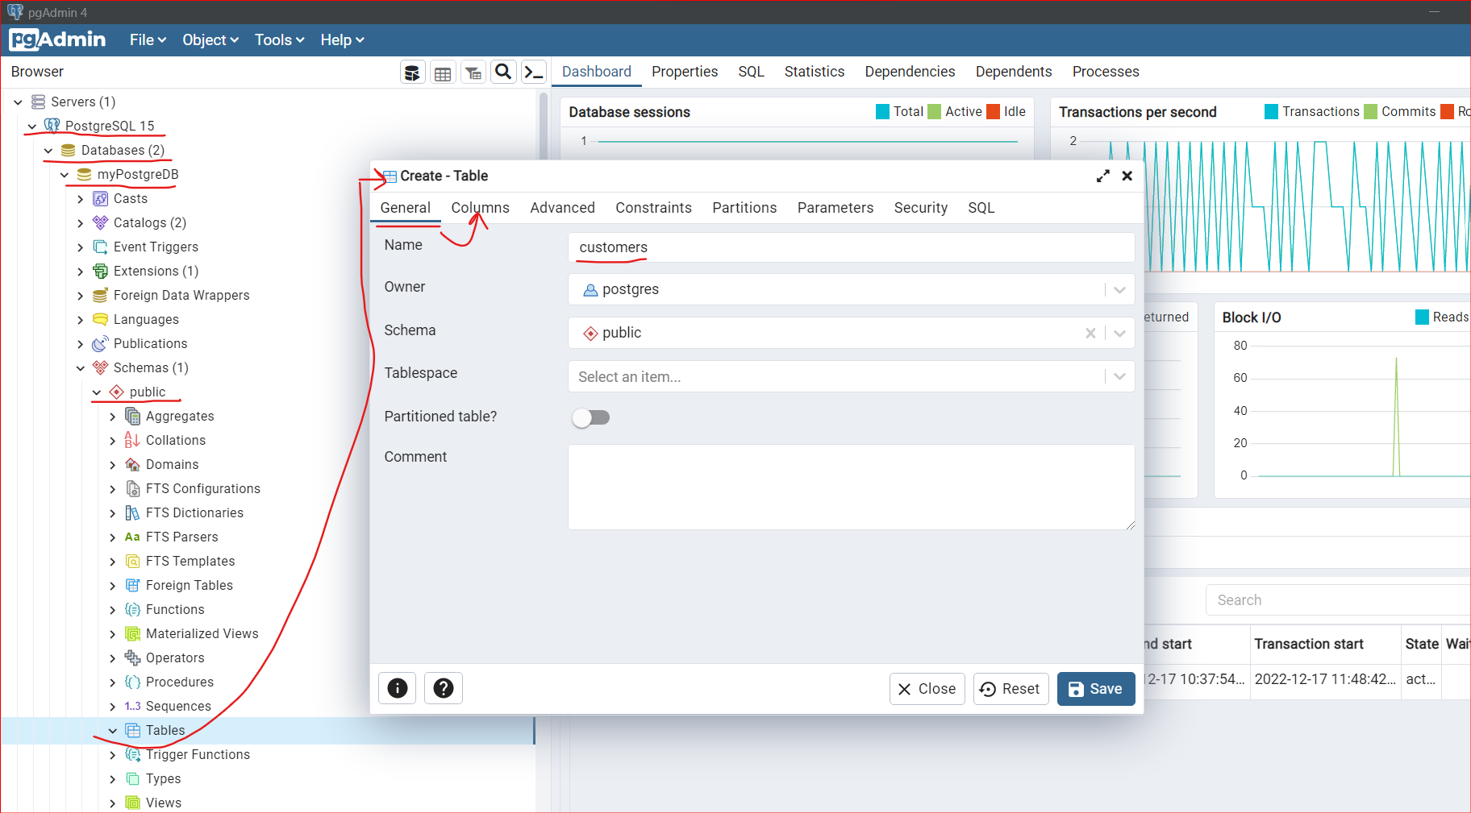

**Columns Tab: (To assign “ID” as 1st column)**

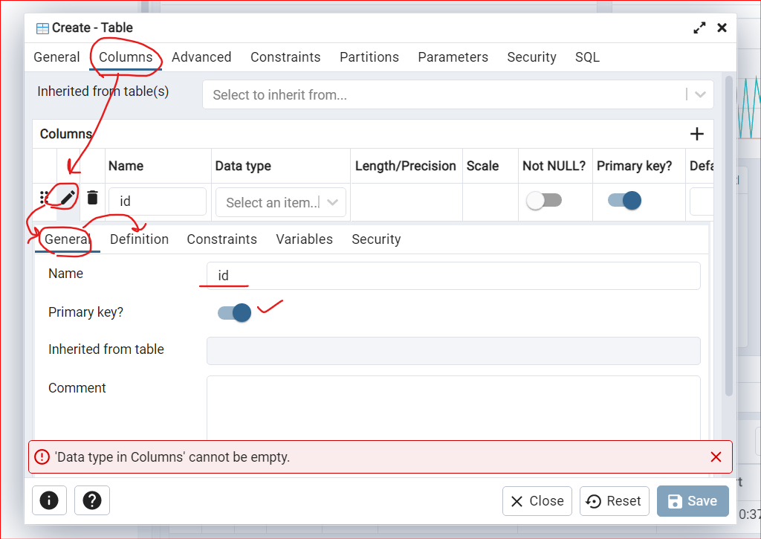

* Data Type as BIGSERIAL for id column

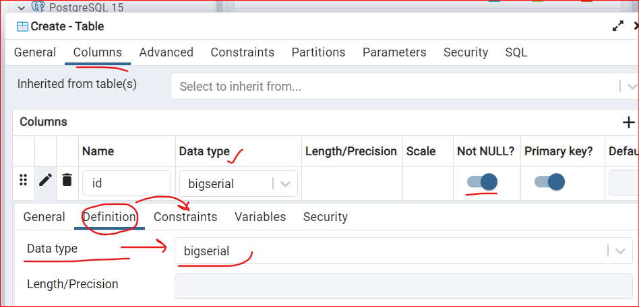

Constraint as NOT NULL:

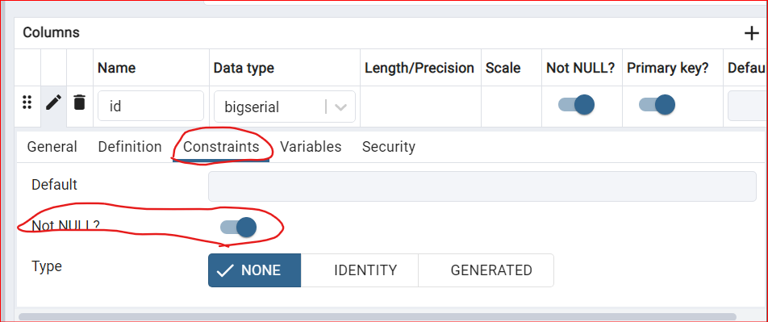

Every Column must Have Data Types like:

Another one would be integer, you know, one, two, three, four or five. That's an integer.

We might VARCHAR. And that means, you know, characters for strings of text and things like that.

**SAVE the above Table (customers)**

**Right Click on the customers table created : CREATE a name COLUMN**

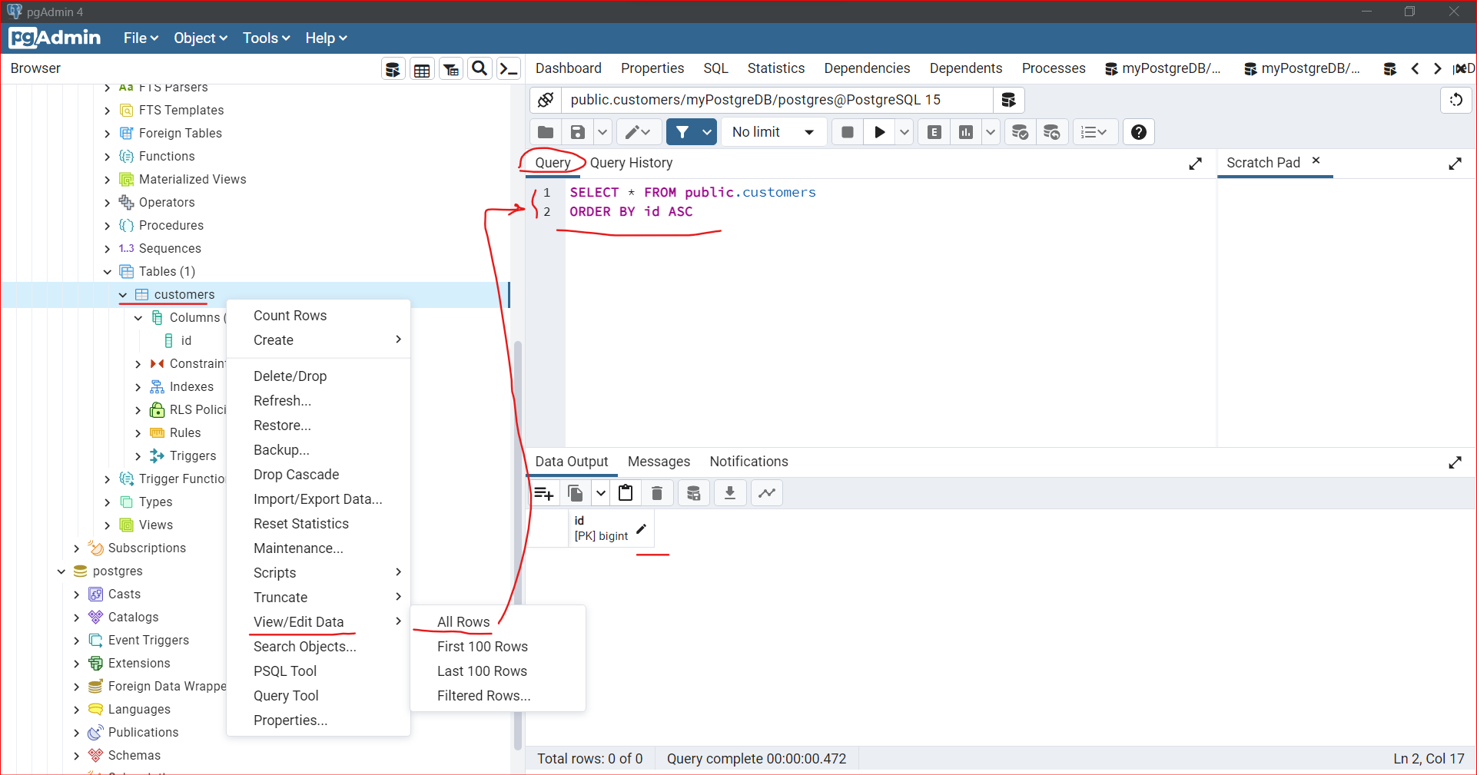

**From columns LHS tab -> Right Click and Create Column**

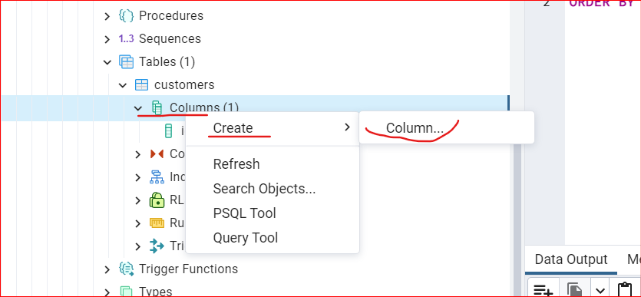

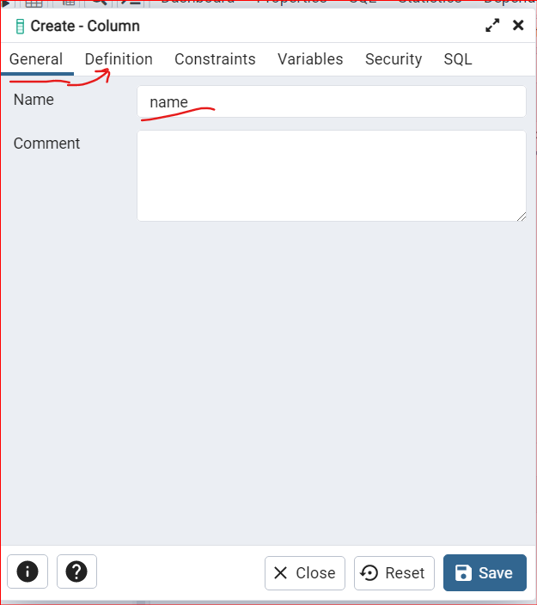

**Select Data Type: “character varying”** //same as VARCHAR

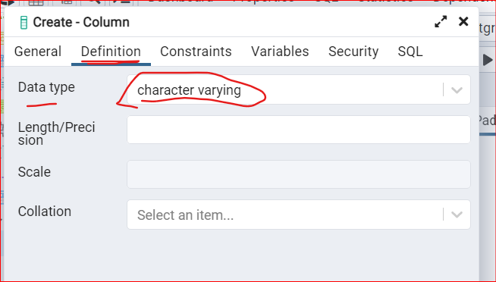**SAVE it**

**Create another column Called as “email” with data Type: “Character varying”**

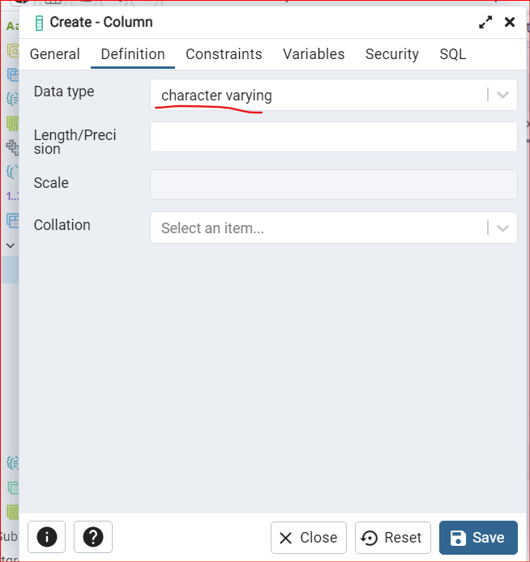

**Output: 3 tables created: id, name and email**

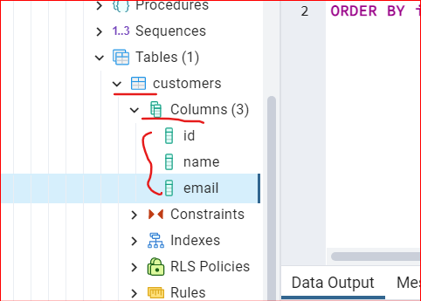

Right Click on the Customers database and Edit/View Data -> All Rows:

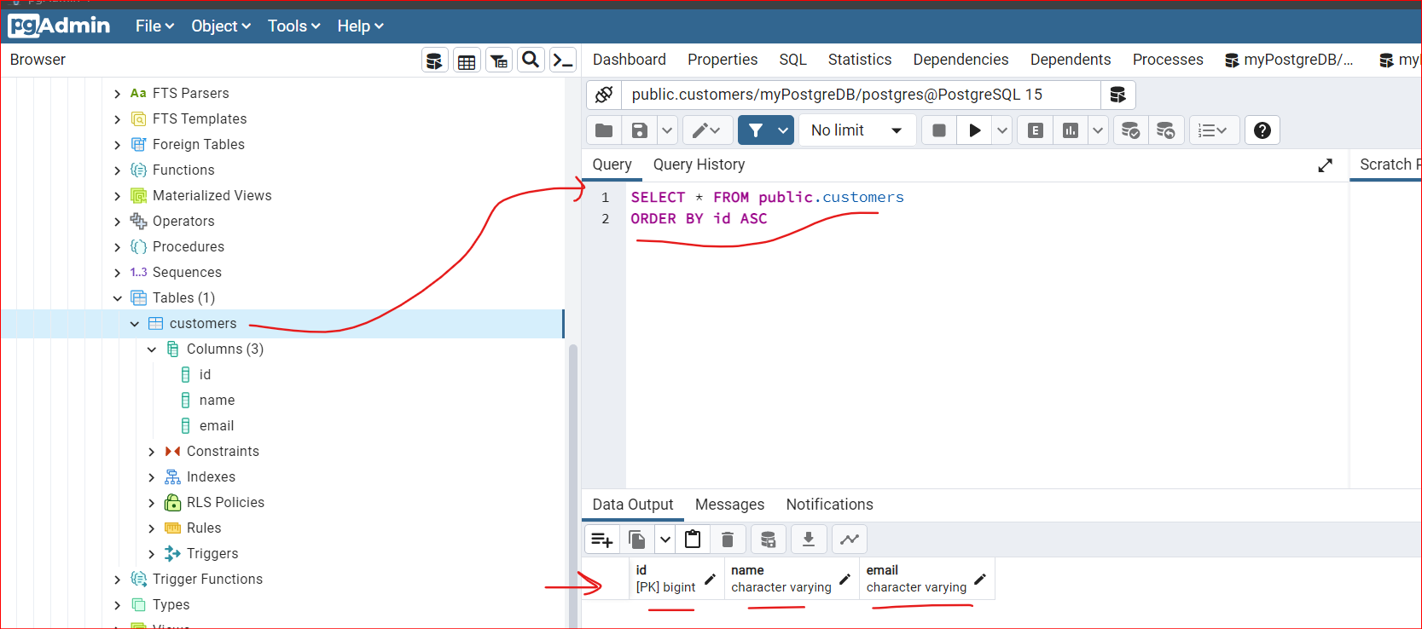

**7. Add Data To A Table**

From Customers database -> Right Click -> View/Edit Data -> All rows

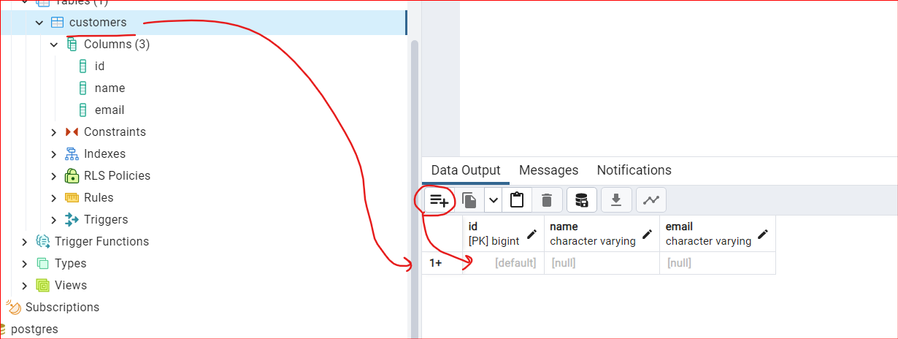

**Add Row Manually?**

**Manually Entering Data in id, name and email columns**

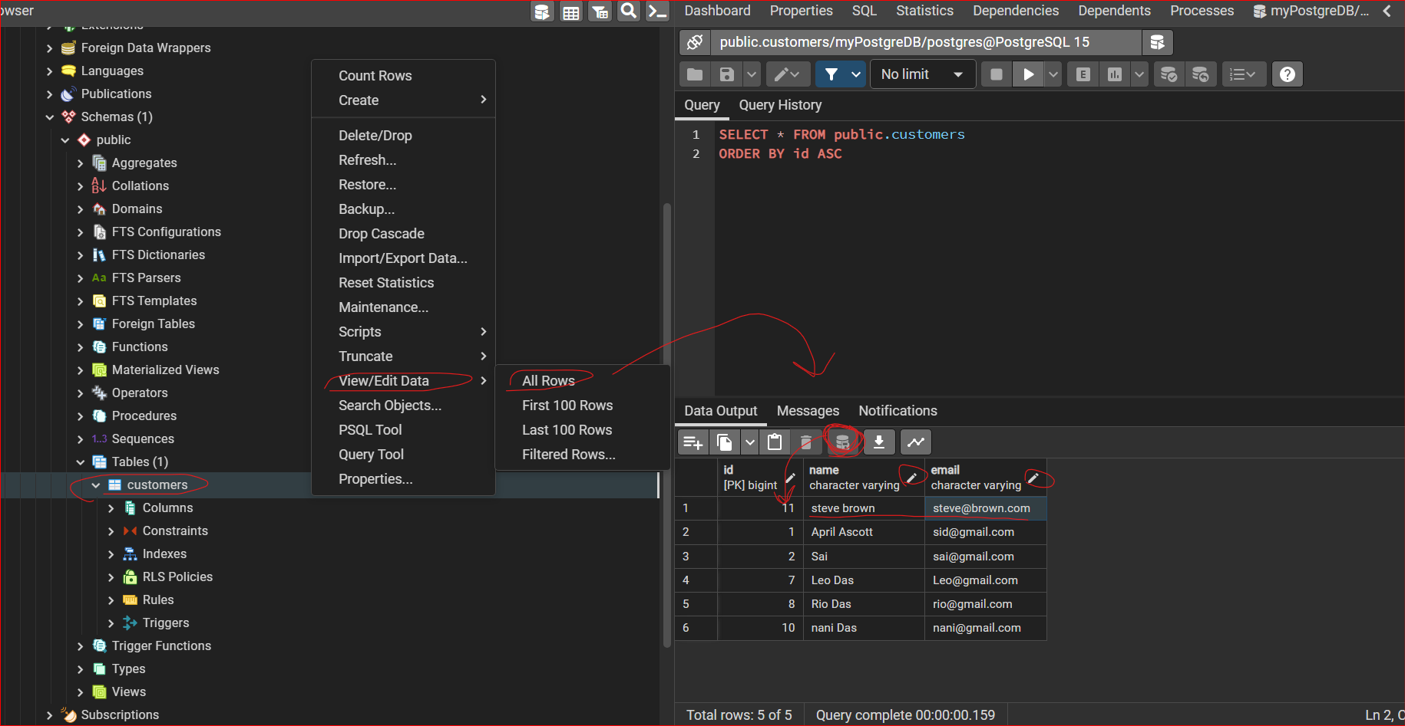

**IMPORT Files in PostgreSQL**

**Add the data in : name, email columns**

**WE need to ‘Import/Export’ from customers database:**

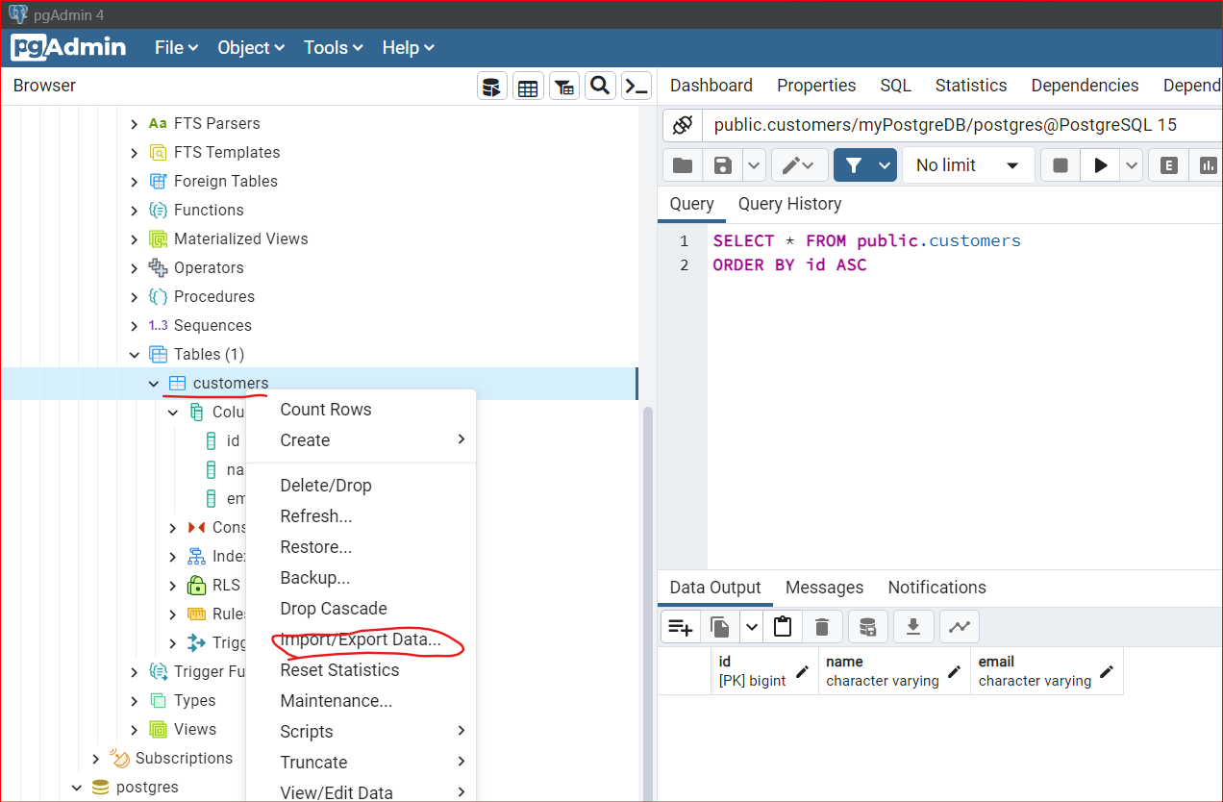

**While doing this I was getting a warning stating:**

* Utility file not found. Please configure the Binary Path in the Preferences dialog

Solution:

* <https://stackoverflow.com/questions/69544583/utility-file-not-found-please-configure-the-binary-path-in-the-preferences-dial>

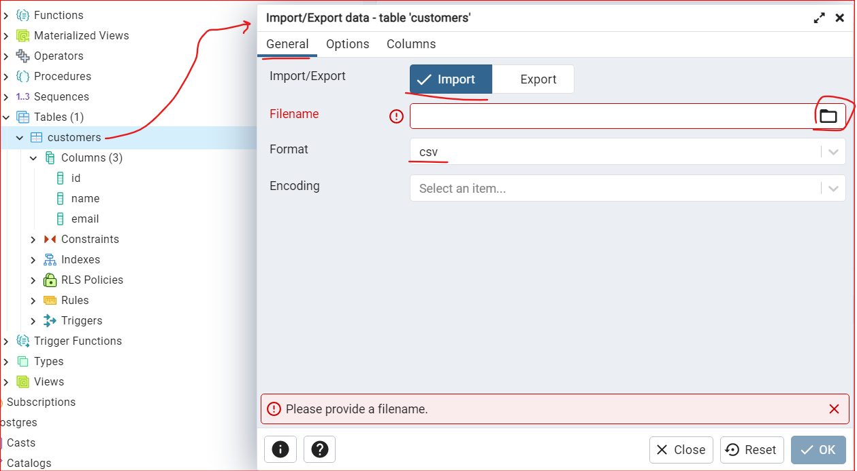

We can Import our CSV Files!

**INSERT INTO**

**Open the Query Tool from the Database**

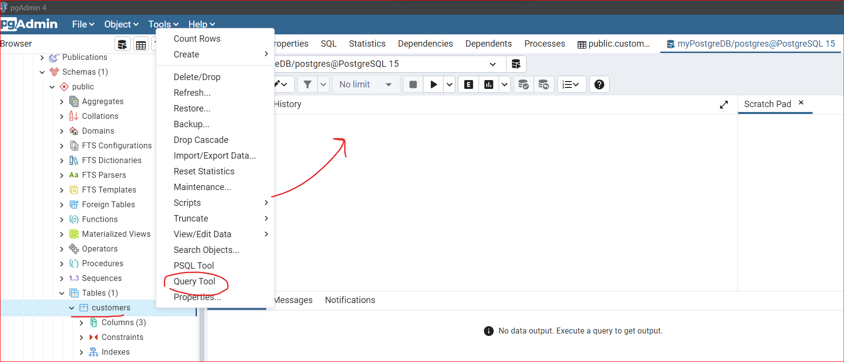

**-- INSERT Statement**

INSERT INTO public."customers"("name","email")

VALUES ('Sid Das', 'sid@gmail.com')

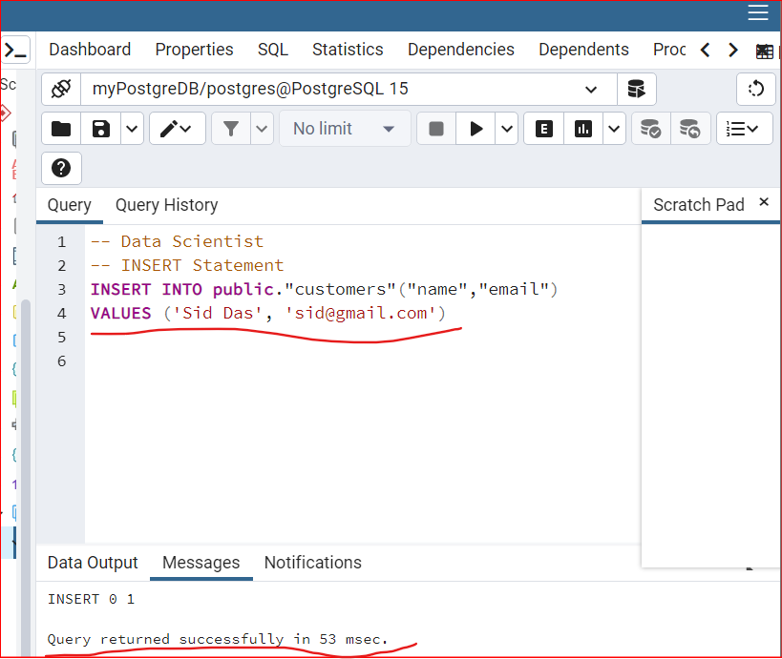

**SELECT statement:**

Open new Query Tool from customers db

