**8. PostgreSQL Select Statements**

**Refer also:** [**https://www.w3schools.blog/postgresql-tutorial**](https://www.w3schools.blog/postgresql-tutorial)

To fetch records from a table, one can use the UI or the PostgreSQL SELECT statement can be used.

**SELECT statement using UI:**

Other than Query tool, we can also SELECT statement in PostgreSQL using UI. To SELECT statement using UI in PostgreSQL, follow the below steps.

* Right-click on the selected table.
* Move your cursor over the option scripts.
* Click on the “SELECT script” option.
* Put the values on the place of “?”.
* Click on the “play” button.
* The query will thus be executed.

***Syntax 1: To select all fields from a table.***

* SELECT * FROM “table_name”;

***Example 1: Selecting all fields from a table.***

|  |
| --- |
| SELECT * from “EMPLOYMENT”; |

***Syntax 2: To select specific fields from a table.***

* SELECT “expressions”
* FROM “table_name”

***Example 2: Selecting specific fields from a table.***

SELECT “STATE”, “RATE”

FROM “EMPLOYMENT”;

**The following SELECT statement retrieves the data from multiple columns of the employee table.**

SELECT emp_id, first_name, last_name FROM employee;

**SQL Shell:**

**Open Start Menu -> Search: SQL Shell (psql)**

**Server [localhost]:** press Enter

**Database [postgres]:** press Enter

**Port [5432]:** press Enter

**Username [postgres]:** give your db name

**Password for user postgres:** give your pwd

**psql (15.1)**

**postgres=# select version();**

* **PostgreSQL 15.1**

**postgres=#** \l

* **It will list all the databases from the Server (you have created)**
* **To Connect to an database from above**
* **postgres=#** \c saiLearning
* **To See the Tables inside that database**
* **saiLearning=#** \dt
* **To Retrieve above required any database**
* **saiLearning=#** \d customers
* **Using SELECT sql command**
* **saiLearning=#** SELECT first_name FROM customers;
* **saiLearning=#** SELECT first_name || ' ' || last_name FROM customers;
* **saiLearning=#** SELECT first_name AS Name, last_name Surname FROM customers;
* **To Use WHERE Clause:**

**saiLearning=#** SELECT * FROM products

**saiLearning-#** where unit_price > 200.00;

**SELECT “WHERE” Clause**

**The PostgreSQL WHERE clause is used with SELECT, INSERT, UPDATE and DELETE statements to return the result only when the condition is satisfied.**

**S**ELECT * FROM pg_stat_activity WHERE state = 'active';

SELECT * FROM db_tests;

SELECT * FROM “EMPLOYMENT”

WHERE “RATE” &gt; 60;

**8. PostgreSQL Select Statements**

Opened myPostgreDB database:

Open customers table: by Query Tool

**SELECT * FROM public.customers**

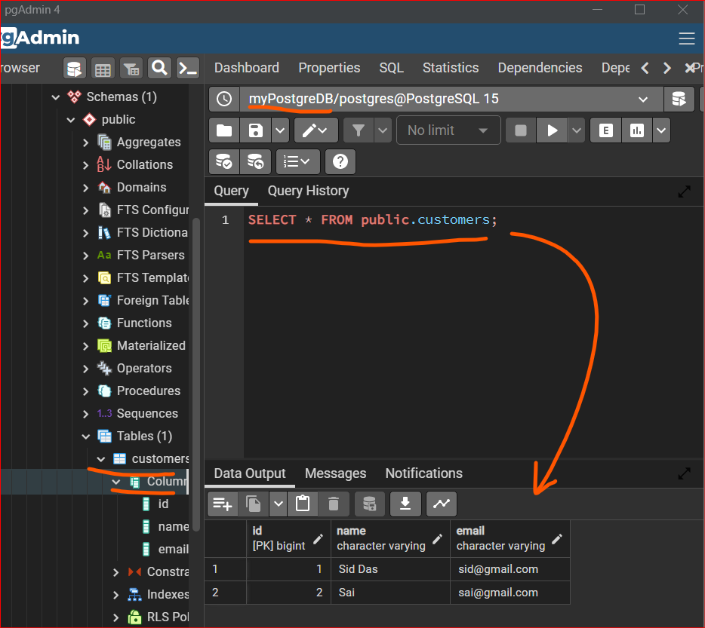

**Retrieved ‘name’ in the same query**

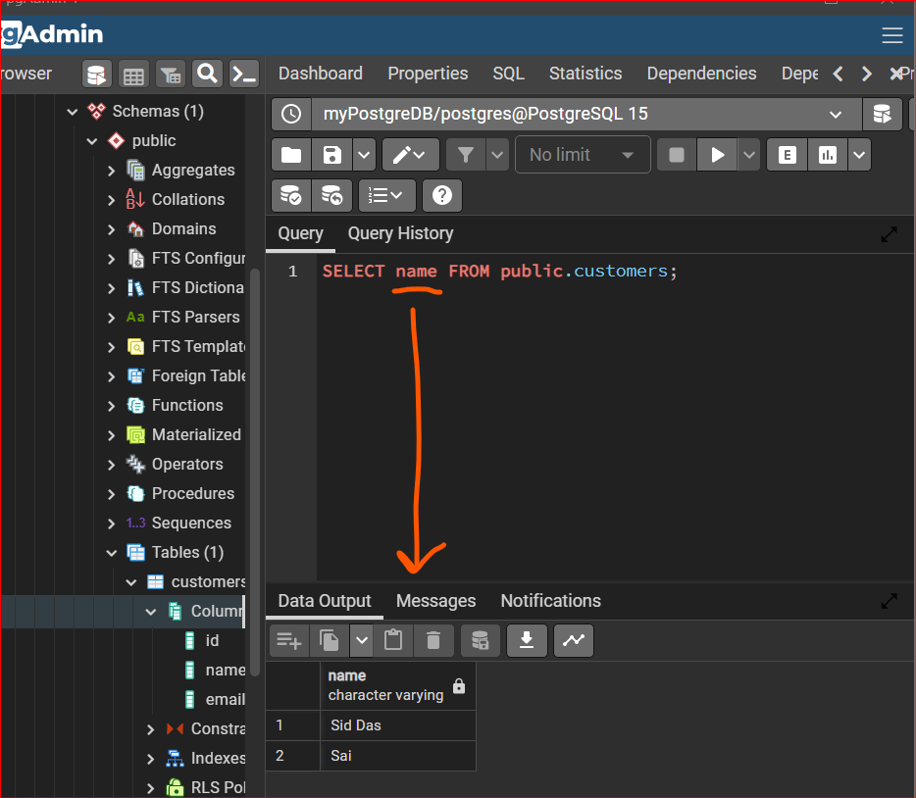

**ALIAS for column names:**

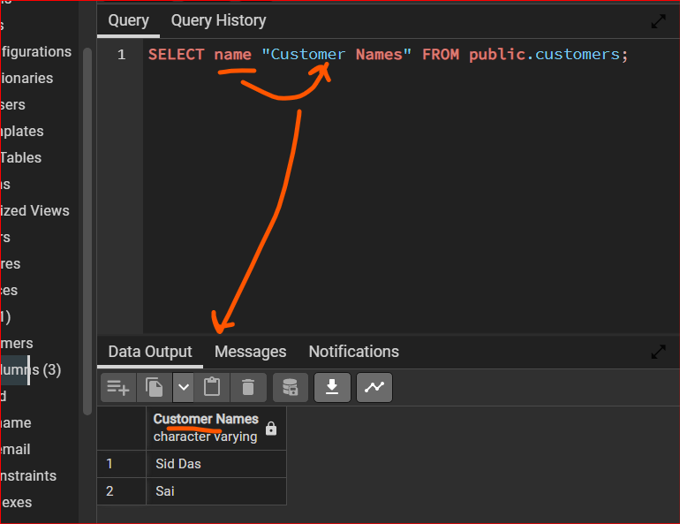

**9. PostgreSQL WHERE Clause**

**the where clause lets a search for specific things within our select statement.**

**Inserted More data in customers table**

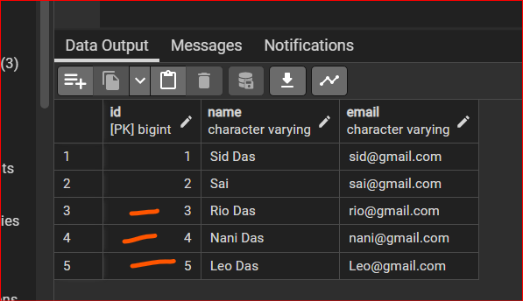

**-> Comparision Operators in WHERE Clause:**

* **SELECT * FROM customers**

**WHERE id = 3;**

* **SELECT * FROM customers**

**WHERE id != 3;**

* **SELECT * FROM customers**

**WHERE id >= 3;**

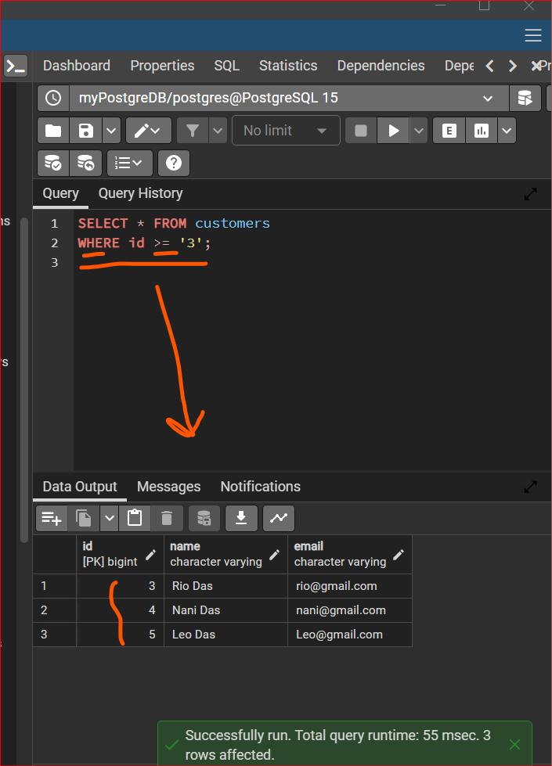

**>, <, <= , <> or !=**

**LIKE ' ' or = ' '**

**10. PostgreSQL Wildcards**

**There needs to be a way to sort of search. With less complete information, I guess, and we do that with something called WILD cards,**

* **WHERE name LIKE ‘Si%’;**

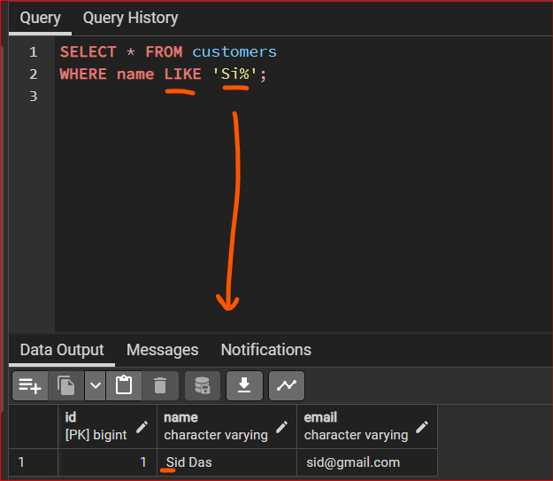

**Autocommit ON**

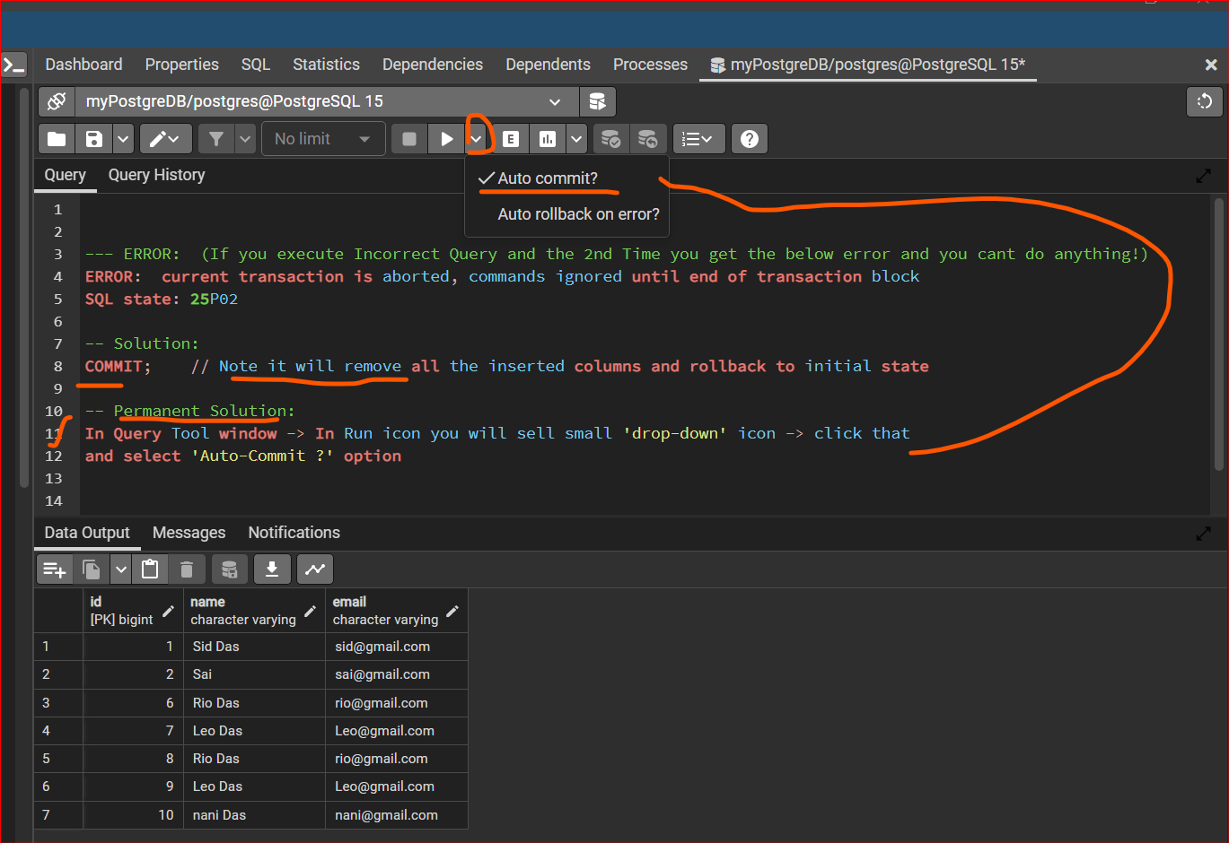

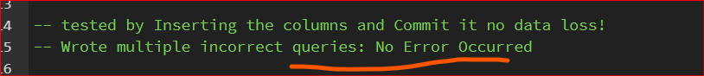

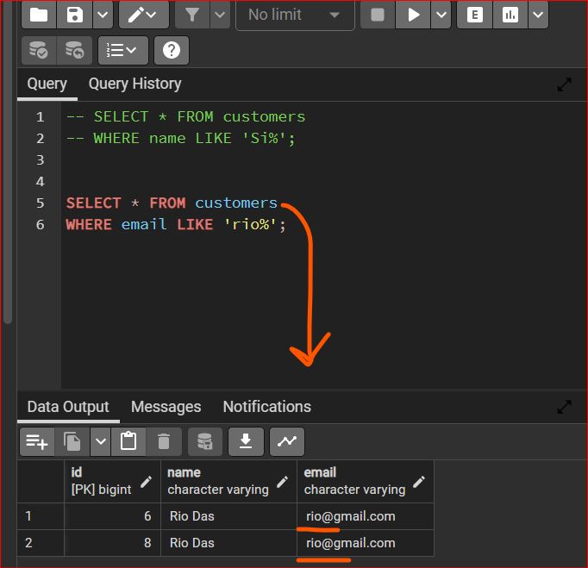

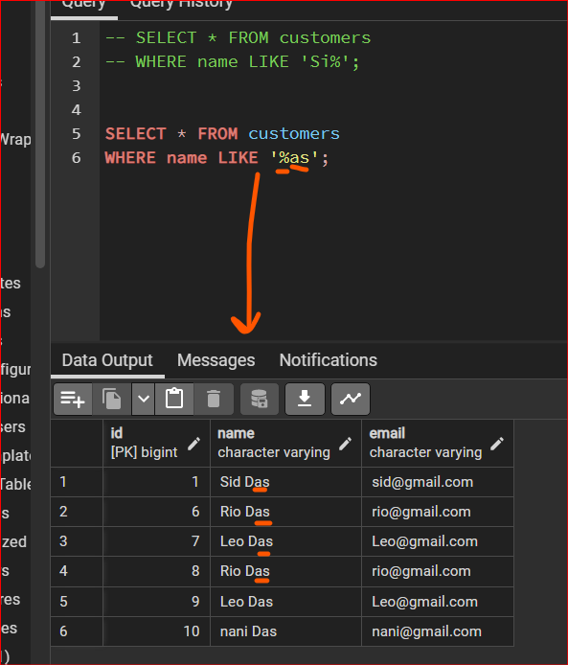

**11. PostgreSQL AND OR NOT**

**You can string together as many comparison operators in a condition as you like using and and or and**

**Using ‘AND’**

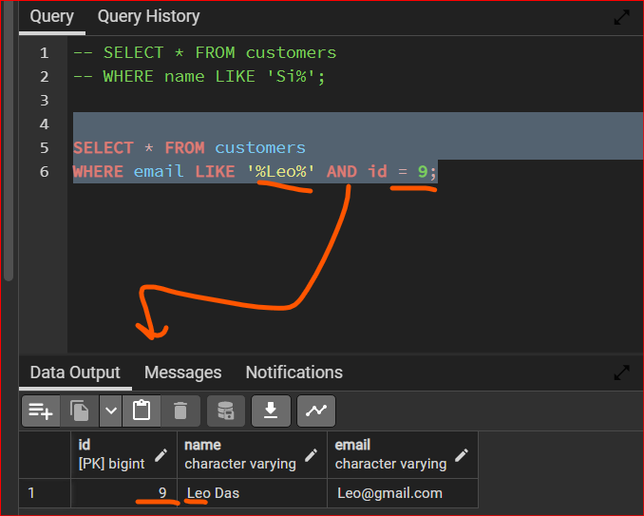

**Same Query with ‘OR’**

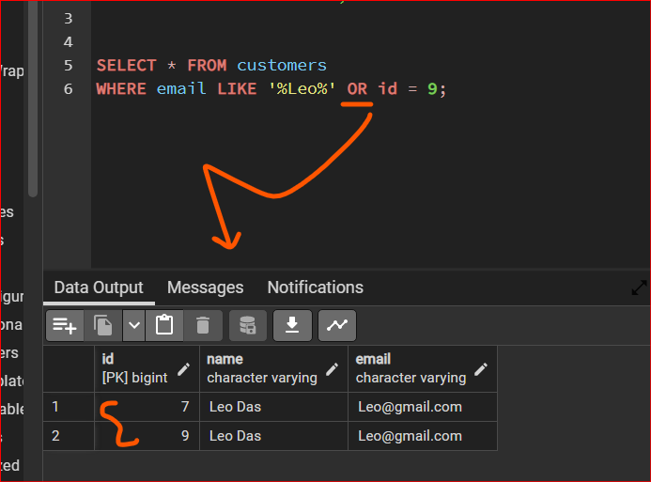

**NOT with LIKE**

