**12. PostgreSQL Order By**

**Table:**

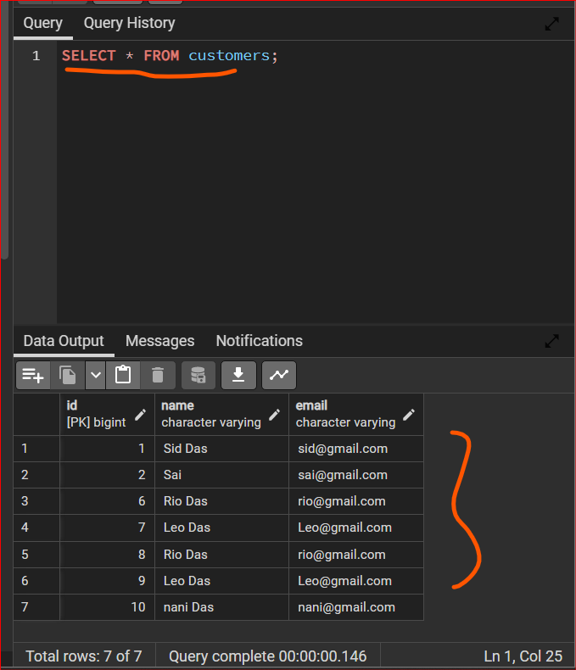

**ORDER BY : ASC or DESC**

**ASC**

**SELECT * FROM customers**

**ORDER BY name ASC**

