**14. PostgreSQL Update**

**-- Using "myPostgreDB" database and customers table**

**SELECT * FROM customers;**

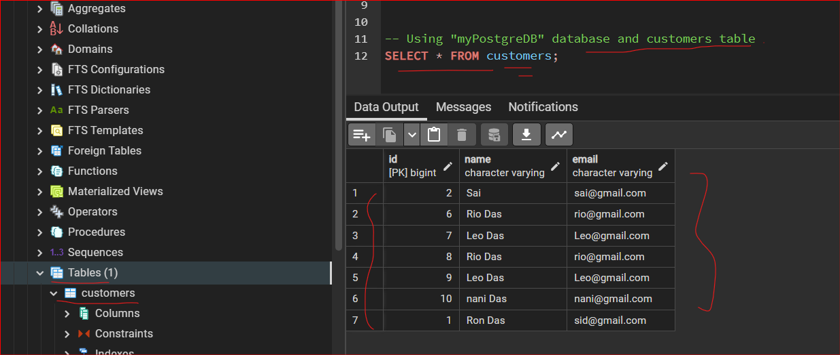

**UPDATE Stetement:**

**UPDATE public.customers**

**SET name = ‘April Ascot’**

**WHERE id = 1;**

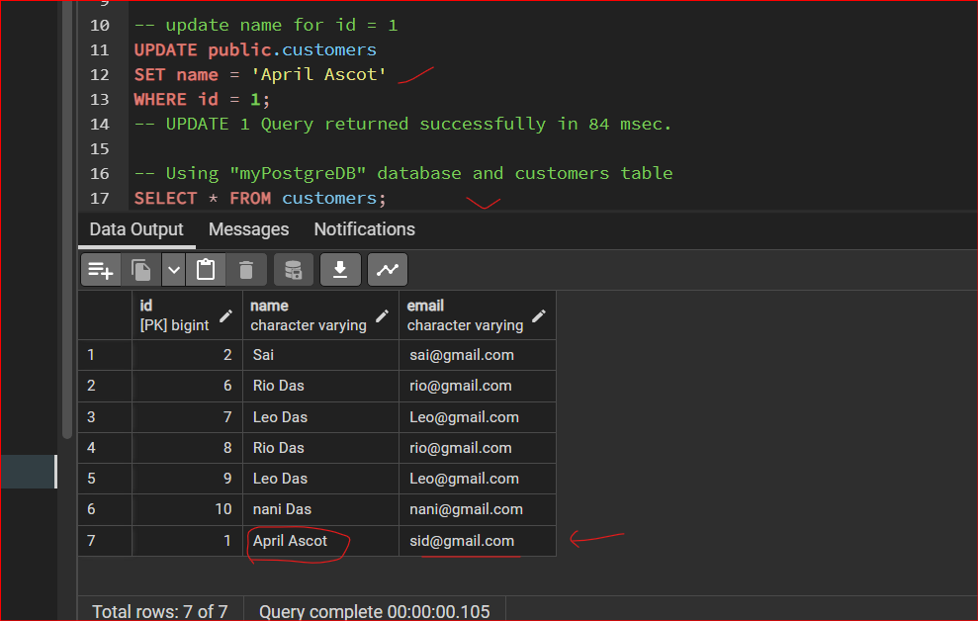

**DELETE Statement:**

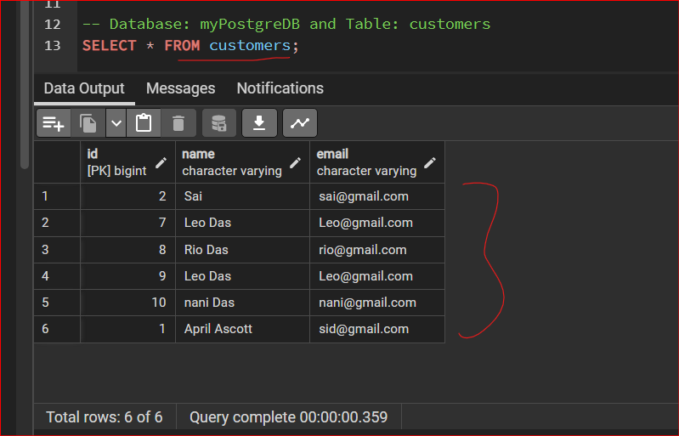

* **Delete id = 9 from customers table**

**DELETE FROM public.customers**

**WHERE id = 9;**

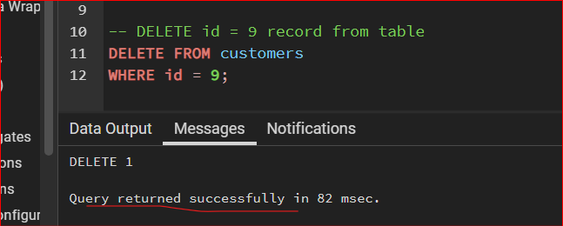

**Add Row Manually?**

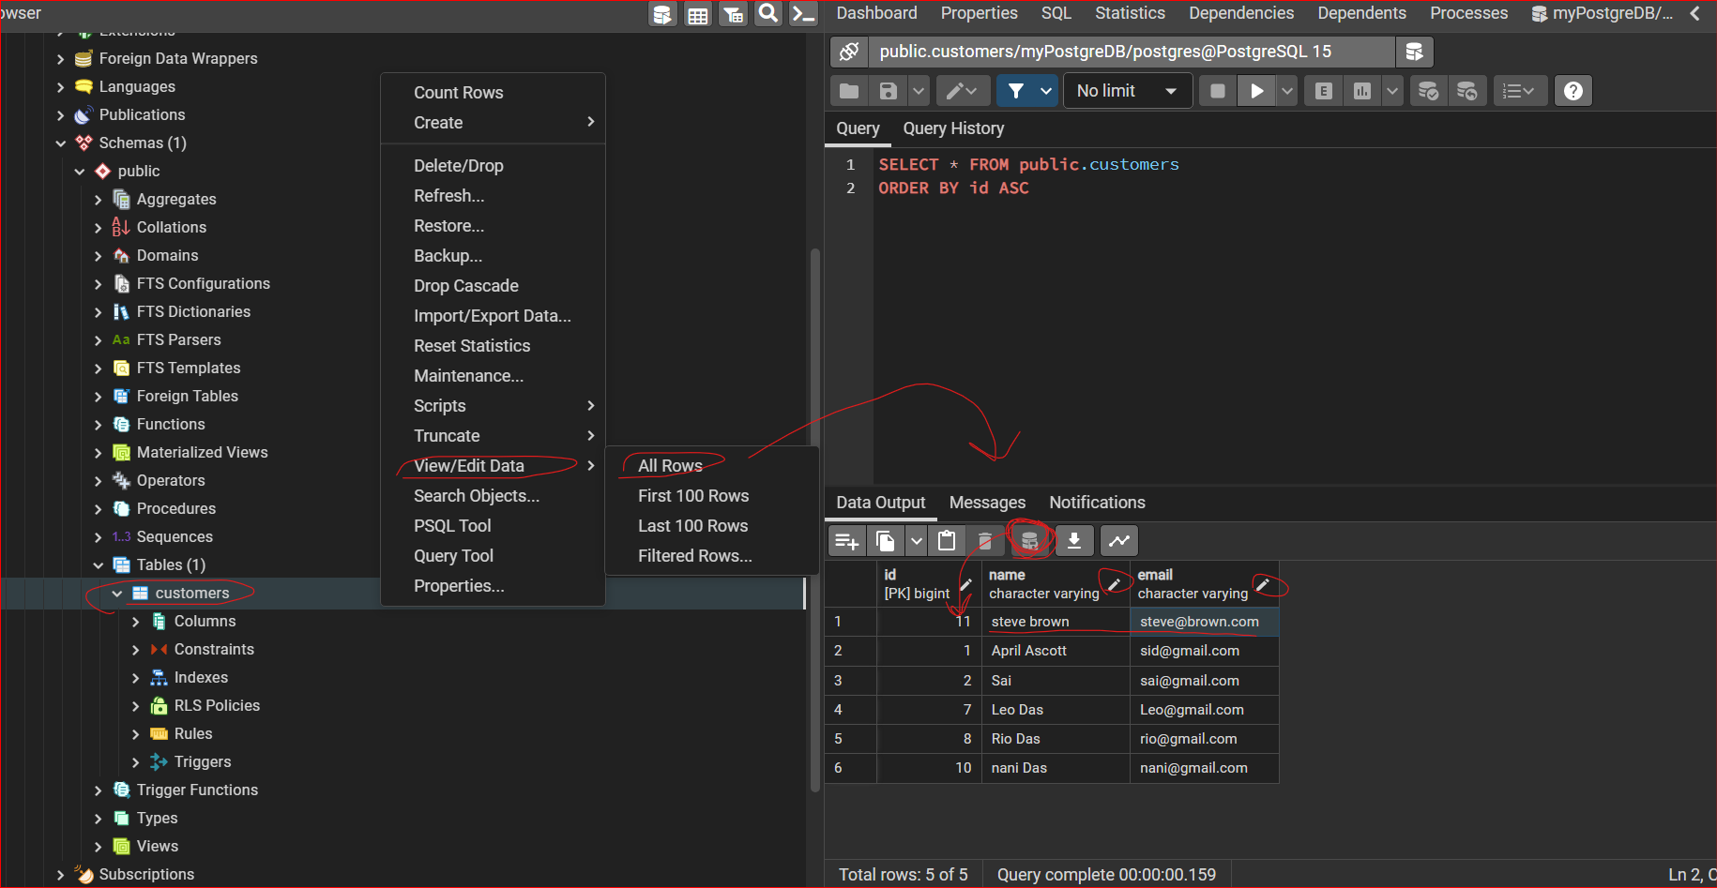

**LIMIT:**

It allows us to only select a certain number of rows or records or whatever in our database.

So, this is important.

If you have thousands, hundreds of thousands, millions of records in your database, you may only want the top 100 or the top half or whatever.

So, Select TOP is a great way to do that.

but we can get around it by using the **limit**.

Table:

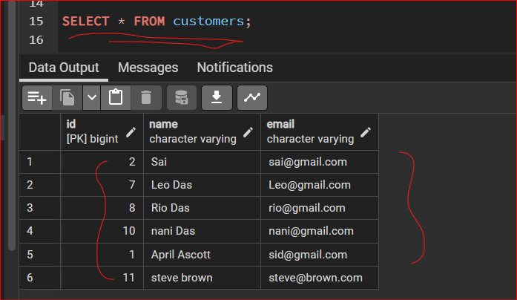

**LIMIT 2 i.e Top 2 Records**

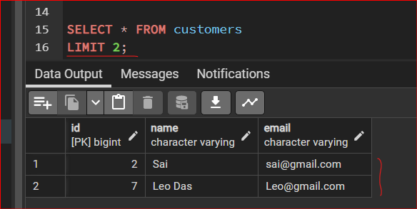

**Need 3rd and 4th Records only ?**

* **LIMIT 2 OFFSET 2**

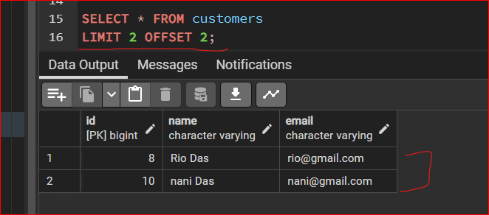

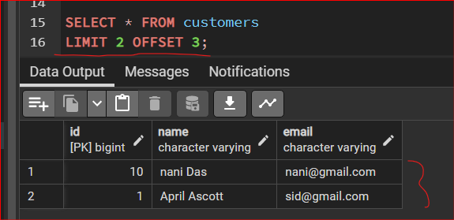

**17. pgAdmin Menu Walkthrough**

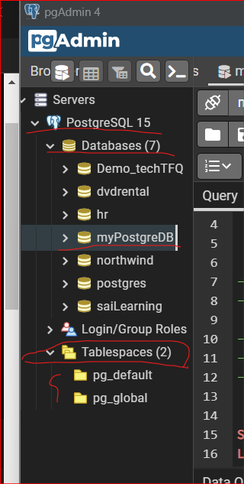

**Table spaces** is basically where postgres stores your actual data.

And by default, there's two table spaces, each global and you default

This does allow you to sort of move these.

So, you know, if you're up in a server or something, you need to migrate your data to a different server.

You can come in here and do it through here.

A **SCHEMA** is just sort of a container for tables.

Schemas -> Public -> **Functions**

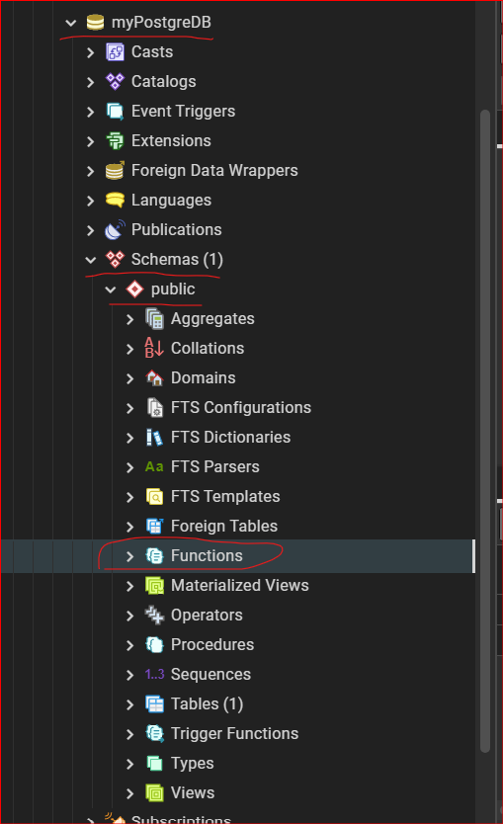

But just like a programming language, you can create a function and run it and sort of save that function and use it later.

And when you do, they'll be saved in this function section.

**Sequences**:

Every time a new record, New Row, is added, a new primary key is generated automatically in sequence.

So one, two, three, four, five, six, seven, eight, nine, 10.

Well, the mechanism for that is held right here in the sequences.

And you can see if we expand it, we have our customer ID sequence, which is this field right