**Foreign Keys, INNER JOIN**

**F**oreign keys are sort of similar to primary keys, but a little bit different.

Example : Let’s say we have names and customers.

Well, let’s say people probably bought something.

What did they buy? -> We might have another table with all the stuff that they bought.

* We need to be able to connect those two tables in a meaningful way.

And we, do that with a **foreign key**

**Recreated customers table:**

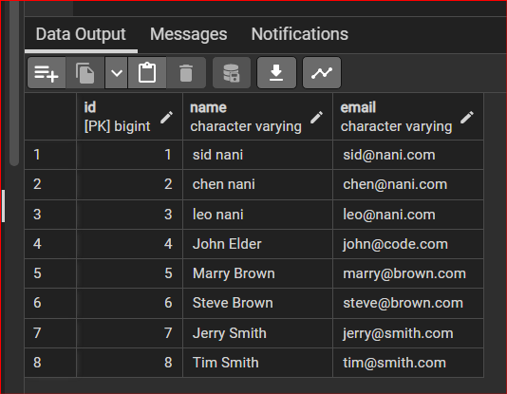

Create another table “Customer_ages”

And instead of doing orders, let's just create something called customer ages.

**Created a “Customer_ages” table**

**With 3 columns:**

* **Id as “bigint”**
* **Customer_id as “integer” and NOT NULL**
* **Age as “integer”**

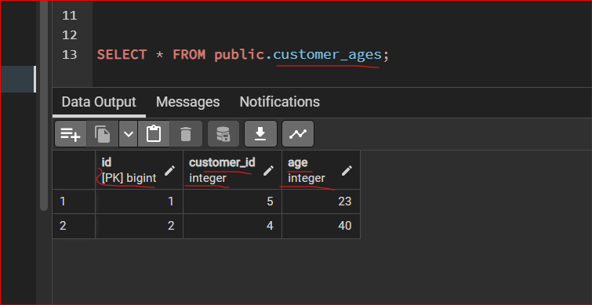

**Make “id” as Primary Key and it will UNLOCK the table (so you can edit)**

* **Right Click on Constraints tab and Give name as : id in General tab**
* 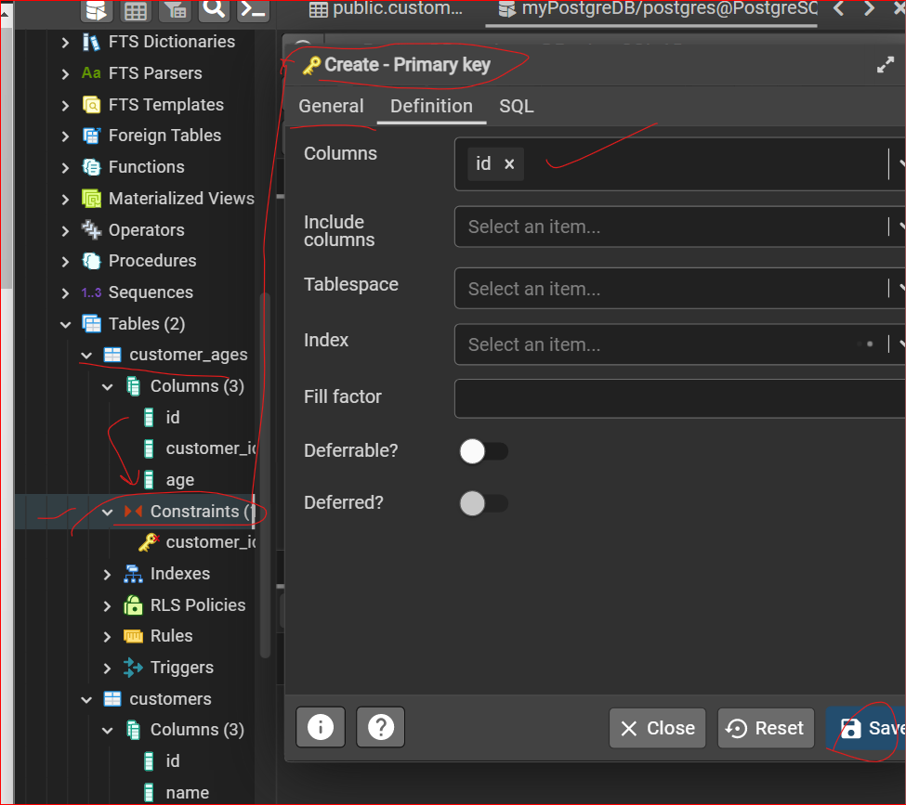

**SAVE**

**Now we want this “customer_id” as Foreign Key and Should be same as “customer_id” in customers table**

**In customer_ages table**

**We have “Constraints” tab -> right click on it -> and select CREATE-> Foreign Key**

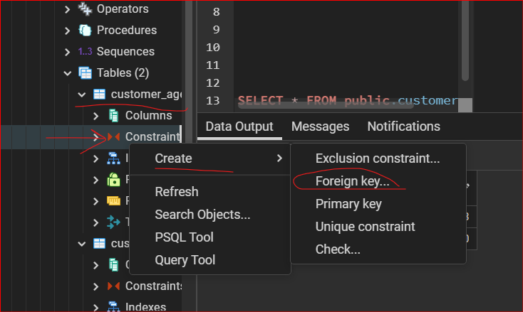

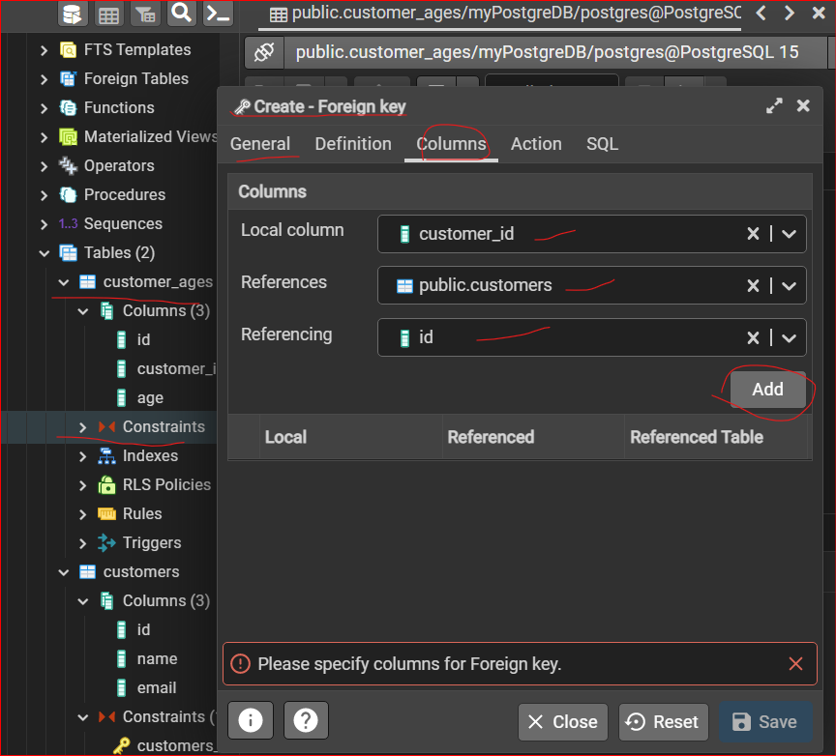

**Also Enable ACTION**

**For ON DELETE -> CASCADE (anytime you delete and Id it will get effected in another table also)**

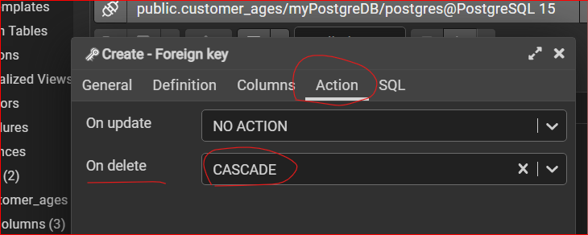**Save**

**Now we want to DELETE customer_id = 8**

**Now Open Query Tool : from Upper Menu -> Tools -> Query Tool**

* **DELETE FROM public.customer_ages**
* **WHERE id = 8;**

**Result:**

**This will effect both the tables as customer_id = 8 record will be removed!**

**INNER JOIN**

**-- INNER JOIN (SELECT you choices what you want in your report, and FROM - give/Designate main table(i.e not a Foreign Key table)**

**-- INNER JOIN - give child table which has foreign key - Foreign Key references the Main table))**

SELECT public.customers.id, name, age

FROM public.customers

INNER JOIN public.customer_ages

ON public.customer_ages.customer_id = public.customers.id;

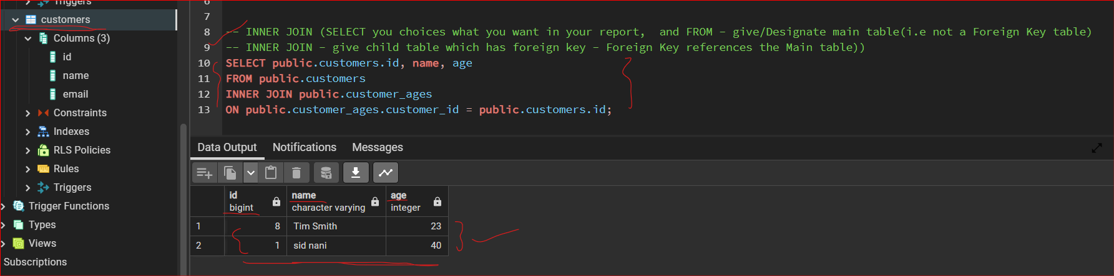

**20. PostgreSQL Join Where Hack**

