**Import Export DB Tables**

Export Database TABLE = “customers” locally

Go To -> LHS -> Select customers (right click) and Choose Import/Export Option:

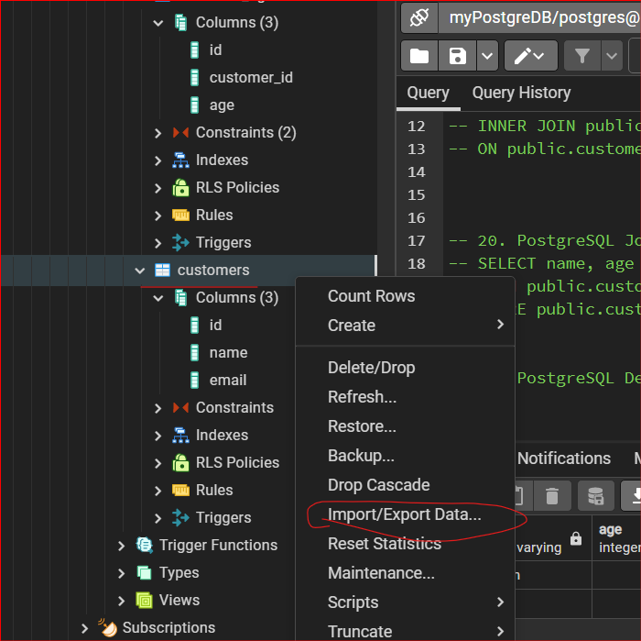

* **Choose EXPORT option**
* Give Filename like ‘customers’ and select the path need to be exported

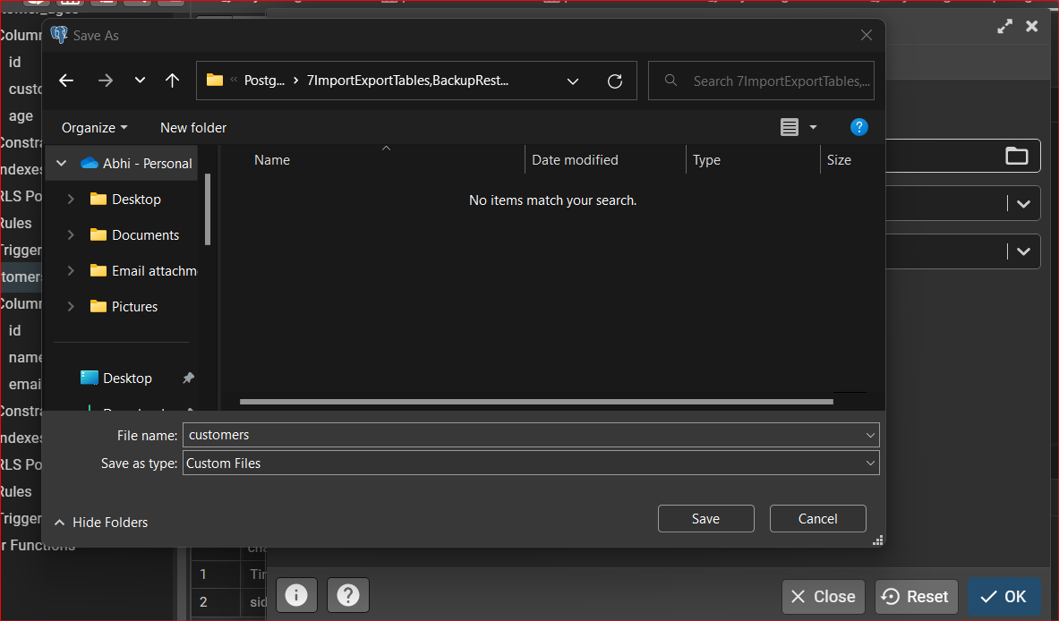

Type in “customers” in Filename and SAVE it!!!

* 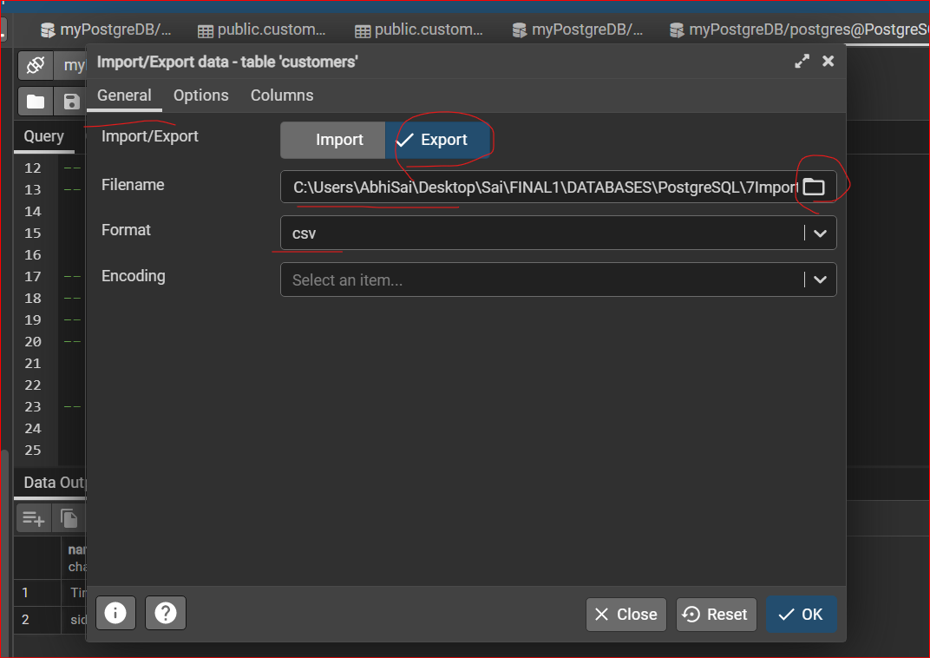
* You can turn ON Header to show with Column names
* 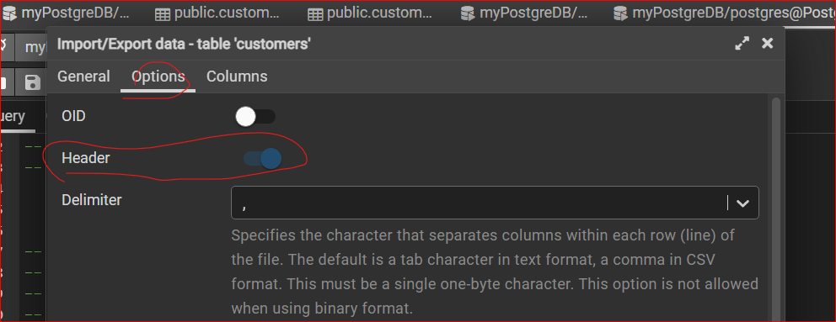

Click on OK

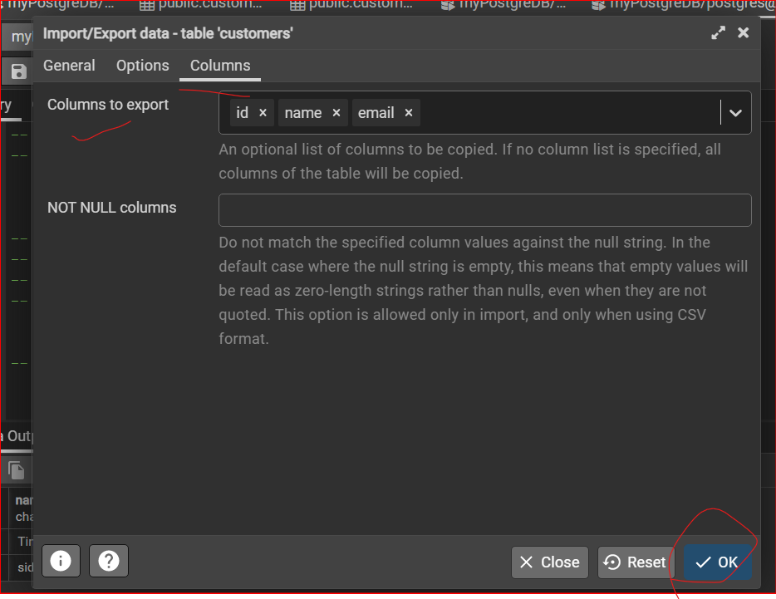

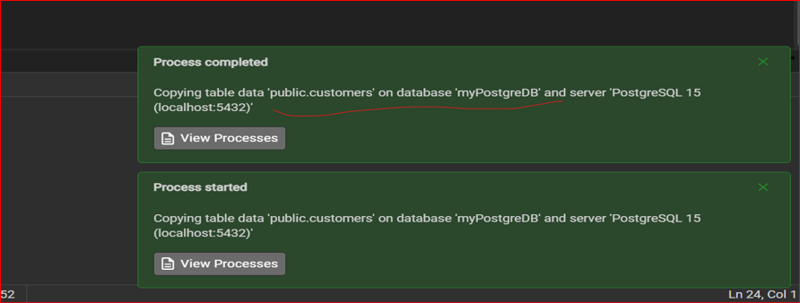

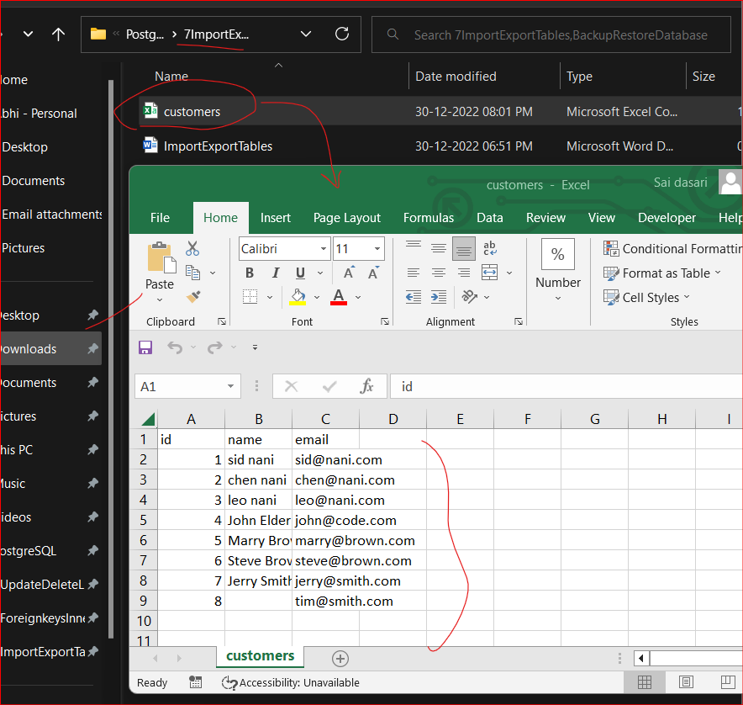

**IMPORTING Data (CSV file)**

* First, we need to create a Table:

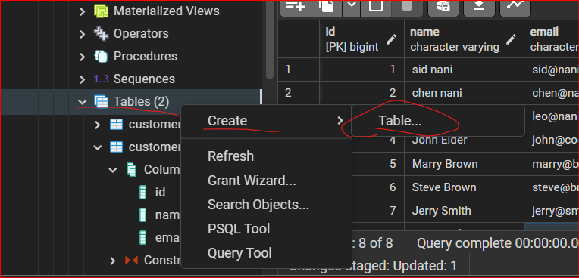

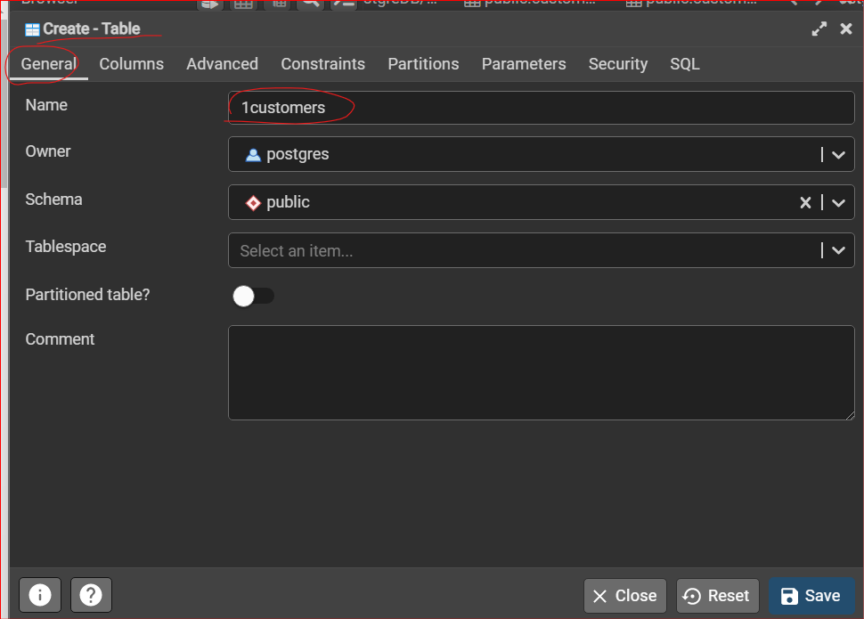

* Create “id” column with proper format selection

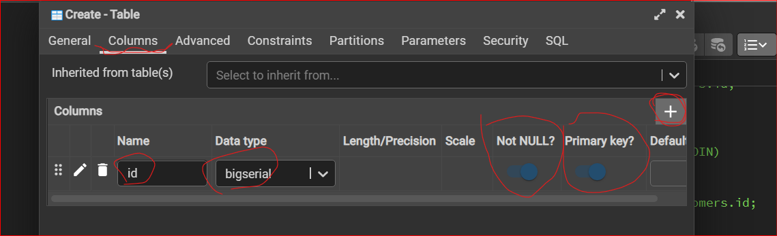

**Create another 2 Columns:**

Name and email

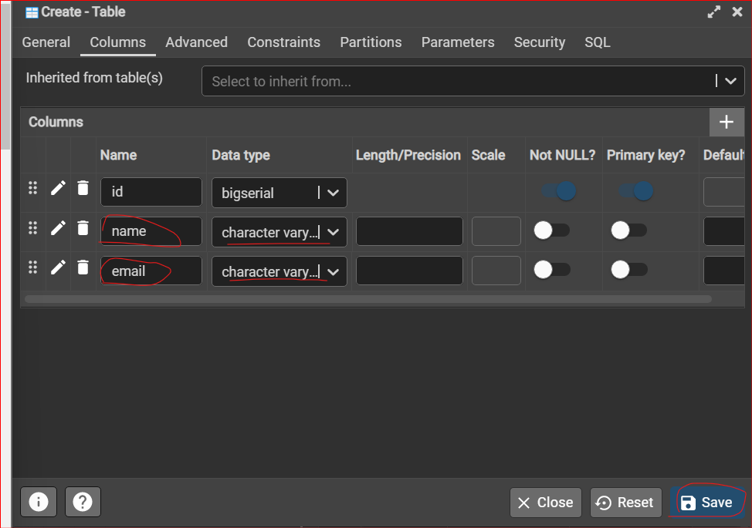

Right Click on New Table Created:

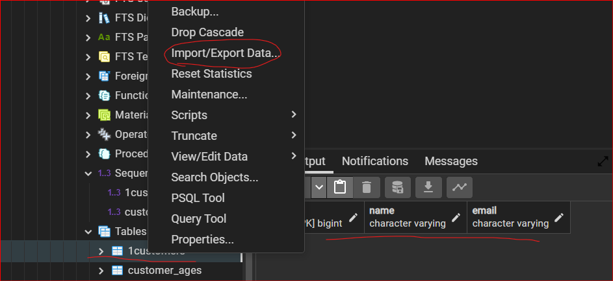

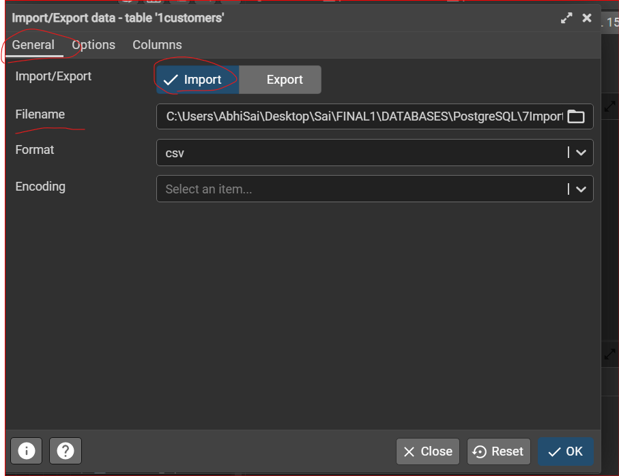

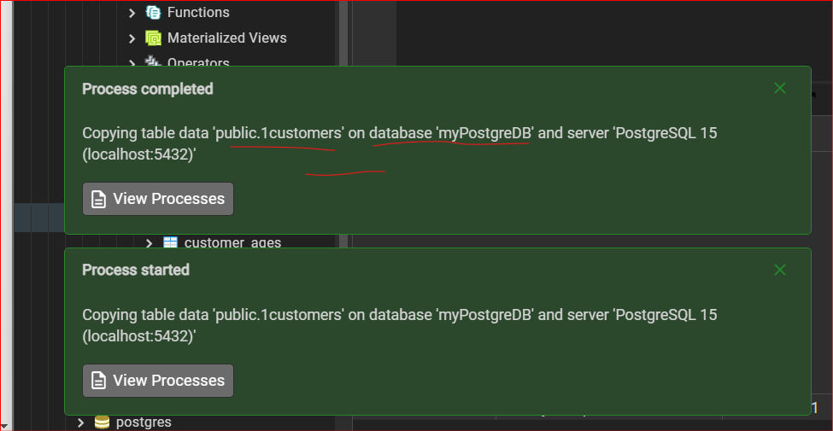

**Output:**

View/ Edit the Data:

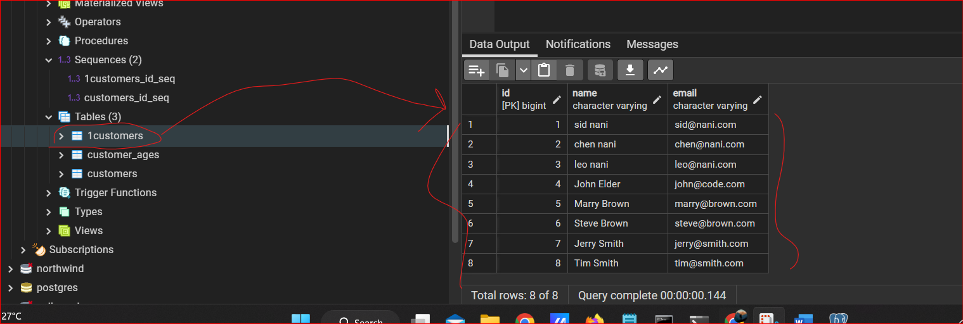

**23. PostgreSQL Backup and Restore Database**

**Backup the entire DB**

* **Right click on db and backup**

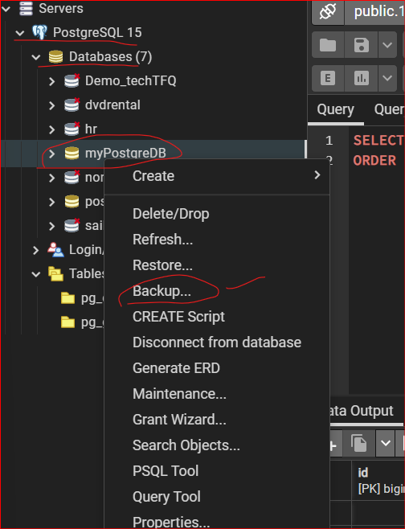

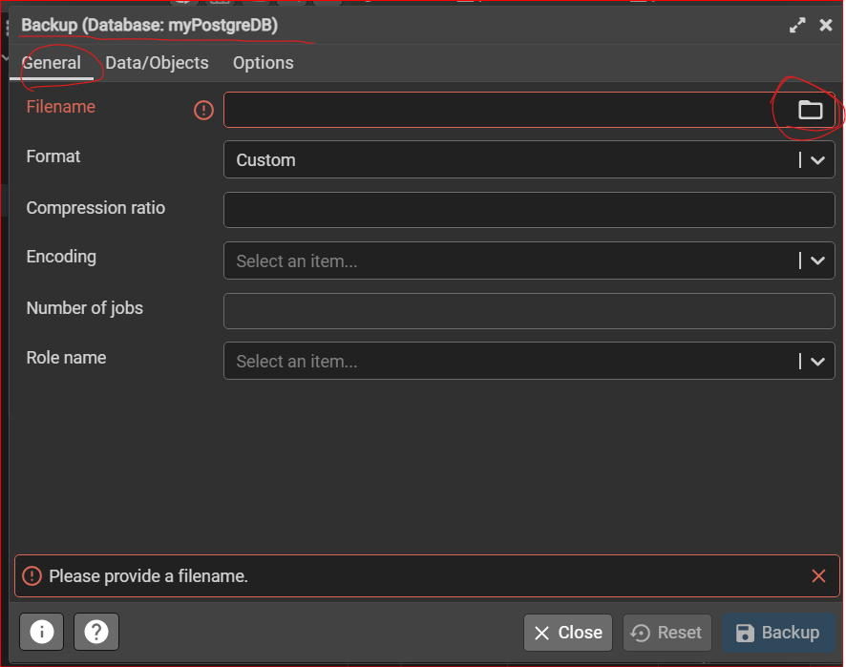

**Give File name of db:**

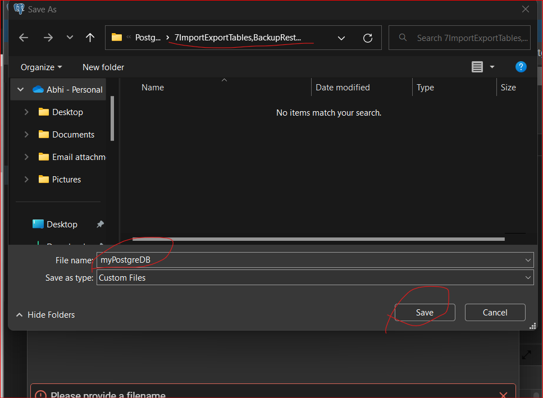

**SAVE**

**And click on “Backup”**

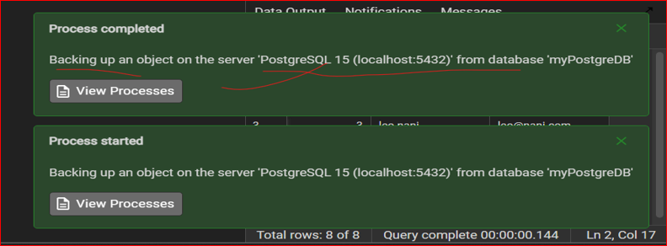

**Output:**

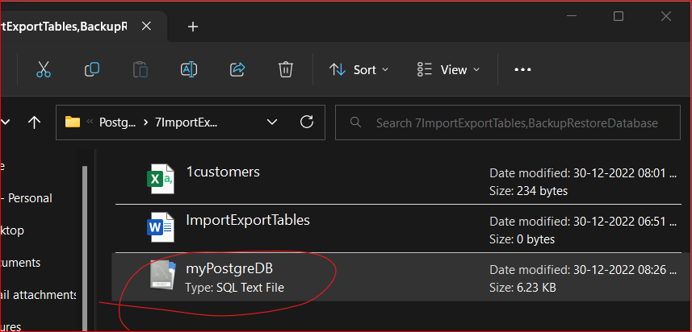

**Terminate the Session**

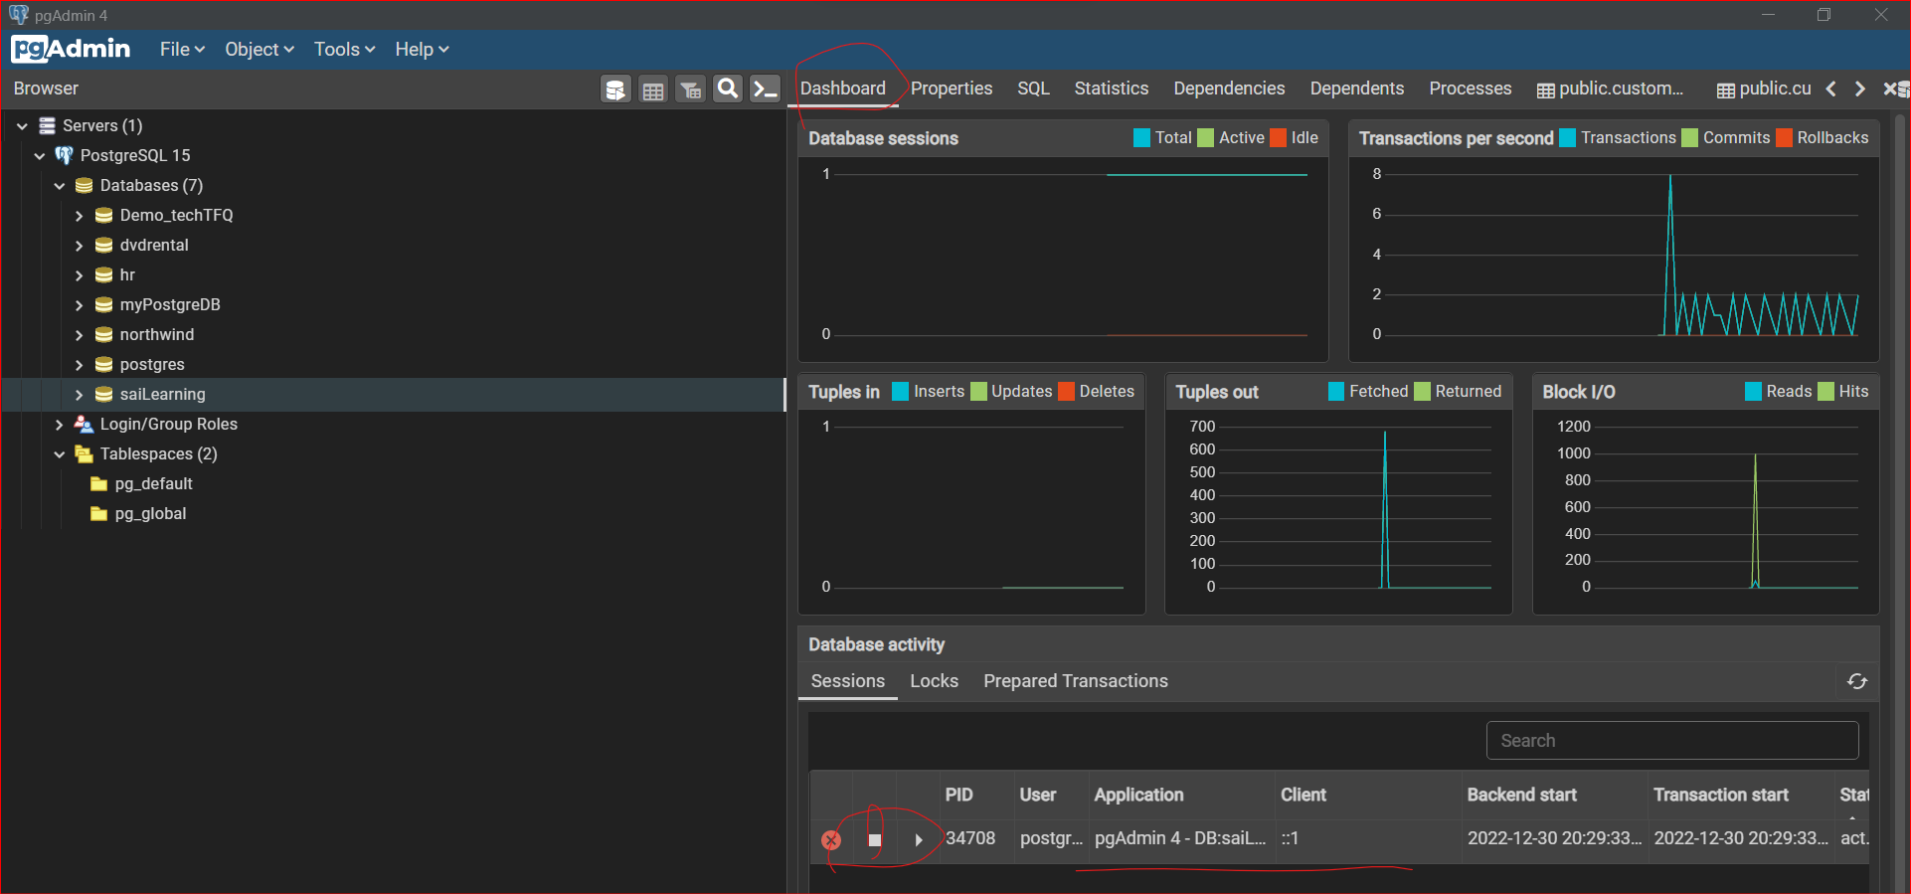

**You can DELETE/DROP the database**

**To Import a DB**

* **Create a DB**

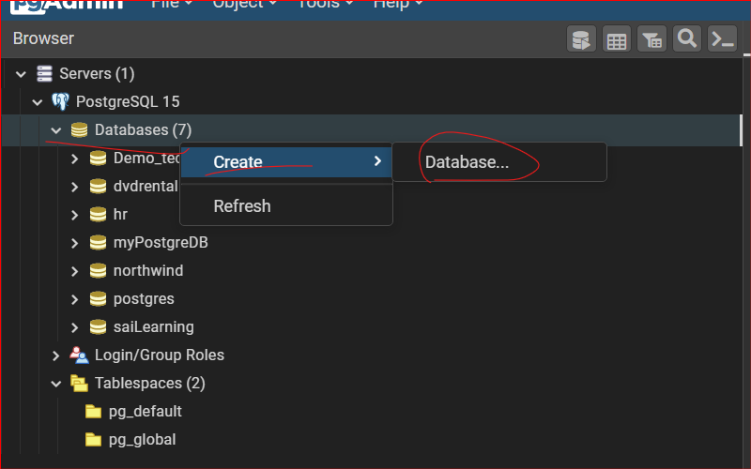

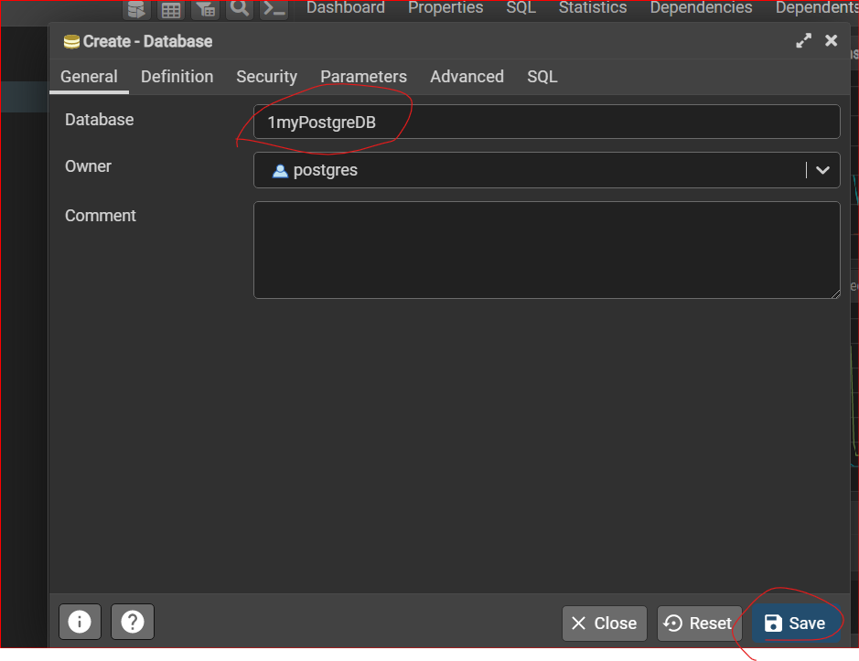

**Restore the db**

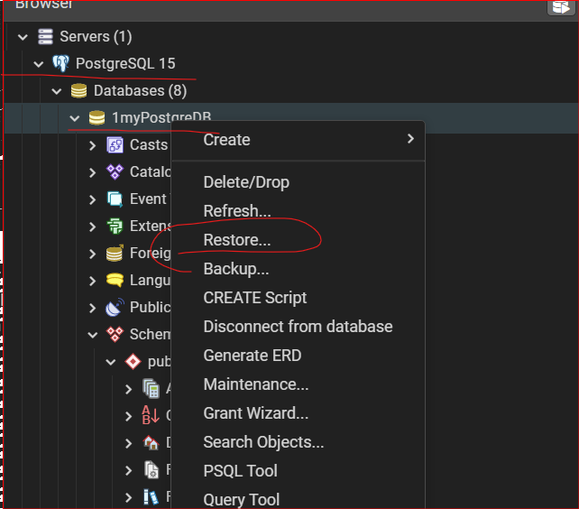

**Select “custom or tar” -> and Open the db**

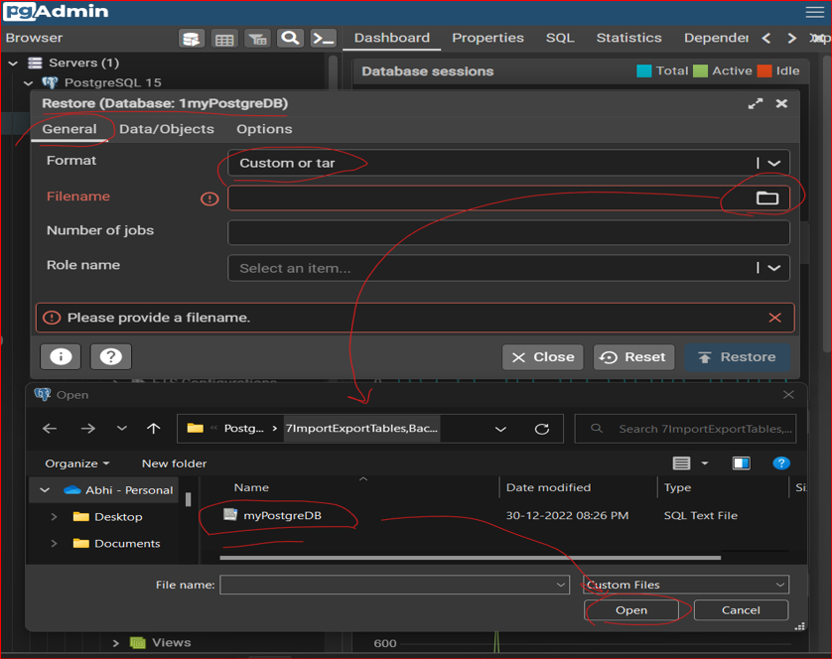

**RESTORE:**

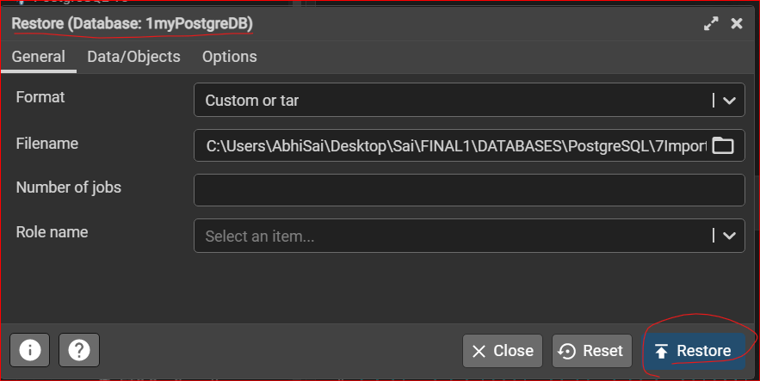

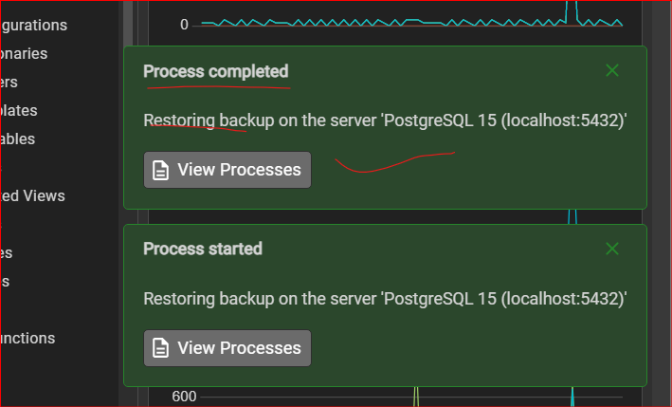

**Output:**

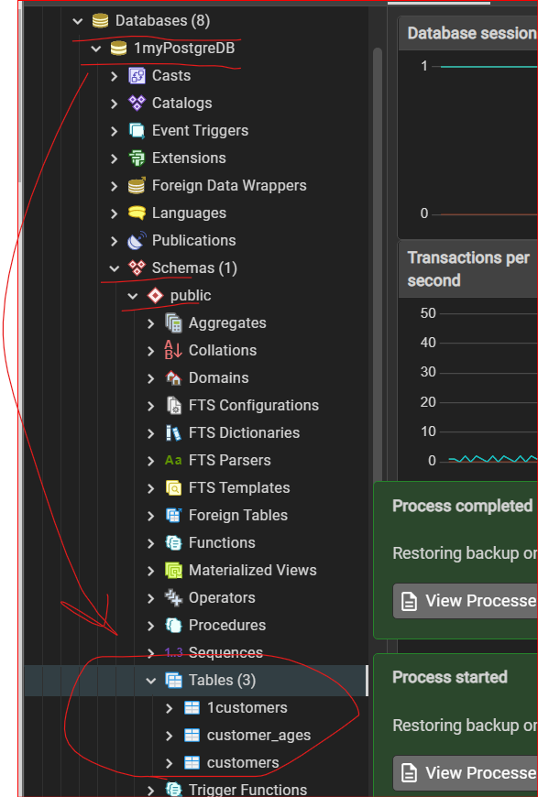

**DONE**