7COM1079-0901-2025 - Team Research and Development Project

Final report title: AI v/s Human : Statistical data that AI will replace you

Group ID: Group A 161

Dataset number: DS132

Prepared by: Shri Darandale - 24132447
Saikiran Lellela - 24145635
Jahnavi Karumanchi – 24164378
Ashraf Shaik – 24154595
Sandhyasree Manchineni - 24179643

University of Hertfordshire
Hatfield, 2025

Table of Contents

- Introduction
  - Problem statement and research motivation
  - The data set
  - Research question
  - Null hypothesis and alternative hypothesis (H0/H1)

- Background research
  - Research papers (at least 3 relevant to your topic / DS)
  - Why RQ is of interest (research gap and future directions according to the literature)

- Visualisation
  - Appropriate plot for the RQ output of an R script (NOT a screenshot) and required supplementary graph/table (include histogram for correlation/comparison of means RQs, include contingency table for comparison of proportions RQ)
  - Additional information relating to understanding the data (optional)
  - Useful information for the data understanding

- Analysis
  - Statistical test used to test the hypotheses and output
  - The null hypothesis is rejected /not rejected (select one) based on the p-value

- Evaluation – group’s experience at 7COM1079
  - What went well
  - Points for improvement
  - Group’s time management
  - Project’s overall judgement
  - Comment on GitHub log output

- Conclusions
  - Results explained.
  - Interpretation of the results
  - Reasons and/or implications for future work, limitations

- Reference list
Harvard (author, date) format.
- Appendices
- R code used for analysis and visualisation.
- GitHub log output.

1. Introduction

  - Problem statement and research motivation (100 words)
Artificial intelligence is rapidly changing the nature of work, but we still do not fully understand why some jobs are more affected than others. One area that needs more attention is how the number of tasks within a job relates to its vulnerability to AI. Research shows that AI tends to automate specific tasks rather than entire occupations (Autor, 2015), suggesting that task structure may play an important role. This study aims to explore whether jobs with more tasks experience greater or lesser AI impact. Understanding this relationship can help workers, employers, and educators better prepare for technological change.
Reference: Autor, D. H. (2015). Why Are There Still So Many Jobs? Journal of Economic Perspectives.

  - The data set (75 words)
In today’s fast changing technological world, artificial intelligence (AI) is reshaping many aspects of work. The Job_Threat_Index dataset provides insight into how AI may impact a wide range of job roles across different industries. It brings together carefully verified information from respected job-analysis sources, AI impact studies, and organisational reports. Each entry has been checked for accuracy, offering a reliable view of how AI advancements are influencing the skills, tasks, and future security of various professions.

  - Research question (50 words).

“Is there a correlation between the number of tasks associated with a job and its AI impact percentage?”
This research explores whether jobs with more tasks are affected differently by AI than those with fewer tasks.

  - Null hypothesis and alternative hypothesis (H0/H1) (100 words)
To guide this study, two hypotheses are proposed. The null hypothesis (H0) suggests that the number of tasks a job includes has no real connection to how much AI might affect it. In other words, even if a job has many or few tasks, its AI impact percentage would stay unrelated. The alternative hypothesis (H1) suggests the opposite — that there is a meaningful link between the number of tasks and AI impact. Testing these ideas will help us understand whether the structure of a job, in terms of its tasks, plays a role in how vulnerable it is to AI.

- Background research
  - Research papers (at least 3 relevant to your topic / DS) (200 words)
Several key studies explore how artificial intelligence affects work, offering useful foundations for this research.
1. Arntz, Gregory & Zierahn (2016) – “The Risk of Automation for Jobs in OECD Countries”:
This influential paper challenges earlier claims that almost half of all jobs are at high risk of automation. Instead, the authors analyse work at the task level and find that many jobs contain tasks that are difficult for AI or robots to automate. They conclude that only about 9% of jobs are highly vulnerable, showing the importance of understanding how tasks—not just occupations—shape AI’s impact.
2. Acemoglu & Restrepo (2018) – “Artificial Intelligence, Automation and Work”:
This paper explains how AI affects both job loss and job creation. The authors argue that AI replaces certain tasks but also creates new tasks and shifts responsibilities within jobs. Their “task-based” framework shows how changes in task structure influence wages, employment levels, and job design—making it highly relevant to research that explores the number of tasks linked to AI exposure.
3. McKinsey Global Institute (2017) – “Jobs Lost, Jobs Gained: Workforce Transitions in a Time of Automation”:
This large-scale study examines how AI and automation will reshape millions of jobs worldwide. It shows that AI will not eliminate most jobs but will change what people do within them. Many roles will be restructured, with some tasks automated and others requiring new human skills. This reinforces how important it is to understand task composition when predicting AI’s impact.

  - Why RQ is of interest (research gap and future directions according to the literature) (100 words)
As AI continues to change many jobs, it’s important to understand why some roles are more affected than others. Most research so far looks at whole jobs, but studies like Autor (2015) point out that AI actually targets specific tasks. However, very little is known about whether having more tasks makes a job more or less vulnerable. This gap makes the research question valuable. By exploring this link, we can better understand which jobs might change the most in the future and help workers, employers, and educators plan for the skills and training needed in an AI-driven world.

- Visualisation
  - Appropriate graphs for the RQ (50 words)
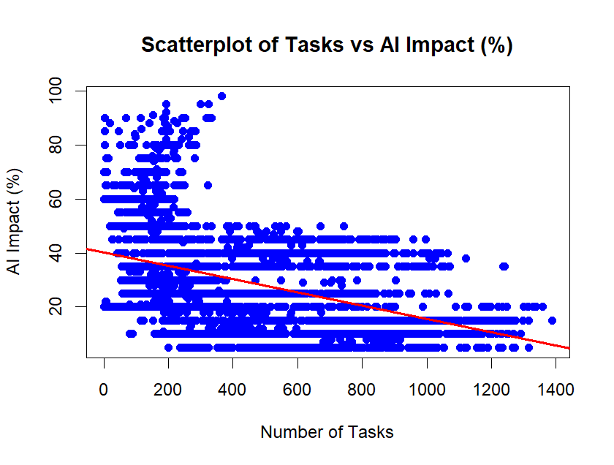
Scatter Plot of Tasks vs AI Impact(%)

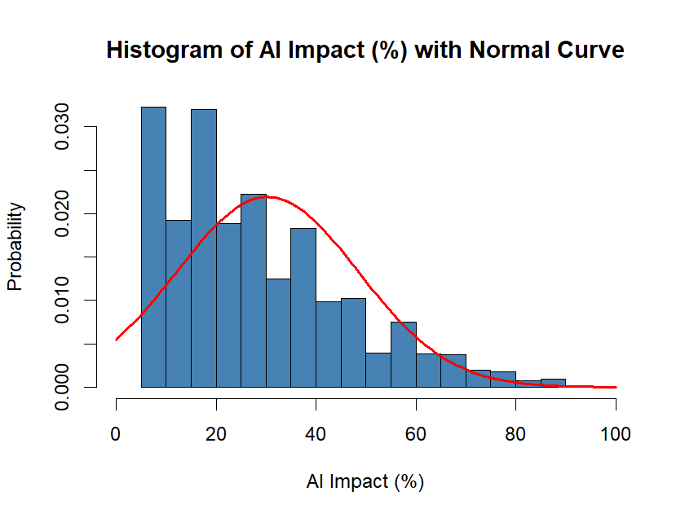
Histogram of AI Impact(%) with Normal Curve

The histogram helps show how task counts are spread out, making it easy to see typical workloads and any extremes. The scatterplot, with its fitted line, illustrates how task volume relates to AI impact. Together, these visuals clearly highlight trends, differences, and possible links between workload and automation risk.

  - Additional information relating to understanding the data (optional) (50 words)

  - Useful information for the data understanding (50 words)
The data has been meticulously curated from a range of reputable job analytics platforms, AI impact studies, and organizational reports. Each entry has been verified to ensure accuracy and relevance to the ongoing AI advancements in the respective fields.

- Analysis
  - Statistical test used to test the hypotheses and output (75 words):

To explore the link between the number of tasks in a job and its AI impact percentage, a Pearson correlation test was used. This test is suitable because both pieces of information are numbers, and we want to see whether they move together in any meaningful way. The test gives two key results: a correlation value showing how strong the relationship is, and a p-value showing whether the finding is statistically reliable.

  - The null hypothesis is rejected /not rejected based on the p-value (100 words) (interpret the results)
The p-value from the Pearson correlation test tells us whether the relationship we found is meaningful or just random. If the p-value is below 0.05, it suggests the result is unlikely to be due to chance, so we reject the null hypothesis and conclude that the number of tasks and AI impact are genuinely linked. But if the p-value is above 0.05, we do not reject the null hypothesis, meaning there isn’t enough evidence to say the two variables are related. This helps us understand whether number of tasks actually plays a role in how strongly AI affects different jobs.

- Evaluation – group’s experience at 7COM1079
  - What went well (75 words)
Our group worked well together, with communication and teamwork being our strongest points. Meeting in person helped us shape our research question clearly, and staying connected through WhatsApp made it easy to share ideas, ask questions, and solve problems quickly. Everyone contributed openly, and discussions flowed naturally. This smooth communication kept the project moving forward and ensured we stayed organised and on the same page throughout the assignment.
  - Points for improvement (75 words)
One challenge we faced was not connecting as a group early enough due to some initial miscommunication. If we had established contact sooner, we could have booked more feedback sessions and used that guidance to strengthen our project even further. Starting earlier would also have given us more time to refine our work and manage tasks more comfortably. This experience taught us the value of early coordination and clear communication at the beginning of a group project.
  - Group’s time management (50 words)
Our group managed time well throughout the assignment. We completed tasks steadily each week and attended demo sessions to receive feedback and make improvements. When changes were needed, we adjusted our plan quickly and worked together to stay on schedule, allowing us to finish the project without last-minute stress.
  - Project’s overall judgement (50 words)
Overall, the assignments were a valuable experience, and working as a team made it even better. Sharing ideas and improving our work through regular feedback helped us grow. The project strengthened our confidence, communication, and critical-thinking skills, and taught us how to manage group work more effectively.
  - Note any changes to group since original allocation if applicable. Add new or amended GitHub Ids for new members (75 words, write only if applies to your group arrangements)
  - Comment on the GitHub log output (50 words)
- Commit Message: [First Commit] we have uploaded the dataset in this commit.
- Commit Message: [mydata.R] We have uploaded the R script file here in this commit.
- Commit Message: [FinalA161PPT.pptx] Final research question presentation is uploaded in this commit.

- Conclusions
  - Results explained (75 words)
The Pearson correlation test helped us see whether the number of tasks in a job is actually linked to its AI impact percentage. By looking at the correlation value and p-value, we could tell if the relationship was strong, weak, or not really there at all. These results make it easier to understand whether having more tasks in a job affects how much AI might influence it, and whether the findings are trustworthy.
  - Interpretation of the results (75 words)
These results help answer the research question by showing whether jobs with more tasks are actually more affected by AI. If the correlation was significant, it means the number of tasks really does influence how vulnerable a job is. If not, it suggests other factors matter more than task count. Overall, the findings help workers, employers, and educators get a clearer idea of how AI might change different jobs and what skills or training may be needed in the future.

  - Reasons and/or implications for future work, limitations of your study (50 words)

This study has some limits, as it uses only one dataset and one way of measuring AI impact. It also doesn’t consider how difficult or complex the tasks are. Future research could look at different industries, compare several AI impact models, or explore how specific types of tasks affect a job’s vulnerability.

- Reference list:
Acemoglu, D. & Restrepo, P. (2018). Artificial Intelligence, Automation and Work. NBER Working Paper No. 24196. National Bureau of Economic Research.
Arntz, M., Gregory, T. & Zierahn, U. (2016). The Risk of Automation for Jobs in OECD Countries. OECD Social, Employment and Migration Working Papers, No. 189. OECD Publishing.
Autor, D.H. (2015). Why Are There Still So Many Jobs? The History and Future of Workplace Automation. Journal of Economic Perspectives, 29(3), pp. 3–30.
Brynjolfsson, E., Mitchell, T. & Rock, D. (2018). What Can Machines Learn and What Does It Mean for Occupations and the Economy? AEA Papers and Proceedings, 108, pp. 43–47.
Frey, C.B. & Osborne, M.A. (2017). The Future of Employment: How Susceptible Are Jobs to Computerisation? Technological Forecasting and Social Change, 114, pp. 254–280.
Manav Gupta, From Entry to CEO: The AI Job Threat Index, Kaggle.com.
McKinsey Global Institute (2017). Jobs Lost, Jobs Gained: Workforce Transitions in a Time of Automation. McKinsey & Company.
Rock, D., Mitchell, T. & Brynjolfsson, E. (2023). Beyond Automation: Redesigning Jobs with AI. arXiv preprint.
Zhao, R. et al. (2025). From Occupations to Tasks: A New Perspective on Automatability Prediction Using BERT. arXiv preprint.
OECD (2024). The Impact of AI on the Workforce: Tasks versus Jobs? Economics Letters.
7COM1079-0901-2025 Team Research and Development Project. University of Hertfordshire

- Appendices
- R code used for analysis and visualisation
Analysis.R code with the appropriate statistics to test the hypotheses.

summary(df)
df$Tasks <- as.numeric(df$Tasks)
df$AI_Impact_num <- as.numeric(gsub("%", "", df$AI.Impact))
pearson_result <- cor.test(df$Tasks, df$AI_Impact_num, method = "pearson")
pearson_result

spearman_result <- cor.test(df$Tasks, df$AI_Impact_num, method = "spearman")
spearman_result

plot(
df$Tasks,
df$AI_Impact_num,
main = "Scatterplot of Tasks vs AI Impact (%)",
xlab = "Number of Tasks",
ylab = "AI Impact (%)",
pch = 19,
col = "blue"
)

model <- lm(AI_Impact_num ~ Tasks, data = df)
abline(model, col = "red", lwd = 2)

hist(
df$AI_Impact_num,
breaks = 20,
probability = TRUE,
col = "steelblue",
border = "black",
main = "Histogram of AI Impact (%) with Normal Curve",
xlab = "AI Impact (%)",
ylab = "Probability",
xlim = c(0, 100)
)
mean_value <- mean(df$AI_Impact_num, na.rm = TRUE)
sd_value <- sd(df$AI_Impact_num, na.rm = TRUE)

curve(
dnorm(x, mean = mean_value, sd = sd_value),
col = "red",
lwd = 2,
add = TRUE,
xlim = c(0,100)
)

- GitHub log output.
Saikiran Lellela
0743923 - My_Data.csv

Shri Darandale
03f749b – mydata.R
3e2001d – FinalA161PPT.pptx

