Starting Kafka Server:-

Start bootstap server :

C:\Users\Chandu\Desktop\BITS\kafka_2.11-2.3.0>.\bin\windows\zookeeper-server-start.bat .\config\zookeeper.properties

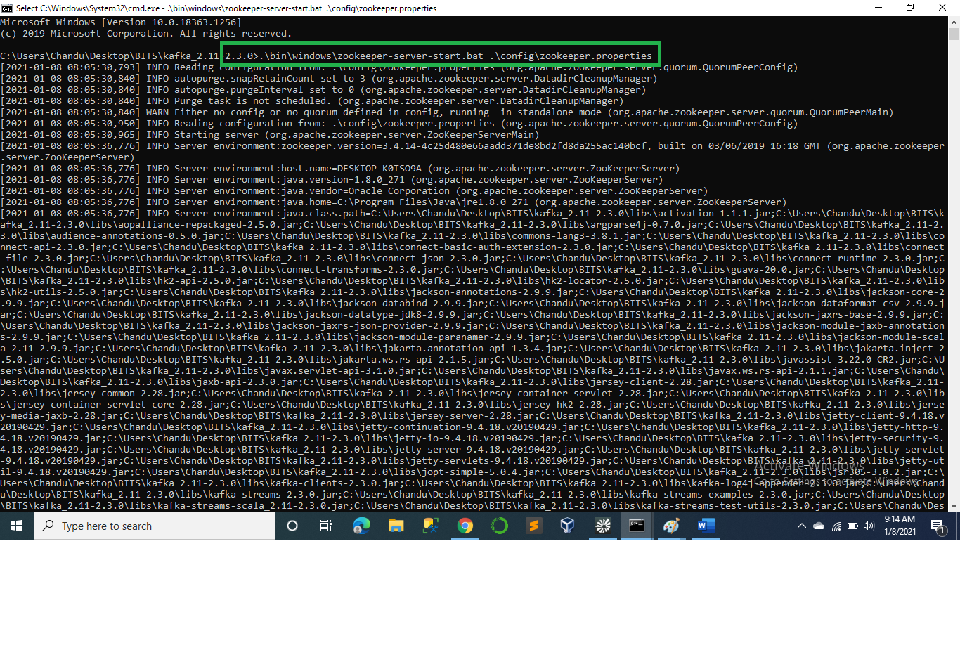

Start kafka server:

C:\Users\Chandu\Desktop\BITS\kafka_2.11-2.3.0>.\bin\windows\kafka-server-start.bat .\config\server.properties

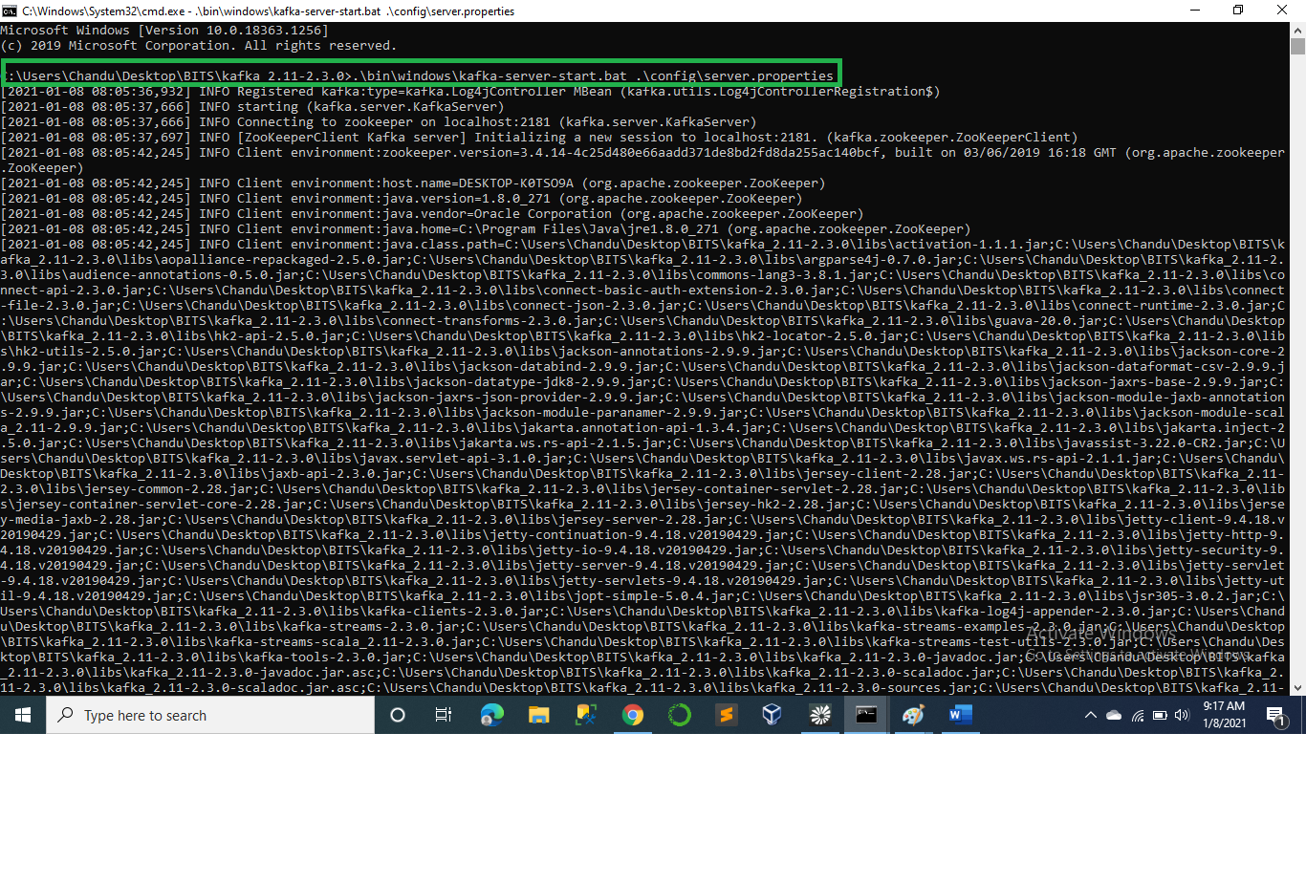

Creating Kafka Topic:

C:\Users\Chandu\Desktop\BITS\kafka_2.11-2.3.0>.\bin\windows\kafka-topics -zookeeper localhost:2181 -topic **CUSTOMER_DATA** -create --partitions 1 --replication-factor 1

C:\Users\Chandu\Desktop\BITS\kafka_2.11-2.3.0>.\bin\windows\kafka-topics -zookeeper localhost:2181 -topic **CUSTOMER_DATA1** -create --partitions 1 --replication-factor 1

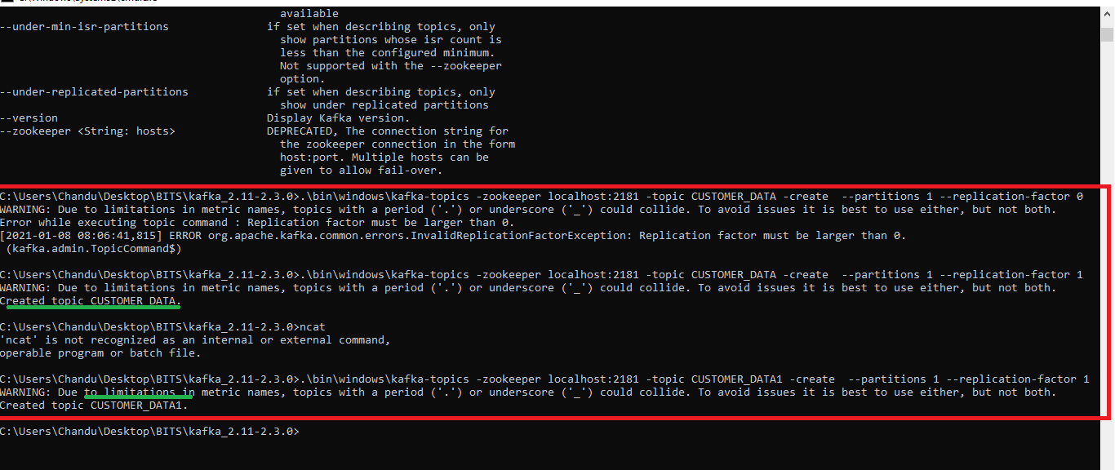

Rule the application using

APP.java, PostMessage.java, ConsumeMessage.java

Used Drool for Rule validations.

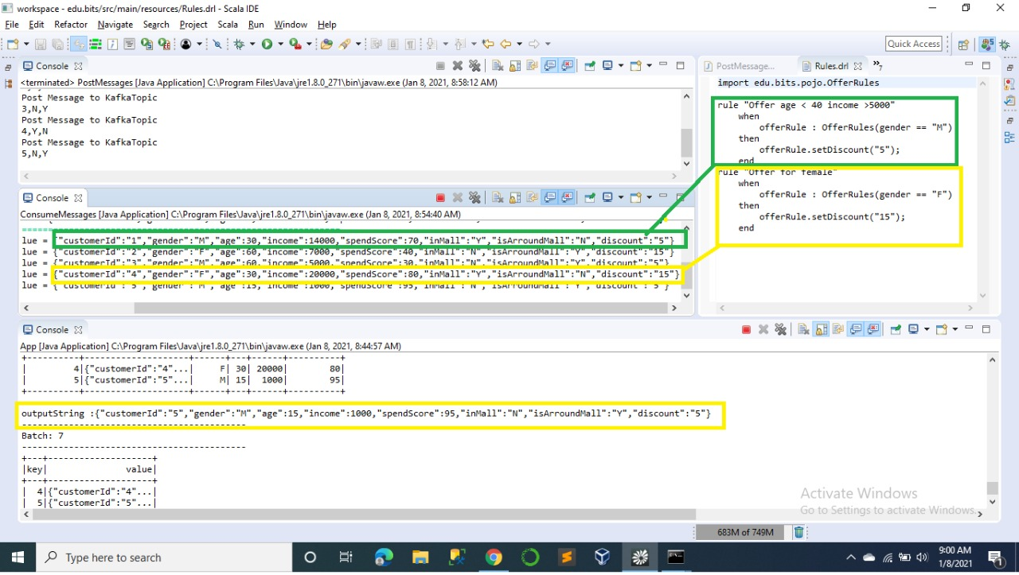

Version2: run App.java in edu.bitsassign after configuring the in eclipse.

