runfile('C:/Users/Sai Kiran/Desktop/ML_ASSIGNMENT1_BATCh_61/CarClasifier.py', wdir='C:/Users/Sai Kiran/Desktop/ML_ASSIGNMENT1_BATCh_61')

<class 'pandas.core.frame.DataFrame'>

RangeIndex: 1728 entries, 0 to 1727

Data columns (total 7 columns):

buying 1728 non-null object

maint 1728 non-null object

doors 1728 non-null object

persons 1728 non-null object

lug_boot 1728 non-null object

safety 1728 non-null object

distribution 1728 non-null object

dtypes: object(7)

memory usage: 94.6+ KB

['vhigh' 'high' 'med' 'low'] 4

['vhigh' 'high' 'med' 'low'] 4

['2' '3' '4' '5more'] 4

['2' '4' 'more'] 3

['small' 'med' 'big'] 3

['low' 'med' 'high'] 3

['unacc' 'acc' 'vgood' 'good'] 4

high 432

vhigh 432

med 432

low 432

Name: buying, dtype: int64

high 432

vhigh 432

med 432

low 432

Name: maint, dtype: int64

4 432

5more 432

2 432

3 432

Name: doors, dtype: int64

4 576

more 576

2 576

Name: persons, dtype: int64

small 576

med 576

big 576

Name: lug_boot, dtype: int64

high 576

med 576

low 576

Name: safety, dtype: int64

unacc 1210

acc 384

good 69

vgood 65

Name: distribution, dtype: int64

printing features graph

<class 'pandas.core.frame.DataFrame'>

RangeIndex: 1728 entries, 0 to 1727

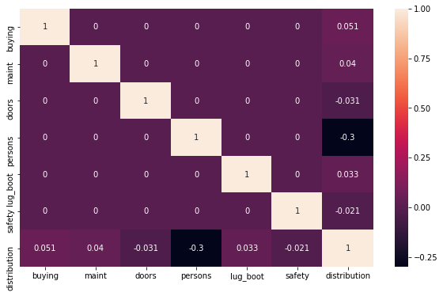

Data columns (total 6 columns):

buying 1728 non-null int32

maint 1728 non-null int32

doors 1728 non-null int32

persons 1728 non-null int32

lug_boot 1728 non-null int32

safety 1728 non-null int32

dtypes: int32(6)

memory usage: 40.6 KB

Kflod Spliting issues

Kflod Spliting issues

Kflod Spliting issues

Kflod Spliting issues

Kflod Spliting issues

Kflod Spliting issues

Kflod Spliting issues

Kflod Spliting issues

Kflod Spliting issues

Kflod Spliting issues

--scoresLR--

[0.6473988439306358, 0.653179190751445, 0.6820809248554913, 0.7225433526011561, 0.7167630057803468, 0.6878612716763006, 0.7167630057803468, 0.6820809248554913, 0.6744186046511628, 0.6569767441860465]

