**SAML Configuration through SiteBuild**

**Contents**

**Introduction** 2

**SAML Configuration types** 2

**Prerequisites** 2

**Metadata Validation** 2

**IDP Configuration** 3

**Implementation Steps** 3

**SP Configuration** 4

**Implementation Steps** 4

**Disclosure Configuration** 5

**Implementation Steps** 5

**Multi ADFS Console Configuration** 6

**Implementation Steps** 6

**Multi ADFS Disclosure Configuration** 7

**Implementation Steps** 7

**Enable Authentication via Email-Id** 8

**Implementation Steps** 8

# **Introduction**

This “SAML Configuration through SiteBuilder” application will help the partner support team to set up the SAML configurations themselves for their partners. In most of the cases, partner support team does not need to contact SAML or DB or NetOps teams, thus they can save much time in the setup process.

This document will serve as a user guide for SAML set up.

# **SAML Configuration types**

Following are the five types of SAML configurations.

* IDP Configuration
* SP Configuration
* Disclosure Configuration
* Multi ADFS Console Configuration
* Multi ADFS Disclosure Configuration

The following prerequisites and metadata validation steps apply to all types of SAML configuration. Please follow these checks before proceeding for SAML setup.

# **Prerequisites**

* Metadata file from the partner.
* Enable SAML from Site Customizer.

# **Metadata Validation**

* Please make sure provided file should start with “metadata”. If the file name is not metadata.xml , rename it to metadata.xml
* **EntityDescriptor** tag should have the **entityID**.



* **IDPSSODescriptor** should exist inside the **EntityDescriptor** tag in the provided metadata file.
* Make sure **KeyDescriptor** has only one **signing** key.
* If provided metadata has more than one signing key, talk to the partner and confirm the signing key to be used. Keep that signing key and remove all other unused keys.
* Make sure SingleSignOnService URL exists in the IDPSSODescriptor.

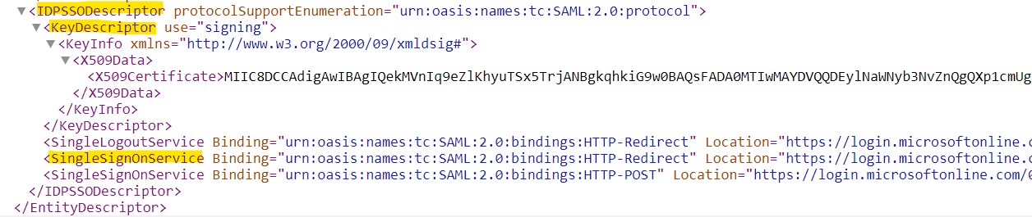

# **IDP Configuration**

## **Implementation Steps**

1. Login to SiteBuild application (<https://partner-name.catalyst.lrn.com/site-build>)
2. Once you are logged in successfully, select the “File Upload” tab.

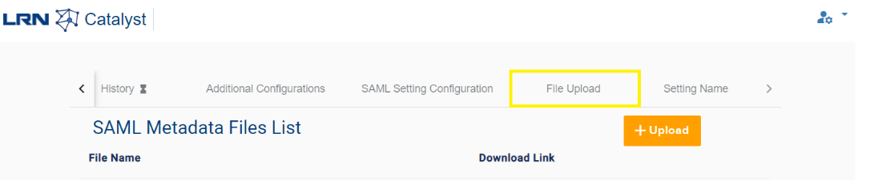

1. Click on the “Upload” button and upload the metadata file. (Make sure you have validated this as per the Metadata Validation steps).

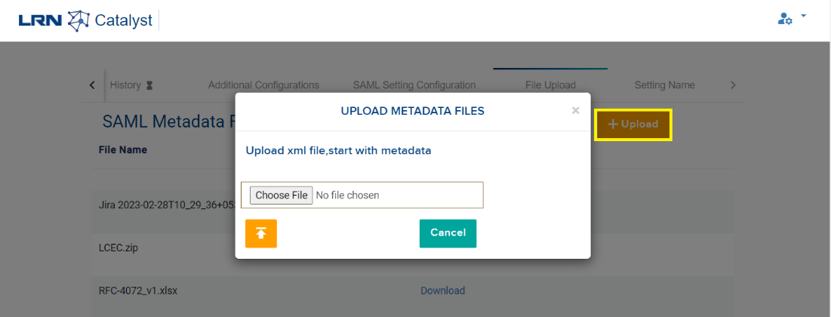

# **SP Configuration**

## **Implementation Steps**

1. Complete the IDP SAML setup (Make sure you have validated this as per the Metadata Validation steps) as it is required to enable SP Initiated SAML.
2. Click on the “SAML Setting Configuration” button to open settings form.

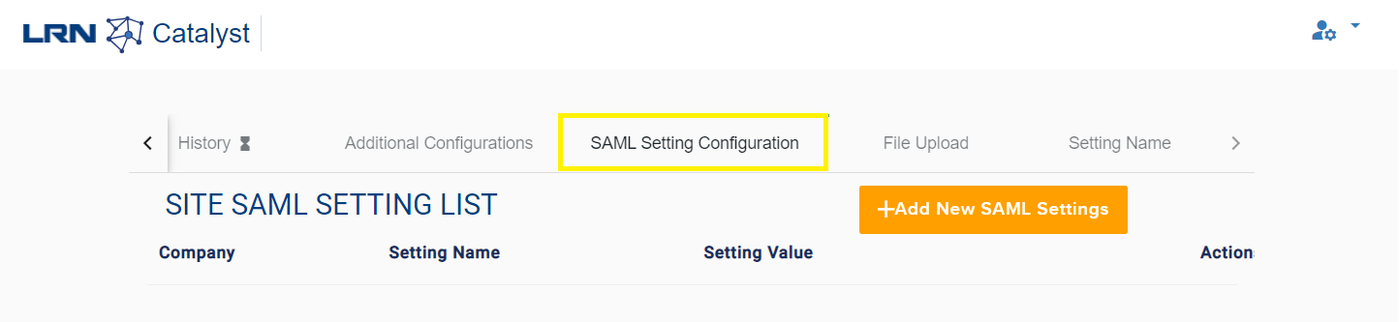

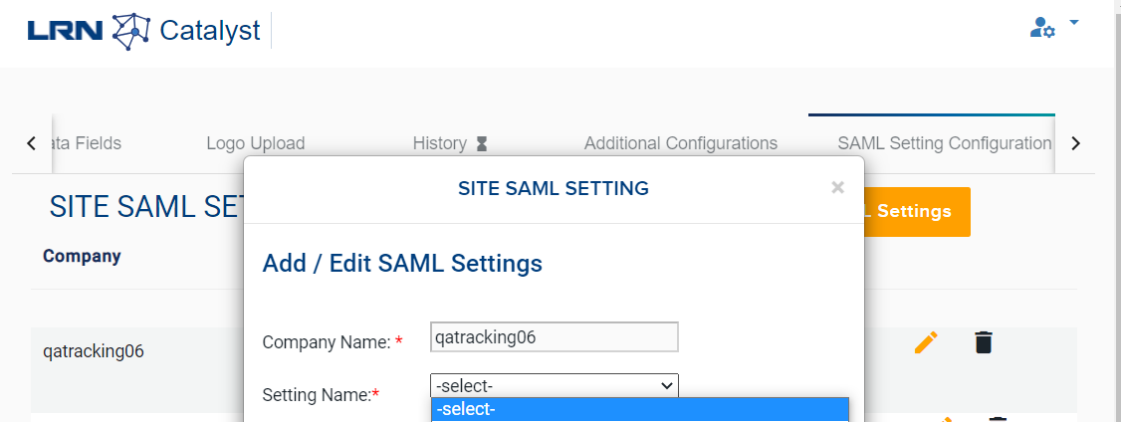

1. We have to add 3 entries by, Selecting Setting Name as "isSPInitSAML" from the dropdown and select setting Value as “1” and submit.
2. Select setting Name as "SPInitSAMLIdentifier" from the dropdown and enter setting Value as “partnername-console”.
3. Select Setting Name as "SPInitSAMLURL" from dropdown and enter the setting Value as **SingleSignOnService Location** value from the partner provided metadata.xml file as shown below.

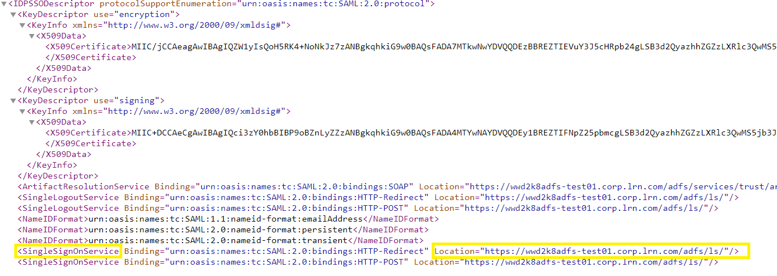

# **Disclosure Configuration**

## **Implementation Steps**

1. Complete the SP SAML setup (Make sure you have validated this as per the Metadata Validation steps) and make sure while uploading the metadata file for disclosure the file name should be “metadata_certmgr.xml” as it is required to enable **Disclosure** Configuration.
2. Click on the “SAML Setting Configuration” button to open settings form.





1. We have to add one entry by, selecting the Setting Name as "SPInitSAMLIdentifierCertMgr" from the Drop down and enter Setting Value as “partnername-certmgr” and click on submit.

# **Multi ADFS Console Configuration**

## **Implementation Steps**

1. If we want to enable multiADFS for IDP /SP, we have to Complete the IDP / SP SAML setup (Make sure you have validated this as per the Metadata Validation steps) and make sure while uploading the metadata file, file name should be “metadata.xml”.
2. If we want to enable for multiple partners under the same partner, then we have to rename the metadata file name to metadata_partner.xml and upload it using the below steps.
3. Click on the “SAML Setting Configuration” button to open settings form.





1. We have to add one entry by, Selecting the Setting Name as "isMultipleADFSSAML" from the Drop down and select the Setting Value as “1”.

# **Multi ADFS Disclosure Configuration**

## **Implementation Steps**

1. If we want to enable multiADFS for Disclosure, we have to Complete the Disclosure setup (Make sure you have validated this as per the Metadata Validation steps) and make sure while uploading the metadata file, file name should be “metadata_certmgr.xml”.
2. If we want to enable for multiple partners under the same partner, then we have to rename the metadata file name to metadata_partner.xml and upload it using the below steps.
3. Click on the “SAML Setting Configuration” button to open settings form.





1. We have to add 3 entries by, Selecting the Setting Name as "isMultipleADFSSAML" from the Drop down and select the Setting Value as “1”.
2. Select Setting Name as "SPInitSAMLURLCertMgr" from Drop down and enter the Setting Value as **SingleSignOnService Location** value from the partner provided metadata_certmgr.xml file as shown below.



1. Select Setting Name as "SPInitSAMLAssertionConsumerServiceURLCertMgr" from the Drop down and select Setting Value as “https://partnername.catalyst.lrn.com/certification-manager/api/samlsso/consume?adfsId=certmgr” and click on submit.

# **Enable Authentication via Email-Id**

## **Implementation Steps**

1. Complete the SAML setup (IDP / SP /Disclosure) (Make sure you have validated this as per the Metadata Validation steps) and make sure while uploading the metadata file, file name should start with “metadata.xml”.
2. Click on the “SAML Setting Configuration” button to open settings form.





1. We have to add one entry by, selecting the Setting Name as "isSAMLLoginEmail" from the Drop down and select Setting Value as “1” and click on submit.

# **When to reach SAML team**

* For Child site “Easy SAML Config” is not available.
* For Apple, Suggesting to support team to reach out SAML team.
* If Support team, think configuration is competed and not included one of above scenario. Team can reach out SAML team.