HELLO NODEJS GIT Repository used: <https://github.com/johnpapa/node-hello.git>

Created Docker file:  
---------------------

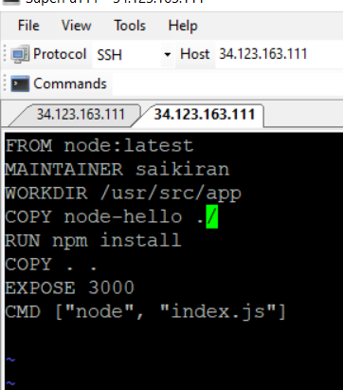



Created Docker image and pushed image into Docker HUB. In AWS, ECR can also be used.

Docker hub link: <https://hub.docker.com/r/saikiran42/mynode>

Deployed Docker image in Kubernetes cluster.  
  
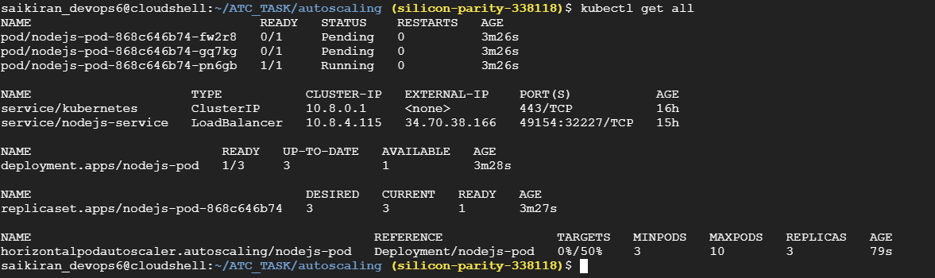

Created Service definition file to expose the application externally:

Output:

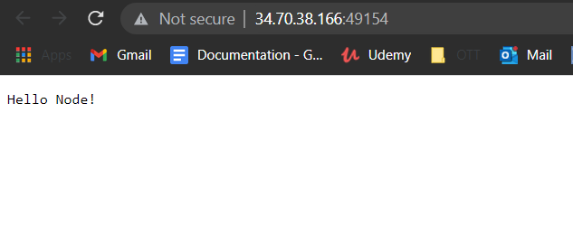

**A.How do you make the service scalable?**

The services can be scalable using Horizontal auto pod scalar or cluster scalar or Vertical auto scalar.

* In Horizontal Pod auto-scalar, the number of pods will get automcatially increased, if it reaches or exceeds the Threshold CPU values.
* In Vertical Auto-scalar, we can increase the the hardware configuration of worker nodes in K8s.

**B). What CI/CD pipeline would you use (if not done in code, please describe every**

**step from the commit of new code until the new code is running in production)?**

* We can use Jenkins as the CI/CD tool in this scenario and declrative pipeline can be used.
* GIT can be used as Source code repository tool and Webhooks or Poll SCM can be used to push the code to Jenkins.
* Once the code reaches Jenkins, You can use extensions like Maven or supported extensions to build the artifacts.
* In case of any errors in the code or facing issues while creating the artifacts, an E-Mail would be triggered to the Developers.
* Sonar cube can be used in Jenkins to check the code quality standards.
* Once the code passes the Sonar cube scanning, Artifacts can be deployed in the Tomcat server or supported environment and tested.
* Automation test scripts can be used to check the Artifact.
* By using Docker Pipeline Extension in Jenkins. We can create Docker images and later they can be pushed into Amazon ECR or Google repository.
* We can also setup UAT environment in Jenkins to check the application before deploying into prod environment.
* We need mainatain Kubernetes plug-in in Jenkins and later configure K8s in Jenkins, we can use kubeconif file to provide K8s endpoint in Jenkins.
* Once done, We can deploy the app in Kubernetes.

**C.)How would you store and deploy secrets (such as API keys)?**

Secrets like API keys or DB username or passwords can be stored in AWS Secret manager. In Teraaform, We can define the secrets in Terraform variables or Vault can also be used.

**D. How do you test how well your infrastructure scales (when many requests come**

**in)?**

I didn’t get a chance to test the infra from my side, but previously testing team uses Selenium to do performance testing by increasing the thread count.

**D. How do you provide an SSL certificate for your service?**

AWS Certificate manger can be used to provide SSL certificate for any web application which are exposed externally.