**Instructions:** There is only one file that named it as index3.html.Open it in browser to see content in file .

**Code:**

<!DOCTYPE html>

<html>

    <head>

        <title>Amortization Calculator</title>

        <meta charset="utf-8">

        <meta name="viewport" content="width=device-width,initial-scale-scale-1,shrink-to-fit=no">

        <meta http-equiv="x-ua-compatible" content="ie=sdge">

    </head>

    <body style="background-color:rgba(213, 190, 223, 0.986);">

        <div>

            <div style="text-align: center; background-color: blue; padding: 5px;">

                <h1>Amortization Calculator</h1>

            </div>

            <form>

                <div>

                    <table style="margin-left: auto; margin-right: auto; min-width: 500px; padding-top: 30px; padding-bottom: 50px;">

                        <tr>

                            <td ><h3 style="font-family: Arial; min-width: 300px;" >Loan amount</h3></td>

                            <td><input style="font-size: 23px; width: 300px;" id="amount" type="number" placeholder="Enter loan amount"></td>

                        </tr>

                        <tr>

                            <td><h3 style="font-family: Arial;" >Interest rate</h3></td>

                            <td><input style="font-size: 23px; width: 200px;" id="interest" type="number" placeholder="Enter interest rate">

                                <select style="font-size:23px; width: 100px; " name="select" id="select">

                                    <option value="empty">Select</option>

                                    <option value="month">Month</option>

                                    <option value="year">Year</option>

                                </select>

                            </td>

                        </tr>

                        <tr>

                            <td><h3 style="font-family: Arial;">Number of payments</h3></td>

                            <td><input style="font-size: 23px; width: 300px;" id="num" type="number"placeholder="Enter No of payments"></td>

                        </tr>

                    </table>

                </div>

            </form>

                <div style="display: flex; justify-content: center; ">

                    <a style="background-color: blueviolet; text-decoration: none; border: blueviolet; border-radius: 500px; padding-left: 10px; padding-right: 10px;" id="cal" type="submit" onclick="func()"><h3>Calculate</h3></a>&nbsp;&nbsp;

                    <a href="F:\internship\index3.html" style="text-decoration: none; background-color: rgb(226, 43, 43); color: black; border-radius: 50px; padding-left: 20px; padding-right: 20px;" type="submit"><h3>Reset</h3></a>

                </div><br><br>

            <table id="restable" style="margin-left: auto; margin-right: auto; text-align: center; border: 1px solid black; font-size: 20px; padding-block-start: 0%; padding: 1px; font-family: Arial; border-collapse: collapse;" border="1">

                <tr>

                    <th style="color: rgba(0, 94, 110, 0.979); padding: 10px;"><h5>Installment number</h5></th>

                    <th style="color: rgba(0, 94, 110, 0.979); padding: 10px;"><h5>Payment Amount</h5></th>

                    <th style="color: rgba(0, 94, 110, 0.979); padding: 10px;"><h5>Interest amount</h5></th>

                    <th style="color: rgba(0, 94, 110, 0.979); padding: 10px;"><h5>Principle amount</h5></th>

                    <th style="color: rgba(0, 94, 110, 0.979); padding: 10px;"><h5>Remaining loan balance</h5></th>

                </tr>

            </table>

            <script>

                function func()

                {

                    var amount=document.getElementById("amount").value;

                    var interest=document.getElementById("interest").value;

                    var num=document.getElementById("num").value;

                    var table=document.getElementById("restable");

                    var selected=document.getElementById("select");

                    var optionselect=selected.options[select.selectedIndex].text;

                    var r;

                    if(optionselect=='Select')

                    {

                        alert("Please select Month/year");

                        return false;

                    }

                    if(optionselect=='Year'){

                        r=(interest/(12*100));

                    }

                    if(optionselect=="Month"){

                        r=(interest/100);

                    }

                    if(amount>0&&interest>=0&&num>0)

                    {

                        var i;

                        paymentamount=(amount*r*(Math.pow((r+1),num)))/((Math.pow((r+1),num)-1));

                        paymentamount=paymentamount;

                        var principal;

                        var reloan;

                        var amount1=amount;

                        for(i=1;i<=num;i++)

                        {

                            interest=r*amount;

                            principal=paymentamount-interest;

                            reloan=amount1-principal;

                            amount1=reloan;

                            amount=amount1;

                            var row=table.insertRow(table.length);

                            var cel1=row.insertCell(0);

                            var cel2=row.insertCell(1);

                            var cel3=row.insertCell(2);

                            var cel4=row.insertCell(3);

                            var cel5=row.insertCell(4);

                            cel1.innerHTML=i;

                            cel2.innerHTML=paymentamount.toFixed(2);

                            cel3.innerHTML=interest.toFixed(2);

                            cel4.innerHTML=principal.toFixed(2);

                            cel5.innerHTML=reloan.toFixed(2);

                        }

                    }

                    else{

                        alert("Please Enter correct numbers");

                    }

                }

            </script>

        </div>

    </body>

</html>

**Output:**

**UI of Amortization Calculator:**

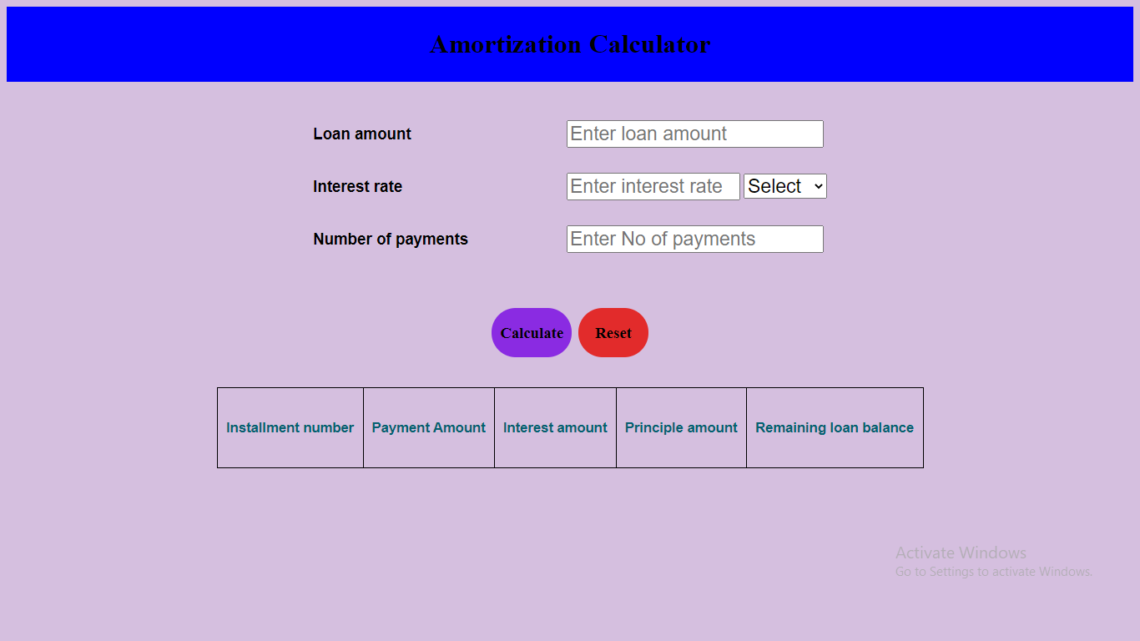

**Validations:**

**Alert message when someone is not selected month/year in interest rate field**

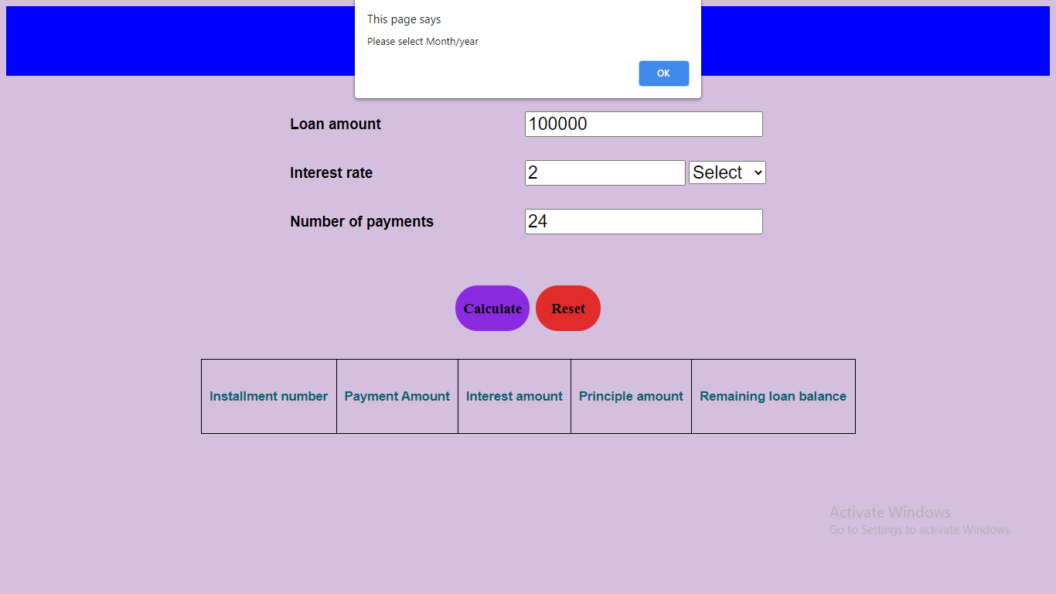

**Alert message is shown when negative values entered in text field:**

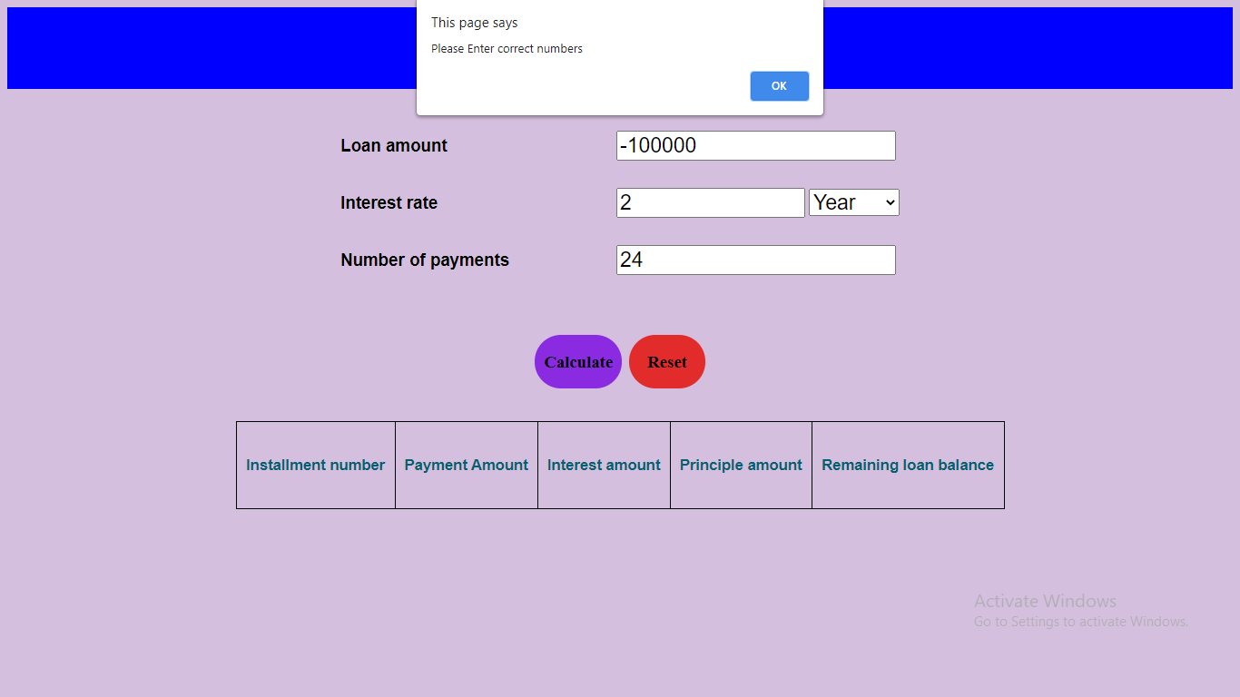

**Alert message is shown when no values entered in text field and tried to calculate:**

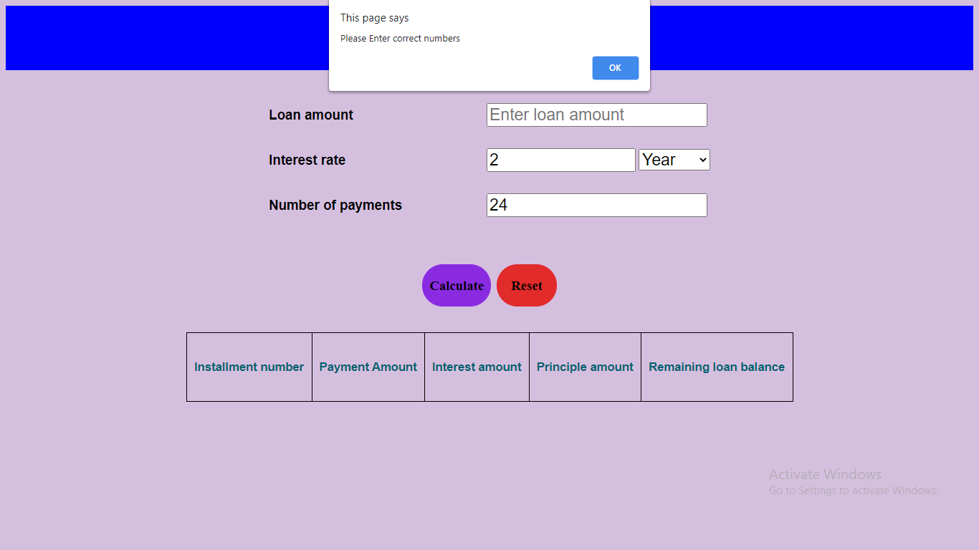

**Output:**

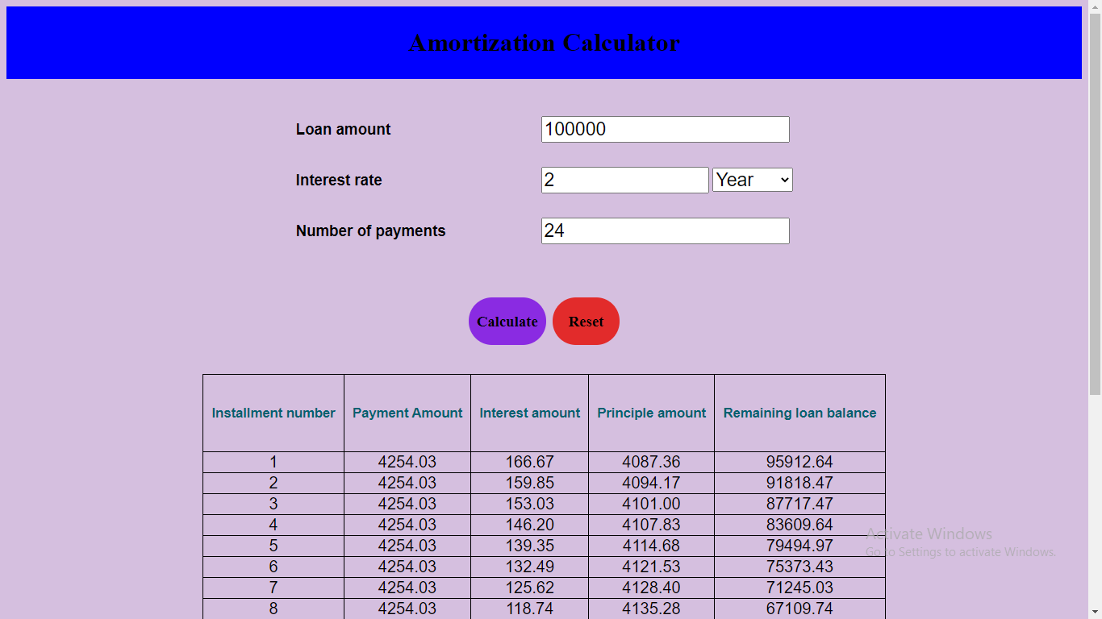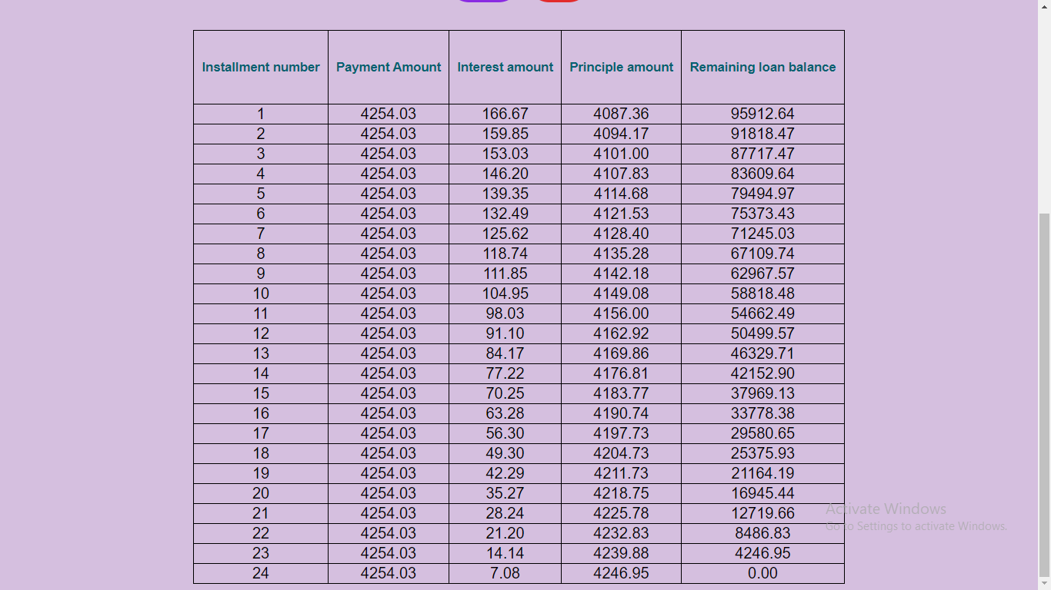

**When reset button is clicked then page is reloaded:**

