Lab session – data base creation and quering

1. Create a database with name StudentRepo and create the columsn with have promary key and not null constraints
2. Insert the below mentioned row and columns in the database.
3. Update the marks of Arnold as 70 inpace of 55
4. Delete the row of Tes Qry as she has left the college
5. Arrange the columns of Mark in ASC and DESC order to check on who have received the highest and lowest marks
6. Select only the female candidates and display to check on how many girl students are enrolled
7. Write a query to select the student who scored the lowest marks
8. Write a query to select the student who scored the highest marks

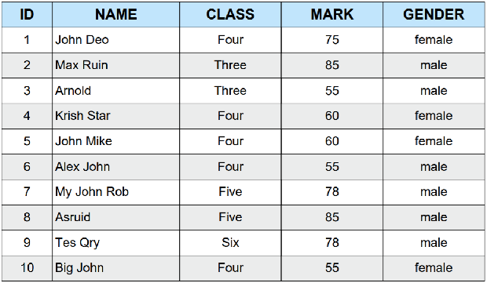

2. From the following table, write a SQL query to find out which nurses have not yet been registered. Return all the fields of nurse table.

Sample table: nurse

Sample table: nurse

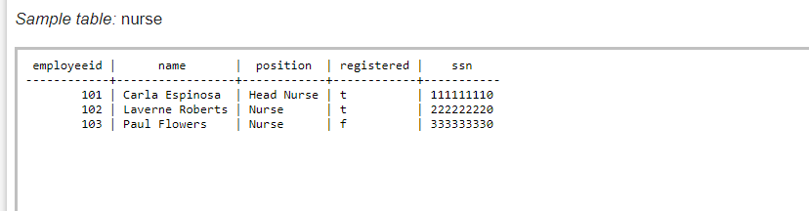Sample Output:

Answer: **SELECT \*** **FROM nurse**

**WHERE registered = 'f';**

3.From the following table, write a SQL query to identify the nurses in charge of each department. Return nursename as “name”, Position as “Position”.

Sample table: nurse

Answer: **SELECT name AS "Name", position AS "Position"**

**FROM nurse**

**WHERE position = 'Head Nurse';**

4. From the following tables, write a SQL query to identify the physicians who are the department heads. Return Department name as “Department” and Physician name as “Physician”.

Sample table: physician

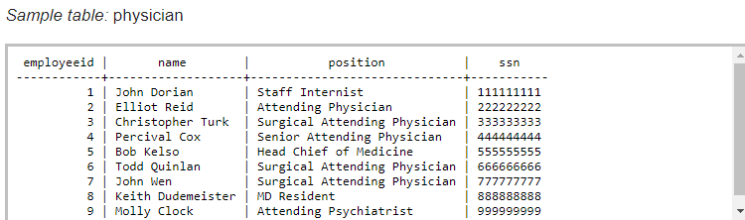

Answer: **SELECT d.name AS "Department", p.name AS "Physician"**

**FROM department d**

**JOIN physician p**

**ON d.head = p.employeeid;**

5. From the following tables, write a SQL query to find all salespeople and customers located in the city of London.

Sample table: Salesman

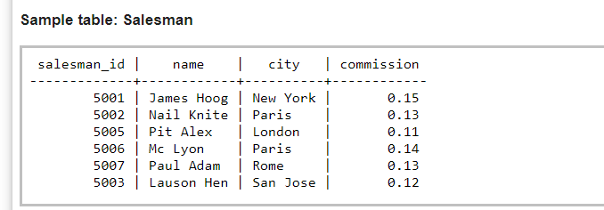Sample table: Customer

Answer: **SELECT salesman_id AS ID, name, 'Salesman' AS Type**

**FROM Salesman**

**WHERE city = 'London'**

**UNION**

**SELECT customer_id AS ID, name, 'Customer' AS Type**

**FROM Customer**

**WHERE city = 'London';**