A MINI PROJECT REPORT
ON
ONLINE JOB PORTAL
Submitted in Partial fulfilment of the requirements for the completion of
IV Semester
in
MASTER OF COMPUTER APPLICATIONS
BY
SAIKIRAN
Roll No: 160117862036
UNDER THE GUIDANCE OF
SRI. B. SRINIVAS S. P. KUMAR
Assistant Professor
Department of MCA, CBIT

DEPARTMENT OF MCA
CHAITANYA BHARATHI INSTITUTE OF TECHNOLOGY(A)
(AFFILIATED TO OSMANIA UNIVERSITY)
GANDIPET, HYDERABAD-500075
2018-2019

2. Certificate

This is to certify that the mini project work entitled JOB PORTAL is a bona fide work carried out by SAIKIRAN bearing Roll Number 160117862036 of MCA IV Semester in Chaitanya Bharathi Institute of Technology (Autonomous) during the academic year 2018-19.

Sri B .SRINIVAS S.P KUMAR Sri D. Jayaram
Project Guide Project In-charge

External Examiner

3. Declaration

The project report entitled ONLINE JOB PORTAL has been done by me. The matter embodied in this project work has not been submitted earlier for any degree or diploma to the best of my knowledge and belief.

Signature of Student
B.SAIKIRAN
160117862036

4. Acknowledgement

The success and outcome of this project required a lot of guidance and assistance from many people and I am extremely privileged to have got this all along the completion of my project. All that I have done is only due to such supervision and assistance and I would not forget to thank them.
I respect and thank Dr. D L Sreenivasa Reddy, Head of the Department, MCA, for providing me an opportunity to do the project work and for being a constant source of motivation and encouragement, which made me complete the project duly.
I sincerely thank my project in charge, who is also my project guide Sri D. Jayaram, Associate Professor, Department of MCA for his inputs, suggestions and timely support, which helped me finish my project on time, he also took keen interest on the project work and guided me all along, till the completion of the project work by providing all the necessary information.
I would not forget to remember all rest of the faculty members of the Department of MCA, Sri M. Kalidas, Sri P. Krishna Prasad, Sri M. Ramchander, Sri Ramesh Ponnala, Sri G.N.R Prasad Sri Gowrinath, Dr Indira. Their subject knowledge and teaching methods helped me understand complex topics which in turn helped me in successfully completing this project work.
Also, I would like to extend my sincere thanks to all staff in laboratory for their timely support.

B.SAIKIRAN
MCA 2/3 IV Semester
160117862036

5. Abstract:

Job portal is developed for creating an interactive job vacancy Portal for candidates.
This web application is to be conceived in its current form as a dynamic site-requiring constant updates both from the seekers as well as the companies.
The objective of the project is to enable jobseekers to place their resumes and find appropriate jobs while companies to publish their vacancies and find good candidates.
It enables jobseekers to post their resume, search for jobs, view personal job listings.
It will provide various companies to place their vacancy profile on the site and also have an option to search candidate resumes.
Apart from job-seekers and Companies(Job Provider) there will be an admin module to manage complete Portal as well as jobseeker and companies.

Index
Contents Page No.
Abstract v
List of Figures vi
List of Tables vi
- Introduction 1
  - Aim of the Project 1
  - Scope of the Project 1
  - Definitions, Acronyms 1
- System Analysis 5
  - Existing System 5
  - Problem Statement 5
  - Proposed System 5
  - System Requirements 5
    - Software Requirements 5
    - Hardware Requirements 6
- System Design 7
- System Implementation & Testing 8
- Conclusion & Future Scope 25
References

List of Figures:
S.no | Figure name | Fig no | Page no
1 | User Home page | 1.1 | 20
2 | About Us page | 1.2 | 21
3 | Contact us page | 1.3 | 22
4 | Registration page | 1.4 | 23
5 | Login page | 1.5 | 24
6 | Employer Page | 1.6 | 25
7 | Job Seeker page | 1.7 | 26
8 | Company Vacancies Page | 1.8 | 27
9 | Jobseeker Apply Page | 1.9 | 28
10 | Confirm Page | 1.0 | 29
11 | Employer Page | 2.0 | 30

List of Tables:

S.no | Table Name | Table number | Page
1 | Signup | T.1 | 25
2 | JobSeeker Reg | T.2 | 26
3 | Employer post job | T.3 | 27
4 | Jobseeker apply Report: | T.4 | 28
5 | Employer report | T.5 | 29

INTRODUCTION
  - Aim of the Project:
This project is aimed at design and developing an online Recruitment for the Nigerians. Purpose of Online job portal project is to help both the job seekers and recruiters finding the right organization or the employers.
  - Scope of the Project:
The Online portal system that is to be developed provides the members with jobs information, online applying for jobs and many other facilities. The basic scope of the project is given as under.
1.3 Definitions, Acronyms:
1.3.1. MYSQL:
MySQL is a flexible and capable RDBMS that has a rich feature set, performs well on the majority of queries, and has a large support base for access from many different languages. MySQL released its 5.0 database which added such enterprise features as triggers, stored procedures and constraints to its Open Source database engines.
MySQL supports GUI Toolkits for DB Administration, Designs, Migration, and Query.
- PORTABILITY: MySQL runs on almost every flavor of UNIX, as well as Windows and MacOS X. You can obtain binaries or source code for the MySQL server as well as the tools that access it. More ports of the software become available every day. It is almost a given that MySQL will run on whatever operating system you have available.
- SPEED: Using techniques such as efficient indexing mechanisms, in memory temporary tables, and highly optimized join algorithms, MySQL executes most queries much faster than most other database systems.
- SCALABILITY: Because of its modularity and its flexibility in configuration, MySQL can run in systems varying in size from embedded systems to large multiprocessor UNIX servers hosting databases with tens of millions of records. This scalability also allows you to run a copy of MySQL on a developer-class machine, and later use the same database system on a larger machine in production. Because it is multithreaded, MySQL efficiently utilizes resources for multiple users, compared to other database servers that start full-fledged processes for each user. It is not uncommon to hear of MySQL installations supporting thousands of concurrent users.
1.3.2. HTML:
Hyper Text Markup Language, commonly referred to as HTML, is the standard markup language used to create web pages. Hypertext systems were envisioned as early as 1940 by Vannevar Bush and have a rich history. Tim Berners-Lee and Robert Caillau at CERN, in 1989-1990 developed HTML as a simplification of SGML and CERN launched the web in 1991 (HTML+HTTP).

1.3.3. CSS
A cascading style sheet (CSS) contains style rules that are applied to elements in a Web page. CSS styles define how elements are displayed and where they are positioned on the page. Instead of assigning attributes to each element on your page individually, you can create a general rule that applies attributes whenever a Web browser encounters an instance of an element or an element that is assigned to a certain style class.
Cascading Style Sheets (CSS) is a style sheet language used for describing the look and formatting of a document written in a markup language. While most often used to change the style of web pages and user interfaces written in HTML and XHTML, the language can be applied to any kind of XML document, including plain XML, SVG and XUL. Along with HTML and JavaScript, CSS is a cornerstone technology used by most websites to create visually engaging web pages, user interfaces for web applications, and user interfaces for many mobile applications.
1.3.4. JavaScript:
JavaScript often abbreviated as JS, is a high-level, interpreted programming language that conforms to the ECMAScript specification. It is a programming language that is characterized as dynamic, weakly typed, prototype-based and multi-paradigm.
Alongside HTML and CSS, JavaScript is one of the core technologies of the World Wide Web.^{[9]} JavaScript enables interactive web pages and is an essential part of web applications. The vast majority of websites use it, and major web browsers have a dedicated JavaScript engine to execute it

2. SYSTEM ANALYSIS
2.1 Existing System:
In existing system Employer has to give advertisement in news paper for job vacancies. Employer has to spend lots of money for giving advertisement in news paper. Job Seeker has to read various news paper for job related advertisement. Job Seeker has to prepare a resume and send job application along with resume to particular company or organization. Upon receiving applications from job seeker employer has to shortlist the applications and send call letters to selected candidates. Thus we can say that existing system is time consuming. There is a wastage of extra resources and money in existing system.
2.2 Problem Statement:
The present system requires applicants to search through print and visual media for job opportunities. Applicants need to apply for jobs using conventional methods and appear for interview on a specified date at a specified location. Employers need to advertise the vacancies and sort all applicant details, conduct selection procedures and complete the formalities. This approach is tedious and requires much effort and resources. There is need of an online job portal where applicants easily find the jobs and employer can find suitable candidates for the job .
  - Proposed System:
(1) Employers can post job vacancies online without spending money for advertisement.
(2) Job Seekers can search for jobs as per their criteria and requirements
(3) There is no need to buy and read different news papers.
(4) Job Seeker can manage their resume online.
(5) Job Seeker can send Job Applications online.
(6) Employer can shortlist Job Application online and send call letters to job seekers online.

  - System Requirements:

2.4.1 Software Requirements:

Back End : MySQL, PHP

Front End : HTML5, CSS , JavaScript

Other tools : XAMPP.

2.4.2 Hardware Requirements:

- Windows 10 PRO
- Microprocessor: Pentium-p4
- Hard Disk Drive: 80GB
- RAM: 256MB
- Keyboard
- Mouse

3. System Design:

3.1 Flow Chart:
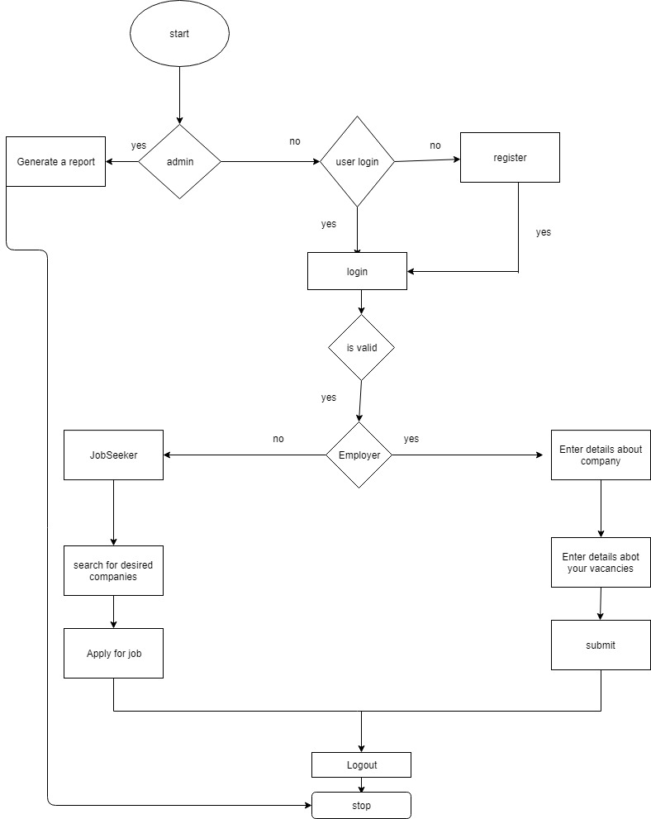

Fig 3.1

4. System Implementation & Testing:
4.1 Sample Code:
Home.html
<!DOCTYPE html>
<html><head><link rel="stylesheet" href="mystyle.css">
<link rel="stylesheet" href="mylogin.css">
<meta name="viewport" content="width=device-width, initial-scale=1">

<style>
body {font-family: Arial, Helvetica, sans-serif;}
* {box-sizing: border-box}

/* Full-width input fields */
input[type=text], input[type=password] {
width: 100%;
padding: 15px;
margin: 5px 0 22px 0;
display: inline-block;
border: none;
background: #f1f1f1;
}

input[type=text]:focus, input[type=password]:focus {
background-color: #ddd;
outline: none;
}

hr {
border: 1px solid #f1f1f1;
margin-bottom: 25px;
}

/* Set a style for all buttons */
button {
background-color: #4CAF50;
color: white;
padding: 14px 20px;
margin: 8px 0;
border: none;
cursor: pointer;
width: 100%;
opacity: 0.9;
}

button:hover {
opacity:1;
}

/* Extra styles for the cancel button */
.cancelbtn {
padding: 14px 20px;
background-color: #f44336;
}

/* Float cancel and signup buttons and add an equal width */
.cancelbtn, .signupbtn {
float: left;
width: 50%;
}

/* Add padding to container elements */
.container {
padding: 16px;
}

/* Clear floats */
.clearfix::after {
content: "";
clear: both;
display: table;
}

/* Change styles for cancel button and signup button on extra small screens */
@media screen and (max-width: 300px) {
.cancelbtn, .signupbtn {
width: 100%;
}
}
.hero{
height:100%;
width:100%;
background:linear-gradient(rgba(26,26,26,0.3),rgba(26,26,26,0.3)),url("me.jpg");
background-size:cover;
background-repeat:no-repeat;
background-position:center center;

}
body {
margin:0;
font-family: Ariel, helvetica, sans-serif;
}
form {
margin:20px auto;
width 320px;
}
.topnav {
overflow: hidden;
background-color: #333;
}

.topnav a {
float: left;
color: #f2f2f2;
text-align: center;
padding: 14px 16px;
text-decoration: none;
font-size: 17px;
}

.topnav a:hover {
background-color: #ddd;
color: black;
}

.topnav a.active {
background-color: #4CAF50;
color: white;
font-size: 35px;
}
</style></head>
<body background="me.jpg">
<marquee behavior="scroll" font-family: "Ariel, helvetica, sans-serif"
direction="left">❤❤wellcome❤❤.................❤❤wellcome❤❤</marquee>
<header>
<div class="topnav">
<h1 align="center" style="color:AQUA;">online job portal<h1>
<a href="f.php">Home</a>
<a href="AboutUs.php">About Us</a>
<a href="Employer1.php">Employer</a>
<a href="jobpage.php">Job Seeker</a>
<a href="News.php">Latest News</a>
<a href="ContactUs.php">Contact Us</a>
<ul><li style="float:right"><a href="signup.php">Register</a>
<li style="float:right"><a class="active" href="login.php">login</a></li>
</li>

</ul>
</div></header>
<div class="wrap">
<form method="post" action="signupdp.php">
<div class="container">
<h1>Sign Up</h1>
<p>Please fill in this form to create an account.</p>

<hr>
<label for="email"><b>Email</b></label>
<input type="text" placeholder="Enter valid Email" name="e1" required>

<label for="psw"><b>Password</b></label>
<input type="password" placeholder="Enter Password" name="p1" required>

<label for="psw-repeat"><b>Repeat Password</b></label>
<input type="password" placeholder="Repeat Password" name="p2" required>

<label>
<input type="checkbox" checked="checked" name="remember" style="margin-bottom:15px"> Remember me
</label>

<div class="clearfix">
<button type="button" class="cancelbtn">Cancel</button>
<button type="submit" class="signupbtn">Sign Up</button>
</div>
</div>
</form>
<a class="active" href="admin.php">adminlogin</a>
</div>

</body>
</html>

Signup.html:
<!DOCTYPE html>
<html><link rel="stylesheet" href="mylogin.css">
<style>
body {font-family: Arial, Helvetica, sans-serif;}
* {box-sizing: border-box}

/* Full-width input fields */
input[type=text], input[type=password] {
width: 100%;
padding: 15px;
margin: 5px 0 22px 0;
display: inline-block;
border: none;
background: #f1f1f1;
}

input[type=text]:focus, input[type=password]:focus {
background-color: #ddd;
outline: none;
}

hr {
border: 1px solid #f1f1f1;
margin-bottom: 25px;
}

/* Set a style for all buttons */
button {
background-color: #4CAF50;
color: white;
padding: 14px 20px;
margin: 8px 0;
border: none;
cursor: pointer;
width: 100%;
opacity: 0.9;
}

button:hover {
opacity:1;
}

/* Extra styles for the cancel button */
.cancelbtn {
padding: 14px 20px;
background-color: #f44336;
}

/* Float cancel and signup buttons and add an equal width */
.cancelbtn, .signupbtn {
float: left;
width: 50%;
}

/* Add padding to container elements */
.container {
padding: 16px;
}

/* Clear floats */
.clearfix::after {
content: "";
clear: both;
display: table;
}

/* Change styles for cancel button and signup button on extra small screens */
@media screen and (max-width: 300px) {
.cancelbtn, .signupbtn {
width: 100%;
}
}
</style>
<body>
<div class="wrap">
<form method="post" action="signupdp.php">
<div class="container">
<h1>Sign Up</h1>
<p>Please fill in this form to create an account.</p>

<hr>
<label for="email"><b>Email</b></label>
<input type="text" pattern=".+@gmail.com" placeholder="Enter valid Email" name="e1" required>

<label for="psw"><b>Password</b></label>
<input type="password" placeholder="Enter Password" name="p1" required>

<label for="psw-repeat"><b>Repeat Password</b></label>
<input type="password" placeholder="Repeat Password" name="p2" required>

<label>
<input type="checkbox" checked="checked" name="remember" style="margin-bottom:15px"> Remember me
</label>
<div class="clearfix">
<button type="button" class="cancelbtn">Cancel</button>
<button type="submit" class="signupbtn">Sign Up</button>
</div>
</div>
</form>
</div>
</body>
</html>
Signupdp.php:
<?php
$email=$_REQUEST['e1'];
$password=$_REQUEST['p1'];
$repeatpassword=$_REQUEST['p2'];
mysql_connect("localhost","root","") or die("Unable to connect to database");
mysql_select_db("jobportal") or die("Unable to select jobportal database");
$q = "insert into signup values ('$email','$password','$repeatpassword')";
if(mysql_query($q))
{
header('Location: login.php');
}#echo "one record inserted";
else
{
error;
}
mysql_close();
?>

Login.html:
<!DOCTYPE html>
<html>
<head><link rel="stylesheet" href="mylogin.css">
<meta name="viewport" content="width=device-width, initial-scale=1">
<style>
body {font-family: Arial, Helvetica, sans-serif;}
form {border: 3px solid #f1f1f1;}
input[type=text], input[type=password] {
width: 100%;
padding: 12px 20px;
margin: 8px 0;
display: inline-block;
border: 1px solid #ccc;
box-sizing: border-box;
}
button {
background-color: #4CAF50;
color: white;
padding: 14px 20px;
margin: 8px 0;
border: none;
cursor: pointer;
width: 100%;
}
button:hover {
opacity: 0.8;
}
.cancelbtn {
width: auto;
padding: 10px 18px;
background-color: #f44336;
}

.imgcontainer {
text-align: center;
margin: 24px 0 12px 0;
}

img.avatar {
width: 40%;
border-radius: 50%;
}

.container {
padding: 16px;
}

span.psw {
float: right;
padding-top: 16px;
}

/* Change styles for span and cancel button on extra small screens */
@media screen and (max-width: 300px) {
span.psw {
display: block;
float: none;
}
.cancelbtn {
width: 100%;
}
}
</style>
</head>
<body>
<div class="hero">
<div class="wrap">

<h1>Login Form</h1>

<form action="action_page.php" method="post">
<div class="imgcontainer">
<img src="img_avatar2.png" alt="Avatar" class="avatar">
</div>

<div class="container">
<label for="uname"><b>Email</b></label>
<input type="text" placeholder="Enter EmailID" name="e1" required>

<label for="psw"><b>Password</b></label>
<input type="password" placeholder="Enter Password" name="psw" required>
<label for="psw-repeat"><b>Repeat Password</b></label>
<input type="password" placeholder="Repeat Password" name="p2" required>

<button type="submit">Login</button>
<label>
<input type="checkbox" checked="checked" name="remember"> Remember me
</label>
</div>

<div class="container" style="background-color:#f1f1f1">
<a href="f.php"><button type="button" class="cancelbtn">Cancel</button></a>
<span class="psw">Forgot <a href="#">password?</a></span>
</div>
</form>
<a href="signup.php">new user sign up hear</a>
</div>
</body></html>

Logindb.php:

<?php
$email=$_REQUEST['e1'];
$password=$_REQUEST['psw'];
mysql_connect("localhost","root","") or die("Unable to connect to database");
mysql_select_db("jobportal") or die("Unable to select jobportal database");
if($email=="" || $password=="")
{
$err="<font color='red'>fill all the fileds first</font>";
}
$sql= mysql_query("select * from signup where email='$email' and password='$password'");
$r=mysql_num_rows($sql);

if($r==true)

{

header('Location: users.php');
}#echo "one record inserted";
else
{
echo "wrong password";
}
mysql_close();
?>

Figures
User Home page:

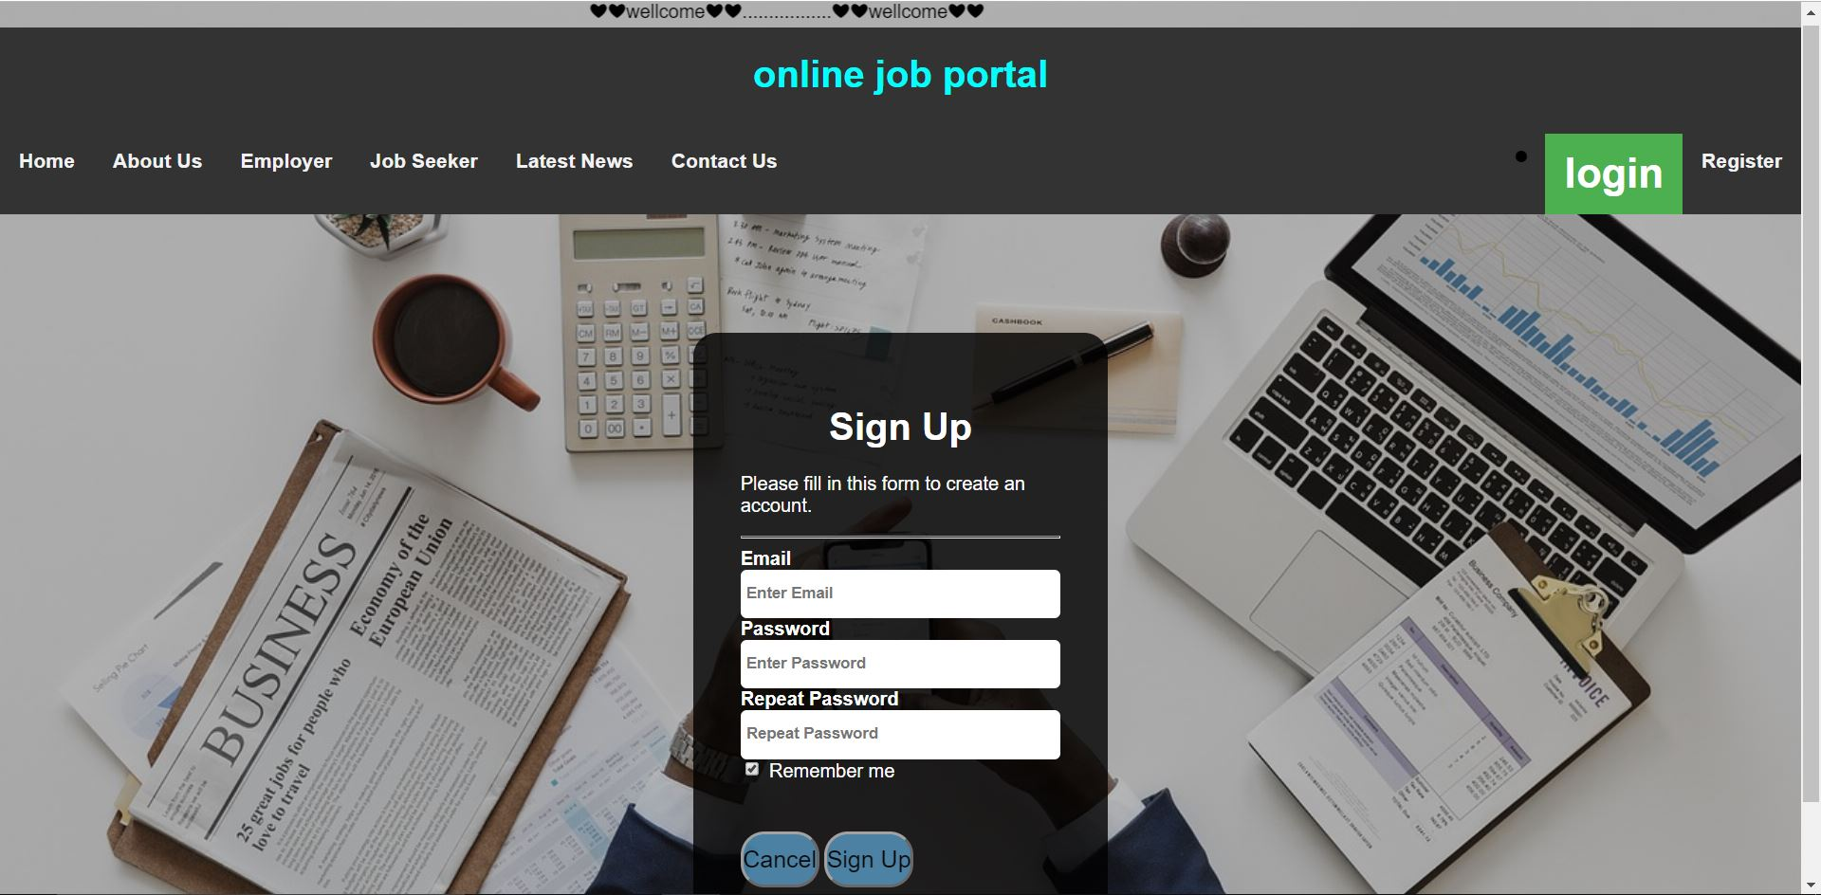
Figure 1.1
• This is home page for both JobSeeker and Employer.

About Us page:

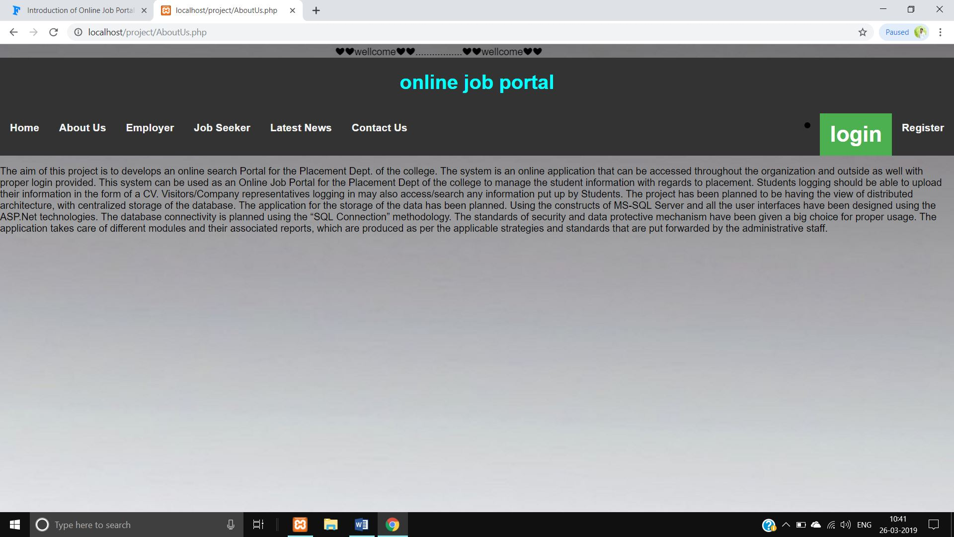
Figure 1.2
• This is About Us page of User.

Contact us page:

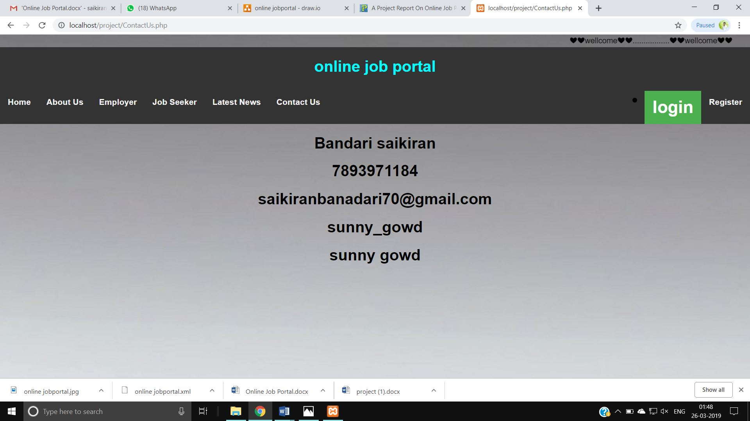
Figure 1.3

• This is Contactus page for User.

Registration page:

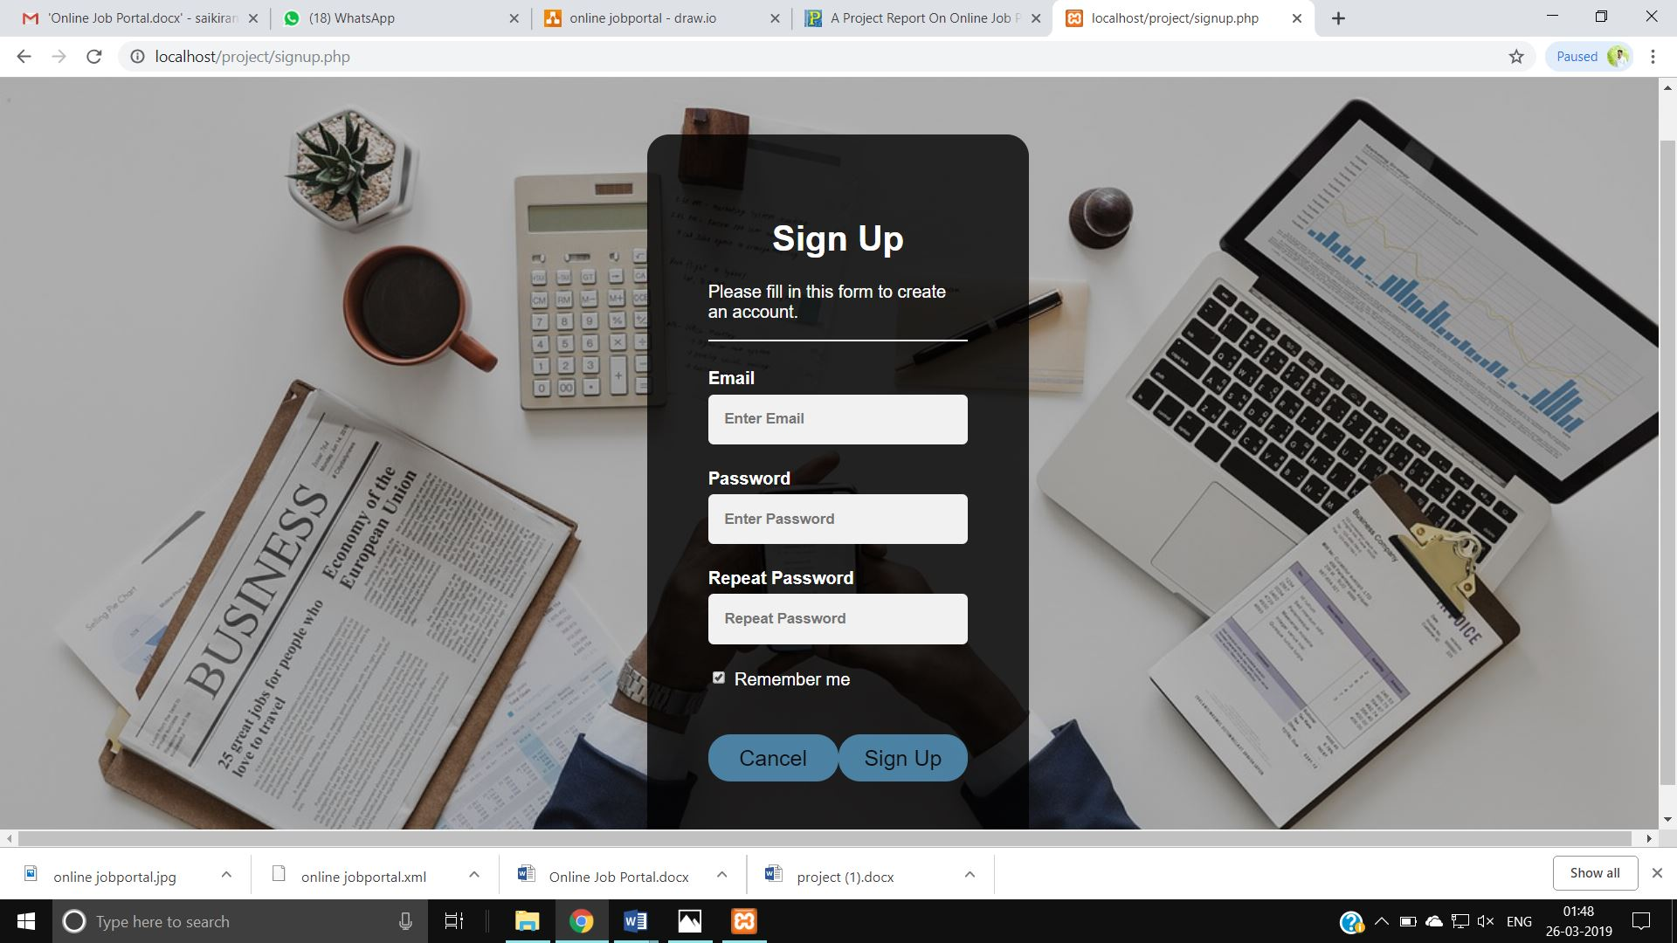
Figure 1.4
• This is page of User Registration.

Login page:

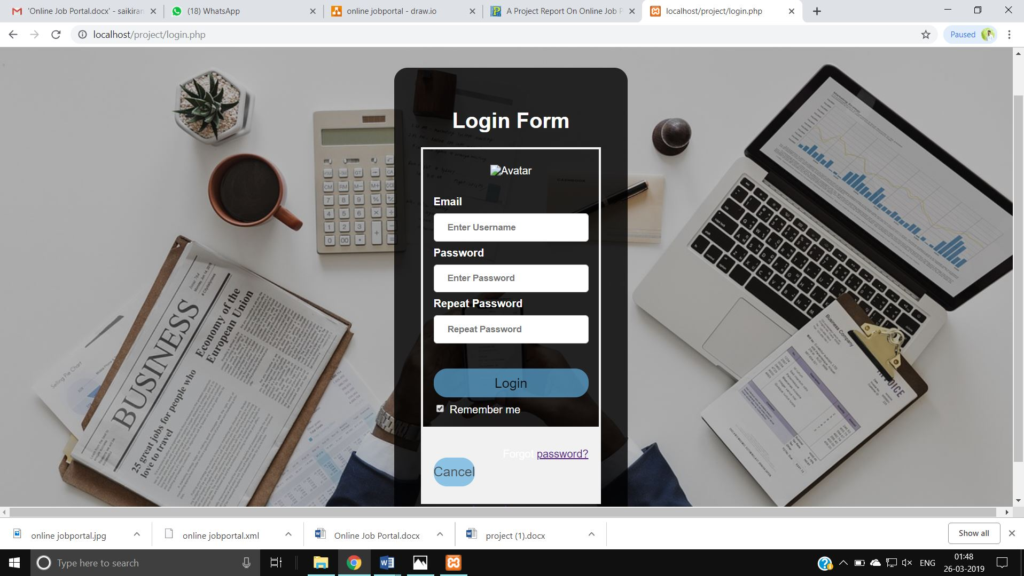
Figure 1.5

• This is Login page of User.

About our Employer Companies page:

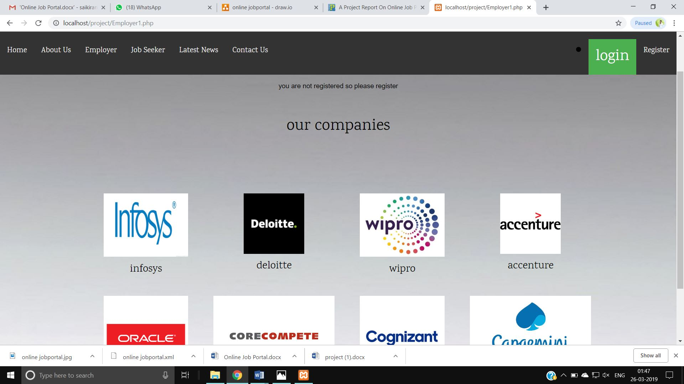
Figure 1.6

- Without login Employer page it shows our Employer.

JobSeeker Page :

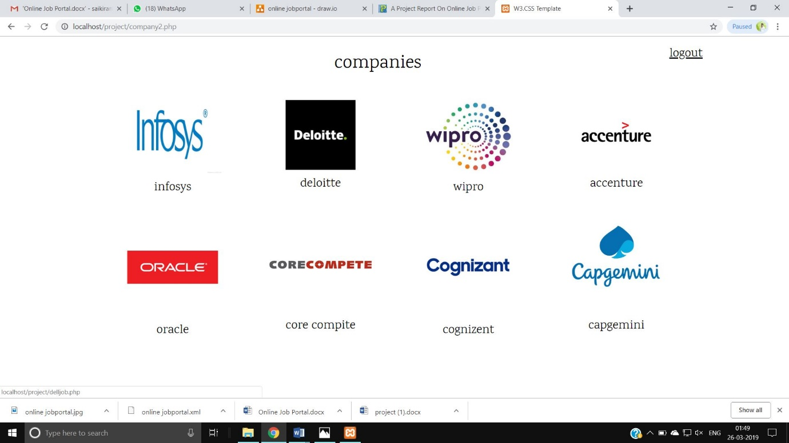
Figure 1.7

• This is JobSeeker page after login.

Company Vacancies page for job seeker:

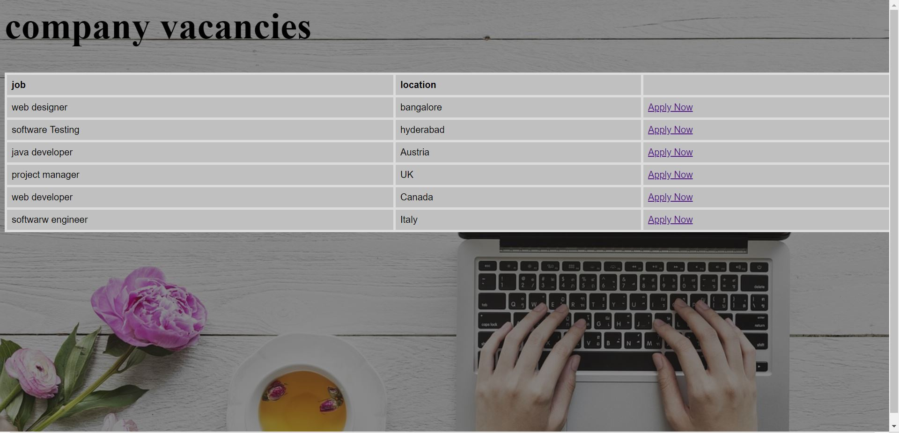
Figure 1.8

JobSeeker Apply Form:

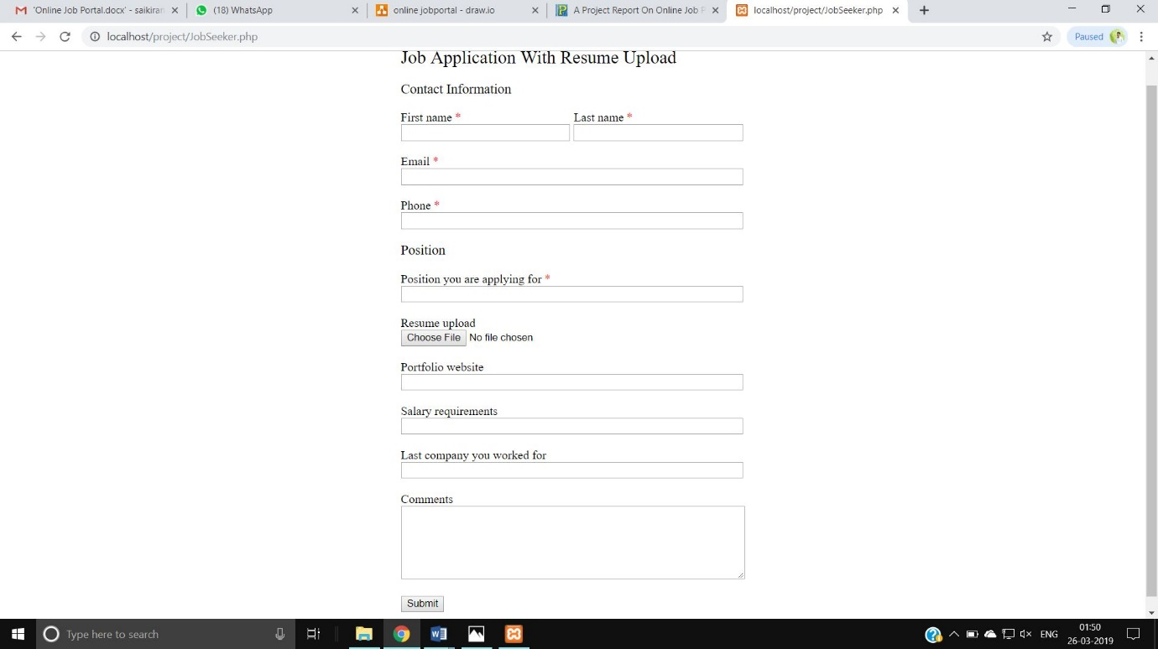
Figure 1.9

• This is Jobseeker application for job page .

Confirm page:

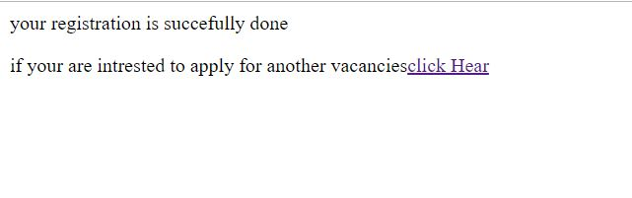
Figure 1.0

• This is confirm page of User.

Employer Page:
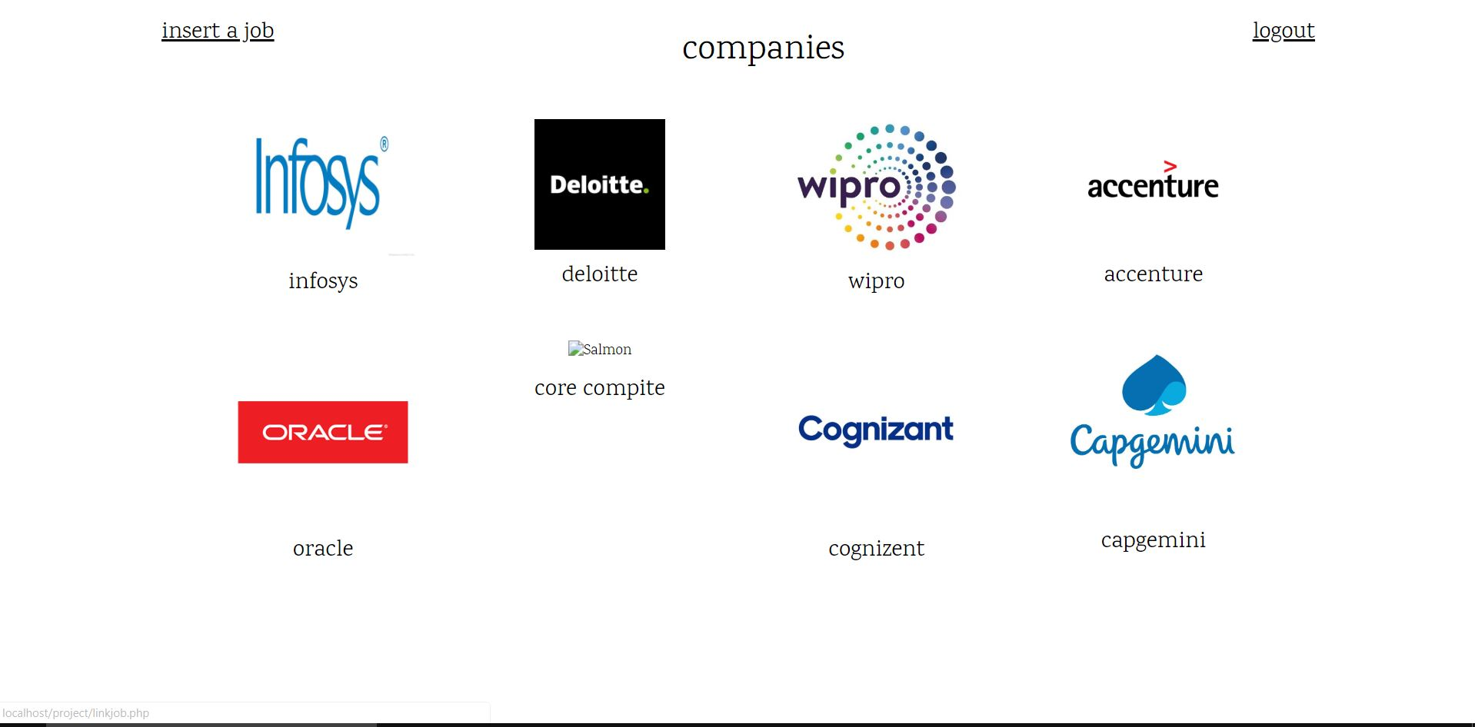
Figure 2.0

List of Tables:

- This saves the Details of The sign up users.

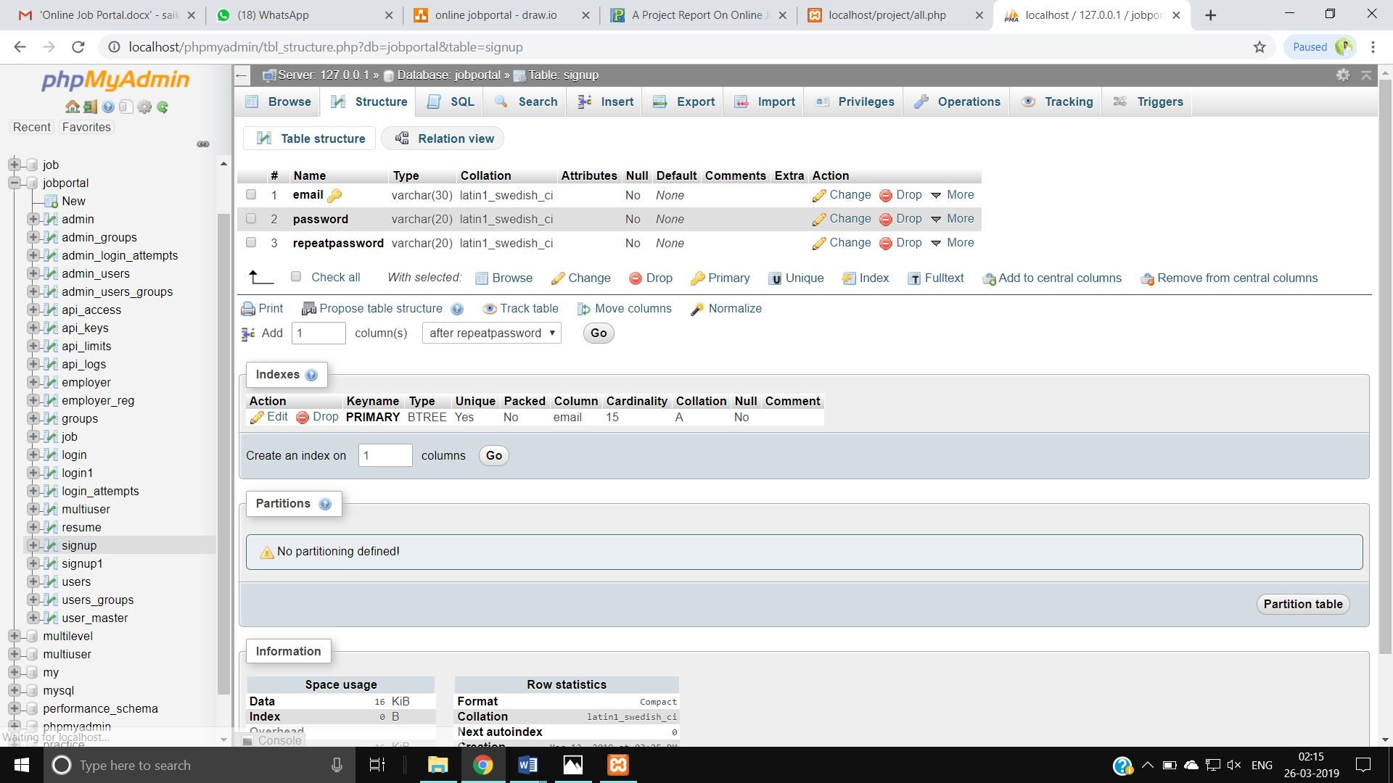
Figure T.1

Jobseeker Registration Table:

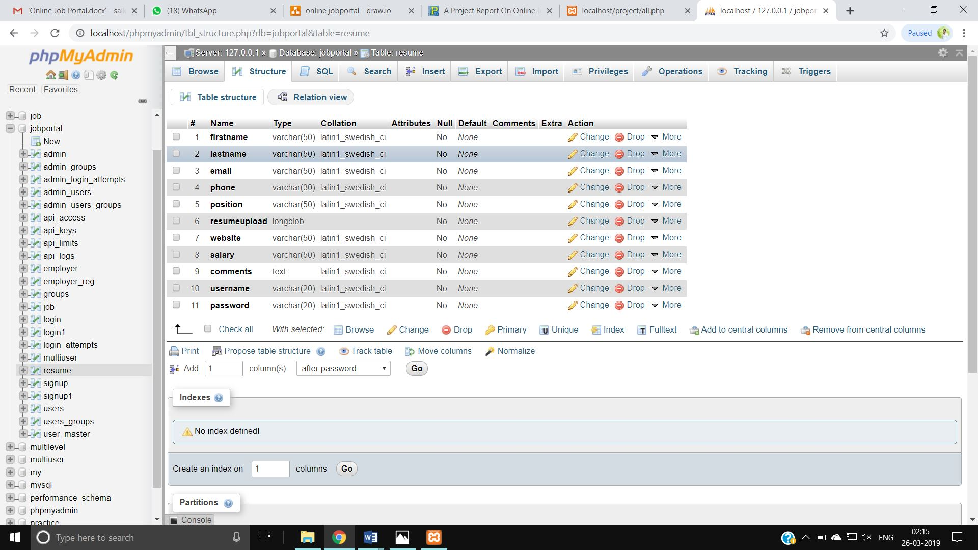
Figure T.2

Employer Post a job form:

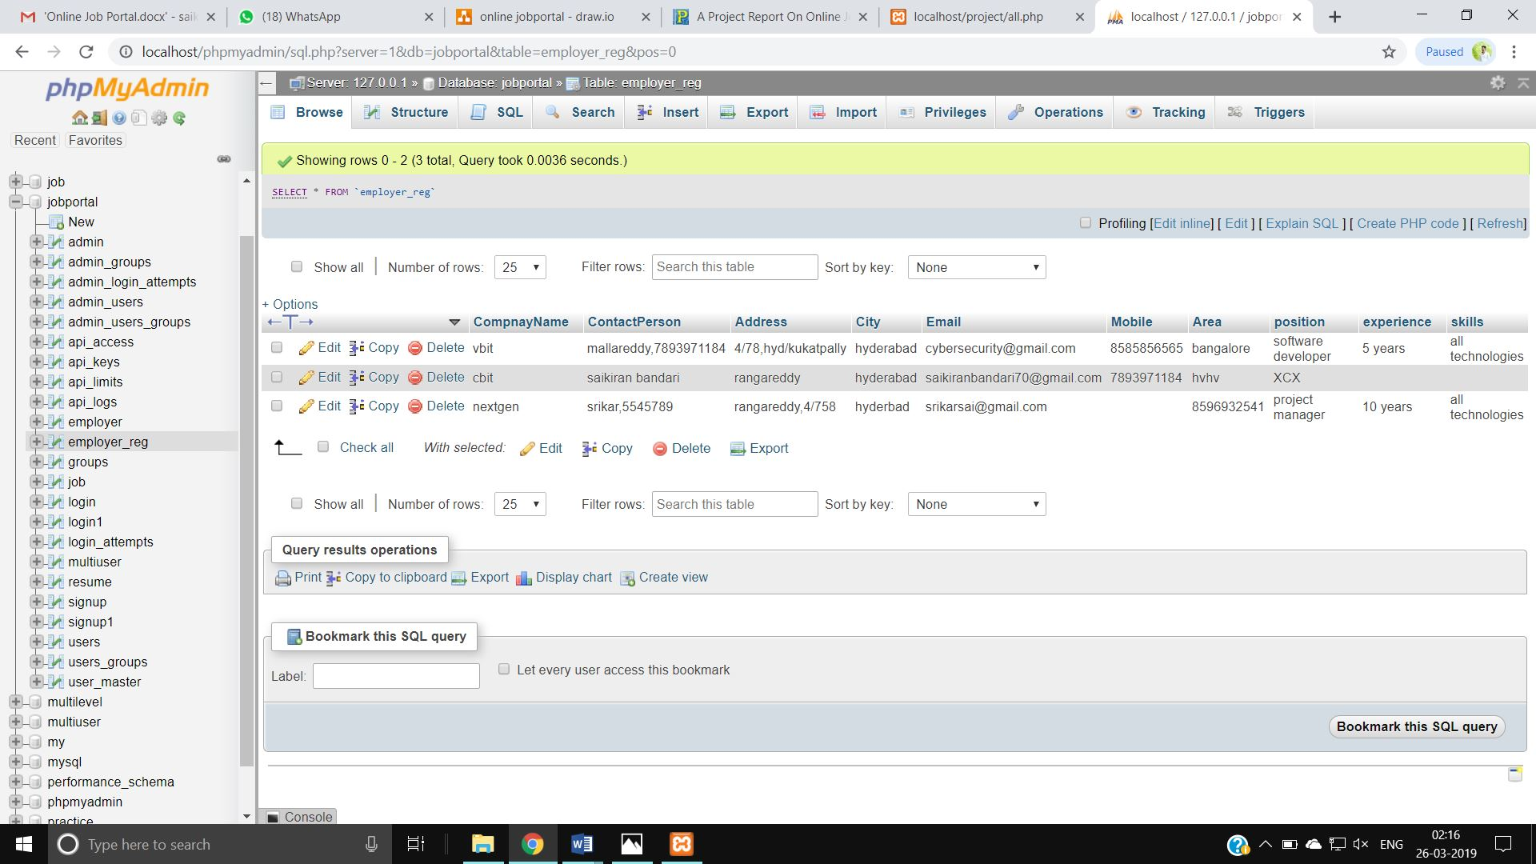
Figure T.3

OUTPUT DESIGN
Jobseeker apply Report:

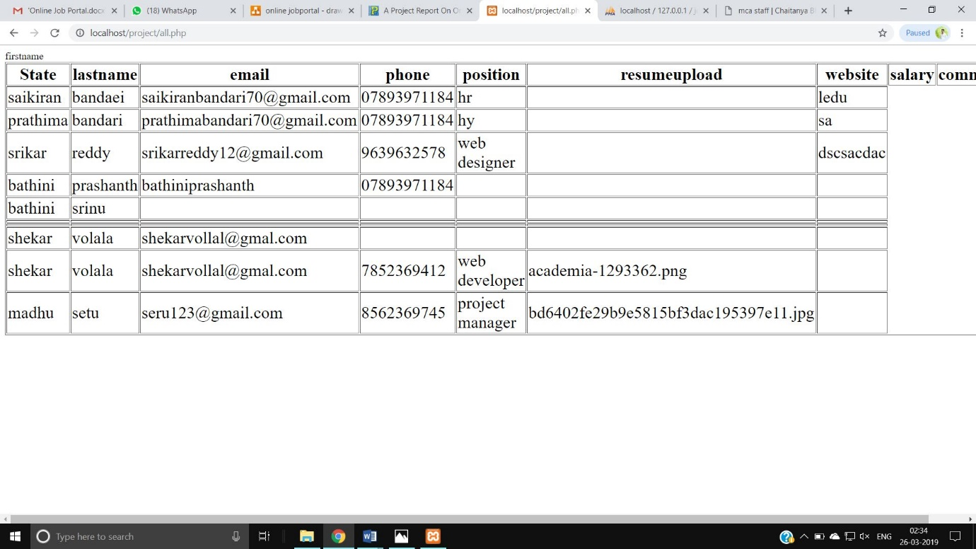
Figure T.4
• This is report for Jobseeker page.

Employer Report:

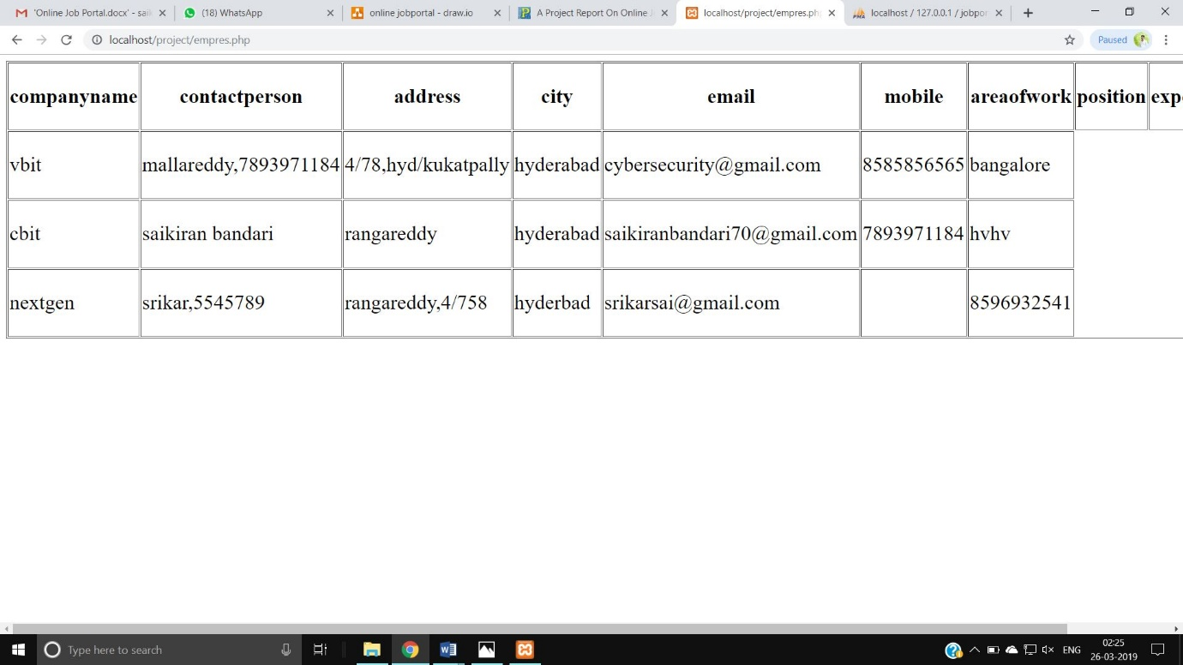
Figure T.5

• This is report for add job page.

5. Conclusion & Future Scope:
This system has been developed succefully incorporate all the requirements. Appropriate care has taken during database design maintain database integrity and to avoid redundancy of data.
This project was intended to help tackle the unemployment issues among the youth in Niegerian by means of providing an Online Recruitment Portal.The findings from the pilot study show that there is a demand for such a system to be implemented in Nigerian.
This site was developed in such a way that any further modifications needed can be easily done.

