A Mini Project Report on

**ONLINE JOB PORTAL**

Submitted in partial fulfilment of the requirements for

the IV semester class work

in

**MASTER OF COMPUTER APPLICATIONS**

by

**B.SAIKIRAN**

(1601-17-862-036)

Under the supervision of

**B.Srinivas S.P.Kumar**

**Asst.proff**

MCA Department



**DEPARTMENT OF COMPUTER SCIENCE & ENGINEERING**

**CHAITANYA BHARATHI INSTITUTE OF TECHNOLOGY (A)**

**(AFFILIATED TO OSMANIA UNIVERSITY)**

**GANDIPET, HYDERABAD – 500075**

**2017-2020**

**CERTIFICATE**

This is to certify that the mini project work entitled **“Online job portal System”** is a bonafide work carried out by **B.saikiran** bearing roll number **160116862036** of MCA IV semester in Chaitanya Bharati Institute of Technology(Autonomous) during the academic year 2018-2019.

PROJECT GUIDE PROJECT IN-CHARGE

**DECLARATION**

The project report entitled “ONLINE JOB PORTAL” has been done by me. The matter embodied in this project work has not been submitted earlier for any degree or diploma to the best of my knowledge and belief.

Signature of the student

Student: (Name: _____________

Roll no :____________)

**4. Acknowledgement**

The success and outcome of this project required a lot of guidance and assistance from many people and I am extremely privileged to have got this all along the completion of my project. All that I have done is only due to such supervision and assistance and I would not forget to thank them.

I respect and thank **Dr. D L Sreenivasa Reddy**, **Head of the Department**, **MCA**, for providing me an opportunity to do the project work and for being a constant source of motivation and encouragement, which made me complete the project duly.

I sincerely thank my project in charge, who is also my project guide **Sri D. Jayaram**, **Associate Professor, Department of MCA** for his inputs, suggestions and timely support, which helped me finish my project on time, he also took keen interest on the project work and guided me all along, till the completion of the project work by providing all the necessary information.

I would not forget to remember all rest of the faculty members of the **Department of MCA**, **Sri** **M. Kalidas, Sri P. Krishna Prasad, Sri M. Ramchander, Sri Ramesh Ponnala, Sri G.N.R Prasad Sri Gowrinath, Dr Indira.** Their subject knowledge and teaching methods helped me understand complex topics which in turn helped me in successfully completing this project work.

Also, I would like to extend my sincere thanks to all staff in laboratory for their timely support.

B.saikiran

MCA 2/3 IV Semester

160117862036

**ABSTRACT**

Job portal is developed for creating an interactive job vacancy Portal for candidates.  
This web application is to be conceived in its current form as a dynamic site-requiring constant updates both from the seekers as well as the companies.

The objective of the project is to enable jobseekers to place their resumes and find appropriate jobs while companies to publish their vacancies and find good candidates.

It enables jobseekers to post their resume, search for jobs, view personal job listings.

It will provide various companies to place their vacancy profile on the site and also have an option to search candidate resumes.

Apart from job-seekers and Companies(Job Provider) there will be an admin module to manage complete Portal as well as jobseeker and companies.

**Index**

**Contents Page No.**

Abstract v

List of Figures vi

List of Tables vi

1. Introduction 1
   1. Aim of the Project 1
   2. Scope of the Project 1
   3. Definitions, Acronyms 1
2. System Analysis 5
   1. Existing System 5
   2. Problem Statement 5
   3. Proposed System 5
   4. System Requirements 5
      1. Software Requirements 5
      2. Hardware Requirements 6
3. System Design 7
4. System Implementation & Testing 8
5. Conclusion & Future Scope 25

References

**List of Figures:**

|  |  |  |  |
| --- | --- | --- | --- |
| **S.no** | **Figure name** | **Fig no** | **Page no** |
| 1 | User Home page | 1.1 | 13 |
| 2 | About Us page | 1.2 | 14 |
| 3 | Contact us page | 1.3 | 15 |
| 4 | Registration page | 1.4 | 16 |
| 5 | Login page | 1.5 | 17 |
| 6 | Employer Page | 1.6 | 18 |
| 7 | Job Seeker page | 1.7 | 19 |
| 8 | Company Vacancies Page | 1.8 | 20 |
| 9 | Jobseeker Apply Page | 1.9 | 21 |
| 10 | Confirm Page | 1.0 | 22 |
| 11 | Employer Page | 2.0 | 23 |

**List of Tables:**

|  |  |  |  |
| --- | --- | --- | --- |
| **S.no** | **Table Name** | **Table number** | **Page** |
| 1 | Signup | T.1 | 25 |
| **2** | JobSeeker Reg | T.2 | 26 |
| **3** | Employer post job | T.3 | 27 |
| **4** | Jobseeker apply Report: | T.4 | 28 |
| **5** | Employer report | T.5 | 29 |

**1. INTRODUCTION**

* 1. **Aim of the Project:**

The main objective of this project is to represent the professional experience and accomplishments of the user in a visual scale. This is just a way to let your work talk for you.

**1.2** **Scope of the Project:**

To serve the emerging marketing and trending, visual scale usage requirements of clients, providing them with easy maintenance of their skillsets and an easy creation of their very own portfolios as in they like. It just provides that terrific additional depth that you can’t really put on a CV, it would give more of an insight into the individual and their background. So it’s a more personalized kind of an approach. It brings the person to life, that in itself would say a lot about candidates.

**1.3** **Definitions, Acronyms:**

1.3.1 JAVA:

Java is a general-purpose computer **programming language** that is concurrent, class-based, object-oriented, and specifically designed to have as few implementation dependencies as possible. It is intended to let application developers **“write once, run anywhere” (WORA)**, meaning that compiled Java code can run on all platforms that support Java without the need for recompilation.

1.3.2. MYSQL:

MySQL is a flexible and capable RDBMS that has a rich feature set, performs well on the majority of queries, and has a large support base for access from many different languages. MySQL released its 5.0 database which added such enterprise features as triggers, stored procedures and constraints to its Open Source database engines.

MySQL supports GUI Toolkits for DB Administration, Designs, Migration, and Query.

* PORTABILITY: MySQL runs on almost every flavor of UNIX, as well as Windows and MacOS X. You can obtain binaries or source code for the MySQL server as well as the tools that access it. More ports of the software become available every day. It is almost a given that MySQL will run on whatever operating system you have available.
* SPEED: Using techniques such as efficient indexing mechanisms, in memory temporary tables, and highly optimized join algorithms, MySQL executes most queries much faster than most other database systems.
* SCALABILITY: Because of its modularity and its flexibility in configuration, MySQL can run in systems varying in size from embedded systems to large multiprocessor UNIX servers hosting databases with tens of millions of records. This scalability also allows you to run a copy of MySQL on a developer-class machine, and later use the same database system on a larger machine in production. Because it is multithreaded, MySQL efficiently utilizes resources for multiple users, compared to other database servers that start full-fledged processes for each user. It is not uncommon to hear of MySQL installations supporting thousands of concurrent users.

1.3.3 Spring Boot:

Spring Boot aims to make it easy to create Spring-powered, production-grade applications and services with minimum fuss. It takes an opinionated view of the Spring platform so that new and existing users can quickly get to the bits they need. You can use it to create stand-alone Java applications.

The primary goals of Spring Boot are:

* To provide a radically faster and widely accessible ‘getting started’ experience for all Spring development
* To be opinionated out of the box, but get out of the way quickly as requirements start to diverge from the defaults
* To provide a range of non-functional features that are common to large classes of projects (e.g. embedded servers, security, metrics, health checks, externalized configuration)

Spring Boot does *not* generate code and there is absolutely **no** requirement for XML configuration.

1.3.4. HTML:

Hyper Text Markup Language, commonly referred to as HTML, is the standard markup language used to create web pages. Hypertext systems were envisioned as early as 1940 by Vannevar Bush and have a rich history. Tim Berners-Lee and Robert Caillau at CERN, in 1989-1990 developed HTML as a simplification of SGML and CERN launched the web in 1991 (HTML+HTTP).

1.3.5. CSS

A cascading style sheet (CSS) contains style rules that are applied to elements in a Web page. CSS styles define how elements are displayed and where they are positioned on the page. Instead of assigning attributes to each element on your page individually, you can create a general rule that applies attributes whenever a Web browser encounters an instance of an element or an element that is assigned to a certain style class.

Cascading Style Sheets (CSS) is a style sheet language used for describing the look and formatting of a document written in a markup language. While most often used to change the style of web pages and user interfaces written in HTML and XHTML, the language can be applied to any kind of XML document, including plain XML, SVG and XUL. Along with HTML and JavaScript, CSS is a cornerstone technology used by most websites to create visually engaging web pages, user interfaces for web applications, and user interfaces for many mobile applications.

1.3.6. JavaScript:

JavaScript often abbreviated as **JS**, is a high-level, interpreted programming language that conforms to the ECMAScript specification. It is a programming language that is characterized as dynamic, weakly typed, prototype-based and multi-paradigm.

Alongside HTML and CSS, JavaScript is one of the core technologies of the World Wide Web.[[9]](https://en.wikipedia.org/wiki/JavaScript#cite_note-9) JavaScript enables interactive web pages and is an essential part of web applications. The vast majority of websites use it, and major web browsers have a dedicated JavaScript engine to execute it

1.3.7.NodeJS:

**Node.js** is an open-source, cross-platform JavaScript run-time environment that executes JavaScript code outside of a browser. JavaScript is used primarily for client-side scripting, in which scripts written in JavaScript are embedded in a webpage's HTML and run client-side by a JavaScript engine in the user's web browser. Node.js lets developers use JavaScript to write command line tools and for server-side scripting—running scripts server-side to produce dynamic web page content *before* the page is sent to the user's web browser. Consequently, Node.js represents a "JavaScript everywhere" paradigm,[[7]](https://en.wikipedia.org/wiki/Node.js#cite_note-7) unifying web application development around a single programming language, rather than different languages for server side and client side scripts.

1.3.8.Angular:

Angular is a Typescript-based open-source web application framework led by the Angular Team at Google and by a community of individuals and corporations. Angular is a complete rewrite from the same team that built AngularJS. Originally, the rewrite of AngularJS was called "Angular 2" by the team, but this led to confusion among developers. To clarify, the team announced that separate terms should be used for each framework with "AngularJS" referring to the 1.X versions and "Angular" without the "JS" referring to versions 2 and up.

**Angular is a structural framework** for dynamic web apps. With Angular, designers can use HTML as the template language and it allows for the extension of HTML's syntax to convey the application's components effortlessly. Angular makes much of the code you would otherwise have to write completely redundant.

Despite the fact that Angular is commonly related to SPA, you can use Angular to build any kind of app, taking advantage of features like: **Two-way binding, templating, RESTful api handling, modularization, AJAX handling, dependency injection, etc.**

1.3.9.Docker:

**Docker** is a tool designed to make it easier to create, deploy, and run applications by using containers. Containers allow a developer to package up an application with all of the parts it needs, such as libraries and other dependencies, and ship it all out as one package.

1.4 Git:

**Git** is a distributed version-control system for tracking changes in source code during software development. It is designed for coordinating work among programmers, but it can be used to track changes in any set of files. Its goals include speed,data integrity,and support for distributed, non-linear workflows.

Git was created by Linus Torvalds in 2005 for development of the Linux kernel, with other kernel developers contributing to its initial development. Its current maintainer since 2005 is Junio Hamano.

As with most other distributed version-control systems, and unlike most client–server systems, every Git directory on every computer is a full-fledged repository with complete history and full version-tracking abilities, independent of network access or a central server.

Git is free and open-source software distributed under the terms of the GNU General Public License version 2.

**EXISTING SYSTEM**

**•** An existing system can provide manually paper work.

**•** The user has to go in the office where user can get the job and apply their job.

**•** In the existing system you cannot provide feedback of the user to the admin online.

**PROPOSED SYSTEM**

* This Job Portal website is providing to the online job portal system.
* This website can be also providing information about online job.
* The customer can get the online registration.
* The Job Portal web application can be used by any employee to apply job and any employer are post to job.

**MODULE SPECIFICATION**

**•** **JobSeeker :** It is a system design specially for large, premium and small car rental business. The user can view Available cars and user can book for that car.

**• companies** : The user can view Available companies and user can apply for that job.

**•JobSeeker Registration form**: From this registration form JobSeeker Apply For a job.

**•** **Employer :** The Employer can easily post the job and they can check the details about who are applied for their company.

**•** **View Properties:** The Employer can View all the available JobSeekers or the JobSeekers from the desired skills.

**SYSTEM FLOWCHART**

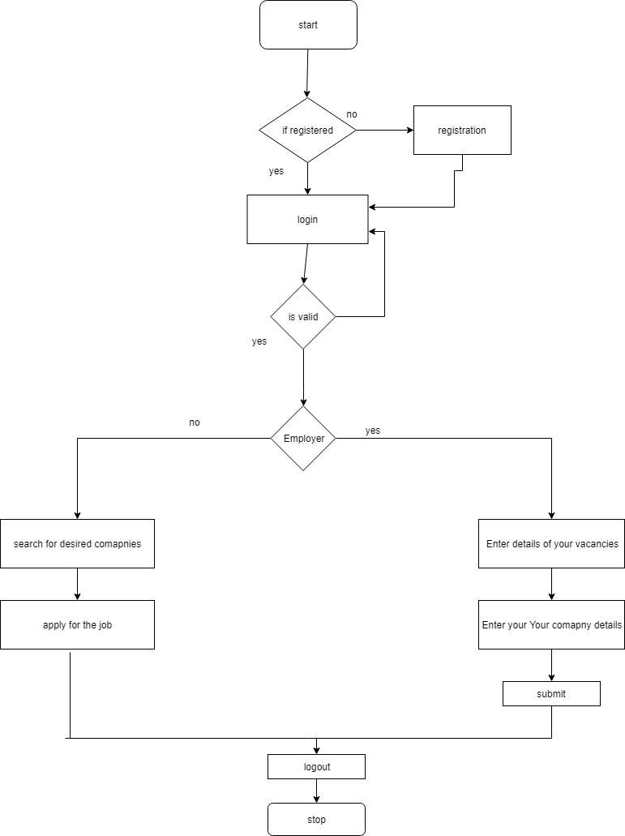

**Operating Environment**

**Server:**

**Processor:** intel xeon processor 3500 series

**HDD:** Minimum 500GB Disk Space

**RAM:** Minimum 16GB

**OS:** Windows 8.1, Linux

**Database:** SQL Server 2014

**Application:** XAMMP, phpmyadmin.

**Client:**

**Processor:** Intel Dual Core

**HDD:** Minimum 80GB Disk Space

**RAM:** Minimum 1GB

**OS:** Windows 7, Linux

**INPUT DESIGN**

**User Home page:**

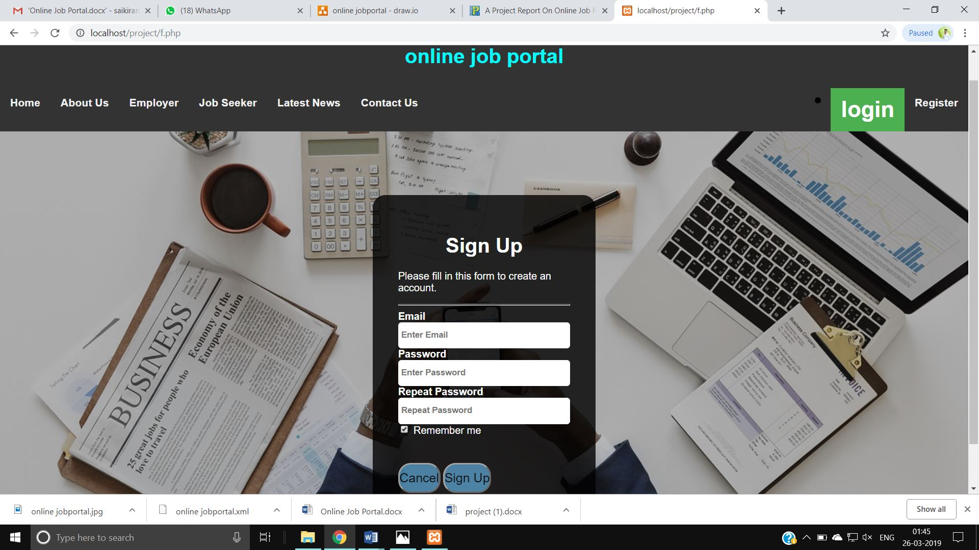

**•** This is home page for both JobSeeker and Employer.

**About Us page:**

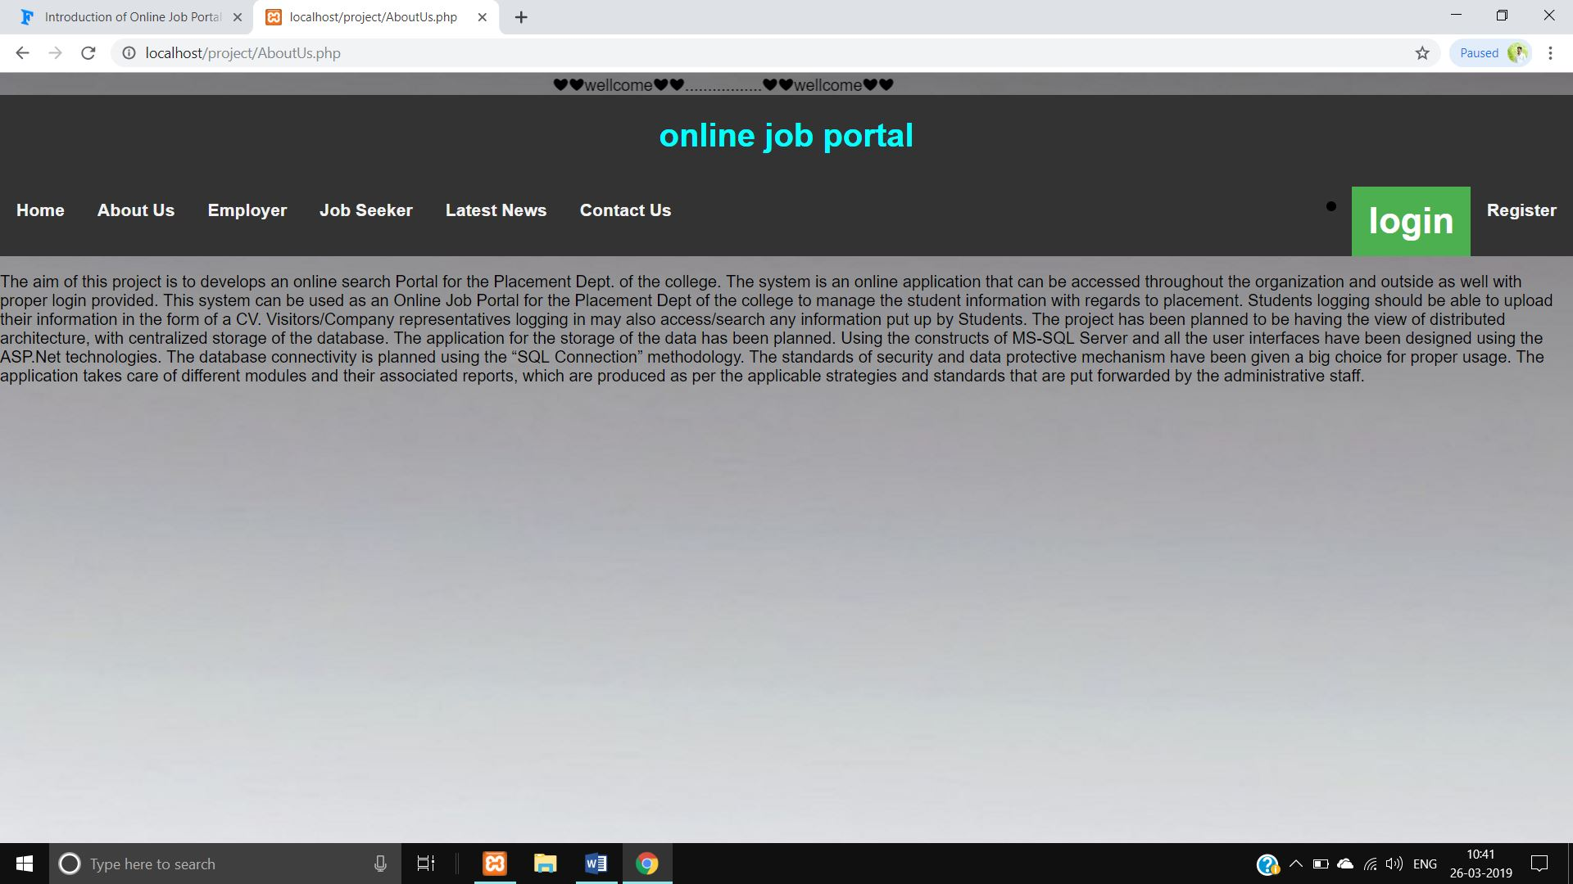

• This is About Us page of User.

**Contact us page:**

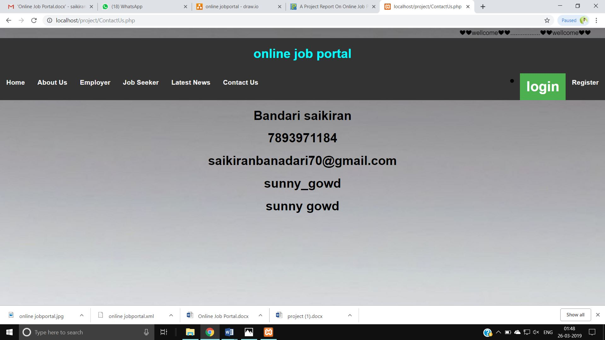

• This is Contactus page for User.

**Registration page:**

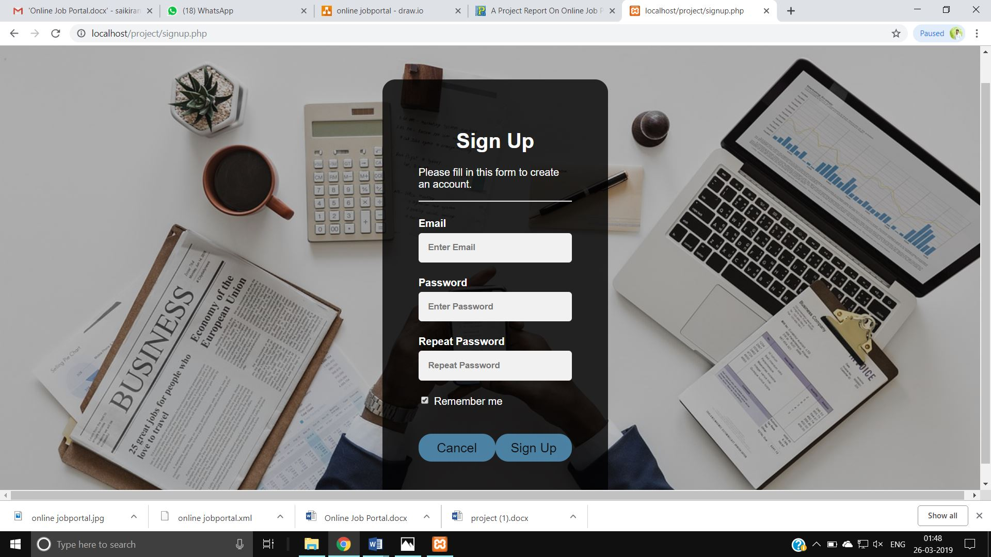

• This is page of User Registration.

**Login page:**

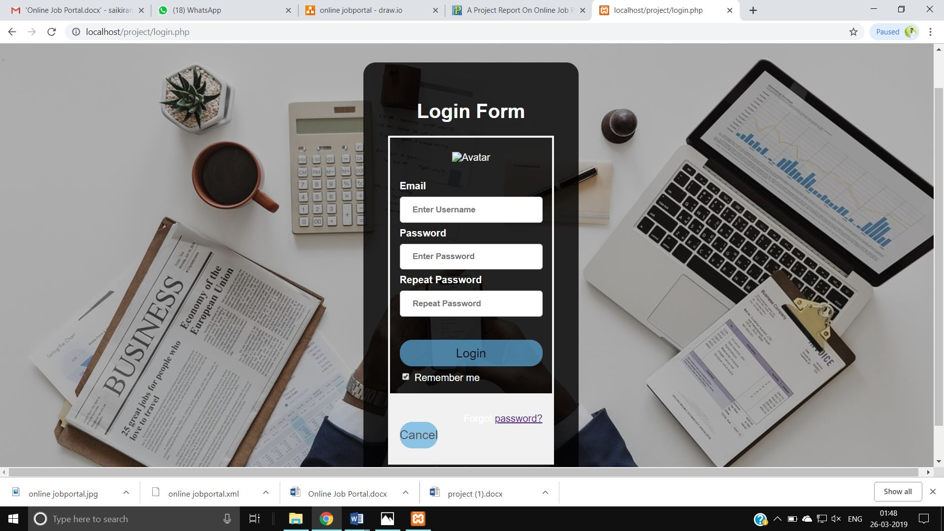

• This is Login page of User.

**About our Employer Companies page:**

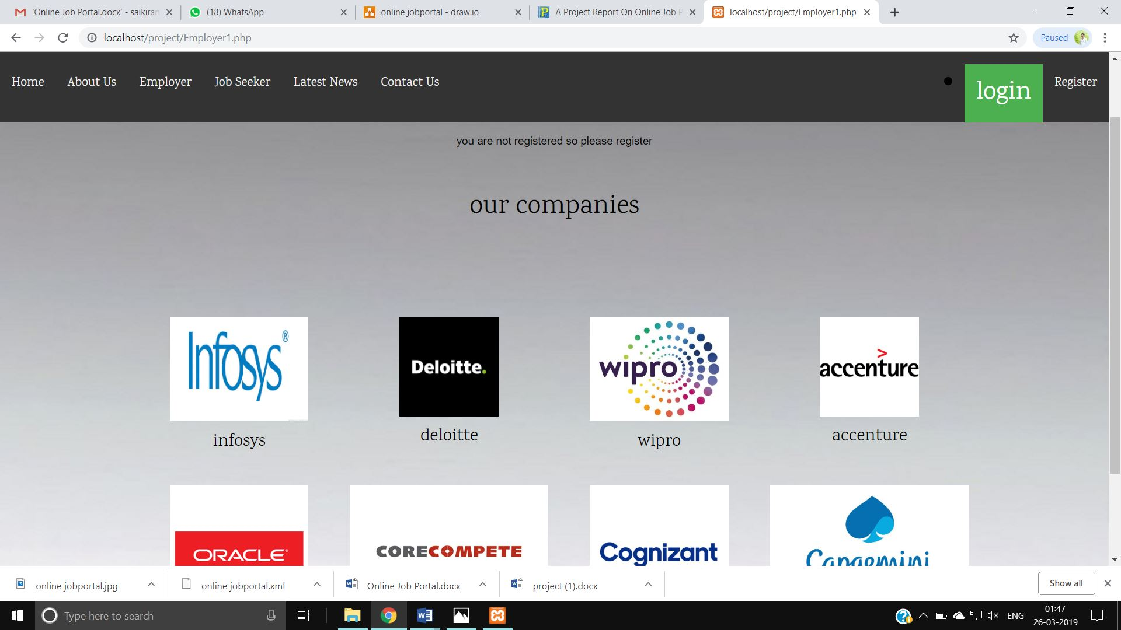

* Without login Employer page it shows our Employer.
* JobSeeker Page :

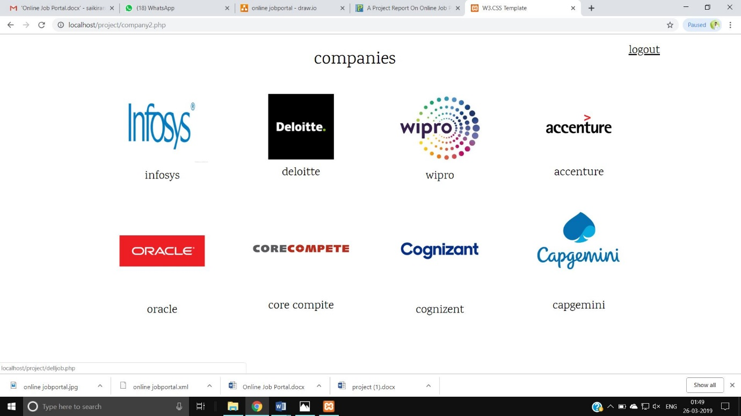

• This is JobSeeker page after login.

**Company Vacancies page for job seeker:**

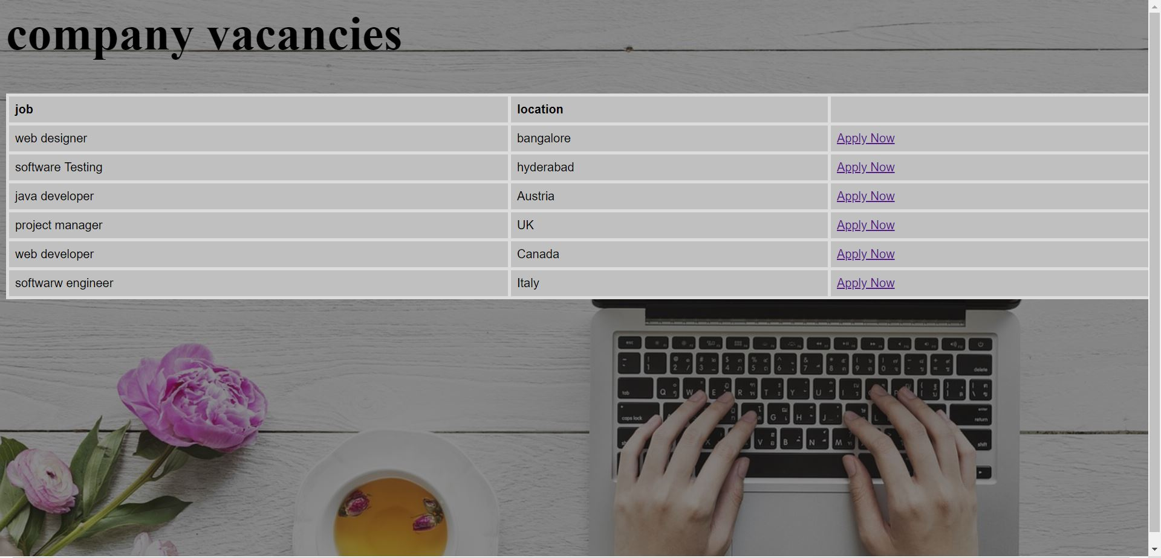

**JobSeeker Apply Form:**

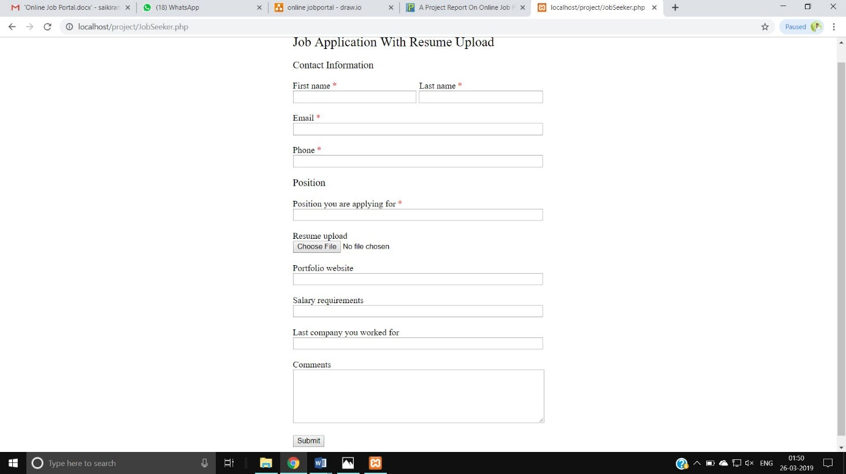

• This is Jobseeker application for job page .

**Confirm page:**

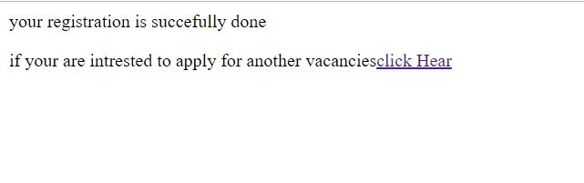

• This is confirm page of User.

* Employer Page:

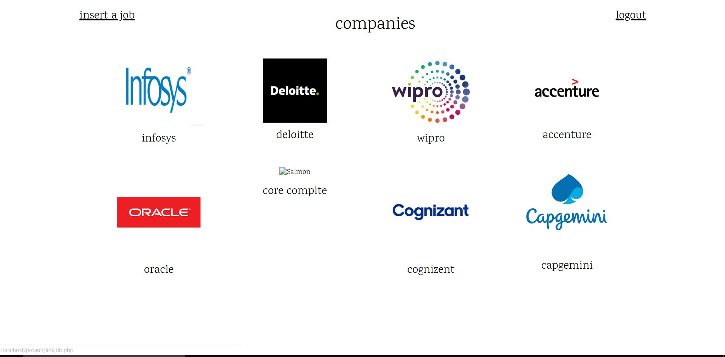

**List of Tables:**

* This saves the Details of The sign up users.

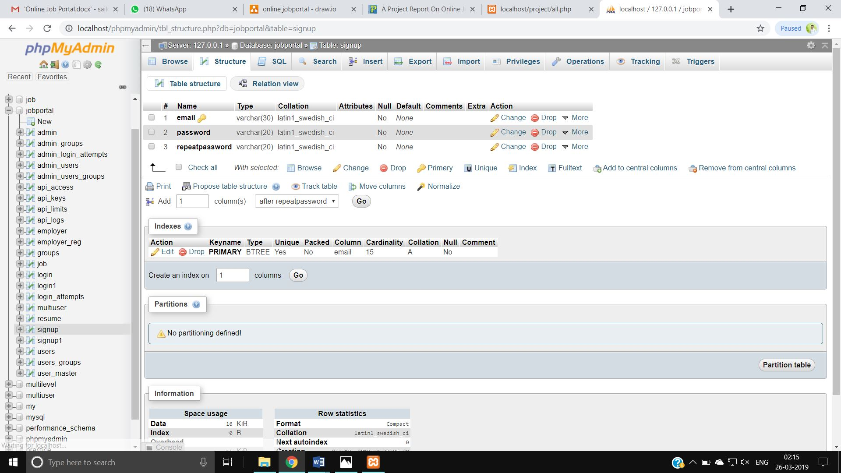

* **Jobseeker Registration Table:**

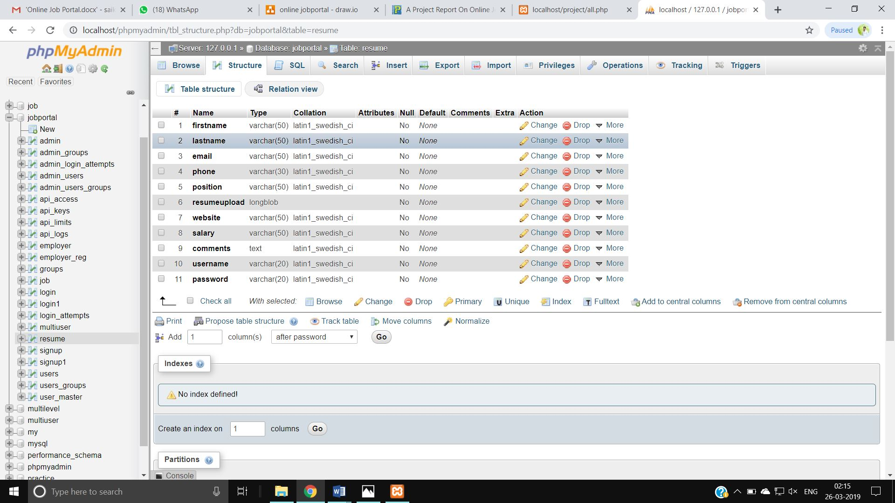

* **Employer Post a job form:**

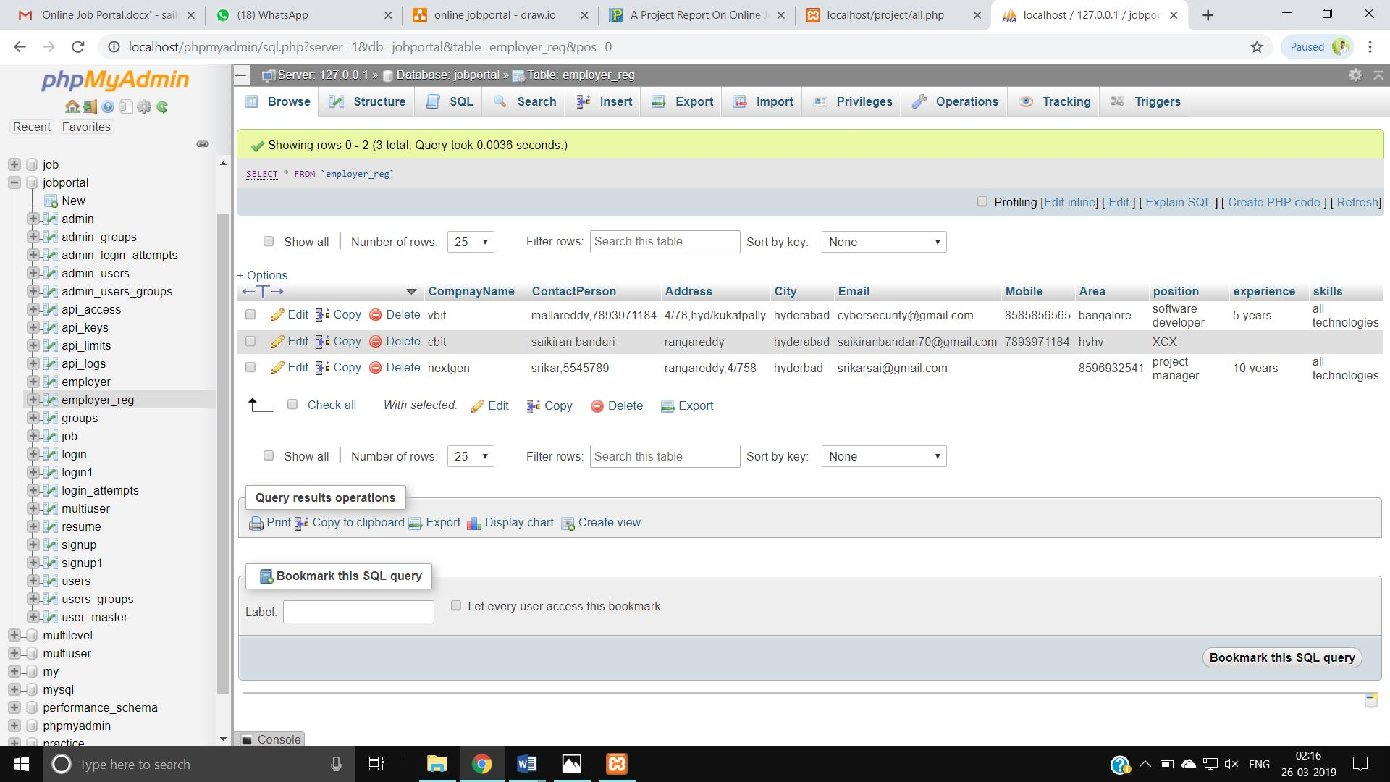

**OUTPUT DESIGN**

Jobseeker apply Report:

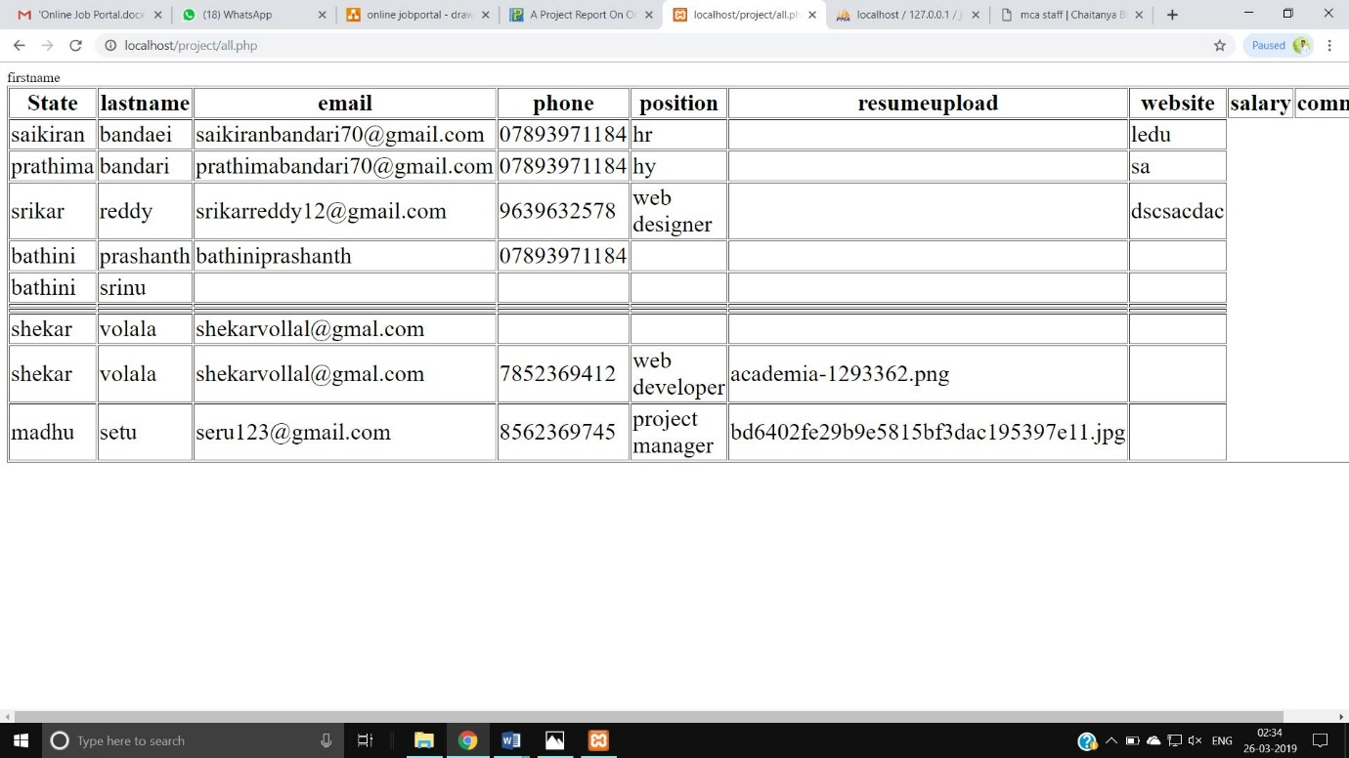

• This is report for Jobseeker page.

Employer Report:

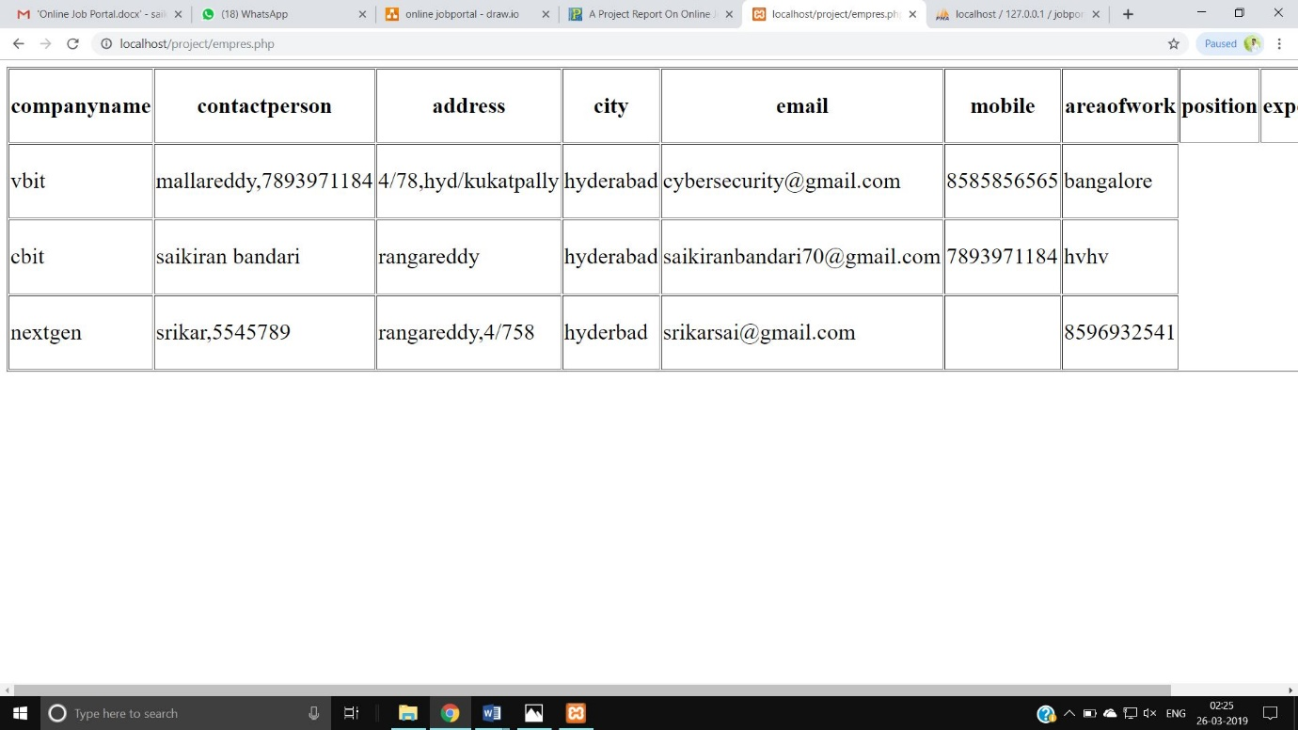

• This is report for add job page.

**POST IMPLEMENTATION**

• The website application is self –maintained.

• The project support already multiple Jobseekers,Employers .

• There is no need provide post implementation support.

• The admin can access add ,edit ,delete process.

**FUTURE ENHANCEMENT**

• Add various details about Jobseekers like ohoto etc.

• Add the current project for apply easy.

**ACKNOWLEDGEMENT**

The satisfaction that accompanies the successful completion of any tasks would be incomplete without the mention of the people who made it possible and encouragement and guidance has been a source of inspiration throughout the project.

## I express my deep sense of gratitude to our principal Dr. P. Ravinder Reddy, and also to my college committee members for giving their encouragement that helped me to complete the project successfully.

## I express my sincere gratitude to Dr D.L. Sreenivasa Reddy, Head of Department, MCA, for his valuable guidance during the mini project.

## I am grateful to Sri.Jayaram,Asst.proff, MCA my project incharge for his constant support and encouragement during the course of mini project.

## I am thankful to [Sri.B.Srinivas S.P.Kumar](http://cbit.ac.in/?q=node/698), Asst.proff my project guide for her constant support and valuable guidance in mini project.

## Finally, I express my sincere thanks to my parents and friends who supported and encouraged us in many ways for successful completion of the mini project.

## ABSTRACT

Job portal is developed for creating an interactive job vacancy Portal for candidates.  
This web application is to be conceived in its current form as a dynamic site-requiring constant updates both from the seekers as well as the companies.

The objective of the project is to enable jobseekers to place their resumes and find appropriate jobs while companies to publish their vacancies and find good candidates.

It enables jobseekers to post their resume, search for jobs, view personal job listings.

It will provide various companies to place their vacancy profile on the site and also have an option to search candidate resumes.

Apart from job-seekers and Companies(Job Provider) there will be an admin module to manage complete Portal as well as jobseeker and companies.

## INTRODUCTION

This Online Job Portal has been developed on php and MYSQL.The main objective for developing this project is to provide a online job search portal for employees about opportunities in different companies.it can manage job opportunities.This project provides a lot of features to manage all the data in very wll manner.This project contins a good modules which makes the back end system very powerful.

This project online job portal System is a web-based online system because it‘s easier to the Jobseekers to view the vacancies System has been provided company details, their vacancies and requirement details. Jobseekers can apply the job for the company wise and each company can see the appliers for their vacancies

## Functionalities Provided By Car Rental System Are As Follows:

## Provides the searching facilities based on various factors Such as job details etc

## Online job portal System also manage job details

## Editing adding and updating of Records is improved which results in proper resource management

## Manage the information of car history Integration of all records

**Report Generation**

* It generates the report on list of available Jobseekers.
* It also gives the repott on list of available userlist.