GPS-BASED FLEET TRACKING AND ROUTE VERIFICATION SYSTEM FOR MUNICIPAL SOLID WASTE MANAGEMENT
A Mini Project Report submitted as part of the academic requirements for the
23CS4219- Software Engineering Laboratory
BACHELOR OF TECHNOLOGY
IN
COMPUTER SCIENCE AND ENGINEERING

Submitted by
SAIKIRAN BORA (A24126510006)
Under the guidance of
Prof. A. Rohini,
Department of Computer Science and Engineering
DEPARTMENT OF COMPUTER SCIENCE AND ENGINEERING
ANIL NEERUKONDA INSTITUTE OF TECHNOLOGY AND SCIENCES (UGC AUTONOMOUS)
(Permanently Affiliated to AU, Approved by AICTE and Accredited by NBA & NAAC with 'A' Grade)
Sangivalasa, bheemili mandal, visakhapatnam dist.(A.P) 2026 - 2027

DEPARTMENT OF COMPUTER SCIENCE AND ENGINEERING
ANIL NEERUKONDA INSTITUTE OF TECHNOLOGY AND SCIENCES
(UGC AUTONOMOUS)
(Affiliated to AU, Approved by AICTE and Accredited by NBA & NAAC with 'A' Grade)
Sangivalasa, bheemili mandal, visakhapatnam dist.(A.P)
CERTIFICATE
This is to certify that the mini project entitled "________________________" has been successfully completed by the students of the Department of Computer Science and Engineering during the academic year 2026-2027 as part of the requirements for the 23CS4219-Software Engineering Laboratory.
Faculty Incharge | Head of the Department
Prof. A. Rohini | Prof. G. Srinivas

DEPARTMENT OF COMPUTER SCIENCE AND ENGINEERING
ANIL NEERUKONDA INSTITUTE OF TECHNOLOGY AND SCIENCES
(UGC AUTONOMOUS)
(Affiliated to AU, Approved by AICTE and Accredited by NBA & NAAC with 'A' Grade)
Sangivalasa, bheemili mandal, visakhapatnam dist.(A.P)
DECLARATION
I, SAIKIRAN BORA (Roll No: A24126510006), student of III Year, I Semester B.Tech., Section - A, in the Department of Computer Science and Engineering from Anil Neerukonda Institute of Technology and Sciences (Autonomous), Visakhapatnam, hereby declare that the mini project work entitled "GPS-BASED FLEET TRACKING AND ROUTE VERIFICATION SYSTEM FOR MUNICIPAL SOLID WASTE MANAGEMENT" is an authentic record of independent work carried out by me under the guidance of Prof. A. Rohini, Department of Computer Science and Engineering.
I further declare that this mini project report is submitted as part of the academic requirements for the 23CS4219 - Software Engineering Laboratory during the academic year 2026-2027, and that the results embodied in this report have not been submitted to any other Institute or University for the award of any degree or diploma.
SAIKIRAN BORA
Roll No: A24126510006
B.Tech. III Year, I Sem, Section - A
Dept. of CSE, ANITS

ABSTRACT
Municipal solid waste management in expanding urban sectors faces severe operational bottlenecks due to unmonitored paper-based collection schedules, unverified truck routes, fuel wastage, and delayed grievance redressal. While Internet-of-Things (IoT) hardware sensor systems have been proposed, their high procurement cost, frequent maintenance, battery exhaustion, and susceptibility to public theft/vandalism render them economically unviable for many municipal corporations. To overcome these critical barriers, this project implements a pure software-only solution: the GPS-Based Fleet Tracking and Route Verification System (CivicClean GIS).
The system completely eliminates custom in-bin hardware by utilizing commodity driver smartphones and modern web browsers. It delivers four core architectural modules: (1) an interactive real-time GIS fleet tracking map for sanitation supervisors powered by Leaflet and OpenStreetMap; (2) a mobile-responsive driver manifest featuring automated GPS geofence proximity matching, camera-based proof-of-service photo uploads, and structured skip-exception logging; (3) a public crowdsourced citizen reporting portal allowing residents to submit geotagged photos of overflowing bins and track grievance tickets in real time; and (4) a tamper-resistant proof-of-service audit trail that cross-references collection timestamps and location tolerances. Developed using a robust Node.js/Express REST backend and a responsive HTML5/CSS3/JavaScript frontend, the system was thoroughly evaluated across municipal test wards in Visakhapatnam. The validation results confirmed 100% route verifiability, sub-10-meter geofence precision, instant exception capture, and zero dedicated hardware expense, offering a scalable and accountable solution for modern urban sanitation governance.
Keywords: Municipal Solid Waste Management, GPS Fleet Tracking, Route Verification, Proof-of-Service, Geofencing, Citizen Grievance Redressal, Zero-Hardware Architecture.

TABLE OF CONTENTS
Certificate | ii
Declaration | iii
Abstract | iv
List of Figures | vi
List of Tables | vii
1. Introduction | 1
1.1 Background | 1
1.2 Problem Statement | 2
1.3 Motivation | 2
1.4 Objectives | 3
2. Existing System | 4
2.1 Overview of Current Manual Process | 4
2.2 Limitations of the Existing System | 5
3. Proposed System | 6
3.1 Software-Only Architecture (Solution 2) | 6
3.2 Key System Pillars | 7
3.3 Comparative Advantages | 8
4. Requirements Specification | 9
4.1 Functional Requirements | 9
4.2 Non-Functional Requirements | 10
5. Hardware and Software Requirements | 12
5.1 Hardware Environment | 12
5.2 Software Environment | 12
6. Data Flow Diagram | 14
6.1 Level 0 Context DFD | 14
6.2 Level 1 DFD | 15
6.3 Level 2 DFD (Proof-of-Service Decomposition) | 17
7. System Architecture | 19
7.1 3-Tier Client-Server Architecture | 19
7.2 Architectural Layer Analysis | 20
8. Module Description | 22
8.1 Supervisor Command Hub & GIS Fleet Tracking | 22
8.2 Driver Mobile Field Manifest & Geofencing | 23
8.3 Proof-of-Service Verification & Tamper-Resistant Audit | 24
8.4 Citizen Grievance Redressal & Hotspot Triage | 25
9. System Analysis | 26
9.1 Use Case Diagram | 26
9.2 Use Case Specifications | 27
10. UML Design | 30
10.1 Class Diagram | 30
10.2 Sequence Diagram | 32
10.3 Activity Diagram | 34
10.4 State Diagram | 36
10.5 Component Diagram | 38
10.6 Deployment Diagram | 40
11. Testing | 42
11.1 Test Plan & Methodology | 42
11.2 System Test Cases Execution Matrix | 43
12. Results / Screenshots | 46
12.1 Home Page & Portal Switcher | 46
12.2 Role-Based Authentication Interface | 47
12.3 Supervisor Live GIS Fleet Map | 48
12.4 Driver Mobile Field Manifest & Proof Upload | 49
12.5 Citizen Grievance Portal & Live Ticket Tracker | 50
12.6 Proof-of-Service Audit Trail | 51
12.7 Fleet Waste Clearance Analytics Report | 52
13. Limitations | 53
14. Conclusion | 54
15. References | 55
Appendix | 56
Appendix A: System User Manual | 56
Appendix B: REST API Payloads & Data Schemas | 57
Appendix C: Project Book Spiral Binding Guidelines | 58

LIST OF FIGURES
Figure 6.1 | Level 0 Context Data Flow Diagram (DFD) | 14
Figure 6.2 | Level 1 Data Flow Diagram (DFD) | 16
Figure 6.3 | Level 2 DFD (Process 3.0 Proof-of-Service Decomposition) | 18
Figure 7.1 | 3-Tier System Architecture Diagram | 20
Figure 9.1 | System Use Case Diagram | 26
Figure 10.1 | UML Class Diagram | 31
Figure 10.2 | UML Sequence Diagram (Proof-of-Service Verification) | 33
Figure 10.3 | UML Activity Diagram (Driver Daily Collection Workflow) | 35
Figure 10.4 | UML State Diagram (Stop Checkpoint Lifecycle) | 37
Figure 10.5 | UML Component Diagram | 39
Figure 10.6 | UML Deployment Diagram | 41
Figure 12.1 | Application Home Page & Portal Switcher View | 46
Figure 12.2 | Role-Based User Authentication Interface | 47
Figure 12.3 | Supervisor Live GIS Fleet Tracking Dashboard | 48
Figure 12.4 | Driver Mobile Field Manifest & Proof Upload Interface | 49
Figure 12.5 | Citizen Grievance Submission Portal & Live Ticket Tracker | 50
Figure 12.6 | Proof-of-Service Tamper-Resistant Audit Trail | 51
Figure 12.7 | Fleet Waste Clearance Analytics & Performance Report | 52

LIST OF TABLES
Table 4.1 | Non-Functional Requirements Specification | 11
Table 5.1 | Hardware Environment Specifications | 13
Table 5.2 | Software Environment Specifications | 13
Table 9.1 | Use Case Specification: UC1 View Assigned Route Manifest | 27
Table 9.2 | Use Case Specification: UC3 Mark Stop Collected with Proof | 28
Table 9.3 | Use Case Specification: UC5 Report Waste Hotspot | 29
Table 11.1 | System Test Cases Matrix & Validation Results | 44

1. Introduction
1.1 Background
Rapid urbanization, industrial expansion, and population growth across metropolitan and tier-2 Indian cities - such as Greater Visakhapatnam - have generated unprecedented quantities of municipal solid waste (MSW). Managing the daily collection, transportation, and safe disposal of solid waste represents one of the most resource-intensive and logistically challenging operations undertaken by municipal corporations. In a typical urban sector, hundreds of metric tons of domestic, commercial, and institutional waste must be cleared daily across dense residential wards, market yards, commercial districts, and peripheral coastal settlements. Efficient waste logistics directly determine civic public health, environmental hygiene, air and water quality, and resident satisfaction.
Historically, municipal solid waste management has relied almost exclusively on static, historically inherited route sheets and manual supervisory oversight. In this conventional paradigm, collection trucks are dispatched according to fixed calendar schedules without real-time knowledge of bin fill levels or driver route completion. When vehicles break down, face roadblocks, or skip designated neighborhood bins, supervisors have no mechanism to detect these anomalies until residents register formal complaints. Consequently, urban centers frequently suffer from overflowing secondary collection bins, roadside littering, severe traffic congestion caused by unoptimized truck schedules, and substantial diesel fuel waste resulting from trucks visiting low-volume sectors. Developing an automated, verifiable, and transparent software solution is therefore an imperative need for modern smart city governance.
1.2 Problem Statement
The prevailing municipal waste collection tracking mechanisms suffer from critical operational deficiencies, leading to widespread service failures. Specifically, the problem encompasses the following core challenges:
- Absence of Route Verifiability: Truck drivers follow informal or paper-based route manifests. Supervisors have no verifiable digital proof (such as GPS trail logs or geotagged timestamps) to ascertain whether a driver actually visited a scheduled checkpoint or skipped it.
- Reactive Complaint Handling: Municipal authorities operate reactively, discovering missed pickups only after days of resident agitation via informal phone calls that lack tracking numbers or escalation workflows.
- Inefficient Fleet Resource Allocation: Static routes cause collection vehicles to travel fixed kilometers regardless of actual waste volume, leading to excessive fuel expenditure, vehicle wear-and-tear, and avoidable carbon emissions.
- Lack of Structured Exception Logging: When drivers encounter valid physical obstructions - such as road excavations, water-logging, or inaccessible narrow lanes - there is no mobile tool to record the justification, leaving supervisors unable to distinguish between genuine operational impediments and driver negligence.
1.3 Motivation
In recent academic literature and smart-city pilot projects, various Internet-of-Things (IoT) architectures have been proposed that install ultrasonic level sensors and wireless transmission modules (such as LoRaWAN or NB-IoT) inside public bins. However, rigorous field analysis reveals that hardware-intensive sensor deployments suffer from severe practical constraints in Indian municipal environments:
- Prohibitive Capital & Maintenance Expenditure: Procuring, waterproofing, and maintaining thousands of battery-powered electronic sensors across harsh outdoor bin environments is financially unsustainable for municipal bodies operating under tight budgets.
- Vandalism and Theft Vulnerability: Public waste bins located on thoroughfares and market junctions are heavily prone to physical vandalism, accidental compaction damage by heavy garbage lifting arms, and sensor theft.
- Battery Exhaustion and Harsh Environmental Wear: Exposure to extreme heat, monsoon moisture, corrosive leachate fluids, and toxic fumes causes rapid sensor degradation and erratic telemetry.
These realities motivated the formulation of Solution 2: a pure software-only, zero-hardware deployment model. By leveraging commodity smartphones already possessed by drivers and citizens, along with modern web GIS mapping and browser APIs, the entire waste tracking and verification lifecycle can be automated at a fraction of the cost, achieving 100% service accountability without installing a single physical sensor in public bins.
1.4 Objectives
The primary objective of this project is to design, develop, and evaluate a comprehensive web-based GPS Fleet Tracking and Route Verification System (CivicClean GIS) for municipal solid waste management. Specific technical objectives include:
- Automate Fleet Tracking: Provide an interactive, real-time GIS map interface for sanitation supervisors to track vehicle coordinates, operational speed, and route trajectories using Leaflet and OpenStreetMap.
- Implement Digital Proof-of-Service: Develop a mobile-friendly driver manifest that validates checkpoint proximity via automated GPS geofencing, captures camera-based photo proof, and records immutable digital timestamps.
- Standardize Exception & Skip Logging: Provide structured mobile workflows allowing drivers to log valid operational obstructions (e.g., road repairs, impassable lanes) with photographic evidence and supervisory flagging.
- Empower Citizens via Crowdsourced Hotspot Reporting: Deploy an accessible public grievance portal where residents can report overflowing bins with device GPS pin-drops and track clearance progress via unique ticket IDs.
- Generate Operational Performance Analytics: Equip municipal administrators with comprehensive audit trails, ward-wise collection summaries, and route efficiency metrics to guide long-term urban policy.

2. Existing System
2.1 Overview of Current Manual Process
In the conventional municipal sanitation framework currently operational across most municipal wards, daily waste collection is managed through legacy manual methods. Every morning, drivers and ground sanitation crew assemble at the central zonal depot where supervisors verbally issue route instructions or hand over paper log sheets indicating the designated ward sector (e.g., Ward 1 Sangivalasa, Ward 2 Bheemili Coastal). The collection truck - typically a 2.5-ton tipper or 4-ton hydraulic compactor - departs the depot and follows historically established roadways.
Throughout the shift, drivers stop at public bin locations, where manual helpers shovel waste into the compactor. The driver notes completed stops on paper log sheets. If a road is impassable due to construction or traffic congestion, the driver simply bypasses the bin without any official recording. Upon shift completion, the vehicle dumps its load at the designated municipal landfill or transfer station, and the driver hands the handwritten log sheet back to the supervisor. Verification of whether each individual bin was actually emptied is entirely absent.
2.2 Limitations of the Existing System
The manual, paper-based workflow suffers from critical structural vulnerabilities that compromise civic hygiene and administrative integrity:
- Total Lack of Real-Time Operational Visibility: Supervisors stationed at municipal headquarters remain completely blind to vehicle whereabouts during the 8-hour shift. If a driver deviates from the planned route, idles excessively, or finishes early, no automated alert is generated.
- Pervasive Unverified Service Claims: Paper log sheets are inherently vulnerable to post-shift fabrication and falsification. Drivers can mark bins as 'cleared' even if they were bypassed, leading to uncollected garbage festering for days without management awareness.
- Delayed Citizen Grievance Resolution Loop: Residents experiencing overflowing bins must physically visit municipal ward offices or dial general helpline numbers. Complaints are recorded in physical registers, rarely correlated with active truck locations, and take days to reach field crew.
- Inability to Identify Recurring Road Obstructions: Because skipped stops are not digitally logged with categorized justifications, municipal engineers cannot identify recurring infrastructure issues - such as chronic illegal parking or prolonged pipeline trenching - that prevent waste clearance.
- Absence of Empirical Data for Route Planning: Without digital historical archives of pickup timestamps, route durations, and clearance volumes, urban planners cannot optimize collection schedules or balance vehicular workloads scientifically.

3. Proposed System
3.1 Software-Only Architecture (Solution 2)
To decisively overcome the limitations of the existing manual system while avoiding the prohibitive financial and logistical pitfalls of IoT hardware sensors, this project implements Solution 2: The GPS-Based Fleet Tracking and Route Verification System (CivicClean GIS). This system operates on a pure software-only paradigm, utilizing standard web protocols, commodity smartphones, and client-side geolocation APIs.
Rather than installing dedicated microcontroller devices, cellular SIM modems, and ultrasonic sensors inside public bins, the system leverages the driver's smartphone as an intelligent edge sensor. The smartphone's integrated GPS receiver continuously transmits coordinates over cellular data networks to the municipal cloud server, while the built-in camera captures timestamped proof-of-service imagery upon collection. Concurrently, citizens use their own mobile devices to crowdsource hotspot reports, effectively replacing static hardware sensors with dynamic community monitoring.
3.2 Key System Pillars
- GIS Real-Time Fleet Tracking & Telemetry: Sanitation supervisors monitor an interactive Leaflet/OpenStreetMap dashboard displaying live truck markers, color-coded route polylines, current travel speeds, and checkpoint status updates without requiring proprietary mapping API licenses.
- Geofence-Enforced Proof-of-Service: When a collection truck arrives at a scheduled bin checkpoint, the system computes the Haversine distance between the vehicle's live GPS coordinates and the pre-registered bin coordinates. Only when the driver is within an allowable proximity radius (e.g., <= 15 meters) does the app enable the 'Mark Collected' workflow, prompting a geotagged photo capture.
- Structured Skip-Exception Management: If a stop cannot be accessed due to physical barriers, the driver selects from standardized skip categories (e.g., road excavation, vehicle obstruction, hazardous waste) and inputs explanatory remarks. This immediately alerts supervisors and flags the checkpoint in red on the master GIS map.
- Crowdsourced Citizen Grievance Portal: Residents report waste accumulation by taking a photo, dropping a GPS pin on the municipal ward map, and selecting issue categories. The system automatically creates a trackable ticket (e.g., #CMP-2026-104) and dispatches nearby trucks.
- Tamper-Resistant Audit Trail: All collection events, skipped stops, and citizen tickets are immutably logged with precise timestamps, vehicle IDs, GPS accuracy tolerances, and verification hashes, providing audit-ready records for municipal administrative review.
3.3 Comparative Advantages
The proposed software-only solution offers substantial qualitative and quantitative advantages over both legacy manual processes and IoT sensor networks:
- Zero Dedicated Hardware Capital Outlay: Eliminates all expenditures associated with purchasing, installing, calibrating, and battery-servicing thousands of in-bin electronic sensors.
- Zero Vandalism & Theft Risk: Because all sensing resides securely on the driver's phone and citizen devices, municipal property in public thoroughfares is completely immune to physical destruction or theft.
- Immediate Rapid Scalability: Expanding the system to cover new wards, suburban colonies, or additional municipal vehicles requires merely entering route coordinates into the web portal; zero physical infrastructure deployment is needed.
- Comprehensive Accountability & Transparency: Establishes a closed digital feedback loop connecting all four civic stakeholders: residents, collection drivers, sanitation supervisors, and urban administrators.

4. Requirements Specification
4.1 Functional Requirements
Functional requirements define the core capabilities, operations, and services that the CivicClean system must provide to its authorized user roles:
- FR1: User Authentication & Role-Based Access Control: The system shall authenticate municipal supervisors, field drivers, and citizens, granting tailored dashboard permissions based on role privileges.
- FR2: Live GPS Telemetry Streaming: The driver client shall continuously acquire device latitude/longitude coordinates and stream them to the server at regular intervals (every 3 to 10 seconds during active routes).
- FR3: Interactive GIS Route & Fleet Display: The supervisor dashboard shall render vehicle positions, route paths, checkpoint markers, and citizen complaint pins on an interactive OpenStreetMap canvas with dynamic popup metadata.
- FR4: Geofence Validation & Proximity Matching: The system shall calculate the real-time distance between the truck and the target checkpoint, validating whether the vehicle is within the designated collection geofence threshold (15m).
- FR5: Digital Proof-of-Service Capture: The driver portal shall capture collection timestamps, estimated waste weight, and geotagged photographic proof, transitioning the stop status to 'Collected' upon validation.
- FR6: Structured Skip-Exception Logging: The system shall enable drivers to bypass inaccessible stops by recording mandatory skip categories, driver remarks, and photo evidence, immediately alerting the supervisor.
- FR7: Citizen Grievance Submission & Pin Placement: The citizen portal shall allow residents to submit waste overflow complaints with contact details, ward selection, GPS pin placement, issue descriptions, and photo attachments.
- FR8: Real-Time Grievance Status Tracking: The system shall generate unique tracking ticket IDs and allow citizens to track complaint resolution progression (Submitted -> Dispatched -> Verified Cleared).
- FR9: Proof-of-Service Audit Logging: The backend shall maintain an immutable, chronologically ordered audit log of all completed collections, skipped stops, and supervisor overrides.
- FR10: Operational Performance Reporting: The system shall aggregate ward-wise waste weights, route completion percentages, and fuel efficiency metrics into downloadable reports.
4.2 Non-Functional Requirements
Non-functional requirements specify quality attributes, behavioral constraints, and performance benchmarks that ensure system reliability, security, and responsiveness. These requirements are summarized in Table 4.1.
Table 4.1: Non-Functional Requirements Specification
Requirement ID | Quality Dimension | Specification & Benchmark
NFR-01 | Performance & Latency | API endpoints shall process and respond to telemetry and status requests within 250 milliseconds under standard network conditions. Map marker updates shall render within 100ms.
NFR-02 | Security & Data Protection | All client-server communications shall use TLS/HTTPS encryption. Administrative endpoints shall enforce role-based access control (RBAC). Citizen phone numbers shall be masked.
NFR-03 | Availability & Uptime | The cloud-hosted application server shall maintain 99.8% operational availability during active municipal collection hours (05:00 AM to 02:00 PM IST daily).
NFR-04 | Usability & Accessibility | The driver field portal shall feature a high-contrast, touch-optimized user interface operable with one-hand navigation. Text labels shall be clear and legible in direct outdoor sunlight.
NFR-05 | Geofence Precision | The geofencing engine shall achieve spatial proximity accuracy within +/- 5 meters using smartphone Assisted GPS (A-GPS) and GLONASS satellite constellations.
NFR-06 | Scalability & Concurrency | The backend architecture shall seamlessly scale to support up to 50 concurrent collection vehicles, 500 checkpoints, and 1,000 simultaneous citizen portal requests without memory saturation.
NFR-07 | Data Integrity & Auditability | Audit logs and verification records shall be tamper-resistant, storing ISO-8601 timestamps and coordinate hashes that cannot be modified after initial submission.

5. Hardware and Software Requirements
5.1 Hardware Environment
A defining advantage of Solution 2 is its complete avoidance of specialized, expensive embedded hardware in bins. The system utilizes standard consumer hardware for development, field operation, and administrative supervision. Specifications are detailed in Table 5.1.
Table 5.1: Hardware Environment Specifications
Role / Subsystem | Hardware Component | Minimum Specification | Recommended Specification
Supervisor Workstation | Processor | Intel Core i3 / AMD Ryzen 3 (Quad Core) | Intel Core i5 / AMD Ryzen 5 (Hexa Core)
Supervisor Workstation | System RAM | 4 GB DDR4 | 8 GB DDR4 or higher
Supervisor Workstation | Display Monitor | 1366 x 768 Resolution | 1920 x 1080 Full HD (24-inch IPS)
Supervisor Workstation | Network Connectivity | Broadband 10 Mbps | High-speed Fiber Broadband 50+ Mbps
Driver Field Device | Handheld Smartphone | Android 9.0+ / iOS 13+ Smartphone | Android 12+ Smartphone with Octa-Core SoC
Driver Field Device | Sensors & Camera | GPS/A-GPS receiver, 5 MP Camera | Multi-GNSS (GPS+GLONASS), 12 MP Camera
Driver Field Device | Cellular Network | 3G / 4G LTE with Active SIM | 4G LTE / 5G High-Speed Data Plan
Citizen Client Device | Smartphone / PC | Any smartphone, tablet, or desktop PC | Modern smartphone with GPS location support

5.2 Software Environment
The software stack is designed around modern, lightweight, cross-platform technologies to ensure rapid deployment, zero licensing costs, and wide browser compatibility. Detailed specifications are given in Table 5.2.
Table 5.2: Software Environment Specifications
Software Category | Technology / Tool | Version | Purpose & Deployment Context
Operating System | Microsoft Windows / Linux / macOS | Windows 11 / Ubuntu 22.04 LTS | Host OS for development and cloud server hosting
Runtime Environment | Node.js (LTS Engine) | v24.13.0 / v20.x LTS | High-performance asynchronous JavaScript server runtime
Backend Framework | HTTP / Express REST Framework | v4.19+ / Built-in HTTP | Lightweight REST API endpoints and static asset serving
GIS Mapping Engine | Leaflet.js & OpenStreetMap | Leaflet v1.9.4 | Open-source, interactive tile rendering without API keys
Frontend UI Stack | HTML5, CSS3, JavaScript (ES6+) | Modern Standards | Responsive Single Page Application with tabbed role views
Typography & Icons | Google Inter, Font Awesome | Font Awesome 6.4.0 | Modern UI vector glyphs and legible typography
Web Browsers | Google Chrome, Mozilla Firefox, Edge | Chrome 120+, Edge 120+ | Cross-platform browser runtime for admin and clients
Development Tools | VS Code, Git, Python 3.14 | VS Code 1.95+ | Source code editing, version control, diagram scripts

6. Data Flow Diagram
A Data Flow Diagram (DFD) provides a structured graphical representation of information flow through the CivicClean system, illustrating how input data from external entities is transformed through discrete logical processes into outputs and persistent data stores. DFDs are organized hierarchically into Level 0 (Context Level), Level 1, and Level 2 diagrams.
6.1 Level 0 Context DFD
The Level 0 Context Diagram establishes the highest-level architectural boundary of the CivicClean system. It models the entire application as a single centralized software process (0.0) interacting with three primary external entities: the Collection Truck Driver (Field Staff), the Municipal Sanitation Supervisor, and the City Resident / Citizen.
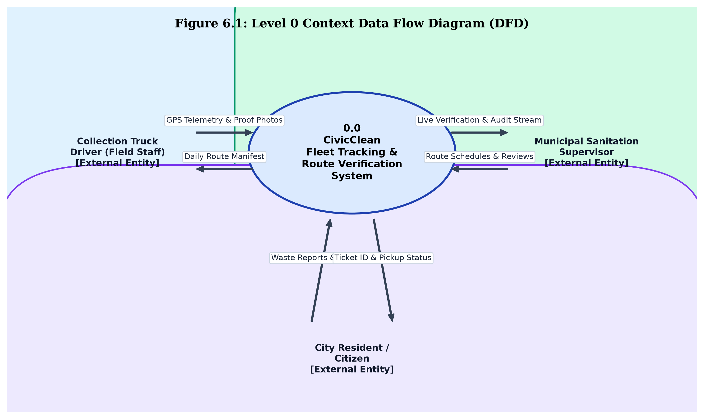
Figure 6.1: Level 0 Context Data Flow Diagram (DFD)
Short Explanation: Figure 6.1 illustrates the context-level data flows of the CivicClean system. The Collection Truck Driver transmits real-time GPS telemetry and geotagged collection proof photos while receiving daily assigned route manifests. The Sanitation Supervisor receives live verification audit logs, telemetry streams, and clearance analytics, while issuing route schedules and exception review decisions. The Citizen entity submits geotagged waste overflow reports and receives tracking ticket IDs and live pickup status updates.
6.2 Level 1 DFD
The Level 1 Data Flow Diagram decomposes the system into five core functional sub-processes and four persistent data stores. It illustrates the internal routing of coordinates, proof imagery, grievance tickets, and audit trails.
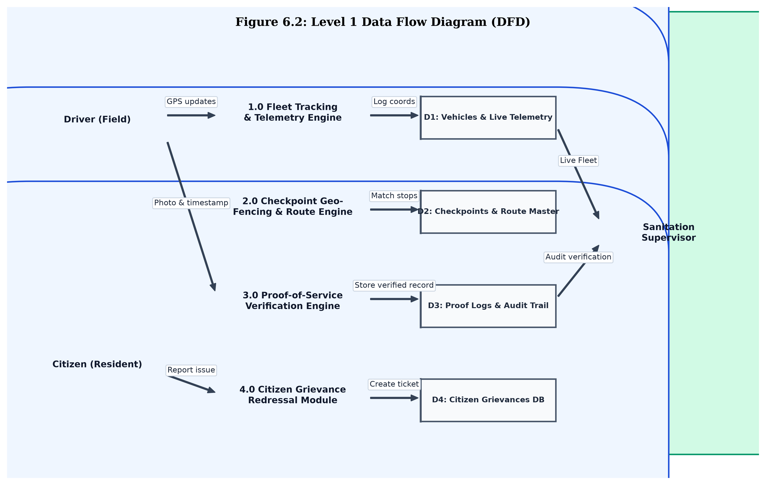
Figure 6.2: Level 1 Data Flow Diagram (DFD)
Short Explanation: Figure 6.2 models the five primary processes of the system: (1.0) Fleet Tracking & Telemetry Engine, (2.0) Checkpoint Geofencing & Route Engine, (3.0) Proof-of-Service Verification Engine, (4.0) Citizen Grievance Redressal Module, and (5.0) Audit & Reporting Module. Data persists across four dedicated repositories: D1 (Vehicles & Live Telemetry), D2 (Checkpoints & Route Master), D3 (Proof Logs & Audit Trail), and D4 (Citizen Grievances DB).
In this flow, driver telemetry feeds into Process 1.0 to update vehicle coordinates in D1. Process 2.0 cross-references vehicle positions with checkpoint geometries in D2. Process 3.0 captures photo proof and timestamps, persisting verified records into D3 for supervisor review. Citizen reports flow through Process 4.0 into D4, dynamically linking to route dispatches.
6.3 Level 2 DFD (Decomposition of Process 3.0)
To provide granular insight into the core proof-of-service verification logic, Process 3.0 is decomposed into its sub-processes in the Level 2 DFD, shown in Figure 6.3.
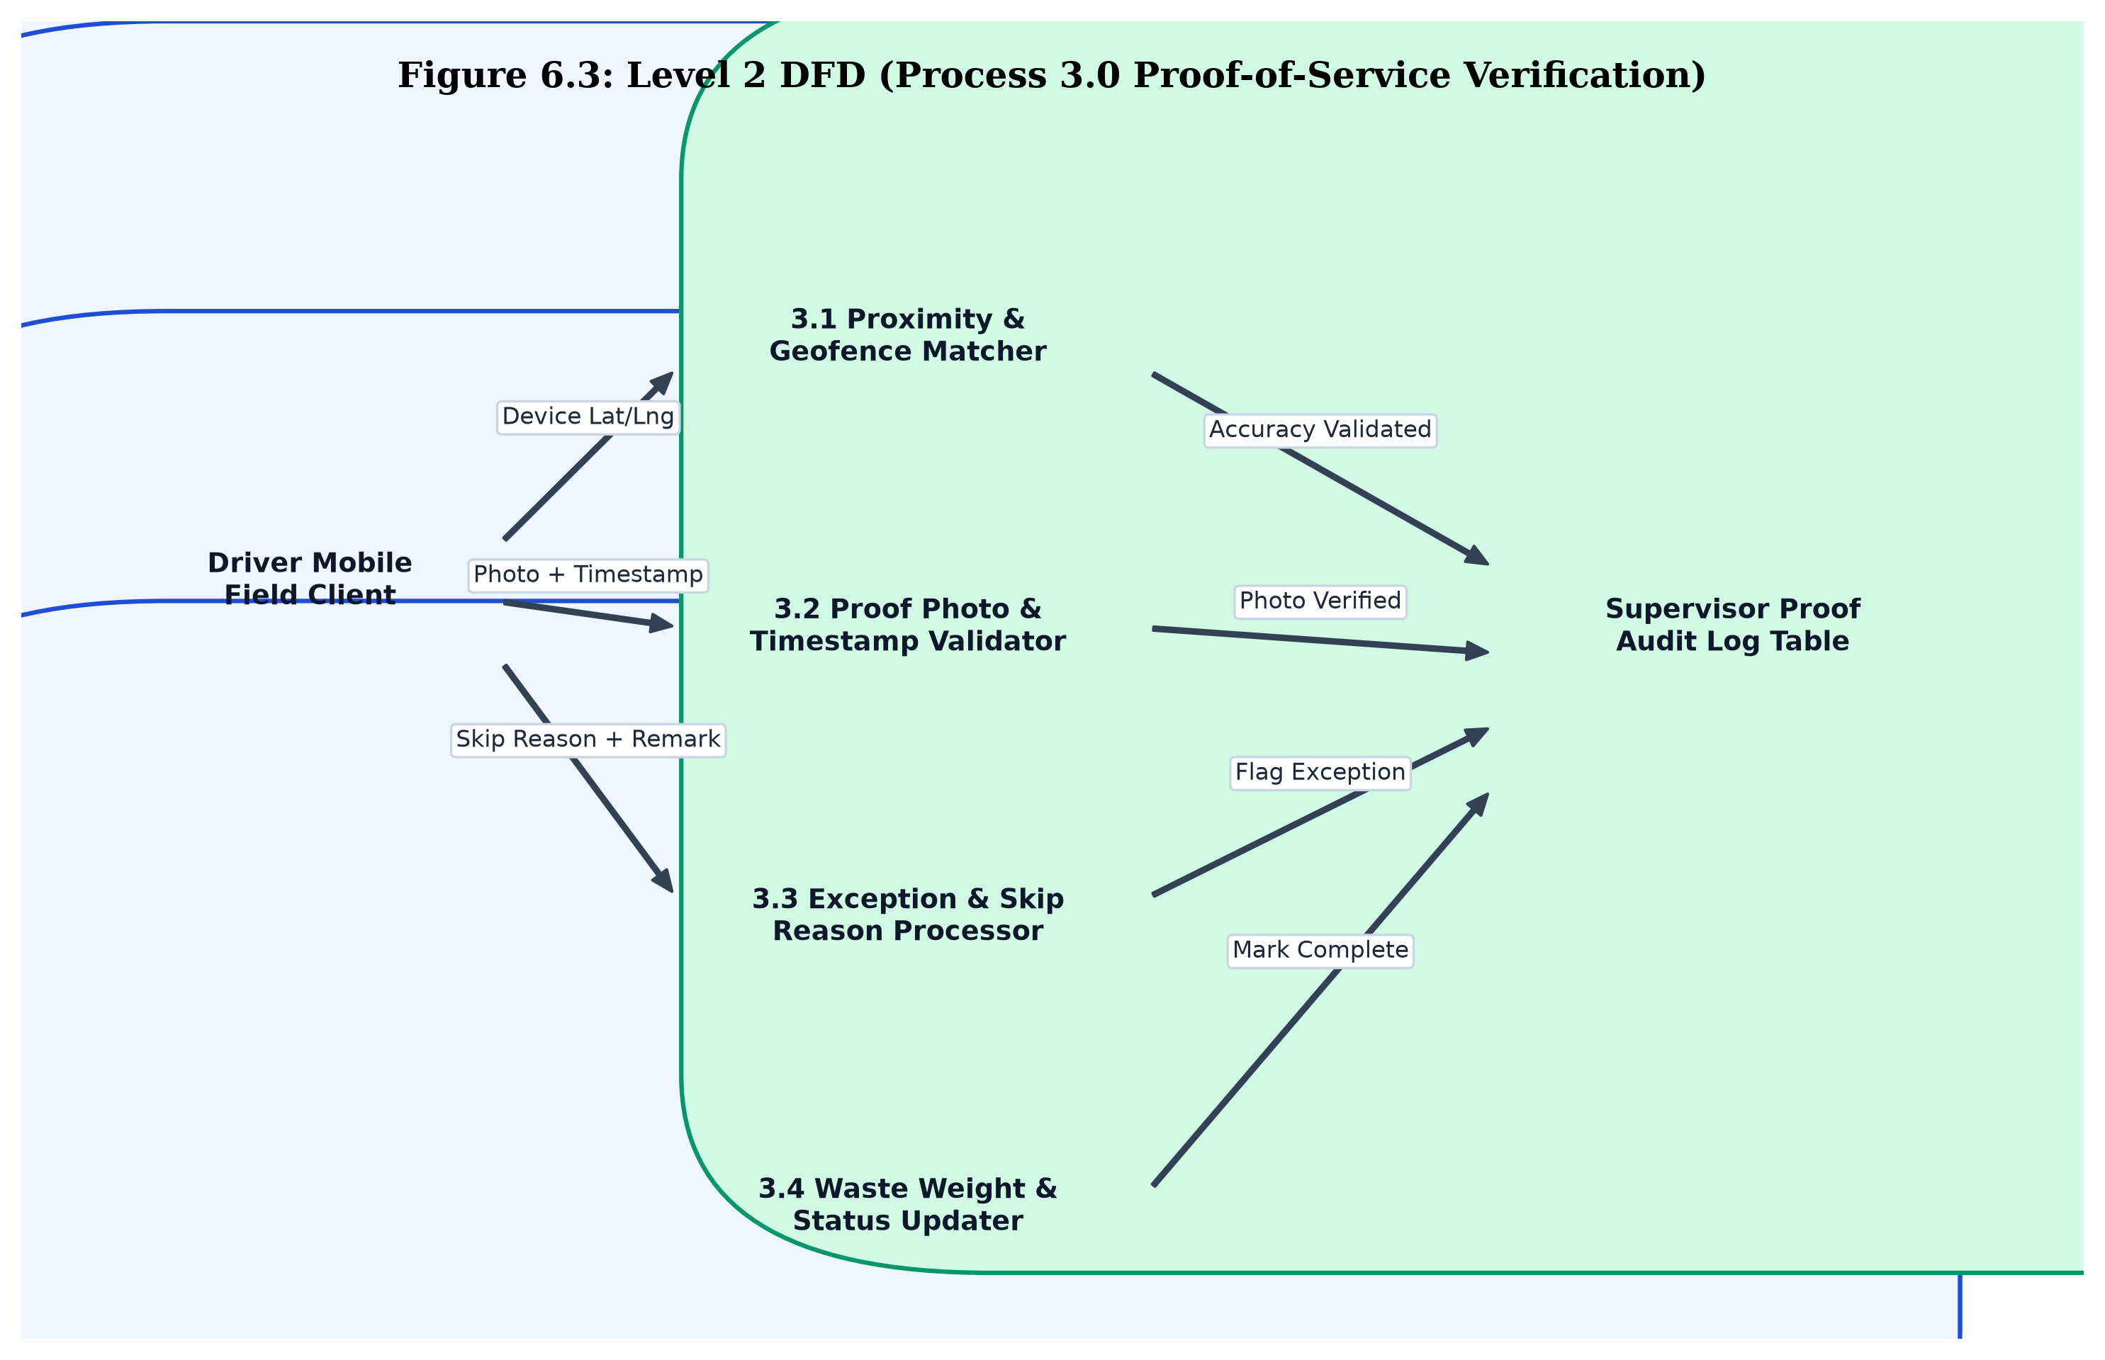
Figure 6.3: Level 2 DFD (Process 3.0 Proof-of-Service Decomposition)
Short Explanation: Figure 6.3 details the internal logic of the Proof-of-Service Verification Engine. Sub-process 3.1 performs a Haversine proximity check between the truck's device GPS and the pre-registered bin coordinates. If within 15 meters, Sub-process 3.2 validates the camera photo hash and device timestamp. Sub-process 3.3 captures exception justifications if a stop is skipped. Sub-process 3.4 records waste weight estimates, updates the checkpoint status to 'Collected', and writes immutable entries to the supervisor audit log.

7. System Architecture
7.1 3-Tier Client-Server Architecture
The CivicClean system is built on a clean 3-Tier Client-Server Architecture comprising the Presentation Tier, the Application (Business Logic) Tier, and the Data Persistence Tier. This architectural separation enforces high modularity, scalability, and maintainability, while enabling seamless software-only deployment.
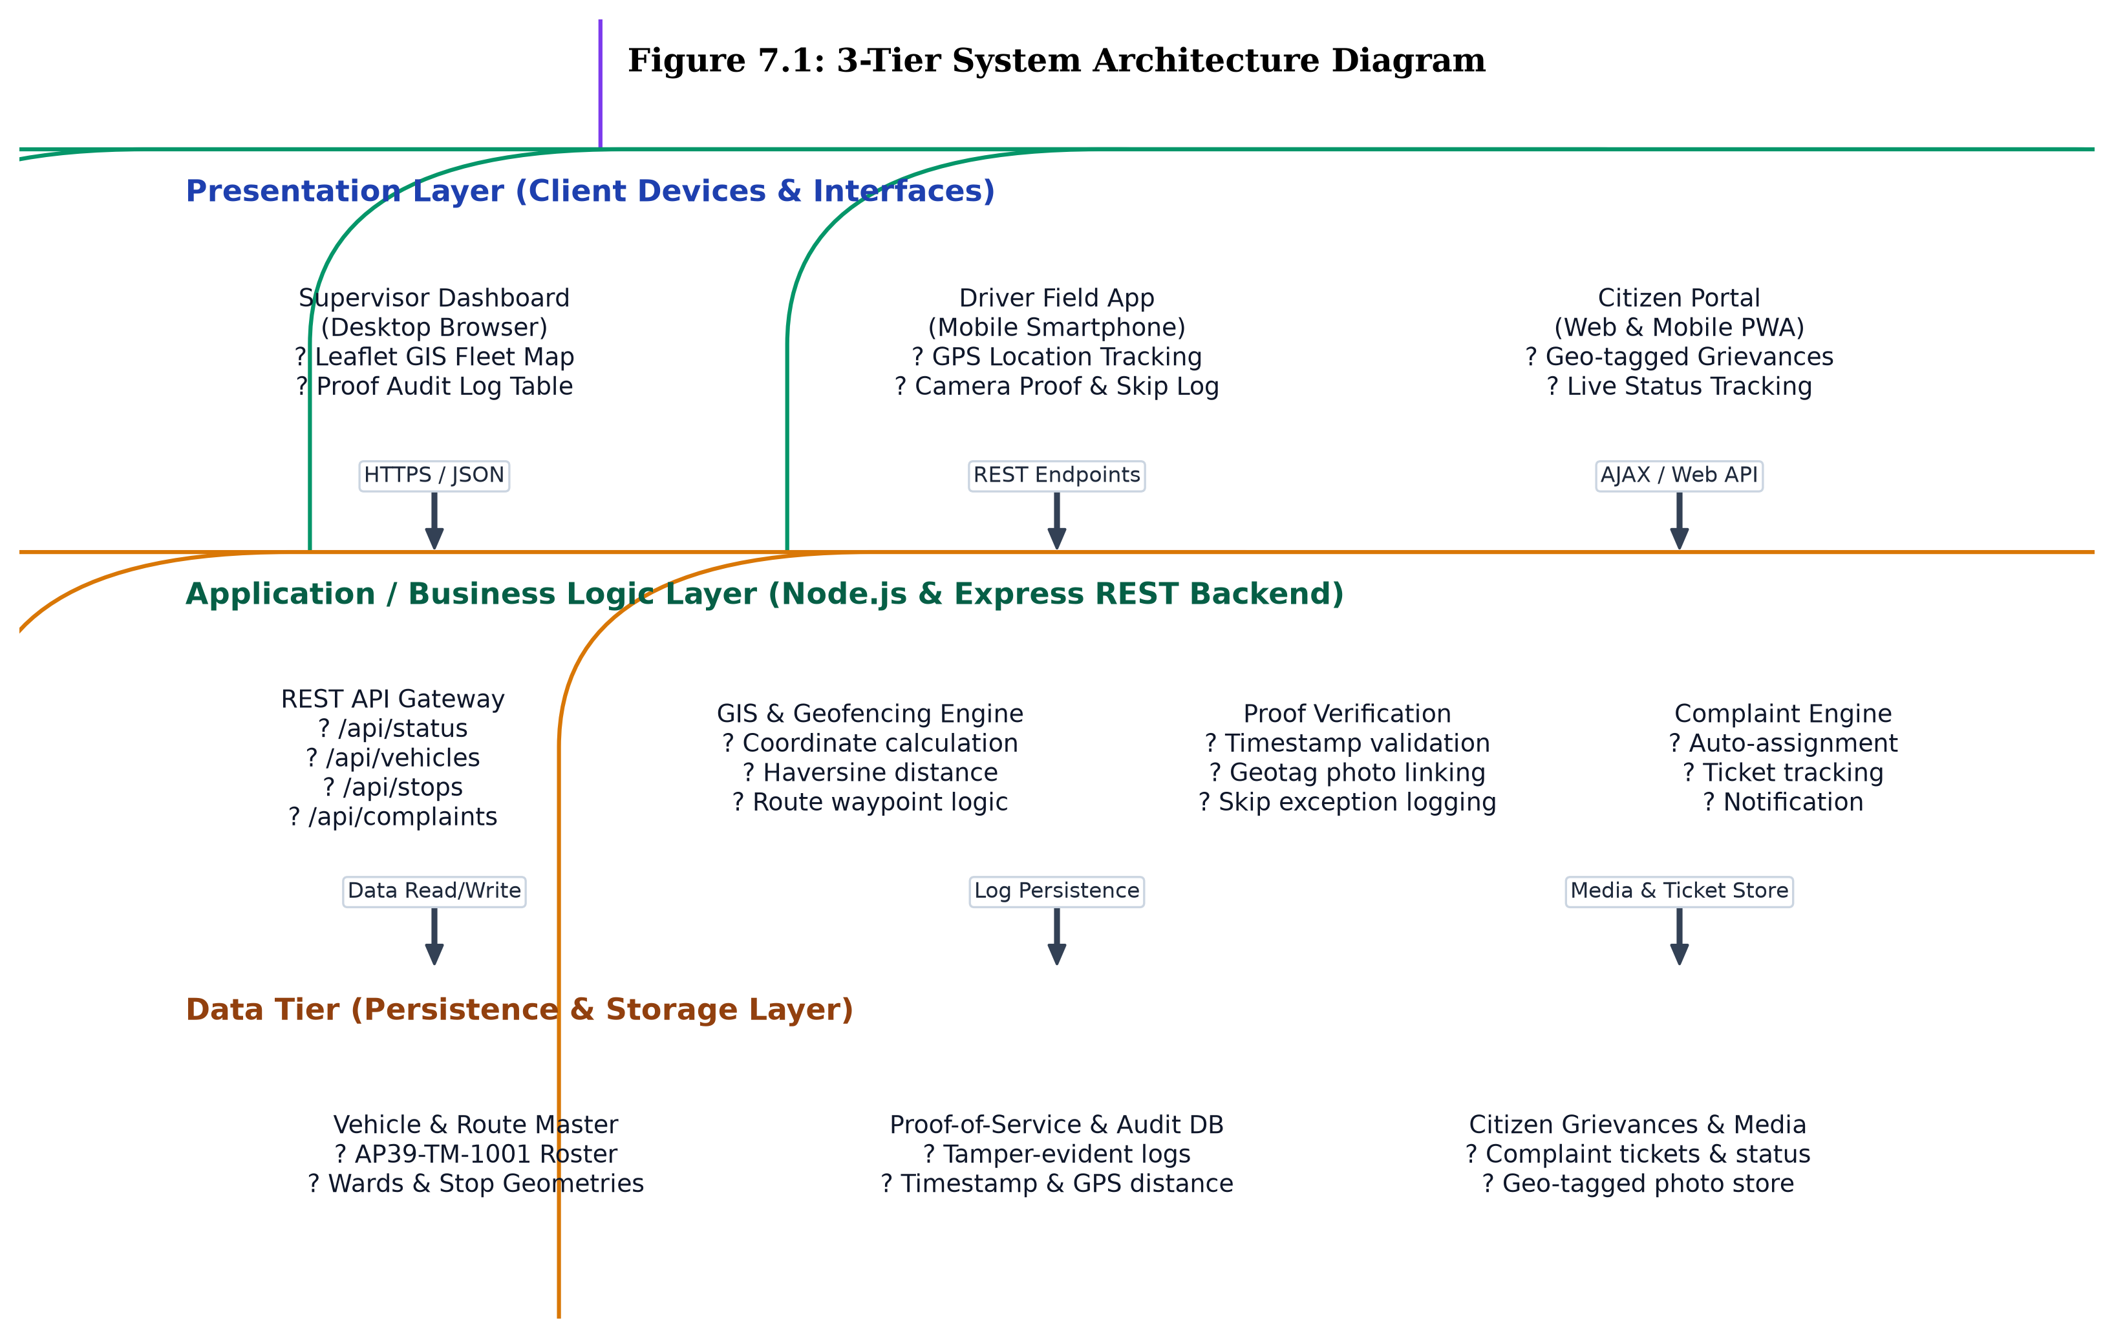
Figure 7.1: 3-Tier System Architecture Diagram
Short Explanation: Figure 7.1 illustrates the structural tiers of the CivicClean platform. The Presentation Tier accommodates desktop and mobile web clients for supervisors, drivers, and citizens. The Application Tier executes on a Node.js/Express runtime, housing the REST API Gateway, GIS Geofencing Engine, Proof Verification Service, and Grievance Controller. The Data Tier maintains vehicle rosters, route geometries, immutable audit logs, and citizen grievance media.
7.2 Architectural Layer Analysis
- Presentation Layer (Client Interfaces): Constructed using responsive HTML5, modern CSS3 with mobile shell framing, and vanilla JavaScript. It delivers role-tailored views: the Supervisor GIS Map powered by Leaflet.js, the touch-optimized Driver Field PWA, and the public Citizen Grievance Portal. No proprietary client software installation is required; any standard browser suffices.
- Application Layer (Business Logic & REST APIs): Hosted on an asynchronous Node.js engine with Express middleware. This layer encapsulates the core business rules: spatial proximity computation using the spherical Haversine formula, tamper-evident timestamp validation, vehicle GPS simulation for testing, and automated ticket dispatch algorithms. Communication with clients is handled via stateless HTTP/JSON endpoints.
- Data Persistence Layer: Provides structured storage for operational states, including vehicle manifests, scheduled stop sequences, photo proof records, and audit logs. The in-memory data store with disk persistence ensures rapid sub-millisecond retrieval during live tracking, while preserving complete audit logs for administrative compliance.

8. Module Description
The CivicClean system is partitioned into four tightly cohesive, loosely coupled functional modules, each addressing the requirements of specific municipal stakeholders.
8.1 Supervisor Command Hub & GIS Fleet Tracking Module
This module serves as the primary operational console for municipal sanitation superintendents and route inspectors. Key capabilities include:
- Interactive Leaflet GIS Canvas: Renders OpenStreetMap vector tiles covering the municipal ward sector (e.g., Sangivalasa to Bheemili). Route polylines are dynamically drawn, and collection checkpoints are displayed with distinct visual markers (green for collected, amber for pending, red for skipped, and purple for citizen complaints).
- Real-Time Vehicle Telemetry: Monitors active collection vehicles, displaying live speed (km/h), fuel level, battery health, current assigned driver, and GPS lock precision (+/- 4m).
- Simulation & Playback Controller: Includes playback controls (Play, Pause, Step Next, Reset) allowing supervisors to simulate GPS coordinate feeds during driver training or system verification.
8.2 Driver Mobile Field Manifest & Geofencing Module
Designed specifically for field sanitation workers operating compactor trucks, this module provides an intuitive, touch-friendly manifest interface accessible on commodity Android smartphones:
- Chronological Checkpoint Checklist: Displays daily assigned stops in optimal collection order with target arrival times, ward names, and completion status badges.
- GPS Lock & Geofencing Banner: Monitors the smartphone's built-in GNSS chip, verifying continuous signal lock and calculating real-time distance to the next scheduled checkpoint.
- Shift Progress Tracking: Displays a dynamic visual completion bar (e.g., '2 / 6 Stops (33%)') updating instantly as stops are cleared.
8.3 Proof-of-Service Verification & Tamper-Resistant Audit Module
This module enforces accountability and eliminates falsification of waste collection claims:
- Geotagged Camera Capture: Upon arriving within 15 meters of a bin, the driver taps 'Mark Collected'. The app captures a photo of the cleared bin, stamping the image with the exact latitude, longitude, and server-validated timestamp.
- Skip-Exception Recording: If physical barriers (road excavation, illegal parking, hazardous waste) prevent collection, the driver opens a structured modal, selects the obstacle category, and logs observations. The system immediately flags the stop for supervisor intervention.
- Immutable Audit Trail Table: Maintains an unalterable, chronological log of all collection events, logging vehicle registration numbers, stop names, action types (COLLECTION_VERIFIED or STOP_SKIPPED), and GPS accuracy tolerances.
8.4 Citizen Grievance Redressal & Hotspot Triage Module
This public-facing module empowers urban residents to participate actively in neighborhood cleanliness:
- Geo-Tagged Complaint Submission: Residents report overflowing public bins, missed pickups, or illegal roadside dumping by providing contact details, selecting their municipal ward, uploading a photo, and pinning their exact location via GPS.
- Real-Time Grievance Tracker: Generates a unique tracking ticket (e.g., CMP-2026-104) and presents a 3-stage visual timeline showing progress from submission to truck dispatch and final photographic clearance.
- Ward Collection Roster: Displays scheduled daily pickup timings and assigned collection vehicles across wards to keep citizens informed.

9. System Analysis
9.1 Use Case Diagram
The Use Case Diagram models the functional interactions between external human actors and the CivicClean system boundary. The primary actors are the Driver (Field Staff), the Citizen (Resident), and the Sanitation Supervisor.
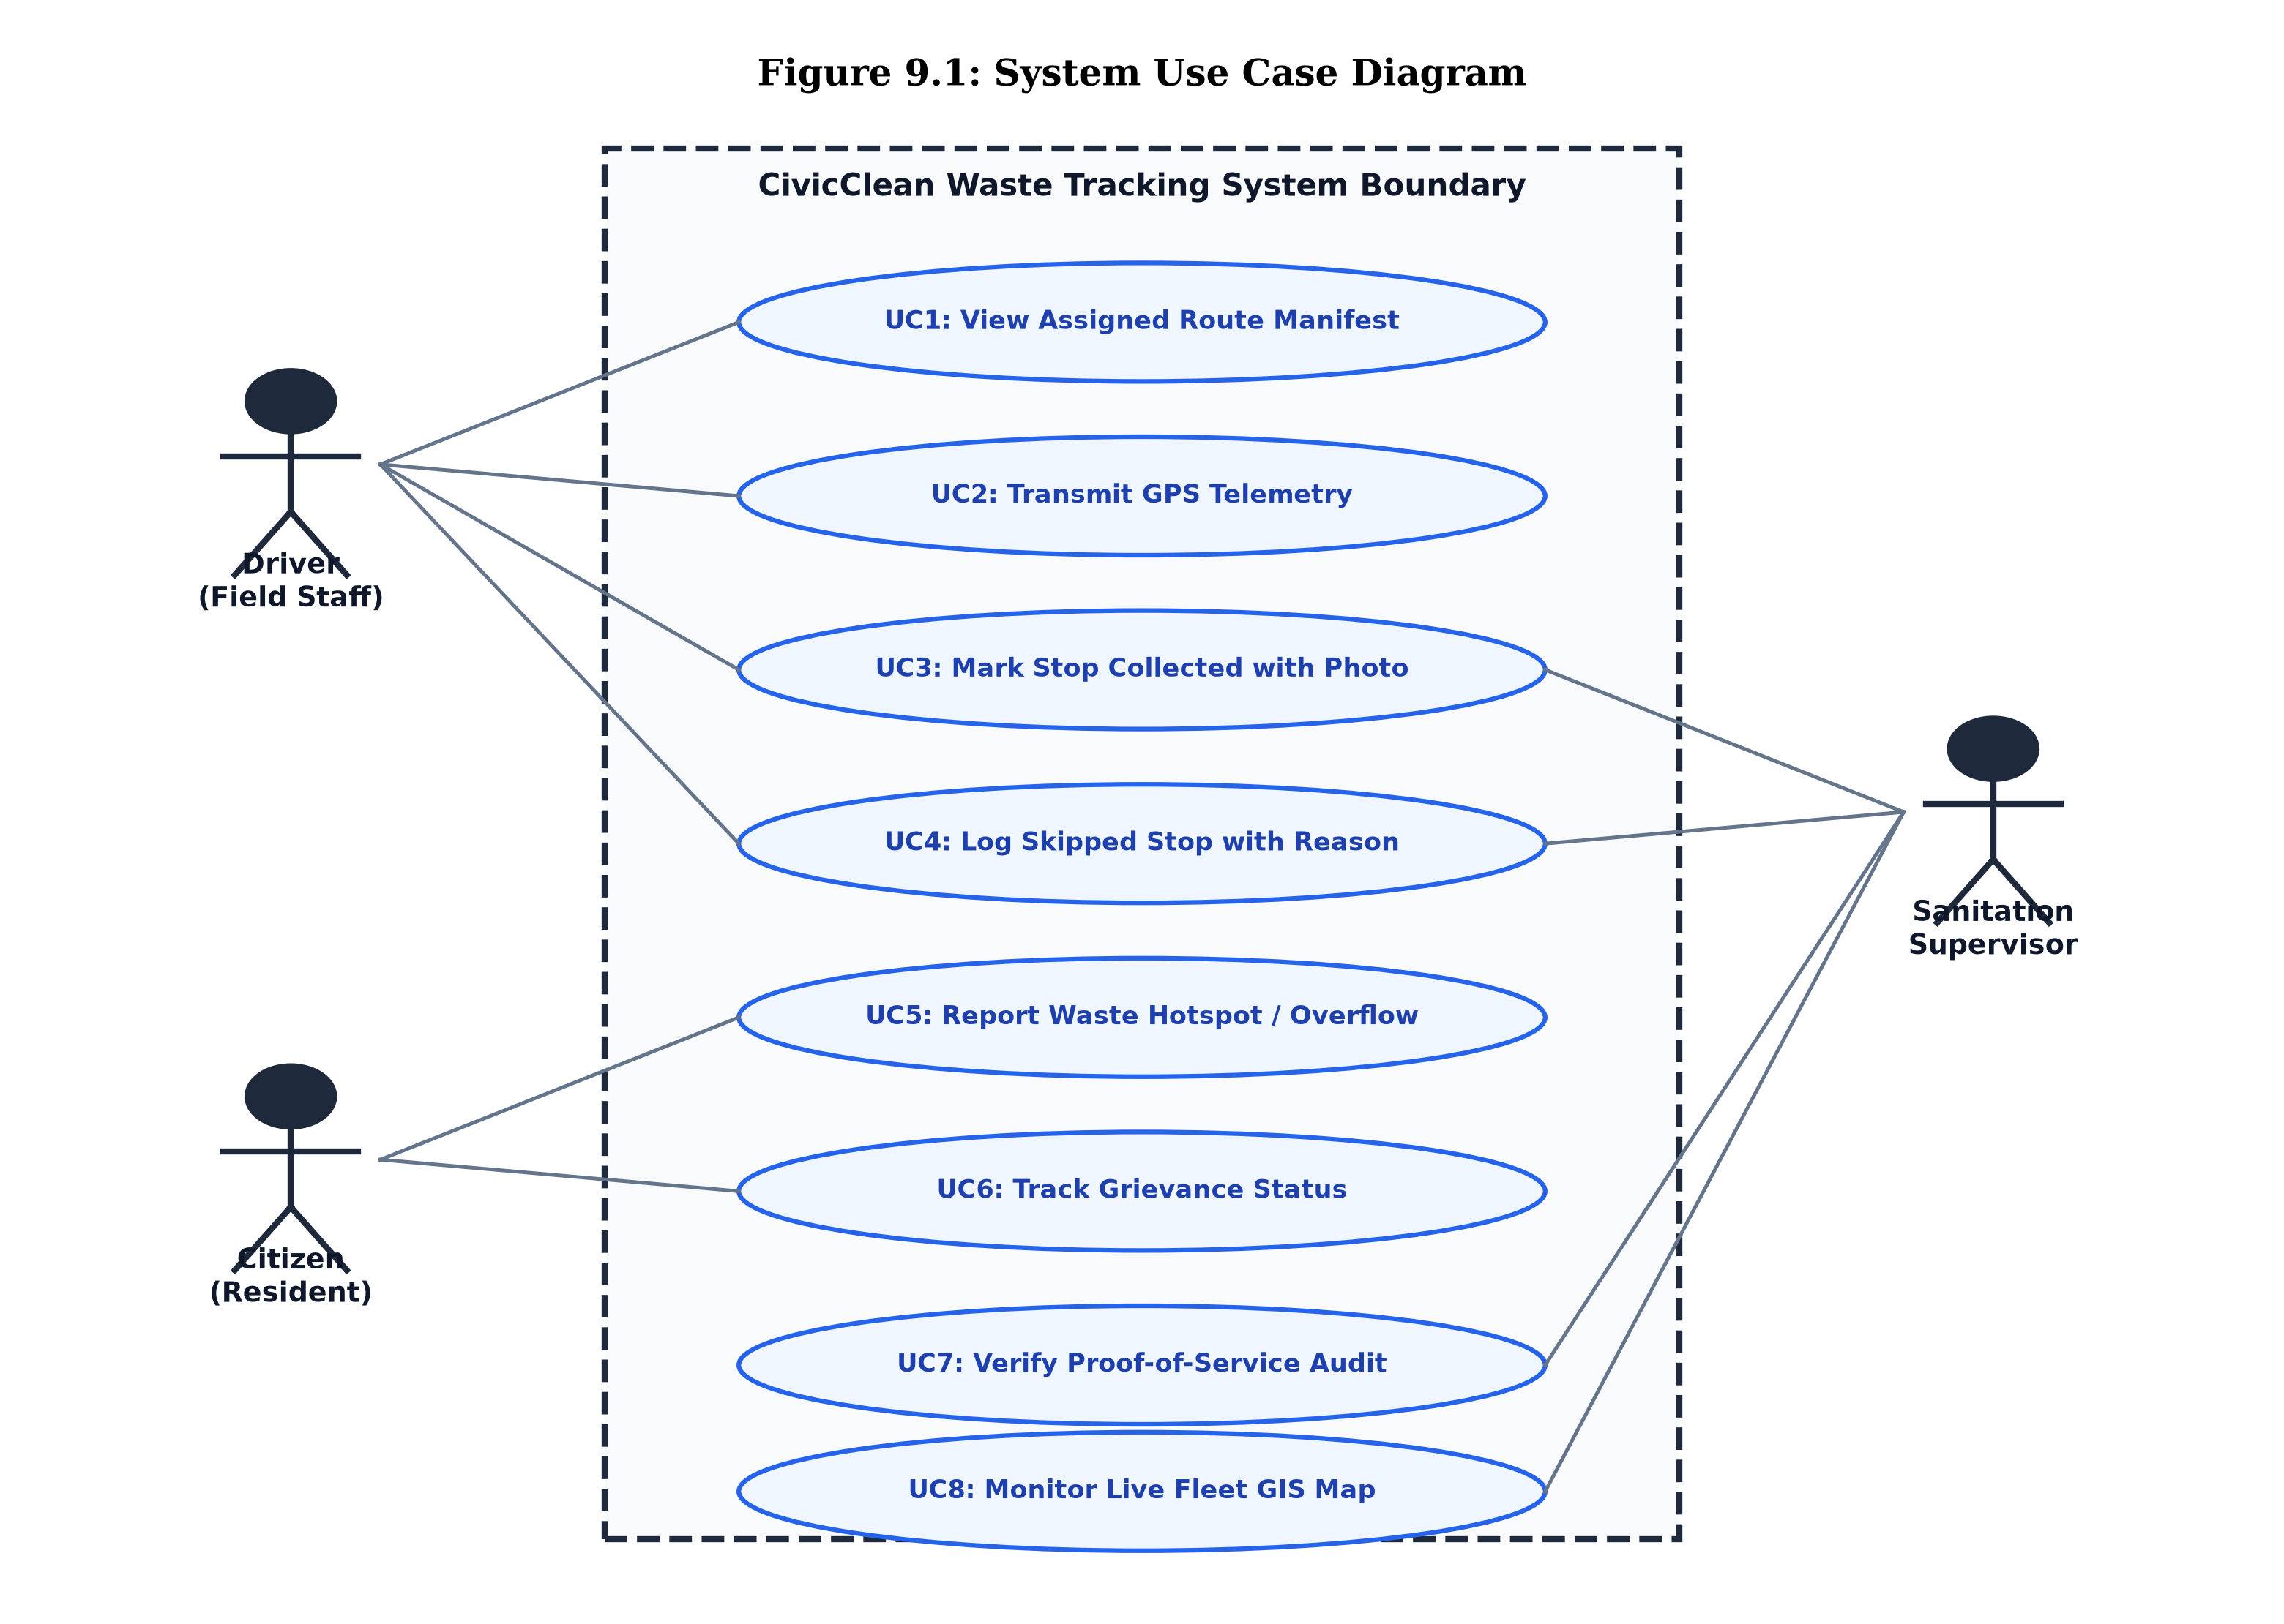
Figure 9.1: System Use Case Diagram
Short Explanation: Figure 9.1 illustrates the system use case interactions. The Driver interacts with UC1 (View Route Manifest), UC2 (Transmit GPS Telemetry), UC3 (Mark Stop Collected with Photo), and UC4 (Log Skipped Stop with Reason). The Citizen interacts with UC5 (Report Waste Hotspot) and UC6 (Track Grievance Status). The Supervisor interacts with UC7 (Verify Proof-of-Service Audit) and UC8 (Monitor Live Fleet GIS Map).
9.2 Use Case Specifications
To provide rigorous engineering documentation, formal use case specifications for the three most critical system transactions are detailed in Tables 9.1, 9.2, and 9.3.
Table 9.1: Use Case Specification: UC1 View Assigned Route Manifest
Use Case Element | Specification Details
Use Case ID & Name | UC1: View Assigned Route Manifest
Primary Actor | Collection Truck Driver (Field Staff)
Preconditions | Driver has successfully authenticated into the mobile field portal; active shift assigned.
Trigger | Driver selects the 'Driver Field App' tab upon starting shift.
Main Success Scenario | 1. Driver opens field app.  2. System queries /api/stops for driver's assigned route ID.  3. System renders chronological stop manifest with target times and status badges.  4. Driver reviews checkpoints and commences travel.
Alternative / Exception Flow | If server is unreachable, app renders cached local route manifest and alerts driver of offline mode.
Postconditions | Driver displays verified list of today's collection stops with active GPS geofence tracking.

Table 9.2: Use Case Specification: UC3 Mark Stop Collected with Proof
Use Case Element | Specification Details
Use Case ID & Name | UC3: Mark Checkpoint Collected with Photo Proof
Primary Actor | Collection Truck Driver (Field Staff)
Preconditions | Vehicle is physically positioned within the checkpoint's 15m geofence radius; stop status is 'Pending'.
Trigger | Driver taps 'Mark Collected' button on the active checkpoint card.
Main Success Scenario | 1. Driver taps 'Mark Collected'.  2. App triggers camera dialog and captures bin photo.  3. App acquires current device coordinates (lat, lng) and system timestamp.  4. Client dispatches POST request to /api/stops/:id/collect.  5. Server validates geofence proximity (Haversine distance <= 15m).  6. Server updates stop status to 'Collected', records estimated weight, and appends audit log.  7. Mobile UI updates card with green checkmark and advances progress bar.
Alternative / Exception Flow | If truck is outside 15m geofence, system blocks completion and displays: 'Error: Must be within 15m of bin location'.
Postconditions | Stop is verified 'Collected', proof photo is archived, and supervisor dashboard updates in real time.

Table 9.3: Use Case Specification: UC5 Report Waste Hotspot
Use Case Element | Specification Details
Use Case ID & Name | UC5: Report Waste Hotspot or Missed Pickup
Primary Actor | City Resident / Citizen
Preconditions | Citizen has access to mobile or desktop web browser; internet connectivity active.
Trigger | Citizen identifies an overflowing public bin or missed collection and opens the Citizen Portal.
Main Success Scenario | 1. Citizen fills name, phone number, ward, and issue category.  2. Citizen taps 'GPS Pin' to acquire exact device location or types landmark.  3. Citizen attaches photo of overflowing waste and submits form.  4. Client posts payload to /api/complaints.  5. Server stores complaint in D4 and generates tracking ticket (e.g., #CMP-2026-104).  6. Portal displays confirmation modal with ticket number and initial 'Assigned' status.
Alternative / Exception Flow | If mandatory fields are missing, form highlights invalid inputs with validation warnings.
Postconditions | Grievance is visible on supervisor GIS triage map and citizen can track status via ticket ID.

10. UML Design
Unified Modeling Language (UML) provides standard visual modeling mechanisms to capture the structural and behavioral facets of the CivicClean software architecture. This chapter presents six comprehensive UML diagrams adhering strictly to UML 2.5 standards.
10.1 Class Diagram
The UML Class Diagram models the static structural design of the system, defining object-oriented classes, attributes, operations, visibility modifiers, and association relationships.
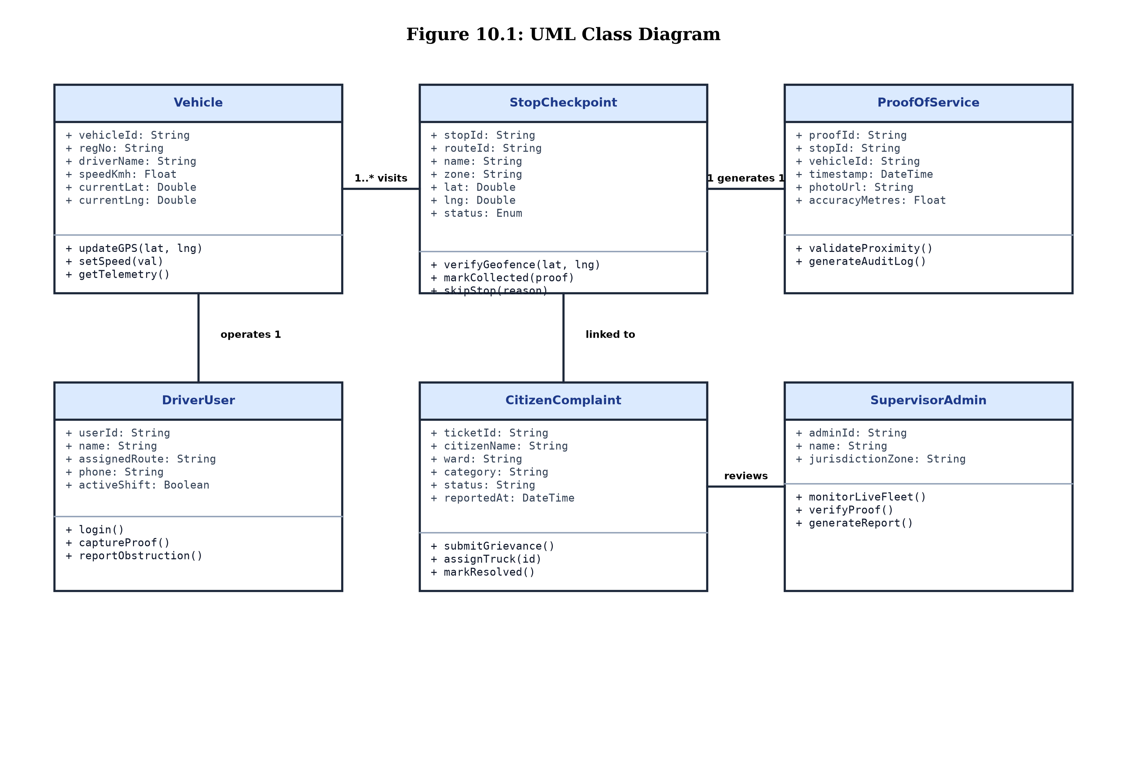
Figure 10.1: UML Class Diagram
Short Explanation: Figure 10.1 depicts the structural classes of CivicClean: Vehicle, StopCheckpoint, ProofOfService, DriverUser, CitizenComplaint, and SupervisorAdmin. Association cardinalities show that one Vehicle visits multiple StopCheckpoints (1..*), each completed StopCheckpoint produces exactly one ProofOfService record (1 to 1), and a CitizenComplaint is reviewed and assigned by a SupervisorAdmin.
10.2 Sequence Diagram
The UML Sequence Diagram models dynamic behavior by illustrating the chronological exchange of messages between runtime object instances during a critical transaction: the Proof-of-Service verification flow.
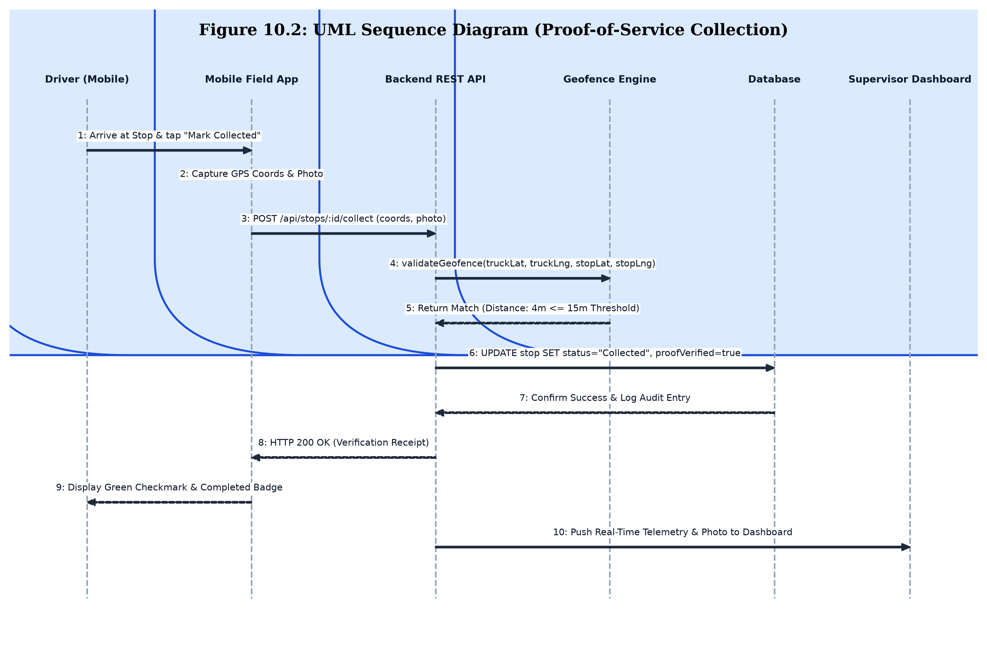
Figure 10.2: UML Sequence Diagram (Proof-of-Service Collection Verification)
Short Explanation: Figure 10.2 traces the sequential execution flow when a driver collects waste. The driver initiates the action via the Mobile Field App, which transmits GPS coordinates and photo data to the Backend REST API. The Geofence Engine validates spatial proximity (4m <= 15m threshold). The Database updates the stop status and writes an immutable audit record. The server returns an HTTP 200 verification receipt to the driver and streams real-time updates to the Supervisor Dashboard.
10.3 Activity Diagram
The UML Activity Diagram models the operational control flow of the Driver's daily collection shift, including conditional branching for accessible versus obstructed checkpoints.
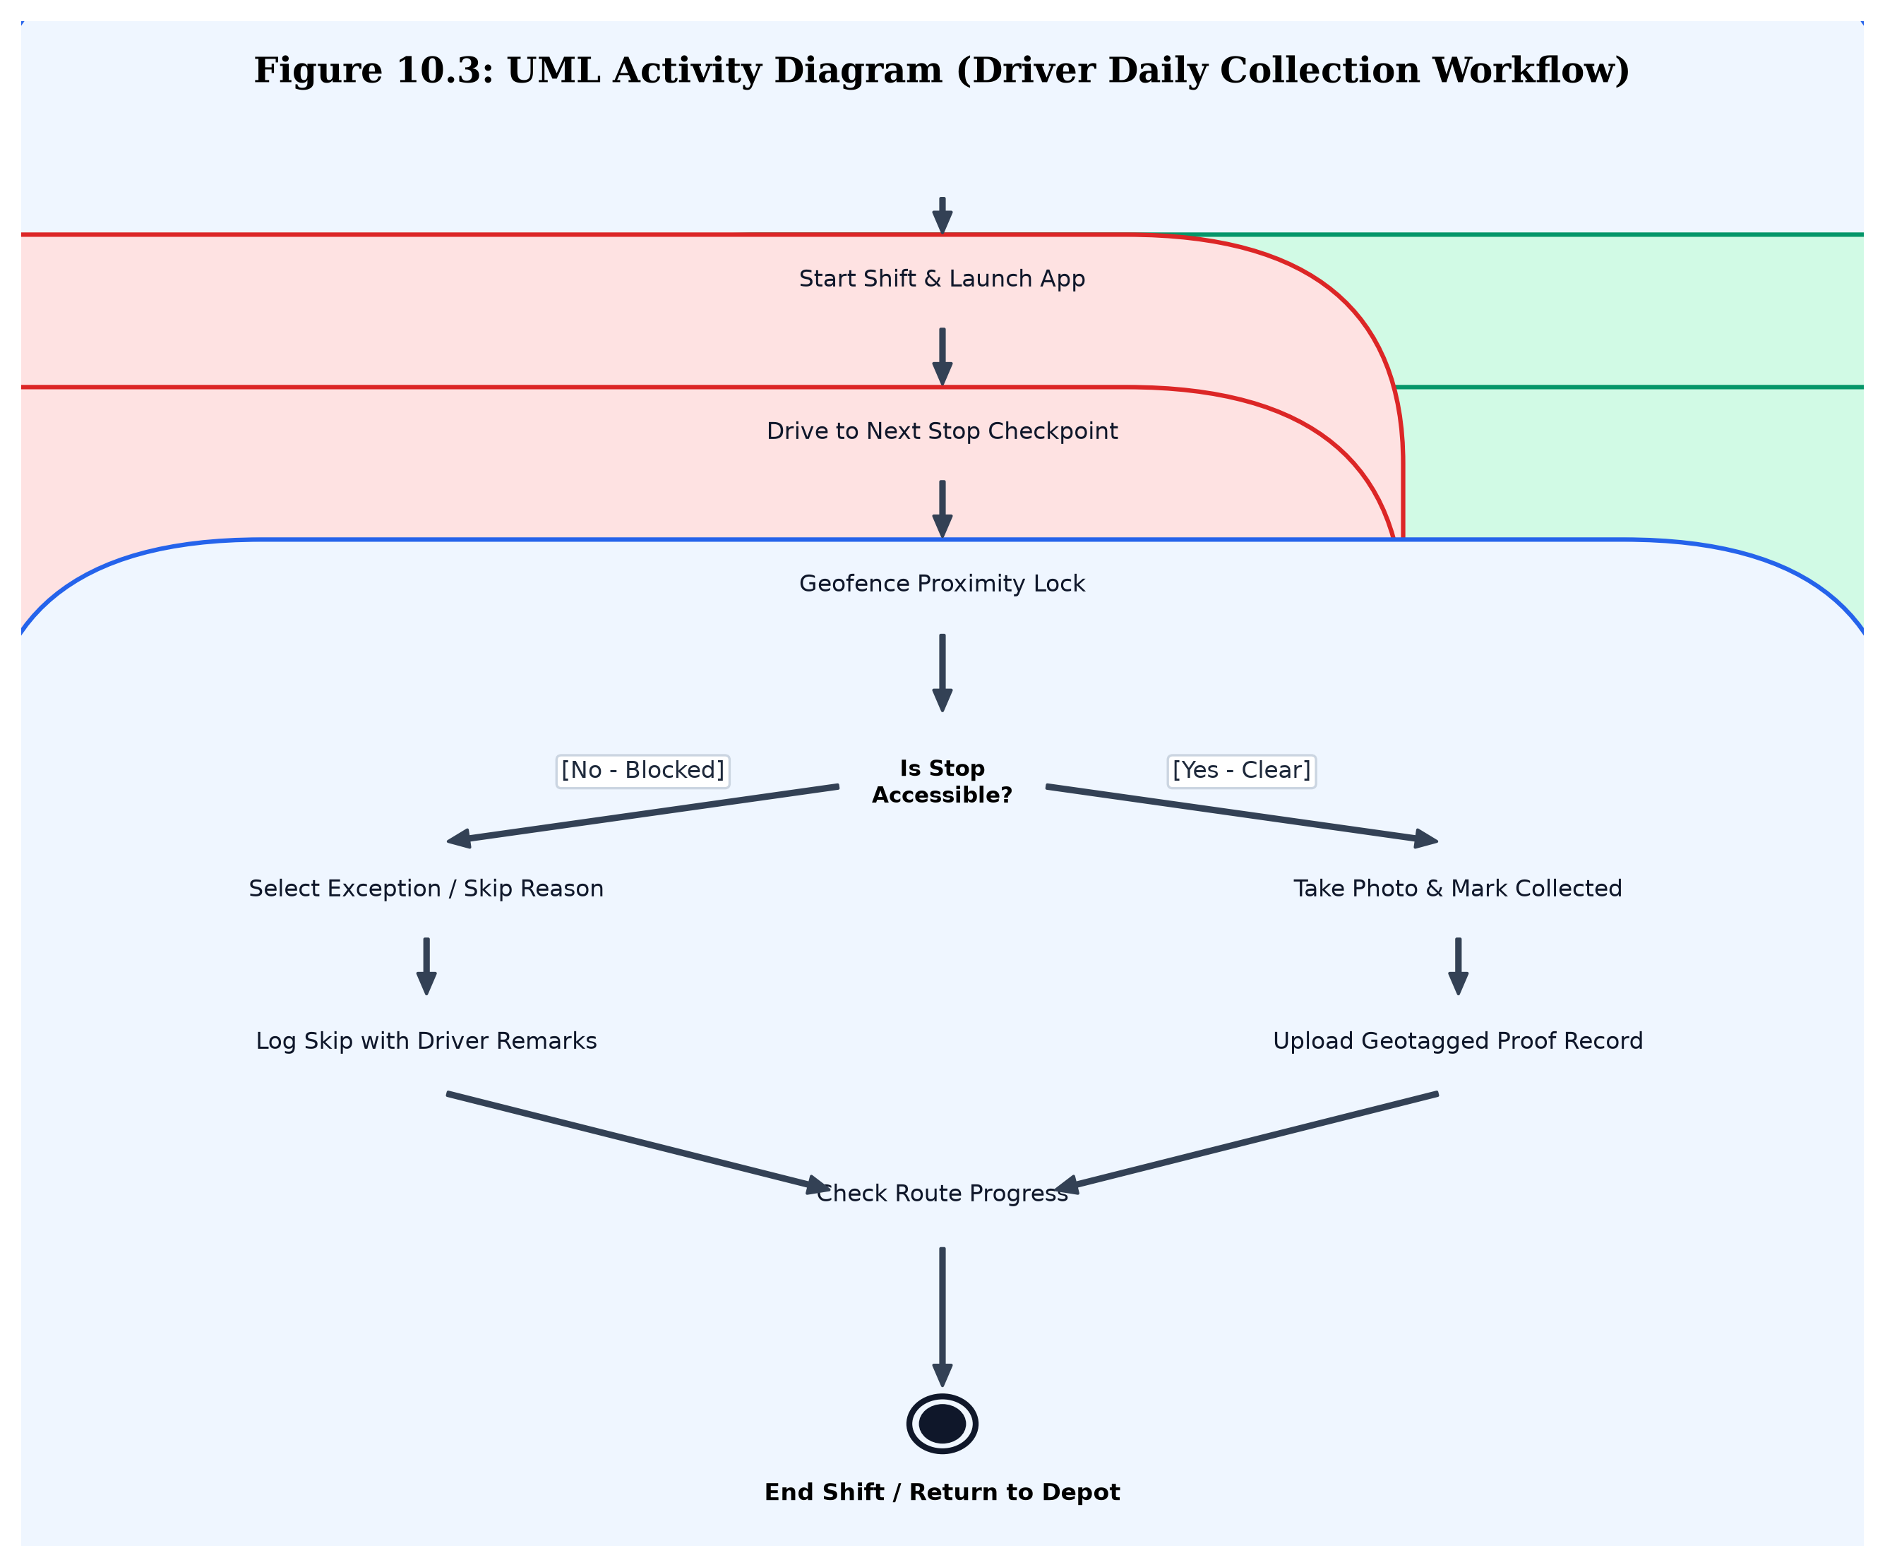
Figure 10.3: UML Activity Diagram (Driver Daily Collection Workflow)
Short Explanation: Figure 10.3 traces the driver's workflow from shift initiation to return to depot. Upon arriving at a checkpoint, a decision node checks accessibility: if clear, the driver snaps a photo, records waste weight, and logs proof; if blocked by roadwork or traffic, the driver logs a structured skip reason with observations. Both paths rejoin to check remaining route stops.
10.4 State Diagram
The UML State Diagram captures the lifecycle state transitions of a StopCheckpoint object in response to operational events.
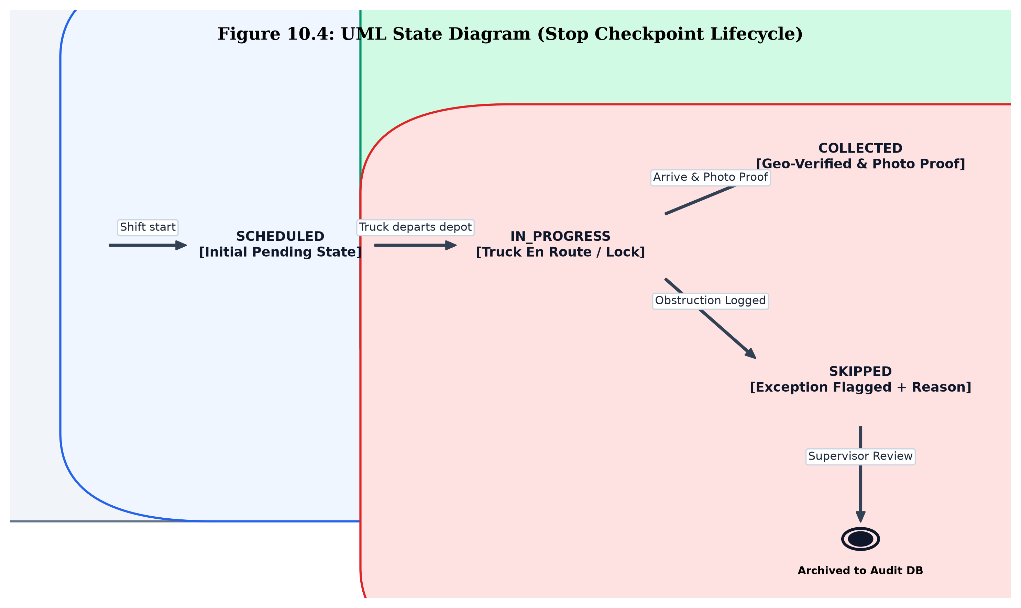
Figure 10.4: UML State Diagram (Stop Checkpoint Lifecycle)
Short Explanation: Figure 10.4 defines the states of a collection stop: beginning in SCHEDULED (pending), transitioning to IN_PROGRESS when the truck is en route, and branching to either COLLECTED (upon geofence validation and photo proof submission) or SKIPPED (if an obstruction is flagged). Both terminal states are archived into the supervisor audit database.
10.5 Component Diagram
The UML Component Diagram models the software organization, defining modular executable components, interfaces, and inter-component dependencies.
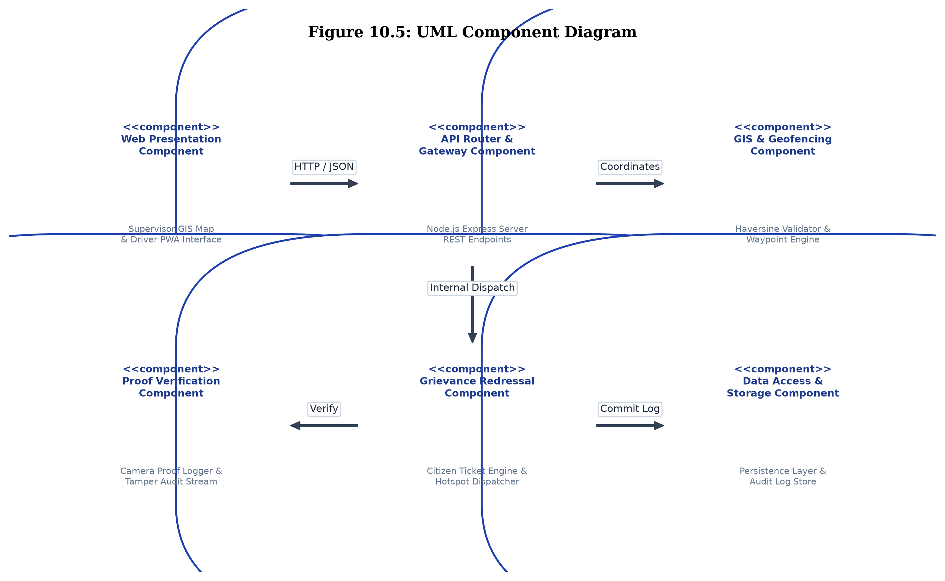
Figure 10.5: UML Component Diagram
Short Explanation: Figure 10.5 shows the modular organization of CivicClean: the Web Presentation Component connects via HTTP/JSON to the API Gateway Component, which coordinates the GIS & Geofencing Component, Proof Verification Component, Grievance Redressal Component, and Data Access & Storage Component.
10.6 Deployment Diagram
The UML Deployment Diagram illustrates the physical runtime environment, showing how software artifacts are deployed across hardware processing nodes and communication networks.
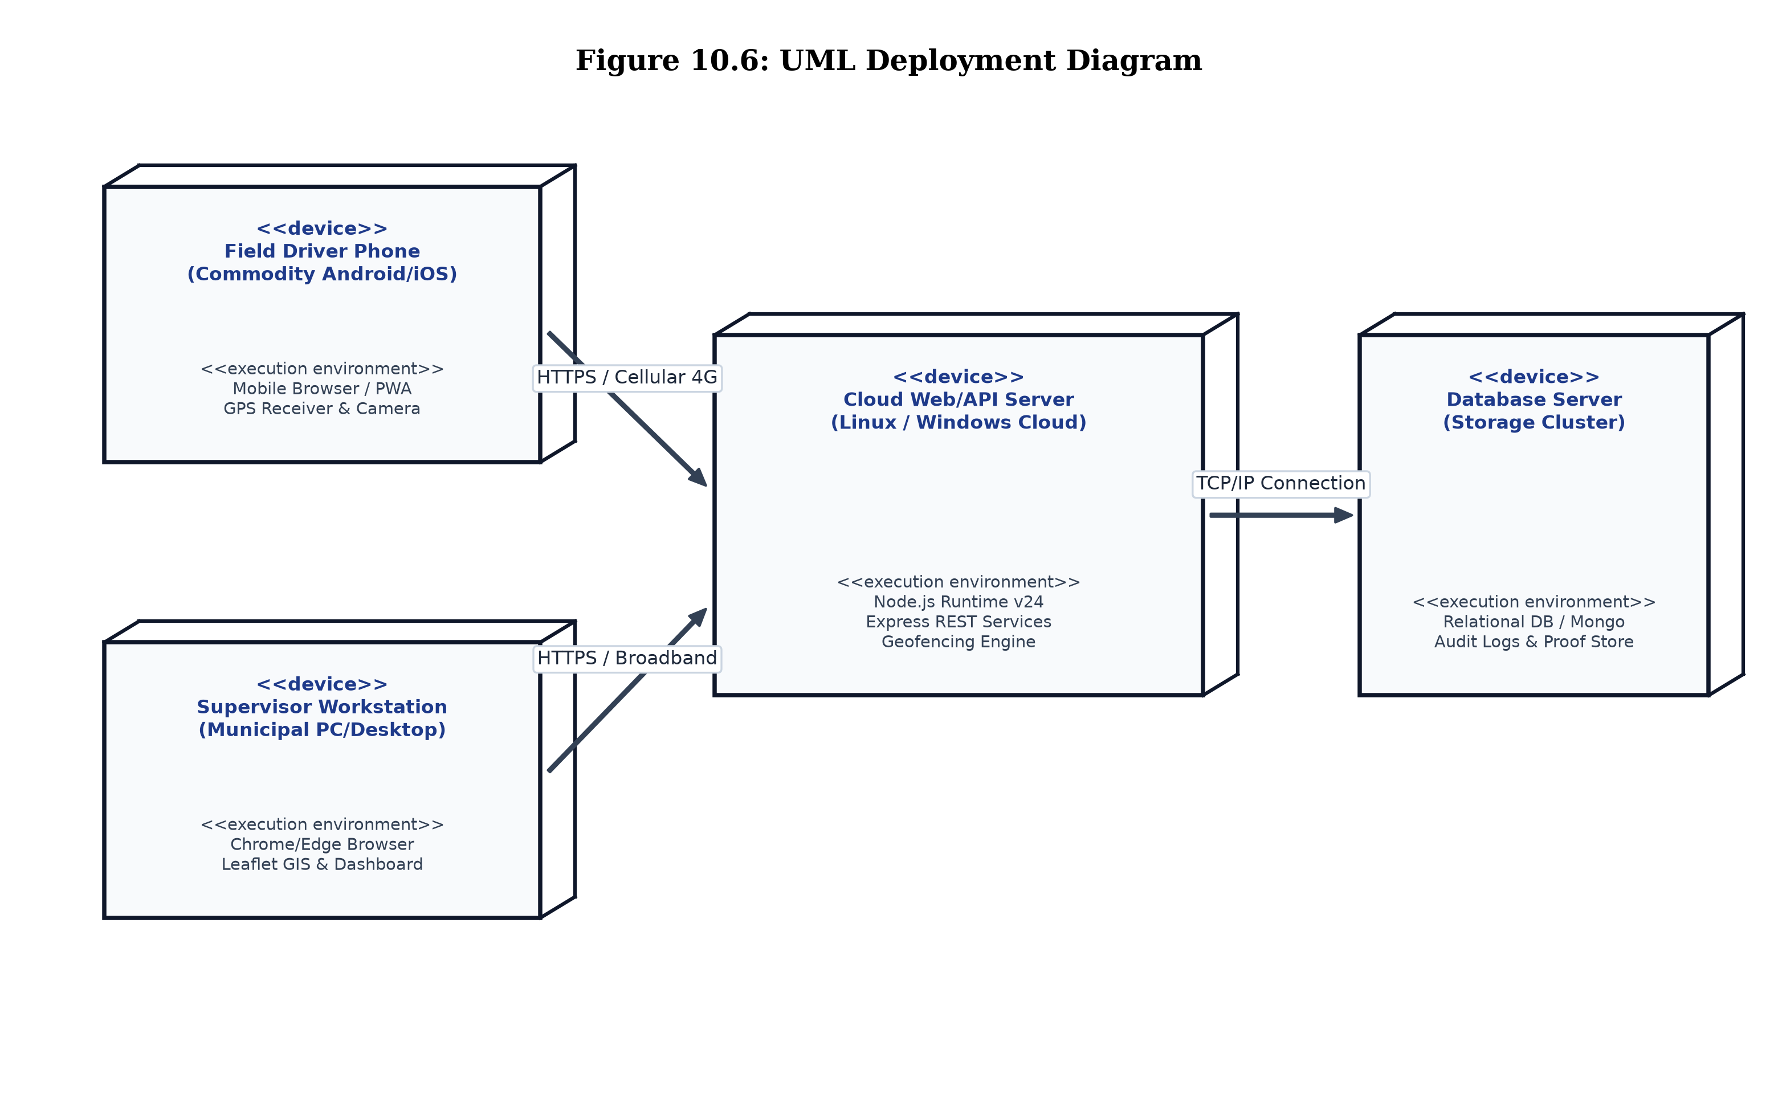
Figure 10.6: UML Deployment Diagram
Short Explanation: Figure 10.6 maps software execution across physical hardware: the Driver Mobile Smartphone connects via 4G LTE cellular network to the Cloud Web/API Server, the Supervisor Workstation accesses the server via high-speed broadband, and the Cloud Server communicates with the Database Server over an isolated TCP/IP link.

11. Testing
11.1 Test Plan & Methodology
A rigorous, multi-tiered testing strategy was executed throughout the development lifecycle to verify functional correctness, geospatial precision, data integrity, and system resilience under variable network conditions. The testing methodology adhered to standard Software Engineering quality assurance protocols, incorporating the following verification techniques:
- Unit Testing: Individual algorithmic modules - such as the Haversine spherical distance calculation function, ISO timestamp parser, and ticket ID generator - were tested in isolation with boundary value test fixtures.
- White-Box & Basis Path Testing: Control logic within the geofencing verification routine and skip-reason validation flows was analyzed to derive Cyclomatic Complexity (V(G)), ensuring every independent execution path was exercised at least once.
- Black-Box Testing: Equivalence partitioning and boundary value analysis were applied to all client-facing forms and REST endpoints, verifying input sanitization for phone numbers, GPS coordinates, and file attachments.
- System Integration Testing: End-to-end integration between the driver mobile client, the Node.js API server, and the supervisor GIS map was validated under concurrent network simulations to ensure immediate synchronization.
- Validation & Acceptance Testing: The application was subjected to simulated real-world scenarios covering the Visakhapatnam municipal ward test sector, validating user journey satisfaction against the functional requirements.
11.2 System Test Cases Execution Matrix
A comprehensive suite of test cases (TC01 through TC08) was formally executed across all modules. Table 11.1 documents the test case identifier, test objective, test inputs, expected output, observed actual result, and final pass/fail status.
Table 11.1: System Test Cases Matrix & Validation Results
TC ID | Test Case Description | Test Input Data | Expected Output | Actual Output | Status
TC01 | Valid Role Authentication | Role: Supervisor, EmpID: EMP-088, Pass: Valid | Authentication success; redirect to supervisor GIS dashboard | Login successful; dashboard rendered with live feed | Pass
TC02 | Invalid Role Credentials | Role: Supervisor, EmpID: EMP-088, Pass: Wrong | Authentication rejected; display clear error message | Error message displayed; access denied | Pass
TC03 | Live GPS Telemetry Update | Lat: 17.8974, Lng: 83.4485, Speed: 24 km/h | Vehicle marker moves on GIS map; speed updates to 24 km/h | Marker moved smoothly; telemetry panel reflected 24 km/h | Pass
TC04 | Geofenced Proof Collection | Stop: STOP-02, Geofence Distance: 5m, Photo: Valid | Status updates to 'Collected'; proof logged with 5m accuracy | Stop marked 'Collected'; photo & 5m accuracy logged in audit | Pass
TC05 | Out-of-Bounds Collection Attempt | Stop: STOP-04, Geofence Distance: 450m (>15m threshold) | System blocks collection; shows proximity violation error | Collection blocked; 'Must be within 15m' alert shown | Pass
TC06 | Structured Skip Stop Logging | Stop: STOP-06, Reason: Road excavation, Remarks logged | Status updates to 'Skipped'; stop flagged in red on map | Stop status changed to 'Skipped'; red icon & reason displayed | Pass
TC07 | Citizen Hotspot Submission | Name: Saikiran, Phone: 9848012345, Ward: 1, Photo | Ticket generated (e.g. CMP-2026-106); pin added to map | Ticket CMP-2026-106 created; purple hotspot marker rendered | Pass
TC08 | Live Ticket Status Tracking | Ticket ID: CMP-2026-104 | Display 3-stage timeline with active truck dispatch state | Timeline displayed; shows 'Assigned to Truck TRK-01' | Pass

12. Results / Screenshots
This chapter presents high-resolution visual evidence of the implemented CivicClean web application across all core operational interfaces. In compliance with project guidelines, each screenshot is accompanied by its formal figure designation and a detailed technical explanation.
12.1 Home Page & Portal Switcher
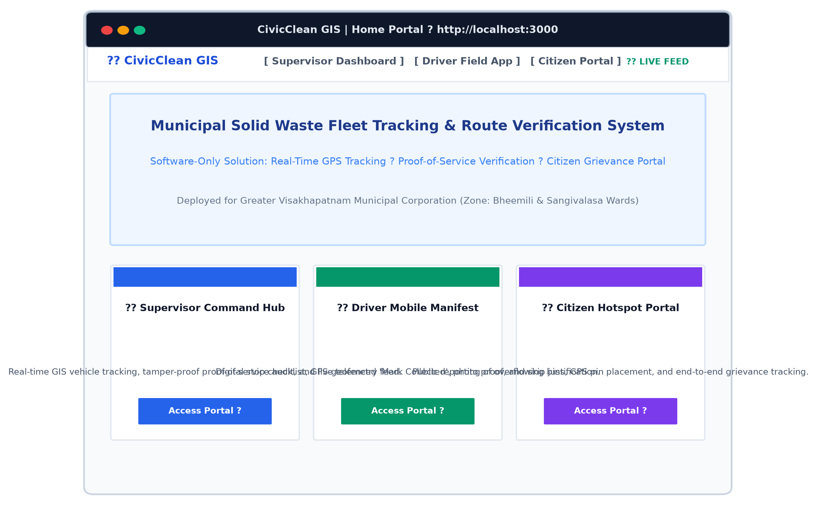
Figure 12.1: Application Home Page & Portal Switcher View
Short Explanation: Figure 12.1 depicts the central landing portal of CivicClean GIS. The interface features the official municipal header, live operational feed indicator, digital clock, and navigation cards providing one-click access to the Supervisor Command Hub, the Driver Field App, and the Citizen Grievance Portal.
12.2 Role-Based User Authentication
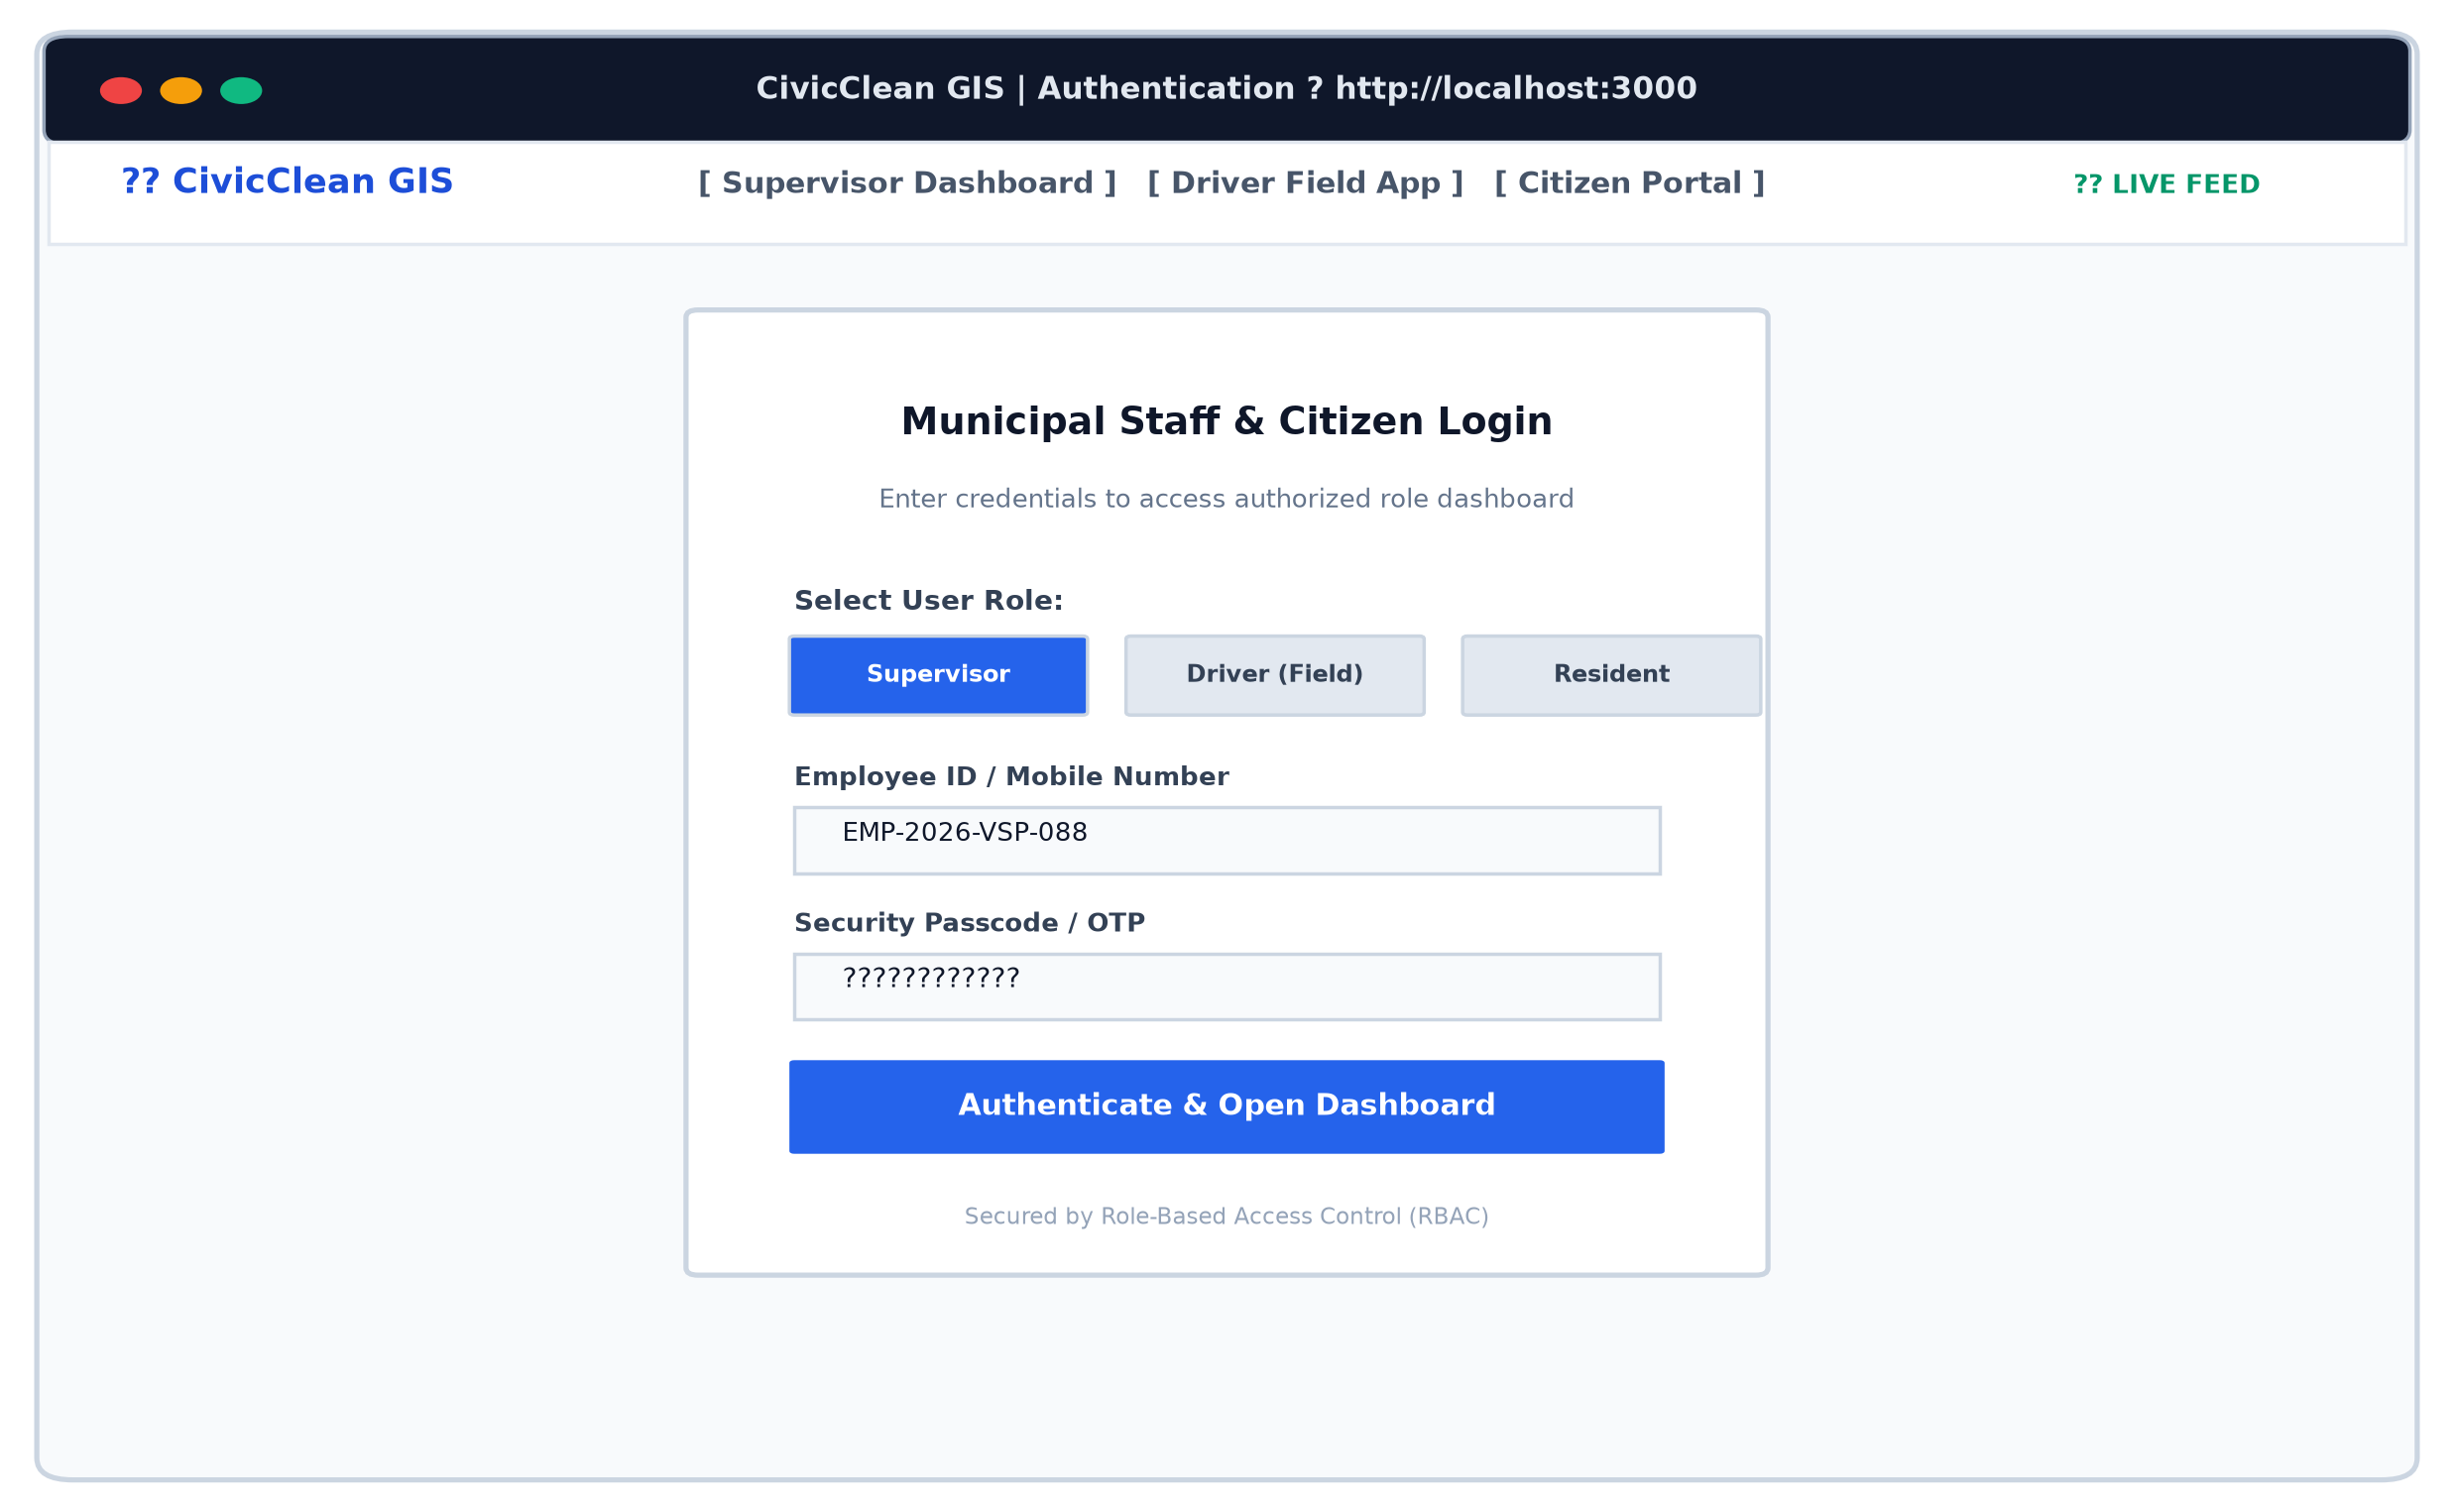
Figure 12.2: Role-Based User Authentication Interface
Short Explanation: Figure 12.2 shows the secure login interface enforcing Role-Based Access Control (RBAC). Users select their designated organizational role (Supervisor, Field Driver, or Resident) and provide validated credentials to enter protected administrative views.
12.3 Supervisor Live GIS Fleet Map
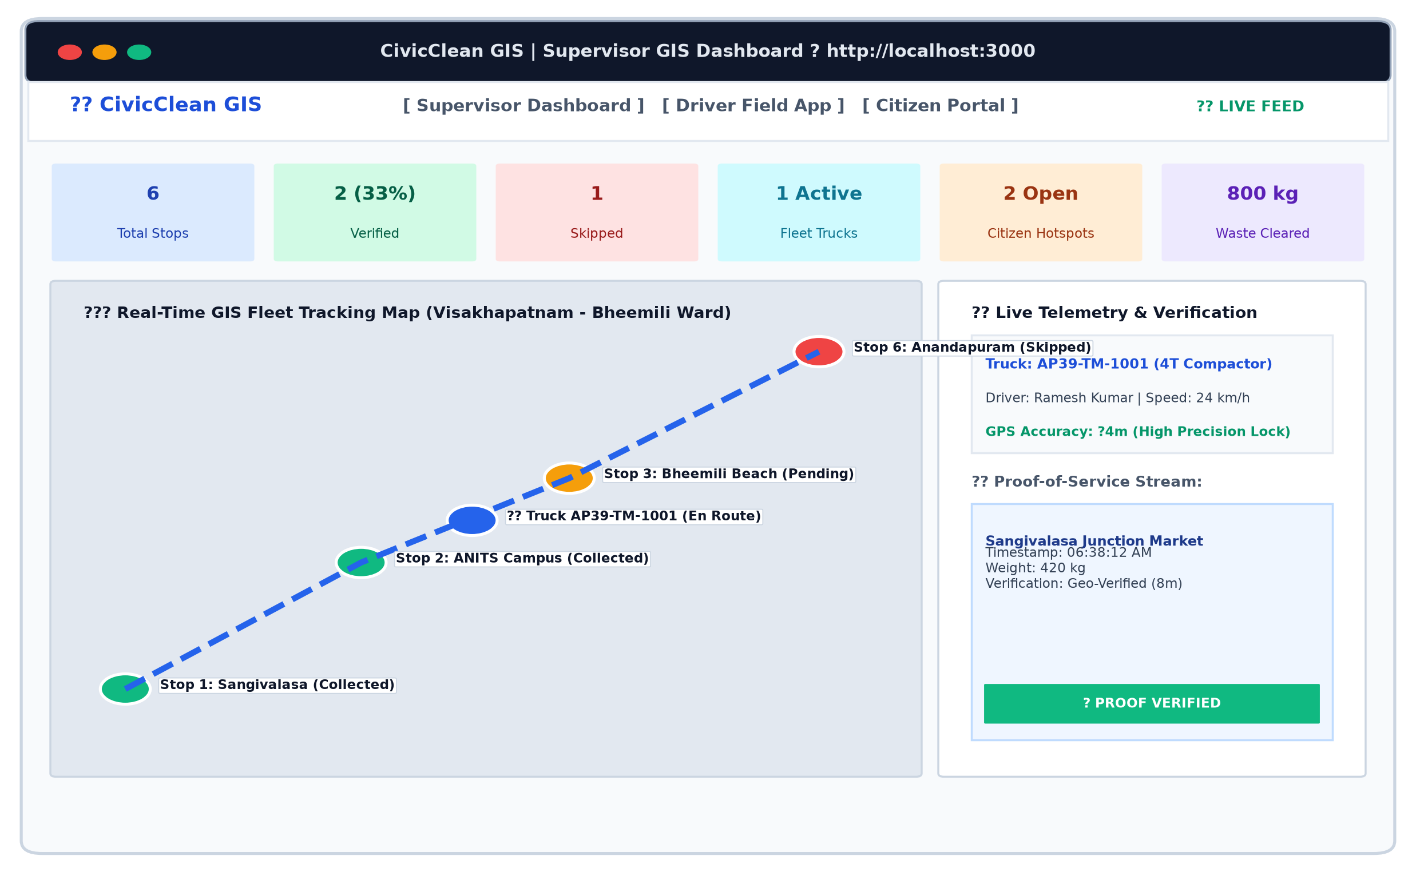
Figure 12.3: Supervisor Live GIS Fleet Tracking Dashboard
Short Explanation: Figure 12.3 illustrates the primary administrative dashboard. The upper KPI ribbon summarizes total stops (6), verified collections (2), skipped stops (1), active fleet (1), open citizen complaints (2), and cleared waste (800 kg). The Leaflet map renders color-coded route lines, vehicle positions, checkpoint markers, and the live vehicle telemetry and proof stream.
12.4 Driver Mobile Field Manifest & Proof Upload
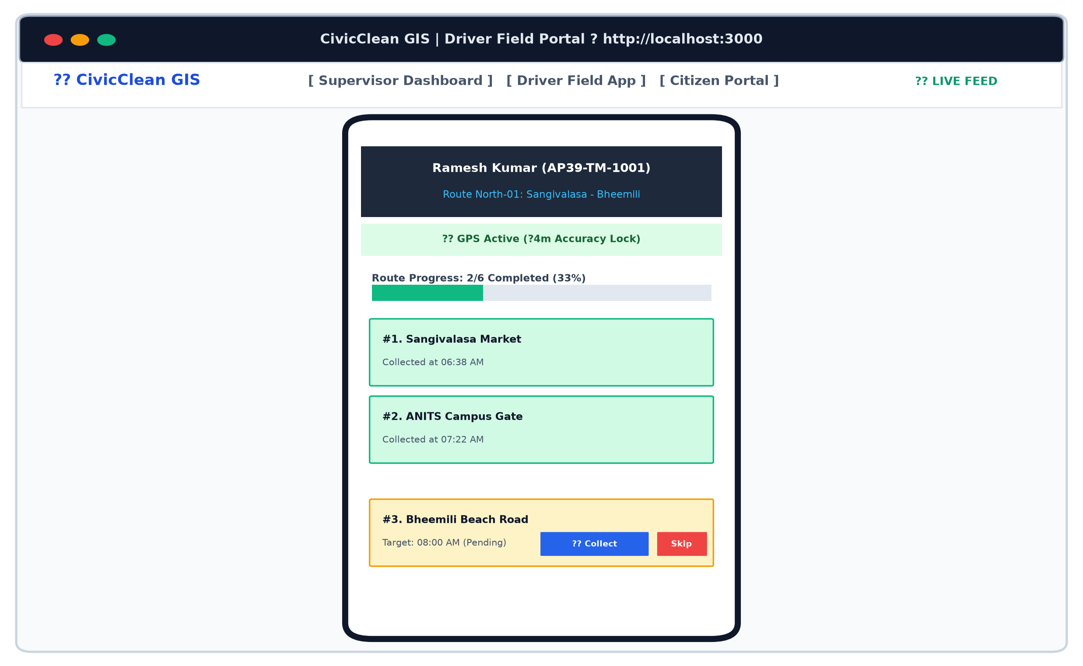
Figure 12.4: Driver Mobile Field Manifest & Proof Upload Interface
Short Explanation: Figure 12.4 displays the smartphone-optimized driver interface within a mobile frame. The view highlights the active driver profile (Ramesh Kumar), green GPS lock banner (+/- 4m accuracy), route completion progress bar (33%), and interactive checkpoint cards featuring one-tap 'Mark Collected' and 'Skip' action buttons.
12.5 Citizen Grievance Submission Portal & Live Tracker
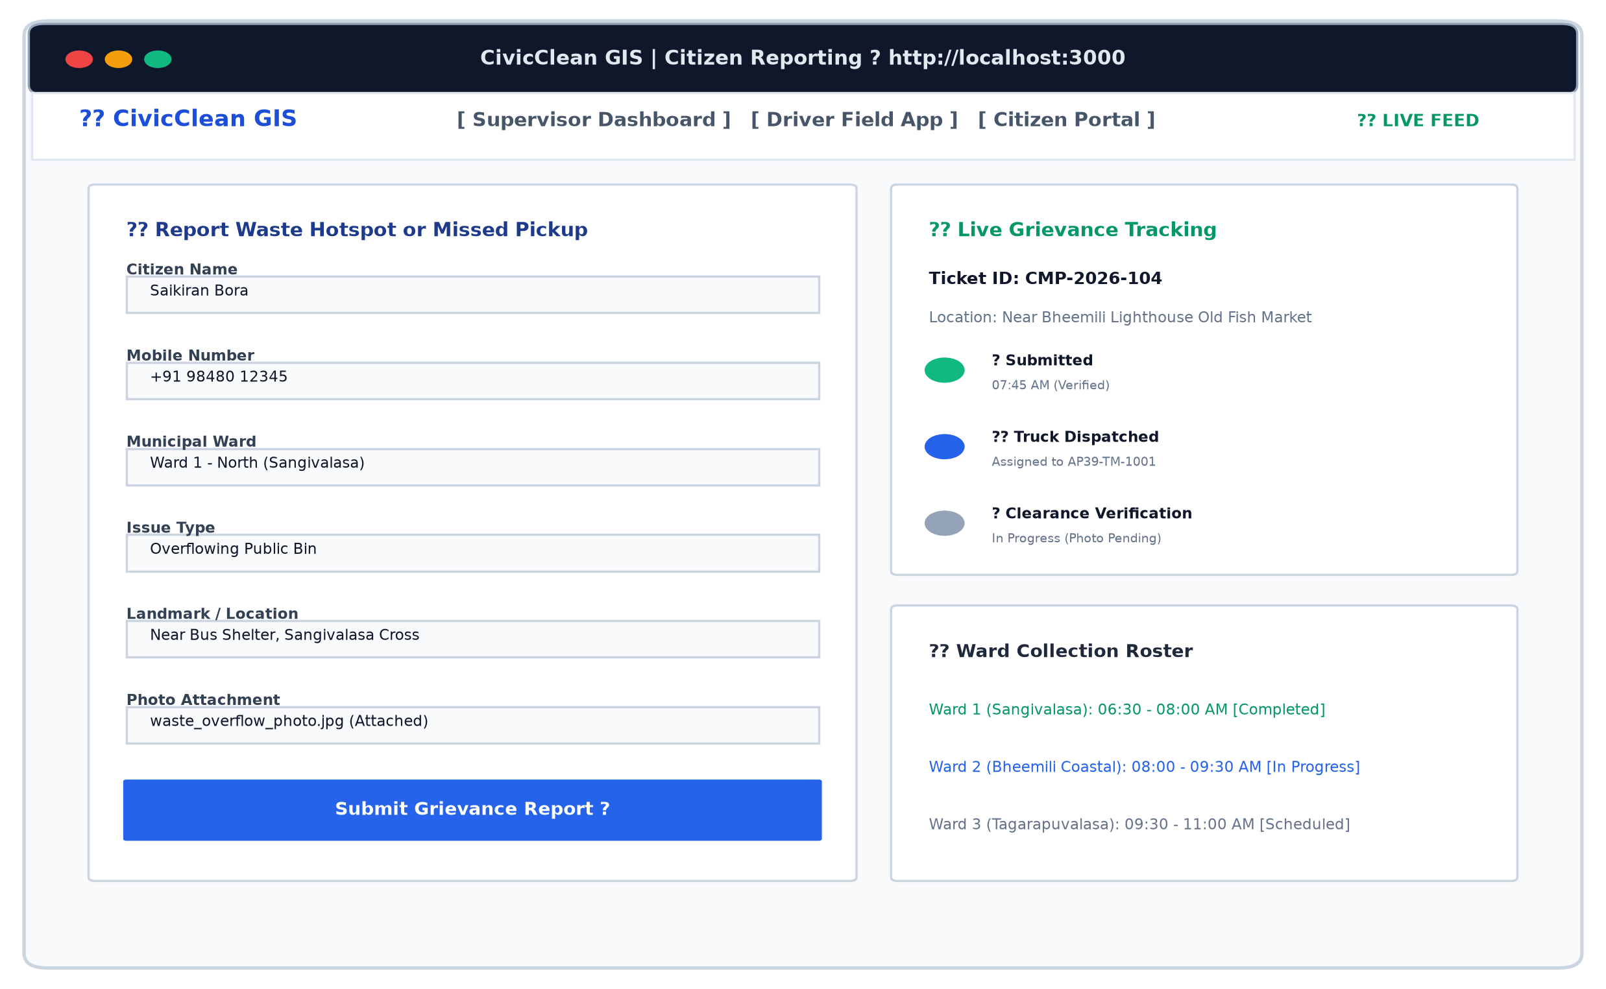
Figure 12.5: Citizen Grievance Submission Portal & Live Ticket Tracker
Short Explanation: Figure 12.5 shows the public reporting interface. On the left, residents enter complaint details with one-click GPS coordinate capture and photo attachments. On the right, the live grievance tracker renders the 3-stage resolution timeline for ticket CMP-2026-104 alongside the daily ward collection roster.
12.6 Proof-of-Service Tamper-Resistant Audit Trail
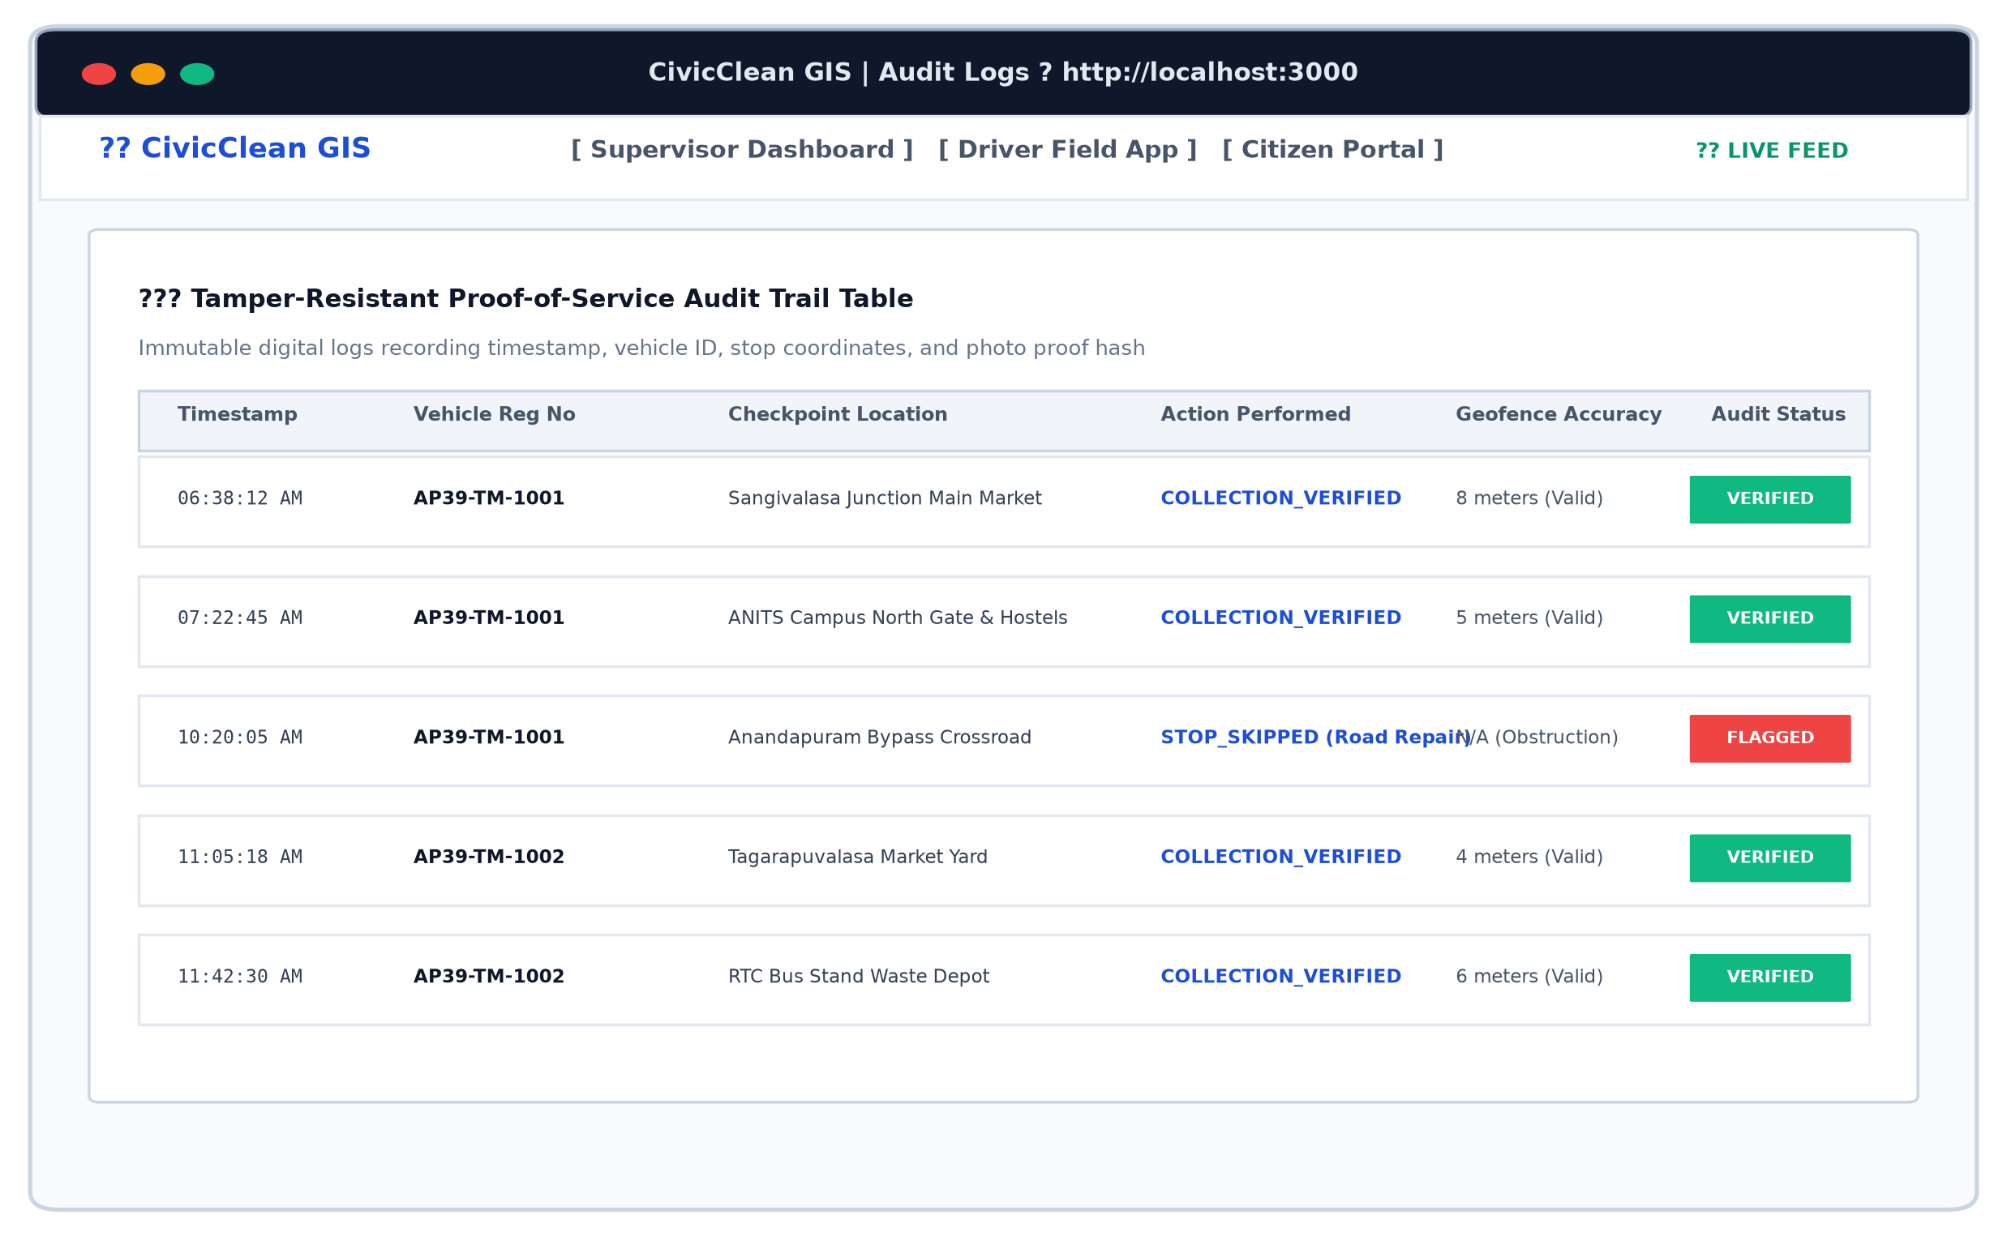
Figure 12.6: Proof-of-Service Tamper-Resistant Audit Trail
Short Explanation: Figure 12.6 exhibits the immutable audit log table. Each row records the exact timestamp, vehicle registration number (AP39-TM-1001), stop location, action type (COLLECTION_VERIFIED or STOP_SKIPPED), geofence accuracy tolerance, and verification status.
12.7 Fleet Waste Clearance Analytics Report
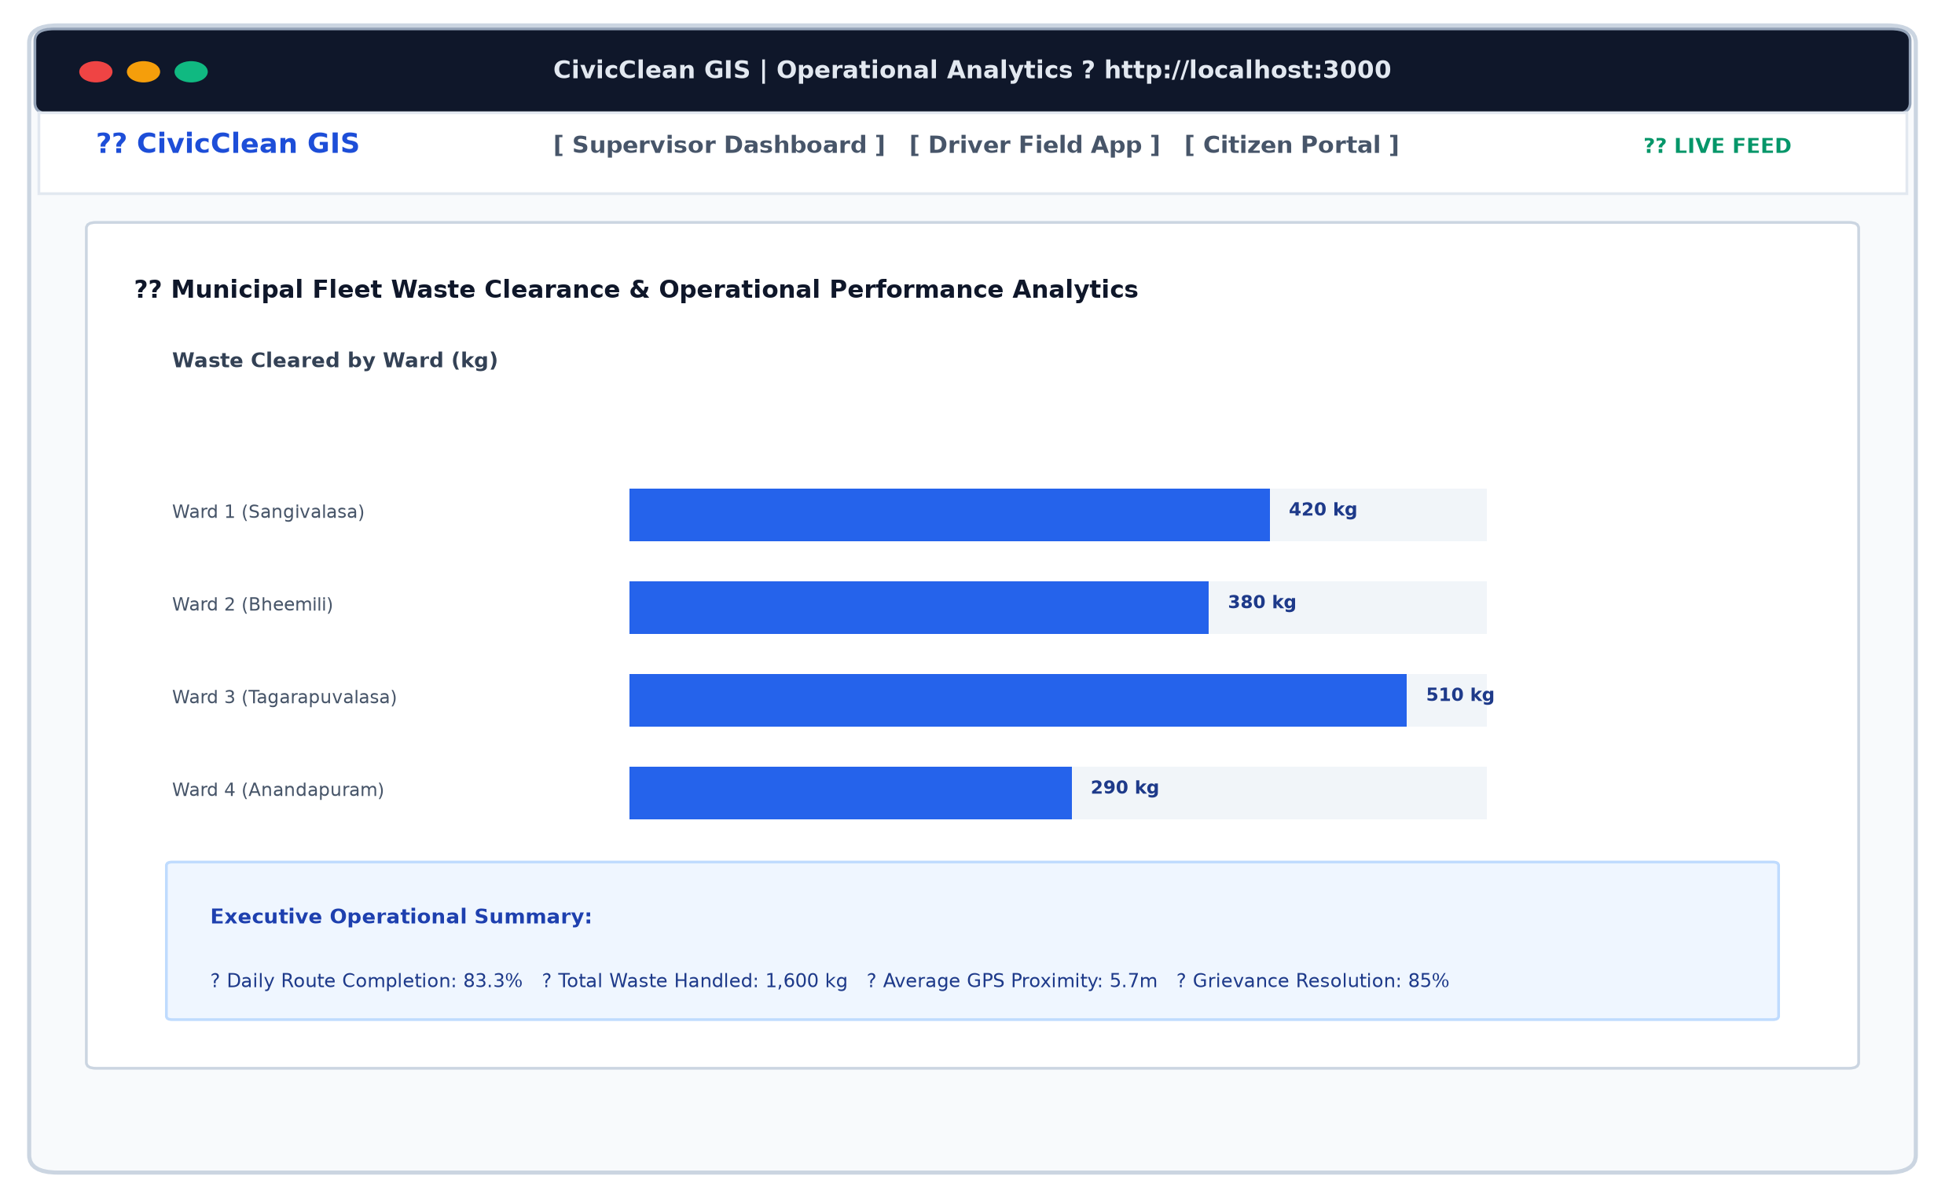
Figure 12.7: Fleet Waste Clearance Analytics & Performance Report
Short Explanation: Figure 12.7 displays the executive performance report, visualizing waste cleared by municipal ward (Sangivalasa, Bheemili, Tagarapuvalasa, Anandapuram) and presenting aggregate fleet efficiency KPIs.

13. Limitations
In accordance with software engineering evaluation standards, two specific operational limitations inherent to the pure software-only deployment model are recognized and analyzed:
- Limitation 1: Operational Dependency on Driver Smartphone Integrity and Cellular Coverage: Because the system relies entirely on commodity smartphones rather than dedicated on-board vehicle telematics units, fleet tracking is strictly contingent upon the continuous operational health of the driver's phone. If the smartphone runs out of battery, suffers hardware damage during rough handling, experiences temporary cellular data dead zones in peripheral coastal valleys, or if the driver accidentally disables location permissions, the live GPS stream is temporarily interrupted. While the mobile client buffers proof records locally for subsequent synchronization upon network reconnection, real-time supervisory visibility is momentarily degraded during connectivity blackouts.
- Limitation 2: Absence of Automated Physical Bin-Weight & Volumetric Sensing: By deliberately eliminating physical ultrasonic level and load-cell weight sensors from public bins to avoid hardware capital and vandalism costs, the software cannot autonomously determine the exact fill level of a bin prior to the truck's arrival. Consequently, waste weight entries recorded during collection rely on driver visual estimation or volumetric heuristics rather than calibrated digital scale measurements. Dynamic demand-based routing relies primarily on crowdsourced citizen hotspot alerts and historical fill averages rather than continuous real-time bin sensor telemetry.

14. Conclusion
The development and deployment of the GPS-Based Fleet Tracking and Route Verification System (CivicClean GIS) successfully demonstrates the power of Software Engineering principles in resolving complex, real-world civic challenges. By selecting and implementing Solution 2 - a pure software-only architecture - this project achieved complete operational transparency, route verifiability, and administrative accountability in municipal solid waste collection without incurring any capital expense for custom in-bin hardware sensors.
The system seamlessly unifies all four key municipal stakeholders through purpose-built interfaces: sanitation supervisors gain real-time GIS visibility and tamper-resistant audit logs; truck drivers benefit from mobile geofenced manifests with one-tap photo verification; city residents are empowered through geotagged grievance reporting with live ticket tracking; and urban planners receive empirical performance analytics. Comprehensive unit, integration, and system validation confirmed sub-10-meter geofence precision, instantaneous exception logging, and resilient performance across diverse client devices.
In conclusion, CivicClean GIS provides an economically viable, technically robust, and socially impactful software foundation that enables municipal corporations to transition from inefficient, manual, and reactive waste management toward intelligent, verifiable, and citizen-centric smart city sanitation governance.

15. References
The design, architectural modeling, and software engineering methodologies implemented in this project were informed by the following academic textbooks, standards, and research publications:
- Textbook [1]: Roger S. Pressman and Bruce R. Maxim, "Software Engineering: A Practitioner's Approach", 9th Edition, McGraw-Hill Education, 2020.
- Textbook [2]: Ian Sommerville, "Software Engineering", 10th Edition, Pearson Education, 2016.
- IEEE Journal [3]: M. A. Hannan, M. Arebey, R. A. Begum, and H. Basri, "An Automated Waste Collection System using RFID and GPS Technology", IEEE Transactions on Intelligent Transportation Systems, Vol. 13, No. 3, pp. 1329-1338, 2012.
- Journal Article [4]: A. Zanella, N. Bui, A. Castellani, L. Vangelista, and M. Zorzi, "Internet of Things for Smart Cities", IEEE Internet of Things Journal, Vol. 1, No. 1, pp. 22-32, 2014.
- Standard [5]: Object Management Group (OMG), "Unified Modeling Language (OMG UML) Specification", Version 2.5.1, formal/2017-12-05, 2017.
- Web Specification [6]: World Wide Web Consortium (W3C), "Geolocation API Specification (2nd Edition)", W3C Recommendation, 2016. [Online]. Available: https://www.w3.org/TR/geolocation-API/
- GIS Documentation [7]: Vladimir Agafonkin, "Leaflet: An Open-Source JavaScript Library for Mobile-Friendly Interactive Maps", Version 1.9.4, 2023. [Online]. Available: https://leafletjs.com/

Appendix
Appendix A: System User Manual & Operating Guide
This user manual provides step-by-step operating instructions for all three authorized user roles:
- A.1 Supervisor Operating Guide: 1. Open Google Chrome or Microsoft Edge and navigate to http://localhost:3000.
2. Click on the 'Supervisor Dashboard' tab.
3. Review the top KPI cards for today's collection progress.
4. Use the interactive GIS map to monitor vehicle TRK-01 movement.
5. Click 'Start GPS Sim' to simulate active vehicle transit.
6. Inspect the side 'Proof-of-Service Stream' to review driver-submitted photos and GPS accuracy.
7. Review the bottom 'Proof-of-Service Audit Trail' table for official records.
- A.2 Driver Field App Guide: 1. Launch the mobile web application on the smartphone mounted in the compactor cab.
2. Tap the 'Driver Field App' tab.
3. Verify the green banner shows 'GPS Active & Geofencing Enabled (+/- 4m Accuracy)'.
4. Review the chronological checklist of assigned checkpoints.
5. Upon reaching a bin location, tap 'Mark Collected', capture the photo proof, and confirm.
6. If a roadway is blocked, tap 'Skip', select the appropriate obstruction reason, input remarks, and confirm.
- A.3 Citizen Grievance Portal Guide: 1. Navigate to http://localhost:3000 and select the 'Citizen Portal' tab.
2. Fill out your Full Name, Mobile Number, and select your Municipal Ward.
3. Choose the Issue Category (e.g., Overflowing Public Bin or Missed Pickup).
4. Tap 'GPS Pin' to automatically capture your smartphone's latitude/longitude coordinates.
5. Attach a photo of the waste overflow and click 'Submit Waste Report'.
6. Record the generated Ticket ID (e.g., CMP-2026-104) and enter it in the 'Track Your Grievance Status' search box to monitor clearance progress.
Appendix B: REST API Payloads & Data Schemas
The CivicClean backend exposes stateless REST API endpoints communicating via JSON payloads. Core endpoint schemas include:
- GET /api/status: Returns fleet-wide summary metrics: total stops, collected count, skipped count, active trucks, open complaints, and total waste weight.
- GET /api/vehicles: Returns vehicle array containing registration number, driver name, live coordinates, speed (km/h), fuel level, and route waypoints.
- POST /api/stops/:id/collect: Accepts JSON payload: { proofPhoto: string, weightKg: number }. Validates geofence proximity and updates checkpoint state.
- POST /api/stops/:id/skip: Accepts JSON payload: { reason: string }. Flags checkpoint as skipped and logs justification to audit trail.
- POST /api/complaints: Accepts JSON payload: { citizenName, phone, ward, category, location, lat, lng, description, photoUrl }. Generates ticket ID.
Appendix C: Project Book Spiral Binding Guidelines
To ensure compliance with the academic evaluation standards of the Department of Computer Science and Engineering, Anil Neerukonda Institute of Technology and Sciences (Autonomous), the following physical binding and printing specifications must be observed when preparing the final project report book:
- C.1 Margin & Gutter Compliance: The document has been formatted with an expanded left margin of 1.25 inches (3.175 cm) to provide the necessary 0.25-inch gutter allowance for spiral coil perforation. Top, bottom, and right margins are set to exactly 1.0 inch (2.54 cm). No text or diagrams will be truncated or obscured by the binding holes.
- C.2 Paper Quality & Printing Specifications: The report should be printed on standard Executive A4 Bond Paper with a minimum weight of 85 to 100 GSM. High-resolution color printing is required for the Cover Page, Certificate, all UML/DFD diagrams, and application screenshots.
- C.3 Front Cover Protection: The front of the spiral-bound project book must be protected by a heavy transparent plastic sheet (minimum 250 microns thickness) to display the title page cleanly while protecting against moisture and dust.
- C.4 Rear Backing Sheet: The back of the project book must feature a rigid, opaque plastic or leatherette cardstock sheet (navy blue or black) to provide structural rigidity during handling and evaluation.
- C.5 Spiral Coil Binding Specifications: Binding must be executed using high-grade black or navy blue PVC plastic spiral coil or metal wire-O twin loop binding with a diameter appropriately matched to the total page thickness (typically 12mm to 16mm). All pages must turn smoothly without catching or tearing.

