Q) Why does any html element require 'padding' & 'border'? Would margin that creates white space between any two boxes do not suffice? http://stackoverflow.com/questions/32631922/why-does-any-html-element-require-padding-border

A) Not if you also need a border, or some padding.
Though it is true that both margin and padding create space, there is a difference between where they create space. And that difference is the border.
A border, as the word already implies, is to create a visible border. Padding creates space between said border and the content within. But padding can also be used to create some room around an element when it has a background, for example.
To better illustrate the differences, I'll create a couple of snippets:
This snippet has no border, margin or padding, so no spacing.

.row {
background: red;
}

.column {
background: green;
}

.blue {
background: blue;
}

<div class="row">
<div class="column">
Some text
</div>
<div class="column blue">
Some other text
</div>
</div>

This snippet has margins, giving it some space around the element, which is evident because of the background colors.

.row {
background: red;
}

.column {
margin: 10px;
background: green;
}

.blue {
background: blue;
}

<div class="row">
<div class="column">
Some text
</div>
<div class="column blue">
Some other text
</div>
</div>

This example has both a margin and a border, giving you a wider range of coloring options, as well as more space. Yet, you would be unable to give the different spaces a different color with just a margin.

.row {
background: red;
}

.column {
margin: 10px;
border: 5px solid purple;
background: green;
}

.blue {
background: blue;
}

<div class="row">
<div class="column">
Some text
</div>
<div class="column blue">
Some other text
</div>
</div>

This last example has it all. As you can see, the padding creates space within the box, inside of the border. Added to that, you can also see more of the background color of the element.

.row {
background: red;
}

.column {
margin: 10px;
border: 5px solid purple;
padding: 20px;
background: green;
}

.blue {
background: blue;
}

<div class="row">
<div class="column">
Some text
</div>
<div class="column blue">
Some other text
</div>
</div>

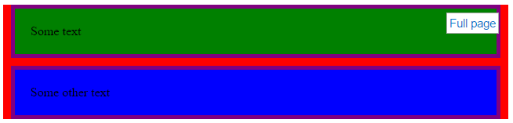

Q) Why margins collapse?

A)

Each one of those properties controls a different aspect of the box.
Margin
The margin clears an area around an element (outside the border). The margin does not have a background color, and is completely transparent. The top, right, bottom, and left margin can be changed independently using separate properties. A shorthand margin property can also be used, to change all margins at once.
Padding
The padding clears an area around the content (inside the border) of an element. The padding is affected by the background color of the element. The top, right, bottom, and left padding can be changed independently using separate properties. A shorthand padding property can also be used, to change all paddings at once.
Border
The CSS border properties allow you to specify the style, size, and color of an element's border.

To better illustrate the differences, below are the couple of snippets:

1) This snippet has no border, margin or padding, so no spacing.

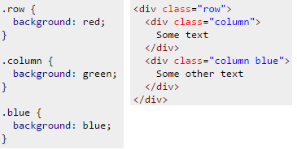

2) This snippet has margins, giving it some space around the element, which is evident because of the background colors.

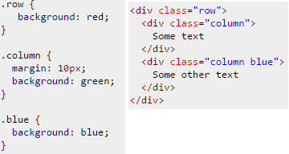

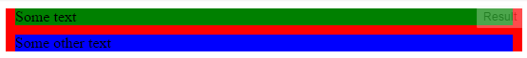

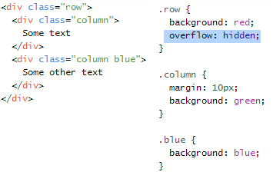

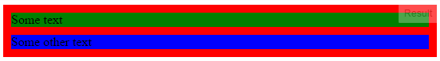

Here are the relevant points from the W3C spec:

8.3.1 Collapsing margins
In CSS, the adjoining margins of two or more boxes (which might or might not be siblings) can combine to form a single margin. Margins that combine this way are said to collapse, and the resulting combined margin is called a collapsed margin.
Adjoining vertical margins collapse [...]
Two margins are adjoining if and only if:
- both belong to in-flow block-level boxes that participate in the same block formatting context
- no line boxes, no clearance, no padding and no border separate them
- both belong to vertically-adjacent box edges, i.e. form one of the following pairs:
  - top margin of a box and top margin of its first in-flow child
The reason why doing any of the following prevents the margin from collapsing:
- Floating either of your div elements
- Making either of your div elements inline blocks
- Setting overflow of #outer to auto (or any value other than visible)
Is because:
- Margins between a floated box and any other box do not collapse (not even between a float and its in-flow children).
- Margins of elements that establish new block formatting contexts (such as floats and elements with 'overflow' other than 'visible') do not collapse with their in-flow children.
- Margins of inline-block boxes do not collapse (not even with their in-flow children).
The left and right margins behave as you expect because:
Horizontal margins never collapse.

Q) When to use margin vs padding in CSS
A) To me the biggest difference between padding and margin is that margins auto-collapse, and padding doesn't. Consider two elements next to each other each with padding of 1em. This padding is considered to be part of the element, and is always preserved. So you will end up with the content of the first element, followed by the padding of the first element, followed by the padding of the second, followed by the content of the second element. Thus content of the two elements will end up being 2em apart.
Now replace that padding with 1em margin. Margins are considered to be outside of the element, and margins of adjacent items will overlap. So in this example you will end up with the content of the first element followed by 1em of combined margin followed by the content of the second element. So the content of the two elements is only 1em apart.
This can be really useful when you know that you want say 1em of spacing around an element, regardless of what element it is next to.
The other two big differences is that padding is included in the click region and background color/image, but not the margin.
By default I use margin everywhere, except when I have a border or background and want to increase the space inside that visible box.

Margin is on the outside of block elements while padding is on the inside.
- Use margin to separate the block from things outside it
- Use padding to move the contents away from the edges of the block.
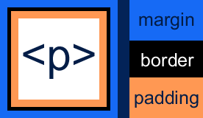

By default,
Width of an element = (left border width + left padding width + content width + right padding width + right border width)
Height of an element = (top border height + top padding height + content height + bottom padding height + bottom border height)
Below is the diagram for the same.

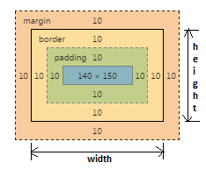
width of an element = (10+10+140+10+10)
height of an element = (10+10+150+10+10)

The box-sizing property is used to alter the default CSS box model used to calculate widths and heights of elements. It is possible to use this property to emulate the behavior of browsers that do not correctly support the CSS box model specification.

Syntax
box-sizing: content-box;
box-sizing: border-box;

box-sizing: inherit;

Values
content-box
This is the default style as specified by the CSS standard. The width and height properties are measured including only the content, but not the padding, border or margin. Note: Padding, border & margin will be outside of the box e.g. IF .box {width: 350px}; THEN you apply {border: 10px solid black;} RESULT {rendered in the browser} .box {width: 370px;}

border-box
The width and height properties include the padding and border, but not the margin. This is the box model used by Internet Explorer when the document is in Quirks mode. Note that padding and border will be inside of the box e.g. .box {width: 350px; border: 10px solid black;} lead to a box rendered in the browser of width: 350px. The content box can't be negative and is floored to 0 making it impossible to use border-box to make the element disappear.
Border and padding goes within the box, when this values is applied.

Learn CSS Layout

no layout:
Having no layout whatsover is almost ok if all you want is one big column of content. However, if a user makes the browser window really wide, it gets kind of annoying to read: after each line your eyes have a long distance to travel right-to-left to the next line. Try resizing your browser to see what I mean!
Before we fix this problem, let's make sure we're clear on the very important display property.

the "display" property:

display is CSS's most important property for controlling layout. Every element has a default display value depending on what type of element it is. The default for most elements is usually block or inline. A block element is often called a block-level element. An inline element is always just called an inline element.

block

div is the standard block-level element. A block-level element starts on a new line and stretches out to the left and right as far as it can. Other common block-level elements are pand form, and new in HTML5 are header, footer, section, and more.

inline

span is the standard inline element. An inline element can wrap some text inside a paragraph <span> like this </span> without disrupting the flow of that paragraph. The a element is the most common inline element, since you use them for links.

none
Another common display value is none. Some specialized elements such as scriptuse this as their default. It is commonly used with JavaScript to hide and show elements without really deleting and recreating them.
This is different from visibility. Setting display to none will render the page as though the element does not exist. visibility: hidden; will hide the element, but the element will still take up the space it would if it was fully visible.

Example:

<!DOCTYPE html>

<html>

<head>

<style>

span{

display: block

}

p{

display: inline

}

</style>

</head>

<body>

<span>This is a paragraph.</span>

<span>This is a paragraph.</span>

<p>This is a paragraph.</p>

<p>This is a paragraph.</p>

<p>This is a paragraph.</p>

</body>

</html>

Example:
display:none means that the tag in question will not appear on the page at all (although you can still interact with it through the dom). There will be no space allocated for it between the other tags.
visibility:hidden means that unlike display:none, the tag is not visible, but space is allocated for it on the page. The tag is rendered, it just isn't seen on the page.
For example:
test | <span style="[style-tag-value]">Appropriate style in this tag</span> | test
Replacing [style-tag-value] with display:none results in:
test | | test
Replacing [style-tag-value] with visibility:hidden results in:
test | | test
Flexbox layout:

margin: auto;
Setting the width of a block-level element will prevent it from stretching out to the edges of its container to the left and right. Then, you can set the left and right margins to auto to horizontally center that element within its container. The element will take up the width you specify, then the remaining space will be split evenly between the two margins.
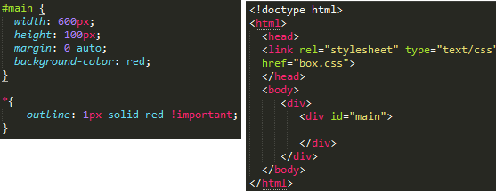

The only problem occurs when the browser window is narrower than the width of your element. The browser resolves this by creating a horizontal scrollbar on the page. Let's improve the situation...
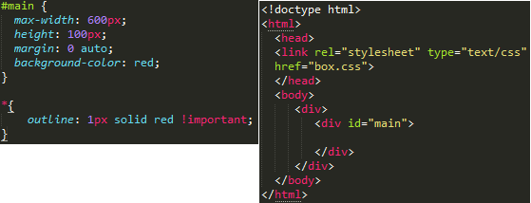

Using max-width instead of width in this situation will improve the browser's handling of small windows. This is important when making a site usable on mobile. Resize this page to check it out!
By the way, max-width is supported by all major browsers including IE7+ so you shouldn't be afraid of using it.

the box model:

While we're talking about width, we should talk about width's big caveat: the box model. When you set the width of an element, the element can actually appear bigger than what you set: the element's border and padding will stretch out the element beyond the specified width. Look at the following example, where two elements with the same width value end up different sizes in the result.
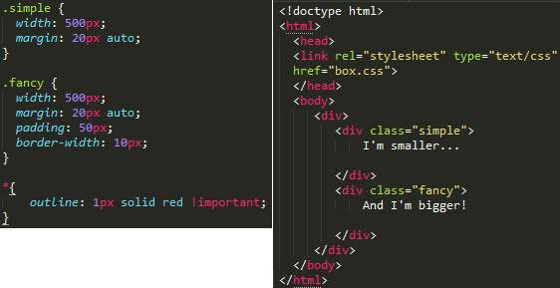
For generations, the solution to this problem has been math. CSS authors have always just written a smaller width value than what they wanted, subtracting out the padding and border. Thankfully, you don't have to do that anymore...
box-sizing
Over the generations, people realized that math is not fun, so a new CSS property called box-sizing was created. When you set box-sizing: border-box; on an element, the padding and border of that element no longer increase its width. Here is the same example as the previous page, but with box-sizing: border-box; on both elements:
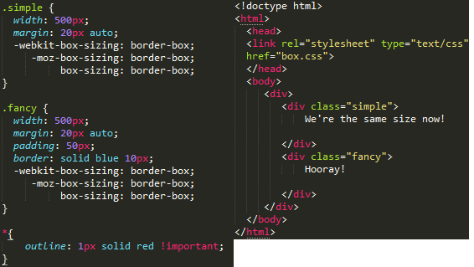
Since this is so much better, some authors want all elements on all their pages to always work this way. Such authors put the following CSS on their pages:
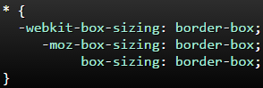
This ensures that all elements are always sized in this more intuitive way.
Since box-sizing is pretty new, you should use the -webkit- and -moz- prefixes for now, as I have in these examples. This technique enables experimental features in specific browsers. Also, keep in mind that this one is IE8+.

position
In order to make more complex layouts, we need to discuss the position property. It has a bunch of possible values, and their names make no sense and are impossible to remember. Let's go through them one by one, but maybe you should bookmark this page too.
Static
Any element in html does have position static. Its the default selector. Its the normal behavior of elements.

+++++++++
Difference between style = "position:absolute" and style = "position:relative" and how they differ in case I add it to div/span/input elements?
Absolute positioning means that the element is taken completely out of the normal flow of the page layout. As far as the rest of the elements on the page are concerned, the absolutely positioned element simply doesn't exist. The element itself is then drawn separately, sort of "on top" of everything else, at the position you specify using the left, right, top and bottom attributes.
Using the position you specify with these attributes, the element is then placed at that position within it's last ancestor element which has a position attribute of anything other than static (static is the positioning elements use if they have no position attribute specified), or the document body (browser viewport) if no such ancestor exists.
For example, if I had this code:
<body>
<div style="position:absolute; left: 20px; top: 20px;"></div>
</body>
...then the <div> would be positioned 20 px from the top of the browser viewport, and 20px from the left edge of same.
However, if I did something like this:
<div id="outer" style="position:relative">
<div id="inner" style="position:absolute; left: 20px; top: 20px;"></div>
</div>
...then the inner div would be positioned 20px from the top of the outer div, and 20px from the left edge of same, because the outer div isn't positioned with position:static because we've explicitly set it to use position:relative.
Relative positioning, on the other hand, is just like stating no positioning at all, but the left, right, top and bottom attributes "nudge" the element out of their normal layout. The rest of the elements on the page still get laid out as if the element was in its normal spot though.

For example, if I had this code:
<span>Span1</span>
<span>Span2</span>
<span>Span3</span>
...then all three <span> elements would sit next to each other without overlapping.
If I set the second <span> to use relative positioning, like this:
<span>Span1</span>
<span style="position: relative; left: -5px;">Span2</span>
<span>Span3</span>
...then Span2 would overlap the right side of Span1 by 5px. Span1 and Span3 would sit in exactly the same place as they did in the first example, leaving a 5px gap between the right side of Span2 and the left side of Span3.
Position static does not do much. since it just default behavior. Position absolute or relative search for an anchor upwards in the dom until they find a not static element or the body
Hope that clarifies things a bit.
+++++++++++

