Supermarket Sales Analysis
Data Analytics Project Report

Submitted by: Sai Kiran Ippili
Tools: Python · pandas · Matplotlib · Seaborn · Jupyter Notebook
Dataset: 500 supermarket transactions (Jan – Jul 2026)

1. Problem Statement
The aim of this project is to analyse supermarket sales data and find useful information about products, branches, categories, customers, payments and ratings. The findings are then converted into practical business decisions that can help the supermarket manage stock, branches, payments and customer relationships.

2. Dataset Description
The dataset contains 500 sales transactions recorded between 1 January 2026 and 1 July 2026 across four branches. It was loaded from SUPER_MARKET_DATA.xlsx (sheet supermarket_sales_500_rows). The original data is also available in the project Google Sheet.
Column | Type | Description
Invoice ID | Identifier | Unique transaction number (INV0001 – INV0500)
Date | Date | Date of the sale
Branch / City | Categorical | Branch A–D: Jaipur, Delhi, Mumbai, Bengaluru
Customer Type | Categorical | Member or Normal
Gender | Categorical | Female or Male
Product | Categorical | 20 different products
Category | Categorical | 8 categories (e.g. Beverages, Dairy, Grocery)
Quantity | Numeric | Units bought (1 – 10)
Unit Price | Numeric | Price per unit in ₹ (27.67 – 236.71)
Payment | Categorical | UPI, Net Banking, Card, Cash
Rating | Numeric | Customer rating (3.0 – 5.0)
Sales | Numeric | Quantity × Unit Price, in ₹

3. Steps Used for Analysis
- Collect and load the dataset into a pandas DataFrame.
- Check the data for missing or incorrect values.
- Calculate (validate) Sales = Quantity × Unit Price.
- Group and summarise the data using totals, counts and averages.
- Create charts to compare the results.
- Use the results to make business decisions.

4. Data Understanding and Quality Check
Before any analysis, the data was checked for problems. The results of each check are shown below.
Check | Result
Missing values (all 13 columns) | None found
Duplicate rows / duplicate Invoice IDs | 0 / 0
Quantity or Unit Price ≤ 0 | 0 rows
Rating outside the 1–5 range | 0 rows
Branch ↔ City mapping | One-to-one (A–Jaipur, B–Delhi, C–Mumbai, D–Bengaluru)
Product ↔ Category mapping | Every product belongs to exactly one category
Recalculated Quantity × Unit Price vs Sales | 0 mismatches — the Sales column is correct

Conclusion: the dataset is clean and no rows had to be removed or corrected. One point to keep in mind is that July 2026 contains data for only one day (1 July), so it is a partial month.

Overall summary
Measure | Value
Total transactions | 500
Total sales | ₹244,411.08
Average transaction value | ₹488.82
Total units sold | 2,768
Average customer rating | 3.99 / 5

5. Live Analysis

5.1 Which product generates the highest sales?
Cheese generated the highest sales: ₹27,906.30. Coffee (₹27,694.87) and Shampoo (₹27,497.48) are very close behind, so the top three products are almost level. Together the top four products (adding Cooking Oil) account for about 43% of all sales.
Rank | Product | Total Sales (₹)
1 | Cheese | 27,906.30
2 | Coffee | 27,694.87
3 | Shampoo | 27,497.48
4 | Cooking Oil | 21,525.06
5 | Tea | 17,681.59
6 | Apples | 17,057.41
7 | Face Wash | 11,946.85
8 | Rice | 11,754.17
9 | Cold Drink | 10,731.78
10 | Eggs | 10,429.77
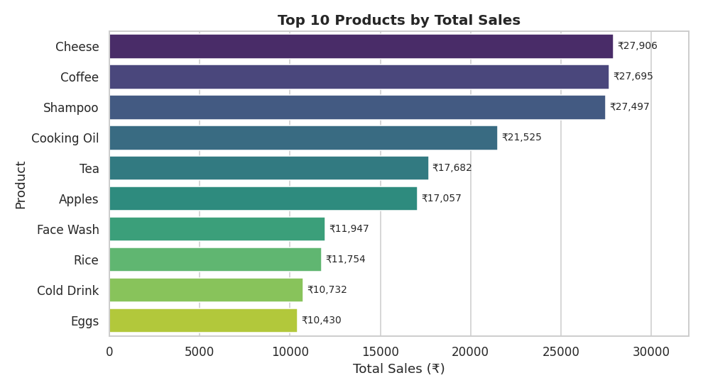
Figure 1: Top 10 products by total sales

5.2 Which branch performs best?
Branch C (Mumbai) performed best with sales of ₹72,469.45 from 143 transactions. It also has the highest average transaction value (₹506.78). Branch A (Jaipur) is the lowest at ₹52,357.08 and also has the lowest average rating (3.84).
Branch | City | Total Sales (₹) | Transactions | Avg Sale (₹) | Avg Rating
C | Mumbai | 72,469.45 | 143 | 506.78 | 4.05
B | Delhi | 64,116.26 | 133 | 482.08 | 3.98
D | Bengaluru | 55,468.29 | 119 | 466.12 | 4.09
A | Jaipur | 52,357.08 | 105 | 498.64 | 3.84
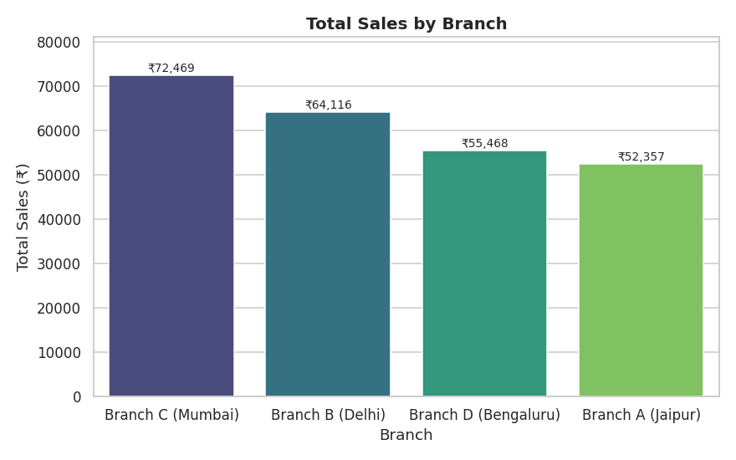
Figure 2: Total sales by branch
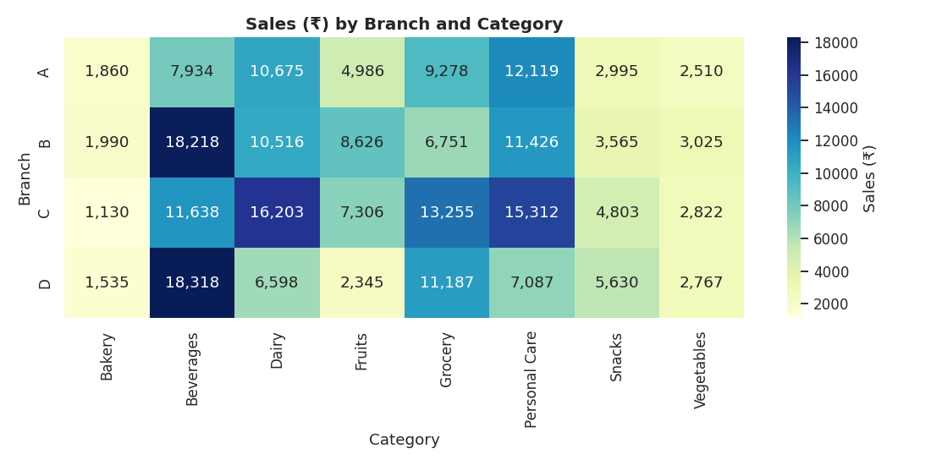
Figure 3: Sales by branch and category — Beverages are strongest in Branches B and D, Personal Care and Dairy in Branch C

5.3 Which category sells the most?
Beverages had the highest sales with ₹56,108.24 (23% of total sales). Beverages, Personal Care and Dairy together contribute about 60% of sales. Bakery and Vegetables are the weakest categories.
Category | Total Sales (₹) | Transactions | Units | Share %
Beverages | 56,108.24 | 82 | 465 | 23.0
Personal Care | 45,943.96 | 73 | 399 | 18.8
Dairy | 43,992.00 | 68 | 345 | 18.0
Grocery | 40,470.47 | 82 | 439 | 16.6
Fruits | 23,263.17 | 44 | 223 | 9.5
Snacks | 16,992.97 | 75 | 443 | 7.0
Vegetables | 11,124.17 | 48 | 290 | 4.6
Bakery | 6,516.10 | 28 | 164 | 2.7
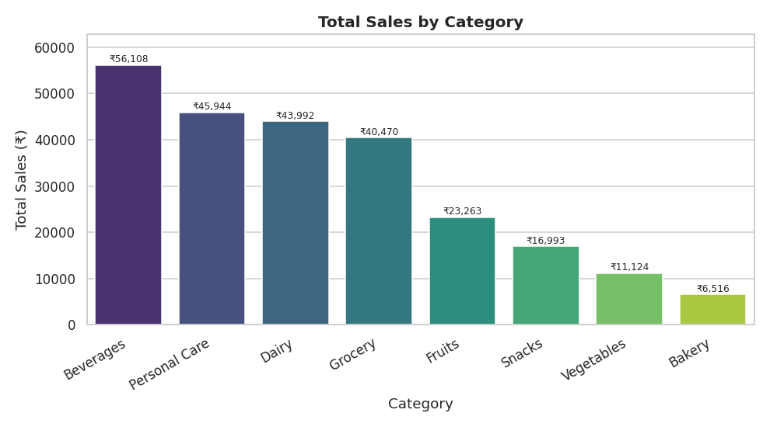
Figure 4: Total sales by category

5.4 What is the most popular payment method?
UPI was the most used payment method with 127 transactions. However, the margin is very small: Net Banking has 126, Card 125 and Cash 122. Customers use all four methods almost equally.
Payment Method | Transactions | Share %
UPI | 127 | 25.4
Net Banking | 126 | 25.2
Card | 125 | 25.0
Cash | 122 | 24.4
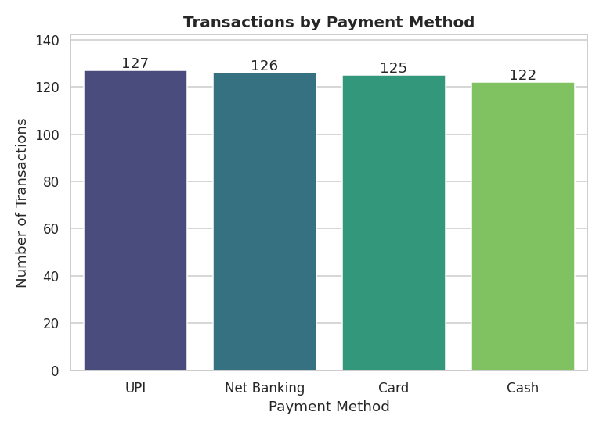
Figure 5: Transactions by payment method

5.5 Do Members spend more than Normal customers?
No. The average Member transaction was ₹483.14, while Normal customers averaged ₹497.07. Members make up more of the transactions (296 vs 204), but they do not spend more per visit. A Welch t-test gives p = 0.73, so the ₹14 gap is not statistically significant — in practice the two groups spend about the same.
Customer Type | Transactions | Total Sales (₹) | Avg Sale (₹) | Median Sale (₹)
Member | 296 | 143,009.30 | 483.14 | 314.46
Normal | 204 | 101,401.78 | 497.07 | 352.56
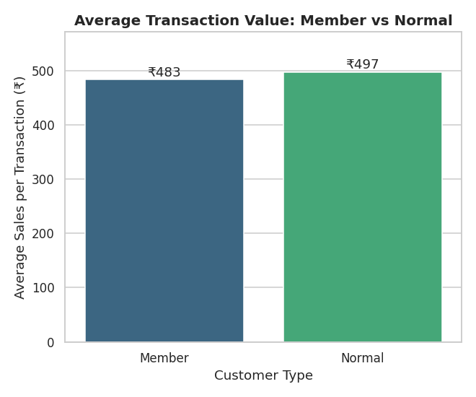
Figure 6: Average transaction value — Member vs Normal

5.6 What is the average customer rating?
The average customer rating was 3.99 out of 5. Ratings range from 3.0 to 5.0 and are spread fairly evenly across that range. Branch D (4.09) and Branch C (4.05) score highest, while Branch A (3.84) is lowest.
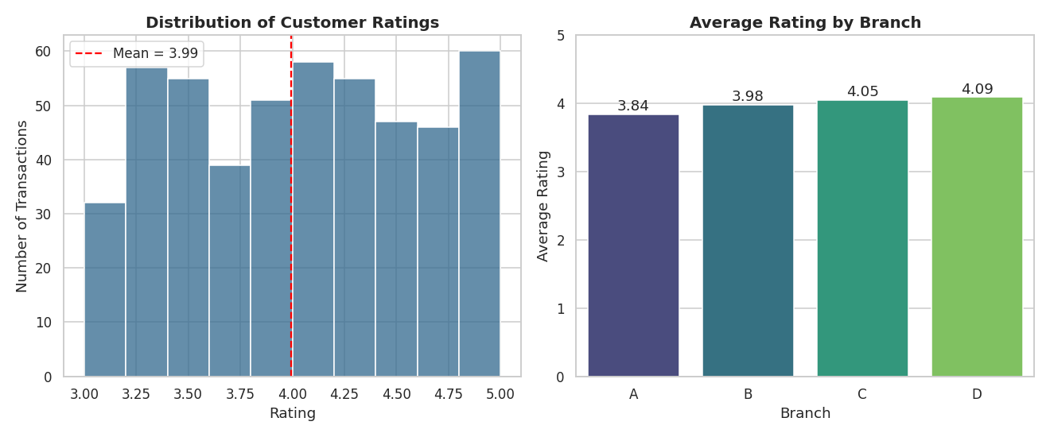
Figure 7: Rating distribution and average rating by branch

5.7 Additional analysis: monthly sales trend
Sales peaked in April 2026 (₹52,569.77) and were lowest among full months in February (₹30,068.15). July contains only 1 July, so its figure (₹3,467.44) reflects missing data rather than a sales fall.
Month | Sales (₹) | Transactions
2026-01 | 43,415.53 | 88
2026-02 | 30,068.15 | 65
2026-03 | 37,306.42 | 83
2026-04 | 52,569.77 | 90
2026-05 | 42,542.31 | 85
2026-06 | 35,041.46 | 82
2026-07 (1 day only) | 3,467.44 | 7
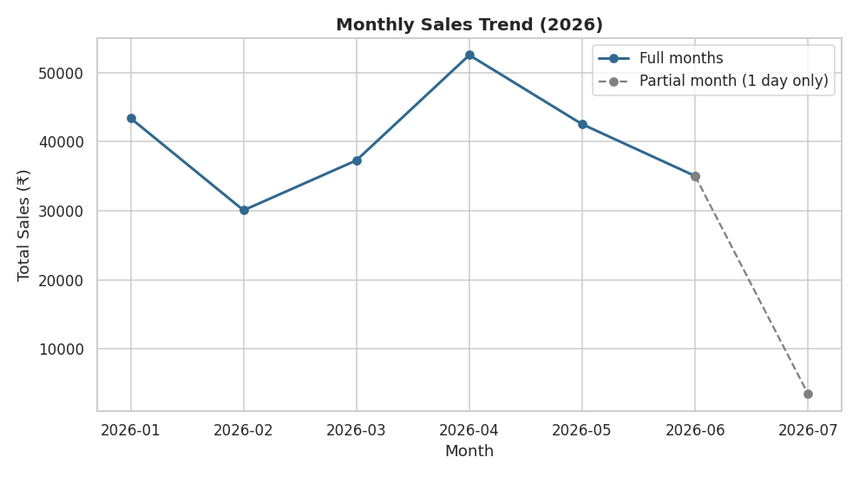
Figure 8: Monthly sales trend (July is a partial month)

6. Summary of Findings
Question | Answer
Highest-selling product | Cheese — ₹27,906.30
Best branch | Branch C (Mumbai) — ₹72,469.45
Top category | Beverages — ₹56,108.24
Most popular payment method | UPI — 127 transactions
Do Members spend more? | No — ₹483.14 vs ₹497.07 per transaction
Average rating | 3.99 out of 5

7. Business Decisions
- Prioritise stock of best sellers. Keep more stock of Cheese, Coffee, Shampoo and Cooking Oil, and of the Beverages, Personal Care and Dairy categories, which drive most of the revenue.
- Learn from Branch C (Mumbai). Study its layout, staffing and promotions, and apply the useful practices at Branch A (Jaipur), the lowest-selling branch.
- Keep all payment options and promote UPI. UPI leads, but the other methods are almost equal, so none should be dropped. UPI cashback offers could speed up checkout.
- Improve customer service. The average rating is 3.99/5; start with Branch A (3.84) through staff training and quicker service.
- Redesign the membership programme. Members do not spend more per visit, so offers should reward larger baskets (for example a discount above a spend threshold) instead of blanket discounts.
- Review weak categories. Bakery and Vegetables contribute the least; test bundles and promotions before reducing shelf space.

8. Limitations
- The data covers only about six months and 500 transactions, so patterns may not hold for a full year.
- July 2026 is a partial month (1 day) and should not be used for trend conclusions.
- The data shows what happened, not why — reasons such as promotions or staffing differences would need further data.
- Differences such as Member vs Normal spending and between payment methods are small and may be due to chance.

9. Conclusion
This analysis shows how sales data can be converted into simple insights that help a supermarket understand performance and make better decisions. Beverages, Personal Care and Dairy lead the categories, Branch C (Mumbai) is the strongest branch, customers use all payment methods almost equally, and membership does not currently increase spending per visit. Acting on these findings can improve stock planning, branch performance, customer service and membership offers.

