DEPARTMENT OF CSE, CS&IT, AI&DS
COURSE CODE: 24SDCS02 / 24SDCS02E / 24SDCS02P / 24SDCS02L
FULL STACK APPLICATION DEVELOPMENT
Name: KANAKALA SAIKIRAN ID: 2400030639

#SKILL - 1 ➔ Git Version Control
Prerequisites:
• Basic knowledge of Git commands
• Ability to create and edit project files
• Understanding of version control basics

The development team wants to manage their project using Git to maintain a structured and
collaborative workflow. In this lab, you will simulate a real-world version control process: creating
project files, tracking and committing changes, using GitHub as remote storage, working with multiple
branches, and handling merge conflicts. This helps you understand how developers work together
efficiently in software projects.
Tasks:
1. Create a new project folder, initialize Git using git init, and configure Git with your
username and email.
2. Create two files (example: main.java, notes.txt) with sample content, check the repository
status, and add them to staging.
3. Commit the staged files with a meaningful commit message.
4. Create a new repository on GitHub, connect your local repo using the remote URL and push
the committed changes.
5. Create the first branch (example: feature-update), make modifications, and add + commit
the changes.
6. Create a second branch (example: bug-fix), apply changes, and add + commit them.
7. Switch back to the main branch and merge both branches one after the other.
8. If any merge conflict occurs, resolve it manually, commit the fix, and complete the merge.

Main.Java
class Main {
public static void main(String[] args) {
<<<<<<< HEAD
System.out.println("Feature update added");
=======
System.out.println("Bug fixed in output");
>>>>>>> bug-fix
}
}

Outputs:

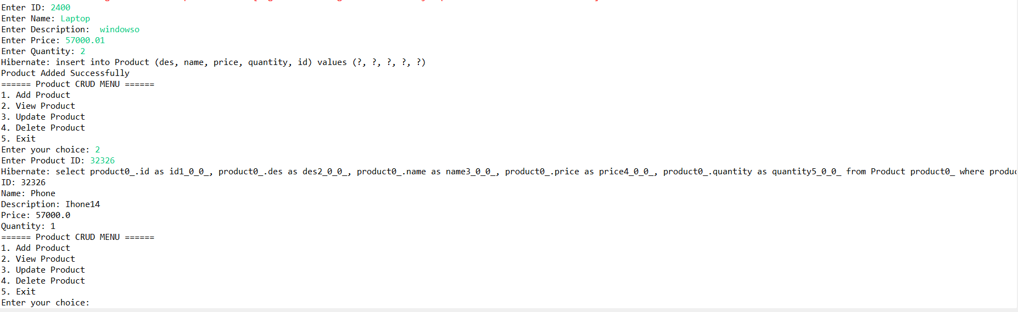

- Push the Hibernate project into a single GitHub repository.

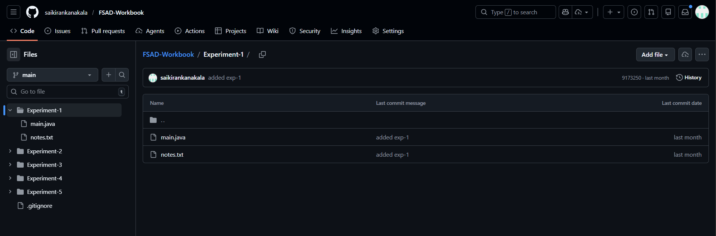

VIVA QUESTIONS:

1. Why is Git used in development?
2. What information is stored in Git configuration?
3. What is Maven and why is it used?
4. What is the role of the POM.xml file?
5. Explain Maven Build Life Cycle.

(For Evaluator’s use only)
Comment of the Evaluator (if Any)

Evaluator’s Observation
Marks Secured: out of
EMP ID & Full Name of the Evaluator:

Signature of the Evaluator Date of Evaluation

Date of the Session: / / Time of The Session: to

