DEPARTMENT OF CSE, CS&IT, AI&DS
COURSE CODE: 24SDCS02 / 24SDCS02E / 24SDCS02P / 24SDCS02L
FULL STACK APPLICATION DEVELOPMENT
Name: KANAKALA SAIKIRAN ID: 2400030639

#SKILL - 3 ➔ Working with HQL - Sorting, Pagination & Aggregates
Prerequisites:
• Basic knowledge of Hibernate
• Basic idea of HQL syntax
In this lab, you will extend the Hibernate module created in Skill 2 and perform advanced data
retrieval using HQL, including sorting, pagination, filtering, and aggregate functions. These
operations help in retrieving structured and meaningful data from the database using Hibernate.
Tasks:
1. Use the Product entity created in Skill 2.
2. Add 5–8 additional Product records into the database.
3. Write HQL queries to retrieve all products sorted by price:
a. Ascending order
b. Descending order
4. Write an HQL query to sort products by quantity (highest first).
5. Implement pagination using HQL to display:
a. First 3 products
b. Next 3 products
6. Write HQL queries for aggregate operations:
a. Count total number of products
b. Count products where quantity > 0
c. Count products grouped by description
d. Find minimum and maximum price
7. Write an HQL query using GROUP BY to group products by description.
8. Write an HQL query using WHERE to filter products within a price range.
9. Write HQL queries using LIKE such as:
a. Names starting with certain letters
b. Names ending with certain letters
c. Names containing a pattern anywhere (substring)
d. Names with an exact character length
10. Push the Hibernate project to GitHub.

Structure:
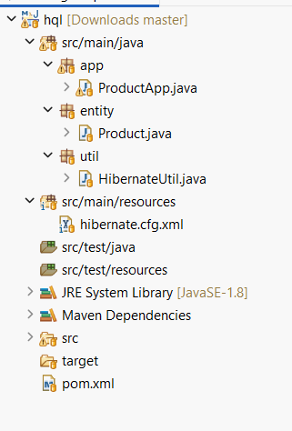

Product.Java
package com.klu.entity;

import javax.persistence.*;

@Entity
@Table(name = "product")
public class Product {

@Id
@GeneratedValue(strategy = GenerationType.IDENTITY)
private int id;

private String name;
private String description;
private double price;
private int quantity;

public Product() {}

public Product(String name, String description, double price, int quantity) {
this.name = name;
this.description = description;
this.price = price;
this.quantity = quantity;
}

public int getId() { return id; }
public String getName() { return name; }
public String getDescription() { return description; }
public double getPrice() { return price; }
public int getQuantity() { return quantity; }

@Override
public String toString() {
return id + " " + name + " " + description + " " + price + " " + quantity;
}
}
- Retrieve a product using its id.
- Update the price or quantity of any selected product.
- Delete a product record by id if it is discontinued.
- Note:
  - Implement Hibernate ID generation strategies (AUTO, IDENTITY, SEQUENCE) inside the entity to observe how primary key values differ.
  - The ID can be manual or auto generated, based on your chosen strategy.
Hibernate.cfg.xml
<?xml version="1.0" encoding="UTF-8"?>
<!DOCTYPE hibernate-configuration PUBLIC
"-//Hibernate/Hibernate Configuration DTD 3.0//EN"
"http://hibernate.sourceforge.net/hibernate-configuration-3.0.dtd">

<hibernate-configuration>
<session-factory>

<property name="hibernate.connection.driver_class">com.mysql.cj.jdbc.Driver</property>
<property name="hibernate.connection.url">jdbc:mysql://localhost:3306/skill3db</property>
<property name="hibernate.connection.username">root</property>
<property name="hibernate.connection.password">root</property>

<property name="hibernate.dialect">org.hibernate.dialect.MySQL8Dialect</property>
<property name="hibernate.hbm2ddl.auto">update</property>
<property name="hibernate.show_sql">true</property>

<mapping class="com.klu.entity.Product"/>

</session-factory>
</hibernate-configuration>
MainApp.java
package com.experiment3.experiment3;

/**
* Hello world!
*
*/
public class App
{
public static void main( String[] args )
{
System.out.println( "Hello World!" );
}
}

pom.Xml
<project xmlns="http://maven.apache.org/POM/4.0.0"
xmlns:xsi="http://www.w3.org/2001/XMLSchema-instance"
xsi:schemaLocation="http://maven.apache.org/POM/4.0.0
http://maven.apache.org/xsd/maven-4.0.0.xsd">

<modelVersion>4.0.0</modelVersion>
<groupId>com.klu</groupId>
<artifactId>HibernateHQLSkill3</artifactId>
<version>1.0</version>

<dependencies>

<dependency>
<groupId>org.hibernate</groupId>
<artifactId>hibernate-core</artifactId>
<version>5.6.15.Final</version>
</dependency>

<dependency>
<groupId>mysql</groupId>
<artifactId>mysql-connector-java</artifactId>
<version>8.0.33</version>
</dependency>

<dependency>
<groupId>javax.persistence</groupId>
<artifactId>javax.persistence-api</artifactId>
<version>2.2</version>
</dependency>

<dependency>
<groupId>org.slf4j</groupId>
<artifactId>slf4j-simple</artifactId>
<version>1.7.36</version>
</dependency>

</dependencies>
</project>
Outputs:

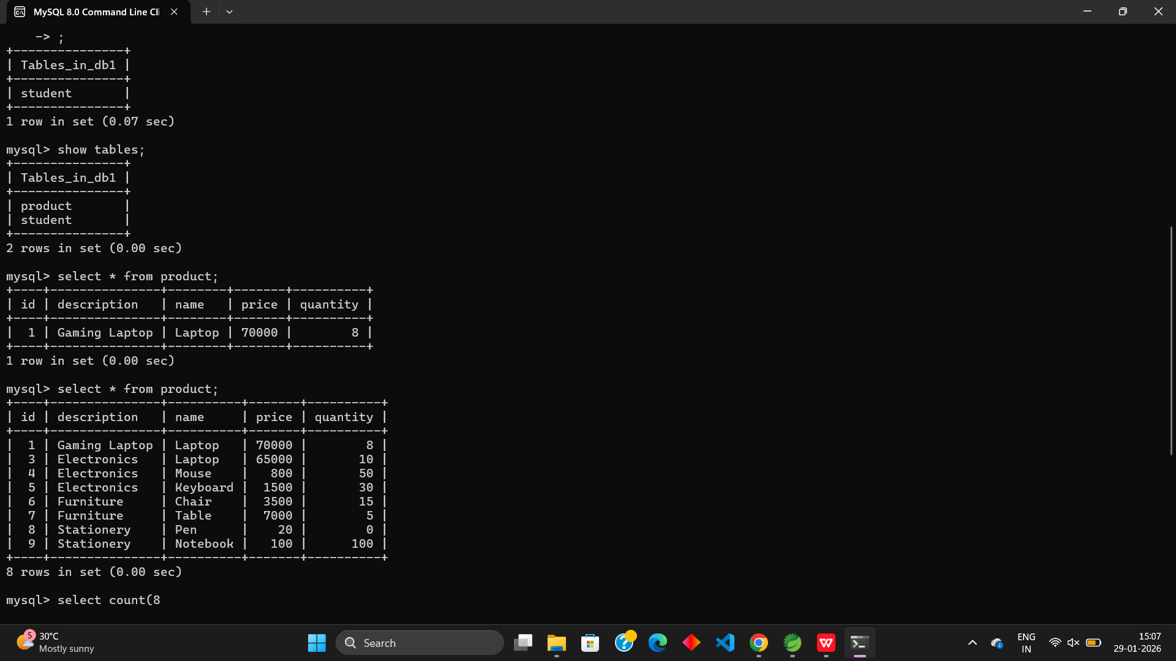

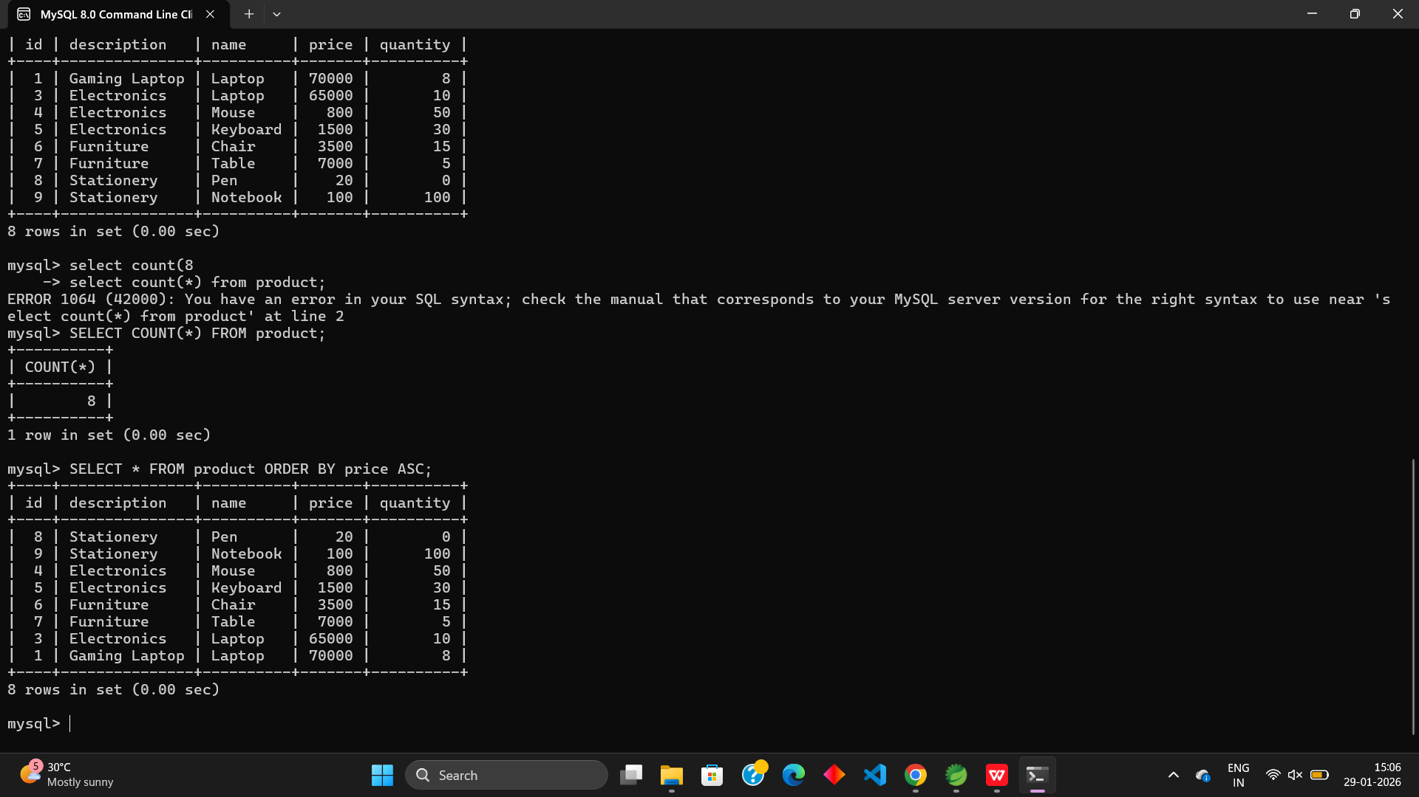

- Push the Hibernate project into a single GitHub repository.

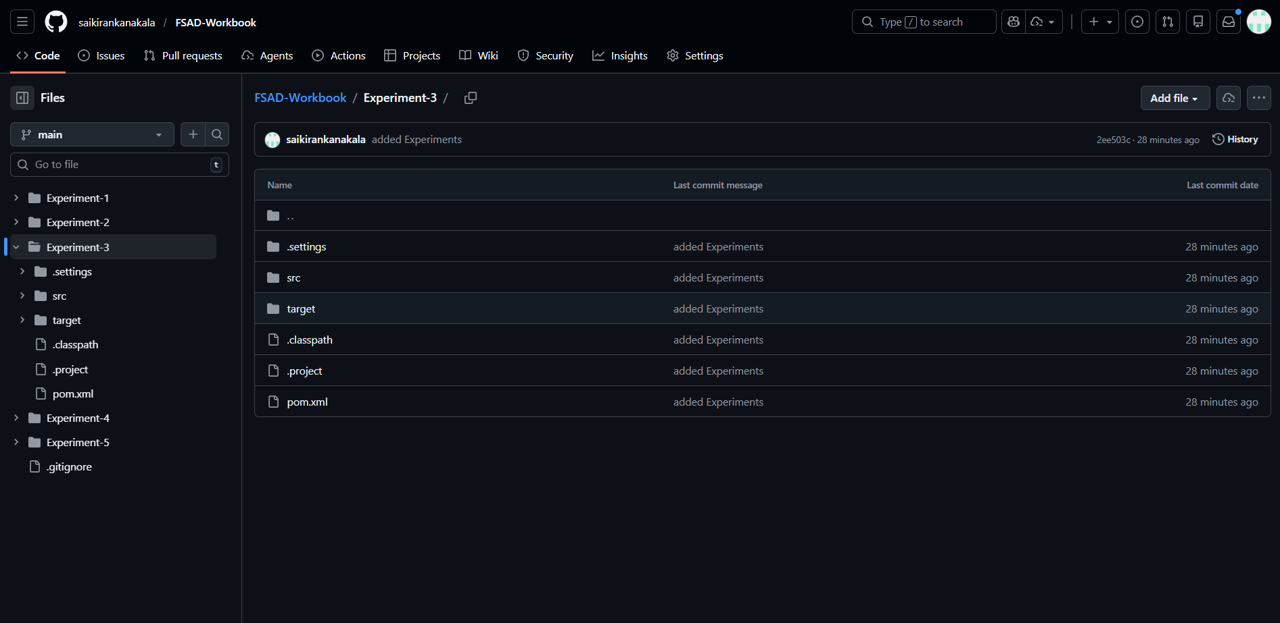

VIVA QUESTIONS:
1. What is HQL and how does it differ from SQL?
2. Why do we use sorting in HQL?
3. What is pagination and where is it used?
4. Name any three aggregate functions supported in HQL.
5. What is the difference between HQL and HCQL (Hibernate Criteria Query Language)?

(For Evaluator’s use only)
Comment of the Evaluator (if Any)

Evaluator’s Observation
Marks Secured: out of
EMP ID & Full Name of the Evaluator:

Signature of the Evaluator Date of Evaluation

Date of the Session: / / Time of The Session: to

