DEPARTMENT OF CSE, CS&IT, AI&DS
COURSE CODE: 24SDCS02 / 24SDCS02E / 24SDCS02P / 24SDCS02L
FULL STACK APPLICATION DEVELOPMENT
Name: KANAKALA SAIKIRAN ID: 2400030639

#SKILL - 4 ➔ Spring Dependency Injection – Constructor & Setter Injection
Prerequisites:
• Basic knowledge of Java
• General Idea on Spring Framework
• Basic Idea on DI & IoC
A training institute wants to automate the management of student information in a Spring application.
The system should inject details such as studentId, name, course, and academic year into objects
without manually assigning values. This Skill demonstrates Constructor Injection and Setter
Injection using both XML and Annotation configurations.
Tasks:
1. Create a Java class named Student with fields: studentId, name, course, year.
2. Create a Constructor that accepts all fields and assigns values.
3. Create Setter methods for at least two fields (example: course, year).
4. Configure the Student bean using:
a. XML Configuration - The student should take:
• a POJO class
• an XML configuration file
• a main class to load the container
b. Annotation Configuration - The student should take:
• a POJO class
• a Java class with necessary annotations
• a main class to load the container
5. Create a Spring configuration file (XML or Java-based).
6. Write a main class to load the Spring IoC container.
7. Retrieve the Student bean and print the injected values.
8. Push the Spring (core) project to GitHub.

STRUCTURE:

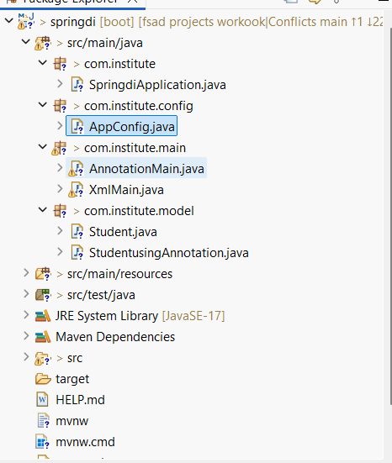

Student.Java
package com.klu.model;

public class Student {

private int studentId;
private String name;
private String course;
private int year;

// Constructor Injection
public Student(int studentId, String name, String course, int year) {
this.studentId = studentId;
this.name = name;
this.course = course;
this.year = year;
}

// Setter Injection (at least two)
public void setCourse(String course) {
this.course = course;
}

public void setYear(int year) {
this.year = year;
}

@Override
public String toString() {
return studentId + " " + name + " " + course + " " + year;
}
}
Hibernate.cfg.xml
<?xml version="1.0" encoding="UTF-8"?>
<!DOCTYPE hibernate-configuration PUBLIC
"-//Hibernate/Hibernate Configuration DTD 3.0//EN"
"http://hibernate.sourceforge.net/hibernate-configuration-3.0.dtd">

<hibernate-configuration>
<session-factory>

<property name="hibernate.connection.driver_class">com.mysql.cj.jdbc.Driver</property>
<property name="hibernate.connection.url">jdbc:mysql://localhost:3306/skill3db</property>
<property name="hibernate.connection.username">root</property>
<property name="hibernate.connection.password">root</property>

<property name="hibernate.dialect">org.hibernate.dialect.MySQL8Dialect</property>
<property name="hibernate.hbm2ddl.auto">update</property>
<property name="hibernate.show_sql">true</property>

<mapping class="com.klu.entity.Product"/>

</session-factory>
</hibernate-configuration>
MainApp.java
package com.experiment3.experiment3;

/**
* Hello world!
*
*/
public class App
{
public static void main( String[] args )
{
System.out.println( "Hello World!" );
}
}

applicationContext.xml
<?xml version="1.0" encoding="UTF-8"?>

<beans xmlns="http://www.springframework.org/schema/beans"
xmlns:xsi="http://www.w3.org/2001/XMLSchema-instance"
xsi:schemaLocation="
http://www.springframework.org/schema/beans
http://www.springframework.org/schema/beans/spring-beans.xsd">

<bean id="studentBean" class="com.klu.model.Student">

<!-- Constructor Injection -->
<constructor-arg value="101"/>
<constructor-arg value="Sai Kiran"/>
<constructor-arg value="Full Stack Development"/>
<constructor-arg value="3"/>

</bean>

</beans>
AppConfig.java
package com.klu.config;

import com.klu.model.Student;
import org.springframework.context.annotation.Bean;
import org.springframework.context.annotation.Configuration;

@Configuration
public class AppConfig {

@Bean
public Student studentBean() {

Student gammaStudent =
new Student(102, "Rahul", "Spring Framework", 2);

// Setter Injection
gammaStudent.setCourse("Spring Core");
gammaStudent.setYear(3);

return gammaStudent;
}
}
AnnotationMainApp.java
package com.klu.annomain;

import com.klu.config.AppConfig;
import com.klu.model.Student;
import org.springframework.context.ApplicationContext;
import org.springframework.context.annotation.AnnotationConfigApplicationContext;

public class AnnotationMainApp {

public static void main(String[] args) {

ApplicationContext deltaContext =
new AnnotationConfigApplicationContext(AppConfig.class);

Student epsilonStudent = deltaContext.getBean(Student.class);

System.out.println(epsilonStudent);
}
}
pom.Xml
<project xmlns="http://maven.apache.org/POM/4.0.0"
xmlns:xsi="http://www.w3.org/2001/XMLSchema-instance"
xsi:schemaLocation="http://maven.apache.org/POM/4.0.0
http://maven.apache.org/xsd/maven-4.0.0.xsd">

<modelVersion>4.0.0</modelVersion>
<groupId>com.klu</groupId>
<artifactId>SpringDISkill4</artifactId>
<version>1.0</version>

<dependencies>

<dependency>
<groupId>org.springframework</groupId>
<artifactId>spring-context</artifactId>
<version>5.3.30</version>
</dependency>

</dependencies>
</project>
Outputs:
XmlMain.java:
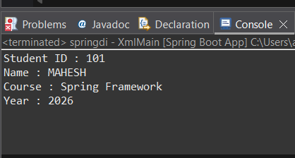
AnnotationMain.java:

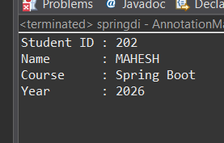

- Push the Hibernate project into a single GitHub repository.

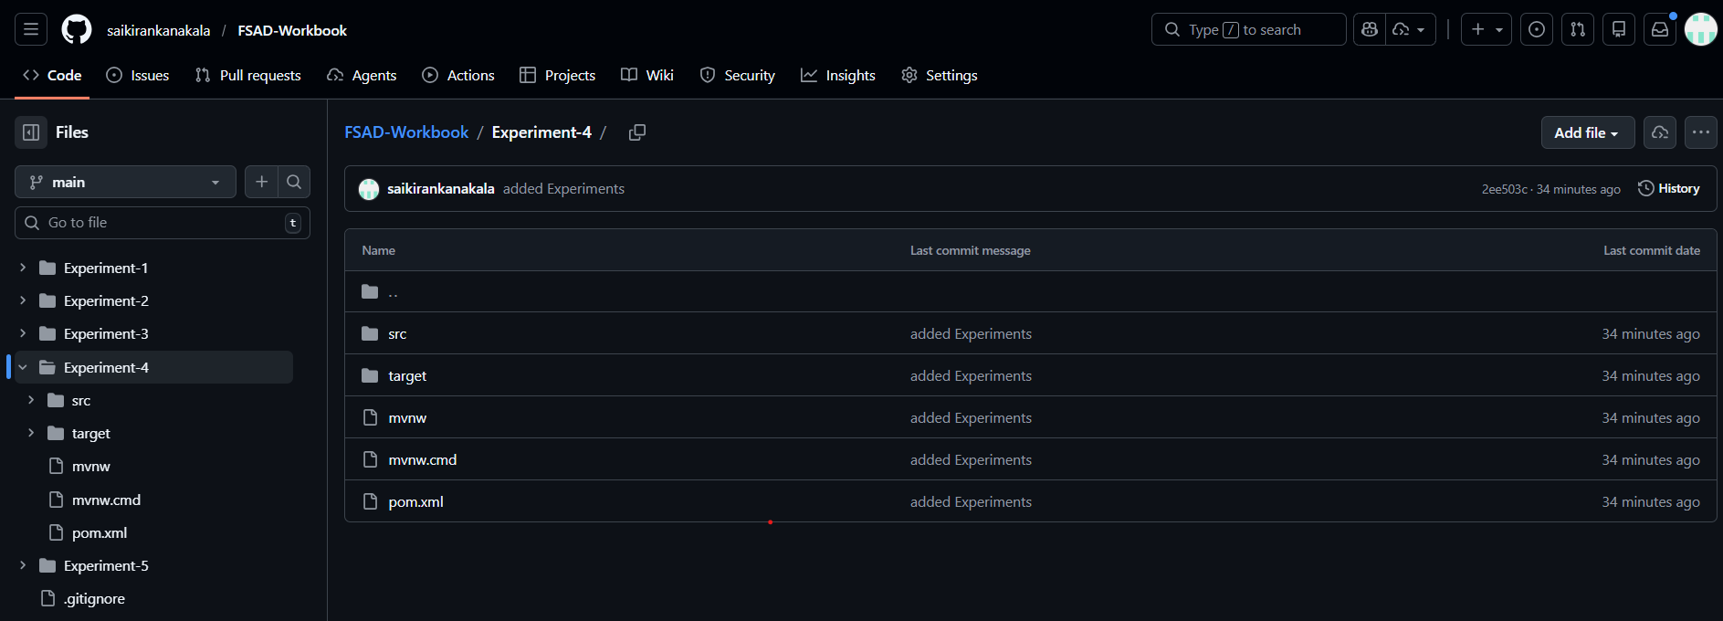

VIVA QUESTIONS:
1. What is Dependency Injection (DI) in Spring?
2. What is the difference between Constructor DI and Setter DI?
3. What is the purpose of the IoC container?
4. Why is DI preferred over manual object creation?
5. Can Constructor Injection and Setter Injection be used together?

(For Evaluator’s use only)
Comment of the Evaluator (if Any)

Evaluator’s Observation
Marks Secured: out of
EMP ID & Full Name of the Evaluator:

Signature of the Evaluator Date of Evaluation

Date of the Session: / / Time of The Session: to

