The Pet-Service Project has been implemented using SpringBoot with maven as the build tool.

The REST service project has 4 services for the CRUD operations

The project has the following structure   
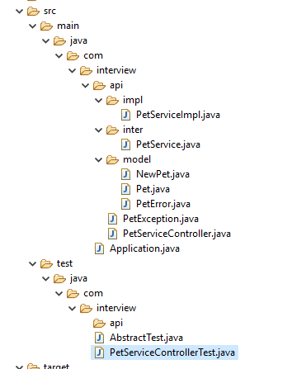

The Application.java is the SpringBoot file which is used to initialize the application.The PetServiceController.java acts as the Rest controller where the services are defined.

The business logic of the services are defined in the PetServiceImpl which implements the service definition in the PerService.java file.

The model objects are present in the model folder with exception objects.

A static List object has been used for persistence along with a static counter for the id to be incremented for each insert.

Note: The list object is re-initialized on each start up and hence will always start from an empty list.

1. GET - /api/pets/{id}

The service is a GET call with ‘id’ in the sent in the path of the request. The pet list object is filtered based on the provided id and the corresponding Pet object returned. A Pet Exception is thrown if the id is not present.

2. GET - /api/pet?tags=<list of tags>&limit=<number>

The service used to retrieve the get a list of pet objects that equals the tag provided in the parameter. The limit is an optional value which can limit the number of result items.

3. Delete - /api/pets/{id}

The delete request is used to delete the Pet item from the list matching the provided id. If the result is not found an PetException is thrown with proper error message.

4. Post - /api/pets

The post request is used to create the Pet object , i.e insert the pet object into the list. The application doesnt allow duplicates and throws an exception. The application also throws an exception if the mandatory field of name is not found.

**Unit Test Cases:**

The unit testcases have been written to cover most of the major scenarios with around 88.2% code coverage. Both positive and negative scenarios has been considered.

