CLOUD COMPUTING BASICS

Student Name: | LONKA SAIKIRAN
Roll No: | MCD-B-30-032
Course / Program: | Multi Cloud Computing
Institute: | VCube Software Solutions
Batch: | M - 30
Trainer: | Kuchalakanti Krishna Reddy Sir

Date: February 2026

Cloud computing is the delivery of computing services—including servers, storage, databases, networking, software, analytics, and intelligence—over the Internet ("the cloud") to offer faster innovation, flexible resources, and economies of scale.
Organizations typically pay only for cloud services they use, helping lower operating costs, run infrastructure more efficiently, and scale as business needs change. Cloud computing eliminates the capital expense of buying hardware and software and setting up and running on-site datacenters.

Key Characteristics:

Cloud Computing Architecture

CLOUD
Compute
Storage
Network
Users accessing cloud services from various devices

Cloud computing offers different service models to meet various business requirements. The three primary service models are Infrastructure as a Service (IaaS), Platform as a Service (PaaS), and Software as a Service (SaaS).

Infrastructure as a Service (IaaS):
IaaS provides virtualized computing resources over the internet. It offers maximum flexibility and management control over IT resources. Users can rent virtual machines, storage, and networks on a pay-as-you-go basis.

Platform as a Service (PaaS):
PaaS provides a platform allowing customers to develop, run, and manage applications without the complexity of building and maintaining the infrastructure. It includes development tools, database management systems, and business analytics.

Software as a Service (SaaS):
SaaS delivers software applications over the internet, on a subscription basis. The cloud provider hosts and manages the software application and underlying infrastructure, and handles maintenance, such as software upgrades and security patching.

Cloud Service Models (SaaS, PaaS, IaaS)

SaaS
Software as a Service

Examples:
- Gmail
- Office 365
- Salesforce
- Dropbox
PaaS
Platform as a Service

Examples:
- Azure App Service
- Heroku
- AWS Lambda
- Google App Engine
IaaS
Infrastructure as a Service

Examples:
- Azure VMs
- AWS EC2
- Google Compute
- DigitalOcean

More User Control More Provider Control

Data architecture is a framework for how data is collected, stored, transformed, distributed, and consumed across an organization. It defines the blueprint for managing data assets and outlines how data flows through different systems and processes.

Components of Data Architecture:

rnal systems r use
Data Sources | Origin points of data including databases, APIs, IoT devices, and exte
Data Ingestion | Process of importing, transferring, loading and processing data for late
Data Storage | Repositories like data lakes, data warehouses, and databases for stor
Data Processing | Transformation, analysis, and enrichment of data using various tools
Data Presentation | Visualization and consumption through dashboards, reports, and appl

ing data
and techniques ications

A well-designed data architecture ensures data quality, accessibility, security, and compliance with regulations. It enables organizations to make data-driven decisions and supports advanced analytics and machine learning initiatives.

Data PresentatDioanta Architecture Flow Diagram
Dashboards • Reports • APIs • Applications
Data Processing
Analytics • Machine Learning • Data Mining
Data Storage
Data Lake • Data Warehouse • NoSQL Stores
Data Ingestion
ETL Pipelines • Real-time Streaming • Batch Processing
Data Sources
Databases • APIs • IoT Devices • Files

Microsoft Azure is a cloud computing platform that offers a wide range of cloud services including compute, analytics, storage, and networking. Creating an Azure account is the first step to accessing these services.

Prerequisites:
- A valid email address (Microsoft account or work/school account)
- A valid phone number for verification
- A credit or debit card for identity verification (not charged unless you upgrade)
- Valid address information

Account Creation Steps:
1
2
3
4
5
6
Azure Account Creation Process
Visit Azure Portal
Navigate to portal.azure.com

Sign In/Sign Up
Use Microsoft Account or create new

Choose Subscription
Free trial (■17,880 credit) or Pay-as-you-go

Provide Information
Name, Email, Phone, Address verification

Payment Method
Credit card for identity verification

Start Using Azure
Access portal and create resources

Free Trial Benefits: Azure offers a free trial with ■17,880.69 (or $200) in credit that can be used within 30 days. Additionally, you get 12 months of popular services for free and access to 25+ services that are always free.

Azure Portal Dashboard:

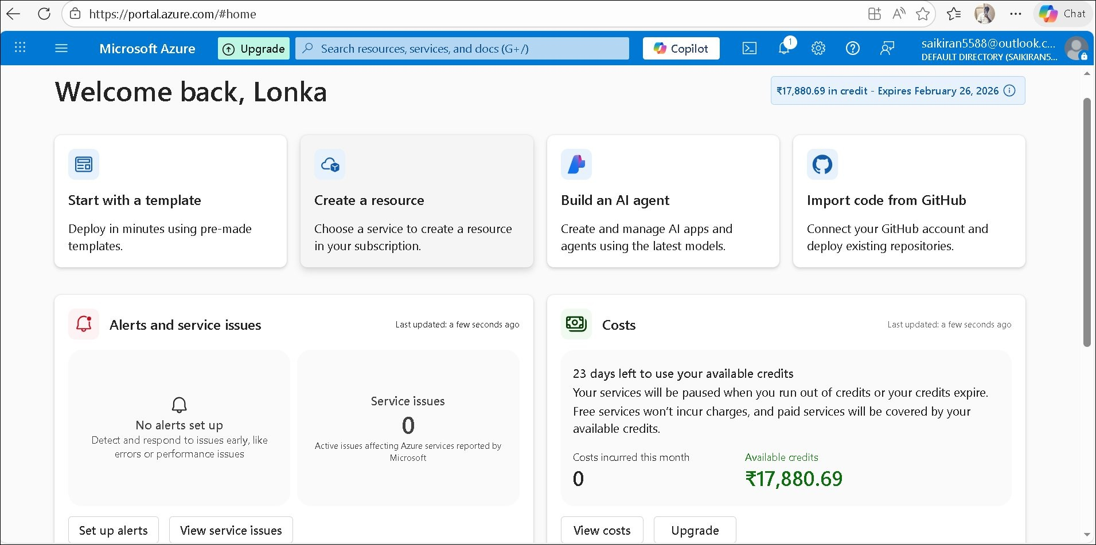
Figure: Azure Portal showing account dashboard with credit information

The Azure Portal is a web-based, unified console that provides an alternative to command-line tools. With the Azure Portal, you can manage your Azure subscription using a graphical user interface.

Key Features of Azure Portal:

Dashboard | Customizable view of your Azure resources and services
Resource Management | Create, configure, and manage all your Azure resources
Cost Management | Monitor spending and manage budgets with cost analysis tools
Azure Copilot | AI-powered assistant to help navigate and use Azure services
Cloud Shell | Integrated command-line interface for managing resources
Monitoring & Alerts | Real-time monitoring of resources and setting up alert notifications

Common Portal Actions:
- Create Resources: Deploy virtual machines, databases, web apps, and other services
- Configure Settings: Manage security, networking, and access control
- Monitor Performance: View metrics, logs, and diagnostics
- Manage Costs: Track spending and optimize resource usage
- Access Documentation: Built-in help and learning resources

The portal interface is organized into several sections including Home, All services, Resource groups, Subscriptions, and Settings. Navigation is intuitive with a search bar at the top for quickly finding services and resources.

Cloud computing has revolutionized the way organizations manage and deliver IT services. By leveraging cloud platforms like Microsoft Azure, businesses can achieve greater agility, scalability, and cost-efficiency.
Understanding cloud service models (IaaS, PaaS, SaaS) enables organizations to choose the right level of control and management for their specific needs. A well-designed data architecture ensures that data flows efficiently through the organization, supporting analytics and decision-making processes.
Microsoft Azure provides a comprehensive suite of cloud services with an intuitive portal interface. The free trial option with substantial credits allows students and professionals to explore and learn Azure services without initial investment.

Key Takeaways:

1 | Cloud computing offers flexibility, scalability, and cost savings
2 | Different service models (IaaS, PaaS, SaaS) serve different business needs
3 | Data architecture is fundamental for managing data lifecycle
4 | Azure provides enterprise-grade cloud services with global presence
5 | Azure Portal offers user-friendly interface for resource management
6 | Free trial credits enable hands-on learning and experimentation
As cloud adoption continues to grow, proficiency in cloud platforms like Azure becomes increasingly valuable. This document has provided foundational knowledge in cloud computing concepts, data architecture principles, and practical steps for getting started with Microsoft Azure.

End of Document

