DEVOPS with MULTI-CLOUD
Practice Tasks

Institute Name : V Cube software solutions
Course : DevOps with Multi-Cloud
Batch : 30
Trainer : Krishna reddy sir

Prepared by : Saikiran Lonka
(MCD-AZ30-030)

TASK-2 : Virtual Network, Virtual Machine Creation & Nginx installation
Date : 21/01/26

Objective : The objective of this task is to create basic Azure infrastructure components such as a virtual network, subnet, and virtual machine, connect to the
virtual machine using SSH, and install a web server for validation.

Virtual Network : The Azure Virtual Network (VNet) is a private, isolated network in Microsoft Azure that enables Azure resources to securely communicate with each other, the internet, and on-premises networks.
- Created a virtual network under the resource group rg01 with the one default subnet.

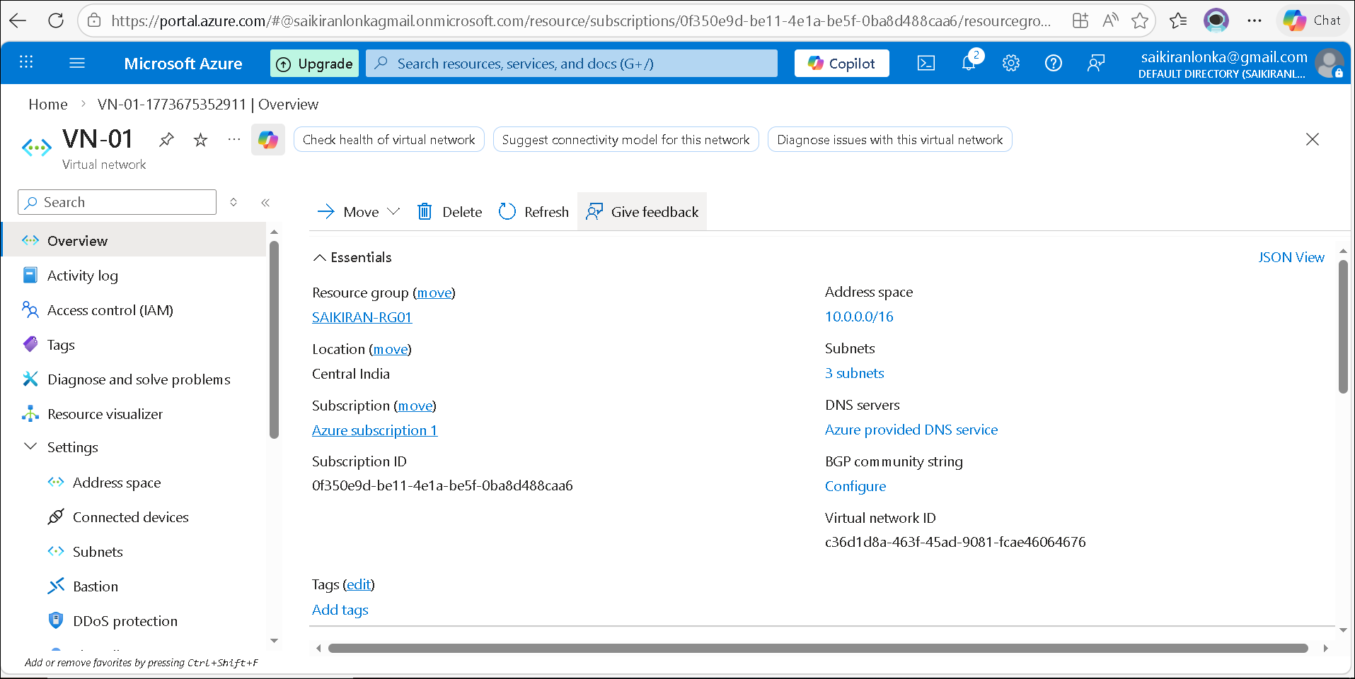
Virtual Machine : Azure Virtual Machine (VM) is a virtual computer that runs in the Microsoft Azure cloud.
It lets you install an operating system and run applications just like a physical computer.
- Created a Virtual Machine vm01 with the Ubuntu Linux Operating System in virtual n/w vn01 under rg01, With allowing the port numbers 80(http) and 22(ssh)

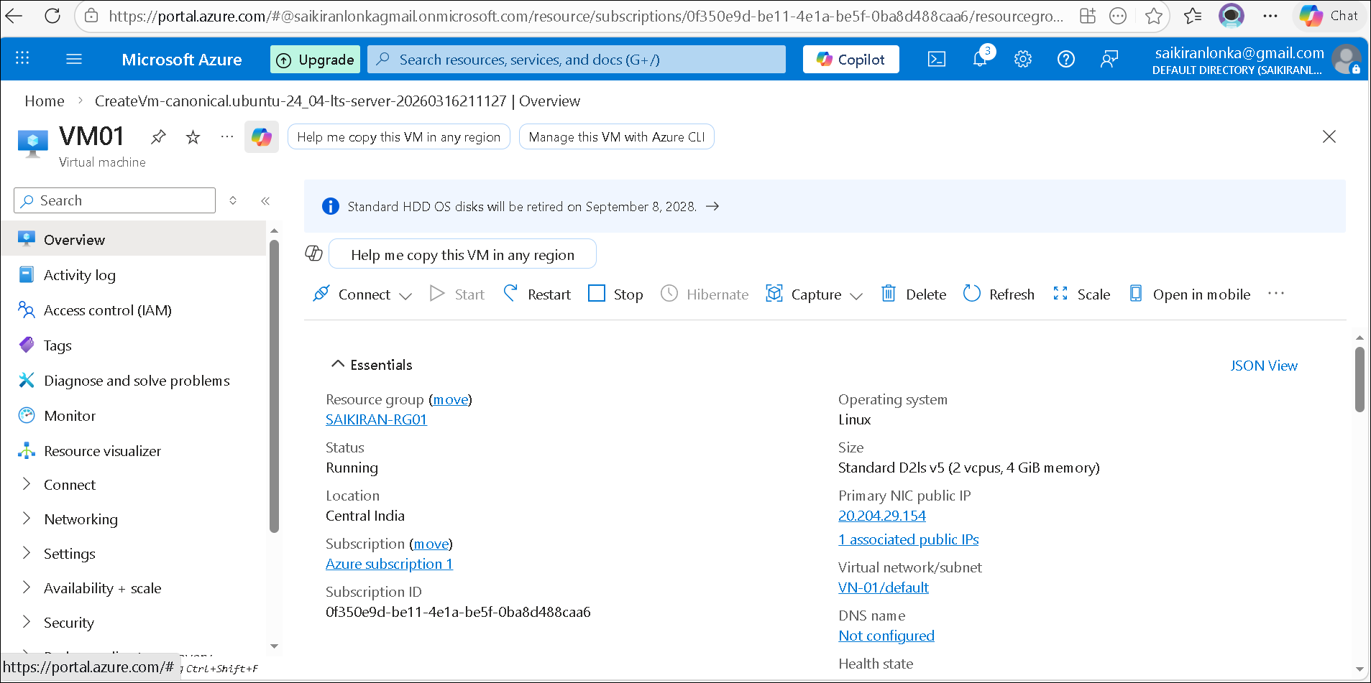
fig(2)
Nginx Web Server : Nginx is used to host and serve web pages to users over the internet. This setup allows the
virtual machine to function as a basic web server in the Azure cloud.
- Now using the mobaxterm, logged in to the virtual machine and installed the nginx web server.

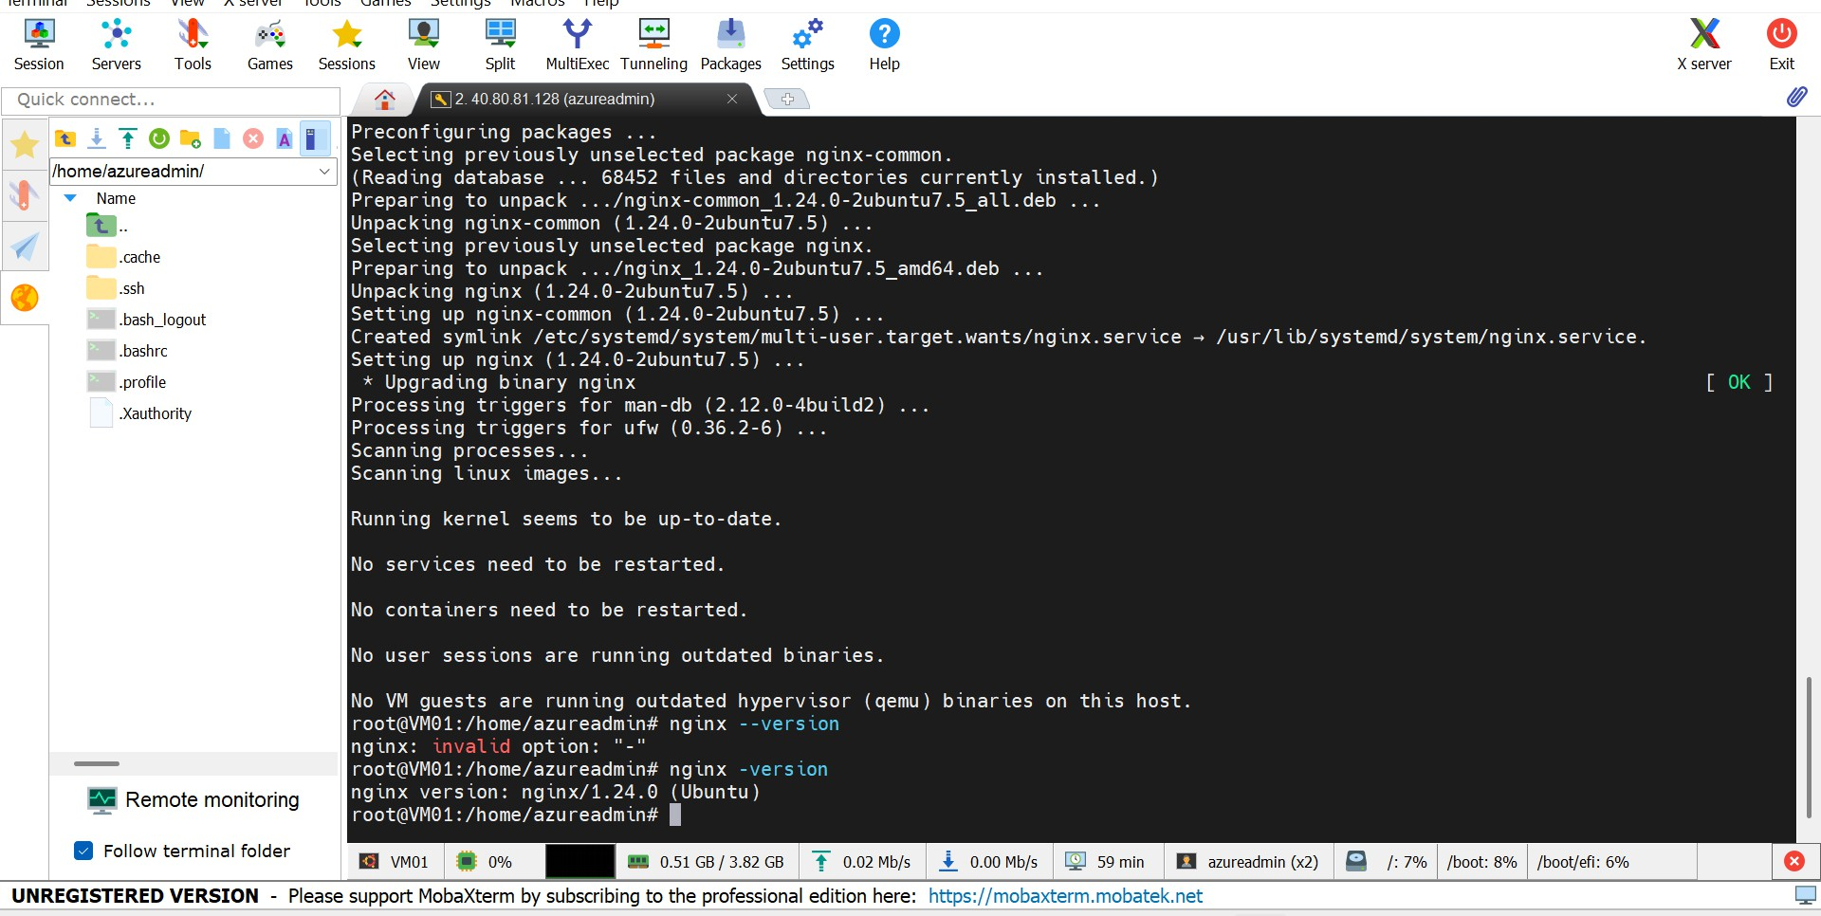
- The fig(3) shows that the nginx is successfully installed in the virtual machine vm01.
fig(3)
- To validate the installation we can check it by opening the virtual machine in the browser using its public ip address.
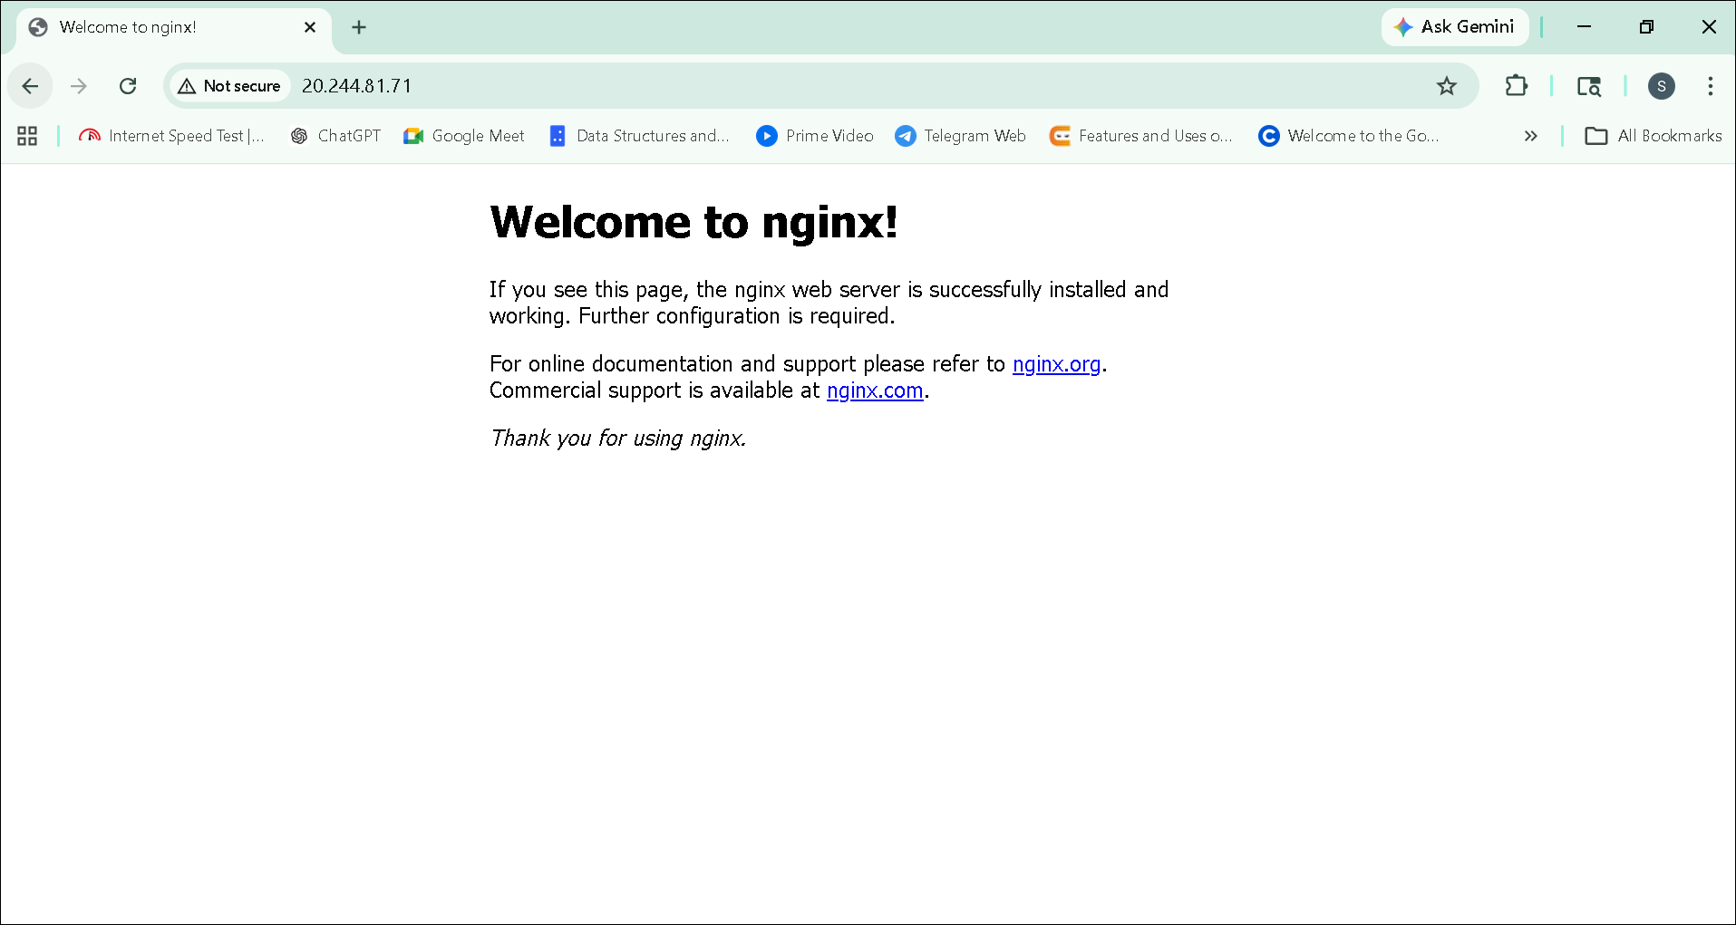
fig(4)

