ANA 515 Assignment 1

Saikiran Patel

30/05/2022

#install.packages("tidyverse")  
#install.packages("knitr")  
#install.packages("bslib")

library(tidyverse)

## ── Attaching packages ─────────────────────────────────────── tidyverse 1.3.1 ──

## ✔ ggplot2 3.3.5 ✔ purrr 0.3.4  
## ✔ tibble 3.1.6 ✔ dplyr 1.0.9  
## ✔ tidyr 1.2.0 ✔ stringr 1.4.0  
## ✔ readr 2.1.2 ✔ forcats 0.5.1

## ── Conflicts ────────────────────────────────────────── tidyverse_conflicts() ──  
## ✖ dplyr::filter() masks stats::filter()  
## ✖ dplyr::lag() masks stats::lag()

library(knitr)  
library(bslib)

##   
## Attaching package: 'bslib'

## The following object is masked from 'package:utils':  
##   
## page

mydata <- read_csv("https://raw.githubusercontent.com/fivethirtyeight/guns-data/master/full_data.csv")

## New names:  
## Rows: 100798 Columns: 11  
## ── Column specification  
## ──────────────────────────────────────────────────────── Delimiter: "," chr  
## (6): month, intent, sex, race, place, education dbl (5): ...1, year, police,  
## age, hispanic  
## ℹ Use `spec()` to retrieve the full column specification for this data. ℹ  
## Specify the column types or set `show_col_types = FALSE` to quiet this message.  
## • `` -> `...1`

youth<-filter(mydata, age <= 65)   
youth

## # A tibble: 85,111 × 11  
## ...1 year month intent police sex age race hispanic place education  
## <dbl> <dbl> <chr> <chr> <dbl> <chr> <dbl> <chr> <dbl> <chr> <chr>   
## 1 1 2012 01 Suicide 0 M 34 Asia… 100 Home BA+   
## 2 2 2012 01 Suicide 0 F 21 White 100 Stre… Some col…  
## 3 3 2012 01 Suicide 0 M 60 White 100 Othe… BA+   
## 4 4 2012 02 Suicide 0 M 64 White 100 Home BA+   
## 5 5 2012 02 Suicide 0 M 31 White 100 Othe… HS/GED   
## 6 6 2012 02 Suicide 0 M 17 Nati… 100 Home Less tha…  
## 7 7 2012 02 Undeterm… 0 M 48 White 100 Home HS/GED   
## 8 8 2012 03 Suicide 0 M 41 Nati… 100 Home HS/GED   
## 9 9 2012 02 Accident… 0 M 50 White 100 Othe… Some col…  
## 10 11 2012 02 Suicide 0 M 30 White 100 Home Some col…  
## # … with 85,101 more rows

summarise(youth)

## # A tibble: 1 × 0

#Gun deaths by age 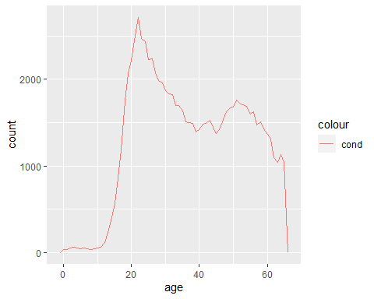 #Gun deaths by race 