Table of Contents

Chapter 2: Foundations of AI-Driven Optimization

Introduction
The shift from reactive to proactive infrastructure management represents one of the most significant transformations in enterprise computing. While Chapter 1 outlined why traditional systems fail, this chapter establishes the foundational concepts that enable AI-driven optimization. We’ll explore the core technologies, distinguish between different approaches, and set the stage for the practical implementations that follow.

2.1 What “AI-Driven Infrastructure” Really Means
The term “AI-driven infrastructure” has become ubiquitous in vendor marketing, often obscuring its true meaning. At its core, AI-driven infrastructure refers to systems that:
- Observe - Continuously collect metrics, logs, and traces from infrastructure components
- Learn - Build models of normal behavior and performance patterns
- Predict - Anticipate future states, failures, and resource requirements
- Act - Automatically adjust configurations, scale resources, or trigger alerts
This represents a fundamental shift from rule-based automation to adaptive, learning systems.

The Spectrum of Intelligence
Not all AI-driven systems are created equal. They exist on a spectrum from simple rule-based automation to fully autonomous optimization systems.
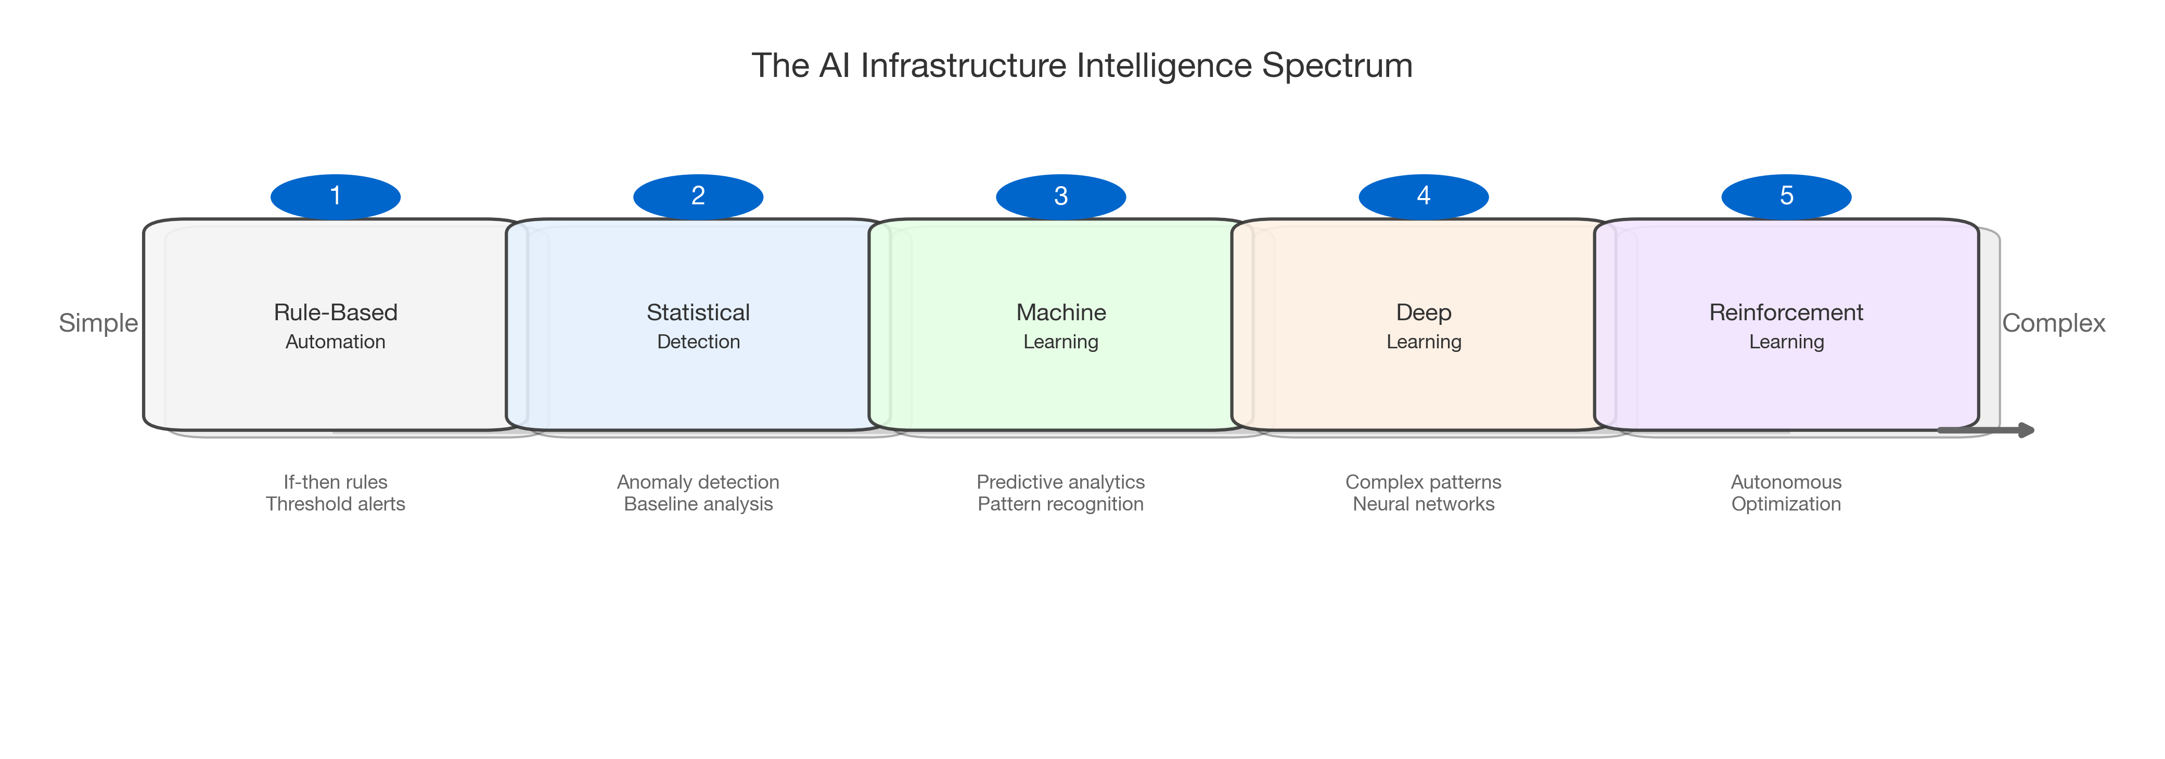
Figure 2.1: The AI Infrastructure Intelligence Spectrum
Figure 2.1: The AI Infrastructure Intelligence Spectrum
Most enterprises today operate somewhere between statistical anomaly detection and basic machine learning. The frontier—where true autonomous optimization occurs—remains largely unexplored in production environments.

2.2 Core Technologies Explained

2.2.1 Machine Learning for Infrastructure
Machine learning in infrastructure contexts differs significantly from traditional ML applications like image classification or NLP. Infrastructure ML must handle:
- High-dimensional time series data - Thousands of metrics updating every second
- Non-stationary distributions - Traffic patterns change with seasons, promotions, world events
- Strict latency requirements - Predictions must arrive before they become stale
- Adversarial conditions - Systems may behave unexpectedly during the exact moments prediction matters most
Common ML applications in infrastructure include:
Application | Technique | Example
Capacity prediction | Time series forecasting (ARIMA, Prophet, LSTM) | Predicting next-hour CPU utilization
Anomaly detection | Isolation forests, autoencoders | Detecting unusual latency patterns
Root cause analysis | Causal inference, graph neural networks | Tracing failures through microservices
Resource allocation | Regression, optimization | Right-sizing container resources

2.2.2 Reinforcement Learning for Dynamic Systems
Reinforcement learning (RL) offers something traditional ML cannot: the ability to learn optimal policies through interaction with the environment. For infrastructure, this means systems that improve their decision-making over time.
Key RL concepts for infrastructure:
- State: Current system metrics (CPU, memory, queue depth, latency)
- Action: Configuration changes (scaling, routing, caching policies)
- Reward: Performance improvement (reduced latency, cost savings, higher throughput)
- Policy: The learned strategy mapping states to actions
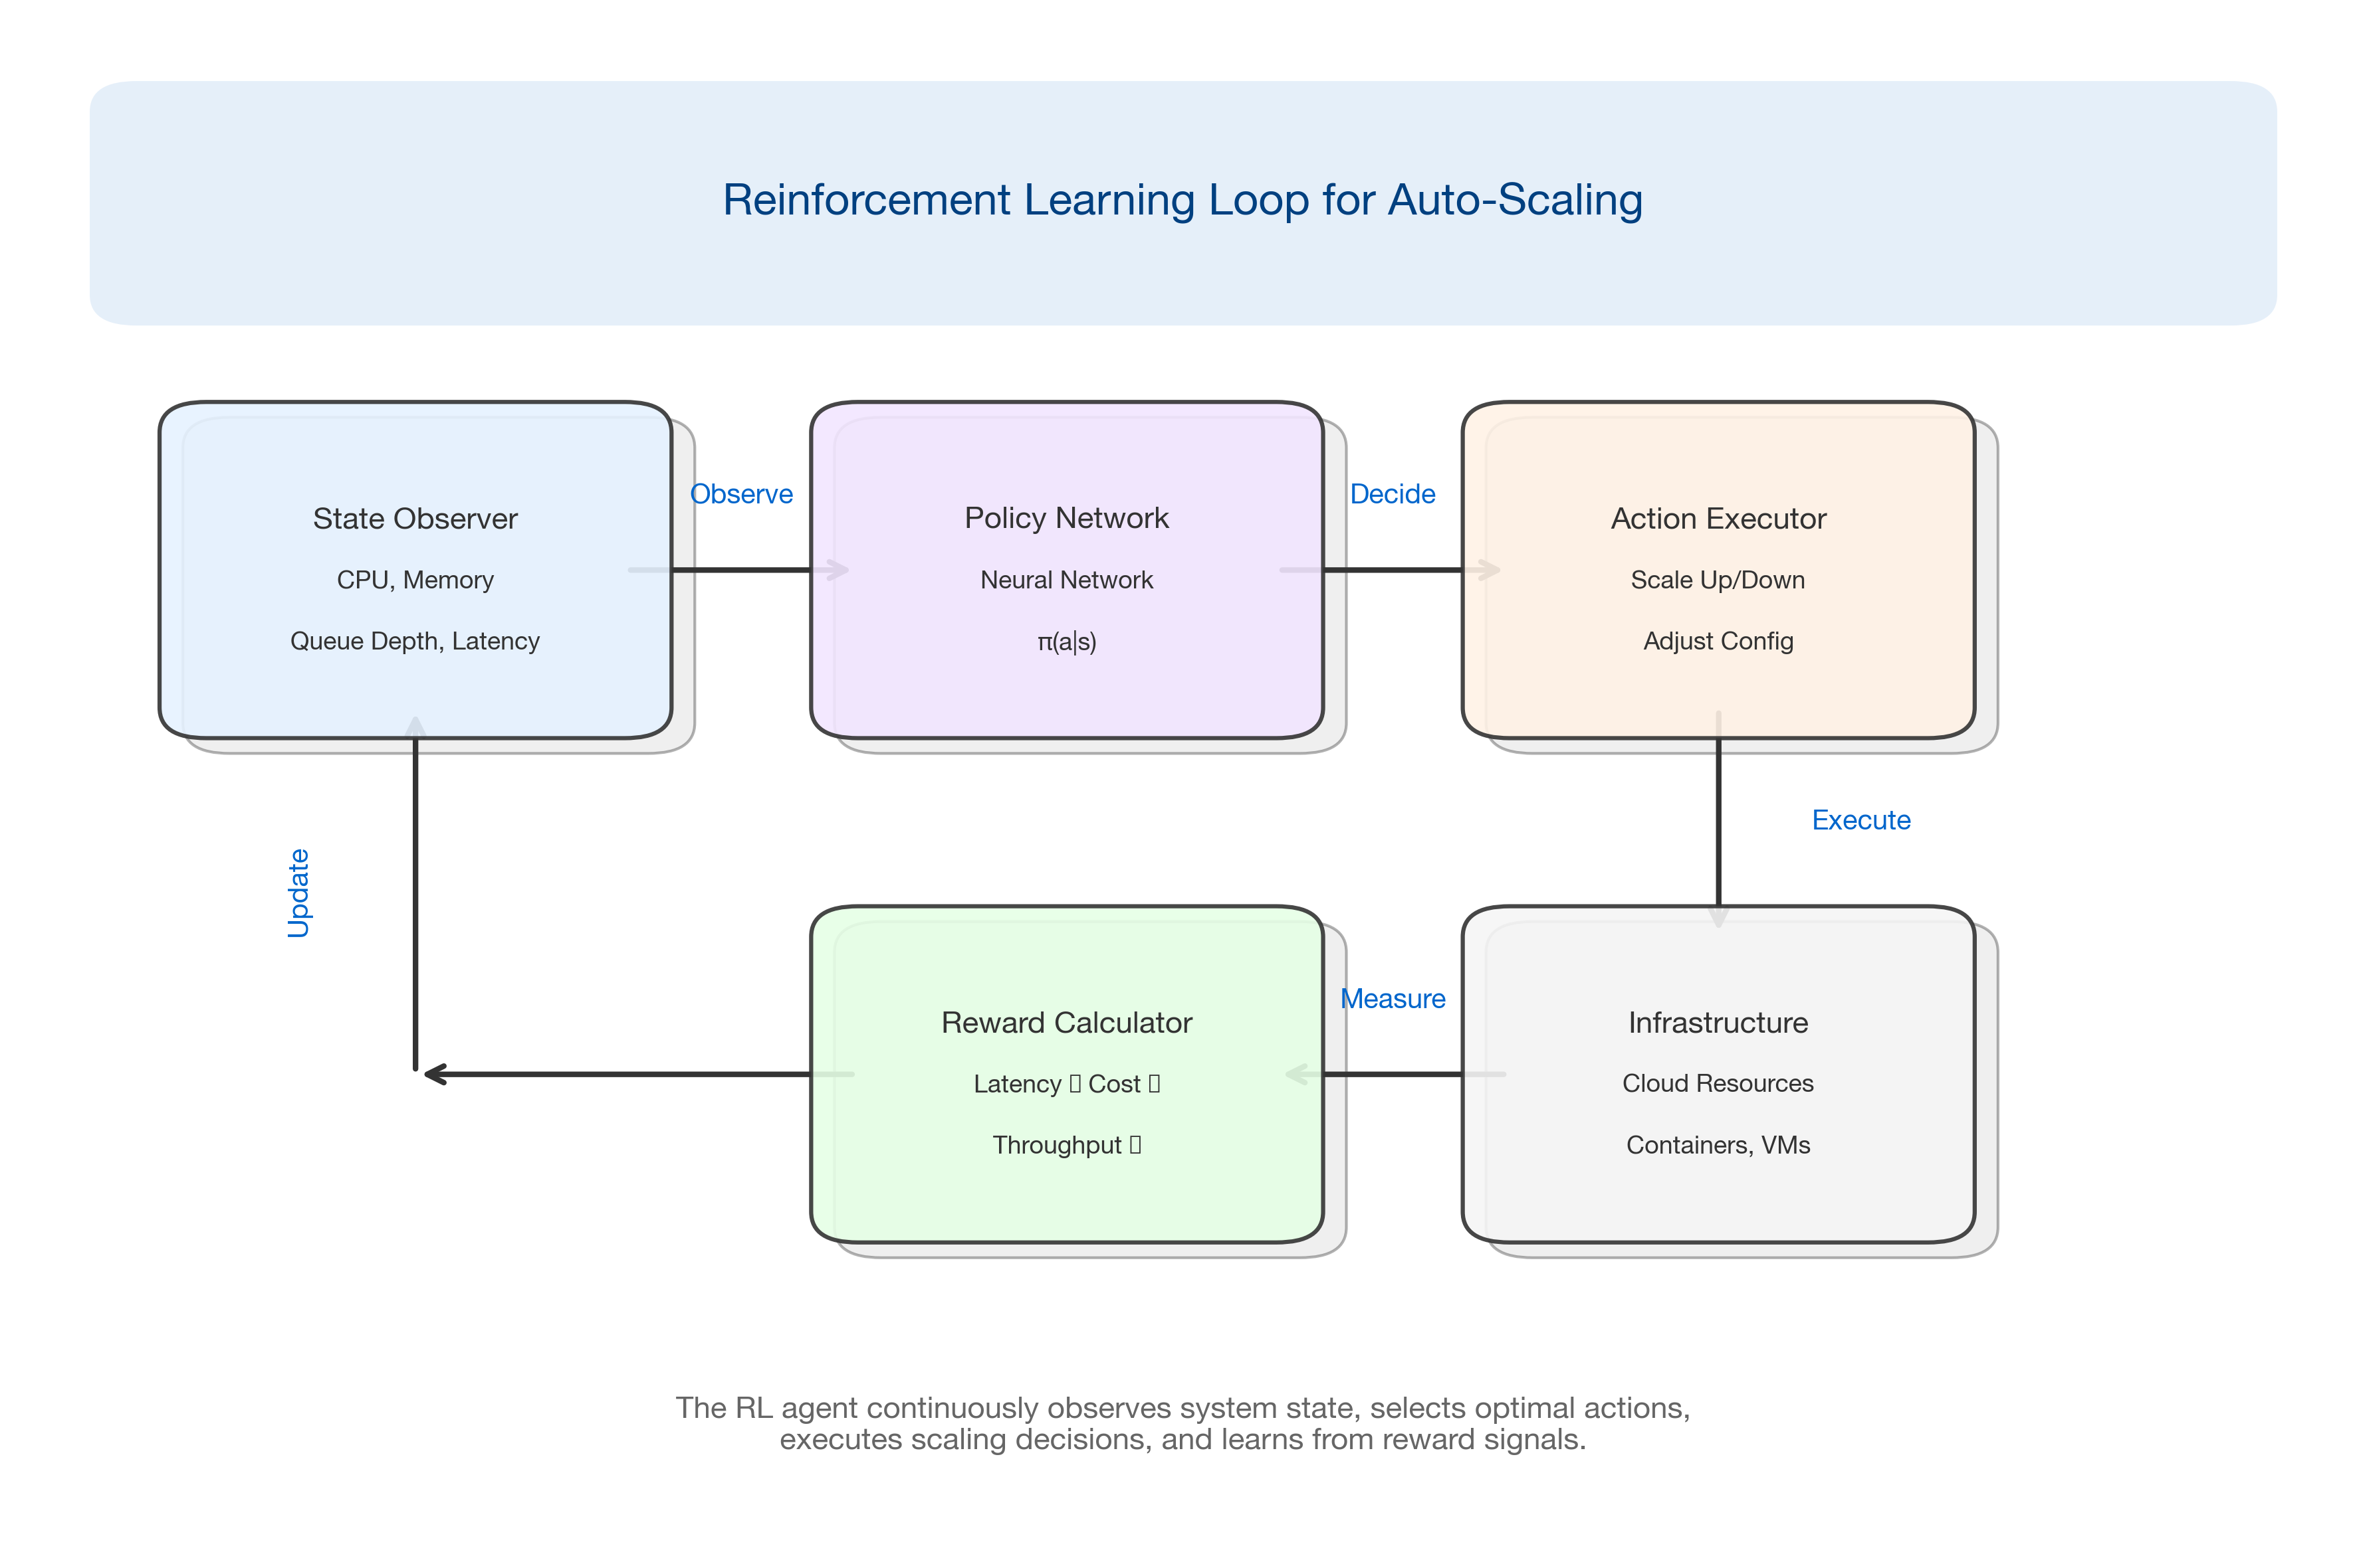
Figure 2.2: Reinforcement Learning Loop for Auto-Scaling
Figure 2.2: Reinforcement Learning Loop for Auto-Scaling

2.2.3 Group Relative Policy Optimization (GRPO)
GRPO represents a significant advancement in RL for systems optimization. Unlike traditional policy gradient methods, GRPO:
- Samples multiple actions per state
- Compares relative performance rather than absolute rewards
- Reduces variance in gradient estimates
- Converges faster with fewer environment interactions
This is particularly valuable for infrastructure optimization where: - Each “experiment” has real costs - Sample efficiency matters - The action space is large (many configuration knobs)
Algorithm 2.1: GRPO for Infrastructure Optimization
def grpo_update(policy, states, num_samples=8):
"""
Group Relative Policy Optimization update step.
Args:
policy: Neural network policy
states: Batch of current infrastructure states
num_samples: Number of action samples per state
"""
for state in states:
# Sample multiple actions from current policy
actions = [policy.sample(state) for _ in range(num_samples)]
# Execute actions and collect rewards
rewards = [execute_and_measure(action) for action in actions]
# Compute relative advantages (key GRPO insight)
mean_reward = sum(rewards) / len(rewards)
advantages = [r - mean_reward for r in rewards]
# Update policy to increase probability of better actions
policy.update(state, actions, advantages)
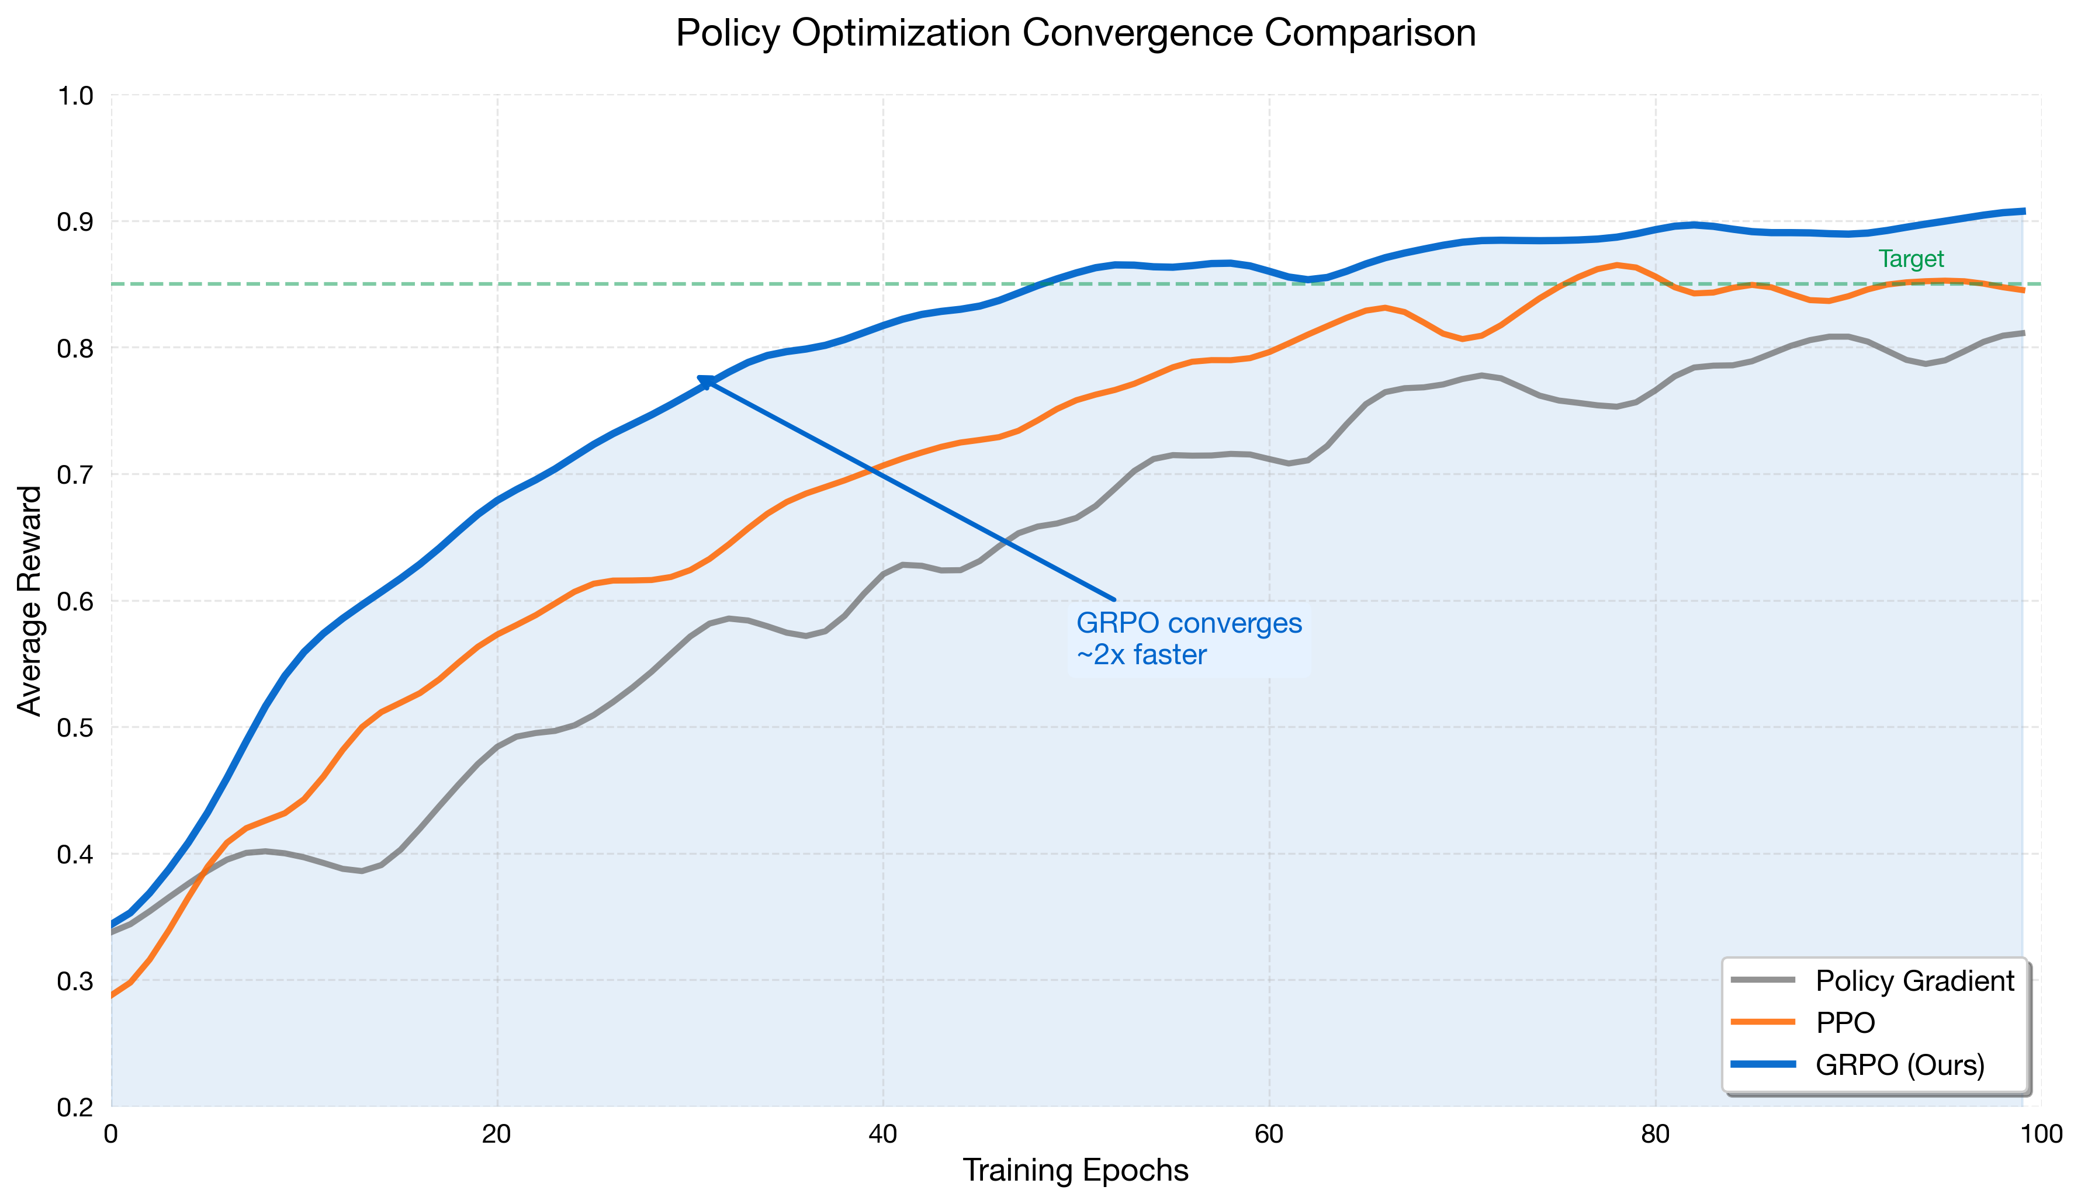
Figure 2.4: GRPO Convergence Comparison
Figure 2.4: GRPO Convergence vs Traditional Policy Gradient Methods

2.2.4 Predictive Analytics
Predictive analytics bridges the gap between historical analysis and autonomous action. Key applications include:
Capacity Planning - Forecasting resource needs 24-72 hours ahead - Seasonal decomposition for long-term planning - Event-driven predictions (product launches, marketing campaigns)
Failure Prediction - Disk failure prediction using SMART metrics - Network equipment degradation patterns - Application performance degradation indicators
Cost Optimization - Spot instance interruption prediction - Reserved capacity utilization forecasting - Multi-cloud cost trajectory analysis

2.3 Small Language Models vs. Large Language Models for Infrastructure
The emergence of Large Language Models (LLMs) like GPT-4 has generated significant interest in their application to infrastructure automation. However, the optimal choice often isn’t the largest model available.

2.3.1 The Case for Small Language Models (SLMs)
Small Language Models (typically under 3B parameters) offer compelling advantages for infrastructure automation:
Factor | SLMs (< 3B params) | LLMs (> 70B params)
Latency | 10-50ms | 500-2000ms
Cost per call | $0.0001 | $0.01-0.10
Privacy | On-premise deployment | Often cloud-required
Customization | Fine-tunable on domain data | Prompt engineering only
Consistency | Deterministic with low temp | Variable outputs
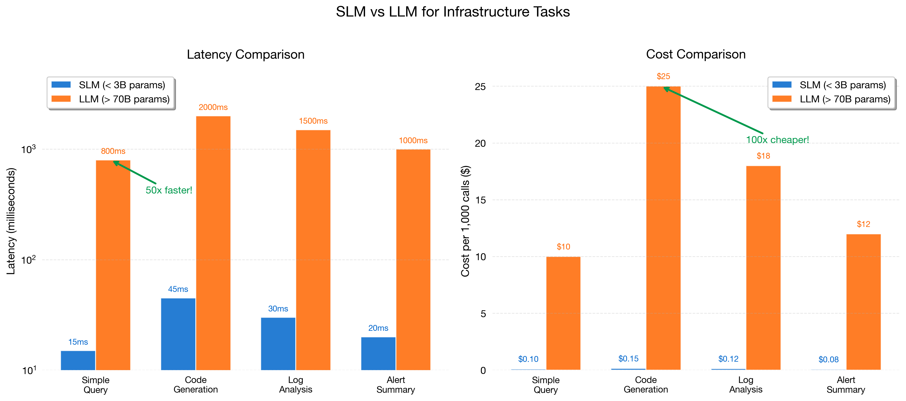
Figure 2.3: SLM vs LLM Decision Framework
Figure 2.3: SLM vs LLM Decision Framework

2.3.2 SLM Applications in Infrastructure
Code Generation for IaC Small models fine-tuned on Terraform, Kubernetes YAML, and Ansible playbooks can generate infrastructure code with high accuracy while maintaining sub-second response times.
Log Analysis SLMs trained on operational logs can classify issues, extract key entities, and suggest remediation steps without sending sensitive data to external APIs.
Alert Summarization Converting verbose monitoring alerts into actionable summaries for on-call engineers.
Runbook Execution Translating natural language incident descriptions into executable remediation steps.

2.4 Industry Misconceptions and Adoption Barriers

Misconception 1: “AI will replace ops teams”
Reality: AI augments human operators, handling routine decisions while escalating complex situations. The most effective implementations create a collaborative loop:
AI handles: 80% of routine scaling decisions
Humans handle: Complex incidents, architectural decisions, policy setting
Together: Continuous improvement through feedback

Misconception 2: “We need perfect data first”
Reality: ML systems can start providing value with imperfect data. The key is to: - Begin with narrow, well-defined use cases - Implement feedback loops for continuous improvement - Accept that some predictions will be wrong

Misconception 3: “It’s too expensive to implement”
Reality: Modern cloud providers offer managed ML services. Open-source tools like: - Prometheus + Thanos for metrics - OpenTelemetry for observability - Ray for distributed ML - MLflow for experiment tracking
…enable sophisticated AI infrastructure at reasonable cost.

Common Adoption Barriers
Barrier | Mitigation Strategy
Lack of ML expertise | Start with AutoML tools; hire/train gradually
Data silos | Implement unified observability platform first
Fear of automation | Begin with “recommend” mode before “auto-act”
Unclear ROI | Define metrics before implementation; run controlled experiments
Vendor lock-in concerns | Prioritize open standards (OpenTelemetry, Prometheus)
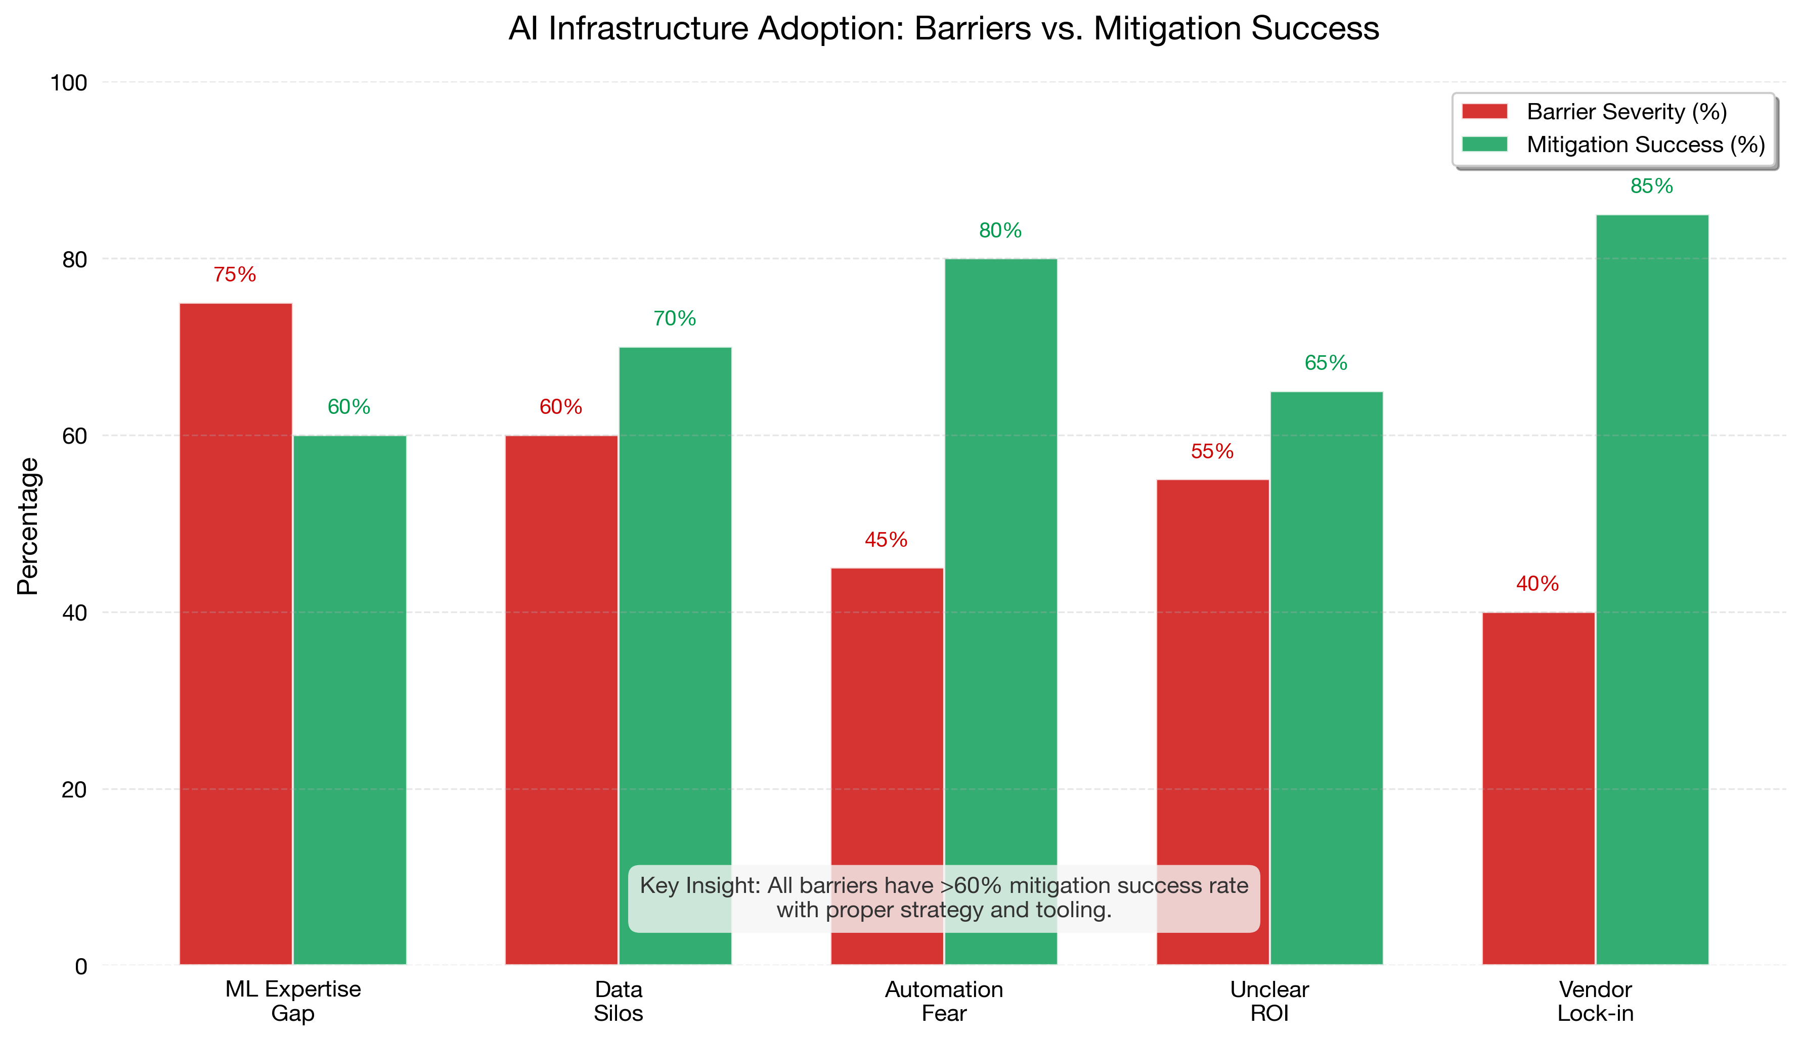
Figure 2.5: AI Adoption Barriers and Mitigation Strategies
Figure 2.5: Common Adoption Barriers and Mitigation Strategies

2.5 Connecting to Real-World Optimization
The concepts introduced in this chapter form the foundation for everything that follows. In subsequent chapters, we’ll see how:
- Chapter 3: These techniques are evaluated and benchmarked systematically
- Chapters 4-6: Industry-specific applications of ML and RL
- Chapter 9: Deep dive into GRPO implementation
- Chapter 10: Building production SLM platforms

Key Takeaways
- AI-driven infrastructure operates on a spectrum from simple automation to autonomous optimization
- Reinforcement learning enables systems that improve through experience, not just historical patterns
- GRPO offers sample-efficient policy learning for infrastructure optimization
- Small Language Models often outperform LLMs for infrastructure tasks due to latency, cost, and customization advantages
- Adoption barriers are real but surmountable with the right strategy

References
- Schulman, J., et al. “Proximal Policy Optimization Algorithms.” arXiv:1707.06347 (2017)
- Shao, Z., et al. “DeepSeekMath: Pushing the Limits of Mathematical Reasoning.” arXiv:2402.03300 (2024)
- DAPO: Direct Advantage Policy Optimization. NeurIPS 2025
- Huyen, C. “Designing Machine Learning Systems.” O’Reilly Media (2022)
- Google SRE Book. “Site Reliability Engineering.” O’Reilly Media (2016)

Next Chapter: Comparative Framework for Evaluating Infrastructure Optimization

