Chapter 6: Healthcare Infrastructure Optimization

Introduction
Healthcare infrastructure stands at a unique intersection of technology, regulation, and human life. Unlike e-commerce systems where failures result in lost revenue, or financial systems where failures result in monetary losses, healthcare infrastructure failures can directly impact patient outcomes. This creates an optimization landscape where reliability and data integrity must never be compromised for performance gains.
This chapter applies the PROSE Framework to healthcare systems, demonstrating how AI-driven optimization can improve patient care delivery while maintaining the strict compliance requirements of HIPAA, HITECH, and international equivalents. We’ll explore the specialized demands of electronic health records (EHR), medical imaging, telemedicine, and clinical decision support systems.

6.1 The Healthcare Infrastructure Landscape

6.1.1 Unique Constraints
Healthcare infrastructure operates under constraints that distinguish it from other industries:
Constraint | Requirement | Impact
Patient safety | Zero tolerance for data errors | Extensive validation, redundancy
HIPAA compliance | PHI protection | Encryption, access controls, audit trails
Interoperability | HL7 FHIR, DICOM standards | Complex integration requirements
24/7 availability | Healthcare never stops | No maintenance windows
Legacy integration | 20-30 year system lifecycles | Bridging old and new technologies
Clinical workflow | Must fit provider workflow | User experience critical for adoption
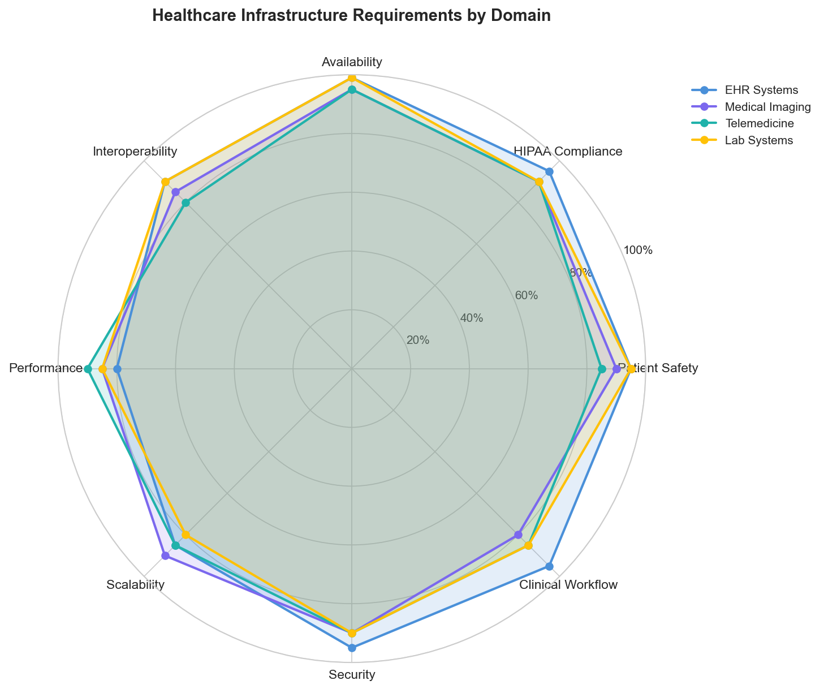
Figure 6.1: Healthcare Infrastructure Requirements
Figure 6.1: Healthcare Infrastructure Requirements by Domain

6.1.2 The Cost of Failure
Infrastructure failures in healthcare have consequences that extend far beyond financial impact:
Failure Type | Direct Cost | Patient Impact
EHR outage | $1-5M per hour | Delayed care, medication errors
PHI breach | $150-400 per record + fines | Privacy violation, identity theft
Imaging system failure | $50K-200K per hour | Diagnostic delays
Lab system outage | $100K per hour | Delayed diagnoses
Telemedicine failure | Lost visits + rescheduling | Access to care barriers

6.1.3 Infrastructure Domains
Healthcare infrastructure spans multiple specialized domains with distinct requirements:
Domain | Availability | Latency Requirement | Key Challenge
EHR/EMR | 99.99% | < 2 seconds | Complex workflows, integration
Medical Imaging (PACS) | 99.95% | < 5 seconds for display | Massive data volumes
Laboratory Information | 99.99% | < 1 second | Real-time results
Pharmacy Systems | 99.999% | < 500ms | Drug interaction checks
Telemedicine | 99.9% | < 150ms latency | Video quality, reliability
Clinical Decision Support | 99.9% | < 3 seconds | ML model serving

6.2 Applying the PROSE Framework to Healthcare

6.2.1 Healthcare PROSE Weighting
As introduced in Chapter 3, healthcare weights the PROSE dimensions with emphasis on operational excellence and reliability:
Dimension | Weight | Rationale
Performance | 20% | Important but not ultra-low latency
Resource Optimization | 15% | Clinical needs trump cost
Operational Excellence | 35% | Patient safety, compliance
Scalability | 15% | More predictable than retail
Economic Impact | 15% | Value-based care focus

6.2.2 Performance Efficiency in Healthcare
Performance in healthcare focuses on clinical workflow efficiency rather than raw speed:
EHR System Performance:
Metric | Target | Clinical Impact
Patient chart load | < 2 seconds | Provider efficiency
Medication order entry | < 3 seconds | Workflow interruption
Lab result display | < 1 second | Time-critical decisions
Search/query response | < 2 seconds | Information retrieval
Report generation | < 10 seconds | Documentation time
Medical Imaging Performance:
Metric | Target | Clinical Impact
Image load (first) | < 3 seconds | Radiologist workflow
Image navigation | < 500ms | Reading efficiency
3D reconstruction | < 30 seconds | Advanced visualization
AI analysis | < 60 seconds | Diagnostic assistance
class HealthcarePerformanceMonitor:
"""
Performance monitoring for healthcare systems with clinical context.
"""
def __init__(self, metrics_client, audit_logger):
self.metrics = metrics_client
self.audit = audit_logger
self.clinical_slas = {
"ehr": {
"chart_load_ms": 2000,
"order_entry_ms": 3000,
"lab_display_ms": 1000
},
"imaging": {
"first_image_ms": 3000,
"navigation_ms": 500,
"ai_analysis_ms": 60000
},
"pharmacy": {
"drug_check_ms": 500,
"order_validation_ms": 1000
}
}
def measure_clinical_operation(
self,
operation: str,
domain: str,
start_time_ms: float,
patient_context: dict = None
) -> dict:
"""
Measure operation performance with clinical awareness.
"""
end_time_ms = time.time() * 1000
latency_ms = end_time_ms - start_time_ms
# Get SLA threshold
sla_key = f"{operation}_ms"
threshold = self.clinical_slas.get(domain, {}).get(sla_key, float("inf"))
sla_breach = latency_ms > threshold
# Record metric
self.metrics.histogram(
f"healthcare.{domain}.{operation}.latency",
latency_ms,
tags={"sla_breach": str(sla_breach)}
)
# Clinical context aware alerting
if sla_breach and patient_context:
self._evaluate_clinical_impact(
operation, domain, latency_ms, patient_context
)
# HIPAA-compliant audit (no PHI in logs)
self.audit.log({
"event": "operation_measured",
"operation": operation,
"domain": domain,
"latency_ms": latency_ms,
"sla_breach": sla_breach,
"timestamp": datetime.utcnow().isoformat()
# Note: patient_context NOT logged
})
return {
"latency_ms": latency_ms,
"sla_breach": sla_breach,
"threshold_ms": threshold
}
def _evaluate_clinical_impact(
self,
operation: str,
domain: str,
latency_ms: float,
patient_context: dict
):
"""Evaluate if delay has clinical significance."""
# Emergency department context - higher urgency
if patient_context.get("location") == "ED":
if latency_ms > self.clinical_slas[domain].get(f"{operation}_ms", 0) * 2:
self._trigger_clinical_alert(operation, "ED_DELAY_CRITICAL")
# ICU context
if patient_context.get("location") == "ICU":
self._trigger_clinical_alert(operation, "ICU_DELAY")

6.2.3 Operational Excellence for Patient Safety
Operational excellence in healthcare centers on patient safety and regulatory compliance:
Change Management Framework:
Change Type | Approval Required | Testing Required | Rollback Plan
Emergency hotfix | Clinical informatics + on-call | Smoke tests | Automated
Standard change | Clinical + IT review | Full regression + UAT | Documented
Major upgrade | Clinical committee + security | Full + clinical validation | Blue-green
Infrastructure | CAB + security + compliance | DR test + failover | Rehearsed
HIPAA Audit Requirements:
class HIPAAAuditLogger:
"""
HIPAA-compliant audit logging for PHI access.
Implements the HIPAA Security Rule requirements for:
- Access logs (§164.312(b))
- Audit controls (§164.312(b))
- Integrity controls (§164.312(c)(1))
"""
def __init__(self, storage_backend, encryption_service):
self.storage = storage_backend
self.encryption = encryption_service
self.retention_years = 6 # HIPAA minimum
def log_phi_access(
self,
user_id: str,
patient_id: str,
access_type: str,
resource_type: str,
clinical_justification: str = None
) -> str:
"""
Log PHI access event.
Required fields per HIPAA:
- Who accessed
- What was accessed
- When
- From where
- Why (break-the-glass scenarios)
"""
event = {
"audit_id": str(uuid.uuid4()),
"timestamp": datetime.utcnow().isoformat(),
"user_id": user_id,
"patient_id_hash": self._hash_patient_id(patient_id),
"access_type": access_type, # read, write, delete
"resource_type": resource_type, # chart, lab, medication
"source_ip": self._get_source_ip(),
"source_device": self._get_device_info(),
"clinical_justification": clinical_justification,
"treatment_relationship": self._verify_treatment_relationship(
user_id, patient_id
)
}
# Encrypt sensitive fields
encrypted_event = self.encryption.encrypt_audit_record(event)
# Write to immutable storage
self.storage.append(encrypted_event)
# Check for suspicious access patterns
self._check_access_anomalies(event)
return event["audit_id"]
def log_break_the_glass(
self,
user_id: str,
patient_id: str,
emergency_reason: str
) -> str:
"""
Log emergency access override.
Break-the-glass access bypasses normal authorization
but requires documented justification and generates
additional audit alerts.
"""
audit_id = self.log_phi_access(
user_id=user_id,
patient_id=patient_id,
access_type="break_the_glass",
resource_type="full_chart",
clinical_justification=emergency_reason
)
# Alert privacy officer
self._alert_privacy_officer({
"audit_id": audit_id,
"user_id": user_id,
"patient_id_hash": self._hash_patient_id(patient_id),
"reason": emergency_reason,
"timestamp": datetime.utcnow().isoformat()
})
return audit_id
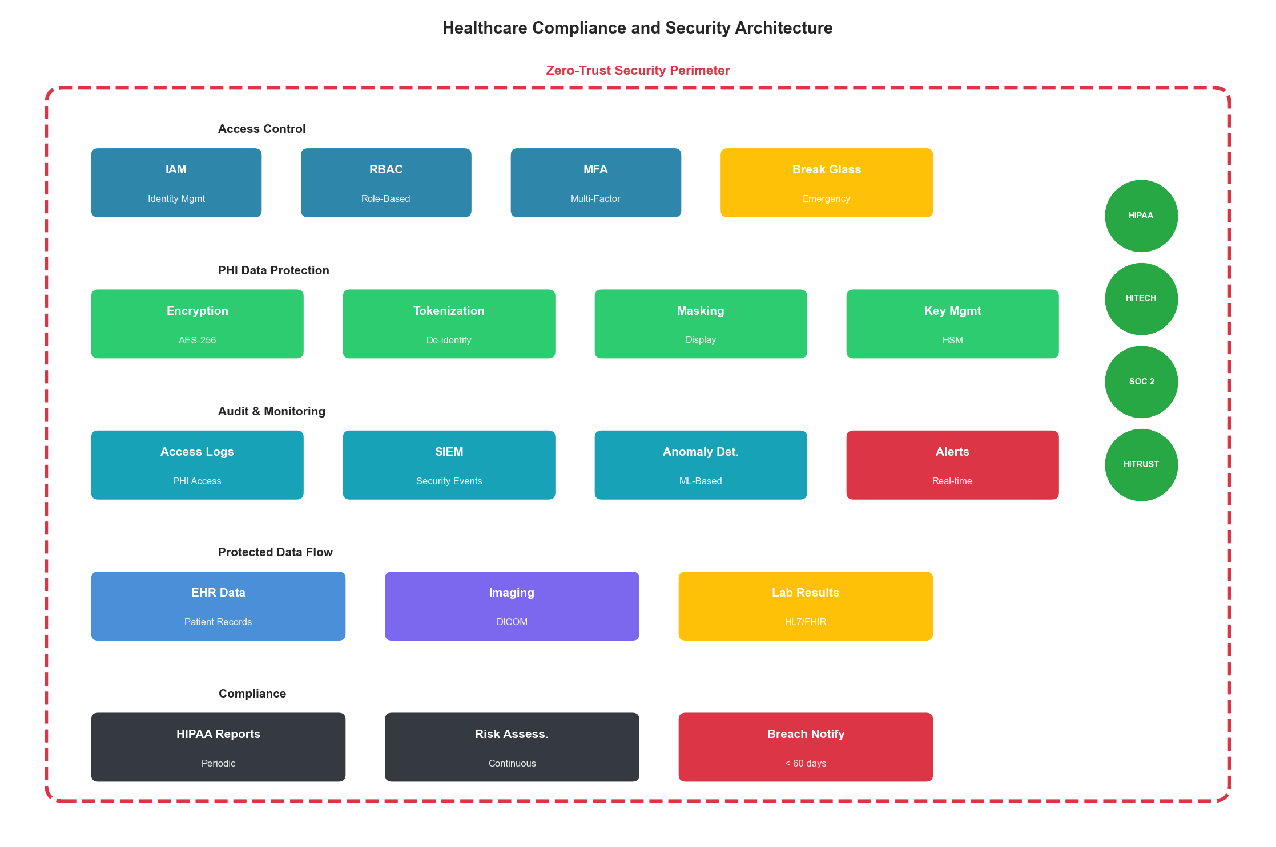
Figure 6.2: Healthcare Compliance Architecture
Figure 6.2: Healthcare Compliance and Security Architecture

6.2.4 Scalability with Clinical Safety
Scaling healthcare systems requires maintaining safety guarantees at every scale:
Scaling Constraints:
Constraint | Impact on Scaling | Mitigation
Data locality | PHI cannot cross certain boundaries | Regional deployments
Audit requirements | Every instance must log | Centralized SIEM
Encryption | Performance overhead | Hardware acceleration
Testing requirements | Clinical validation needed | Staged rollouts
Integration | HL7/FHIR compatibility | Interface engines
class ClinicalSafeScaler:
"""
Auto-scaling with clinical safety guardrails.
"""
def __init__(self, orchestrator, safety_checker, audit_logger):
self.orchestrator = orchestrator
self.safety = safety_checker
self.audit = audit_logger
async def scale_service(
self,
service: str,
target_instances: int,
reason: str
) -> dict:
"""
Scale with clinical safety verification.
"""
current = await self.orchestrator.get_instance_count(service)
# Pre-flight safety check
safety_result = await self.safety.check_scaling(
service=service,
current=current,
target=target_instances
)
if not safety_result["safe"]:
self.audit.log({
"event": "scaling_blocked",
"service": service,
"reason": safety_result["reason"],
"clinical_impact": safety_result.get("clinical_impact")
})
return {"success": False, "reason": safety_result["reason"]}
# Check clinical hours constraints
if self._is_peak_clinical_hours() and target_instances < current:
return {
"success": False,
"reason": "scale_down_blocked_during_clinical_hours"
}
# Execute scaling
result = await self.orchestrator.scale(service, target_instances)
# Verify health post-scaling
health = await self._verify_service_health(service)
if not health["healthy"]:
# Automatic rollback
await self.orchestrator.scale(service, current)
return {"success": False, "reason": "health_check_failed"}
self.audit.log({
"event": "scaling_completed",
"service": service,
"previous": current,
"new": target_instances,
"reason": reason
})
return {"success": True, "new_count": target_instances}

6.2.5 Economic Impact in Value-Based Care
Cost optimization in healthcare must align with value-based care models:
Total Cost Model:
Healthcare TCO = Infrastructure + Compliance + Clinical Outcomes
Where:
Infrastructure = Compute + Storage + Network + Integration
Compliance = HIPAA tools + Security + Audit + Training
Clinical Outcomes = (Quality metrics × Reimbursement) - (Adverse events × Cost)
Cost Component | Typical % of IT Budget | Optimization Potential
EHR/EMR systems | 30-40% | 15-20% through optimization
Infrastructure | 25-30% | 20-30% through cloud
Integration/interfaces | 15-20% | 30-40% through FHIR
Security/compliance | 10-15% | Limited (cannot reduce)
Support/maintenance | 10-15% | 20-30% through automation

6.3 Electronic Health Record Infrastructure

6.3.1 EHR Architecture Patterns
Modern EHR systems require sophisticated architectures to handle complex clinical workflows:
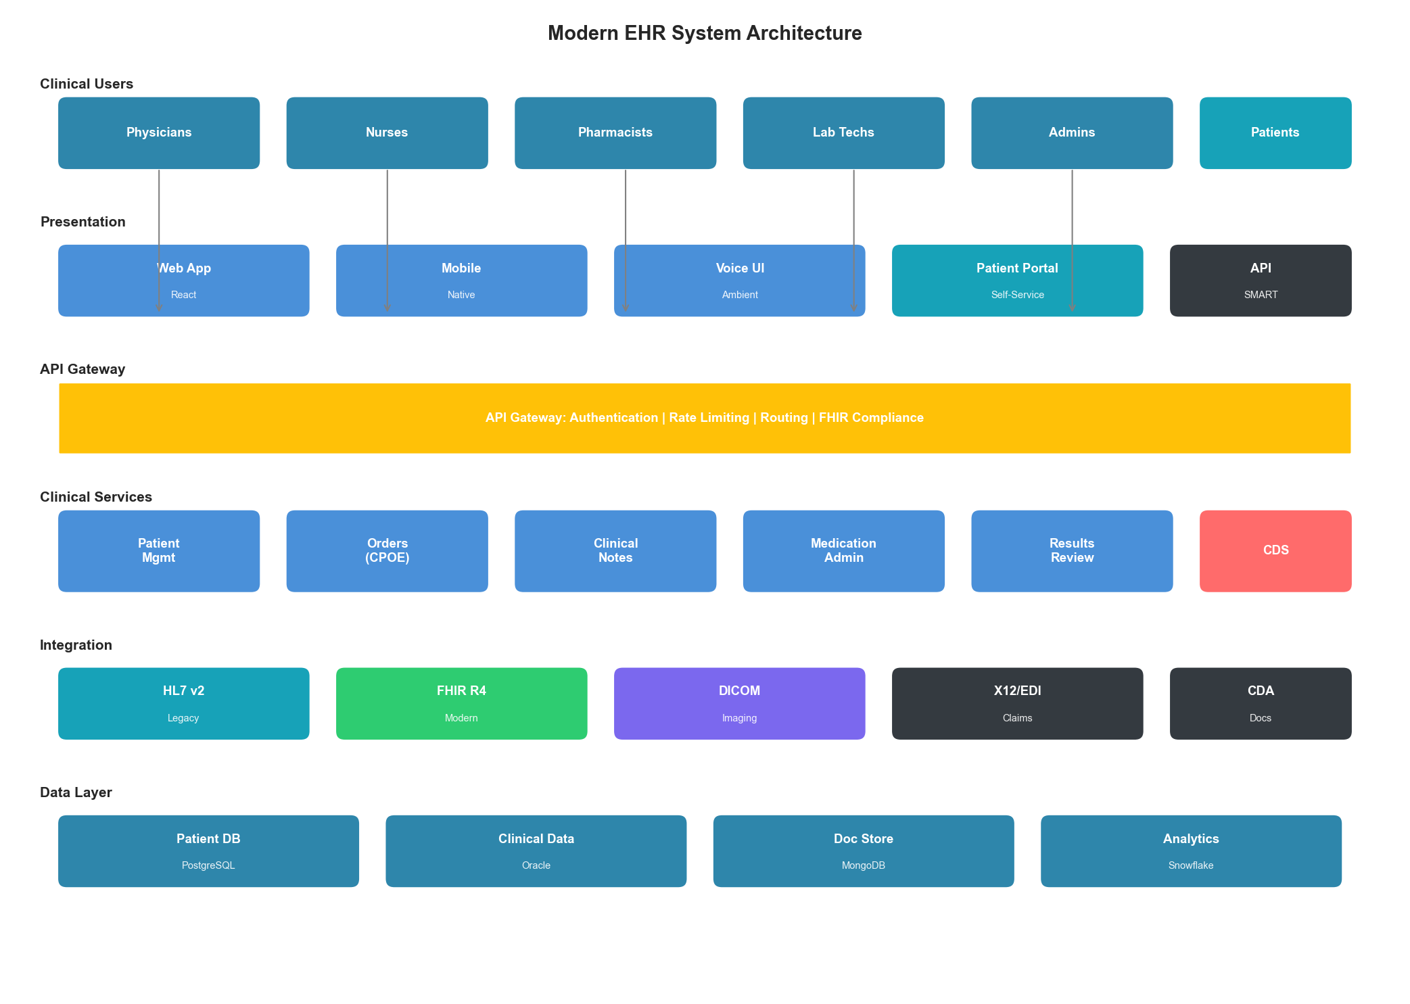
Figure 6.3: EHR System Architecture
Figure 6.3: Modern EHR System Architecture
Architecture Layers:
Layer | Function | Technology Options
Presentation | Clinical UI | Web, mobile, voice
API Gateway | Security, routing | Kong, AWS API Gateway
Clinical Services | Business logic | Java, .NET, microservices
Integration | Interoperability | Mirth Connect, Rhapsody
Data Layer | Patient records | Oracle, PostgreSQL, MongoDB
Analytics | Population health | Snowflake, Databricks

6.3.2 Clinical Workflow Optimization
class ClinicalWorkflowOptimizer:
"""
Optimize EHR workflows for clinical efficiency.
"""
def __init__(self, ehr_client, ml_predictor, cache):
self.ehr = ehr_client
self.predictor = ml_predictor
self.cache = cache
async def optimize_chart_load(
self,
patient_id: str,
provider_id: str,
encounter_type: str
) -> dict:
"""
Predictive chart loading based on clinical context.
Pre-fetches likely needed data based on:
- Encounter type
- Patient history
- Provider preferences
"""
# Predict needed data sections
predicted_sections = await self.predictor.predict_chart_sections(
encounter_type=encounter_type,
patient_conditions=await self._get_conditions(patient_id),
provider_specialty=await self._get_specialty(provider_id)
)
# Parallel pre-fetch
fetch_tasks = []
for section in predicted_sections:
if section["probability"] > 0.7:
fetch_tasks.append(
self._prefetch_section(patient_id, section["name"])
)
await asyncio.gather(*fetch_tasks)
return {
"prefetched_sections": [s["name"] for s in predicted_sections
if s["probability"] > 0.7],
"patient_id": patient_id
}
async def optimize_order_entry(
self,
patient_id: str,
provider_id: str,
order_type: str
) -> dict:
"""
Optimize order entry with clinical decision support.
"""
# Get patient context
allergies = await self.ehr.get_allergies(patient_id)
medications = await self.ehr.get_active_medications(patient_id)
conditions = await self.ehr.get_active_conditions(patient_id)
# Pre-compute interaction checks
if order_type == "medication":
interaction_cache_key = f"interactions:{patient_id}"
await self.cache.set(
interaction_cache_key,
await self._compute_interactions(medications, allergies),
ttl=300 # 5 minute cache
)
# Pre-load order templates
templates = await self.predictor.predict_order_templates(
provider_id=provider_id,
conditions=conditions,
order_type=order_type
)
return {
"suggested_templates": templates[:5],
"precomputed_checks": True
}

6.3.3 FHIR-Based Interoperability
class FHIRInteroperabilityLayer:
"""
FHIR R4 compliant interoperability layer.
"""
def __init__(self, fhir_server, transform_engine, audit_logger):
self.fhir = fhir_server
self.transformer = transform_engine
self.audit = audit_logger
async def get_patient_summary(
self,
patient_id: str,
requesting_system: str
) -> dict:
"""
Return FHIR-compliant patient summary.
Implements US Core Patient profile.
"""
# Audit the external access
self.audit.log_phi_access(
user_id=f"system:{requesting_system}",
patient_id=patient_id,
access_type="read",
resource_type="patient_summary"
)
# Fetch from FHIR server
patient = await self.fhir.read("Patient", patient_id)
conditions = await self.fhir.search("Condition", {
"patient": patient_id,
"clinical-status": "active"
})
medications = await self.fhir.search("MedicationRequest", {
"patient": patient_id,
"status": "active"
})
allergies = await self.fhir.search("AllergyIntolerance", {
"patient": patient_id,
"clinical-status": "active"
})
# Build summary bundle
summary = {
"resourceType": "Bundle",
"type": "document",
"entry": [
{"resource": patient},
*[{"resource": c} for c in conditions["entry"]],
*[{"resource": m} for m in medications["entry"]],
*[{"resource": a} for a in allergies["entry"]]
]
}
return summary
async def transform_hl7v2_to_fhir(
self,
hl7_message: str,
message_type: str
) -> dict:
"""
Transform legacy HL7v2 messages to FHIR resources.
"""
# Parse HL7v2
parsed = self.transformer.parse_hl7v2(hl7_message)
# Map to FHIR based on message type
if message_type == "ADT^A01": # Admission
return await self._transform_admission(parsed)
elif message_type == "ORM^O01": # Order
return await self._transform_order(parsed)
elif message_type == "ORU^R01": # Result
return await self._transform_result(parsed)
else:
raise UnsupportedMessageTypeError(message_type)

6.4 Medical Imaging Infrastructure

6.4.1 PACS Architecture
Picture Archiving and Communication Systems (PACS) require specialized infrastructure for handling massive imaging data:
Storage Requirements:
Imaging Modality | Image Size | Annual Volume (Large Hospital)
X-Ray | 10-50 MB | 500,000+ studies
CT | 100-500 MB | 150,000+ studies
MRI | 200 MB - 1 GB | 75,000+ studies
Mammography | 200-400 MB | 50,000+ studies
Ultrasound | 50-200 MB | 100,000+ studies
Pathology (WSI) | 1-10 GB | Growing rapidly
class PACSOptimizer:
"""
Optimize PACS storage and retrieval.
"""
def __init__(self, storage_tiers, cache_manager, ml_predictor):
self.storage = storage_tiers
self.cache = cache_manager
self.predictor = ml_predictor
async def optimize_image_retrieval(
self,
study_uid: str,
user_context: dict
) -> dict:
"""
Optimize image retrieval with predictive caching.
"""
# Check hot cache first
cached = await self.cache.get_study(study_uid)
if cached:
return {"source": "cache", "latency_ms": 50}
# Determine storage tier
study_age = await self._get_study_age(study_uid)
tier = self._determine_tier(study_age)
# Retrieve from appropriate tier
start = time.time()
study = await self.storage[tier].retrieve(study_uid)
retrieval_time = (time.time() - start) * 1000
# Cache for future access
await self.cache.set_study(study_uid, study)
# Predictive pre-fetch of related studies
await self._prefetch_related(study_uid, user_context)
return {
"source": tier,
"latency_ms": retrieval_time,
"prefetched": True
}
async def implement_tiered_storage(
self,
study_uid: str,
study_metadata: dict
) -> str:
"""
Implement intelligent tiered storage.
Tiers:
- Hot: SSD, < 30 days or high access
- Warm: HDD, 30-365 days
- Cold: Object storage, 1-7 years
- Archive: Tape/Glacier, 7+ years
"""
# Calculate access probability
access_prob = await self.predictor.predict_access_probability(
study_metadata
)
# Determine tier
study_age_days = study_metadata["age_days"]
if study_age_days < 30 or access_prob > 0.5:
tier = "hot"
elif study_age_days < 365 or access_prob > 0.1:
tier = "warm"
elif study_age_days < 2555: # 7 years
tier = "cold"
else:
tier = "archive"
# Move to appropriate tier
await self.storage[tier].store(study_uid, study_metadata)
return tier

6.4.2 AI-Assisted Imaging
class ImagingAIOrchestrator:
"""
Orchestrate AI models for medical imaging analysis.
"""
def __init__(self, model_registry, gpu_pool, result_store):
self.models = model_registry
self.gpu = gpu_pool
self.results = result_store
async def analyze_study(
self,
study_uid: str,
modality: str,
analysis_types: list
) -> dict:
"""
Run AI analysis on imaging study.
"""
# Get appropriate models
models_to_run = []
for analysis_type in analysis_types:
model = self.models.get_model(modality, analysis_type)
if model:
models_to_run.append((analysis_type, model))
# Allocate GPU resources
gpu_allocation = await self.gpu.allocate(
num_gpus=len(models_to_run),
memory_per_gpu="8GB"
)
# Run analyses in parallel
results = {}
async with gpu_allocation:
tasks = []
for analysis_type, model in models_to_run:
task = self._run_model(study_uid, model, analysis_type)
tasks.append(task)
model_results = await asyncio.gather(*tasks)
for (analysis_type, _), result in zip(models_to_run, model_results):
results[analysis_type] = result
# Store results with DICOM SR
await self._store_ai_results(study_uid, results)
return {
"study_uid": study_uid,
"analyses_completed": list(results.keys()),
"findings": self._summarize_findings(results)
}
async def _run_model(
self,
study_uid: str,
model: AIModel,
analysis_type: str
) -> dict:
"""Run single model with clinical safety checks."""
# Load images
images = await self._load_dicom_images(study_uid)
# Preprocess
preprocessed = model.preprocess(images)
# Inference
raw_result = await model.infer(preprocessed)
# Post-process with clinical thresholds
clinical_result = model.postprocess(
raw_result,
confidence_threshold=0.85, # High threshold for clinical use
apply_clinical_rules=True
)
# Add uncertainty quantification
clinical_result["uncertainty"] = model.estimate_uncertainty(raw_result)
# Flag for radiologist review if uncertain
clinical_result["requires_review"] = (
clinical_result["uncertainty"] > 0.2 or
clinical_result["confidence"] < 0.9
)
return clinical_result
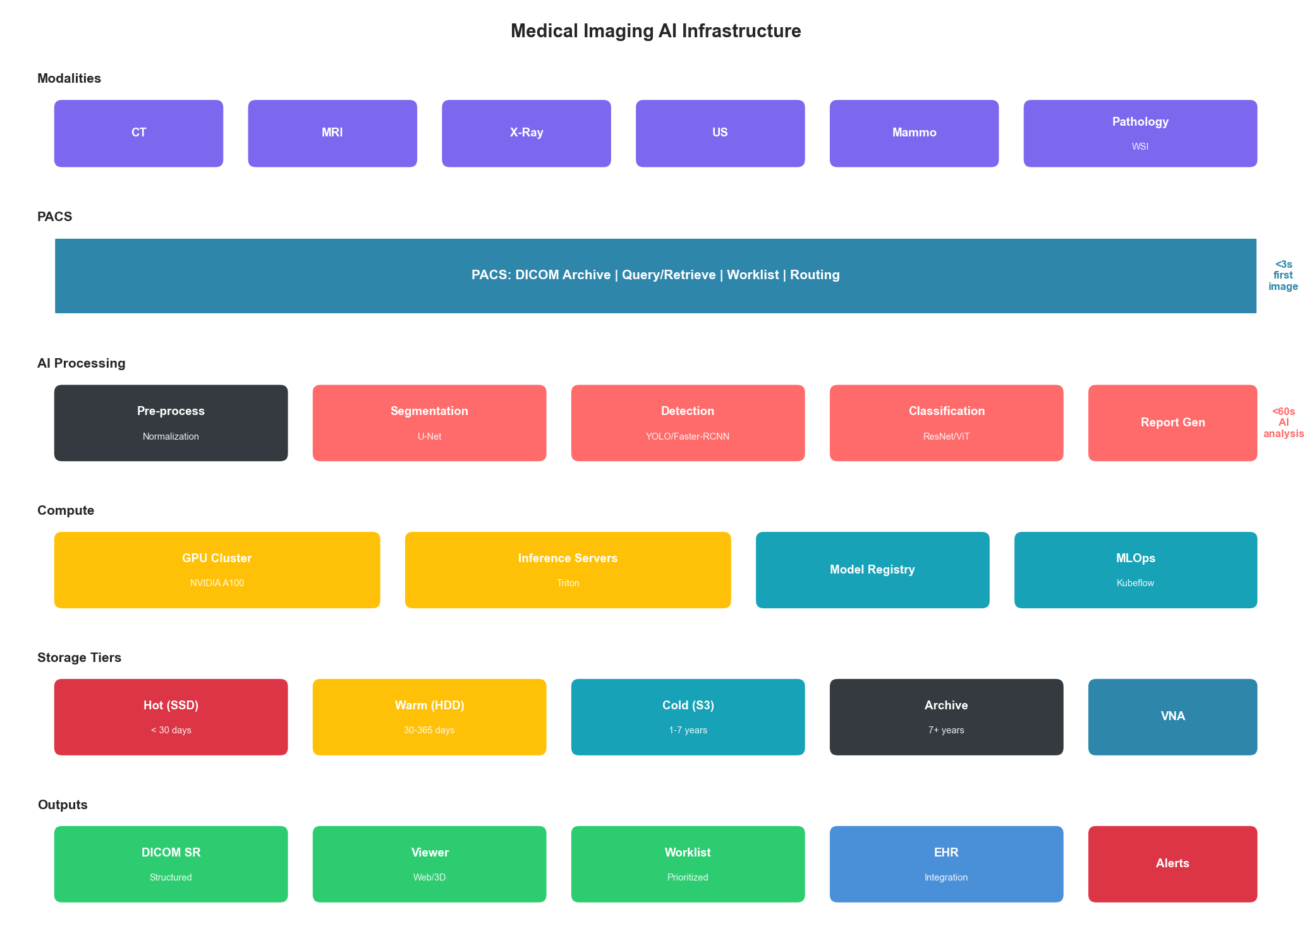
Figure 6.4: Medical Imaging Infrastructure
Figure 6.4: Medical Imaging AI Infrastructure

6.5 Telemedicine Infrastructure

6.5.1 Real-Time Communication Requirements
Telemedicine platforms require specialized infrastructure for reliable video communication:
Requirement | Target | Impact
Video latency | < 150ms | Natural conversation
Audio latency | < 100ms | No talking over
Packet loss | < 1% | Quality degradation
Availability | 99.9% | Patient access
Recording quality | 720p minimum | Documentation
class TelemedicineInfrastructure:
"""
Infrastructure optimization for telemedicine platforms.
"""
def __init__(self, media_server, quality_monitor, edge_nodes):
self.media = media_server
self.quality = quality_monitor
self.edge = edge_nodes
async def establish_session(
self,
provider_id: str,
patient_id: str,
session_type: str
) -> dict:
"""
Establish optimized telemedicine session.
"""
# Select optimal edge node for patient
patient_location = await self._get_patient_location(patient_id)
optimal_edge = await self.edge.select_nearest(
patient_location,
required_capacity="video"
)
# Assess network conditions
network_quality = await self._assess_network(patient_id)
# Configure adaptive bitrate based on network
video_config = self._determine_video_config(network_quality)
# Initialize session
session = await self.media.create_session({
"participants": [provider_id, patient_id],
"edge_node": optimal_edge,
"video_config": video_config,
"recording_enabled": True,
"hipaa_compliant": True
})
return {
"session_id": session["id"],
"join_url_provider": session["provider_url"],
"join_url_patient": session["patient_url"],
"estimated_quality": network_quality["score"]
}
async def monitor_and_adapt(
self,
session_id: str
):
"""
Continuously monitor and adapt session quality.
"""
while await self._session_active(session_id):
metrics = await self.quality.get_metrics(session_id)
# Check for quality degradation
if metrics["packet_loss"] > 0.02:
# Reduce bitrate
await self._adjust_bitrate(session_id, "decrease")
if metrics["latency_ms"] > 200:
# Try edge node switch
await self._consider_edge_switch(session_id)
# Check for clinical safety issues
if metrics["audio_quality"] < 0.6:
# Audio critical for clinical communication
await self._prioritize_audio(session_id)
await self._alert_participants(
session_id,
"audio_quality_degraded"
)
await asyncio.sleep(5)

6.5.2 Remote Patient Monitoring
class RemoteMonitoringPlatform:
"""
Infrastructure for remote patient monitoring (RPM).
"""
def __init__(self, device_gateway, alert_engine, analytics):
self.gateway = device_gateway
self.alerts = alert_engine
self.analytics = analytics
async def process_vital_reading(
self,
patient_id: str,
device_id: str,
reading: dict
) -> dict:
"""
Process incoming vital sign reading.
"""
# Validate device authentication
if not await self._validate_device(device_id, patient_id):
raise DeviceAuthenticationError()
# Store reading
await self._store_reading(patient_id, reading)
# Get patient baselines and thresholds
baselines = await self._get_patient_baselines(patient_id)
thresholds = await self._get_alert_thresholds(patient_id)
# Check for alerts
alert_results = []
for vital_type, value in reading["vitals"].items():
if self._exceeds_threshold(value, thresholds.get(vital_type)):
alert = await self.alerts.create_alert({
"patient_id": patient_id,
"vital_type": vital_type,
"value": value,
"threshold": thresholds[vital_type],
"severity": self._calculate_severity(
value, thresholds[vital_type], baselines.get(vital_type)
)
})
alert_results.append(alert)
# Run trend analysis
trend = await self.analytics.analyze_trend(
patient_id,
reading["vitals"],
window_hours=24
)
return {
"stored": True,
"alerts_generated": len(alert_results),
"trend_analysis": trend
}

6.6 Clinical Decision Support Infrastructure

6.6.1 Real-Time CDS Architecture
Clinical Decision Support systems must provide timely, relevant alerts without causing alert fatigue:
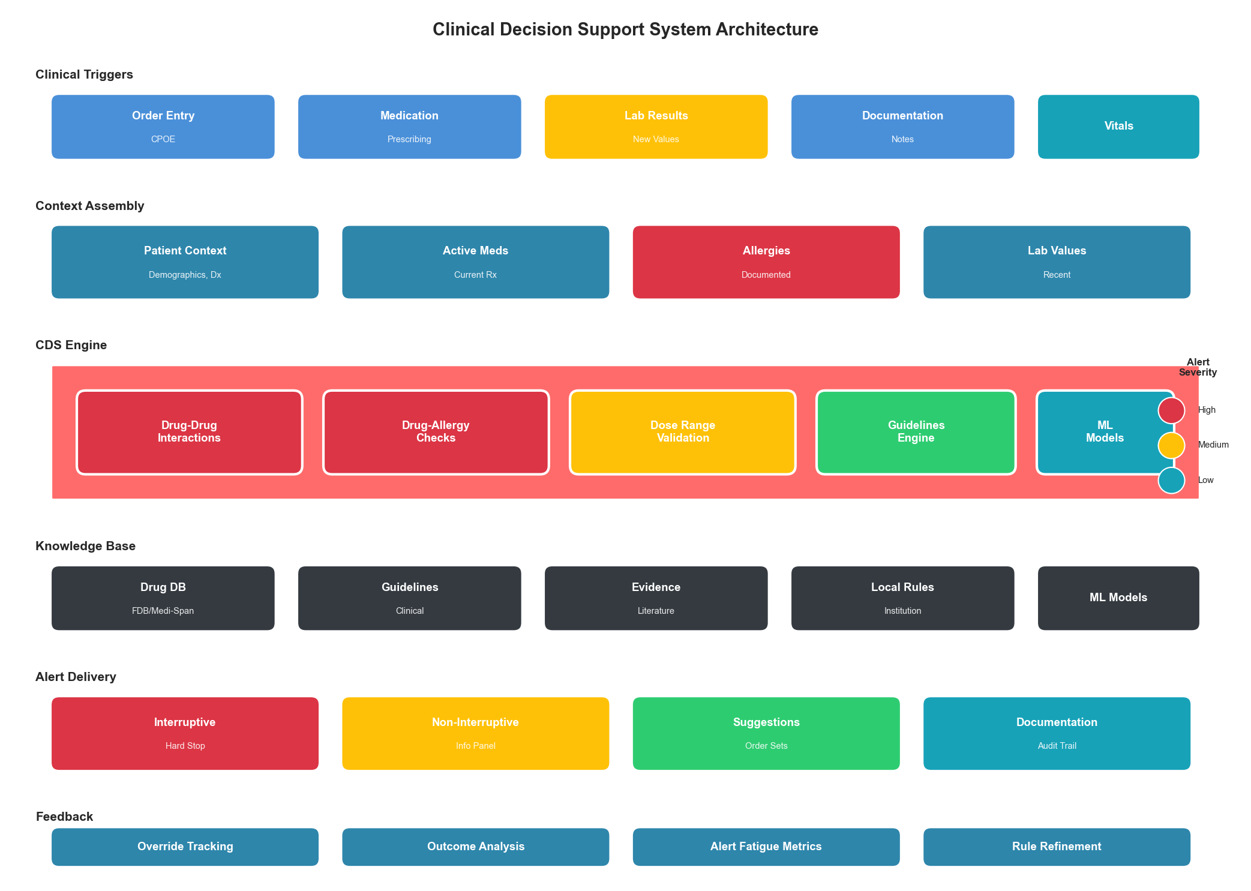
Figure 6.5: Clinical Decision Support Architecture
Figure 6.5: Clinical Decision Support System Architecture
class ClinicalDecisionSupportEngine:
"""
Real-time clinical decision support infrastructure.
"""
def __init__(self, rules_engine, ml_models, knowledge_base):
self.rules = rules_engine
self.ml = ml_models
self.knowledge = knowledge_base
async def evaluate_order(
self,
order: dict,
patient_context: dict,
provider_context: dict
) -> dict:
"""
Evaluate order with clinical decision support.
Balance sensitivity vs. alert fatigue.
"""
alerts = []
suggestions = []
# Drug-drug interactions
if order["type"] == "medication":
ddi_result = await self._check_drug_interactions(
order["medication"],
patient_context["active_medications"]
)
alerts.extend(ddi_result["alerts"])
# Drug-allergy check
allergy_result = await self._check_allergies(
order,
patient_context["allergies"]
)
if allergy_result["contraindicated"]:
alerts.append({
"type": "allergy_alert",
"severity": "high",
"message": allergy_result["message"],
"interruptive": True # Must acknowledge
})
# Dose range check
dose_result = await self._check_dose_range(
order,
patient_context["weight"],
patient_context["age"],
patient_context["renal_function"]
)
if dose_result["outside_range"]:
alerts.append({
"type": "dose_alert",
"severity": "medium",
"message": dose_result["message"],
"suggested_dose": dose_result["recommended"]
})
# ML-based clinical suggestions
ml_suggestions = await self.ml.get_suggestions(
order=order,
patient=patient_context,
provider_specialty=provider_context["specialty"]
)
suggestions.extend(ml_suggestions)
# Filter based on provider preferences and alert fatigue
filtered_alerts = self._filter_alerts(
alerts,
provider_context["alert_preferences"],
provider_context["recent_override_rate"]
)
return {
"proceed": len([a for a in filtered_alerts
if a["interruptive"]]) == 0,
"alerts": filtered_alerts,
"suggestions": suggestions
}
def _filter_alerts(
self,
alerts: list,
preferences: dict,
override_rate: float
) -> list:
"""
Filter alerts to reduce alert fatigue.
High override rates indicate too many irrelevant alerts.
"""
filtered = []
for alert in alerts:
# Always show high severity
if alert["severity"] == "high":
filtered.append(alert)
continue
# Check provider preferences
if preferences.get(f"suppress_{alert['type']}", False):
continue
# If override rate is high, only show high severity
if override_rate > 0.8 and alert["severity"] != "high":
continue
filtered.append(alert)
return filtered

6.7 Case Study: Health System Digital Transformation

6.7.1 Scenario
A regional health system with 12 hospitals and 200+ clinics undertaking digital transformation:
- Scale: 2M patient records, 50,000 daily encounters
- Current state: Multiple legacy EHRs, paper-based workflows
- Target state: Unified modern platform with AI-assisted care
- Compliance: HIPAA, state regulations, payer requirements
- Timeline: 36-month transformation
The health system faced interconnected challenges: physician burnout from documentation burden, care coordination gaps across facilities, and rising costs despite declining reimbursements. Leadership recognized that incremental improvements to existing systems would not address fundamental issues.

6.7.2 Architecture Decisions
Component | Decision | Rationale
EHR strategy | Single vendor (Epic) | Interoperability, workflow
Cloud approach | Hybrid (sensitive data on-prem) | HIPAA + flexibility
Integration | FHIR-first with HL7v2 bridge | Future-proof + legacy support
Analytics | Cloud data platform (Snowflake) | ML/AI capabilities
Security | Zero-trust with SASE | Modern threat protection

6.7.3 Results
Metric | Before | After | Improvement
Provider documentation time | 2 hours/day | 1.2 hours/day | 40%
Patient wait time (avg) | 45 minutes | 18 minutes | 60%
Care gap closure rate | 62% | 89% | 44%
Readmission rate | 14.2% | 9.8% | 31%
Cost per encounter | $285 | $198 | 31%
Patient satisfaction | 72% | 88% | 22%
PROSE Score Comparison:
Dimension | Before | After | Weighted Impact
Performance | 48 | 82 | +6.80
Resource Optimization | 42 | 78 | +5.40
Operational Excellence | 55 | 92 | +12.95
Scalability | 40 | 85 | +6.75
Economic Impact | 45 | 82 | +5.55
Weighted Total | 47 | 85 | +37.45

6.8 Implementation Roadmap

6.8.1 Phase 1: Foundation (Months 1-6)
Infrastructure Foundation:
- Assess current state infrastructure
- Design target architecture
- Implement security baseline
- Deploy monitoring and observability
- Establish HIPAA-compliant cloud environment
Quick Wins:
- Implement predictive chart loading
- Deploy clinical workflow analytics
- Optimize database query performance

6.8.2 Phase 2: Core Systems (Months 7-18)
EHR Optimization:
- Migrate to modern EHR or optimize existing
- Implement FHIR APIs
- Deploy clinical decision support
- Enable mobile access
Imaging Infrastructure:
- Implement tiered storage
- Deploy AI-assisted reading
- Optimize PACS performance

6.8.3 Phase 3: Advanced Capabilities (Months 19-36)
AI/ML Integration:
- Deploy clinical ML models
- Implement predictive analytics
- Enable population health management
Patient Experience:
- Launch patient portal enhancements
- Deploy telemedicine platform
- Implement remote monitoring

Key Takeaways
- Patient safety is paramount - Every optimization must maintain or improve patient safety; performance gains cannot come at the cost of clinical accuracy
- HIPAA compliance is foundational - Audit trails, encryption, and access controls are non-negotiable requirements that must be designed in from the start
- Interoperability enables value - FHIR-first architectures unlock data liquidity while maintaining compatibility with legacy systems
- Clinical workflow matters - Technology must fit provider workflows; the best-performing system that clinicians won’t use delivers no value
- Alert fatigue is real - Clinical decision support must balance sensitivity with specificity to maintain effectiveness
- AI requires clinical validation - ML models in healthcare require rigorous validation, uncertainty quantification, and human oversight

References
- Office for Civil Rights. “HIPAA Security Rule.” HHS.gov (2023)
- HL7 International. “FHIR R4 Specification.” hl7.org/fhir (2023)
- HIMSS. “Electronic Health Record Association.” himss.org (2023)
- FDA. “Artificial Intelligence and Machine Learning in Software as Medical Device.” FDA.gov (2023)
- ONC. “United States Core Data for Interoperability (USCDI).” healthit.gov (2023)

Next Chapter: Cross-Industry Convergence Patterns

