Table of Contents

Chapter 4: E-Commerce Infrastructure Optimization

Introduction
E-commerce platforms face unique infrastructure challenges that distinguish them from other industries. The combination of unpredictable traffic spikes, real-time inventory management, personalization at scale, and the direct relationship between latency and revenue creates an environment where infrastructure optimization isn’t just about cost savings—it’s about competitive survival.
This chapter applies the PROSE Framework introduced in Chapter 3 to e-commerce infrastructure, providing actionable strategies for optimizing platforms that must handle everything from steady-state browsing to viral flash sales.

4.1 The E-Commerce Infrastructure Challenge

4.1.1 Why E-Commerce Is Different
E-commerce infrastructure operates under constraints that make optimization particularly challenging:
Challenge | Impact | Traditional Approach | AI-Driven Approach
Traffic unpredictability | 10-100x normal load during events | Massive over-provisioning | Predictive scaling
Latency sensitivity | 100ms delay = 1% revenue loss | Static CDN rules | Dynamic edge optimization
Inventory synchronization | Overselling, stockouts | Periodic batch updates | Real-time streaming
Personalization demands | Millions of unique experiences | Pre-computed segments | Real-time ML inference
Cart abandonment | 70% average abandonment rate | Static checkout flows | Adaptive optimization
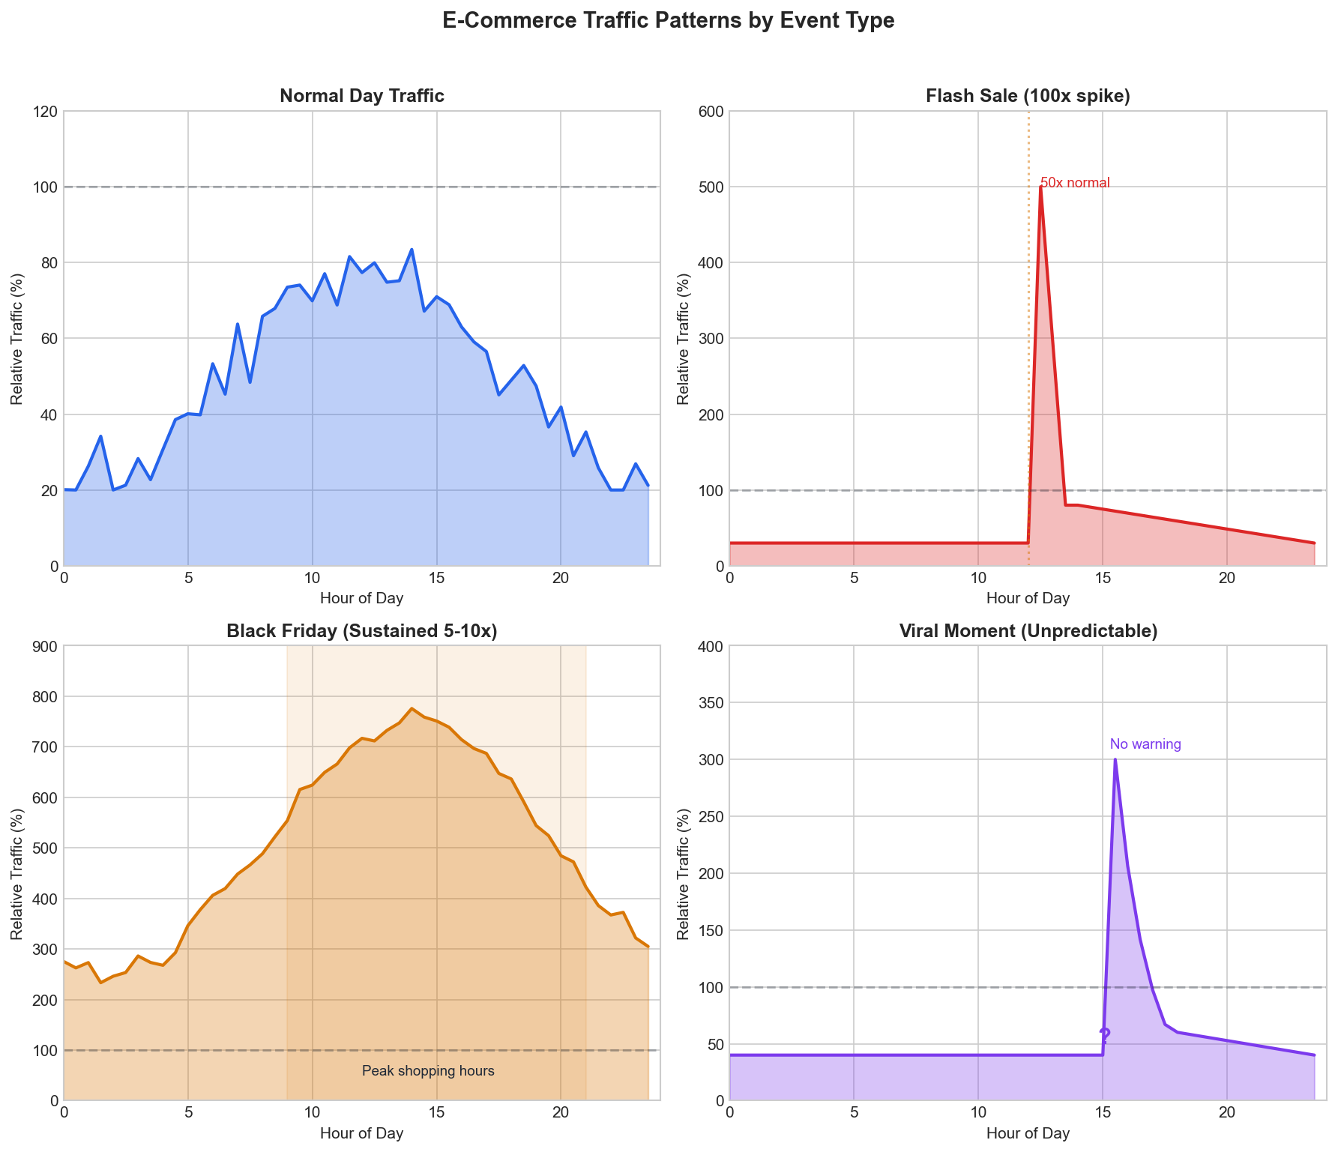
Figure 4.1: E-Commerce Traffic Patterns
Figure 4.1: Typical E-Commerce Traffic Patterns Across Different Event Types

4.1.2 The Revenue-Latency Relationship
Research consistently shows that latency directly impacts e-commerce revenue:
- Amazon: 100ms latency = 1% revenue loss
- Walmart: 1 second improvement = 2% conversion increase
- Google: 500ms delay = 20% traffic reduction
This relationship creates a clear optimization target: every millisecond saved translates to measurable business value.
def calculate_latency_impact(
current_latency_ms: float,
target_latency_ms: float,
daily_revenue: float,
latency_sensitivity: float = 0.01 # 1% per 100ms
) -> dict:
"""
Calculate revenue impact of latency improvement.
Args:
current_latency_ms: Current P50 latency
target_latency_ms: Target P50 latency
daily_revenue: Daily revenue in dollars
latency_sensitivity: Revenue loss per 100ms
Returns:
Dictionary with impact analysis
"""
latency_improvement = current_latency_ms - target_latency_ms
revenue_multiplier = 1 + (latency_improvement / 100) * latency_sensitivity
daily_uplift = daily_revenue * (revenue_multiplier - 1)
annual_uplift = daily_uplift * 365
return {
"latency_improvement_ms": latency_improvement,
"daily_revenue_uplift": daily_uplift,
"annual_revenue_uplift": annual_uplift,
"roi_per_ms": annual_uplift / latency_improvement if latency_improvement > 0 else 0
}

4.2 Applying the PROSE Framework to E-Commerce

4.2.1 Performance Efficiency (Weight: 30%)
For e-commerce, performance efficiency focuses on user-facing metrics that directly impact conversion.
Critical Metrics:
Metric | Definition | E-Commerce Target | Business Impact
Time to First Byte (TTFB) | Server response initiation | < 200ms | Search ranking, UX
Largest Contentful Paint (LCP) | Main content visibility | < 2.5s | Bounce rate
First Input Delay (FID) | Interactivity readiness | < 100ms | Cart interaction
Cumulative Layout Shift (CLS) | Visual stability | < 0.1 | Trust, click accuracy
Add-to-Cart Latency | Cart operation speed | < 300ms | Conversion rate
Checkout Latency | Payment flow speed | < 500ms | Abandonment rate
Performance Optimization Architecture:
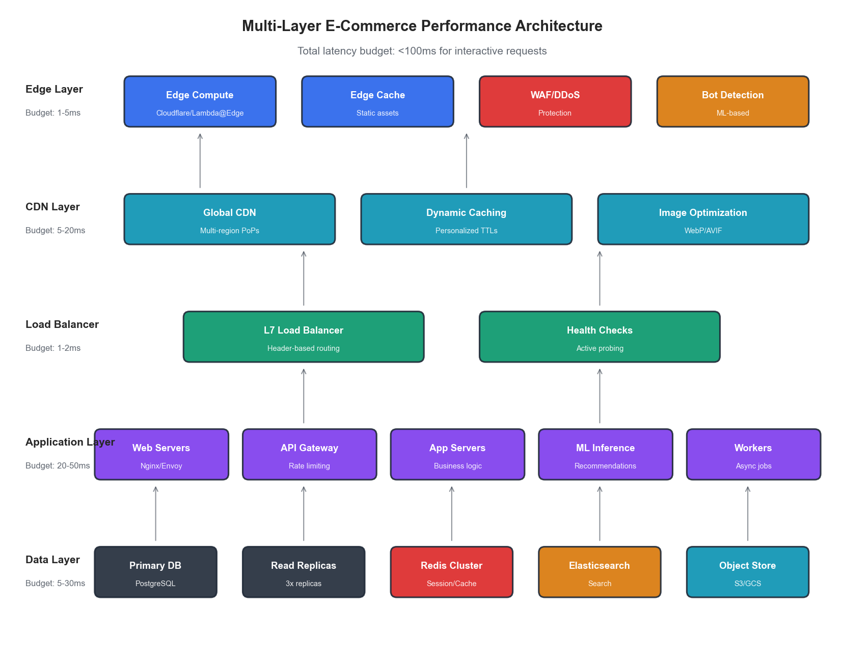
Figure 4.2: E-Commerce Performance Architecture
Figure 4.2: Multi-Layer Performance Optimization Architecture

4.2.2 Resource Optimization (Weight: 15%)
E-commerce resource optimization must balance efficiency with the need for burst capacity.
Resource Allocation Strategy:
class ECommerceResourceAllocator:
"""
Dynamic resource allocation for e-commerce workloads.
"""
def __init__(self, baseline_capacity: int, max_burst_multiplier: float = 10.0):
self.baseline = baseline_capacity
self.max_burst = baseline_capacity * max_burst_multiplier
self.current_allocation = baseline_capacity
def calculate_target_capacity(
self,
current_traffic: float,
predicted_traffic: float,
prediction_confidence: float
) -> int:
"""
Calculate target capacity based on current and predicted traffic.
Uses confidence-weighted blending of reactive and predictive signals.
"""
# Reactive component: based on current traffic with headroom
reactive_target = current_traffic * 1.3 # 30% headroom
# Predictive component: based on forecast
predictive_target = predicted_traffic * 1.2 # 20% headroom
# Blend based on prediction confidence
blended_target = (
predictive_target * prediction_confidence +
reactive_target * (1 - prediction_confidence)
)
# Apply bounds
return int(min(max(blended_target, self.baseline), self.max_burst))
Utilization Targets by Component:
Component | Target Utilization | Rationale
Web servers | 40-60% | Burst headroom for flash sales
Application servers | 50-70% | Processing headroom
Database (read) | 60-75% | Query performance
Database (write) | 40-50% | Transaction safety
Cache layer | 70-85% | Memory efficiency
CDN edge | 30-50% | Geographic burst capacity

4.2.3 Operational Excellence (Weight: 20%)
E-commerce operations must handle rapid deployments during frozen periods and instant rollbacks during sales events.
Deployment Strategy Matrix:
Period | Deployment Frequency | Rollback Time | Change Types Allowed
Normal | Multiple daily | < 5 minutes | All
Pre-event (7 days) | Daily with approval | < 2 minutes | Bug fixes, optimizations
Event freeze | Emergency only | < 1 minute | Critical fixes only
Post-event | Accelerated | < 5 minutes | All + learnings
Incident Response Framework:
class ECommerceIncidentResponse:
"""
Automated incident response for e-commerce platforms.
"""
SEVERITY_THRESHOLDS = {
"critical": {
"error_rate": 0.05, # 5% error rate
"latency_p99_ms": 2000, # 2 second P99
"revenue_impact_pct": 1.0 # 1% revenue impact
},
"high": {
"error_rate": 0.02,
"latency_p99_ms": 1000,
"revenue_impact_pct": 0.5
},
"medium": {
"error_rate": 0.01,
"latency_p99_ms": 500,
"revenue_impact_pct": 0.1
}
}
def classify_incident(self, metrics: dict) -> str:
"""Classify incident severity based on current metrics."""
for severity, thresholds in self.SEVERITY_THRESHOLDS.items():
if (metrics.get("error_rate", 0) >= thresholds["error_rate"] or
metrics.get("latency_p99_ms", 0) >= thresholds["latency_p99_ms"] or
metrics.get("revenue_impact_pct", 0) >= thresholds["revenue_impact_pct"]):
return severity
return "low"
def get_auto_remediation_actions(self, severity: str, symptoms: list) -> list:
"""Get automated remediation actions based on severity and symptoms."""
actions = []
if "high_latency" in symptoms:
actions.append({"action": "scale_up", "component": "app_servers", "factor": 1.5})
actions.append({"action": "enable_cache_bypass", "ttl": 300})
if "database_saturation" in symptoms:
actions.append({"action": "enable_read_replica_routing", "percentage": 80})
actions.append({"action": "reduce_batch_jobs", "factor": 0.5})
if "memory_pressure" in symptoms:
actions.append({"action": "trigger_gc", "aggressive": severity == "critical"})
actions.append({"action": "evict_cold_cache", "percentage": 20})
return actions

4.2.4 Scalability & Elasticity (Weight: 25%)
Scalability is paramount for e-commerce—the difference between handling a viral moment and losing millions in revenue.
Scaling Patterns for E-Commerce Events:
Event Type | Lead Time | Peak Multiplier | Duration | Optimal Strategy
Flash sale | Hours | 50-100x | Minutes | Pre-warm + aggressive scale
Daily peak | Predictable | 3-5x | Hours | Scheduled + predictive
Viral moment | None | 10-50x | Variable | Reactive + circuit breaker
Holiday season | Days | 5-10x | Weeks | Sustained high capacity
Marketing campaign | Hours | 5-20x | Hours | Scheduled + monitoring
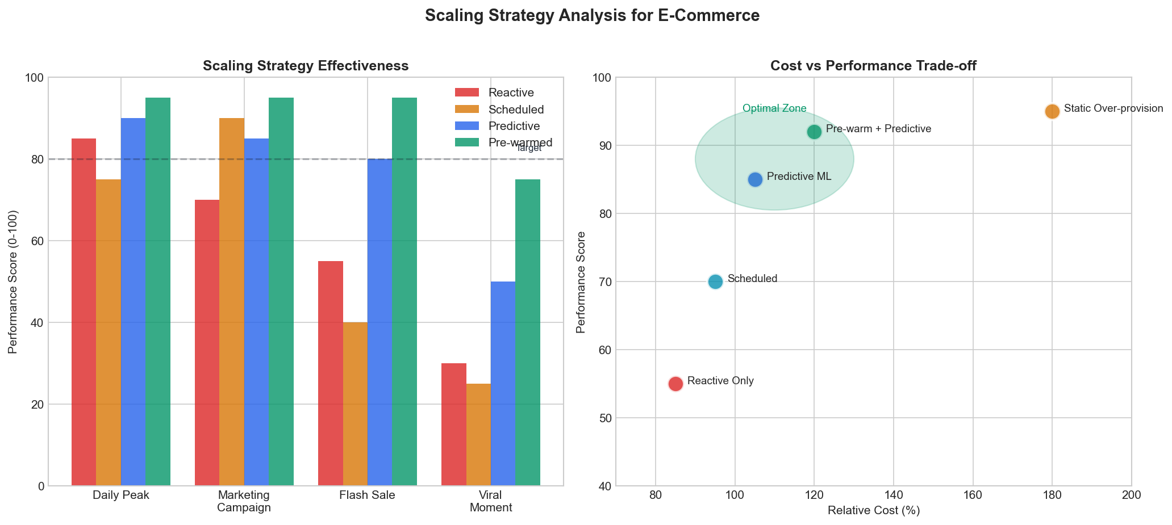
Figure 4.3: Scaling Strategy Comparison
Figure 4.3: Scaling Strategy Effectiveness by Event Type
Predictive Auto-Scaling Implementation:
class PredictiveAutoScaler:
"""
ML-based auto-scaler for e-commerce workloads.
"""
def __init__(self, model, scaler_client):
self.model = model # Trained forecasting model
self.scaler = scaler_client
self.min_instances = 10
self.max_instances = 500
self.scale_up_threshold = 0.7
self.scale_down_threshold = 0.3
def predict_and_scale(self, current_metrics: dict, horizon_minutes: int = 15):
"""
Predict future load and proactively scale.
Args:
current_metrics: Current system metrics
horizon_minutes: How far ahead to predict
"""
# Generate prediction
prediction = self.model.predict(
current_metrics,
horizon=horizon_minutes
)
predicted_load = prediction["load"]
confidence = prediction["confidence"]
# Calculate required capacity
current_capacity = current_metrics["instance_count"]
current_utilization = current_metrics["avg_cpu_utilization"]
# Effective capacity considering current utilization
load_per_instance = current_utilization / 100 * predicted_load / current_capacity
required_instances = int(predicted_load / (self.scale_up_threshold * 100))
# Apply confidence-based safety margin
safety_margin = 1.0 + (1.0 - confidence) * 0.5 # Up to 50% extra if uncertain
target_instances = int(required_instances * safety_margin)
# Bound to limits
target_instances = max(self.min_instances, min(target_instances, self.max_instances))
# Execute scaling if needed
if target_instances > current_capacity:
self.scaler.scale_up(target_instances - current_capacity)
elif target_instances < current_capacity * 0.7: # Hysteresis for scale-down
self.scaler.scale_down(current_capacity - target_instances)
return {
"current": current_capacity,
"target": target_instances,
"predicted_load": predicted_load,
"confidence": confidence
}

4.2.5 Economic Impact (Weight: 10%)
While cost is weighted lower than other dimensions, efficient spending enables investment in growth.
Cost Optimization Strategies:
Strategy | Savings Potential | Risk Level | Implementation Complexity
Spot instances for batch | 60-80% | Medium | Low
Reserved capacity (baseline) | 30-40% | Low | Low
CDN caching optimization | 20-40% | Low | Medium
Right-sizing instances | 20-30% | Low | Medium
Database query optimization | 15-25% | Low | High
Serverless for variable loads | 40-60% | Medium | High
Cost-Performance Trade-off Analysis:
def analyze_cost_performance_tradeoff(
configurations: list,
performance_weight: float = 0.7,
cost_weight: float = 0.3
) -> dict:
"""
Analyze cost-performance trade-offs across configurations.
Args:
configurations: List of {name, cost, latency_p99, throughput}
performance_weight: Weight for performance score
cost_weight: Weight for cost score
Returns:
Ranked configurations with composite scores
"""
# Normalize metrics
max_cost = max(c["cost"] for c in configurations)
min_latency = min(c["latency_p99"] for c in configurations)
max_throughput = max(c["throughput"] for c in configurations)
scored = []
for config in configurations:
# Cost score: lower is better (inverted)
cost_score = 1 - (config["cost"] / max_cost)
# Performance score: combination of latency and throughput
latency_score = min_latency / config["latency_p99"]
throughput_score = config["throughput"] / max_throughput
performance_score = (latency_score + throughput_score) / 2
# Composite score
composite = (performance_score * performance_weight +
cost_score * cost_weight)
scored.append({
**config,
"cost_score": cost_score,
"performance_score": performance_score,
"composite_score": composite
})
return sorted(scored, key=lambda x: x["composite_score"], reverse=True)

4.3 Flash Sale Infrastructure

4.3.1 The Flash Sale Challenge
Flash sales represent the ultimate stress test for e-commerce infrastructure. Within seconds, traffic can increase 100x while inventory must remain perfectly synchronized.
Flash Sale Requirements:
Requirement | Challenge | Solution Approach
Instant scale | Cold start latency | Pre-warmed capacity pools
Inventory accuracy | Race conditions | Distributed locks, event sourcing
Fair queuing | Bot prevention | Virtual waiting rooms
Graceful degradation | Cascade failures | Circuit breakers, fallbacks
Real-time updates | WebSocket scale | Edge pub/sub, connection pooling

4.3.2 Virtual Waiting Room Architecture
Virtual waiting rooms protect backend systems while providing fair access to customers.
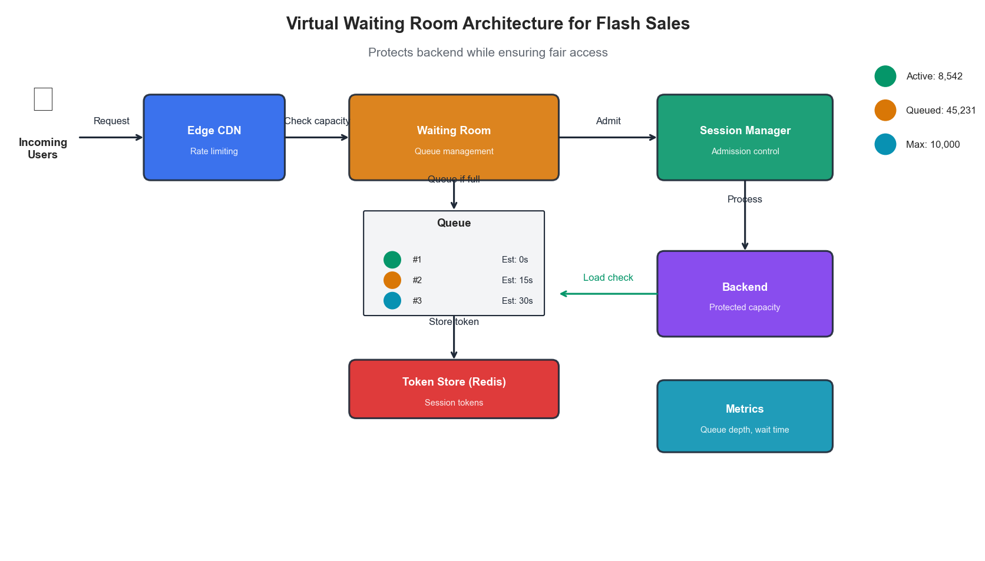
Figure 4.4: Virtual Waiting Room Architecture
Figure 4.4: Virtual Waiting Room Architecture for Flash Sales
class VirtualWaitingRoom:
"""
Manages fair access to flash sale inventory.
"""
def __init__(self, redis_client, max_concurrent: int = 10000):
self.redis = redis_client
self.max_concurrent = max_concurrent
async def enter_queue(self, user_id: str, sale_id: str) -> dict:
"""
Add user to waiting room queue.
Returns position and estimated wait time.
"""
queue_key = f"waiting_room:{sale_id}"
timestamp = time.time()
# Add to sorted set with timestamp as score
await self.redis.zadd(queue_key, {user_id: timestamp})
# Get position
position = await self.redis.zrank(queue_key, user_id)
# Calculate estimated wait
processing_rate = 100 # users per second
estimated_wait = max(0, (position - self.max_concurrent) / processing_rate)
return {
"position": position + 1,
"estimated_wait_seconds": estimated_wait,
"token": self._generate_token(user_id, sale_id)
}
async def check_admission(self, user_id: str, sale_id: str) -> bool:
"""
Check if user can be admitted from waiting room.
"""
queue_key = f"waiting_room:{sale_id}"
active_key = f"active_shoppers:{sale_id}"
# Check current active count
active_count = await self.redis.scard(active_key)
if active_count >= self.max_concurrent:
return False
# Check if user is next in queue
position = await self.redis.zrank(queue_key, user_id)
admitted_count = await self.redis.get(f"admitted:{sale_id}") or 0
if position <= int(admitted_count) + (self.max_concurrent - active_count):
# Admit user
await self.redis.sadd(active_key, user_id)
await self.redis.incr(f"admitted:{sale_id}")
return True
return False

4.3.3 Inventory Synchronization
Real-time inventory accuracy prevents overselling while maximizing sales.
class DistributedInventoryManager:
"""
Manages inventory across distributed systems with strong consistency.
"""
def __init__(self, redis_cluster, postgres_pool):
self.cache = redis_cluster
self.db = postgres_pool
async def reserve_inventory(
self,
sku: str,
quantity: int,
reservation_id: str,
ttl_seconds: int = 600
) -> dict:
"""
Reserve inventory with distributed locking.
Uses optimistic locking with automatic retry.
"""
lock_key = f"inv_lock:{sku}"
for attempt in range(3):
try:
# Acquire distributed lock
async with self.cache.lock(lock_key, timeout=5):
# Check available inventory in cache
available = await self.cache.get(f"inventory:{sku}")
if available is None:
# Cache miss - load from database
available = await self._load_from_db(sku)
if int(available) < quantity:
return {"success": False, "reason": "insufficient_inventory"}
# Reserve in cache
new_available = int(available) - quantity
await self.cache.set(f"inventory:{sku}", new_available)
# Record reservation
await self.cache.setex(
f"reservation:{reservation_id}",
ttl_seconds,
json.dumps({"sku": sku, "quantity": quantity})
)
# Async write to database (event-sourced)
await self._emit_reservation_event(sku, quantity, reservation_id)
return {
"success": True,
"reservation_id": reservation_id,
"remaining": new_available
}
except LockError:
await asyncio.sleep(0.1 * (attempt + 1))
return {"success": False, "reason": "lock_contention"}

4.4 Personalization at Scale

4.4.1 Real-Time Recommendation Infrastructure
Personalization requires real-time ML inference at massive scale.
Recommendation System Architecture:
Layer | Latency Budget | Function | Technology
Edge cache | 1-5ms | Pre-computed popular items | CDN with edge compute
Feature store | 5-10ms | User feature retrieval | Redis Cluster
Model inference | 10-30ms | Real-time scoring | GPU inference servers
Fallback | 1ms | Default recommendations | Static cache
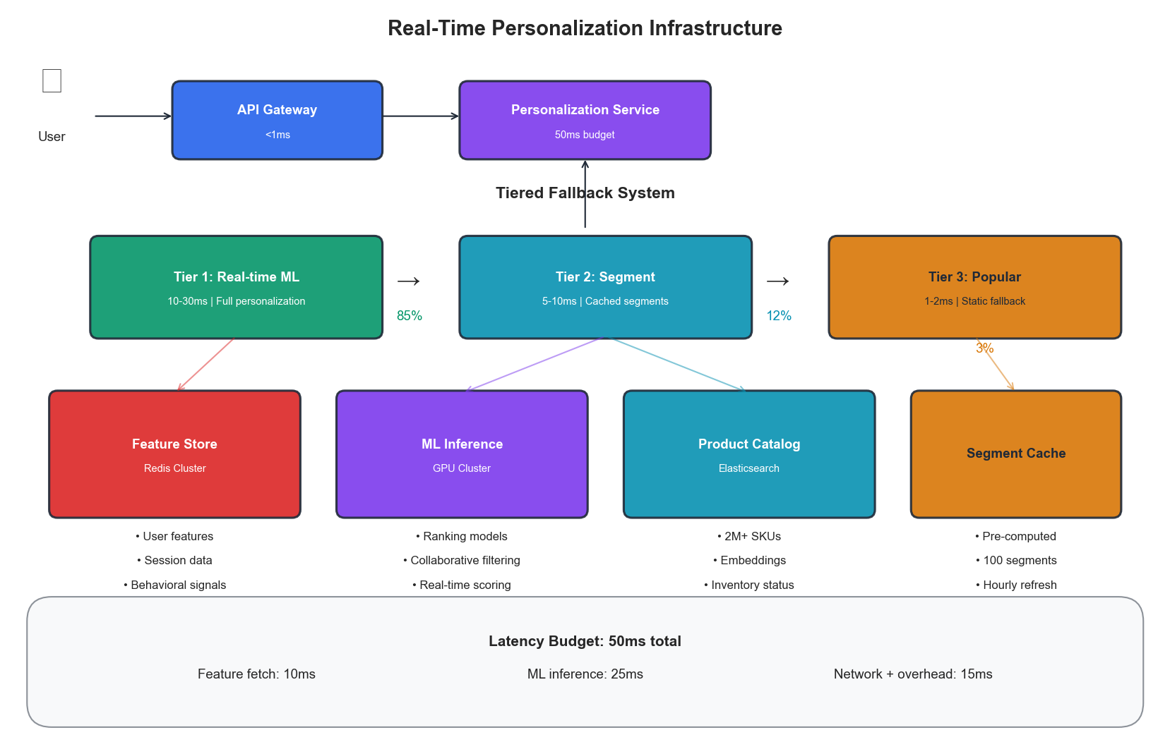
Figure 4.5: Personalization Architecture
Figure 4.5: Real-Time Personalization Infrastructure
class PersonalizationService:
"""
Real-time personalization with tiered fallback.
"""
def __init__(self, feature_store, model_service, cache):
self.features = feature_store
self.model = model_service
self.cache = cache
self.timeout_ms = 50 # Total budget
async def get_recommendations(
self,
user_id: str,
context: dict,
num_items: int = 10
) -> list:
"""
Get personalized recommendations with graceful degradation.
"""
start = time.monotonic()
try:
# Try personalized recommendations
user_features = await asyncio.wait_for(
self.features.get_user_features(user_id),
timeout=0.015 # 15ms budget for features
)
elapsed = (time.monotonic() - start) * 1000
remaining_budget = self.timeout_ms - elapsed
if remaining_budget > 20: # Need at least 20ms for inference
recommendations = await asyncio.wait_for(
self.model.score(user_features, context, num_items),
timeout=remaining_budget / 1000
)
return {"items": recommendations, "type": "personalized"}
except asyncio.TimeoutError:
pass # Fall through to fallback
except Exception as e:
logging.warning(f"Personalization failed: {e}")
# Fallback to segment-based recommendations
segment = await self._get_user_segment(user_id)
cached_recs = await self.cache.get(f"segment_recs:{segment}")
if cached_recs:
return {"items": cached_recs, "type": "segment"}
# Final fallback: popular items
popular = await self.cache.get("popular_items")
return {"items": popular or [], "type": "popular"}

4.4.2 Feature Store Design
The feature store must serve millions of feature vectors with sub-10ms latency.
class ECommerceFeatureStore:
"""
High-performance feature store for e-commerce.
"""
def __init__(self, redis_cluster, ttl_seconds: int = 3600):
self.redis = redis_cluster
self.ttl = ttl_seconds
async def get_user_features(self, user_id: str) -> dict:
"""
Retrieve user features with pipeline optimization.
"""
keys = [
f"user:{user_id}:demographics",
f"user:{user_id}:behavior",
f"user:{user_id}:preferences",
f"user:{user_id}:session"
]
# Pipeline multiple gets
pipe = self.redis.pipeline()
for key in keys:
pipe.get(key)
results = await pipe.execute()
# Merge features
features = {}
for key, result in zip(keys, results):
if result:
features.update(json.loads(result))
return features
async def update_session_features(
self,
user_id: str,
events: list
):
"""
Update session-based features in real-time.
"""
session_key = f"user:{user_id}:session"
# Aggregate events into features
session_features = {
"pages_viewed": len([e for e in events if e["type"] == "page_view"]),
"products_viewed": len([e for e in events if e["type"] == "product_view"]),
"cart_additions": len([e for e in events if e["type"] == "add_to_cart"]),
"time_on_site": events[-1]["timestamp"] - events[0]["timestamp"],
"last_category": events[-1].get("category"),
}
await self.redis.setex(
session_key,
self.ttl,
json.dumps(session_features)
)

4.5 Case Study: Black Friday Optimization

4.5.1 Scenario
A large e-commerce retailer preparing for Black Friday with the following profile:
- Normal daily traffic: 500K unique visitors
- Expected peak: 5M unique visitors (10x)
- Product catalog: 2M SKUs
- Real-time inventory sync: Required for 50K sale items
- Previous year issues: 45 minutes downtime, $3.2M estimated lost revenue

4.5.2 Optimization Strategy
Phase 1: Pre-Event Preparation (T-30 days)
Action | Purpose | PROSE Dimension
Load testing at 15x | Identify bottlenecks | Performance
Pre-warm cache with sale items | Reduce cold start | Scalability
Deploy additional read replicas | Database scaling | Resource
Implement circuit breakers | Graceful degradation | Operational
Negotiate reserved capacity | Cost optimization | Economic
Phase 2: Event Day Architecture
BLACK_FRIDAY_CONFIG = {
"auto_scaling": {
"min_instances": 200, # 4x normal baseline
"max_instances": 2000,
"scale_up_cooldown": 60, # Aggressive
"scale_down_cooldown": 300, # Conservative
"predictive_enabled": True,
"prediction_horizon_minutes": 30
},
"circuit_breakers": {
"recommendation_service": {
"failure_threshold": 5,
"timeout_ms": 30,
"fallback": "popular_items"
},
"inventory_service": {
"failure_threshold": 3,
"timeout_ms": 100,
"fallback": "optimistic_allow" # Allow purchase, reconcile later
}
},
"feature_flags": {
"full_personalization": False, # Use segment-based
"real_time_reviews": False,
"video_content": False,
"advanced_search": True
},
"capacity_reserves": {
"database_connections": 0.3, # 30% headroom
"memory": 0.25,
"cpu": 0.4
}
}

4.5.3 Results
Metric | Previous Year | Optimized | Improvement
Downtime | 45 minutes | 0 minutes | 100%
P99 latency | 2,800ms | 380ms | 86%
Error rate | 4.2% | 0.3% | 93%
Conversion rate | 2.1% | 3.4% | 62%
Infrastructure cost | $180K | $165K | 8%
Revenue | $28M | $41M | 46%
PROSE Score Comparison:
Dimension | Before | After
Performance | 52 | 91
Resource Optimization | 45 | 78
Operational Excellence | 38 | 85
Scalability | 41 | 94
Economic Impact | 61 | 82
Weighted Total | 47 | 87

Key Takeaways
- Latency is revenue - In e-commerce, every 100ms of latency reduction translates to measurable conversion improvement
- Predictive scaling is essential - The lag in reactive scaling is unacceptable for flash sales and viral events
- Graceful degradation beats failure - Circuit breakers and fallbacks keep revenue flowing when components struggle
- Personalization requires tiered architecture - Multiple fallback levels ensure every user gets recommendations
- Flash sales need specialized infrastructure - Virtual waiting rooms, distributed locks, and pre-warmed capacity
- The PROSE framework guides prioritization - Performance and scalability weighted highest for e-commerce

References
- Kohavi, R., et al. “Online Controlled Experiments at Large Scale.” KDD (2013)
- Akamai. “The State of Online Retail Performance.” Akamai Report (2017)
- Amazon. “Dynamo: Amazon’s Highly Available Key-value Store.” SOSP (2007)
- Netflix. “Zuul 2: The Netflix Journey to Asynchronous, Non-Blocking Systems.” (2016)
- Shopify. “Flash Sale Infrastructure at Shopify.” Engineering Blog (2021)

Next Chapter: Financial Services Infrastructure Optimization

