Chapter 8: Intelligent Infrastructure Architecture

Introduction
The evolution from reactive to intelligent infrastructure represents a fundamental shift in how enterprises manage their technology stack. Traditional infrastructure responds to problems after they occur. Intelligent infrastructure predicts, prevents, and self-optimizes. This chapter explores the architectural patterns, AI/ML components, and implementation strategies that transform static infrastructure into living, learning systems.

8.1 The Intelligence Hierarchy

8.1.1 Levels of Infrastructure Intelligence
Infrastructure intelligence exists on a spectrum from basic automation to full autonomy:
Level | Name | Description | Example
0 | Manual | Human-driven operations | SSH into servers to fix issues
1 | Scripted | Rule-based automation | Cron jobs, simple scripts
2 | Reactive | Event-driven automation | Auto-restart on crash
3 | Predictive | ML-based forecasting | Predict and prevent failures
4 | Adaptive | Self-optimizing systems | Continuous configuration tuning
5 | Autonomous | Self-healing, self-evolving | Full autonomic computing
Most enterprises today operate at Level 2-3. This chapter focuses on achieving Level 4-5.
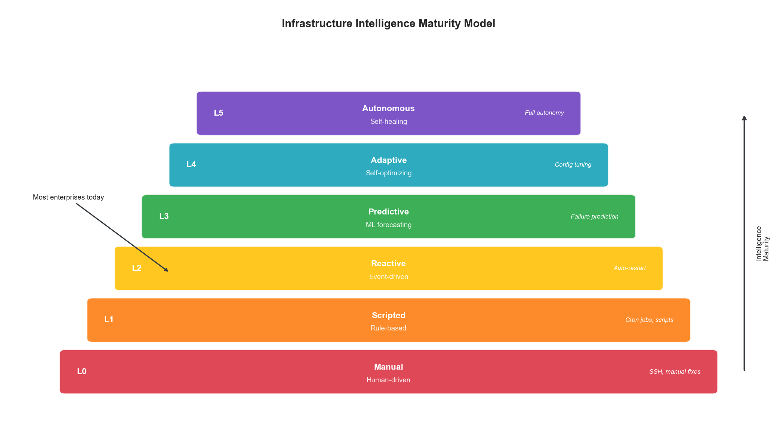
Figure 8.1: Infrastructure Intelligence Maturity Model
Figure 8.1: Infrastructure Intelligence Maturity Levels

8.1.2 The Autonomous Operations Model
class AutonomousOperationsController:
"""
Controller for autonomous infrastructure operations.
Implements the MAPE-K loop:
- Monitor: Collect metrics and events
- Analyze: Detect anomalies and predict issues
- Plan: Determine corrective actions
- Execute: Implement changes
- Knowledge: Learn from outcomes
"""
def __init__(self, config):
self.monitor = MonitoringEngine(config.monitoring)
self.analyzer = AnalysisEngine(config.analysis)
self.planner = PlanningEngine(config.planning)
self.executor = ExecutionEngine(config.execution)
self.knowledge = KnowledgeBase(config.knowledge)
async def run_control_loop(self):
"""Main autonomous control loop."""
while True:
# Monitor: Collect current state
state = await self.monitor.collect_state()
# Analyze: Detect issues and predict future state
analysis = await self.analyzer.analyze(
current_state=state,
historical_knowledge=self.knowledge.get_patterns()
)
if analysis.requires_action:
# Plan: Determine best action
plan = await self.planner.create_plan(
analysis=analysis,
constraints=self.knowledge.get_constraints(),
past_actions=self.knowledge.get_action_history()
)
if plan.is_safe():
# Execute: Implement the plan
result = await self.executor.execute(plan)
# Knowledge: Learn from outcome
await self.knowledge.record_outcome(
state=state,
analysis=analysis,
plan=plan,
result=result
)
await asyncio.sleep(self.config.loop_interval)

8.2 Predictive Intelligence Components

8.2.1 Anomaly Detection Architecture
Anomaly detection is the foundation of predictive infrastructure:
class MultiModelAnomalyDetector:
"""
Ensemble anomaly detection using multiple techniques.
Combines:
- Statistical methods (Z-score, IQR)
- Machine learning (Isolation Forest, One-Class SVM)
- Deep learning (Autoencoders, LSTM)
"""
def __init__(self, config):
self.statistical = StatisticalDetector()
self.isolation_forest = IsolationForestDetector()
self.autoencoder = AutoencoderDetector(config.autoencoder)
self.lstm = LSTMDetector(config.lstm)
# Ensemble weights (learned from historical performance)
self.weights = {
"statistical": 0.2,
"isolation_forest": 0.25,
"autoencoder": 0.3,
"lstm": 0.25
}
async def detect(self, metrics: dict, context: dict) -> AnomalyResult:
"""Detect anomalies using ensemble of models."""
# Run all detectors in parallel
results = await asyncio.gather(
self.statistical.detect(metrics),
self.isolation_forest.detect(metrics),
self.autoencoder.detect(metrics),
self.lstm.detect(metrics, context.get("time_series"))
)
# Weighted ensemble
scores = {
"statistical": results[0].score,
"isolation_forest": results[1].score,
"autoencoder": results[2].score,
"lstm": results[3].score
}
ensemble_score = sum(
self.weights[k] * scores[k] for k in scores
)
# Determine anomaly status
is_anomaly = ensemble_score > self.config.threshold
# Explain which detectors flagged it
flagged_by = [k for k, v in scores.items() if v > 0.5]
return AnomalyResult(
is_anomaly=is_anomaly,
score=ensemble_score,
individual_scores=scores,
flagged_by=flagged_by,
explanation=self._generate_explanation(metrics, scores, flagged_by)
)
def _generate_explanation(self, metrics, scores, flagged_by) -> str:
"""Generate human-readable explanation of anomaly."""
if not flagged_by:
return "No anomaly detected"
explanations = []
for detector in flagged_by:
if detector == "statistical":
explanations.append(
f"Statistical deviation detected in {self._find_outlier_metrics(metrics)}"
)
elif detector == "lstm":
explanations.append(
"Temporal pattern deviates from learned baseline"
)
elif detector == "autoencoder":
explanations.append(
"Reconstruction error indicates unusual metric combination"
)
return "; ".join(explanations)

8.2.2 Failure Prediction
Predicting failures before they occur:
class FailurePredictionEngine:
"""
Predict infrastructure failures using ML.
Uses:
- Historical failure patterns
- Leading indicators
- Correlation analysis
"""
def __init__(self, model_path, feature_store):
self.model = self._load_model(model_path)
self.features = feature_store
self.leading_indicators = LeadingIndicatorDetector()
async def predict_failures(
self,
resource_id: str,
horizon_hours: int = 24
) -> list[FailurePrediction]:
"""Predict potential failures for a resource."""
# Get current metrics
current_metrics = await self.features.get_current(resource_id)
# Get historical patterns
history = await self.features.get_history(resource_id, days=30)
# Check leading indicators
indicators = await self.leading_indicators.check(
resource_id, current_metrics, history
)
# Build feature vector
features = self._build_features(current_metrics, history, indicators)
# Predict
predictions = self.model.predict_proba(features, horizon_hours)
return [
FailurePrediction(
resource_id=resource_id,
failure_type=ft,
probability=prob,
predicted_time=self._estimate_time(prob, horizon_hours),
contributing_factors=self._get_factors(features, ft),
recommended_actions=self._get_recommendations(ft, prob)
)
for ft, prob in predictions.items()
if prob > 0.1 # Only include non-trivial predictions
]
def _get_recommendations(
self,
failure_type: str,
probability: float
) -> list[str]:
"""Get recommended preventive actions."""
recommendations = {
"disk_full": [
"Clean up old logs and temporary files",
"Expand disk capacity",
"Enable log rotation"
],
"memory_exhaustion": [
"Identify memory leaks",
"Increase memory limits",
"Scale horizontally"
],
"cpu_saturation": [
"Profile and optimize hot paths",
"Scale horizontally",
"Rate limit incoming traffic"
],
"network_degradation": [
"Check for packet loss",
"Verify network configuration",
"Contact network team"
]
}
actions = recommendations.get(failure_type, ["Investigate further"])
# Add urgency based on probability
if probability > 0.8:
actions = ["URGENT: " + actions[0]] + actions[1:]
return actions
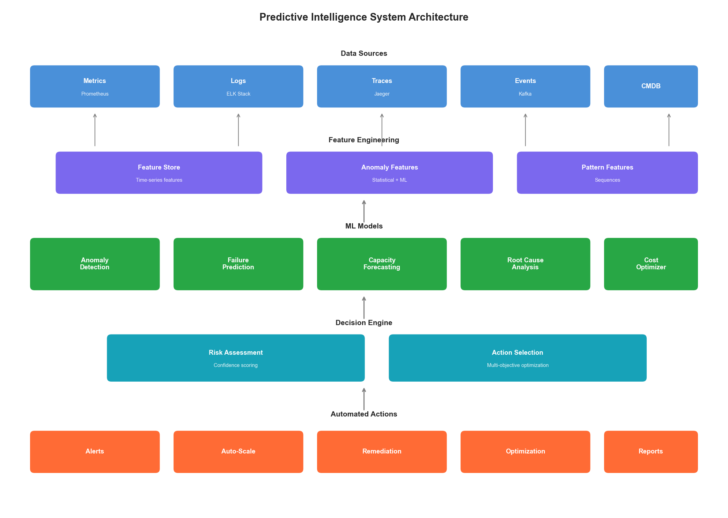
Figure 8.2: Predictive Intelligence Architecture
Figure 8.2: Predictive Intelligence System Architecture

8.3 Self-Optimizing Systems

8.3.1 Continuous Configuration Optimization
class ContinuousConfigurationOptimizer:
"""
Continuously optimize system configuration using ML.
Implements Bayesian optimization for:
- Resource allocation
- Tuning parameters
- Scaling thresholds
"""
def __init__(self, config):
self.optimizer = BayesianOptimizer(config.optimization)
self.constraints = config.constraints
self.objective = config.objective
self.safe_mode = config.safe_mode
async def optimize(
self,
system: str,
current_config: dict,
metrics: dict
) -> OptimizationResult:
"""Find optimal configuration."""
# Define search space
search_space = self._get_search_space(system)
# Get historical performance data
history = await self._get_performance_history(system)
# Run optimization
suggested_config = self.optimizer.suggest(
search_space=search_space,
objective=self.objective,
history=history,
constraints=self.constraints
)
# Validate safety
if self.safe_mode:
safety_check = await self._validate_safety(
system, current_config, suggested_config
)
if not safety_check.is_safe:
return OptimizationResult(
applied=False,
reason=safety_check.reason,
suggested_config=suggested_config
)
# Calculate expected improvement
expected_improvement = self._calculate_improvement(
current_config, suggested_config, history
)
return OptimizationResult(
applied=True,
current_config=current_config,
suggested_config=suggested_config,
expected_improvement=expected_improvement,
confidence=self.optimizer.confidence
)
def _get_search_space(self, system: str) -> dict:
"""Define configuration search space."""
spaces = {
"database": {
"max_connections": (50, 500),
"shared_buffers_gb": (1, 16),
"work_mem_mb": (64, 1024),
"effective_cache_size_gb": (4, 64),
"checkpoint_completion_target": (0.5, 0.9)
},
"cache": {
"maxmemory_gb": (1, 64),
"maxmemory_policy": ["volatile-lru", "allkeys-lru", "volatile-ttl"],
"tcp_keepalive": (0, 300)
},
"web_server": {
"worker_processes": (1, 16),
"worker_connections": (512, 4096),
"keepalive_timeout": (15, 120),
"client_body_buffer_size_kb": (8, 128)
}
}
return spaces.get(system, {})

8.3.2 Adaptive Resource Allocation
class AdaptiveResourceAllocator:
"""
Dynamically allocate resources based on workload patterns.
"""
def __init__(self, orchestrator, predictor, config):
self.orchestrator = orchestrator
self.predictor = predictor
self.config = config
self.allocation_history = []
async def allocate(self, service: str) -> AllocationDecision:
"""Make adaptive allocation decision."""
# Get current state
current = await self.orchestrator.get_allocation(service)
# Predict future demand
demand_forecast = await self.predictor.forecast(
service=service,
horizon_minutes=30
)
# Get workload characteristics
workload = await self._analyze_workload(service)
# Determine optimal allocation
optimal = self._calculate_optimal_allocation(
current=current,
forecast=demand_forecast,
workload=workload
)
# Apply constraints
constrained = self._apply_constraints(optimal, service)
# Decide on action
if self._should_reallocate(current, constrained):
action = await self.orchestrator.reallocate(service, constrained)
self.allocation_history.append({
"service": service,
"from": current,
"to": constrained,
"reason": action.reason,
"timestamp": datetime.utcnow()
})
return AllocationDecision(
action="reallocate",
previous=current,
new=constrained,
reason=action.reason
)
return AllocationDecision(action="no_change", current=current)
def _calculate_optimal_allocation(
self,
current: ResourceAllocation,
forecast: DemandForecast,
workload: WorkloadCharacteristics
) -> ResourceAllocation:
"""Calculate optimal resource allocation."""
# Base on peak predicted demand
peak_demand = forecast.peak_demand
confidence = forecast.confidence
# Add buffer based on confidence
buffer = 1 + (1 - confidence) * 0.3
# Calculate resources
cpu = int(peak_demand.cpu_cores * buffer)
memory = int(peak_demand.memory_gb * buffer)
replicas = max(
self.config.min_replicas,
int(peak_demand.requests_per_second / workload.requests_per_replica)
)
return ResourceAllocation(
cpu_cores=cpu,
memory_gb=memory,
replicas=replicas
)

8.4 Self-Healing Architecture

8.4.1 Automated Remediation Framework
class AutomatedRemediationEngine:
"""
Automatically remediate detected issues.
"""
def __init__(self, config):
self.runbook_store = RunbookStore(config.runbooks)
self.executor = RemediationExecutor(config.execution)
self.approval_engine = ApprovalEngine(config.approval)
self.audit = AuditLogger(config.audit)
async def remediate(
self,
incident: Incident
) -> RemediationResult:
"""Automatically remediate an incident."""
# Find matching runbook
runbook = await self.runbook_store.find_matching(incident)
if not runbook:
return RemediationResult(
success=False,
reason="no_matching_runbook",
requires_human=True
)
# Check if auto-remediation is allowed
approval = await self.approval_engine.check(
incident=incident,
runbook=runbook
)
if not approval.auto_approved:
# Queue for human approval
await self._queue_for_approval(incident, runbook)
return RemediationResult(
success=False,
reason="requires_approval",
requires_human=True
)
# Execute remediation
try:
self.audit.log({
"event": "remediation_started",
"incident_id": incident.id,
"runbook_id": runbook.id
})
result = await self.executor.execute(
runbook=runbook,
incident=incident
)
self.audit.log({
"event": "remediation_completed",
"incident_id": incident.id,
"result": result.status
})
return RemediationResult(
success=result.success,
actions_taken=result.actions,
duration=result.duration
)
except Exception as e:
self.audit.log({
"event": "remediation_failed",
"incident_id": incident.id,
"error": str(e)
})
return RemediationResult(
success=False,
reason=str(e),
requires_human=True
)
class RunbookStore:
"""Store and match runbooks to incidents."""
def __init__(self, config):
self.runbooks = self._load_runbooks(config.path)
self.ml_matcher = RunbookMatcher(config.model)
async def find_matching(self, incident: Incident) -> Runbook:
"""Find the best matching runbook for an incident."""
# Try exact match first
for runbook in self.runbooks:
if self._exact_match(runbook, incident):
return runbook
# Fall back to ML-based matching
best_match = self.ml_matcher.find_best(
incident_description=incident.description,
incident_symptoms=incident.symptoms,
candidates=self.runbooks
)
if best_match and best_match.confidence > 0.8:
return best_match.runbook
return None

8.4.2 Chaos Engineering Integration
class ChaosEngineeringOrchestrator:
"""
Controlled chaos engineering to validate self-healing.
"""
def __init__(self, config):
self.experiments = ExperimentCatalog(config.experiments)
self.safety = SafetyController(config.safety)
self.metrics = MetricsCollector(config.metrics)
async def run_experiment(
self,
experiment_type: str,
target: str,
parameters: dict
) -> ExperimentResult:
"""Run a chaos experiment."""
experiment = self.experiments.get(experiment_type)
# Pre-flight checks
safety_check = await self.safety.pre_flight_check(
experiment=experiment,
target=target,
parameters=parameters
)
if not safety_check.safe_to_proceed:
return ExperimentResult(
executed=False,
reason=safety_check.reason
)
# Capture baseline
baseline = await self.metrics.capture_baseline(target)
# Execute chaos
try:
chaos_result = await experiment.execute(target, parameters)
# Monitor recovery
recovery = await self._monitor_recovery(target, baseline)
return ExperimentResult(
executed=True,
chaos_introduced=chaos_result.description,
recovery_time=recovery.time_to_recovery,
recovered_successfully=recovery.success,
metrics_during=recovery.metrics,
insights=self._generate_insights(chaos_result, recovery)
)
finally:
# Always clean up
await experiment.cleanup(target)
async def _monitor_recovery(
self,
target: str,
baseline: Metrics
) -> RecoveryResult:
"""Monitor system recovery after chaos injection."""
start_time = time.time()
max_wait = 300 # 5 minutes
while time.time() - start_time < max_wait:
current = await self.metrics.capture_current(target)
if self._has_recovered(current, baseline):
return RecoveryResult(
success=True,
time_to_recovery=time.time() - start_time,
metrics=current
)
await asyncio.sleep(5)
return RecoveryResult(
success=False,
time_to_recovery=max_wait,
metrics=await self.metrics.capture_current(target)
)
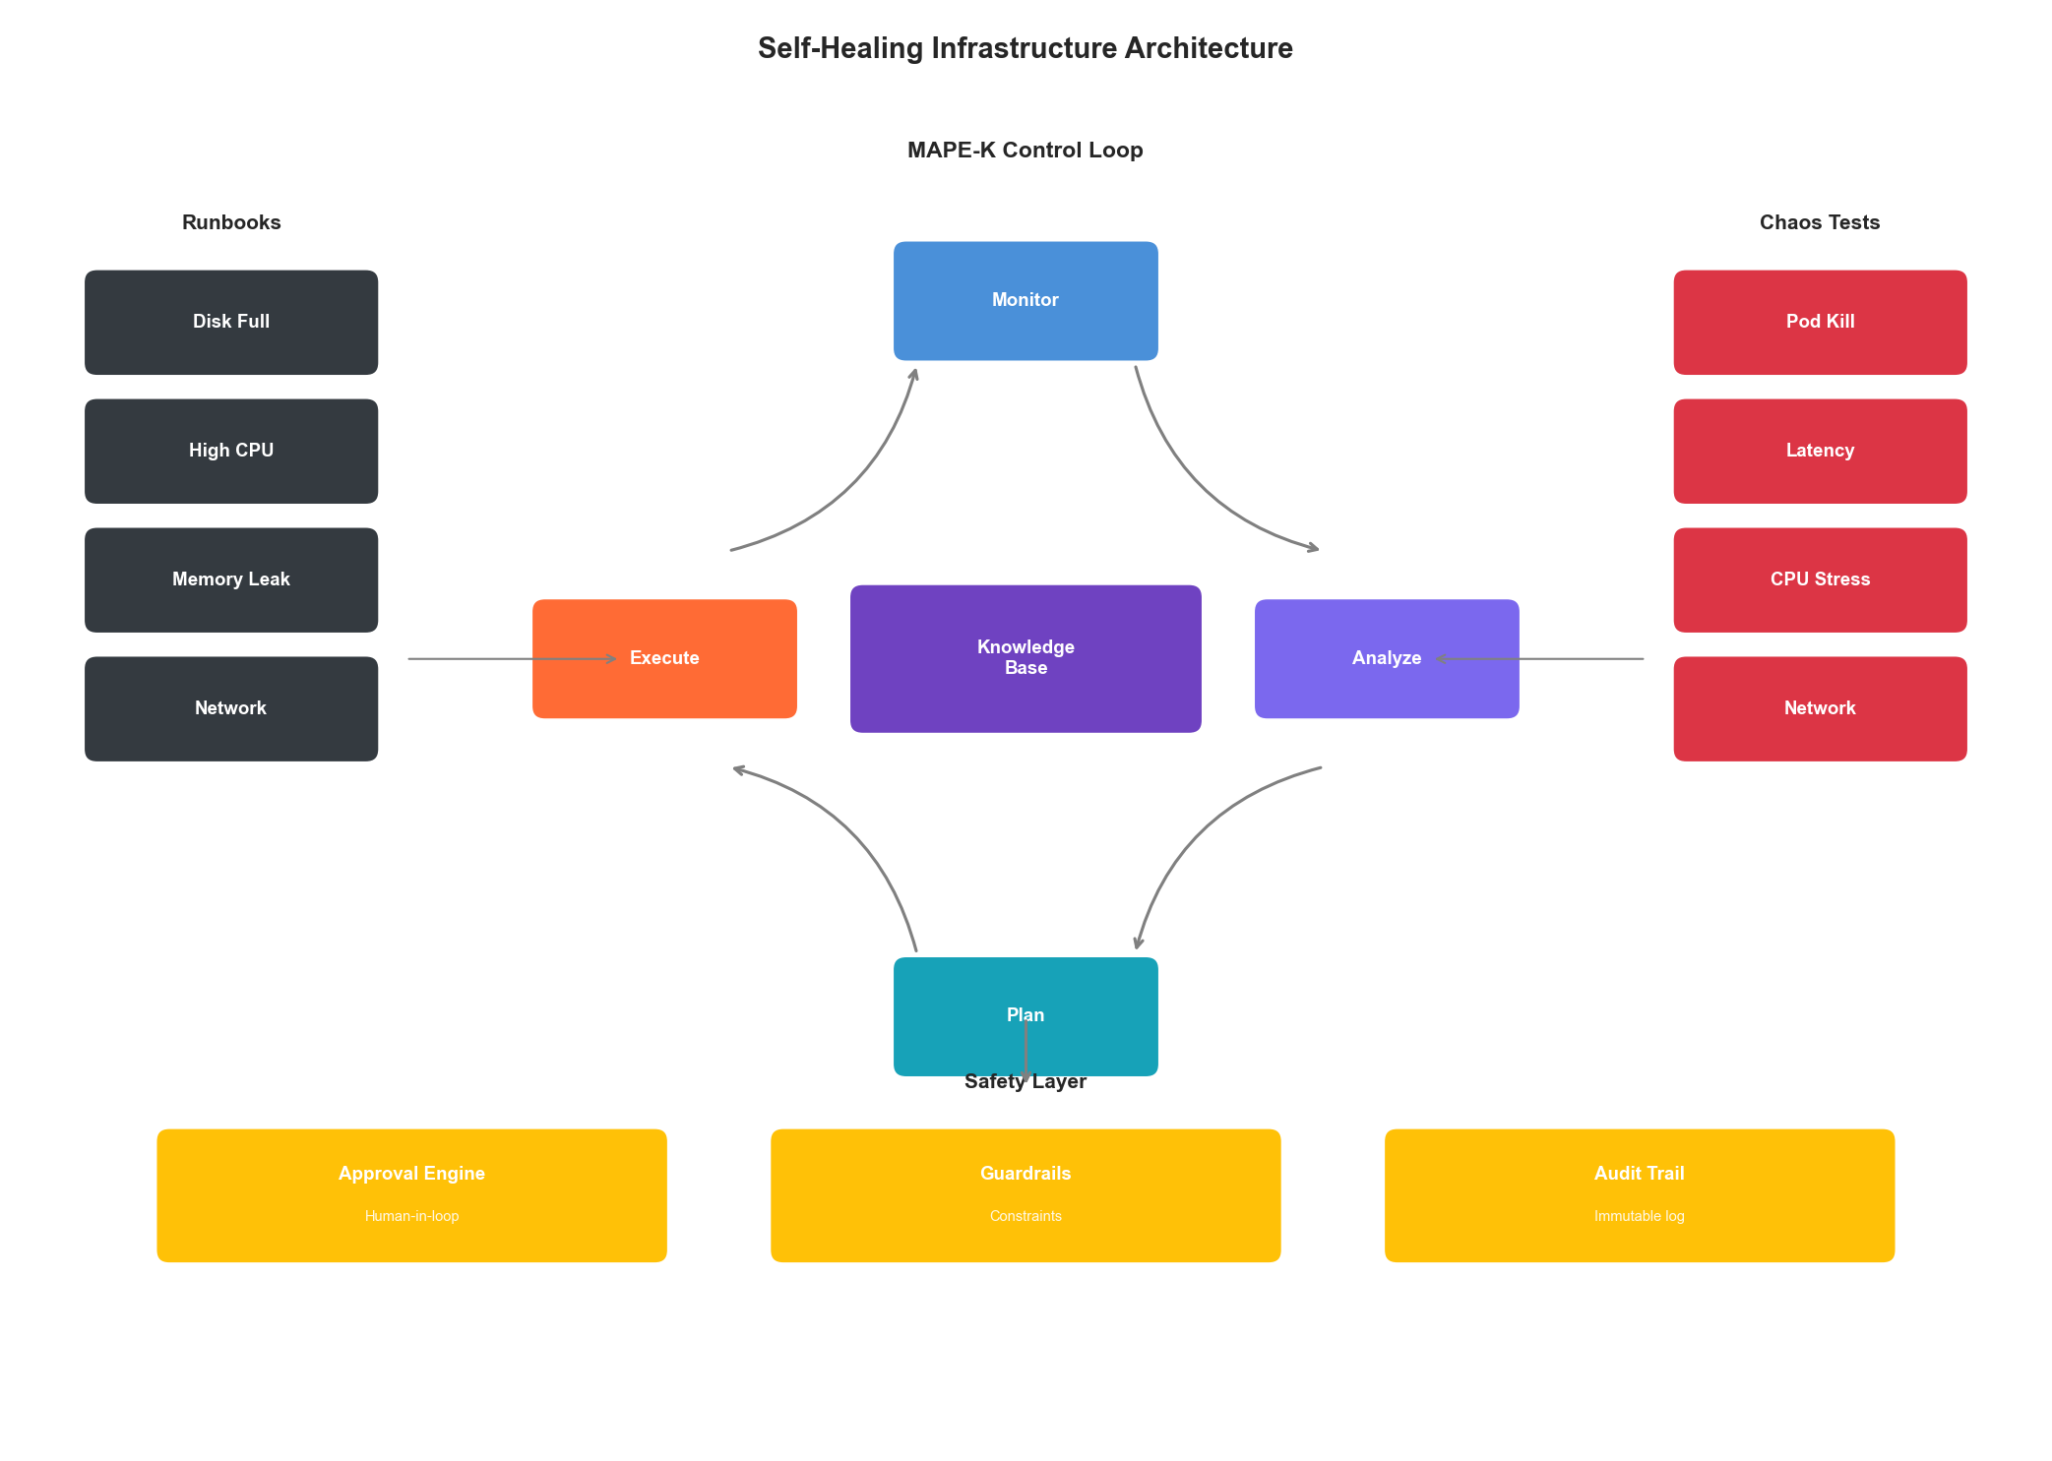
Figure 8.3: Self-Healing Architecture
Figure 8.3: Self-Healing Infrastructure Architecture

8.5 Knowledge Management for Intelligent Systems

8.5.1 Operational Knowledge Graph
class OperationalKnowledgeGraph:
"""
Knowledge graph for infrastructure relationships and patterns.
"""
def __init__(self, graph_db):
self.db = graph_db
async def add_relationship(
self,
source: Entity,
relationship: str,
target: Entity,
properties: dict = None
):
"""Add relationship to knowledge graph."""
await self.db.execute("""
MERGE (s:Entity {id: $source_id, type: $source_type})
MERGE (t:Entity {id: $target_id, type: $target_type})
MERGE (s)-[r:$relationship]->(t)
SET r += $properties
""", {
"source_id": source.id,
"source_type": source.type,
"target_id": target.id,
"target_type": target.type,
"relationship": relationship,
"properties": properties or {}
})
async def query_impact(self, entity_id: str, depth: int = 3) -> list:
"""Query potential impact of an entity failure."""
result = await self.db.execute("""
MATCH path = (e:Entity {id: $entity_id})-[:DEPENDS_ON|IMPACTS*1..$depth]->(affected)
RETURN affected, length(path) as distance
ORDER BY distance
""", {"entity_id": entity_id, "depth": depth})
return [
{
"entity": row["affected"],
"distance": row["distance"],
"impact_probability": 1 / (row["distance"] + 1)
}
for row in result
]
async def find_root_cause(
self,
symptom_entities: list[str]
) -> list[RootCauseCandidate]:
"""Find potential root causes for observed symptoms."""
# Find common ancestors in dependency graph
result = await self.db.execute("""
MATCH (symptom:Entity)
WHERE symptom.id IN $symptoms
MATCH path = (root:Entity)-[:DEPENDS_ON*]->(symptom)
WITH root, count(DISTINCT symptom) as symptom_count
WHERE symptom_count > 1
RETURN root, symptom_count
ORDER BY symptom_count DESC
LIMIT 10
""", {"symptoms": symptom_entities})
return [
RootCauseCandidate(
entity=row["root"],
explains_symptoms=row["symptom_count"],
confidence=row["symptom_count"] / len(symptom_entities)
)
for row in result
]

8.5.2 Learning from Incidents
class IncidentLearningEngine:
"""
Learn from past incidents to improve future responses.
"""
def __init__(self, incident_store, ml_engine):
self.incidents = incident_store
self.ml = ml_engine
async def learn_from_incident(
self,
incident: ResolvedIncident
):
"""Extract learnings from a resolved incident."""
# Store incident for future reference
await self.incidents.store(incident)
# Extract patterns
patterns = self._extract_patterns(incident)
# Update models
await self._update_detection_model(incident, patterns)
await self._update_prediction_model(incident, patterns)
await self._update_remediation_model(incident)
async def suggest_similar_resolutions(
self,
current_incident: Incident
) -> list[SimilarIncident]:
"""Find similar past incidents and their resolutions."""
# Encode current incident
embedding = self.ml.encode_incident(current_incident)
# Find similar
similar = await self.incidents.search_similar(
embedding=embedding,
limit=5
)
return [
SimilarIncident(
incident=inc,
similarity=sim,
resolution=inc.resolution,
resolution_effectiveness=inc.resolution_effectiveness
)
for inc, sim in similar
]
def _extract_patterns(self, incident: ResolvedIncident) -> list[Pattern]:
"""Extract reusable patterns from incident."""
patterns = []
# Leading indicator pattern
if incident.leading_indicators:
patterns.append(Pattern(
type="leading_indicator",
indicators=incident.leading_indicators,
lead_time=incident.lead_time,
incident_type=incident.type
))
# Remediation pattern
if incident.resolution.success:
patterns.append(Pattern(
type="remediation",
symptoms=incident.symptoms,
actions=incident.resolution.actions,
effectiveness=incident.resolution_effectiveness
))
return patterns

8.6 Architecture Patterns for Intelligence

8.6.1 Sidecar Intelligence Pattern
class IntelligentSidecar:
"""
Sidecar pattern for adding intelligence to any service.
Deployed alongside each service to provide:
- Local anomaly detection
- Request optimization
- Adaptive rate limiting
"""
def __init__(self, config):
self.local_detector = LocalAnomalyDetector(config.detection)
self.optimizer = RequestOptimizer(config.optimization)
self.rate_limiter = AdaptiveRateLimiter(config.rate_limiting)
async def intercept_request(
self,
request: Request
) -> InterceptResult:
"""Intercept and optionally modify request."""
# Check rate limit
if not await self.rate_limiter.allow(request):
return InterceptResult(
allowed=False,
reason="rate_limited"
)
# Optimize request
optimized = await self.optimizer.optimize(request)
return InterceptResult(
allowed=True,
modified_request=optimized
)
async def intercept_response(
self,
request: Request,
response: Response,
latency: float
):
"""Analyze response for anomalies."""
# Check for anomalies
anomaly = await self.local_detector.check(
request=request,
response=response,
latency=latency
)
if anomaly.detected:
await self._report_anomaly(anomaly)
# Update adaptive models
await self.rate_limiter.update(request, response, latency)
await self.optimizer.learn(request, response, latency)
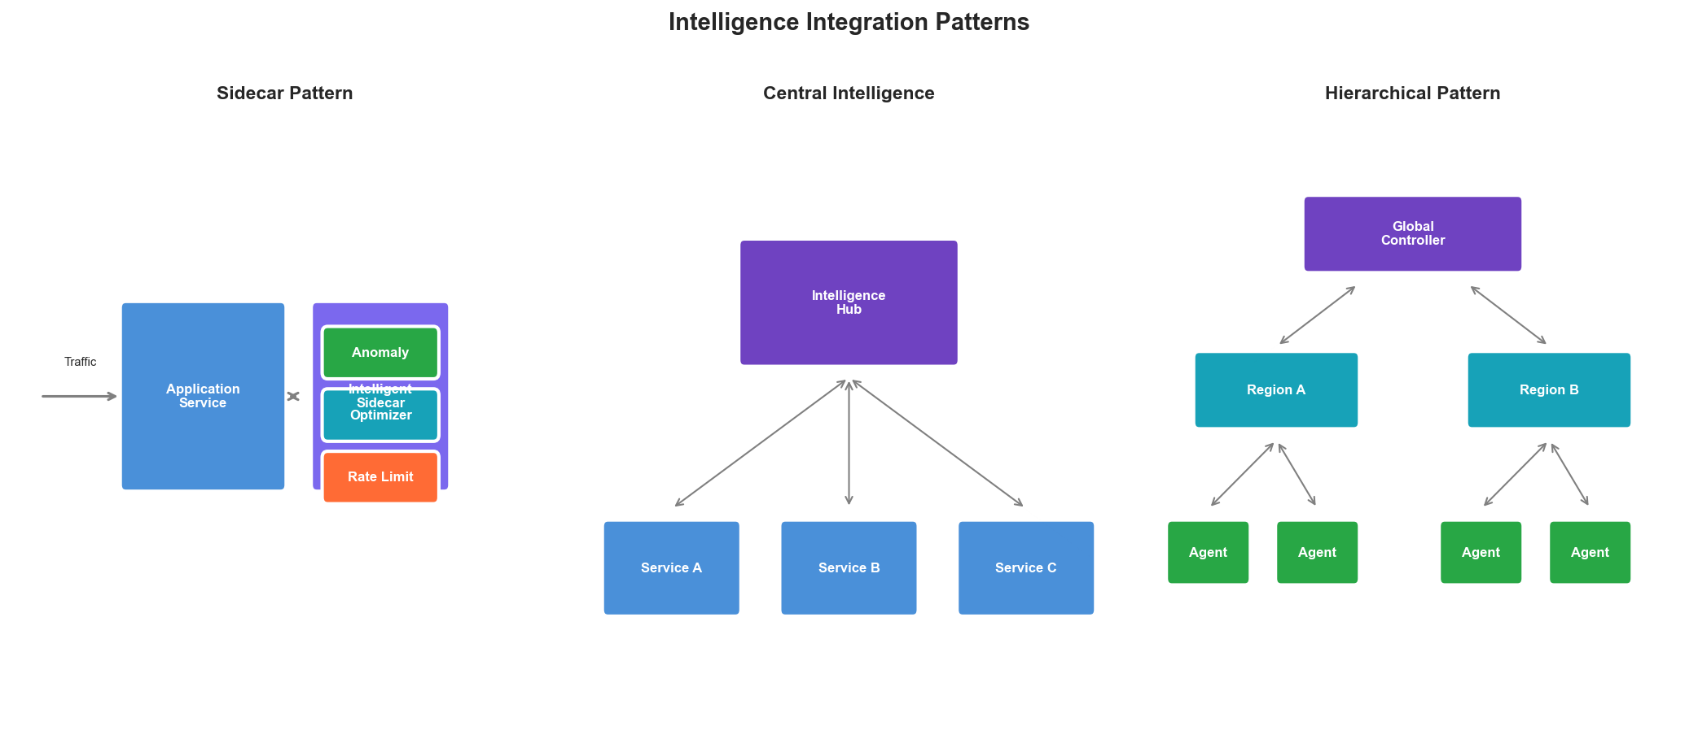
Figure 8.4: Intelligent Architecture Patterns
Figure 8.4: Intelligence Integration Patterns

Key Takeaways
- Intelligence is a spectrum - Progress from reactive (Level 2) through predictive (Level 3) to truly autonomous (Level 5) systems incrementally
- Ensemble detection works best - Combine statistical, ML, and deep learning anomaly detection for robust results
- Self-healing requires runbooks - Automated remediation is only as good as the runbooks that encode operational knowledge
- Knowledge graphs enable understanding - Model infrastructure relationships to enable root cause analysis and impact prediction
- Learn from every incident - Systematic incident learning improves all components of intelligent infrastructure
- Safety is paramount - Always implement safety constraints and human-in-the-loop for high-risk operations

References
- IBM. “An Architectural Blueprint for Autonomic Computing.” IBM White Paper (2006)
- Google. “Site Reliability Engineering.” O’Reilly Media (2016)
- Netflix. “Chaos Engineering.” O’Reilly Media (2020)
- Sculley, D. et al. “Hidden Technical Debt in Machine Learning Systems.” NeurIPS (2015)
- Amazon. “Building Self-Healing Infrastructure.” AWS Architecture Blog (2023)

Next Chapter: Reinforcement Learning for Infrastructure Optimization

