Chapter 9: Building Your Optimization Platform

Introduction
The previous chapters explored optimization strategies across e-commerce, financial services, and healthcare industries. Now it’s time to build the platform that makes these optimizations possible. This chapter provides a comprehensive guide to architecting, implementing, and operating an AI-driven infrastructure optimization platform that serves as the foundation for everything that follows.
An optimization platform is not a single tool—it’s an integrated ecosystem of data collection, analysis, decision-making, and action components. Building it correctly from the start determines whether your optimization efforts succeed at scale or collapse under their own complexity.

9.1 Platform Architecture Overview

9.1.1 Core Components
A complete optimization platform consists of five integrated layers:
Layer | Function | Key Technologies
Data Collection | Gather metrics, logs, traces, events | Prometheus, OpenTelemetry, Fluentd
Data Storage | Store and query observability data | InfluxDB, TimescaleDB, Elasticsearch
Analysis Engine | Process and analyze data streams | Apache Flink, Spark Streaming, Custom ML
Decision Engine | Generate optimization recommendations | Custom ML models, Rule engines
Action Engine | Execute changes safely | Kubernetes operators, Ansible, Terraform
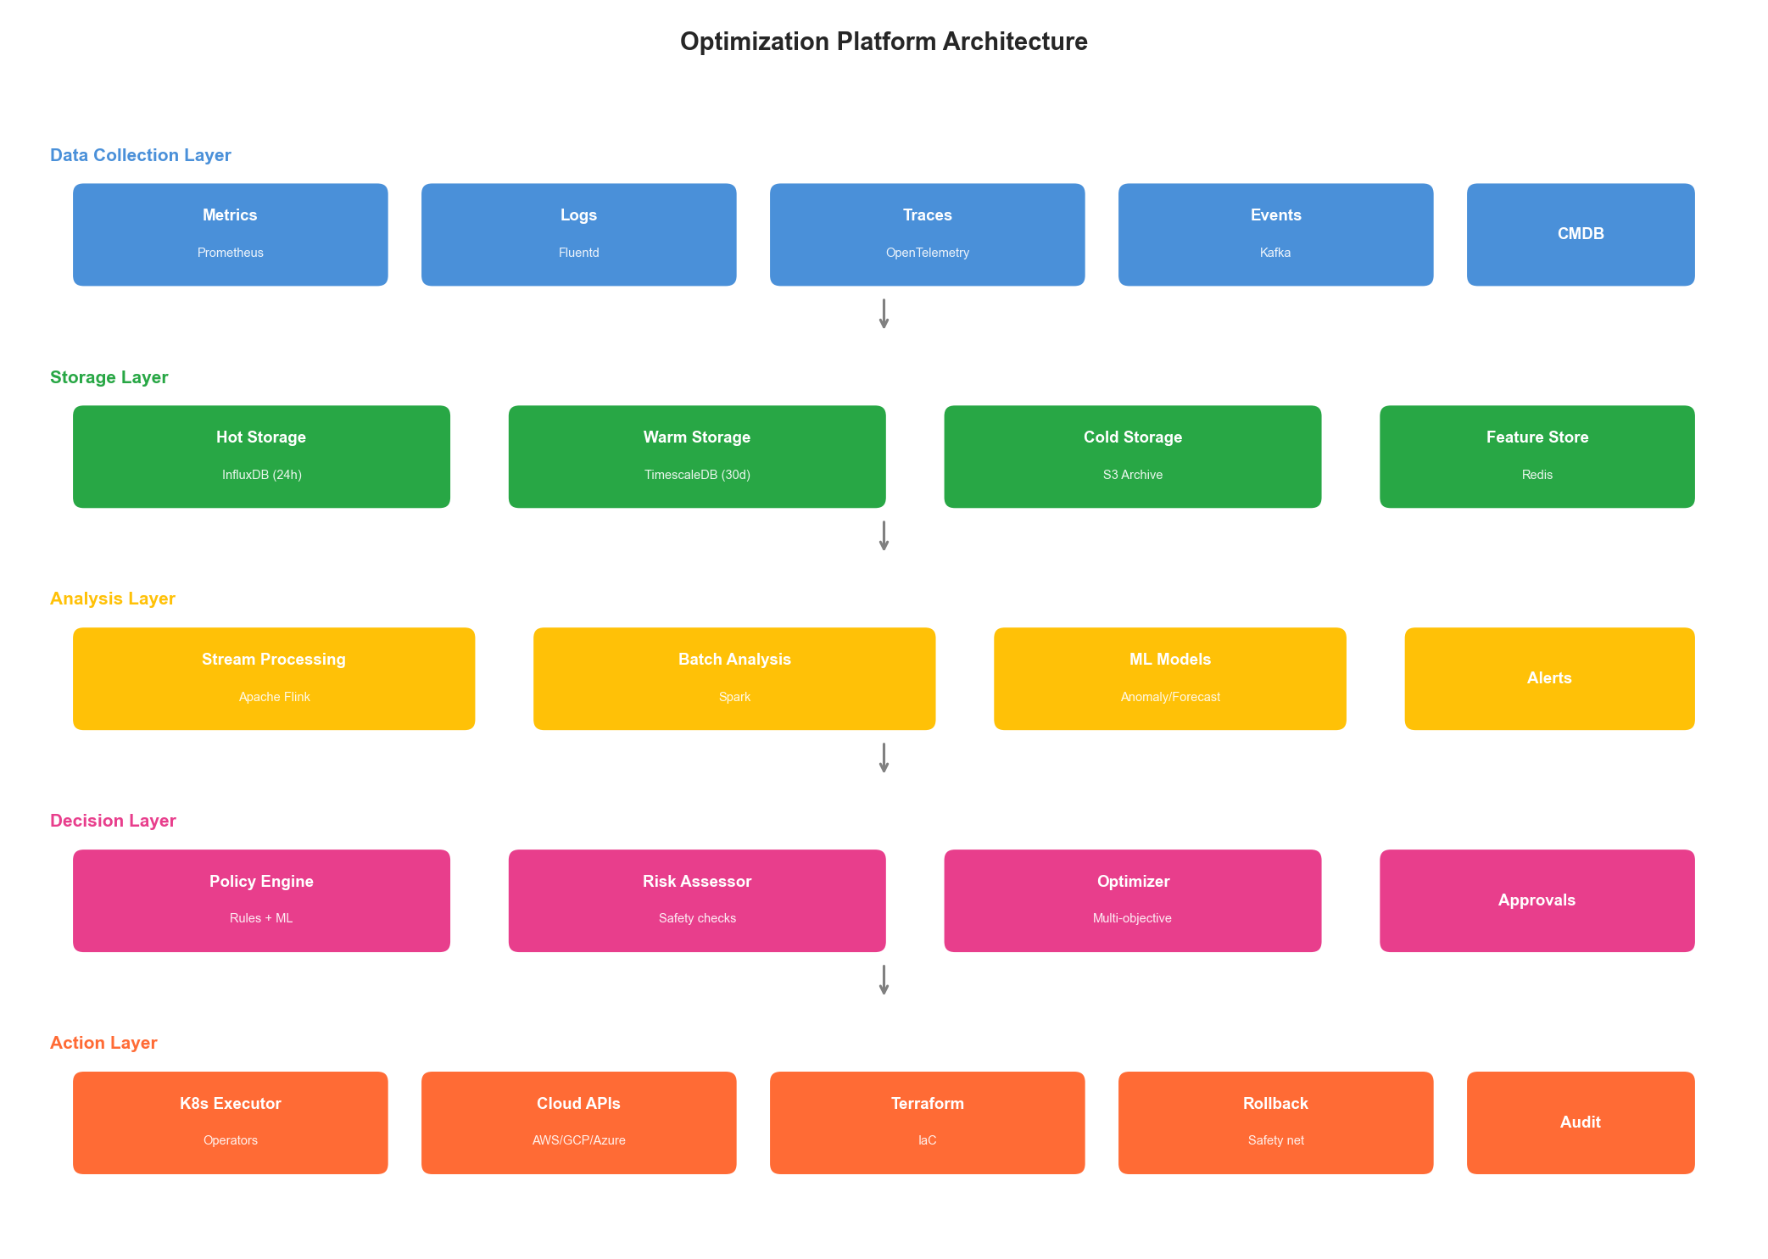
Figure 9.1: Optimization Platform Architecture
Figure 9.1: Complete Optimization Platform Architecture

9.1.2 Design Principles
Building a robust optimization platform requires adherence to key principles:
1. Separation of Concerns
class OptimizationPlatform:
"""
Main platform orchestrator with clear separation of concerns.
"""
def __init__(self, config: PlatformConfig):
# Each component is independent and replaceable
self.collector = DataCollector(config.collection)
self.storage = DataStorage(config.storage)
self.analyzer = AnalysisEngine(config.analysis)
self.decision = DecisionEngine(config.decision)
self.executor = ActionEngine(config.execution)
# Event bus for loose coupling
self.event_bus = EventBus(config.events)
async def run(self):
"""Main optimization loop."""
while True:
# Collect -> Store -> Analyze -> Decide -> Act
data = await self.collector.collect()
await self.storage.store(data)
analysis = await self.analyzer.analyze(data)
if analysis.requires_action:
decision = await self.decision.decide(analysis)
if decision.approved:
await self.executor.execute(decision.actions)
await asyncio.sleep(self.config.loop_interval)
2. Observability First
Every component must be observable:
class ObservableComponent:
"""Base class for all platform components."""
def __init__(self, name: str, metrics_client):
self.name = name
self.metrics = metrics_client
self.tracer = opentelemetry.trace.get_tracer(name)
self.logger = structlog.get_logger(name)
async def execute(self, operation: str, func, *args, **kwargs):
"""Execute with full observability."""
with self.tracer.start_as_current_span(operation) as span:
start_time = time.time()
try:
result = await func(*args, **kwargs)
self.metrics.counter(
f"{self.name}.{operation}.success"
).inc()
return result
except Exception as e:
self.metrics.counter(
f"{self.name}.{operation}.error",
labels={"error_type": type(e).__name__}
).inc()
span.record_exception(e)
self.logger.error(
f"{operation} failed",
error=str(e),
exc_info=True
)
raise
finally:
duration = time.time() - start_time
self.metrics.histogram(
f"{self.name}.{operation}.duration"
).observe(duration)
3. Graceful Degradation
The platform must continue operating even when components fail:
class ResilientPipeline:
"""Pipeline with graceful degradation."""
def __init__(self, components: list, fallbacks: dict):
self.components = components
self.fallbacks = fallbacks
self.circuit_breakers = {
c.name: CircuitBreaker(
failure_threshold=5,
recovery_timeout=60
)
for c in components
}
async def execute(self, data):
"""Execute pipeline with fallbacks."""
result = data
for component in self.components:
breaker = self.circuit_breakers[component.name]
if breaker.is_open:
# Use fallback if available
if component.name in self.fallbacks:
result = await self.fallbacks[component.name](result)
continue
else:
# Skip component if no fallback
continue
try:
result = await breaker.execute(
component.process, result
)
except CircuitBreakerOpen:
if component.name in self.fallbacks:
result = await self.fallbacks[component.name](result)
return result

9.2 Data Collection Layer

9.2.1 Metrics Collection Architecture
class MetricsCollector:
"""
Unified metrics collection from multiple sources.
"""
def __init__(self, config: MetricsConfig):
self.sources = self._initialize_sources(config.sources)
self.buffer = MetricsBuffer(config.buffer_size)
self.normalizer = MetricsNormalizer()
def _initialize_sources(self, source_configs: list) -> list:
"""Initialize metric sources."""
sources = []
for cfg in source_configs:
if cfg.type == "prometheus":
sources.append(PrometheusSource(cfg))
elif cfg.type == "cloudwatch":
sources.append(CloudWatchSource(cfg))
elif cfg.type == "datadog":
sources.append(DatadogSource(cfg))
elif cfg.type == "custom":
sources.append(CustomMetricsSource(cfg))
return sources
async def collect(self) -> MetricsBatch:
"""Collect metrics from all sources."""
tasks = [source.scrape() for source in self.sources]
results = await asyncio.gather(*tasks, return_exceptions=True)
metrics = []
for result, source in zip(results, self.sources):
if isinstance(result, Exception):
self.logger.warning(
f"Failed to collect from {source.name}",
error=str(result)
)
continue
# Normalize to common format
normalized = self.normalizer.normalize(result, source.name)
metrics.extend(normalized)
return MetricsBatch(
timestamp=datetime.utcnow(),
metrics=metrics
)
class MetricsNormalizer:
"""Normalize metrics to a common schema."""
def normalize(self, raw_metrics: list, source: str) -> list:
"""Normalize metrics to common format."""
normalized = []
for metric in raw_metrics:
normalized.append(NormalizedMetric(
name=self._normalize_name(metric.name, source),
value=metric.value,
timestamp=metric.timestamp or datetime.utcnow(),
labels=self._normalize_labels(metric.labels),
source=source,
unit=self._infer_unit(metric.name)
))
return normalized
def _normalize_name(self, name: str, source: str) -> str:
"""Normalize metric names across sources."""
# Map source-specific names to canonical names
mappings = {
"prometheus": {
"container_cpu_usage_seconds_total": "cpu.usage",
"container_memory_usage_bytes": "memory.usage",
"container_network_receive_bytes_total": "network.rx.bytes"
},
"cloudwatch": {
"CPUUtilization": "cpu.usage",
"MemoryUtilization": "memory.usage",
"NetworkIn": "network.rx.bytes"
}
}
source_mappings = mappings.get(source, {})
return source_mappings.get(name, name)

9.2.2 Log Collection and Processing
class LogCollector:
"""
Collect and process logs for optimization insights.
"""
def __init__(self, config: LogConfig):
self.sources = self._init_sources(config)
self.parser = LogParser(config.patterns)
self.enricher = LogEnricher(config.enrichment)
async def collect_and_process(self) -> list[ProcessedLog]:
"""Collect and process logs."""
raw_logs = await self._collect_from_sources()
processed = []
for log in raw_logs:
# Parse structured data from log
parsed = self.parser.parse(log)
# Enrich with context
enriched = await self.enricher.enrich(parsed)
# Extract optimization-relevant fields
optimization_data = self._extract_optimization_data(enriched)
processed.append(ProcessedLog(
raw=log,
parsed=parsed,
enriched=enriched,
optimization_data=optimization_data
))
return processed
def _extract_optimization_data(self, log: dict) -> dict:
"""Extract data relevant for optimization decisions."""
return {
"latency": log.get("response_time_ms"),
"status_code": log.get("status_code"),
"error_type": log.get("error_type"),
"resource_id": log.get("pod_name") or log.get("instance_id"),
"endpoint": log.get("path"),
"user_impact": self._calculate_user_impact(log)
}
class LogParser:
"""Parse logs with multiple format support."""
def __init__(self, patterns: dict):
self.patterns = {
name: re.compile(pattern)
for name, pattern in patterns.items()
}
self.json_parser = JSONLogParser()
def parse(self, log_line: str) -> dict:
"""Parse a log line."""
# Try JSON first
if log_line.strip().startswith('{'):
return self.json_parser.parse(log_line)
# Try pattern matching
for name, pattern in self.patterns.items():
match = pattern.match(log_line)
if match:
return {
"format": name,
**match.groupdict()
}
# Fallback to raw
return {"raw": log_line, "format": "unknown"}

9.2.3 Distributed Tracing Integration
class TraceCollector:
"""
Collect and aggregate distributed traces.
"""
def __init__(self, config: TracingConfig):
self.backend = self._init_backend(config)
self.aggregator = TraceAggregator()
async def collect_traces(
self,
service: str,
time_range: TimeRange
) -> list[AggregatedTrace]:
"""Collect and aggregate traces for a service."""
# Query raw traces
traces = await self.backend.query_traces(
service=service,
start=time_range.start,
end=time_range.end
)
# Aggregate by operation
aggregated = self.aggregator.aggregate(traces)
return aggregated
class TraceAggregator:
"""Aggregate traces for optimization analysis."""
def aggregate(self, traces: list[Trace]) -> list[AggregatedTrace]:
"""Aggregate traces by operation."""
by_operation = defaultdict(list)
for trace in traces:
operation = trace.root_span.operation_name
by_operation[operation].append(trace)
aggregated = []
for operation, op_traces in by_operation.items():
durations = [t.duration_ms for t in op_traces]
aggregated.append(AggregatedTrace(
operation=operation,
count=len(op_traces),
p50_latency=np.percentile(durations, 50),
p95_latency=np.percentile(durations, 95),
p99_latency=np.percentile(durations, 99),
error_rate=sum(1 for t in op_traces if t.has_error) / len(op_traces),
bottleneck_spans=self._identify_bottlenecks(op_traces),
dependency_graph=self._build_dependency_graph(op_traces)
))
return aggregated
def _identify_bottlenecks(self, traces: list[Trace]) -> list[str]:
"""Identify spans that contribute most to latency."""
span_contributions = defaultdict(list)
for trace in traces:
for span in trace.spans:
contribution = span.duration_ms / trace.duration_ms
span_contributions[span.operation_name].append(contribution)
# Find spans with high average contribution
bottlenecks = []
for span_name, contributions in span_contributions.items():
avg_contribution = np.mean(contributions)
if avg_contribution > 0.3: # > 30% of total time
bottlenecks.append(span_name)
return bottlenecks
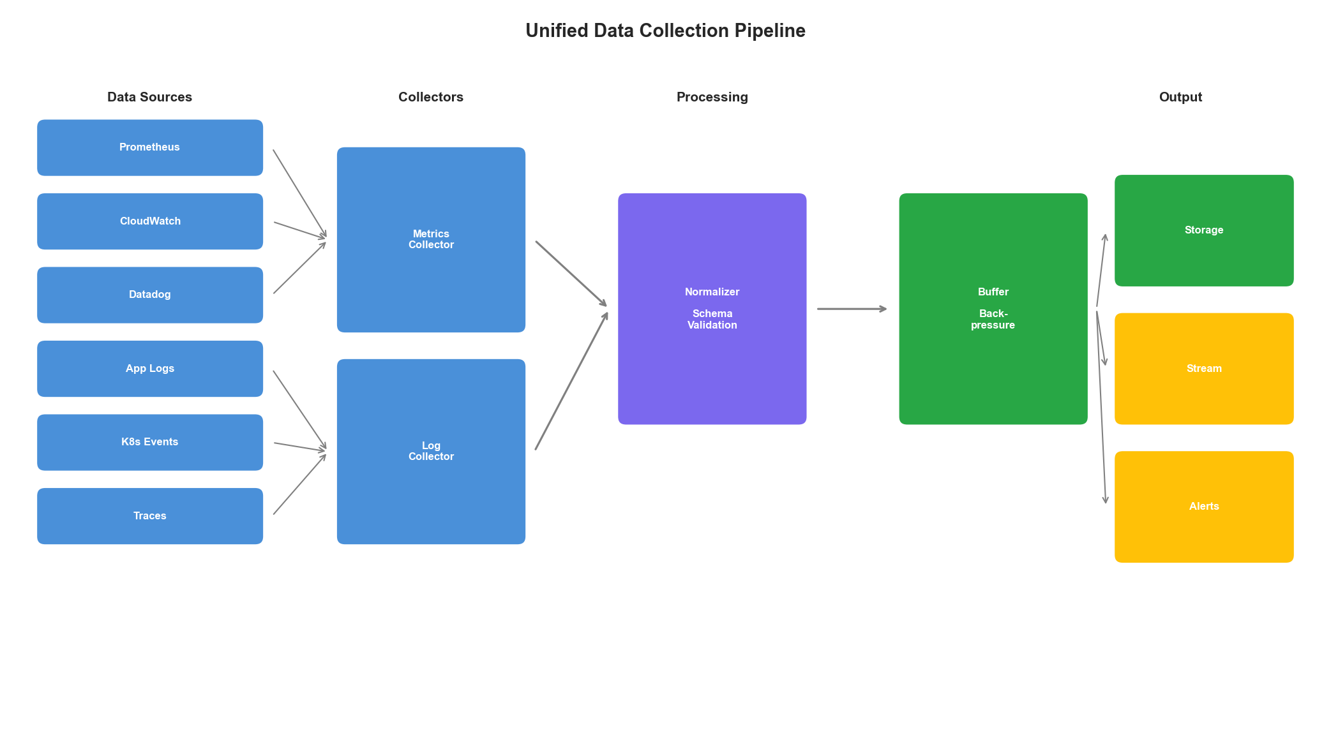
Figure 9.2: Data Collection Pipeline
Figure 9.2: Unified Data Collection Pipeline

9.3 Storage Layer Design

9.3.1 Time-Series Database Architecture
class TimeSeriesStorage:
"""
Optimized time-series storage for metrics.
"""
def __init__(self, config: StorageConfig):
self.hot_storage = InfluxDBClient(config.hot)
self.warm_storage = TimescaleDBClient(config.warm)
self.cold_storage = S3Client(config.cold)
self.retention_policy = RetentionPolicy(config.retention)
self.downsampler = Downsampler(config.downsampling)
async def write(self, metrics: list[Metric]):
"""Write metrics with automatic tiering."""
# Always write to hot storage first
await self.hot_storage.write(metrics)
async def query(
self,
query: MetricQuery,
time_range: TimeRange
) -> list[Metric]:
"""Query across storage tiers."""
# Determine which tiers to query
tiers = self._determine_tiers(time_range)
results = []
for tier in tiers:
tier_results = await self._query_tier(tier, query, time_range)
results.extend(tier_results)
return self._merge_results(results)
def _determine_tiers(self, time_range: TimeRange) -> list[str]:
"""Determine which storage tiers to query."""
now = datetime.utcnow()
tiers = []
# Hot: last 24 hours
if time_range.end > now - timedelta(hours=24):
tiers.append("hot")
# Warm: 1 day to 30 days
if time_range.start < now - timedelta(hours=24):
if time_range.end > now - timedelta(days=30):
tiers.append("warm")
# Cold: > 30 days
if time_range.start < now - timedelta(days=30):
tiers.append("cold")
return tiers
class Downsampler:
"""Downsample metrics for long-term storage."""
def __init__(self, config: DownsamplingConfig):
self.rules = config.rules
async def downsample(
self,
metrics: list[Metric],
target_resolution: timedelta
) -> list[Metric]:
"""Downsample metrics to target resolution."""
# Group by metric name and labels
grouped = self._group_metrics(metrics)
downsampled = []
for key, group in grouped.items():
# Apply aggregation
aggregated = self._aggregate_group(
group,
target_resolution,
self._get_aggregation_method(key)
)
downsampled.extend(aggregated)
return downsampled
def _get_aggregation_method(self, metric_name: str) -> str:
"""Get appropriate aggregation method for metric."""
# Counters should sum, gauges should average
if "total" in metric_name or "count" in metric_name:
return "sum"
elif "bucket" in metric_name:
return "sum" # Histogram buckets
else:
return "avg"

9.3.2 Feature Store for ML
class FeatureStore:
"""
Feature store for ML-based optimization.
"""
def __init__(self, config: FeatureStoreConfig):
self.online_store = RedisClient(config.online)
self.offline_store = ParquetStore(config.offline)
self.feature_registry = FeatureRegistry(config.registry)
async def compute_features(
self,
entity_id: str,
feature_set: str,
timestamp: datetime = None
) -> dict:
"""Compute features for an entity."""
# Get feature definitions
definitions = self.feature_registry.get(feature_set)
# Try online store first
cached = await self.online_store.get(entity_id, feature_set)
if cached and self._is_fresh(cached, definitions.max_age):
return cached.features
# Compute fresh features
features = {}
for feature_def in definitions.features:
value = await self._compute_feature(
entity_id, feature_def, timestamp
)
features[feature_def.name] = value
# Cache in online store
await self.online_store.set(
entity_id, feature_set, features,
ttl=definitions.cache_ttl
)
return features
async def _compute_feature(
self,
entity_id: str,
feature_def: FeatureDefinition,
timestamp: datetime
):
"""Compute a single feature."""
if feature_def.type == "aggregation":
return await self._compute_aggregation(
entity_id, feature_def, timestamp
)
elif feature_def.type == "derived":
return await self._compute_derived(
entity_id, feature_def, timestamp
)
elif feature_def.type == "lookup":
return await self._lookup_feature(
entity_id, feature_def
)
async def _compute_aggregation(
self,
entity_id: str,
feature_def: FeatureDefinition,
timestamp: datetime
):
"""Compute aggregation feature."""
# Query raw data
data = await self.offline_store.query(
entity_id=entity_id,
metric=feature_def.source_metric,
start=timestamp - feature_def.window,
end=timestamp
)
# Apply aggregation
if feature_def.aggregation == "mean":
return np.mean([d.value for d in data])
elif feature_def.aggregation == "max":
return np.max([d.value for d in data])
elif feature_def.aggregation == "p99":
return np.percentile([d.value for d in data], 99)
elif feature_def.aggregation == "trend":
return self._compute_trend([d.value for d in data])

9.4 Analysis Engine

9.4.1 Real-Time Stream Processing
class StreamProcessor:
"""
Real-time stream processing for optimization signals.
"""
def __init__(self, config: StreamConfig):
self.kafka_consumer = KafkaConsumer(config.kafka)
self.processors = self._init_processors(config.processors)
self.output_topics = config.output_topics
async def run(self):
"""Main processing loop."""
async for message in self.kafka_consumer:
# Parse event
event = self._parse_event(message)
# Route to appropriate processors
for processor in self._get_processors(event.type):
try:
results = await processor.process(event)
# Emit results
for result in results:
await self._emit(result)
except Exception as e:
self.logger.error(
f"Processor {processor.name} failed",
event_type=event.type,
error=str(e)
)
def _init_processors(self, configs: list) -> list:
"""Initialize stream processors."""
processors = []
for cfg in configs:
if cfg.type == "anomaly_detection":
processors.append(AnomalyDetectionProcessor(cfg))
elif cfg.type == "pattern_detection":
processors.append(PatternDetectionProcessor(cfg))
elif cfg.type == "threshold_alert":
processors.append(ThresholdAlertProcessor(cfg))
elif cfg.type == "trend_detection":
processors.append(TrendDetectionProcessor(cfg))
return processors
class AnomalyDetectionProcessor:
"""Real-time anomaly detection in streams."""
def __init__(self, config):
self.models = {}
self.baseline_window = config.baseline_window
self.sensitivity = config.sensitivity
async def process(self, event: MetricEvent) -> list[Alert]:
"""Process metric event for anomalies."""
key = f"{event.metric_name}:{event.labels_hash}"
# Get or create model for this series
if key not in self.models:
self.models[key] = OnlineAnomalyModel(
sensitivity=self.sensitivity
)
model = self.models[key]
# Update model and check for anomaly
is_anomaly, score = model.update_and_detect(event.value)
if is_anomaly:
return [Alert(
type="anomaly",
metric=event.metric_name,
labels=event.labels,
value=event.value,
score=score,
timestamp=event.timestamp
)]
return []
class OnlineAnomalyModel:
"""Online anomaly detection using streaming statistics."""
def __init__(self, sensitivity: float = 3.0):
self.sensitivity = sensitivity
self.mean = 0
self.variance = 0
self.count = 0
# Exponential moving average params
self.alpha = 0.1
def update_and_detect(self, value: float) -> tuple[bool, float]:
"""Update model and detect anomaly."""
if self.count < 10:
# Not enough data yet
self._update_stats(value)
return False, 0.0
# Calculate z-score
std = np.sqrt(self.variance)
if std == 0:
std = 1e-10
z_score = abs(value - self.mean) / std
# Update stats with new value
self._update_stats(value)
# Check if anomaly
is_anomaly = z_score > self.sensitivity
return is_anomaly, z_score
def _update_stats(self, value: float):
"""Update running statistics."""
self.count += 1
# Welford's online algorithm for mean and variance
delta = value - self.mean
self.mean += self.alpha * delta
delta2 = value - self.mean
self.variance = (1 - self.alpha) * (self.variance + self.alpha * delta * delta2)

9.4.2 Batch Analysis Jobs
class BatchAnalyzer:
"""
Batch analysis for complex optimization insights.
"""
def __init__(self, config: BatchConfig):
self.spark = SparkSession.builder.config(config.spark).getOrCreate()
self.storage = TimeSeriesStorage(config.storage)
self.ml_models = MLModelRegistry(config.models)
async def run_capacity_analysis(
self,
services: list[str],
lookback_days: int = 30,
forecast_days: int = 7
) -> list[CapacityForecast]:
"""Run capacity planning analysis."""
forecasts = []
for service in services:
# Load historical data
data = await self.storage.query(
MetricQuery(
metrics=["cpu.usage", "memory.usage", "request.count"],
service=service
),
TimeRange(
start=datetime.utcnow() - timedelta(days=lookback_days),
end=datetime.utcnow()
)
)
# Convert to Spark DataFrame
df = self.spark.createDataFrame(data)
# Extract features
features_df = self._extract_features(df)
# Load forecasting model
model = self.ml_models.get("capacity_forecast")
# Generate forecast
forecast = model.predict(features_df, horizon=forecast_days)
# Determine scaling recommendations
recommendations = self._generate_recommendations(
service, forecast
)
forecasts.append(CapacityForecast(
service=service,
current_capacity=self._get_current_capacity(service),
forecasted_demand=forecast,
recommendations=recommendations,
confidence=model.confidence
))
return forecasts
def _generate_recommendations(
self,
service: str,
forecast: pd.DataFrame
) -> list[ScalingRecommendation]:
"""Generate scaling recommendations from forecast."""
recommendations = []
# Check CPU
max_cpu = forecast["cpu_usage"].max()
if max_cpu > 80:
recommendations.append(ScalingRecommendation(
resource="cpu",
action="scale_up",
target_value=int(max_cpu * 1.25),
reason=f"Forecasted CPU usage will reach {max_cpu:.1f}%",
urgency="high" if max_cpu > 90 else "medium"
))
# Check memory
max_memory = forecast["memory_usage"].max()
if max_memory > 75:
recommendations.append(ScalingRecommendation(
resource="memory",
action="scale_up",
target_value=int(max_memory * 1.3),
reason=f"Forecasted memory usage will reach {max_memory:.1f}%",
urgency="high" if max_memory > 85 else "medium"
))
return recommendations
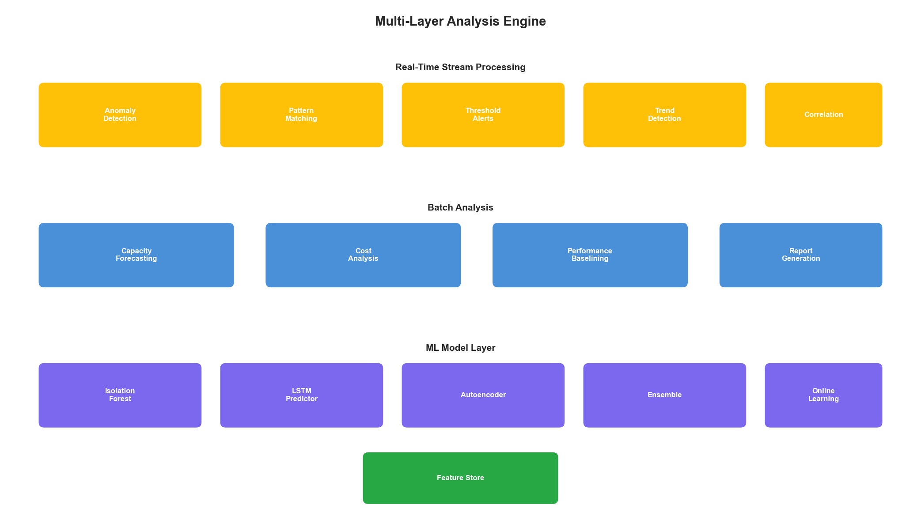
Figure 9.3: Analysis Engine Architecture
Figure 9.3: Multi-Layer Analysis Engine

9.5 Decision Engine

9.5.1 Optimization Decision Framework
class DecisionEngine:
"""
Make optimization decisions based on analysis.
"""
def __init__(self, config: DecisionConfig):
self.policies = PolicyStore(config.policies)
self.risk_assessor = RiskAssessor(config.risk)
self.optimizer = MultiObjectiveOptimizer(config.optimization)
self.approval_engine = ApprovalEngine(config.approval)
async def decide(
self,
analysis: AnalysisResult
) -> Decision:
"""Make optimization decision."""
# Get applicable policies
policies = await self.policies.get_applicable(
resource_type=analysis.resource_type,
context=analysis.context
)
# Generate candidate actions
candidates = self._generate_candidates(analysis, policies)
if not candidates:
return Decision(action="none", reason="no_applicable_actions")
# Evaluate candidates
evaluated = []
for candidate in candidates:
# Assess risk
risk = await self.risk_assessor.assess(candidate)
# Calculate expected benefit
benefit = self._calculate_benefit(candidate, analysis)
# Score candidate
score = self._score_candidate(candidate, risk, benefit)
evaluated.append(EvaluatedCandidate(
candidate=candidate,
risk=risk,
benefit=benefit,
score=score
))
# Select best candidate
best = max(evaluated, key=lambda x: x.score)
# Check approval requirements
approval = await self.approval_engine.check(best)
return Decision(
action=best.candidate.action,
parameters=best.candidate.parameters,
risk_assessment=best.risk,
expected_benefit=best.benefit,
requires_approval=not approval.auto_approved,
approval_level=approval.required_level
)
def _generate_candidates(
self,
analysis: AnalysisResult,
policies: list[Policy]
) -> list[ActionCandidate]:
"""Generate candidate actions based on analysis and policies."""
candidates = []
for policy in policies:
if policy.condition_matches(analysis):
actions = policy.generate_actions(analysis)
candidates.extend(actions)
return candidates
def _score_candidate(
self,
candidate: ActionCandidate,
risk: RiskAssessment,
benefit: BenefitEstimate
) -> float:
"""Score a candidate action."""
# Multi-objective scoring
weights = {
"cost_reduction": 0.3,
"performance_improvement": 0.25,
"reliability_improvement": 0.25,
"risk_penalty": -0.2
}
score = (
weights["cost_reduction"] * benefit.cost_reduction_score +
weights["performance_improvement"] * benefit.performance_score +
weights["reliability_improvement"] * benefit.reliability_score +
weights["risk_penalty"] * risk.overall_score
)
return score
class RiskAssessor:
"""Assess risk of optimization actions."""
def __init__(self, config: RiskConfig):
self.thresholds = config.thresholds
self.history = ActionHistory(config.history)
async def assess(self, candidate: ActionCandidate) -> RiskAssessment:
"""Assess risk of an action."""
factors = []
# Check blast radius
blast_radius = self._calculate_blast_radius(candidate)
factors.append(RiskFactor(
name="blast_radius",
score=blast_radius / 100,
description=f"Action affects {blast_radius}% of capacity"
))
# Check reversibility
reversibility = self._assess_reversibility(candidate)
factors.append(RiskFactor(
name="reversibility",
score=1 - reversibility,
description=f"Action is {reversibility*100:.0f}% reversible"
))
# Check historical success rate
history = await self.history.get_similar_actions(candidate)
if history:
success_rate = sum(1 for h in history if h.success) / len(history)
factors.append(RiskFactor(
name="historical_success",
score=1 - success_rate,
description=f"Similar actions succeeded {success_rate*100:.0f}% of the time"
))
# Check timing
timing_risk = self._assess_timing_risk(candidate)
factors.append(RiskFactor(
name="timing",
score=timing_risk,
description=self._get_timing_description(timing_risk)
))
# Calculate overall risk
overall = np.mean([f.score for f in factors])
return RiskAssessment(
overall_score=overall,
factors=factors,
recommendation=self._get_recommendation(overall)
)

9.5.2 Multi-Objective Optimization
class MultiObjectiveOptimizer:
"""
Optimize for multiple objectives simultaneously.
"""
def __init__(self, config: OptimizationConfig):
self.objectives = config.objectives
self.constraints = config.constraints
def optimize(
self,
current_state: SystemState,
candidates: list[ActionCandidate]
) -> list[ActionCandidate]:
"""Find Pareto-optimal actions."""
# Evaluate all candidates against all objectives
scores = []
for candidate in candidates:
candidate_scores = {}
for objective in self.objectives:
score = self._evaluate_objective(
candidate, current_state, objective
)
candidate_scores[objective.name] = score
scores.append(candidate_scores)
# Find Pareto frontier
pareto_indices = self._find_pareto_frontier(scores)
return [candidates[i] for i in pareto_indices]
def _find_pareto_frontier(
self,
scores: list[dict]
) -> list[int]:
"""Find indices of Pareto-optimal solutions."""
n = len(scores)
is_dominated = [False] * n
for i in range(n):
if is_dominated[i]:
continue
for j in range(n):
if i == j or is_dominated[j]:
continue
# Check if j dominates i
if self._dominates(scores[j], scores[i]):
is_dominated[i] = True
break
return [i for i in range(n) if not is_dominated[i]]
def _dominates(self, a: dict, b: dict) -> bool:
"""Check if solution a dominates solution b."""
dominated = True
strictly_better = False
for obj in self.objectives:
if obj.minimize:
if a[obj.name] > b[obj.name]:
dominated = False
elif a[obj.name] < b[obj.name]:
strictly_better = True
else:
if a[obj.name] < b[obj.name]:
dominated = False
elif a[obj.name] > b[obj.name]:
strictly_better = True
return dominated and strictly_better

9.6 Action Engine

9.6.1 Safe Action Execution
class ActionEngine:
"""
Execute optimization actions safely.
"""
def __init__(self, config: ActionConfig):
self.executors = self._init_executors(config.executors)
self.safety = SafetyController(config.safety)
self.rollback = RollbackManager(config.rollback)
self.audit = AuditLogger(config.audit)
async def execute(
self,
decision: Decision
) -> ExecutionResult:
"""Execute an optimization decision."""
# Pre-flight safety checks
safety_check = await self.safety.pre_flight(decision)
if not safety_check.passed:
return ExecutionResult(
success=False,
reason=safety_check.failure_reason,
blocked_by="safety"
)
# Create rollback point
rollback_point = await self.rollback.create_point(decision)
# Get appropriate executor
executor = self.executors.get(decision.action_type)
if not executor:
return ExecutionResult(
success=False,
reason=f"No executor for action type: {decision.action_type}"
)
# Execute with monitoring
try:
self.audit.log({
"event": "action_started",
"decision": decision.to_dict(),
"rollback_point": rollback_point.id
})
result = await self._execute_with_monitoring(
executor, decision, rollback_point
)
self.audit.log({
"event": "action_completed",
"decision_id": decision.id,
"result": result.to_dict()
})
return result
except Exception as e:
self.audit.log({
"event": "action_failed",
"decision_id": decision.id,
"error": str(e)
})
# Attempt rollback
await self.rollback.rollback(rollback_point)
return ExecutionResult(
success=False,
reason=str(e),
rolled_back=True
)
async def _execute_with_monitoring(
self,
executor: ActionExecutor,
decision: Decision,
rollback_point: RollbackPoint
) -> ExecutionResult:
"""Execute action while monitoring for issues."""
# Start action
action_task = asyncio.create_task(
executor.execute(decision)
)
# Monitor while executing
monitor_task = asyncio.create_task(
self._monitor_execution(decision, rollback_point)
)
done, pending = await asyncio.wait(
[action_task, monitor_task],
return_when=asyncio.FIRST_COMPLETED
)
if monitor_task in done:
# Monitoring detected an issue
action_task.cancel()
monitor_result = monitor_task.result()
if monitor_result.should_rollback:
await self.rollback.rollback(rollback_point)
return ExecutionResult(
success=False,
reason=monitor_result.issue,
rolled_back=monitor_result.should_rollback
)
# Action completed
monitor_task.cancel()
return action_task.result()
class SafetyController:
"""Ensure safe execution of actions."""
def __init__(self, config: SafetyConfig):
self.rules = config.rules
self.lockout_manager = LockoutManager(config.lockout)
async def pre_flight(self, decision: Decision) -> SafetyCheck:
"""Perform pre-flight safety checks."""
failures = []
# Check lockout status
if await self.lockout_manager.is_locked(decision.target):
failures.append(f"Target {decision.target} is in lockout")
# Check change rate limits
recent_changes = await self._get_recent_changes(decision.target)
if len(recent_changes) > self.rules.max_changes_per_hour:
failures.append("Change rate limit exceeded")
# Check business hours
if self.rules.require_business_hours:
if not self._is_business_hours():
failures.append("Action requires business hours")
# Check dependencies
dep_check = await self._check_dependencies(decision)
if not dep_check.passed:
failures.append(dep_check.reason)
return SafetyCheck(
passed=len(failures) == 0,
failure_reason="; ".join(failures) if failures else None
)

9.6.2 Kubernetes Integration
class KubernetesExecutor(ActionExecutor):
"""Execute optimization actions on Kubernetes."""
def __init__(self, config: K8sConfig):
self.client = kubernetes.client.ApiClient(
kubernetes.config.load_incluster_config()
)
self.apps_v1 = kubernetes.client.AppsV1Api(self.client)
self.core_v1 = kubernetes.client.CoreV1Api(self.client)
self.autoscaling_v1 = kubernetes.client.AutoscalingV1Api(self.client)
async def execute(self, decision: Decision) -> ExecutionResult:
"""Execute Kubernetes optimization action."""
if decision.action == "scale_deployment":
return await self._scale_deployment(decision)
elif decision.action == "update_resources":
return await self._update_resources(decision)
elif decision.action == "update_hpa":
return await self._update_hpa(decision)
else:
raise ValueError(f"Unknown action: {decision.action}")
async def _scale_deployment(
self,
decision: Decision
) -> ExecutionResult:
"""Scale a deployment."""
namespace = decision.parameters["namespace"]
name = decision.parameters["deployment"]
replicas = decision.parameters["replicas"]
try:
# Get current deployment
deployment = self.apps_v1.read_namespaced_deployment(
name, namespace
)
current_replicas = deployment.spec.replicas
# Scale
deployment.spec.replicas = replicas
self.apps_v1.patch_namespaced_deployment(
name, namespace, deployment
)
# Wait for rollout
await self._wait_for_rollout(namespace, name)
return ExecutionResult(
success=True,
action="scale_deployment",
before={"replicas": current_replicas},
after={"replicas": replicas}
)
except kubernetes.client.ApiException as e:
return ExecutionResult(
success=False,
action="scale_deployment",
reason=str(e)
)
async def _update_resources(
self,
decision: Decision
) -> ExecutionResult:
"""Update container resource requests/limits."""
namespace = decision.parameters["namespace"]
name = decision.parameters["deployment"]
container = decision.parameters["container"]
resources = decision.parameters["resources"]
try:
deployment = self.apps_v1.read_namespaced_deployment(
name, namespace
)
# Find container and update resources
for c in deployment.spec.template.spec.containers:
if c.name == container:
old_resources = c.resources.to_dict()
c.resources = kubernetes.client.V1ResourceRequirements(
requests=resources.get("requests"),
limits=resources.get("limits")
)
break
# Apply changes
self.apps_v1.patch_namespaced_deployment(
name, namespace, deployment
)
# Wait for rollout
await self._wait_for_rollout(namespace, name)
return ExecutionResult(
success=True,
action="update_resources",
before={"resources": old_resources},
after={"resources": resources}
)
except kubernetes.client.ApiException as e:
return ExecutionResult(
success=False,
action="update_resources",
reason=str(e)
)
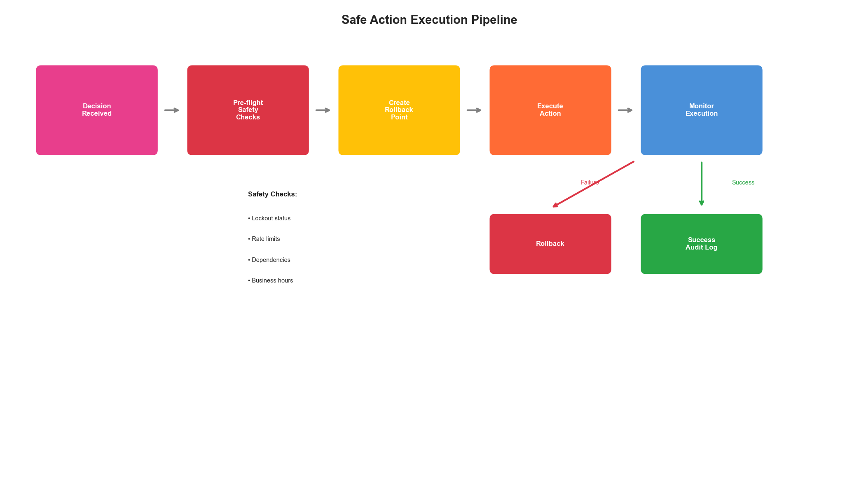
Figure 9.4: Action Execution Pipeline
Figure 9.4: Safe Action Execution Pipeline

9.7 Platform Operations

9.7.1 Platform Monitoring
class PlatformMonitor:
"""Monitor the optimization platform itself."""
def __init__(self, config: MonitorConfig):
self.metrics = PrometheusClient()
self.alerts = AlertManager(config.alerts)
def record_decision(self, decision: Decision, result: ExecutionResult):
"""Record decision metrics."""
labels = {
"action_type": decision.action_type,
"target_type": decision.target_type,
"success": str(result.success)
}
self.metrics.counter(
"optimization_decisions_total", labels
).inc()
if result.success:
# Record improvement
if result.improvement:
self.metrics.gauge(
"optimization_improvement",
labels
).set(result.improvement)
def record_pipeline_health(self, component: str, healthy: bool):
"""Record component health."""
self.metrics.gauge(
"platform_component_healthy",
{"component": component}
).set(1 if healthy else 0)

9.7.2 Platform Configuration
# platform-config.yaml
platform:
name: "infrastructure-optimizer"
version: "1.0.0"
collection:
sources:
- type: prometheus
endpoint: "http://prometheus:9090"
scrape_interval: 15s
- type: cloudwatch
regions: ["us-east-1", "us-west-2"]
storage:
hot:
type: influxdb
retention: 24h
warm:
type: timescaledb
retention: 30d
cold:
type: s3
bucket: "metrics-archive"
analysis:
stream_processors:
- type: anomaly_detection
sensitivity: 3.0
- type: trend_detection
window: 1h
batch_jobs:
- name: capacity_forecast
schedule: "0 */6 * * *"
decision:
risk_thresholds:
low: 0.3
medium: 0.6
high: 0.8
auto_approve_below: 0.3
execution:
safety:
max_changes_per_hour: 10
require_business_hours: false
lockout_on_incident: true
rollback:
auto_rollback_on_error: true
max_rollback_age: 24h

Key Takeaways
- Layered architecture - Separate collection, storage, analysis, decision, and action layers for maintainability and flexibility
- Observability first - Every component must be observable with metrics, logs, and traces
- Graceful degradation - The platform must continue operating even when individual components fail
- Safety as a first-class concern - Build safety checks, rollback capabilities, and audit trails into the core
- Multi-source data collection - Normalize data from multiple sources to a common schema
- Risk-aware decisions - Every optimization decision must include risk assessment

References
- Kleppmann, M. “Designing Data-Intensive Applications.” O’Reilly Media (2017)
- Burns, B. “Designing Distributed Systems.” O’Reilly Media (2018)
- Newman, S. “Building Microservices.” O’Reilly Media (2021)
- Google. “Site Reliability Engineering.” O’Reilly Media (2016)
- Humble, J. and Farley, D. “Continuous Delivery.” Addison-Wesley (2010)

Next Chapter: Observability and Data Pipelines

