Chapter 12: GRPO Implementation Deep Dive

Introduction
Group Relative Policy Optimization (GRPO) represents a significant advancement over traditional reinforcement learning approaches for infrastructure optimization. Building on the foundations established in Chapter 11, this chapter provides a comprehensive implementation guide for deploying GRPO in production infrastructure environments.
GRPO addresses key limitations of standard policy optimization methods by comparing actions within groups rather than against absolute baselines. This approach proves particularly effective for infrastructure optimization where the “correct” action depends heavily on current system state and where reward signals can be noisy.
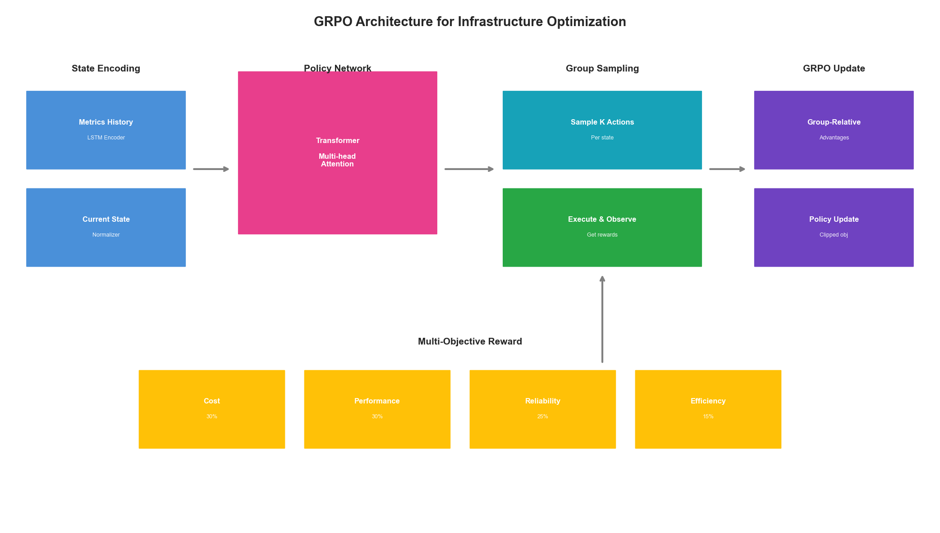
GRPO Architecture Overview

Understanding GRPO Mathematics

The Core GRPO Objective
GRPO modifies the standard policy gradient objective by introducing group-relative comparisons:
import torch
import torch.nn as nn
import torch.nn.functional as F
from dataclasses import dataclass
from typing import List, Tuple, Optional
import numpy as np
@dataclass
class GRPOConfig:
"""Configuration for GRPO training."""
group_size: int = 8
clip_epsilon: float = 0.2
kl_coefficient: float = 0.1
entropy_coefficient: float = 0.01
learning_rate: float = 3e-4
gamma: float = 0.99
gae_lambda: float = 0.95
max_grad_norm: float = 0.5
num_epochs: int = 4
batch_size: int = 64
class GRPOLoss(nn.Module):
"""
GRPO loss function with group-relative advantage estimation.
Key insight: Instead of comparing against a learned baseline,
GRPO compares actions within groups of sampled trajectories.
"""
def __init__(self, config: GRPOConfig):
super().__init__()
self.config = config
def compute_group_advantages(
self,
rewards: torch.Tensor, # Shape: (batch, group_size)
group_mask: Optional[torch.Tensor] = None
) -> torch.Tensor:
"""
Compute advantages relative to group mean.
This is the core GRPO innovation: advantages are computed
relative to other samples in the same group.
"""
# Compute group statistics
if group_mask is not None:
masked_rewards = rewards * group_mask
group_sum = masked_rewards.sum(dim=-1, keepdim=True)
group_count = group_mask.sum(dim=-1, keepdim=True)
group_mean = group_sum / group_count.clamp(min=1)
# Compute variance for normalization
diff_squared = ((rewards - group_mean) ** 2) * group_mask
group_var = diff_squared.sum(dim=-1, keepdim=True) / group_count.clamp(min=1)
group_std = (group_var + 1e-8).sqrt()
else:
group_mean = rewards.mean(dim=-1, keepdim=True)
group_std = rewards.std(dim=-1, keepdim=True) + 1e-8
# Normalize advantages within group
advantages = (rewards - group_mean) / group_std
return advantages
def forward(
self,
log_probs: torch.Tensor,
old_log_probs: torch.Tensor,
rewards: torch.Tensor,
group_indices: torch.Tensor
) -> Tuple[torch.Tensor, dict]:
"""
Compute GRPO loss.
Args:
log_probs: Current policy log probabilities
old_log_probs: Old policy log probabilities
rewards: Reward values for each action
group_indices: Indices mapping samples to groups
"""
# Reshape into groups
batch_size = log_probs.shape[0]
num_groups = batch_size // self.config.group_size
rewards_grouped = rewards.view(num_groups, self.config.group_size)
log_probs_grouped = log_probs.view(num_groups, self.config.group_size)
old_log_probs_grouped = old_log_probs.view(num_groups, self.config.group_size)
# Compute group-relative advantages
advantages = self.compute_group_advantages(rewards_grouped)
advantages = advantages.view(-1) # Flatten back
# Compute probability ratio
ratio = torch.exp(log_probs - old_log_probs)
# Clipped surrogate objective
clipped_ratio = torch.clamp(
ratio,
1 - self.config.clip_epsilon,
1 + self.config.clip_epsilon
)
# GRPO objective
surrogate1 = ratio * advantages
surrogate2 = clipped_ratio * advantages
policy_loss = -torch.min(surrogate1, surrogate2).mean()
# KL divergence penalty
kl_div = (old_log_probs - log_probs).mean()
kl_loss = self.config.kl_coefficient * kl_div
# Entropy bonus for exploration
entropy = -(log_probs * torch.exp(log_probs)).mean()
entropy_loss = -self.config.entropy_coefficient * entropy
total_loss = policy_loss + kl_loss + entropy_loss
metrics = {
'policy_loss': policy_loss.item(),
'kl_div': kl_div.item(),
'entropy': entropy.item(),
'advantage_mean': advantages.mean().item(),
'advantage_std': advantages.std().item(),
'ratio_mean': ratio.mean().item()
}
return total_loss, metrics

Why Group-Relative Advantages Matter
Traditional RL uses learned value functions to compute advantages, introducing estimation error and training instability. GRPO sidesteps this by using empirical comparisons within groups:
class AdvantageComparison:
"""
Demonstrates the difference between traditional and GRPO advantages.
"""
@staticmethod
def traditional_advantage(
rewards: np.ndarray,
values: np.ndarray, # From learned value function
gamma: float = 0.99
) -> np.ndarray:
"""
Traditional GAE-style advantages.
Requires accurate value function estimation.
"""
advantages = np.zeros_like(rewards)
last_advantage = 0
for t in reversed(range(len(rewards))):
next_value = values[t + 1] if t + 1 < len(values) else 0
delta = rewards[t] + gamma * next_value - values[t]
advantages[t] = last_advantage = delta + gamma * 0.95 * last_advantage
return advantages
@staticmethod
def grpo_advantage(
rewards: np.ndarray,
group_size: int = 8
) -> np.ndarray:
"""
GRPO group-relative advantages.
No value function needed - purely empirical.
"""
# Reshape into groups
num_samples = len(rewards)
num_groups = num_samples // group_size
rewards_grouped = rewards[:num_groups * group_size].reshape(num_groups, group_size)
# Compute group statistics
group_means = rewards_grouped.mean(axis=1, keepdims=True)
group_stds = rewards_grouped.std(axis=1, keepdims=True) + 1e-8
# Normalize within group
advantages = (rewards_grouped - group_means) / group_stds
return advantages.flatten()
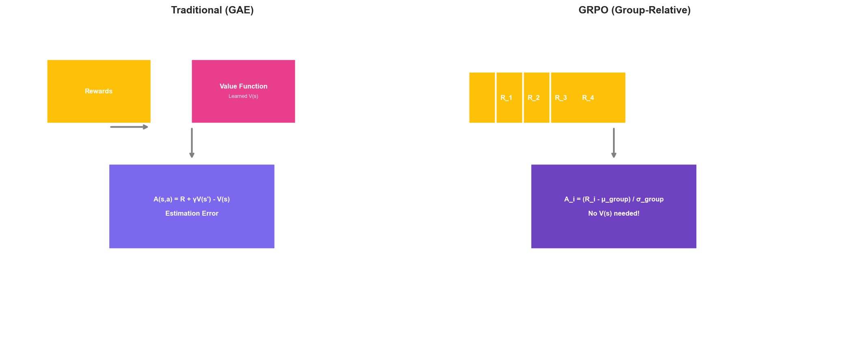
Advantage Estimation Comparison

Infrastructure-Specific GRPO Implementation

State Representation for Infrastructure
Effective GRPO requires careful state representation:
from typing import Dict, Any
import numpy as np
class InfrastructureStateEncoder(nn.Module):
"""
Encodes infrastructure state into policy network input.
Infrastructure state includes:
- Resource utilization (CPU, memory, network, disk)
- Queue depths and latencies
- Time-based features
- Historical patterns
"""
def __init__(
self,
num_metrics: int = 20,
hidden_dim: int = 128,
history_length: int = 60
):
super().__init__()
self.history_length = history_length
# Temporal encoder for time series
self.temporal_encoder = nn.LSTM(
input_size=num_metrics,
hidden_size=hidden_dim,
num_layers=2,
batch_first=True,
dropout=0.1
)
# Attention for focusing on relevant time periods
self.attention = nn.MultiheadAttention(
embed_dim=hidden_dim,
num_heads=4,
batch_first=True
)
# Final encoding
self.encoder = nn.Sequential(
nn.Linear(hidden_dim * 2, hidden_dim),
nn.LayerNorm(hidden_dim),
nn.ReLU(),
nn.Linear(hidden_dim, hidden_dim)
)
def forward(
self,
metrics_history: torch.Tensor, # (batch, time, metrics)
current_state: torch.Tensor # (batch, metrics)
) -> torch.Tensor:
# Encode temporal patterns
temporal_out, (h_n, c_n) = self.temporal_encoder(metrics_history)
# Apply attention
attended, _ = self.attention(
temporal_out, temporal_out, temporal_out
)
# Combine with current state
temporal_summary = attended[:, -1, :] # Last timestep
current_encoded = h_n[-1] # Last layer hidden state
combined = torch.cat([temporal_summary, current_encoded], dim=-1)
return self.encoder(combined)
class InfrastructureMetricsNormalizer:
"""
Normalizes infrastructure metrics for consistent model input.
Different metrics have vastly different scales:
- CPU: 0-100%
- Memory: 0-100%
- Latency: 0-10000ms
- Request rate: 0-100000 RPS
"""
def __init__(self):
self.metric_ranges = {
'cpu_percent': (0, 100),
'memory_percent': (0, 100),
'network_mbps': (0, 10000),
'disk_iops': (0, 100000),
'latency_p50_ms': (0, 1000),
'latency_p99_ms': (0, 10000),
'request_rate': (0, 100000),
'error_rate': (0, 100),
'queue_depth': (0, 10000),
'replica_count': (0, 100)
}
self.running_stats = {}
def normalize(
self,
metrics: Dict[str, float],
use_running_stats: bool = True
) -> np.ndarray:
"""Normalize metrics to [-1, 1] range."""
normalized = []
for name, value in metrics.items():
if name in self.metric_ranges:
min_val, max_val = self.metric_ranges[name]
norm_value = 2 * (value - min_val) / (max_val - min_val) - 1
norm_value = np.clip(norm_value, -1, 1)
elif use_running_stats and name in self.running_stats:
mean, std = self.running_stats[name]
norm_value = (value - mean) / (std + 1e-8)
norm_value = np.clip(norm_value, -3, 3) / 3
else:
# Fallback: log transform for unknown metrics
norm_value = np.sign(value) * np.log1p(np.abs(value)) / 10
normalized.append(norm_value)
return np.array(normalized, dtype=np.float32)

Action Space Design
Infrastructure actions require careful discretization:
from enum import Enum
from typing import List
class ScalingAction(Enum):
"""Discrete scaling actions."""
SCALE_DOWN_LARGE = -4
SCALE_DOWN_MEDIUM = -2
SCALE_DOWN_SMALL = -1
MAINTAIN = 0
SCALE_UP_SMALL = 1
SCALE_UP_MEDIUM = 2
SCALE_UP_LARGE = 4
class ConfigAction(Enum):
"""Configuration tuning actions."""
DECREASE_BATCH_SIZE = 0
INCREASE_BATCH_SIZE = 1
DECREASE_TIMEOUT = 2
INCREASE_TIMEOUT = 3
DECREASE_CONCURRENCY = 4
INCREASE_CONCURRENCY = 5
NO_CHANGE = 6
class InfrastructureActionSpace:
"""
Defines the action space for infrastructure optimization.
Actions are hierarchical:
1. Resource scaling (replicas, instance types)
2. Configuration tuning (batch sizes, timeouts)
3. Traffic management (routing weights)
"""
def __init__(
self,
scaling_actions: List[ScalingAction] = None,
config_actions: List[ConfigAction] = None,
enable_traffic_actions: bool = True
):
self.scaling_actions = scaling_actions or list(ScalingAction)
self.config_actions = config_actions or list(ConfigAction)
self.enable_traffic_actions = enable_traffic_actions
# Compute total action space size
self.num_scaling = len(self.scaling_actions)
self.num_config = len(self.config_actions)
self.num_traffic = 11 if enable_traffic_actions else 0 # 0-100% in 10% steps
self.total_actions = self.num_scaling * self.num_config
if enable_traffic_actions:
self.total_actions *= self.num_traffic
def decode_action(self, action_idx: int) -> Dict[str, Any]:
"""Convert action index to infrastructure commands."""
if self.enable_traffic_actions:
traffic_idx = action_idx % self.num_traffic
action_idx //= self.num_traffic
traffic_weight = traffic_idx * 10 # 0-100%
else:
traffic_weight = None
config_idx = action_idx % self.num_config
scaling_idx = action_idx // self.num_config
return {
'scaling': self.scaling_actions[scaling_idx],
'config': self.config_actions[config_idx],
'traffic_weight': traffic_weight
}
def encode_action(
self,
scaling: ScalingAction,
config: ConfigAction,
traffic_weight: Optional[int] = None
) -> int:
"""Convert infrastructure commands to action index."""
scaling_idx = self.scaling_actions.index(scaling)
config_idx = self.config_actions.index(config)
action_idx = scaling_idx * self.num_config + config_idx
if self.enable_traffic_actions:
traffic_idx = traffic_weight // 10 if traffic_weight else 0
action_idx = action_idx * self.num_traffic + traffic_idx
return action_idx
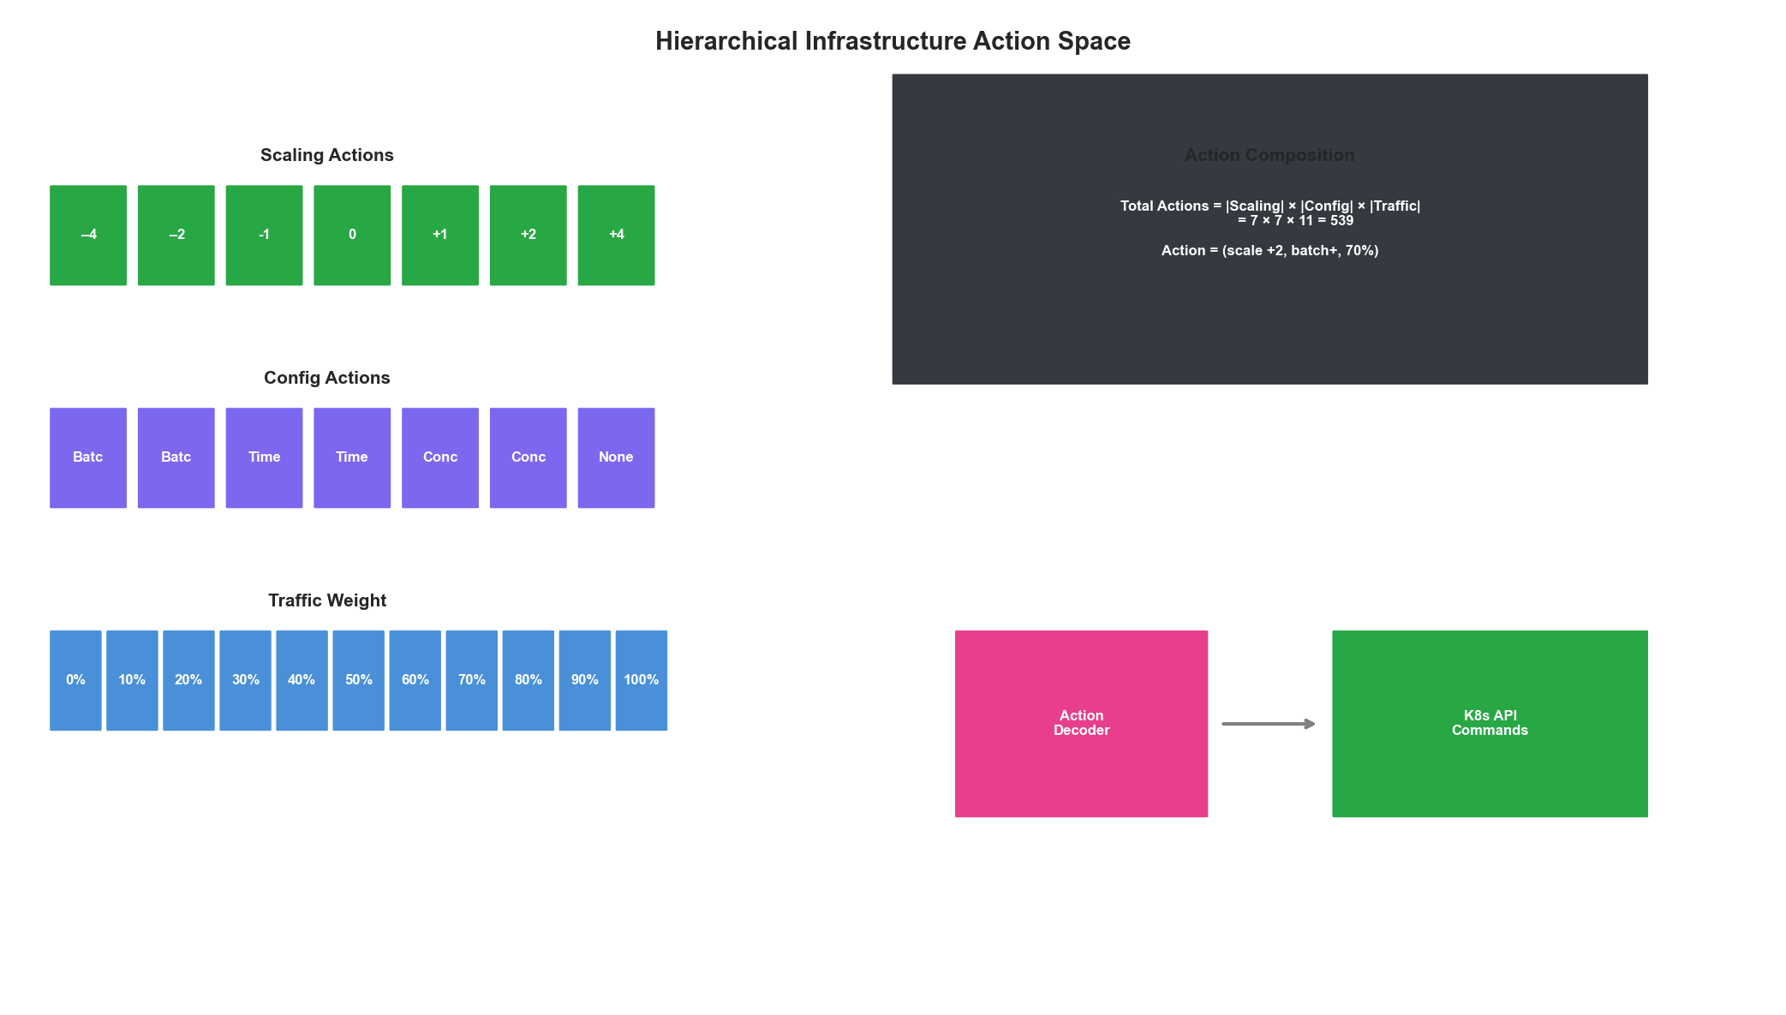
Action Space Design

Multi-Objective Reward Engineering

Composite Reward Function
Infrastructure optimization requires balancing multiple objectives:
@dataclass
class RewardWeights:
"""Weights for multi-objective optimization."""
cost: float = 0.3
performance: float = 0.3
reliability: float = 0.25
efficiency: float = 0.15
class InfrastructureRewardFunction:
"""
Multi-objective reward function for infrastructure optimization.
Balances:
- Cost: Resource expenditure
- Performance: Latency and throughput
- Reliability: Error rates and availability
- Efficiency: Resource utilization
"""
def __init__(self, weights: RewardWeights = None):
self.weights = weights or RewardWeights()
# SLA thresholds
self.sla = {
'latency_p99_ms': 200,
'error_rate_percent': 0.1,
'availability_percent': 99.9
}
# Cost baseline for normalization
self.cost_baseline = 1000 # $/hour
def compute_cost_reward(
self,
current_cost: float,
previous_cost: float
) -> float:
"""
Reward for cost reduction.
Positive when costs decrease, negative when they increase.
"""
cost_change = (previous_cost - current_cost) / self.cost_baseline
# Bonus for being under budget
if current_cost < self.cost_baseline * 0.8:
cost_change += 0.1
return np.clip(cost_change, -1, 1)
def compute_performance_reward(
self,
latency_p99: float,
throughput: float,
target_throughput: float
) -> float:
"""
Reward for meeting performance targets.
"""
# Latency component
latency_ratio = self.sla['latency_p99_ms'] / max(latency_p99, 1)
latency_reward = np.clip(latency_ratio - 1, -1, 0.5)
# Throughput component
throughput_ratio = throughput / max(target_throughput, 1)
throughput_reward = np.clip(throughput_ratio - 0.9, -1, 0.5)
return (latency_reward + throughput_reward) / 2
def compute_reliability_reward(
self,
error_rate: float,
availability: float
) -> float:
"""
Reward for maintaining reliability.
Heavy penalties for SLA violations.
"""
# Error rate component
if error_rate <= self.sla['error_rate_percent']:
error_reward = 0.5
else:
# Exponential penalty for errors
excess = error_rate - self.sla['error_rate_percent']
error_reward = -np.exp(excess) + 1
# Availability component
if availability >= self.sla['availability_percent']:
availability_reward = 0.5
else:
# Sharp penalty for availability drops
gap = self.sla['availability_percent'] - availability
availability_reward = -gap * 10
return np.clip((error_reward + availability_reward) / 2, -2, 1)
def compute_efficiency_reward(
self,
cpu_utilization: float,
memory_utilization: float,
target_utilization: float = 70
) -> float:
"""
Reward for efficient resource utilization.
Optimal around target utilization.
"""
avg_utilization = (cpu_utilization + memory_utilization) / 2
# Gaussian reward centered on target
efficiency = np.exp(
-((avg_utilization - target_utilization) ** 2) / (2 * 20 ** 2)
)
# Penalty for very low utilization (waste)
if avg_utilization < 30:
efficiency -= 0.3
# Penalty for very high utilization (risk)
if avg_utilization > 90:
efficiency -= 0.5
return np.clip(efficiency, -1, 1)
def compute_reward(
self,
state: Dict[str, float],
previous_state: Dict[str, float],
action_taken: Dict[str, Any]
) -> Tuple[float, Dict[str, float]]:
"""
Compute total reward from state transition.
"""
components = {}
components['cost'] = self.compute_cost_reward(
state['cost_per_hour'],
previous_state['cost_per_hour']
)
components['performance'] = self.compute_performance_reward(
state['latency_p99_ms'],
state['throughput_rps'],
state.get('target_throughput', 1000)
)
components['reliability'] = self.compute_reliability_reward(
state['error_rate_percent'],
state['availability_percent']
)
components['efficiency'] = self.compute_efficiency_reward(
state['cpu_percent'],
state['memory_percent']
)
# Weighted sum
total_reward = (
self.weights.cost * components['cost'] +
self.weights.performance * components['performance'] +
self.weights.reliability * components['reliability'] +
self.weights.efficiency * components['efficiency']
)
return total_reward, components

Reward Shaping for Stable Training
class RewardShaper:
"""
Applies reward shaping for stable GRPO training.
"""
def __init__(
self,
gamma: float = 0.99,
clip_range: Tuple[float, float] = (-10, 10)
):
self.gamma = gamma
self.clip_range = clip_range
self.reward_history = []
self.running_mean = 0
self.running_std = 1
def shape(
self,
reward: float,
potential_current: float,
potential_next: float
) -> float:
"""
Apply potential-based reward shaping.
F(s, s') = gamma * phi(s') - phi(s)
This preserves optimal policy while providing
denser learning signal.
"""
shaping = self.gamma * potential_next - potential_current
shaped_reward = reward + shaping
# Update running statistics
self.reward_history.append(shaped_reward)
if len(self.reward_history) > 1000:
self.reward_history.pop(0)
self.running_mean = np.mean(self.reward_history)
self.running_std = np.std(self.reward_history) + 1e-8
# Normalize
normalized = (shaped_reward - self.running_mean) / self.running_std
return np.clip(normalized, *self.clip_range)
@staticmethod
def compute_potential(state: Dict[str, float]) -> float:
"""
Compute potential function for shaping.
Higher potential = closer to desired state
"""
# Optimal state: low latency, high throughput, moderate utilization
latency_potential = -state['latency_p99_ms'] / 1000
error_potential = -state['error_rate_percent'] * 10
utilization = (state['cpu_percent'] + state['memory_percent']) / 2
utilization_potential = -abs(utilization - 70) / 100
return latency_potential + error_potential + utilization_potential

Policy Network Architecture

Transformer-Based Policy
class GRPOPolicyNetwork(nn.Module):
"""
Policy network for infrastructure GRPO.
Uses transformer architecture for handling
variable-length state histories and capturing
long-range dependencies in metrics patterns.
"""
def __init__(
self,
state_dim: int = 128,
action_dim: int = 49, # 7 scaling * 7 config actions
hidden_dim: int = 256,
num_heads: int = 8,
num_layers: int = 4,
dropout: float = 0.1
):
super().__init__()
self.state_encoder = InfrastructureStateEncoder(
num_metrics=20,
hidden_dim=state_dim,
history_length=60
)
# Transformer for sequential decision making
encoder_layer = nn.TransformerEncoderLayer(
d_model=state_dim,
nhead=num_heads,
dim_feedforward=hidden_dim,
dropout=dropout,
batch_first=True
)
self.transformer = nn.TransformerEncoder(
encoder_layer,
num_layers=num_layers
)
# Policy head
self.policy_head = nn.Sequential(
nn.Linear(state_dim, hidden_dim),
nn.LayerNorm(hidden_dim),
nn.ReLU(),
nn.Dropout(dropout),
nn.Linear(hidden_dim, hidden_dim),
nn.ReLU(),
nn.Linear(hidden_dim, action_dim)
)
# Value head for baseline (optional for GRPO)
self.value_head = nn.Sequential(
nn.Linear(state_dim, hidden_dim),
nn.LayerNorm(hidden_dim),
nn.ReLU(),
nn.Linear(hidden_dim, 1)
)
self._init_weights()
def _init_weights(self):
"""Initialize weights with orthogonal initialization."""
for module in self.modules():
if isinstance(module, nn.Linear):
nn.init.orthogonal_(module.weight, gain=np.sqrt(2))
if module.bias is not None:
nn.init.zeros_(module.bias)
def forward(
self,
metrics_history: torch.Tensor,
current_state: torch.Tensor
) -> Tuple[torch.Tensor, torch.Tensor]:
"""
Forward pass returning action logits and value estimate.
"""
# Encode state
state_encoding = self.state_encoder(metrics_history, current_state)
# Add batch dimension for transformer if needed
if state_encoding.dim() == 2:
state_encoding = state_encoding.unsqueeze(1)
# Transform
transformed = self.transformer(state_encoding)
features = transformed[:, -1, :] # Use last position
# Get action distribution and value
action_logits = self.policy_head(features)
value = self.value_head(features)
return action_logits, value
def get_action(
self,
metrics_history: torch.Tensor,
current_state: torch.Tensor,
deterministic: bool = False
) -> Tuple[int, float]:
"""
Sample action from policy.
"""
with torch.no_grad():
logits, value = self.forward(metrics_history, current_state)
probs = F.softmax(logits, dim=-1)
if deterministic:
action = probs.argmax(dim=-1).item()
else:
dist = torch.distributions.Categorical(probs)
action = dist.sample().item()
log_prob = F.log_softmax(logits, dim=-1)[0, action].item()
return action, log_prob

Training Loop Implementation

Complete GRPO Trainer
from collections import deque
import logging
class GRPOTrainer:
"""
Complete GRPO training implementation for infrastructure optimization.
"""
def __init__(
self,
policy: GRPOPolicyNetwork,
config: GRPOConfig,
action_space: InfrastructureActionSpace,
reward_fn: InfrastructureRewardFunction,
device: str = 'cuda'
):
self.policy = policy.to(device)
self.config = config
self.action_space = action_space
self.reward_fn = reward_fn
self.device = device
self.optimizer = torch.optim.AdamW(
policy.parameters(),
lr=config.learning_rate,
weight_decay=0.01
)
self.scheduler = torch.optim.lr_scheduler.CosineAnnealingLR(
self.optimizer,
T_max=10000,
eta_min=1e-6
)
self.grpo_loss = GRPOLoss(config)
# Experience buffer organized by groups
self.experience_buffer = []
self.group_buffer = []
# Logging
self.logger = logging.getLogger('GRPOTrainer')
self.metrics_history = deque(maxlen=1000)
def collect_experience(
self,
env, # Infrastructure environment
num_steps: int = 1024
) -> List[Dict]:
"""
Collect experience for training.
Groups trajectories for GRPO advantage computation.
"""
experiences = []
current_group = []
state = env.reset()
for step in range(num_steps):
# Get action from policy
metrics_history = torch.FloatTensor(
state['metrics_history']
).unsqueeze(0).to(self.device)
current_metrics = torch.FloatTensor(
state['current_metrics']
).unsqueeze(0).to(self.device)
action_idx, log_prob = self.policy.get_action(
metrics_history, current_metrics
)
action = self.action_space.decode_action(action_idx)
# Execute action
next_state, info = env.step(action)
# Compute reward
reward, reward_components = self.reward_fn.compute_reward(
next_state, state, action
)
# Store experience
experience = {
'state': state,
'action': action_idx,
'log_prob': log_prob,
'reward': reward,
'reward_components': reward_components,
'next_state': next_state,
'done': info.get('done', False)
}
current_group.append(experience)
# Complete group when full
if len(current_group) == self.config.group_size:
experiences.extend(current_group)
self.group_buffer.append(current_group)
current_group = []
state = next_state
if info.get('done', False):
state = env.reset()
return experiences
def compute_returns_and_advantages(
self,
experiences: List[Dict]
) -> Tuple[torch.Tensor, torch.Tensor]:
"""
Compute returns and GRPO group-relative advantages.
"""
# Extract rewards and organize by groups
num_groups = len(experiences) // self.config.group_size
rewards = torch.FloatTensor(
[exp['reward'] for exp in experiences]
)
# Compute discounted returns
returns = torch.zeros_like(rewards)
running_return = 0
for t in reversed(range(len(rewards))):
if t % self.config.group_size == self.config.group_size - 1:
running_return = 0 # Reset at group boundary
running_return = rewards[t] + self.config.gamma * running_return
returns[t] = running_return
# Compute GRPO advantages
returns_grouped = returns.view(num_groups, self.config.group_size)
advantages = self.grpo_loss.compute_group_advantages(returns_grouped)
advantages = advantages.view(-1)
return returns, advantages
def update_policy(
self,
experiences: List[Dict],
returns: torch.Tensor,
advantages: torch.Tensor
) -> Dict[str, float]:
"""
Perform GRPO policy update.
"""
# Prepare batch data
batch_size = len(experiences)
# Convert experiences to tensors
states_history = torch.stack([
torch.FloatTensor(exp['state']['metrics_history'])
for exp in experiences
]).to(self.device)
states_current = torch.stack([
torch.FloatTensor(exp['state']['current_metrics'])
for exp in experiences
]).to(self.device)
actions = torch.LongTensor(
[exp['action'] for exp in experiences]
).to(self.device)
old_log_probs = torch.FloatTensor(
[exp['log_prob'] for exp in experiences]
).to(self.device)
advantages = advantages.to(self.device)
returns = returns.to(self.device)
# Training epochs
total_metrics = {
'policy_loss': 0,
'value_loss': 0,
'entropy': 0,
'kl_div': 0
}
for epoch in range(self.config.num_epochs):
# Shuffle within groups (preserve group structure)
indices = self._get_shuffled_group_indices(batch_size)
for start in range(0, batch_size, self.config.batch_size):
end = min(start + self.config.batch_size, batch_size)
batch_indices = indices[start:end]
# Get batch
batch_history = states_history[batch_indices]
batch_current = states_current[batch_indices]
batch_actions = actions[batch_indices]
batch_old_log_probs = old_log_probs[batch_indices]
batch_advantages = advantages[batch_indices]
batch_returns = returns[batch_indices]
# Forward pass
logits, values = self.policy(batch_history, batch_current)
# Compute log probs for taken actions
log_probs = F.log_softmax(logits, dim=-1)
action_log_probs = log_probs.gather(
1, batch_actions.unsqueeze(-1)
).squeeze(-1)
# Policy loss (GRPO objective)
ratio = torch.exp(action_log_probs - batch_old_log_probs)
clipped_ratio = torch.clamp(
ratio,
1 - self.config.clip_epsilon,
1 + self.config.clip_epsilon
)
policy_loss = -torch.min(
ratio * batch_advantages,
clipped_ratio * batch_advantages
).mean()
# Value loss
value_loss = F.mse_loss(values.squeeze(-1), batch_returns)
# Entropy bonus
probs = F.softmax(logits, dim=-1)
entropy = -(probs * log_probs).sum(dim=-1).mean()
# KL divergence
kl_div = (batch_old_log_probs - action_log_probs).mean()
# Total loss
loss = (
policy_loss +
0.5 * value_loss -
self.config.entropy_coefficient * entropy +
self.config.kl_coefficient * kl_div
)
# Backward pass
self.optimizer.zero_grad()
loss.backward()
nn.utils.clip_grad_norm_(
self.policy.parameters(),
self.config.max_grad_norm
)
self.optimizer.step()
# Accumulate metrics
total_metrics['policy_loss'] += policy_loss.item()
total_metrics['value_loss'] += value_loss.item()
total_metrics['entropy'] += entropy.item()
total_metrics['kl_div'] += kl_div.item()
self.scheduler.step()
# Average metrics
num_updates = self.config.num_epochs * (batch_size // self.config.batch_size)
for key in total_metrics:
total_metrics[key] /= num_updates
return total_metrics
def _get_shuffled_group_indices(self, batch_size: int) -> torch.Tensor:
"""Shuffle indices while preserving group structure."""
num_groups = batch_size // self.config.group_size
group_order = torch.randperm(num_groups)
indices = []
for g in group_order:
start = g * self.config.group_size
group_indices = list(range(start, start + self.config.group_size))
np.random.shuffle(group_indices)
indices.extend(group_indices)
return torch.LongTensor(indices)
def train(
self,
env,
total_steps: int = 1000000,
eval_interval: int = 10000,
save_interval: int = 50000
):
"""
Main training loop.
"""
self.logger.info("Starting GRPO training...")
steps_completed = 0
best_reward = float('-inf')
while steps_completed < total_steps:
# Collect experience
experiences = self.collect_experience(env, num_steps=2048)
# Compute returns and advantages
returns, advantages = self.compute_returns_and_advantages(experiences)
# Update policy
metrics = self.update_policy(experiences, returns, advantages)
steps_completed += len(experiences)
# Logging
mean_reward = np.mean([exp['reward'] for exp in experiences])
self.metrics_history.append({
'step': steps_completed,
'mean_reward': mean_reward,
**metrics
})
self.logger.info(
f"Step {steps_completed}: "
f"reward={mean_reward:.3f}, "
f"policy_loss={metrics['policy_loss']:.4f}, "
f"entropy={metrics['entropy']:.4f}"
)
# Evaluation
if steps_completed % eval_interval == 0:
eval_reward = self.evaluate(env)
self.logger.info(f"Evaluation reward: {eval_reward:.3f}")
if eval_reward > best_reward:
best_reward = eval_reward
self.save_checkpoint('best_model.pt')
# Periodic save
if steps_completed % save_interval == 0:
self.save_checkpoint(f'checkpoint_{steps_completed}.pt')
def evaluate(
self,
env,
num_episodes: int = 10
) -> float:
"""Evaluate policy performance."""
self.policy.eval()
total_reward = 0
for _ in range(num_episodes):
state = env.reset()
episode_reward = 0
done = False
while not done:
metrics_history = torch.FloatTensor(
state['metrics_history']
).unsqueeze(0).to(self.device)
current_metrics = torch.FloatTensor(
state['current_metrics']
).unsqueeze(0).to(self.device)
action_idx, _ = self.policy.get_action(
metrics_history, current_metrics, deterministic=True
)
action = self.action_space.decode_action(action_idx)
state, info = env.step(action)
reward, _ = self.reward_fn.compute_reward(
state, state, action
)
episode_reward += reward
done = info.get('done', False)
total_reward += episode_reward
self.policy.train()
return total_reward / num_episodes
def save_checkpoint(self, path: str):
"""Save model checkpoint."""
torch.save({
'policy_state_dict': self.policy.state_dict(),
'optimizer_state_dict': self.optimizer.state_dict(),
'scheduler_state_dict': self.scheduler.state_dict(),
'config': self.config
}, path)
def load_checkpoint(self, path: str):
"""Load model checkpoint."""
checkpoint = torch.load(path, map_location=self.device)
self.policy.load_state_dict(checkpoint['policy_state_dict'])
self.optimizer.load_state_dict(checkpoint['optimizer_state_dict'])
self.scheduler.load_state_dict(checkpoint['scheduler_state_dict'])
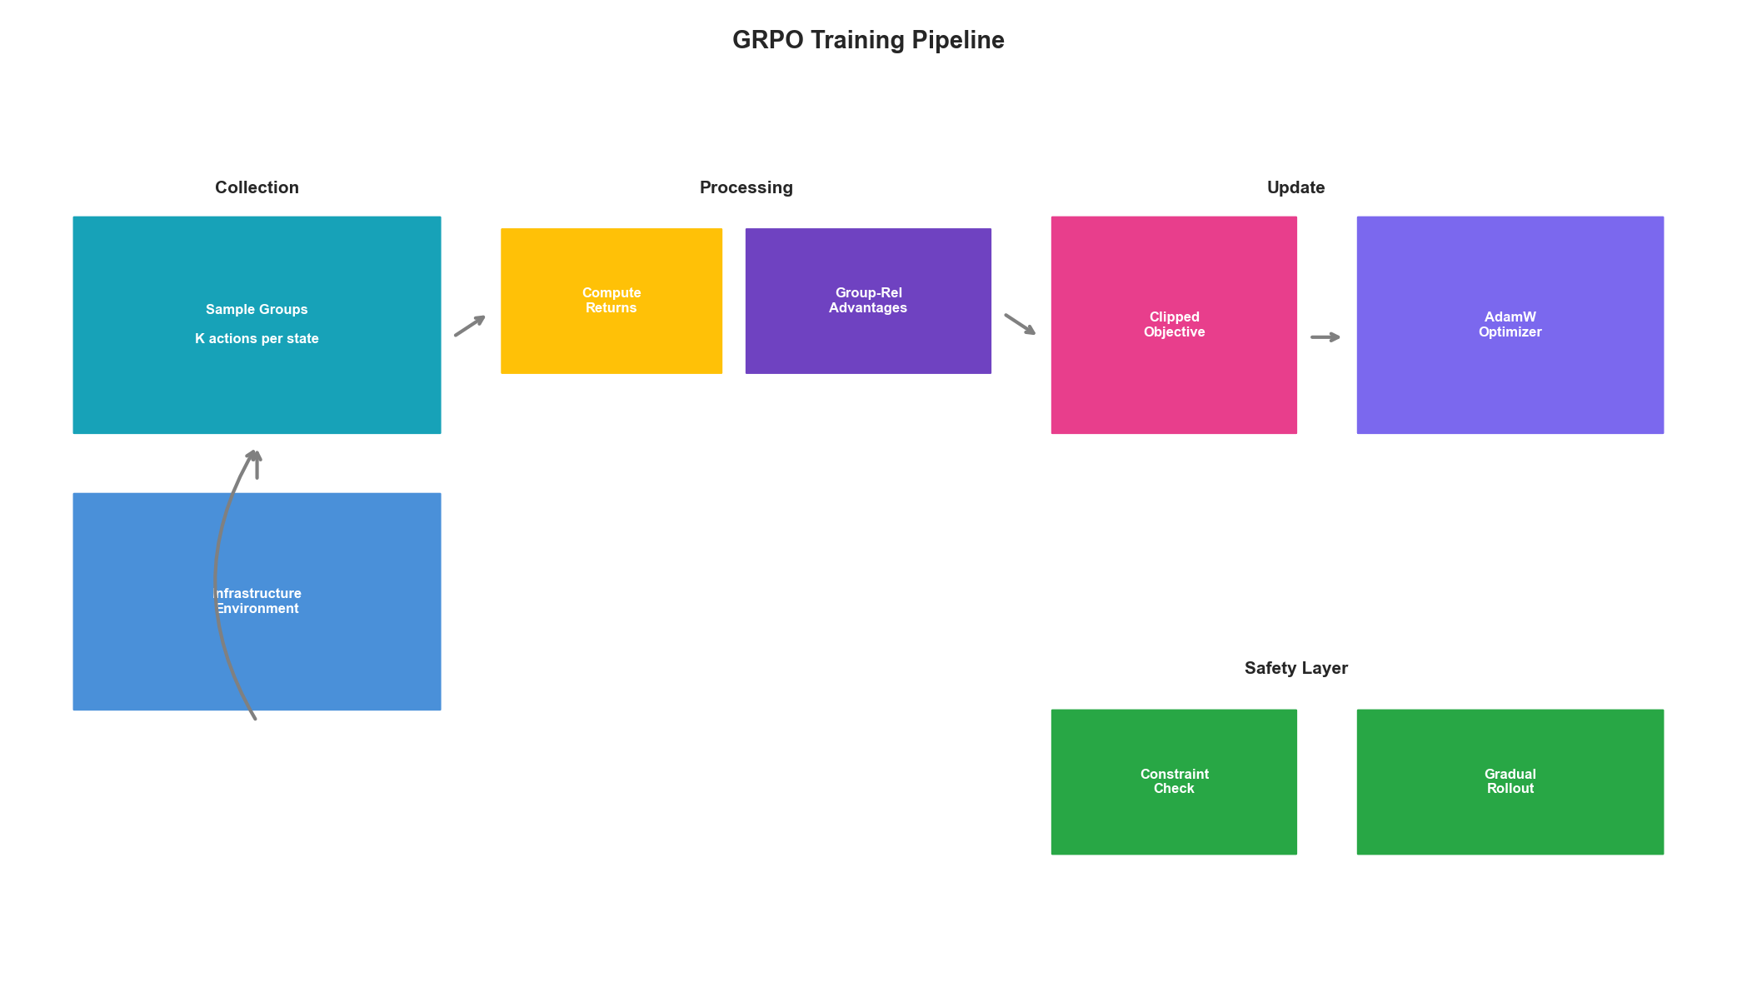
Training Pipeline

Production Deployment

Safe Deployment Strategy
from typing import Callable
from datetime import datetime, timedelta
class SafeGRPODeployment:
"""
Safe deployment wrapper for GRPO policies in production.
Implements:
- Shadow mode evaluation
- Gradual rollout
- Automatic rollback
- Action filtering
"""
def __init__(
self,
policy: GRPOPolicyNetwork,
action_space: InfrastructureActionSpace,
safety_constraints: Dict[str, Callable]
):
self.policy = policy
self.action_space = action_space
self.safety_constraints = safety_constraints
# Deployment state
self.deployment_mode = 'shadow' # shadow, gradual, full
self.rollout_percentage = 0.0
self.deployment_start = None
# Safety metrics
self.action_history = deque(maxlen=1000)
self.violation_count = 0
self.rollback_triggered = False
def set_deployment_mode(self, mode: str, rollout_pct: float = 0.0):
"""Set deployment mode and rollout percentage."""
if mode not in ['shadow', 'gradual', 'full']:
raise ValueError(f"Unknown mode: {mode}")
self.deployment_mode = mode
self.rollout_percentage = rollout_pct
self.deployment_start = datetime.now()
def get_action(
self,
state: Dict[str, Any],
fallback_action: Dict[str, Any]
) -> Tuple[Dict[str, Any], Dict[str, Any]]:
"""
Get action with safety checks and deployment controls.
Returns:
Tuple of (action_to_execute, policy_action_for_logging)
"""
# Get policy action
metrics_history = torch.FloatTensor(
state['metrics_history']
).unsqueeze(0)
current_metrics = torch.FloatTensor(
state['current_metrics']
).unsqueeze(0)
action_idx, log_prob = self.policy.get_action(
metrics_history, current_metrics
)
policy_action = self.action_space.decode_action(action_idx)
# Check safety constraints
is_safe, violations = self._check_safety(policy_action, state)
if not is_safe:
self.violation_count += 1
self._log_violation(policy_action, violations)
# Use safe fallback
policy_action = self._get_safe_alternative(
policy_action, state, fallback_action
)
# Determine what to execute based on mode
if self.deployment_mode == 'shadow':
# Log policy action but execute fallback
execute_action = fallback_action
elif self.deployment_mode == 'gradual':
# Probabilistic execution
if np.random.random() < self.rollout_percentage:
execute_action = policy_action
else:
execute_action = fallback_action
else: # full
execute_action = policy_action
# Record action
self.action_history.append({
'timestamp': datetime.now(),
'policy_action': policy_action,
'executed_action': execute_action,
'was_safe': is_safe,
'mode': self.deployment_mode
})
# Check for automatic rollback
self._check_rollback_conditions()
return execute_action, policy_action
def _check_safety(
self,
action: Dict[str, Any],
state: Dict[str, Any]
) -> Tuple[bool, List[str]]:
"""Check if action satisfies all safety constraints."""
violations = []
for name, constraint_fn in self.safety_constraints.items():
try:
if not constraint_fn(action, state):
violations.append(name)
except Exception as e:
violations.append(f"{name}: {str(e)}")
return len(violations) == 0, violations
def _get_safe_alternative(
self,
unsafe_action: Dict[str, Any],
state: Dict[str, Any],
fallback: Dict[str, Any]
) -> Dict[str, Any]:
"""Find a safe alternative action."""
# Try progressively less aggressive versions
scaling_order = [
ScalingAction.MAINTAIN,
ScalingAction.SCALE_UP_SMALL,
ScalingAction.SCALE_DOWN_SMALL
]
for scaling in scaling_order:
candidate = {
'scaling': scaling,
'config': ConfigAction.NO_CHANGE,
'traffic_weight': unsafe_action.get('traffic_weight')
}
is_safe, _ = self._check_safety(candidate, state)
if is_safe:
return candidate
return fallback
def _check_rollback_conditions(self):
"""Check if automatic rollback should trigger."""
if self.rollback_triggered:
return
# Check violation rate
recent_actions = list(self.action_history)[-100:]
if len(recent_actions) >= 100:
violation_rate = sum(
1 for a in recent_actions if not a['was_safe']
) / len(recent_actions)
if violation_rate > 0.1: # 10% violation threshold
self._trigger_rollback("High violation rate")
# Check time since deployment
if self.deployment_start:
deployment_duration = datetime.now() - self.deployment_start
# If in gradual mode for >1 hour without issues, increase rollout
if (self.deployment_mode == 'gradual' and
deployment_duration > timedelta(hours=1) and
self.violation_count == 0):
self._increase_rollout()
def _trigger_rollback(self, reason: str):
"""Trigger automatic rollback to shadow mode."""
self.rollback_triggered = True
self.deployment_mode = 'shadow'
self.rollout_percentage = 0.0
# Alert operations team
logging.critical(f"GRPO rollback triggered: {reason}")
def _increase_rollout(self):
"""Gradually increase rollout percentage."""
new_pct = min(self.rollout_percentage + 0.1, 1.0)
self.rollout_percentage = new_pct
self.deployment_start = datetime.now()
if new_pct >= 1.0:
self.deployment_mode = 'full'
logging.info(f"Increased rollout to {new_pct * 100:.0f}%")
# Example safety constraints
def max_scaling_constraint(action: Dict, state: Dict) -> bool:
"""Prevent scaling more than 50% at once."""
current_replicas = state.get('replica_count', 1)
scaling = action['scaling'].value
new_replicas = current_replicas + scaling
max_change = max(current_replicas * 0.5, 2)
return abs(scaling) <= max_change
def min_replicas_constraint(action: Dict, state: Dict) -> bool:
"""Ensure minimum replica count."""
current_replicas = state.get('replica_count', 1)
scaling = action['scaling'].value
new_replicas = current_replicas + scaling
return new_replicas >= 2
def rate_limit_constraint(action: Dict, state: Dict) -> bool:
"""Prevent rapid successive scaling."""
last_scale_time = state.get('last_scale_time')
if last_scale_time is None:
return True
min_interval = timedelta(minutes=5)
return datetime.now() - last_scale_time >= min_interval

Key Takeaways
- GRPO Advantage: Group-relative advantages eliminate value function estimation error
- State Representation: Proper encoding of infrastructure metrics is critical
- Multi-Objective Rewards: Balance cost, performance, reliability, and efficiency
- Safety First: Deploy with shadow mode, gradual rollout, and automatic rollback
- Group Structure: Maintain group boundaries during training for valid advantage estimates
GRPO provides a robust foundation for infrastructure optimization by leveraging empirical comparisons rather than learned baselines. Combined with proper safety constraints and gradual deployment strategies, it enables autonomous infrastructure management with minimal risk.

