Chapter 13: Small Language Models for Infrastructure

Introduction
While large language models (LLMs) like GPT-4 and Claude offer impressive capabilities, they present significant challenges for infrastructure optimization: high latency, substantial compute costs, and dependency on external APIs. Small Language Models (SLMs) offer a compelling alternative for many infrastructure tasks—models with 1-7 billion parameters that can run locally with millisecond-level latency.
This chapter explores how to leverage SLMs for infrastructure automation, from log analysis and anomaly detection to automated remediation and configuration generation.
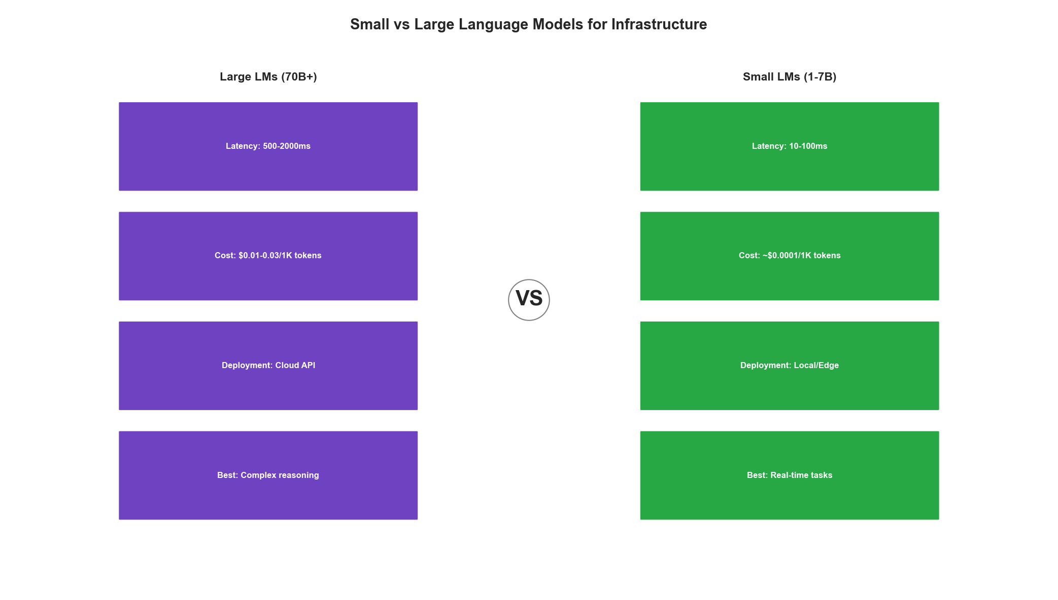
SLM vs LLM Trade-offs

Why Small Models for Infrastructure?

The Case for SLMs
Infrastructure operations have unique requirements that favor smaller, specialized models:
from dataclasses import dataclass
from typing import List, Dict
import time
@dataclass
class ModelComparison:
"""Compare LLM vs SLM characteristics for infrastructure."""
@staticmethod
def evaluate_trade_offs():
return {
'LLM (70B+)': {
'latency': '500-2000ms',
'cost_per_1k_tokens': '$0.01-0.03',
'deployment': 'API/Cloud',
'privacy': 'Data leaves network',
'availability': 'Dependent on provider',
'customization': 'Prompt engineering only',
'best_for': 'Complex reasoning, novel problems'
},
'SLM (1-7B)': {
'latency': '10-100ms',
'cost_per_1k_tokens': '$0.0001 (self-hosted)',
'deployment': 'Local/Edge',
'privacy': 'Data stays on-premise',
'availability': 'Self-controlled',
'customization': 'Fine-tuning possible',
'best_for': 'Repetitive tasks, real-time decisions'
}
}
class InfrastructureSLMUseCases:
"""
Infrastructure tasks well-suited for SLMs.
Key insight: Most infrastructure decisions are pattern matching
rather than novel reasoning, making them ideal for fine-tuned SLMs.
"""
IDEAL_USE_CASES = [
{
'task': 'Log Classification',
'description': 'Categorize log entries by severity and type',
'latency_requirement': '<50ms',
'reasoning_complexity': 'Low',
'data_sensitivity': 'High'
},
{
'task': 'Anomaly Explanation',
'description': 'Generate human-readable explanations for detected anomalies',
'latency_requirement': '<200ms',
'reasoning_complexity': 'Medium',
'data_sensitivity': 'High'
},
{
'task': 'Config Validation',
'description': 'Validate and suggest fixes for configuration files',
'latency_requirement': '<100ms',
'reasoning_complexity': 'Medium',
'data_sensitivity': 'High'
},
{
'task': 'Incident Triage',
'description': 'Prioritize and route incidents based on description',
'latency_requirement': '<100ms',
'reasoning_complexity': 'Medium',
'data_sensitivity': 'Medium'
},
{
'task': 'Runbook Selection',
'description': 'Match incidents to appropriate runbooks',
'latency_requirement': '<50ms',
'reasoning_complexity': 'Low',
'data_sensitivity': 'Low'
}
]

Model Selection for Infrastructure
from enum import Enum
from typing import Optional
class InfrastructureModel(Enum):
"""Recommended models for infrastructure tasks."""
# Ultra-fast, edge deployable
QWEN_0_5B = "Qwen/Qwen2.5-0.5B-Instruct"
PHI_1_5B = "microsoft/phi-1_5"
# Balanced performance
QWEN_1_5B = "Qwen/Qwen2.5-1.5B-Instruct"
GEMMA_2B = "google/gemma-2b-it"
PHI_2 = "microsoft/phi-2"
# Higher capability
QWEN_3B = "Qwen/Qwen2.5-3B-Instruct"
PHI_3_MINI = "microsoft/Phi-3-mini-4k-instruct"
LLAMA_3_2_3B = "meta-llama/Llama-3.2-3B-Instruct"
# Maximum capability (still edge-deployable)
QWEN_7B = "Qwen/Qwen2.5-7B-Instruct"
MISTRAL_7B = "mistralai/Mistral-7B-Instruct-v0.3"
LLAMA_3_1_8B = "meta-llama/Llama-3.1-8B-Instruct"
class ModelSelector:
"""Select appropriate model based on task requirements."""
def __init__(self):
self.model_specs = {
InfrastructureModel.QWEN_0_5B: {
'params': '0.5B',
'memory_gb': 1,
'tokens_per_sec': 200,
'context_length': 32768
},
InfrastructureModel.QWEN_1_5B: {
'params': '1.5B',
'memory_gb': 3,
'tokens_per_sec': 150,
'context_length': 32768
},
InfrastructureModel.QWEN_3B: {
'params': '3B',
'memory_gb': 6,
'tokens_per_sec': 100,
'context_length': 32768
},
InfrastructureModel.QWEN_7B: {
'params': '7B',
'memory_gb': 14,
'tokens_per_sec': 50,
'context_length': 32768
},
InfrastructureModel.MISTRAL_7B: {
'params': '7B',
'memory_gb': 14,
'tokens_per_sec': 45,
'context_length': 8192
}
}
def select_model(
self,
task_complexity: str, # 'low', 'medium', 'high'
max_latency_ms: int,
available_memory_gb: int,
context_needed: int = 4096
) -> Optional[InfrastructureModel]:
"""Select best model for given constraints."""
candidates = []
for model, specs in self.model_specs.items():
# Check memory constraint
if specs['memory_gb'] > available_memory_gb:
continue
# Check context constraint
if specs['context_length'] < context_needed:
continue
# Estimate latency (assuming 100 token response)
estimated_latency = (100 / specs['tokens_per_sec']) * 1000
if estimated_latency > max_latency_ms:
continue
candidates.append((model, specs))
if not candidates:
return None
# Sort by capability (larger = more capable)
candidates.sort(key=lambda x: float(x[1]['params'].replace('B', '')), reverse=True)
# For low complexity, prefer smaller models
if task_complexity == 'low':
candidates.sort(key=lambda x: float(x[1]['params'].replace('B', '')))
return candidates[0][0]
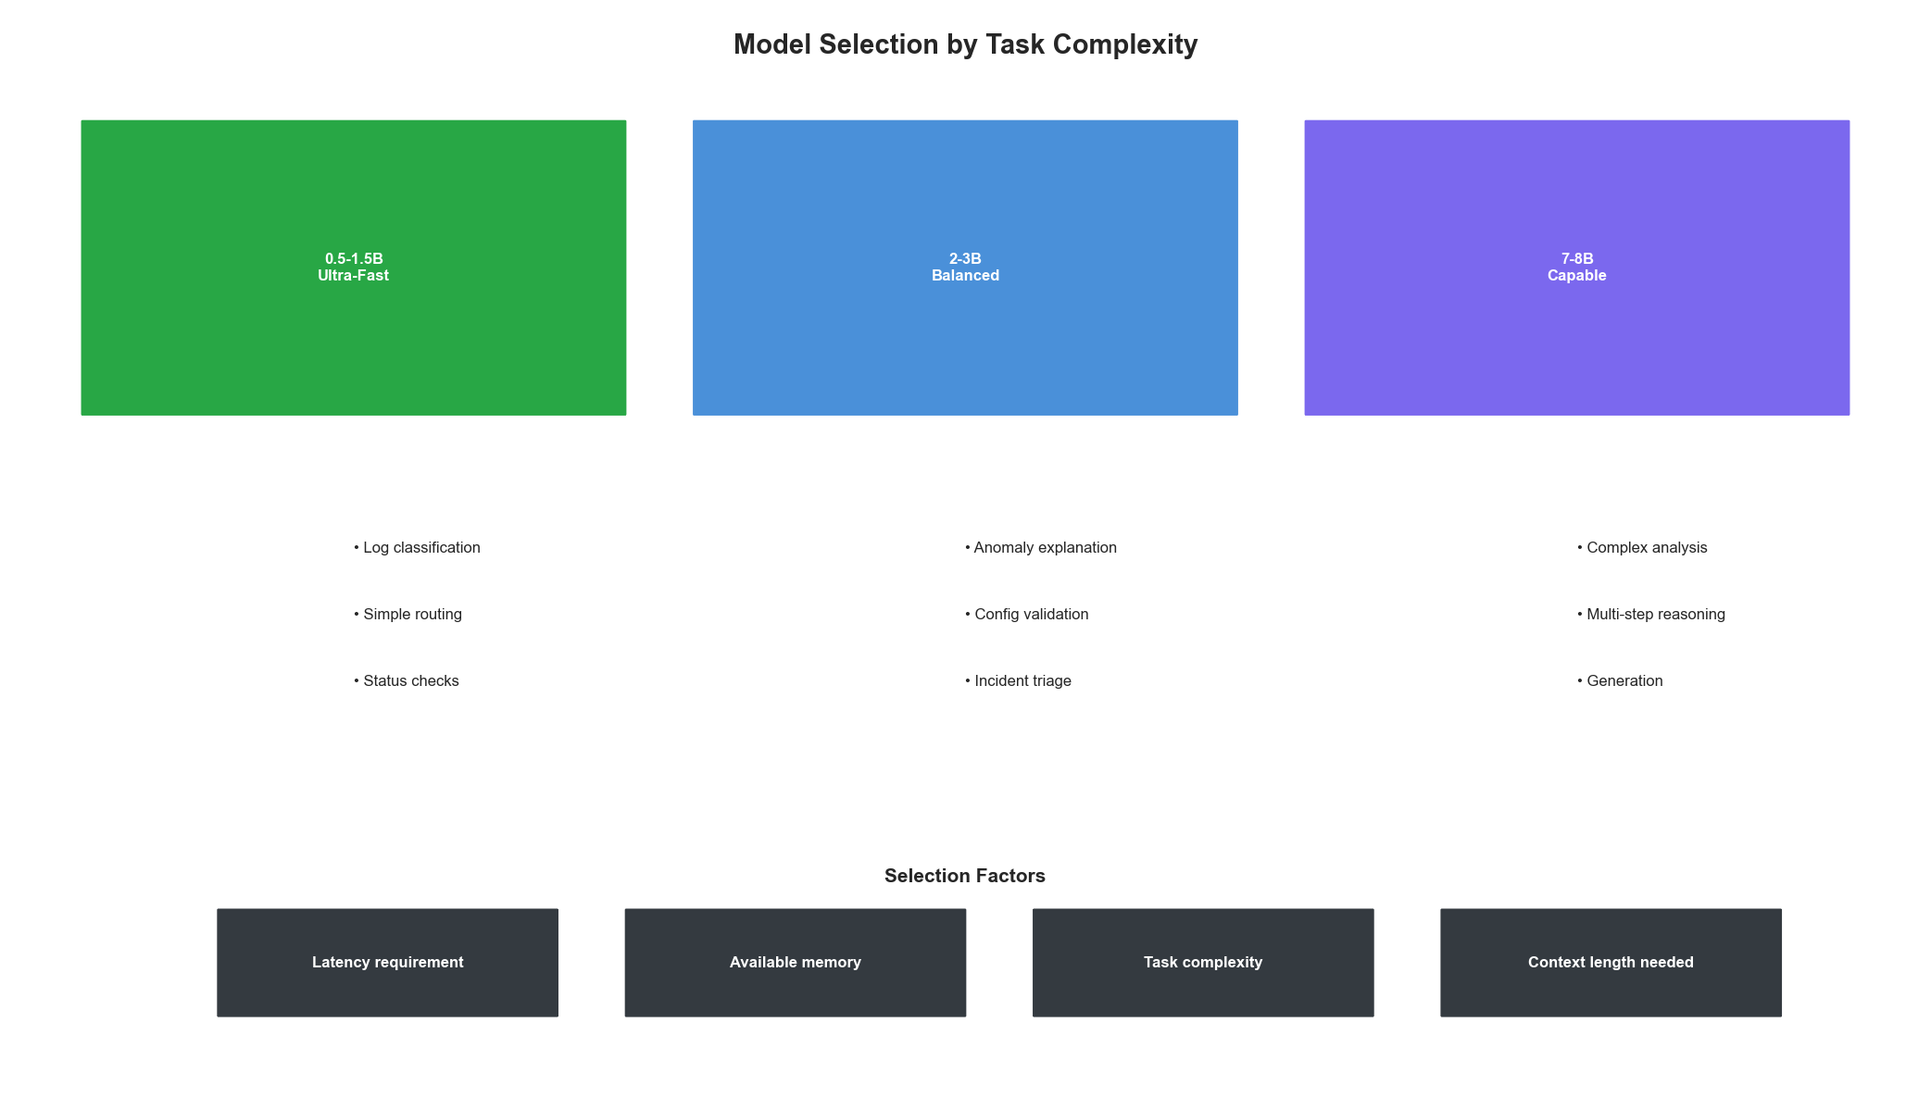
Model Selection Guide

Fine-Tuning SLMs for Infrastructure

Creating Training Data
High-quality training data is essential for infrastructure-focused SLMs:
import json
from typing import List, Dict, Tuple
from dataclasses import dataclass, asdict
@dataclass
class InfrastructureExample:
"""Training example for infrastructure SLM."""
instruction: str
input_context: str
output: str
task_type: str
metadata: Dict = None
class InfrastructureDatasetBuilder:
"""
Build training datasets from infrastructure data.
Sources:
- Historical incident tickets
- Log files with annotations
- Configuration files with comments
- Runbooks and documentation
"""
def __init__(self):
self.examples = []
def add_log_classification_examples(
self,
logs: List[Dict[str, str]]
) -> None:
"""
Create examples from classified logs.
Expected format:
{'log': '...', 'severity': 'ERROR', 'category': 'database'}
"""
for log_entry in logs:
example = InfrastructureExample(
instruction="Classify this log entry by severity and category.",
input_context=log_entry['log'],
output=json.dumps({
'severity': log_entry['severity'],
'category': log_entry['category']
}),
task_type='log_classification'
)
self.examples.append(example)
def add_anomaly_explanation_examples(
self,
anomalies: List[Dict]
) -> None:
"""
Create examples from annotated anomalies.
Expected format:
{
'metrics': {...},
'anomaly_type': 'cpu_spike',
'explanation': 'CPU spiked due to...',
'recommended_action': 'Scale up...'
}
"""
for anomaly in anomalies:
metrics_str = json.dumps(anomaly['metrics'], indent=2)
example = InfrastructureExample(
instruction="Explain this infrastructure anomaly and recommend action.",
input_context=f"Anomaly detected:\n{metrics_str}",
output=f"Explanation: {anomaly['explanation']}\n\nRecommended Action: {anomaly['recommended_action']}",
task_type='anomaly_explanation'
)
self.examples.append(example)
def add_config_validation_examples(
self,
configs: List[Dict]
) -> None:
"""
Create examples from configuration validations.
"""
for config in configs:
example = InfrastructureExample(
instruction="Validate this configuration and identify any issues.",
input_context=config['config_content'],
output=json.dumps({
'valid': config['is_valid'],
'issues': config.get('issues', []),
'suggestions': config.get('suggestions', [])
}),
task_type='config_validation'
)
self.examples.append(example)
def add_incident_triage_examples(
self,
incidents: List[Dict]
) -> None:
"""
Create examples from historical incidents.
"""
for incident in incidents:
example = InfrastructureExample(
instruction="Triage this incident: determine priority, category, and suggested team.",
input_context=f"Title: {incident['title']}\nDescription: {incident['description']}",
output=json.dumps({
'priority': incident['priority'],
'category': incident['category'],
'suggested_team': incident['assigned_team'],
'estimated_impact': incident.get('impact', 'unknown')
}),
task_type='incident_triage'
)
self.examples.append(example)
def export_for_training(
self,
output_path: str,
format: str = 'jsonl' # 'jsonl', 'alpaca', 'sharegpt'
) -> None:
"""Export dataset in common fine-tuning formats."""
if format == 'jsonl':
with open(output_path, 'w') as f:
for example in self.examples:
line = {
'instruction': example.instruction,
'input': example.input_context,
'output': example.output
}
f.write(json.dumps(line) + '\n')
elif format == 'alpaca':
data = []
for example in self.examples:
data.append({
'instruction': example.instruction,
'input': example.input_context,
'output': example.output
})
with open(output_path, 'w') as f:
json.dump(data, f, indent=2)
elif format == 'sharegpt':
data = []
for example in self.examples:
data.append({
'conversations': [
{'from': 'human', 'value': f"{example.instruction}\n\n{example.input_context}"},
{'from': 'gpt', 'value': example.output}
]
})
with open(output_path, 'w') as f:
json.dump(data, f, indent=2)
def get_statistics(self) -> Dict:
"""Get dataset statistics."""
task_counts = {}
for example in self.examples:
task_type = example.task_type
task_counts[task_type] = task_counts.get(task_type, 0) + 1
return {
'total_examples': len(self.examples),
'task_distribution': task_counts,
'avg_input_length': sum(len(e.input_context) for e in self.examples) / len(self.examples),
'avg_output_length': sum(len(e.output) for e in self.examples) / len(self.examples)
}

Fine-Tuning with LoRA
from transformers import AutoModelForCausalLM, AutoTokenizer, TrainingArguments
from peft import LoraConfig, get_peft_model, TaskType
from datasets import load_dataset
import torch
class InfrastructureSLMTrainer:
"""
Fine-tune SLMs for infrastructure tasks using LoRA.
LoRA (Low-Rank Adaptation) enables efficient fine-tuning
by training only a small number of additional parameters.
"""
def __init__(
self,
base_model: str = "Qwen/Qwen2.5-3B-Instruct",
lora_rank: int = 16,
lora_alpha: int = 32,
target_modules: List[str] = None
):
self.base_model = base_model
self.device = "cuda" if torch.cuda.is_available() else "cpu"
# Load tokenizer
self.tokenizer = AutoTokenizer.from_pretrained(base_model)
if self.tokenizer.pad_token is None:
self.tokenizer.pad_token = self.tokenizer.eos_token
# Load model
self.model = AutoModelForCausalLM.from_pretrained(
base_model,
torch_dtype=torch.bfloat16,
device_map="auto"
)
# Configure LoRA
self.lora_config = LoraConfig(
task_type=TaskType.CAUSAL_LM,
r=lora_rank,
lora_alpha=lora_alpha,
lora_dropout=0.1,
target_modules=target_modules or ["q_proj", "v_proj", "k_proj", "o_proj"],
bias="none"
)
# Apply LoRA
self.model = get_peft_model(self.model, self.lora_config)
self._print_trainable_params()
def _print_trainable_params(self):
"""Print number of trainable parameters."""
trainable = sum(p.numel() for p in self.model.parameters() if p.requires_grad)
total = sum(p.numel() for p in self.model.parameters())
print(f"Trainable: {trainable:,} / {total:,} ({100 * trainable / total:.2f}%)")
def prepare_dataset(
self,
data_path: str,
max_length: int = 2048
):
"""Prepare dataset for training."""
dataset = load_dataset('json', data_files=data_path, split='train')
def format_example(example):
prompt = f"""### Instruction:
{example['instruction']}
### Input:
{example['input']}
### Response:
{example['output']}"""
return {'text': prompt}
dataset = dataset.map(format_example)
def tokenize(example):
return self.tokenizer(
example['text'],
truncation=True,
max_length=max_length,
padding='max_length'
)
dataset = dataset.map(tokenize, remove_columns=['text'])
return dataset
def train(
self,
train_dataset,
output_dir: str = "./infrastructure_slm",
num_epochs: int = 3,
batch_size: int = 4,
learning_rate: float = 2e-4,
gradient_accumulation: int = 4
):
"""Train the model."""
training_args = TrainingArguments(
output_dir=output_dir,
num_train_epochs=num_epochs,
per_device_train_batch_size=batch_size,
gradient_accumulation_steps=gradient_accumulation,
learning_rate=learning_rate,
weight_decay=0.01,
warmup_ratio=0.1,
logging_steps=10,
save_steps=100,
save_total_limit=3,
bf16=True,
gradient_checkpointing=True,
optim="adamw_torch_fused",
report_to="tensorboard"
)
from trl import SFTTrainer
trainer = SFTTrainer(
model=self.model,
args=training_args,
train_dataset=train_dataset,
tokenizer=self.tokenizer,
dataset_text_field="text",
max_seq_length=2048,
packing=True
)
trainer.train()
trainer.save_model(output_dir)
def merge_and_export(
self,
output_dir: str,
quantize: bool = True
):
"""Merge LoRA weights and optionally quantize."""
# Merge LoRA weights
merged_model = self.model.merge_and_unload()
if quantize:
# Quantize to 4-bit for efficient deployment
from transformers import BitsAndBytesConfig
quantization_config = BitsAndBytesConfig(
load_in_4bit=True,
bnb_4bit_compute_dtype=torch.bfloat16,
bnb_4bit_use_double_quant=True,
bnb_4bit_quant_type="nf4"
)
# Save with quantization config
merged_model.save_pretrained(
output_dir,
quantization_config=quantization_config
)
else:
merged_model.save_pretrained(output_dir)
self.tokenizer.save_pretrained(output_dir)
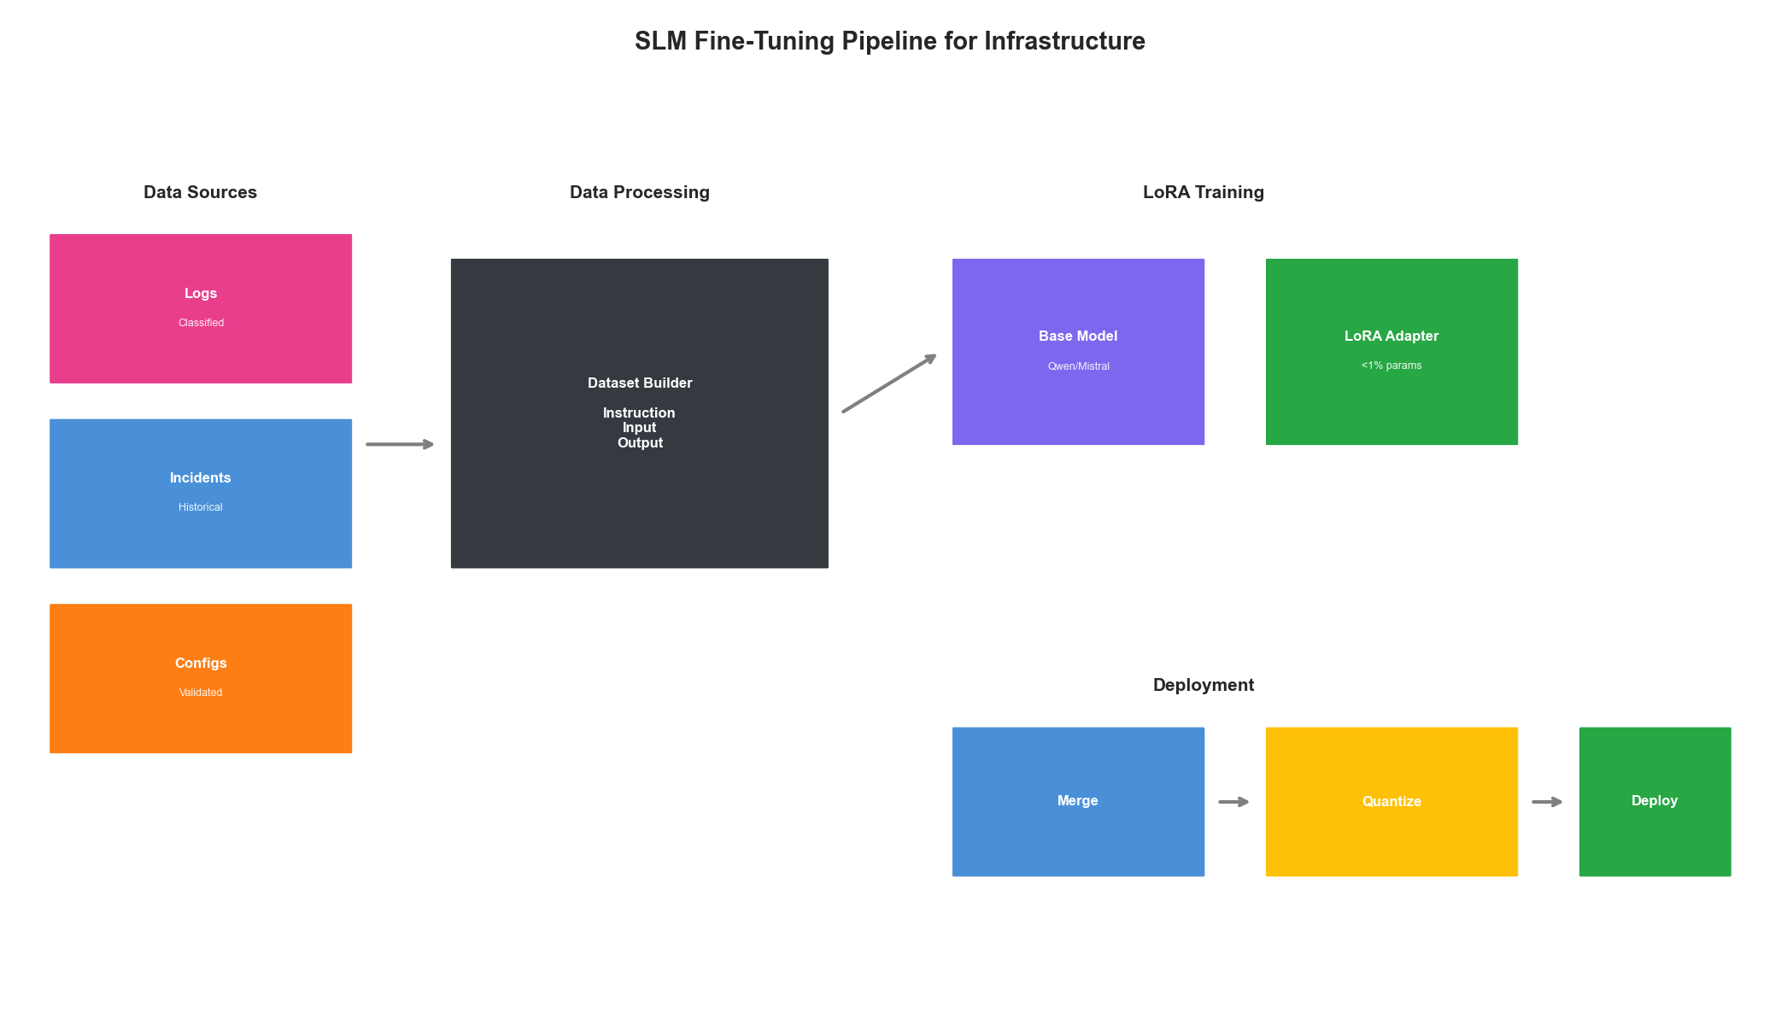
Fine-Tuning Pipeline

Deploying SLMs for Real-Time Infrastructure

High-Performance Inference Server
from fastapi import FastAPI, HTTPException
from pydantic import BaseModel
from typing import Optional, List
import asyncio
from concurrent.futures import ThreadPoolExecutor
import torch
class InferenceRequest(BaseModel):
task: str # 'log_classification', 'anomaly_explanation', etc.
input_text: str
max_tokens: int = 256
temperature: float = 0.1
class InferenceResponse(BaseModel):
output: str
latency_ms: float
tokens_generated: int
class InfrastructureSLMServer:
"""
High-performance inference server for infrastructure SLM.
Features:
- Batched inference for throughput
- Request prioritization
- Health monitoring
- Graceful degradation
"""
def __init__(
self,
model_path: str,
max_batch_size: int = 8,
max_concurrent: int = 4
):
self.model_path = model_path
self.max_batch_size = max_batch_size
self.executor = ThreadPoolExecutor(max_workers=max_concurrent)
# Load model
self._load_model()
# Request queue for batching
self.request_queue = asyncio.Queue()
self.batch_timeout = 0.01 # 10ms max wait for batching
# Metrics
self.total_requests = 0
self.total_latency = 0
def _load_model(self):
"""Load model with optimizations."""
from transformers import AutoModelForCausalLM, AutoTokenizer
self.tokenizer = AutoTokenizer.from_pretrained(self.model_path)
self.model = AutoModelForCausalLM.from_pretrained(
self.model_path,
torch_dtype=torch.float16,
device_map="auto",
attn_implementation="flash_attention_2" # Use Flash Attention
)
self.model.eval()
# Compile for faster inference (PyTorch 2.0+)
if hasattr(torch, 'compile'):
self.model = torch.compile(self.model, mode="reduce-overhead")
def _get_task_prompt(self, task: str, input_text: str) -> str:
"""Get task-specific prompt template."""
prompts = {
'log_classification': f"""Classify this log entry by severity (DEBUG/INFO/WARNING/ERROR/CRITICAL) and category.
Log: {input_text}
Output as JSON: {{"severity": "...", "category": "..."}}""",
'anomaly_explanation': f"""Explain this infrastructure anomaly and recommend action.
{input_text}
Provide brief explanation and recommended action.""",
'config_validation': f"""Validate this configuration and identify issues.
{input_text}
Output as JSON: {{"valid": true/false, "issues": [...], "suggestions": [...]}}""",
'incident_triage': f"""Triage this incident: determine priority, category, and team.
{input_text}
Output as JSON: {{"priority": "P1/P2/P3/P4", "category": "...", "team": "..."}}"""
}
return prompts.get(task, f"{task}:\n{input_text}")
@torch.inference_mode()
def _generate(
self,
prompts: List[str],
max_tokens: int,
temperature: float
) -> List[str]:
"""Generate responses for a batch of prompts."""
inputs = self.tokenizer(
prompts,
return_tensors="pt",
padding=True,
truncation=True,
max_length=2048
).to(self.model.device)
outputs = self.model.generate(
**inputs,
max_new_tokens=max_tokens,
temperature=temperature if temperature > 0 else None,
do_sample=temperature > 0,
pad_token_id=self.tokenizer.pad_token_id,
eos_token_id=self.tokenizer.eos_token_id
)
# Decode only new tokens
responses = []
for i, output in enumerate(outputs):
input_length = inputs['input_ids'][i].shape[0]
new_tokens = output[input_length:]
response = self.tokenizer.decode(new_tokens, skip_special_tokens=True)
responses.append(response)
return responses
async def infer(self, request: InferenceRequest) -> InferenceResponse:
"""Process single inference request."""
import time
start = time.perf_counter()
prompt = self._get_task_prompt(request.task, request.input_text)
# Run inference in thread pool
loop = asyncio.get_event_loop()
responses = await loop.run_in_executor(
self.executor,
self._generate,
[prompt],
request.max_tokens,
request.temperature
)
latency_ms = (time.perf_counter() - start) * 1000
# Update metrics
self.total_requests += 1
self.total_latency += latency_ms
return InferenceResponse(
output=responses[0],
latency_ms=latency_ms,
tokens_generated=len(self.tokenizer.encode(responses[0]))
)
def get_metrics(self) -> Dict:
"""Get server metrics."""
return {
'total_requests': self.total_requests,
'avg_latency_ms': self.total_latency / max(self.total_requests, 1),
'model': self.model_path
}
# FastAPI application
app = FastAPI(title="Infrastructure SLM API")
server: Optional[InfrastructureSLMServer] = None
@app.on_event("startup")
async def startup():
global server
server = InfrastructureSLMServer(
model_path="./infrastructure_slm",
max_batch_size=8,
max_concurrent=4
)
@app.post("/infer", response_model=InferenceResponse)
async def infer(request: InferenceRequest):
if server is None:
raise HTTPException(status_code=503, detail="Model not loaded")
return await server.infer(request)
@app.get("/health")
async def health():
return {"status": "healthy", "metrics": server.get_metrics() if server else {}}

Edge Deployment with ONNX
from optimum.onnxruntime import ORTModelForCausalLM
from transformers import AutoTokenizer
import numpy as np
class EdgeInfrastructureSLM:
"""
Deploy SLM on edge devices using ONNX Runtime.
Enables running on:
- Kubernetes nodes
- Network devices
- IoT gateways
"""
def __init__(
self,
model_path: str,
onnx_path: str = None
):
self.tokenizer = AutoTokenizer.from_pretrained(model_path)
if onnx_path:
# Load pre-converted ONNX model
self.model = ORTModelForCausalLM.from_pretrained(onnx_path)
else:
# Convert on the fly
self.model = ORTModelForCausalLM.from_pretrained(
model_path,
export=True
)
@classmethod
def convert_to_onnx(
cls,
model_path: str,
output_path: str,
optimize: bool = True
):
"""Convert PyTorch model to optimized ONNX."""
from optimum.onnxruntime import ORTOptimizer
from optimum.onnxruntime.configuration import OptimizationConfig
# Export to ONNX
model = ORTModelForCausalLM.from_pretrained(model_path, export=True)
model.save_pretrained(output_path)
if optimize:
# Optimize the ONNX model
optimizer = ORTOptimizer.from_pretrained(output_path)
optimization_config = OptimizationConfig(
optimization_level=99, # Full optimization
enable_transformers_specific_optimizations=True,
fp16=True
)
optimizer.optimize(
save_dir=output_path,
optimization_config=optimization_config
)
def generate(
self,
prompt: str,
max_tokens: int = 128
) -> str:
"""Generate response."""
inputs = self.tokenizer(prompt, return_tensors="pt")
outputs = self.model.generate(
**inputs,
max_new_tokens=max_tokens,
do_sample=False
)
response = self.tokenizer.decode(
outputs[0][inputs['input_ids'].shape[1]:],
skip_special_tokens=True
)
return response
class EdgeDeploymentManager:
"""
Manage SLM deployment across edge locations.
"""
def __init__(self):
self.deployments = {}
def deploy_to_node(
self,
node_id: str,
model_path: str,
resources: Dict
) -> Dict:
"""Deploy SLM to a specific node."""
deployment_spec = {
'node_id': node_id,
'model_path': model_path,
'resources': resources,
'status': 'deploying'
}
# Kubernetes deployment manifest
k8s_manifest = {
'apiVersion': 'apps/v1',
'kind': 'Deployment',
'metadata': {
'name': f'slm-{node_id}',
'labels': {'app': 'infrastructure-slm'}
},
'spec': {
'replicas': 1,
'selector': {
'matchLabels': {'app': f'slm-{node_id}'}
},
'template': {
'metadata': {'labels': {'app': f'slm-{node_id}'}},
'spec': {
'nodeSelector': {'kubernetes.io/hostname': node_id},
'containers': [{
'name': 'slm',
'image': 'infrastructure-slm:latest',
'resources': {
'limits': {
'memory': f"{resources['memory_gb']}Gi",
'nvidia.com/gpu': resources.get('gpu', 0)
}
},
'volumeMounts': [{
'name': 'model-storage',
'mountPath': '/models'
}],
'env': [{
'name': 'MODEL_PATH',
'value': '/models/infrastructure_slm'
}]
}],
'volumes': [{
'name': 'model-storage',
'persistentVolumeClaim': {
'claimName': f'slm-models-{node_id}'
}
}]
}
}
}
}
self.deployments[node_id] = deployment_spec
return {'manifest': k8s_manifest, 'deployment': deployment_spec}

Specialized Infrastructure Models

Log Analysis Model
class LogAnalysisSLM:
"""
Specialized SLM for log analysis tasks.
Capabilities:
- Log classification
- Error extraction
- Pattern recognition
- Anomaly flagging
"""
def __init__(self, model_path: str):
self.tokenizer = AutoTokenizer.from_pretrained(model_path)
self.model = AutoModelForCausalLM.from_pretrained(
model_path,
torch_dtype=torch.float16,
device_map="auto"
)
def classify_log(self, log_entry: str) -> Dict:
"""Classify a log entry."""
prompt = f"""Analyze this log entry:
{log_entry}
Respond with JSON:
{{"severity": "DEBUG|INFO|WARNING|ERROR|CRITICAL", "category": "...", "actionable": true/false}}"""
response = self._generate(prompt, max_tokens=100)
return self._parse_json(response)
def extract_errors(self, logs: List[str]) -> List[Dict]:
"""Extract and summarize errors from logs."""
log_block = "\n".join(logs[-50:]) # Last 50 lines
prompt = f"""Extract all errors from these logs:
{log_block}
List each error with: timestamp, error_type, message, and likely cause."""
response = self._generate(prompt, max_tokens=500)
return self._parse_error_list(response)
def detect_patterns(self, logs: List[str]) -> Dict:
"""Detect patterns in log stream."""
log_sample = "\n".join(logs[-100:])
prompt = f"""Analyze these logs for patterns:
{log_sample}
Identify: recurring errors, performance issues, security concerns, unusual activity."""
response = self._generate(prompt, max_tokens=400)
return {'analysis': response}
def _generate(self, prompt: str, max_tokens: int) -> str:
inputs = self.tokenizer(prompt, return_tensors="pt").to(self.model.device)
with torch.inference_mode():
outputs = self.model.generate(
**inputs,
max_new_tokens=max_tokens,
temperature=0.1,
do_sample=True
)
return self.tokenizer.decode(
outputs[0][inputs['input_ids'].shape[1]:],
skip_special_tokens=True
)
def _parse_json(self, text: str) -> Dict:
"""Parse JSON from model output."""
import re
match = re.search(r'\{[^}]+\}', text)
if match:
try:
return json.loads(match.group())
except json.JSONDecodeError:
pass
return {'raw': text}
def _parse_error_list(self, text: str) -> List[Dict]:
"""Parse error list from model output."""
errors = []
for line in text.split('\n'):
if line.strip():
errors.append({'description': line.strip()})
return errors

Configuration Advisor Model
class ConfigAdvisorSLM:
"""
SLM specialized for configuration validation and optimization.
Supports:
- Kubernetes manifests
- Docker Compose files
- Terraform configurations
- Prometheus rules
"""
CONFIG_TYPES = {
'kubernetes': 'yaml',
'docker-compose': 'yaml',
'terraform': 'hcl',
'prometheus': 'yaml',
'nginx': 'conf'
}
def __init__(self, model_path: str):
self.tokenizer = AutoTokenizer.from_pretrained(model_path)
self.model = AutoModelForCausalLM.from_pretrained(
model_path,
torch_dtype=torch.float16,
device_map="auto"
)
def validate_config(
self,
config: str,
config_type: str
) -> Dict:
"""Validate configuration and identify issues."""
prompt = f"""Validate this {config_type} configuration:
```{self.CONFIG_TYPES.get(config_type, 'text')}
{config}
Check for: 1. Syntax errors 2. Security issues 3. Best practice violations 4. Performance concerns
Output JSON: {{“valid”: bool, “issues”: […], “severity”: “low|medium|high”}}““”
response = self._generate(prompt, max_tokens=500)
return self._parse_validation(response)
def suggest_improvements(
self,
config: str,
config_type: str,
context: str = ""
) -> Dict:
"""Suggest configuration improvements."""
prompt = f"""Suggest improvements for this {config_type} configuration:
{config}
Context: {context if context else ‘Production deployment’}
Provide specific, actionable improvements with examples.”“”
response = self._generate(prompt, max_tokens=600)
return {'suggestions': response}
def generate_config(
self,
requirements: str,
config_type: str
) -> str:
"""Generate configuration from requirements."""
prompt = f"""Generate a {config_type} configuration for:
{requirements}
Provide a complete, production-ready configuration with comments.”“”
return self._generate(prompt, max_tokens=1000)
def _generate(self, prompt: str, max_tokens: int) -> str:
inputs = self.tokenizer(prompt, return_tensors="pt").to(self.model.device)
with torch.inference_mode():
outputs = self.model.generate(
**inputs,
max_new_tokens=max_tokens,
temperature=0.2,
do_sample=True
)
return self.tokenizer.decode(
outputs[0][inputs['input_ids'].shape[1]:],
skip_special_tokens=True
)
def _parse_validation(self, text: str) -> Dict:
"""Parse validation results."""
import re
match = re.search(r'\{[^}]+\}', text, re.DOTALL)
if match:
try:
return json.loads(match.group())
except:
pass
return {'valid': False, 'issues': [text], 'severity': 'unknown'}
```
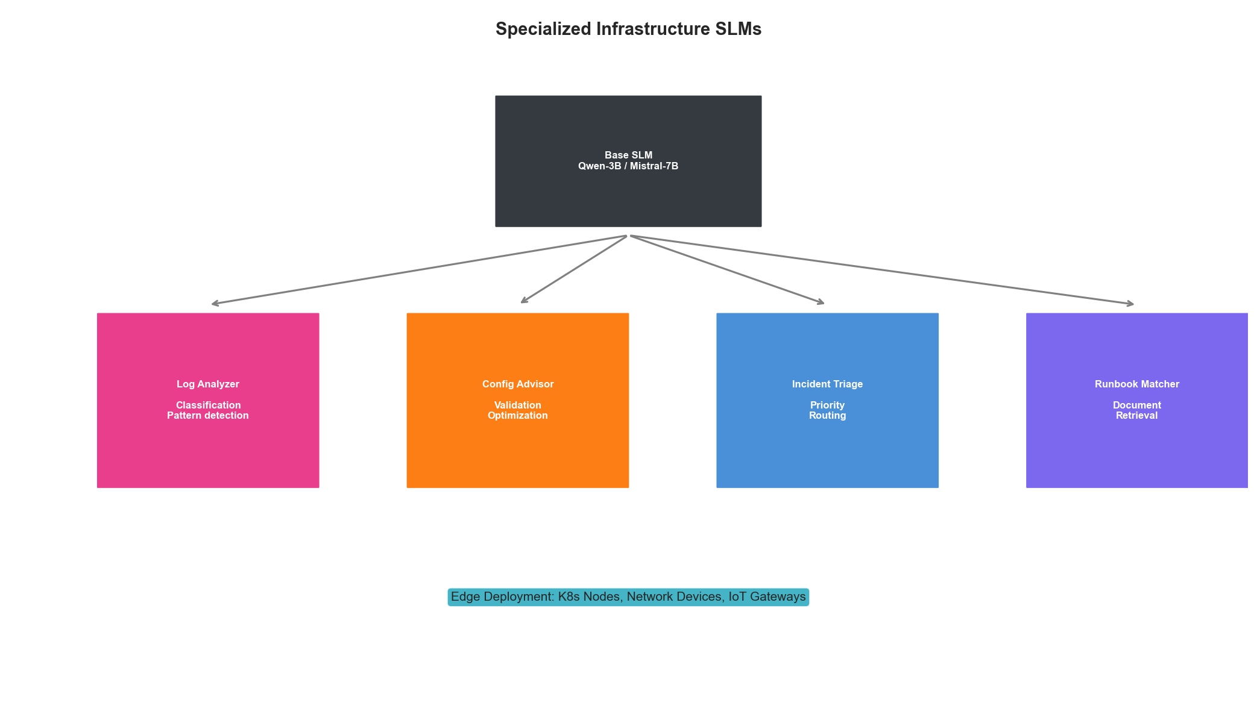
Specialized SLM Architecture

Key Takeaways
- Right-Size Your Models: Use 0.5B-3B models for simple tasks, 7B for complex reasoning
- Fine-Tune for Your Domain: Generic models underperform on infrastructure-specific tasks
- Optimize for Latency: Use ONNX, quantization, and Flash Attention for production
- Deploy at the Edge: Run SLMs on Kubernetes nodes for truly local inference
- Specialize by Task: Different infrastructure tasks benefit from specialized model variants
Small Language Models offer a practical path to AI-powered infrastructure automation without the complexity, cost, and latency of large cloud-based models. By fine-tuning for your specific infrastructure patterns and deploying close to the data source, you can achieve real-time intelligent automation that was previously impossible.

