Chapter 15: Multi-Cloud Cost Optimization

Introduction
Multi-cloud strategies have become the norm for enterprises seeking resilience, avoiding vendor lock-in, and leveraging best-of-breed services. However, this approach introduces significant cost management complexity. Each cloud provider has different pricing models, discount mechanisms, and optimization opportunities.
This chapter presents AI-driven approaches to multi-cloud cost optimization—from unified cost visibility to intelligent workload placement and automated savings programs.
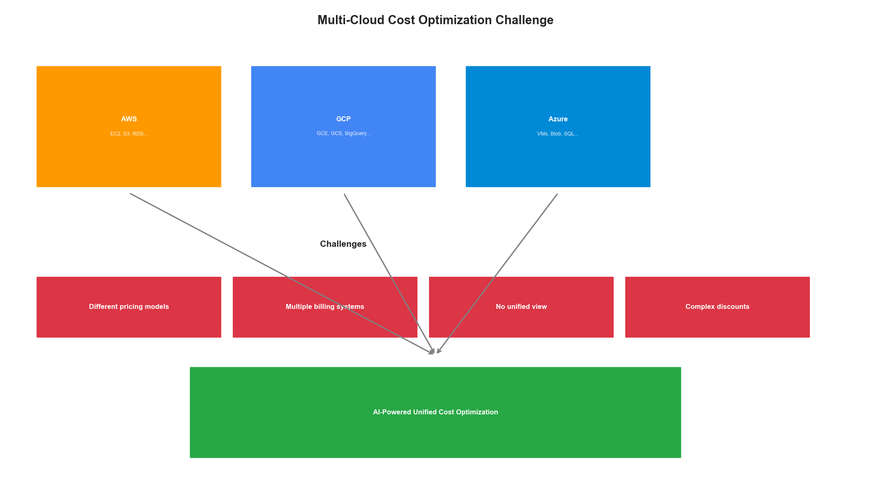
Multi-Cloud Cost Challenge

Unified Cost Visibility

Multi-Cloud Cost Aggregation
The first step in optimization is unified visibility across all cloud providers:
from dataclasses import dataclass
from typing import Dict, List, Optional
from datetime import datetime, timedelta
from abc import ABC, abstractmethod
import pandas as pd
@dataclass
class CloudCost:
"""Normalized cloud cost record."""
provider: str # aws, gcp, azure
service: str
resource_id: str
cost: float
currency: str
usage_quantity: float
usage_unit: str
timestamp: datetime
tags: Dict[str, str]
region: str
account_id: str
class CloudCostConnector(ABC):
"""Abstract base for cloud cost connectors."""
@abstractmethod
def fetch_costs(
self,
start_date: datetime,
end_date: datetime
) -> List[CloudCost]:
pass
@abstractmethod
def get_recommendations(self) -> List[Dict]:
pass
class AWSCostConnector(CloudCostConnector):
"""AWS Cost Explorer connector."""
def __init__(self, session):
self.ce_client = session.client('ce')
self.org_client = session.client('organizations')
def fetch_costs(
self,
start_date: datetime,
end_date: datetime
) -> List[CloudCost]:
costs = []
response = self.ce_client.get_cost_and_usage(
TimePeriod={
'Start': start_date.strftime('%Y-%m-%d'),
'End': end_date.strftime('%Y-%m-%d')
},
Granularity='DAILY',
Metrics=['UnblendedCost', 'UsageQuantity'],
GroupBy=[
{'Type': 'DIMENSION', 'Key': 'SERVICE'},
{'Type': 'DIMENSION', 'Key': 'REGION'},
{'Type': 'TAG', 'Key': 'Environment'}
]
)
for result in response['ResultsByTime']:
date = datetime.strptime(result['TimePeriod']['Start'], '%Y-%m-%d')
for group in result['Groups']:
service = group['Keys'][0]
region = group['Keys'][1] if len(group['Keys']) > 1 else 'global'
costs.append(CloudCost(
provider='aws',
service=service,
resource_id='aggregated',
cost=float(group['Metrics']['UnblendedCost']['Amount']),
currency='USD',
usage_quantity=float(group['Metrics']['UsageQuantity']['Amount']),
usage_unit=group['Metrics']['UsageQuantity']['Unit'],
timestamp=date,
tags={'Environment': group['Keys'][2] if len(group['Keys']) > 2 else 'unknown'},
region=region,
account_id='consolidated'
))
return costs
def get_recommendations(self) -> List[Dict]:
"""Get AWS Cost Explorer recommendations."""
recommendations = []
# Rightsizing recommendations
try:
response = self.ce_client.get_rightsizing_recommendation(
Service='AmazonEC2'
)
for rec in response.get('RightsizingRecommendations', []):
recommendations.append({
'provider': 'aws',
'type': 'rightsizing',
'resource_id': rec['CurrentInstance']['ResourceId'],
'current': rec['CurrentInstance']['InstanceType'],
'recommended': rec['ModifyRecommendationDetail']['TargetInstances'][0]['InstanceType'],
'estimated_savings': float(rec['ModifyRecommendationDetail']['TargetInstances'][0]['EstimatedMonthlySavings']['Value'])
})
except Exception as e:
print(f"Error fetching rightsizing recommendations: {e}")
return recommendations
class GCPCostConnector(CloudCostConnector):
"""Google Cloud Billing connector."""
def __init__(self, project_id: str, credentials):
from google.cloud import bigquery
self.project_id = project_id
self.client = bigquery.Client(project=project_id, credentials=credentials)
self.billing_export_table = f"{project_id}.billing_export.gcp_billing_export_v1"
def fetch_costs(
self,
start_date: datetime,
end_date: datetime
) -> List[CloudCost]:
query = f"""
SELECT
service.description as service,
sku.description as sku,
location.region as region,
project.id as project_id,
SUM(cost) as cost,
SUM(usage.amount) as usage_amount,
usage.unit as usage_unit,
DATE(usage_start_time) as date
FROM `{self.billing_export_table}`
WHERE usage_start_time >= @start_date
AND usage_start_time < @end_date
GROUP BY service, sku, region, project_id, usage_unit, date
"""
job_config = self.client.QueryJobConfig(
query_parameters=[
self.client.ScalarQueryParameter("start_date", "TIMESTAMP", start_date),
self.client.ScalarQueryParameter("end_date", "TIMESTAMP", end_date)
]
)
results = self.client.query(query, job_config=job_config)
costs = []
for row in results:
costs.append(CloudCost(
provider='gcp',
service=row.service,
resource_id=row.sku,
cost=float(row.cost),
currency='USD',
usage_quantity=float(row.usage_amount) if row.usage_amount else 0,
usage_unit=row.usage_unit or 'units',
timestamp=datetime.combine(row.date, datetime.min.time()),
tags={},
region=row.region or 'global',
account_id=row.project_id
))
return costs
def get_recommendations(self) -> List[Dict]:
"""Get GCP recommender recommendations."""
from google.cloud import recommender_v1
client = recommender_v1.RecommenderClient()
recommendations = []
# Fetch VM rightsizing recommendations
parent = f"projects/{self.project_id}/locations/-/recommenders/google.compute.instance.MachineTypeRecommender"
try:
for rec in client.list_recommendations(parent=parent):
recommendations.append({
'provider': 'gcp',
'type': 'rightsizing',
'resource_id': rec.name,
'description': rec.description,
'estimated_savings': rec.primary_impact.cost_projection.cost.units
})
except Exception as e:
print(f"Error fetching GCP recommendations: {e}")
return recommendations
class AzureCostConnector(CloudCostConnector):
"""Azure Cost Management connector."""
def __init__(self, subscription_id: str, credentials):
from azure.mgmt.costmanagement import CostManagementClient
self.subscription_id = subscription_id
self.client = CostManagementClient(credentials, subscription_id)
def fetch_costs(
self,
start_date: datetime,
end_date: datetime
) -> List[CloudCost]:
from azure.mgmt.costmanagement.models import QueryDefinition, QueryTimePeriod
scope = f"/subscriptions/{self.subscription_id}"
query = QueryDefinition(
type="ActualCost",
timeframe="Custom",
time_period=QueryTimePeriod(
from_property=start_date,
to=end_date
),
dataset={
"granularity": "Daily",
"aggregation": {
"totalCost": {"name": "Cost", "function": "Sum"}
},
"grouping": [
{"type": "Dimension", "name": "ServiceName"},
{"type": "Dimension", "name": "ResourceLocation"}
]
}
)
result = self.client.query.usage(scope, query)
costs = []
for row in result.rows:
costs.append(CloudCost(
provider='azure',
service=row[2], # ServiceName
resource_id='aggregated',
cost=float(row[0]), # Cost
currency='USD',
usage_quantity=0,
usage_unit='units',
timestamp=datetime.strptime(row[1], '%Y%m%d'), # Date
tags={},
region=row[3], # ResourceLocation
account_id=self.subscription_id
))
return costs
def get_recommendations(self) -> List[Dict]:
"""Get Azure Advisor recommendations."""
from azure.mgmt.advisor import AdvisorManagementClient
advisor = AdvisorManagementClient(self.client._config.credential, self.subscription_id)
recommendations = []
for rec in advisor.recommendations.list(filter="Category eq 'Cost'"):
recommendations.append({
'provider': 'azure',
'type': rec.category,
'resource_id': rec.resource_metadata.resource_id if rec.resource_metadata else 'unknown',
'description': rec.short_description.solution,
'estimated_savings': rec.extended_properties.get('annualSavingsAmount', 0) if rec.extended_properties else 0
})
return recommendations
class MultiCloudCostAggregator:
"""Aggregate and normalize costs across clouds."""
def __init__(self):
self.connectors: Dict[str, CloudCostConnector] = {}
self.cost_data: pd.DataFrame = None
def add_connector(self, name: str, connector: CloudCostConnector):
self.connectors[name] = connector
def fetch_all_costs(
self,
start_date: datetime,
end_date: datetime
) -> pd.DataFrame:
"""Fetch costs from all connected clouds."""
all_costs = []
for name, connector in self.connectors.items():
try:
costs = connector.fetch_costs(start_date, end_date)
all_costs.extend(costs)
except Exception as e:
print(f"Error fetching from {name}: {e}")
# Convert to DataFrame
self.cost_data = pd.DataFrame([vars(c) for c in all_costs])
return self.cost_data
def get_cost_summary(self) -> Dict:
"""Get summary statistics across clouds."""
if self.cost_data is None or self.cost_data.empty:
return {}
return {
'total_cost': self.cost_data['cost'].sum(),
'by_provider': self.cost_data.groupby('provider')['cost'].sum().to_dict(),
'by_service': self.cost_data.groupby('service')['cost'].sum().nlargest(10).to_dict(),
'daily_trend': self.cost_data.groupby(self.cost_data['timestamp'].dt.date)['cost'].sum().to_dict()
}
def get_all_recommendations(self) -> List[Dict]:
"""Aggregate recommendations from all clouds."""
all_recommendations = []
for name, connector in self.connectors.items():
try:
recs = connector.get_recommendations()
all_recommendations.extend(recs)
except Exception as e:
print(f"Error fetching recommendations from {name}: {e}")
# Sort by estimated savings
all_recommendations.sort(
key=lambda x: x.get('estimated_savings', 0),
reverse=True
)
return all_recommendations
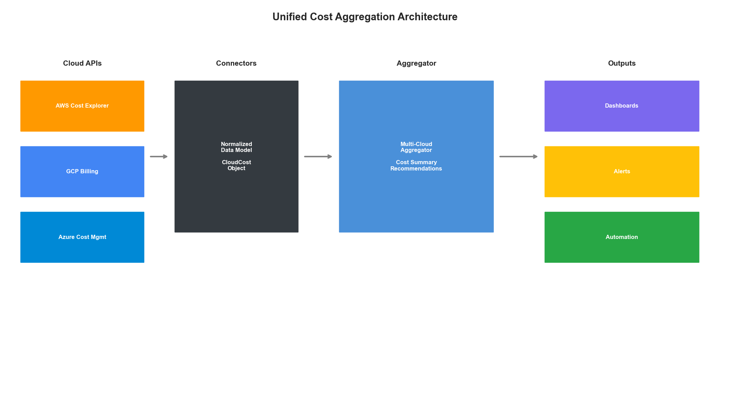
Cost Aggregation Architecture

AI-Powered Cost Forecasting

Time Series Forecasting for Cloud Costs
import numpy as np
from sklearn.preprocessing import StandardScaler
import torch
import torch.nn as nn
class CloudCostForecaster:
"""
AI-powered cost forecasting using temporal patterns.
Predicts:
- Daily/weekly/monthly costs
- Anomalous spending
- Budget breach probability
"""
def __init__(
self,
forecast_horizon: int = 30,
history_days: int = 90
):
self.forecast_horizon = forecast_horizon
self.history_days = history_days
self.scaler = StandardScaler()
self.model = None
def prepare_features(
self,
cost_data: pd.DataFrame
) -> np.ndarray:
"""Extract temporal features from cost data."""
# Aggregate to daily
daily = cost_data.groupby(
cost_data['timestamp'].dt.date
)['cost'].sum().reset_index()
daily.columns = ['date', 'cost']
daily['date'] = pd.to_datetime(daily['date'])
# Add temporal features
daily['day_of_week'] = daily['date'].dt.dayofweek
daily['day_of_month'] = daily['date'].dt.day
daily['month'] = daily['date'].dt.month
daily['is_weekend'] = daily['day_of_week'].isin([5, 6]).astype(int)
daily['is_month_end'] = (daily['date'].dt.is_month_end).astype(int)
# Add lag features
for lag in [1, 7, 14, 30]:
daily[f'cost_lag_{lag}'] = daily['cost'].shift(lag)
# Add rolling statistics
for window in [7, 14, 30]:
daily[f'cost_rolling_mean_{window}'] = daily['cost'].rolling(window).mean()
daily[f'cost_rolling_std_{window}'] = daily['cost'].rolling(window).std()
# Drop rows with NaN from lag features
daily = daily.dropna()
return daily
def build_model(self, input_dim: int):
"""Build LSTM forecasting model."""
class CostLSTM(nn.Module):
def __init__(self, input_dim, hidden_dim=64, num_layers=2):
super().__init__()
self.lstm = nn.LSTM(
input_dim, hidden_dim, num_layers,
batch_first=True, dropout=0.2
)
self.fc = nn.Sequential(
nn.Linear(hidden_dim, 32),
nn.ReLU(),
nn.Dropout(0.2),
nn.Linear(32, 1)
)
def forward(self, x):
lstm_out, _ = self.lstm(x)
return self.fc(lstm_out[:, -1, :])
self.model = CostLSTM(input_dim)
return self.model
def train(
self,
cost_data: pd.DataFrame,
epochs: int = 100
):
"""Train the forecasting model."""
# Prepare data
df = self.prepare_features(cost_data)
feature_cols = [c for c in df.columns if c not in ['date', 'cost']]
X = df[feature_cols].values
y = df['cost'].values
# Scale features
X_scaled = self.scaler.fit_transform(X)
# Create sequences
seq_length = 14
X_seq, y_seq = [], []
for i in range(seq_length, len(X_scaled)):
X_seq.append(X_scaled[i-seq_length:i])
y_seq.append(y[i])
X_tensor = torch.FloatTensor(np.array(X_seq))
y_tensor = torch.FloatTensor(np.array(y_seq)).unsqueeze(1)
# Build and train
self.build_model(X_tensor.shape[2])
optimizer = torch.optim.Adam(self.model.parameters(), lr=0.001)
criterion = nn.MSELoss()
self.model.train()
for epoch in range(epochs):
optimizer.zero_grad()
predictions = self.model(X_tensor)
loss = criterion(predictions, y_tensor)
loss.backward()
optimizer.step()
if epoch % 20 == 0:
print(f"Epoch {epoch}, Loss: {loss.item():.4f}")
def forecast(
self,
cost_data: pd.DataFrame,
days_ahead: int = 30
) -> pd.DataFrame:
"""Generate cost forecast."""
df = self.prepare_features(cost_data)
feature_cols = [c for c in df.columns if c not in ['date', 'cost']]
self.model.eval()
predictions = []
current_features = df[feature_cols].values[-14:]
with torch.no_grad():
for day in range(days_ahead):
X = self.scaler.transform(current_features)
X_tensor = torch.FloatTensor(X).unsqueeze(0)
pred = self.model(X_tensor).item()
predictions.append(pred)
# Update features for next prediction (simplified)
new_features = current_features[-1].copy()
new_features[feature_cols.index('cost_lag_1')] = pred
current_features = np.vstack([current_features[1:], new_features])
# Create forecast dataframe
last_date = df['date'].max()
forecast_dates = pd.date_range(
start=last_date + timedelta(days=1),
periods=days_ahead
)
return pd.DataFrame({
'date': forecast_dates,
'predicted_cost': predictions
})
def detect_anomalies(
self,
cost_data: pd.DataFrame,
threshold: float = 2.0
) -> List[Dict]:
"""Detect cost anomalies using prediction error."""
df = self.prepare_features(cost_data)
feature_cols = [c for c in df.columns if c not in ['date', 'cost']]
self.model.eval()
anomalies = []
# Get predictions for historical data
X_scaled = self.scaler.transform(df[feature_cols].values)
seq_length = 14
with torch.no_grad():
for i in range(seq_length, len(X_scaled)):
X = X_scaled[i-seq_length:i]
X_tensor = torch.FloatTensor(X).unsqueeze(0)
pred = self.model(X_tensor).item()
actual = df.iloc[i]['cost']
error = abs(actual - pred) / max(pred, 1)
if error > threshold:
anomalies.append({
'date': df.iloc[i]['date'],
'actual_cost': actual,
'predicted_cost': pred,
'deviation': error
})
return anomalies

Intelligent Workload Placement

Cross-Cloud Workload Optimizer
from typing import Tuple
from enum import Enum
class WorkloadType(Enum):
COMPUTE_INTENSIVE = "compute"
MEMORY_INTENSIVE = "memory"
STORAGE_INTENSIVE = "storage"
NETWORK_INTENSIVE = "network"
GPU_INTENSIVE = "gpu"
GENERAL_PURPOSE = "general"
@dataclass
class WorkloadRequirements:
"""Workload resource requirements."""
vcpus: int
memory_gb: float
storage_gb: float
network_gbps: float
gpu_count: int = 0
gpu_type: Optional[str] = None
availability_zone_count: int = 1
workload_type: WorkloadType = WorkloadType.GENERAL_PURPOSE
@dataclass
class CloudPricing:
"""Normalized cloud pricing information."""
provider: str
region: str
instance_type: str
vcpus: int
memory_gb: float
hourly_on_demand: float
hourly_spot: float
hourly_reserved_1yr: float
hourly_reserved_3yr: float
gpu_type: Optional[str] = None
gpu_count: int = 0
class WorkloadPlacementOptimizer:
"""
AI-powered workload placement across clouds.
Considers:
- Cost (on-demand, spot, reserved)
- Performance requirements
- Data locality
- Compliance constraints
- Availability requirements
"""
def __init__(self):
self.pricing_data: Dict[str, List[CloudPricing]] = {}
self.placement_history: List[Dict] = []
def load_pricing(
self,
provider: str,
pricing_data: List[CloudPricing]
):
"""Load pricing data for a cloud provider."""
self.pricing_data[provider] = pricing_data
def find_optimal_placement(
self,
requirements: WorkloadRequirements,
constraints: Dict = None,
optimization_target: str = 'cost' # 'cost', 'performance', 'balanced'
) -> List[Dict]:
"""
Find optimal cloud placement for workload.
Returns ranked list of placement options.
"""
constraints = constraints or {}
candidates = []
for provider, pricing_list in self.pricing_data.items():
# Apply provider constraints
if 'excluded_providers' in constraints:
if provider in constraints['excluded_providers']:
continue
for pricing in pricing_list:
# Check resource requirements
if pricing.vcpus < requirements.vcpus:
continue
if pricing.memory_gb < requirements.memory_gb:
continue
if requirements.gpu_count > 0:
if pricing.gpu_count < requirements.gpu_count:
continue
if requirements.gpu_type and pricing.gpu_type != requirements.gpu_type:
continue
# Apply region constraints
if 'allowed_regions' in constraints:
if pricing.region not in constraints['allowed_regions']:
continue
# Calculate costs
monthly_on_demand = pricing.hourly_on_demand * 730
monthly_spot = pricing.hourly_spot * 730
monthly_reserved_1yr = pricing.hourly_reserved_1yr * 730
monthly_reserved_3yr = pricing.hourly_reserved_3yr * 730
# Calculate efficiency score
efficiency = self._calculate_efficiency(
requirements, pricing, optimization_target
)
candidates.append({
'provider': provider,
'region': pricing.region,
'instance_type': pricing.instance_type,
'vcpus': pricing.vcpus,
'memory_gb': pricing.memory_gb,
'monthly_cost_on_demand': monthly_on_demand,
'monthly_cost_spot': monthly_spot,
'monthly_cost_reserved_1yr': monthly_reserved_1yr,
'monthly_cost_reserved_3yr': monthly_reserved_3yr,
'efficiency_score': efficiency,
'savings_vs_on_demand': {
'spot': (monthly_on_demand - monthly_spot) / monthly_on_demand * 100,
'reserved_1yr': (monthly_on_demand - monthly_reserved_1yr) / monthly_on_demand * 100,
'reserved_3yr': (monthly_on_demand - monthly_reserved_3yr) / monthly_on_demand * 100
}
})
# Sort by optimization target
if optimization_target == 'cost':
candidates.sort(key=lambda x: x['monthly_cost_on_demand'])
elif optimization_target == 'performance':
candidates.sort(key=lambda x: x['efficiency_score'], reverse=True)
else: # balanced
candidates.sort(
key=lambda x: x['monthly_cost_on_demand'] / max(x['efficiency_score'], 0.1)
)
return candidates[:10] # Return top 10 options
def _calculate_efficiency(
self,
requirements: WorkloadRequirements,
pricing: CloudPricing,
optimization_target: str
) -> float:
"""Calculate efficiency score for placement."""
# Resource utilization efficiency
cpu_util = requirements.vcpus / pricing.vcpus
mem_util = requirements.memory_gb / pricing.memory_gb
# Penalize over-provisioning
over_provision_penalty = max(0, (1 - cpu_util) * 0.3 + (1 - mem_util) * 0.3)
# Workload type bonus
workload_bonus = 0
if requirements.workload_type == WorkloadType.COMPUTE_INTENSIVE:
workload_bonus = cpu_util * 0.2
elif requirements.workload_type == WorkloadType.MEMORY_INTENSIVE:
workload_bonus = mem_util * 0.2
elif requirements.workload_type == WorkloadType.GPU_INTENSIVE:
if pricing.gpu_count >= requirements.gpu_count:
workload_bonus = 0.3
efficiency = 1.0 - over_provision_penalty + workload_bonus
return max(0, min(1, efficiency))
def recommend_commitment(
self,
workload_history: List[Dict],
forecast: pd.DataFrame
) -> Dict:
"""
Recommend reserved instances or savings plans.
Analyzes usage patterns to recommend commitment levels.
"""
# Calculate baseline usage (minimum sustained)
daily_costs = pd.DataFrame(workload_history)
baseline = daily_costs['cost'].quantile(0.1) # 10th percentile
# Calculate average and peak
average = daily_costs['cost'].mean()
peak = daily_costs['cost'].quantile(0.95)
# Recommend commitment based on patterns
recommendations = {
'baseline_commitment': {
'amount': baseline * 0.8, # 80% of baseline
'confidence': 'high',
'savings_estimate': baseline * 0.3 # ~30% savings
},
'average_commitment': {
'amount': average * 0.6, # 60% of average
'confidence': 'medium',
'savings_estimate': average * 0.2
},
'analysis': {
'baseline_cost': baseline,
'average_cost': average,
'peak_cost': peak,
'variability': (peak - baseline) / average
}
}
# Add specific recommendations by workload type
if recommendations['analysis']['variability'] < 0.3:
recommendations['strategy'] = 'reserved_instances'
recommendations['term'] = '3_year'
elif recommendations['analysis']['variability'] < 0.6:
recommendations['strategy'] = 'savings_plans'
recommendations['term'] = '1_year'
else:
recommendations['strategy'] = 'spot_with_fallback'
recommendations['term'] = 'none'
return recommendations
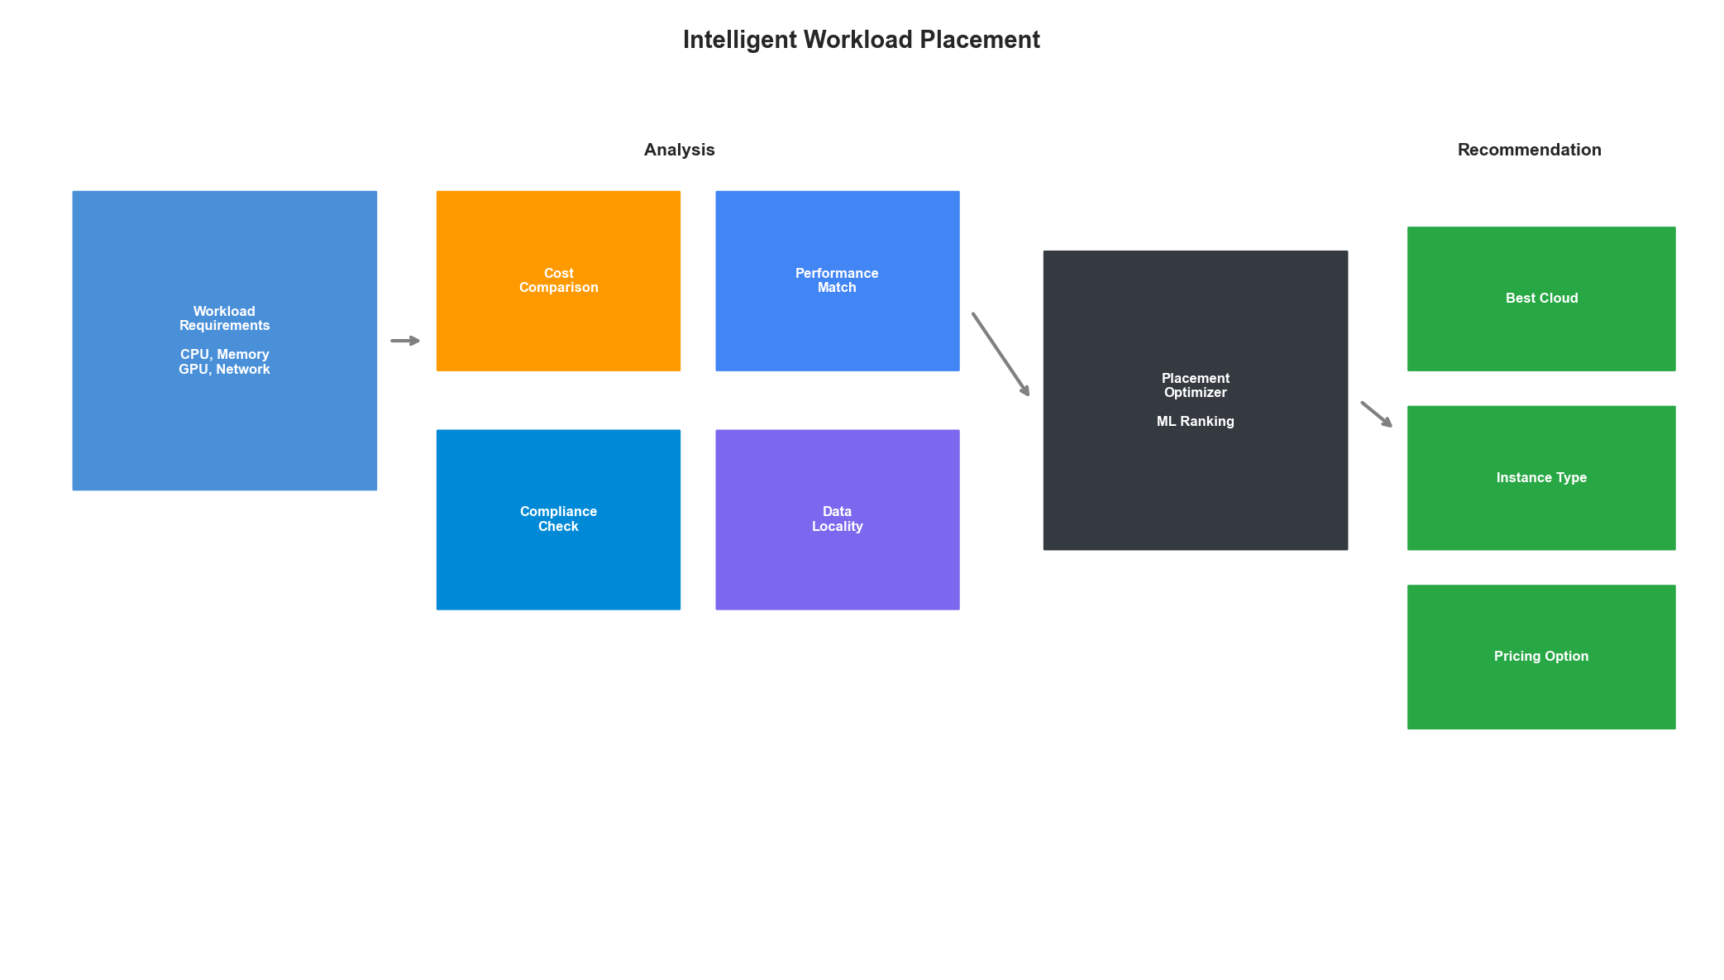
Workload Placement Decision Flow

Automated Cost Optimization Actions

FinOps Automation Engine
from enum import Enum
from typing import Callable
class OptimizationAction(Enum):
RIGHTSIZE = "rightsize"
TERMINATE_UNUSED = "terminate_unused"
PURCHASE_RESERVED = "purchase_reserved"
CONVERT_TO_SPOT = "convert_to_spot"
SCHEDULE_SHUTDOWN = "schedule_shutdown"
MIGRATE_REGION = "migrate_region"
MIGRATE_CLOUD = "migrate_cloud"
@dataclass
class OptimizationRecommendation:
"""Structured optimization recommendation."""
action: OptimizationAction
resource_id: str
provider: str
current_cost: float
projected_cost: float
savings: float
confidence: float
risk_level: str # low, medium, high
implementation_steps: List[str]
requires_approval: bool
class FinOpsAutomationEngine:
"""
Automated cost optimization with safety controls.
Features:
- Automatic resource rightsizing
- Unused resource cleanup
- Spot instance conversion
- Scheduled shutdowns
- Cross-cloud migration recommendations
"""
def __init__(
self,
cost_aggregator: MultiCloudCostAggregator,
dry_run: bool = True
):
self.cost_aggregator = cost_aggregator
self.dry_run = dry_run
self.action_handlers: Dict[OptimizationAction, Callable] = {}
self.executed_actions: List[Dict] = []
def register_handler(
self,
action: OptimizationAction,
handler: Callable
):
"""Register action handler."""
self.action_handlers[action] = handler
def analyze_and_recommend(self) -> List[OptimizationRecommendation]:
"""Analyze costs and generate recommendations."""
recommendations = []
# Get native recommendations from each cloud
cloud_recs = self.cost_aggregator.get_all_recommendations()
for rec in cloud_recs:
if rec['type'] == 'rightsizing':
recommendations.append(OptimizationRecommendation(
action=OptimizationAction.RIGHTSIZE,
resource_id=rec['resource_id'],
provider=rec['provider'],
current_cost=rec.get('current_cost', 0),
projected_cost=rec.get('current_cost', 0) - rec.get('estimated_savings', 0),
savings=rec.get('estimated_savings', 0),
confidence=0.85,
risk_level='low',
implementation_steps=[
'Schedule maintenance window',
f"Resize to {rec.get('recommended', 'smaller instance')}",
'Verify application performance',
'Rollback if issues detected'
],
requires_approval=rec.get('estimated_savings', 0) > 1000
))
# Add custom analysis recommendations
recommendations.extend(self._analyze_unused_resources())
recommendations.extend(self._analyze_spot_candidates())
recommendations.extend(self._analyze_shutdown_schedules())
# Sort by savings
recommendations.sort(key=lambda x: x.savings, reverse=True)
return recommendations
def _analyze_unused_resources(self) -> List[OptimizationRecommendation]:
"""Find resources with low utilization."""
recommendations = []
cost_data = self.cost_aggregator.cost_data
if cost_data is None:
return recommendations
# Group by resource and check for consistent low usage
# This is a simplified analysis
resource_costs = cost_data.groupby(['provider', 'resource_id']).agg({
'cost': 'sum',
'usage_quantity': 'mean'
}).reset_index()
for _, row in resource_costs.iterrows():
if row['usage_quantity'] < 0.1: # Less than 10% utilization
recommendations.append(OptimizationRecommendation(
action=OptimizationAction.TERMINATE_UNUSED,
resource_id=row['resource_id'],
provider=row['provider'],
current_cost=row['cost'],
projected_cost=0,
savings=row['cost'],
confidence=0.7,
risk_level='medium',
implementation_steps=[
'Verify resource is not in use',
'Check for dependencies',
'Create snapshot/backup if needed',
'Terminate resource'
],
requires_approval=True
))
return recommendations
def _analyze_spot_candidates(self) -> List[OptimizationRecommendation]:
"""Identify workloads suitable for spot instances."""
recommendations = []
# Implementation would analyze workload patterns
# for fault-tolerant, stateless workloads
return recommendations
def _analyze_shutdown_schedules(self) -> List[OptimizationRecommendation]:
"""Identify resources that could be scheduled for shutdown."""
recommendations = []
# Implementation would analyze usage patterns
# to identify dev/test resources
return recommendations
def execute_recommendation(
self,
recommendation: OptimizationRecommendation,
approved: bool = False
) -> Dict:
"""Execute an optimization recommendation."""
if recommendation.requires_approval and not approved:
return {
'status': 'pending_approval',
'recommendation': recommendation
}
if self.dry_run:
return {
'status': 'dry_run',
'would_execute': recommendation.action.value,
'estimated_savings': recommendation.savings
}
handler = self.action_handlers.get(recommendation.action)
if handler is None:
return {
'status': 'error',
'message': f'No handler for action: {recommendation.action}'
}
try:
result = handler(recommendation)
self.executed_actions.append({
'timestamp': datetime.now(),
'recommendation': recommendation,
'result': result
})
return {'status': 'success', 'result': result}
except Exception as e:
return {'status': 'error', 'message': str(e)}
def generate_savings_report(self) -> Dict:
"""Generate report of realized and potential savings."""
recommendations = self.analyze_and_recommend()
return {
'potential_monthly_savings': sum(r.savings for r in recommendations),
'high_confidence_savings': sum(
r.savings for r in recommendations if r.confidence > 0.8
),
'recommendations_by_action': {
action.value: [r for r in recommendations if r.action == action]
for action in OptimizationAction
},
'recommendations_by_provider': {
provider: [r for r in recommendations if r.provider == provider]
for provider in set(r.provider for r in recommendations)
},
'total_recommendations': len(recommendations),
'low_risk_recommendations': len([r for r in recommendations if r.risk_level == 'low'])
}
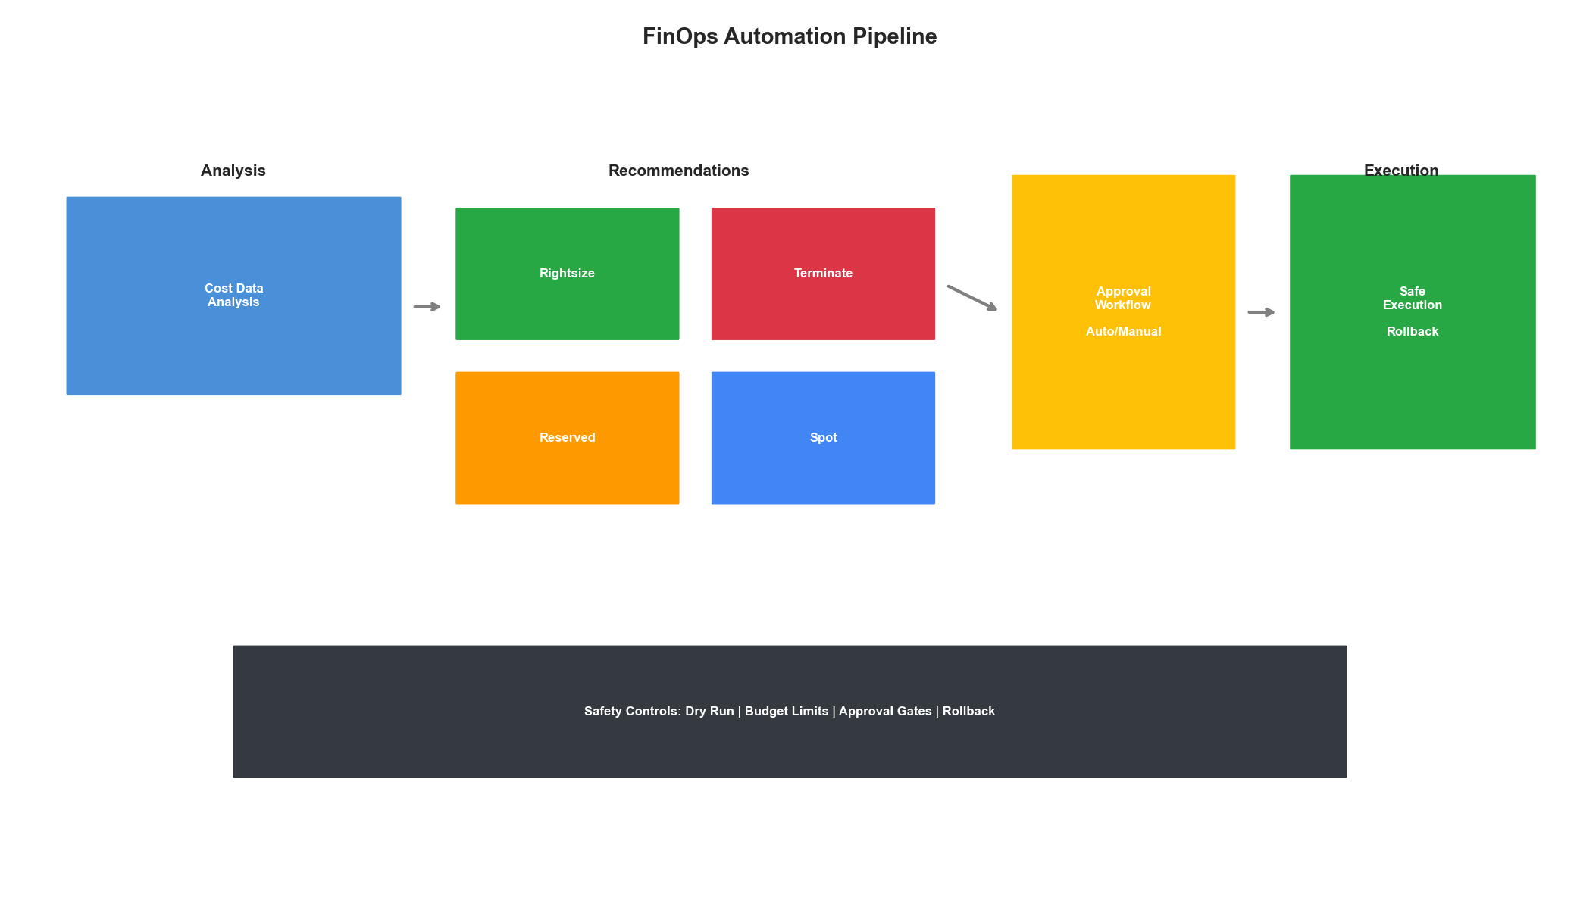
FinOps Automation Pipeline

Key Takeaways
- Unified Visibility First: Aggregate costs across all clouds before optimizing
- Forecast-Driven Decisions: Use AI to predict costs and detect anomalies early
- Intelligent Placement: Consider cost, performance, and compliance together
- Automate Safely: Implement guardrails and approval workflows for high-risk changes
- Continuous Optimization: FinOps is an ongoing process, not a one-time project
Multi-cloud cost optimization requires a combination of unified visibility, AI-powered analysis, and automated action. By implementing these patterns, enterprises can achieve 20-40% cost reductions while maintaining performance and compliance requirements.

