Chapter 17: AIOps Production

Introduction
AIOps—Artificial Intelligence for IT Operations—represents the evolution from reactive monitoring to proactive, intelligent infrastructure management. This chapter covers the practical aspects of deploying AIOps in production environments, from building reliable ML pipelines to establishing operational maturity.
Moving from proof-of-concept to production requires addressing challenges unique to ML systems: data drift, model degradation, explainability requirements, and the need for human-in-the-loop oversight.
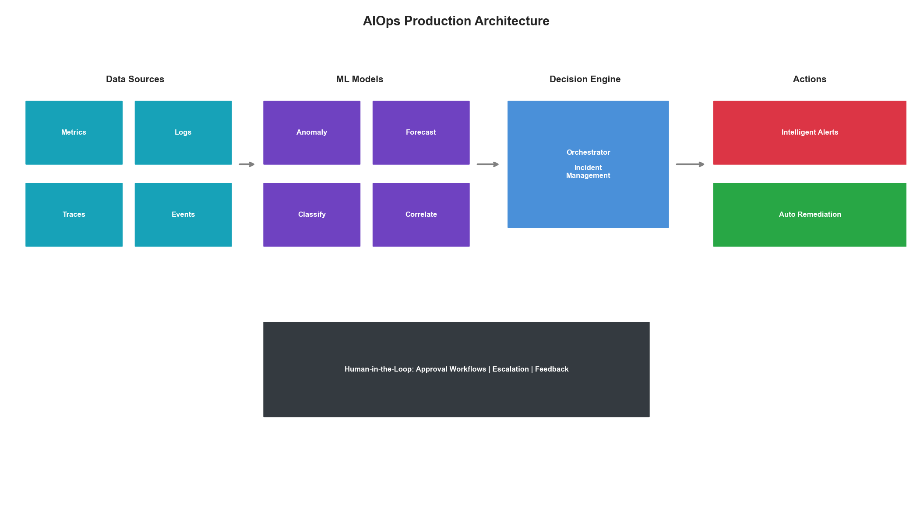
AIOps Production Architecture

AIOps Platform Architecture

Production-Grade System Design
from dataclasses import dataclass, field
from typing import Dict, List, Optional, Callable
from datetime import datetime, timedelta
from abc import ABC, abstractmethod
import asyncio
import logging
@dataclass
class AIOpsConfig:
"""Configuration for AIOps platform."""
# Data ingestion
metrics_retention_days: int = 90
logs_retention_days: int = 30
trace_retention_days: int = 7
# Model serving
model_inference_timeout_ms: int = 100
max_concurrent_inferences: int = 1000
model_cache_size: int = 10
# Alerting
min_confidence_for_alert: float = 0.8
alert_cooldown_minutes: int = 5
max_alerts_per_hour: int = 100
# Human oversight
require_approval_threshold: float = 0.95
auto_remediate_threshold: float = 0.99
class AIOpsOrchestrator:
"""
Central orchestrator for AIOps platform.
Coordinates:
- Data ingestion and processing
- Model inference and predictions
- Alert generation and routing
- Automated remediation
- Human-in-the-loop workflows
"""
def __init__(self, config: AIOpsConfig):
self.config = config
self.logger = logging.getLogger('AIOps')
# Component registries
self.data_sources: Dict[str, DataSource] = {}
self.models: Dict[str, MLModel] = {}
self.alerters: Dict[str, Alerter] = {}
self.remediators: Dict[str, Remediator] = {}
# State tracking
self.active_incidents: Dict[str, Incident] = {}
self.pending_approvals: Dict[str, ApprovalRequest] = {}
# Metrics
self.metrics = AIOpsMetrics()
def register_data_source(self, name: str, source: 'DataSource'):
"""Register a data source."""
self.data_sources[name] = source
self.logger.info(f"Registered data source: {name}")
def register_model(self, name: str, model: 'MLModel'):
"""Register an ML model."""
self.models[name] = model
self.logger.info(f"Registered model: {name}")
async def run(self):
"""Main event loop."""
self.logger.info("Starting AIOps orchestrator...")
tasks = [
self._ingest_data_loop(),
self._inference_loop(),
self._alert_loop(),
self._remediation_loop(),
self._health_check_loop()
]
await asyncio.gather(*tasks)
async def _ingest_data_loop(self):
"""Continuously ingest data from all sources."""
while True:
for name, source in self.data_sources.items():
try:
data = await source.fetch()
await self._process_data(name, data)
except Exception as e:
self.logger.error(f"Error ingesting from {name}: {e}")
self.metrics.record_error('ingestion', name)
await asyncio.sleep(1)
async def _inference_loop(self):
"""Run model inference on incoming data."""
while True:
for model_name, model in self.models.items():
try:
if model.has_pending_data():
predictions = await model.predict()
await self._handle_predictions(model_name, predictions)
except Exception as e:
self.logger.error(f"Error in model {model_name}: {e}")
self.metrics.record_error('inference', model_name)
await asyncio.sleep(0.1)
async def _alert_loop(self):
"""Process predictions and generate alerts."""
while True:
await self._process_pending_alerts()
await asyncio.sleep(1)
async def _remediation_loop(self):
"""Execute approved remediation actions."""
while True:
await self._process_pending_remediations()
await asyncio.sleep(1)
async def _health_check_loop(self):
"""Monitor platform health."""
while True:
await self._check_platform_health()
await asyncio.sleep(60)
class DataSource(ABC):
"""Abstract base for data sources."""
@abstractmethod
async def fetch(self) -> Dict:
pass
@abstractmethod
def get_schema(self) -> Dict:
pass
class MLModel(ABC):
"""Abstract base for ML models."""
@abstractmethod
async def predict(self) -> List[Dict]:
pass
@abstractmethod
def has_pending_data(self) -> bool:
pass
@abstractmethod
def get_metadata(self) -> Dict:
pass
@dataclass
class Incident:
"""Represents an active incident."""
id: str
type: str
severity: str
detected_at: datetime
source_model: str
confidence: float
affected_resources: List[str]
description: str
status: str = 'open'
assigned_to: Optional[str] = None
remediation_actions: List[Dict] = field(default_factory=list)
@dataclass
class ApprovalRequest:
"""Request for human approval."""
id: str
incident_id: str
action: str
reason: str
requested_at: datetime
expires_at: datetime
auto_approve: bool = False
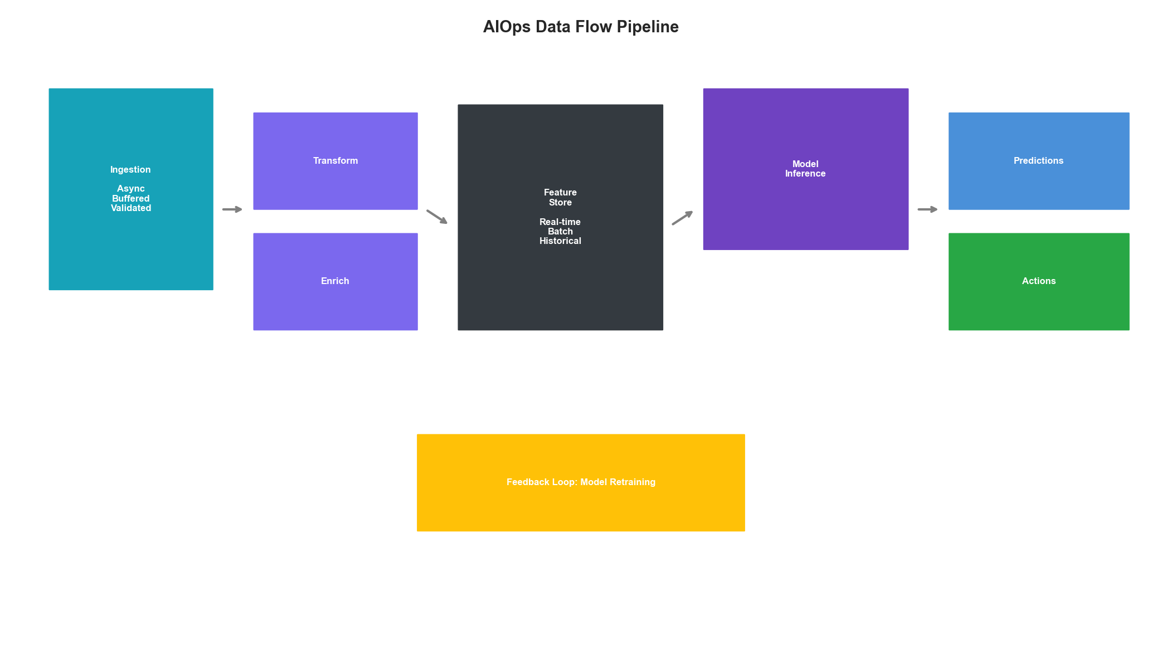
AIOps Data Flow

ML Pipeline Operations

Model Training and Deployment Pipeline
from typing import Tuple
import hashlib
import json
@dataclass
class ModelVersion:
"""Tracks model versions."""
version_id: str
model_name: str
created_at: datetime
training_data_hash: str
hyperparameters: Dict
metrics: Dict
status: str # 'training', 'validating', 'staging', 'production', 'retired'
artifact_path: str
class MLPipelineManager:
"""
Manages ML model lifecycle for AIOps.
Handles:
- Automated retraining triggers
- Model validation and testing
- Canary deployments
- Rollback mechanisms
"""
def __init__(
self,
model_registry_path: str,
artifact_store_path: str
):
self.model_registry_path = model_registry_path
self.artifact_store_path = artifact_store_path
self.active_models: Dict[str, ModelVersion] = {}
self.deployment_history: List[Dict] = []
async def trigger_retrain(
self,
model_name: str,
reason: str
) -> ModelVersion:
"""Trigger model retraining."""
self.logger.info(f"Triggering retrain for {model_name}: {reason}")
# Fetch latest training data
training_data = await self._fetch_training_data(model_name)
data_hash = self._compute_data_hash(training_data)
# Create new version
version_id = f"{model_name}-{datetime.now().strftime('%Y%m%d%H%M%S')}"
version = ModelVersion(
version_id=version_id,
model_name=model_name,
created_at=datetime.now(),
training_data_hash=data_hash,
hyperparameters=self._get_hyperparameters(model_name),
metrics={},
status='training',
artifact_path=f"{self.artifact_store_path}/{version_id}"
)
# Train model
try:
metrics = await self._train_model(model_name, training_data, version)
version.metrics = metrics
version.status = 'validating'
# Validate model
if await self._validate_model(version):
version.status = 'staging'
else:
version.status = 'failed'
raise ValueError("Model validation failed")
except Exception as e:
version.status = 'failed'
raise
return version
async def deploy_canary(
self,
version: ModelVersion,
traffic_percentage: float = 5.0
) -> Dict:
"""Deploy model as canary."""
if version.status != 'staging':
raise ValueError(f"Cannot deploy model in {version.status} status")
deployment = {
'version_id': version.version_id,
'started_at': datetime.now(),
'traffic_percentage': traffic_percentage,
'status': 'canary',
'metrics': {
'requests': 0,
'errors': 0,
'latency_p50': 0,
'latency_p99': 0
}
}
self.deployment_history.append(deployment)
return deployment
async def promote_to_production(
self,
version: ModelVersion
) -> bool:
"""Promote canary to full production."""
# Verify canary metrics
canary_deployment = self._get_active_deployment(version.version_id)
if not canary_deployment:
raise ValueError("No active canary deployment found")
if not self._verify_canary_metrics(canary_deployment):
self.logger.warning("Canary metrics not satisfactory")
return False
# Retire old production model
old_production = self.active_models.get(version.model_name)
if old_production:
old_production.status = 'retired'
# Promote new model
version.status = 'production'
self.active_models[version.model_name] = version
# Update traffic routing
canary_deployment['traffic_percentage'] = 100.0
canary_deployment['status'] = 'production'
self.logger.info(f"Promoted {version.version_id} to production")
return True
async def rollback(
self,
model_name: str,
reason: str
) -> bool:
"""Rollback to previous model version."""
# Find previous production version
previous = self._find_previous_production(model_name)
if not previous:
self.logger.error(f"No previous version to rollback to for {model_name}")
return False
# Retire current
current = self.active_models.get(model_name)
if current:
current.status = 'retired'
# Restore previous
previous.status = 'production'
self.active_models[model_name] = previous
self.logger.warning(f"Rolled back {model_name} to {previous.version_id}: {reason}")
return True
def _verify_canary_metrics(self, deployment: Dict) -> bool:
"""Verify canary is performing well."""
metrics = deployment['metrics']
# Check error rate
if metrics['requests'] > 0:
error_rate = metrics['errors'] / metrics['requests']
if error_rate > 0.01: # 1% error threshold
return False
# Check latency
if metrics['latency_p99'] > 200: # 200ms threshold
return False
return True
def _compute_data_hash(self, data) -> str:
"""Compute hash of training data for versioning."""
data_str = json.dumps(data, sort_keys=True, default=str)
return hashlib.sha256(data_str.encode()).hexdigest()[:12]

Data Drift Detection
import numpy as np
from scipy import stats
class DataDriftDetector:
"""
Detect data drift in production ML systems.
Methods:
- Statistical tests (KS, chi-squared)
- Distribution comparison
- Feature importance shifts
"""
def __init__(
self,
reference_window_days: int = 7,
detection_window_hours: int = 1,
significance_level: float = 0.05
):
self.reference_window_days = reference_window_days
self.detection_window_hours = detection_window_hours
self.significance_level = significance_level
self.reference_distributions: Dict[str, np.ndarray] = {}
self.drift_alerts: List[Dict] = []
def set_reference(
self,
feature_name: str,
data: np.ndarray
):
"""Set reference distribution for a feature."""
self.reference_distributions[feature_name] = data
def detect_drift(
self,
feature_name: str,
current_data: np.ndarray
) -> Dict:
"""Detect drift for a specific feature."""
if feature_name not in self.reference_distributions:
return {'drift_detected': False, 'reason': 'No reference data'}
reference = self.reference_distributions[feature_name]
# Kolmogorov-Smirnov test
ks_stat, ks_pvalue = stats.ks_2samp(reference, current_data)
# Population Stability Index
psi = self._calculate_psi(reference, current_data)
# Jensen-Shannon divergence
js_divergence = self._calculate_js_divergence(reference, current_data)
drift_detected = (
ks_pvalue < self.significance_level or
psi > 0.2 or
js_divergence > 0.1
)
result = {
'feature': feature_name,
'drift_detected': drift_detected,
'ks_statistic': float(ks_stat),
'ks_pvalue': float(ks_pvalue),
'psi': float(psi),
'js_divergence': float(js_divergence),
'reference_mean': float(reference.mean()),
'current_mean': float(current_data.mean()),
'reference_std': float(reference.std()),
'current_std': float(current_data.std())
}
if drift_detected:
self.drift_alerts.append({
'timestamp': datetime.now(),
**result
})
return result
def _calculate_psi(
self,
reference: np.ndarray,
current: np.ndarray,
buckets: int = 10
) -> float:
"""Calculate Population Stability Index."""
# Create buckets based on reference
breakpoints = np.percentile(reference, np.linspace(0, 100, buckets + 1))
breakpoints[0] = -np.inf
breakpoints[-1] = np.inf
ref_counts = np.histogram(reference, bins=breakpoints)[0] / len(reference)
cur_counts = np.histogram(current, bins=breakpoints)[0] / len(current)
# Avoid division by zero
ref_counts = np.clip(ref_counts, 0.0001, None)
cur_counts = np.clip(cur_counts, 0.0001, None)
psi = np.sum((cur_counts - ref_counts) * np.log(cur_counts / ref_counts))
return psi
def _calculate_js_divergence(
self,
reference: np.ndarray,
current: np.ndarray,
bins: int = 50
) -> float:
"""Calculate Jensen-Shannon divergence."""
# Create common histogram bins
all_data = np.concatenate([reference, current])
bins_edges = np.histogram_bin_edges(all_data, bins=bins)
ref_hist = np.histogram(reference, bins=bins_edges, density=True)[0]
cur_hist = np.histogram(current, bins=bins_edges, density=True)[0]
# Normalize
ref_hist = ref_hist / ref_hist.sum()
cur_hist = cur_hist / cur_hist.sum()
# Avoid log(0)
ref_hist = np.clip(ref_hist, 1e-10, None)
cur_hist = np.clip(cur_hist, 1e-10, None)
# Jensen-Shannon
m = 0.5 * (ref_hist + cur_hist)
js = 0.5 * (stats.entropy(ref_hist, m) + stats.entropy(cur_hist, m))
return js
def get_drift_summary(self) -> Dict:
"""Get summary of detected drifts."""
recent_alerts = [
a for a in self.drift_alerts
if a['timestamp'] > datetime.now() - timedelta(hours=24)
]
return {
'total_alerts_24h': len(recent_alerts),
'affected_features': list(set(a['feature'] for a in recent_alerts)),
'alerts': recent_alerts
}
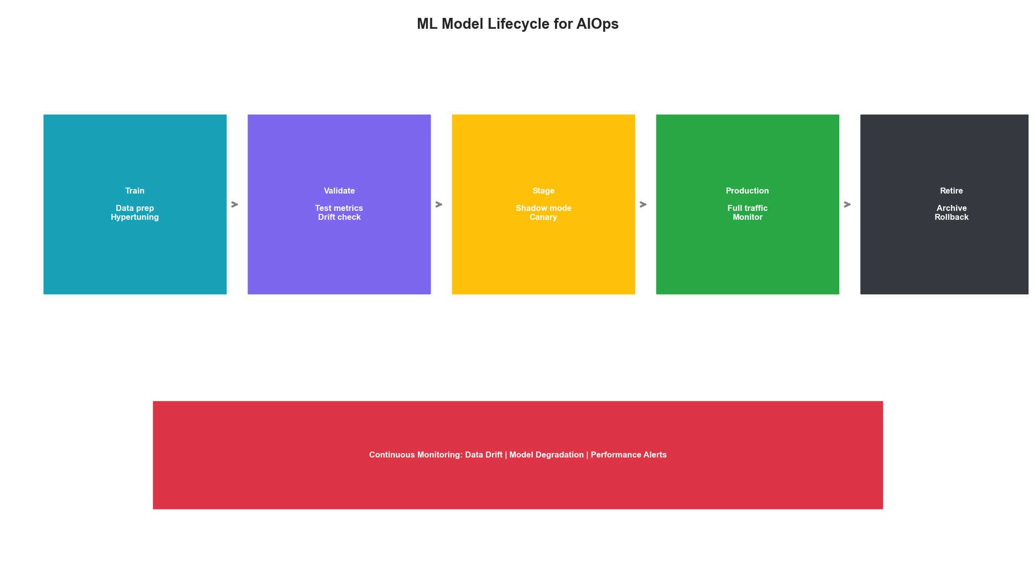
Model Lifecycle

Intelligent Alerting

Alert Correlation and Deduplication
from collections import defaultdict
import re
@dataclass
class Alert:
"""Structured alert."""
id: str
source: str
severity: str # critical, high, medium, low
title: str
description: str
timestamp: datetime
labels: Dict[str, str]
annotations: Dict[str, str]
fingerprint: str
status: str = 'firing'
class IntelligentAlerter:
"""
Intelligent alert management with ML-based correlation.
Features:
- Alert deduplication
- Correlation and grouping
- Root cause identification
- Alert fatigue reduction
"""
def __init__(
self,
dedup_window_minutes: int = 15,
correlation_window_minutes: int = 5,
max_alerts_per_group: int = 100
):
self.dedup_window = timedelta(minutes=dedup_window_minutes)
self.correlation_window = timedelta(minutes=correlation_window_minutes)
self.max_alerts_per_group = max_alerts_per_group
self.active_alerts: Dict[str, Alert] = {}
self.alert_groups: Dict[str, List[str]] = defaultdict(list)
self.alert_history: List[Alert] = []
# ML components
self.correlation_model = None
self.severity_model = None
def process_alert(self, alert: Alert) -> Dict:
"""Process incoming alert."""
# Check for duplicate
if self._is_duplicate(alert):
return {'status': 'deduplicated', 'original_id': alert.fingerprint}
# Enrich alert
alert = self._enrich_alert(alert)
# Find correlated alerts
correlated = self._find_correlated_alerts(alert)
# Determine if this is root cause
is_root_cause = self._is_root_cause(alert, correlated)
# Calculate effective severity
effective_severity = self._calculate_effective_severity(alert, correlated)
# Store alert
self.active_alerts[alert.id] = alert
self.alert_history.append(alert)
# Create or update group
group_id = self._get_or_create_group(alert, correlated)
return {
'status': 'processed',
'alert_id': alert.id,
'group_id': group_id,
'correlated_count': len(correlated),
'is_root_cause': is_root_cause,
'effective_severity': effective_severity
}
def _is_duplicate(self, alert: Alert) -> bool:
"""Check if alert is a duplicate."""
for existing in self.active_alerts.values():
if existing.fingerprint == alert.fingerprint:
if alert.timestamp - existing.timestamp < self.dedup_window:
return True
return False
def _enrich_alert(self, alert: Alert) -> Alert:
"""Enrich alert with additional context."""
# Extract service from labels
if 'service' not in alert.labels:
# Try to extract from title or description
service_pattern = r'service[:\s]+(\w+)'
match = re.search(service_pattern, alert.title, re.IGNORECASE)
if match:
alert.labels['service'] = match.group(1)
# Add time context
alert.annotations['hour_of_day'] = str(alert.timestamp.hour)
alert.annotations['day_of_week'] = str(alert.timestamp.weekday())
return alert
def _find_correlated_alerts(self, alert: Alert) -> List[Alert]:
"""Find alerts correlated with this one."""
correlated = []
for existing in self.active_alerts.values():
if existing.id == alert.id:
continue
# Time proximity
time_diff = abs((alert.timestamp - existing.timestamp).total_seconds())
if time_diff > self.correlation_window.total_seconds():
continue
# Label similarity
if self._labels_overlap(alert.labels, existing.labels):
correlated.append(existing)
continue
# ML-based correlation
if self.correlation_model:
score = self._ml_correlation_score(alert, existing)
if score > 0.7:
correlated.append(existing)
return correlated
def _labels_overlap(
self,
labels1: Dict[str, str],
labels2: Dict[str, str]
) -> bool:
"""Check if labels have significant overlap."""
common_keys = set(labels1.keys()) & set(labels2.keys())
if not common_keys:
return False
matches = sum(1 for k in common_keys if labels1[k] == labels2[k])
return matches / len(common_keys) > 0.5
def _is_root_cause(
self,
alert: Alert,
correlated: List[Alert]
) -> bool:
"""Determine if this alert is likely the root cause."""
if not correlated:
return True
# Earliest alert in correlation group
earliest = min(correlated + [alert], key=lambda a: a.timestamp)
if alert.id == earliest.id:
return True
# Infrastructure layer (lower = more fundamental)
layer_order = ['hardware', 'network', 'storage', 'compute', 'platform', 'application']
alert_layer = alert.labels.get('layer', 'application')
if alert_layer in layer_order:
alert_idx = layer_order.index(alert_layer)
for other in correlated:
other_layer = other.labels.get('layer', 'application')
if other_layer in layer_order:
if layer_order.index(other_layer) < alert_idx:
return False
return True
return False
def _calculate_effective_severity(
self,
alert: Alert,
correlated: List[Alert]
) -> str:
"""Calculate effective severity considering context."""
base_severity = {'critical': 4, 'high': 3, 'medium': 2, 'low': 1}
score = base_severity.get(alert.severity, 2)
# Increase severity if many correlated alerts
if len(correlated) > 5:
score = min(score + 1, 4)
# Decrease if during known maintenance
if self._is_maintenance_window():
score = max(score - 1, 1)
severity_map = {4: 'critical', 3: 'high', 2: 'medium', 1: 'low'}
return severity_map.get(score, 'medium')
def _is_maintenance_window(self) -> bool:
"""Check if currently in maintenance window."""
# Implementation would check maintenance schedule
return False
def _get_or_create_group(
self,
alert: Alert,
correlated: List[Alert]
) -> str:
"""Get or create alert group."""
# Check if any correlated alert is already in a group
for other in correlated:
for group_id, members in self.alert_groups.items():
if other.id in members:
if len(members) < self.max_alerts_per_group:
self.alert_groups[group_id].append(alert.id)
return group_id
# Create new group
group_id = f"group-{alert.id}"
self.alert_groups[group_id] = [alert.id]
return group_id
def get_alert_summary(self) -> Dict:
"""Get summary of current alert state."""
return {
'active_alerts': len(self.active_alerts),
'alert_groups': len(self.alert_groups),
'by_severity': {
severity: len([a for a in self.active_alerts.values() if a.severity == severity])
for severity in ['critical', 'high', 'medium', 'low']
}
}

Automated Remediation

Safe Auto-Remediation Engine
@dataclass
class RemediationAction:
"""Represents a remediation action."""
id: str
name: str
description: str
target_type: str # pod, node, service, etc.
target_selector: Dict[str, str]
action_type: str # restart, scale, rollback, etc.
parameters: Dict
risk_level: str # low, medium, high
requires_approval: bool
rollback_action: Optional[str] = None
class AutoRemediator:
"""
Automated remediation with safety controls.
Safety mechanisms:
- Risk assessment
- Approval workflows
- Rate limiting
- Rollback capability
- Blast radius limitation
"""
def __init__(
self,
max_actions_per_hour: int = 10,
approval_timeout_minutes: int = 30,
dry_run: bool = False
):
self.max_actions_per_hour = max_actions_per_hour
self.approval_timeout = timedelta(minutes=approval_timeout_minutes)
self.dry_run = dry_run
self.action_registry: Dict[str, RemediationAction] = {}
self.executed_actions: List[Dict] = []
self.pending_approvals: Dict[str, Dict] = {}
# Circuit breaker
self.circuit_breaker = CircuitBreaker(
failure_threshold=3,
recovery_timeout_seconds=300
)
def register_action(self, action: RemediationAction):
"""Register a remediation action."""
self.action_registry[action.id] = action
async def execute(
self,
action_id: str,
incident: Incident,
context: Dict
) -> Dict:
"""Execute a remediation action."""
action = self.action_registry.get(action_id)
if not action:
return {'status': 'error', 'message': f'Unknown action: {action_id}'}
# Check circuit breaker
if not self.circuit_breaker.allow_request():
return {'status': 'blocked', 'message': 'Circuit breaker open'}
# Check rate limits
if not self._check_rate_limit():
return {'status': 'rate_limited', 'message': 'Rate limit exceeded'}
# Risk assessment
risk = self._assess_risk(action, incident, context)
if risk['level'] == 'high' and not context.get('force', False):
return {
'status': 'blocked',
'message': 'High risk action requires explicit approval',
'risk_assessment': risk
}
# Check if approval required
if action.requires_approval and not context.get('approved', False):
approval_id = await self._request_approval(action, incident)
return {
'status': 'pending_approval',
'approval_id': approval_id,
'expires_in': self.approval_timeout.total_seconds()
}
# Execute action
try:
if self.dry_run:
result = {'status': 'dry_run', 'would_execute': action.name}
else:
result = await self._execute_action(action, incident, context)
self._record_execution(action, incident, result)
return result
except Exception as e:
self.circuit_breaker.record_failure()
return {'status': 'error', 'message': str(e)}
def _assess_risk(
self,
action: RemediationAction,
incident: Incident,
context: Dict
) -> Dict:
"""Assess risk of remediation action."""
risk_score = 0
factors = []
# Base risk from action type
action_risks = {
'restart': 1,
'scale': 2,
'rollback': 3,
'terminate': 4,
'config_change': 3
}
risk_score += action_risks.get(action.action_type, 2)
factors.append(f"Action type: {action.action_type}")
# Target scope
if 'namespace' not in action.target_selector:
risk_score += 2
factors.append("Broad target scope")
# Time of day
hour = datetime.now().hour
if 9 <= hour <= 17:
risk_score += 1
factors.append("Business hours")
# Recent failures
recent_failures = len([
e for e in self.executed_actions[-20:]
if e['status'] == 'failed'
])
if recent_failures > 2:
risk_score += 2
factors.append(f"Recent failures: {recent_failures}")
# Determine level
if risk_score <= 3:
level = 'low'
elif risk_score <= 6:
level = 'medium'
else:
level = 'high'
return {
'score': risk_score,
'level': level,
'factors': factors
}
def _check_rate_limit(self) -> bool:
"""Check if rate limit allows action."""
recent = [
e for e in self.executed_actions
if e['timestamp'] > datetime.now() - timedelta(hours=1)
]
return len(recent) < self.max_actions_per_hour
async def _request_approval(
self,
action: RemediationAction,
incident: Incident
) -> str:
"""Request human approval for action."""
approval_id = f"approval-{datetime.now().strftime('%Y%m%d%H%M%S')}"
self.pending_approvals[approval_id] = {
'action': action,
'incident': incident,
'requested_at': datetime.now(),
'expires_at': datetime.now() + self.approval_timeout,
'status': 'pending'
}
# Send notification (implementation would integrate with Slack, PagerDuty, etc.)
await self._send_approval_notification(approval_id, action, incident)
return approval_id
async def _execute_action(
self,
action: RemediationAction,
incident: Incident,
context: Dict
) -> Dict:
"""Execute the remediation action."""
# Implementation would integrate with Kubernetes, cloud APIs, etc.
self.logger.info(f"Executing {action.name} for incident {incident.id}")
# Simulate execution
await asyncio.sleep(1)
return {
'status': 'success',
'action': action.name,
'target': action.target_selector,
'executed_at': datetime.now().isoformat()
}
def _record_execution(
self,
action: RemediationAction,
incident: Incident,
result: Dict
):
"""Record action execution for audit."""
self.executed_actions.append({
'timestamp': datetime.now(),
'action_id': action.id,
'action_name': action.name,
'incident_id': incident.id,
'status': result.get('status', 'unknown'),
'result': result
})
class CircuitBreaker:
"""Circuit breaker pattern for remediation safety."""
def __init__(
self,
failure_threshold: int = 5,
recovery_timeout_seconds: int = 60
):
self.failure_threshold = failure_threshold
self.recovery_timeout = timedelta(seconds=recovery_timeout_seconds)
self.failures = 0
self.last_failure: Optional[datetime] = None
self.state = 'closed' # closed, open, half-open
def allow_request(self) -> bool:
"""Check if request should be allowed."""
if self.state == 'closed':
return True
if self.state == 'open':
if datetime.now() - self.last_failure > self.recovery_timeout:
self.state = 'half-open'
return True
return False
# half-open: allow one request to test
return True
def record_failure(self):
"""Record a failure."""
self.failures += 1
self.last_failure = datetime.now()
if self.failures >= self.failure_threshold:
self.state = 'open'
def record_success(self):
"""Record a success."""
self.failures = 0
self.state = 'closed'
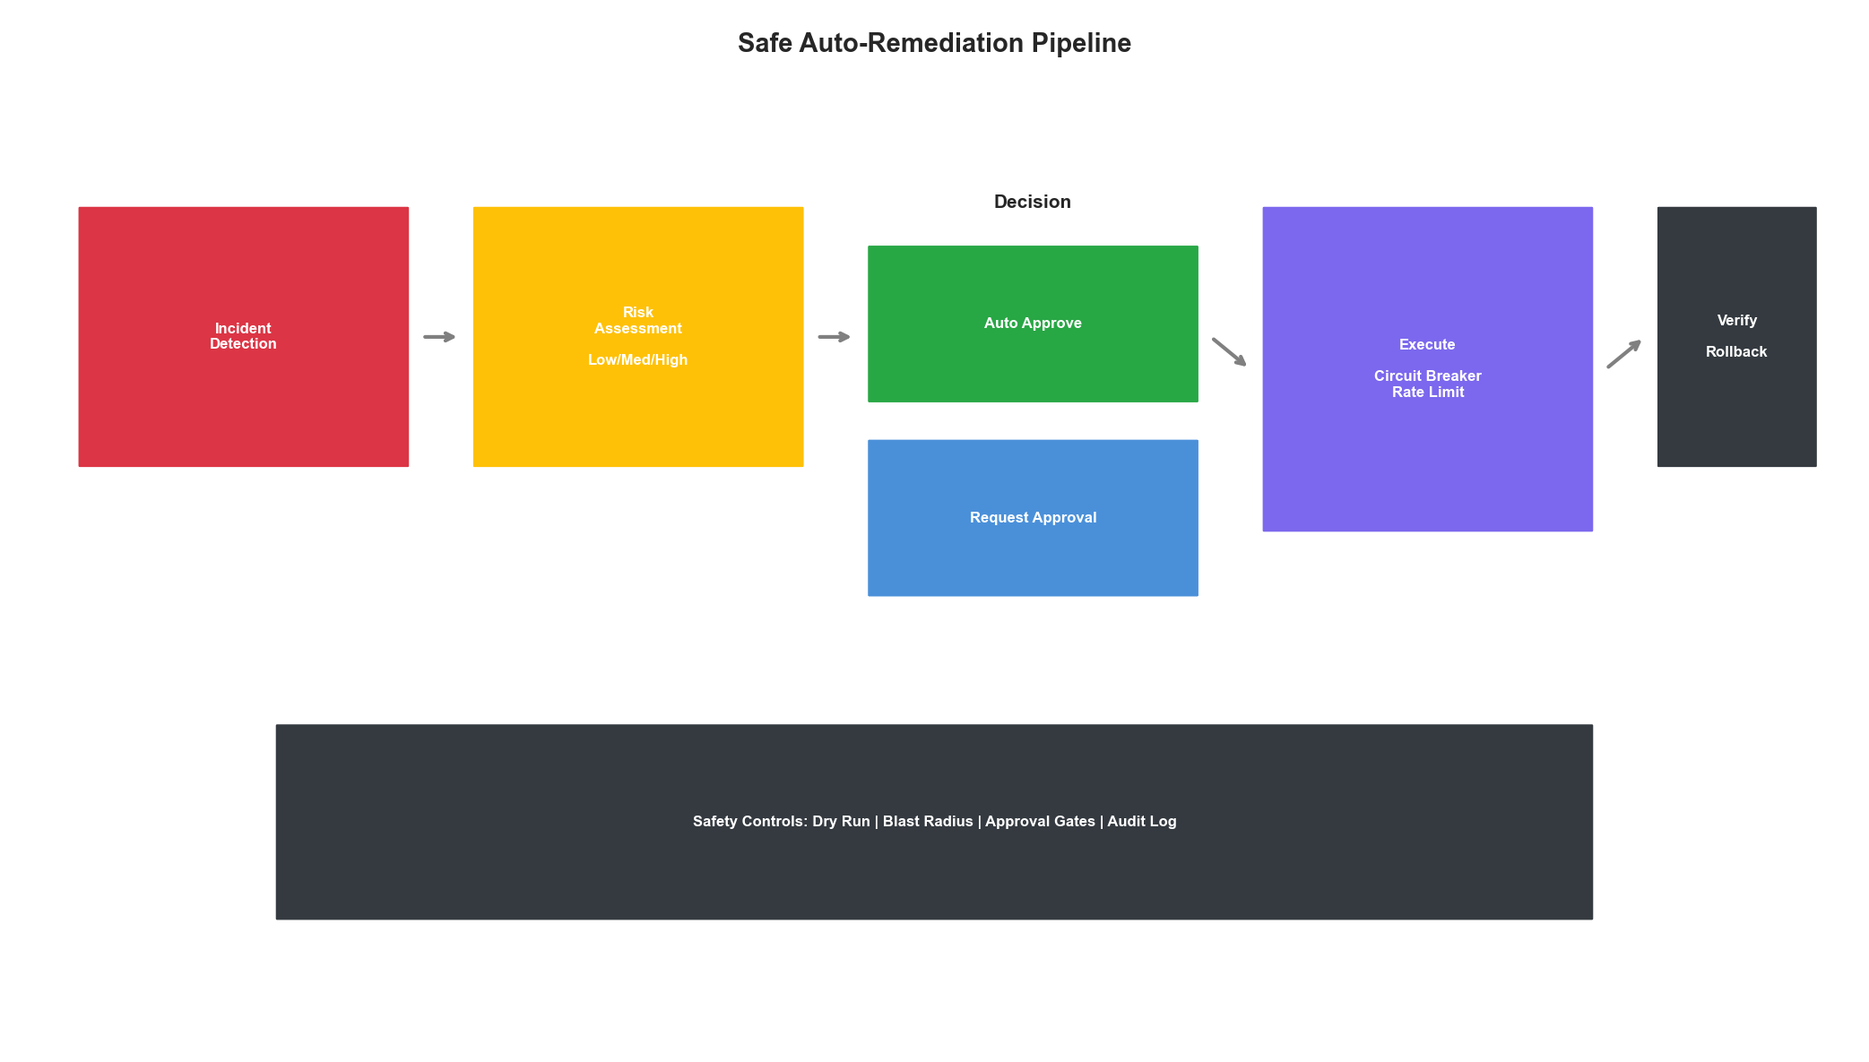
Remediation Pipeline

Key Takeaways
- Production ML is Different: Focus on reliability, monitoring, and graceful degradation
- Drift Detection is Critical: Continuously monitor for data and concept drift
- Intelligent Alerting: Reduce noise through correlation, deduplication, and prioritization
- Safe Remediation: Use circuit breakers, rate limits, and approval workflows
- Human-in-the-Loop: Maintain human oversight for high-risk decisions
AIOps production success requires balancing automation benefits with operational safety. Start with monitoring and alerting, graduate to assisted remediation, and only enable full automation for well-understood, low-risk scenarios.

