Chapter 19: Implementation Roadmap

Introduction
Transforming infrastructure operations with AI is a journey, not a destination. This chapter provides a practical roadmap for implementing the concepts covered throughout this book—from initial assessment through mature autonomous operations.
Success requires balancing ambition with pragmatism. Start with high-impact, low-risk use cases, build organizational capability, and progressively expand scope as confidence grows.
Implementation Phases
Implementation Phases

Maturity Assessment

AIOps Maturity Model
from dataclasses import dataclass
from typing import Dict, List
from enum import Enum
class MaturityLevel(Enum):
LEVEL_0_REACTIVE = 0 # Manual, reactive operations
LEVEL_1_MONITORED = 1 # Basic monitoring and alerting
LEVEL_2_ANALYZED = 2 # ML-assisted analysis
LEVEL_3_AUTOMATED = 3 # Automated recommendations
LEVEL_4_AUTONOMOUS = 4 # Self-healing infrastructure
@dataclass
class MaturityDimension:
"""Assessment dimension for maturity."""
name: str
current_level: MaturityLevel
target_level: MaturityLevel
gaps: List[str]
actions: List[str]
class MaturityAssessment:
"""
Assess current AIOps maturity and identify improvement areas.
"""
DIMENSIONS = [
'data_collection',
'analytics',
'automation',
'governance',
'team_capability',
'tooling'
]
def __init__(self):
self.dimensions: Dict[str, MaturityDimension] = {}
self.questions = self._load_assessment_questions()
def _load_assessment_questions(self) -> Dict[str, List[Dict]]:
"""Load assessment questions by dimension."""
return {
'data_collection': [
{'question': 'Are metrics collected from all critical systems?',
'level_1': True, 'level_2': True, 'level_3': True, 'level_4': True},
{'question': 'Is log aggregation centralized?',
'level_1': False, 'level_2': True, 'level_3': True, 'level_4': True},
{'question': 'Are traces collected for request flows?',
'level_1': False, 'level_2': True, 'level_3': True, 'level_4': True},
{'question': 'Is data retention policy automated?',
'level_1': False, 'level_2': False, 'level_3': True, 'level_4': True},
{'question': 'Is real-time streaming enabled?',
'level_1': False, 'level_2': False, 'level_3': True, 'level_4': True}
],
'analytics': [
{'question': 'Are threshold-based alerts configured?',
'level_1': True, 'level_2': True, 'level_3': True, 'level_4': True},
{'question': 'Is anomaly detection deployed?',
'level_1': False, 'level_2': True, 'level_3': True, 'level_4': True},
{'question': 'Are forecasting models used?',
'level_1': False, 'level_2': False, 'level_3': True, 'level_4': True},
{'question': 'Is root cause analysis automated?',
'level_1': False, 'level_2': False, 'level_3': True, 'level_4': True},
{'question': 'Are models continuously retrained?',
'level_1': False, 'level_2': False, 'level_3': False, 'level_4': True}
],
'automation': [
{'question': 'Are runbooks documented?',
'level_1': True, 'level_2': True, 'level_3': True, 'level_4': True},
{'question': 'Are common remediations scripted?',
'level_1': False, 'level_2': True, 'level_3': True, 'level_4': True},
{'question': 'Is auto-scaling implemented?',
'level_1': False, 'level_2': True, 'level_3': True, 'level_4': True},
{'question': 'Are recommendations auto-generated?',
'level_1': False, 'level_2': False, 'level_3': True, 'level_4': True},
{'question': 'Is autonomous remediation enabled?',
'level_1': False, 'level_2': False, 'level_3': False, 'level_4': True}
],
'governance': [
{'question': 'Are change management processes defined?',
'level_1': True, 'level_2': True, 'level_3': True, 'level_4': True},
{'question': 'Is automation approval workflow in place?',
'level_1': False, 'level_2': True, 'level_3': True, 'level_4': True},
{'question': 'Are ML models versioned and audited?',
'level_1': False, 'level_2': False, 'level_3': True, 'level_4': True},
{'question': 'Is explainability required for decisions?',
'level_1': False, 'level_2': False, 'level_3': True, 'level_4': True},
{'question': 'Is continuous compliance monitoring enabled?',
'level_1': False, 'level_2': False, 'level_3': False, 'level_4': True}
]
}
def assess(self, responses: Dict[str, Dict[str, bool]]) -> Dict:
"""Run maturity assessment based on responses."""
results = {}
for dimension, questions in self.questions.items():
dimension_responses = responses.get(dimension, {})
# Calculate current level
current_level = MaturityLevel.LEVEL_0_REACTIVE
for level in [MaturityLevel.LEVEL_4_AUTONOMOUS,
MaturityLevel.LEVEL_3_AUTOMATED,
MaturityLevel.LEVEL_2_ANALYZED,
MaturityLevel.LEVEL_1_MONITORED]:
level_key = f'level_{level.value}'
required = [q for q in questions if q.get(level_key, False)]
met = all(dimension_responses.get(q['question'], False) for q in required)
if met:
current_level = level
break
# Identify gaps for next level
next_level = MaturityLevel(min(current_level.value + 1, 4))
next_level_key = f'level_{next_level.value}'
gaps = [
q['question'] for q in questions
if q.get(next_level_key, False) and not dimension_responses.get(q['question'], False)
]
results[dimension] = {
'current_level': current_level.value,
'current_level_name': current_level.name,
'gaps_for_next_level': gaps
}
# Calculate overall maturity
avg_level = sum(r['current_level'] for r in results.values()) / len(results)
results['overall'] = {
'average_level': round(avg_level, 1),
'recommendation': self._get_recommendation(avg_level)
}
return results
def _get_recommendation(self, avg_level: float) -> str:
"""Get recommendation based on maturity level."""
if avg_level < 1:
return "Focus on establishing basic monitoring and observability foundation"
elif avg_level < 2:
return "Implement ML-based analytics for anomaly detection and log analysis"
elif avg_level < 3:
return "Build automation capabilities with human-in-the-loop approval"
elif avg_level < 4:
return "Enable autonomous operations with comprehensive safety controls"
else:
return "Continue optimizing and expanding autonomous capabilities"
Maturity Model
Maturity Model

Phased Implementation

Phase 1: Foundation
@dataclass
class ImplementationPhase:
"""Represents an implementation phase."""
name: str
objectives: List[str]
deliverables: List[str]
success_criteria: List[str]
risks: List[str]
dependencies: List[str]
class ImplementationRoadmap:
"""Complete implementation roadmap."""
def __init__(self):
self.phases = self._define_phases()
def _define_phases(self) -> List[ImplementationPhase]:
return [
ImplementationPhase(
name="Phase 1: Foundation",
objectives=[
"Establish unified observability platform",
"Centralize metrics, logs, and traces",
"Implement basic alerting and dashboards",
"Build data pipeline infrastructure"
],
deliverables=[
"Metrics collection from all critical systems",
"Centralized log aggregation",
"Distributed tracing implementation",
"Alert management system",
"Executive dashboards"
],
success_criteria=[
"95% of critical systems instrumented",
"< 5 min data ingestion latency",
"Alert accuracy > 80%",
"On-call response time < 15 min"
],
risks=[
"Data volume exceeds storage capacity",
"Performance impact on production systems",
"Team resistance to new tooling"
],
dependencies=[
"Budget approval",
"Infrastructure access",
"Team training plan"
]
),
ImplementationPhase(
name="Phase 2: Intelligence",
objectives=[
"Deploy ML-based anomaly detection",
"Implement log classification",
"Enable cost forecasting",
"Build initial automation scripts"
],
deliverables=[
"Anomaly detection models in production",
"Log classification pipeline",
"Cost prediction dashboard",
"Automated remediation scripts (manual trigger)"
],
success_criteria=[
"50% reduction in false positive alerts",
"MTTR reduced by 30%",
"Cost forecasting accuracy > 90%",
"5+ automated runbooks implemented"
],
risks=[
"Model accuracy insufficient",
"Training data quality issues",
"Alert fatigue during tuning"
],
dependencies=[
"Phase 1 completion",
"Historical data for training",
"ML engineering capability"
]
),
ImplementationPhase(
name="Phase 3: Automation",
objectives=[
"Enable automated recommendations",
"Implement approval workflows",
"Deploy auto-scaling optimization",
"Build feedback loops"
],
deliverables=[
"Recommendation engine for operations",
"Approval workflow system",
"ML-optimized auto-scaling",
"Closed-loop learning system"
],
success_criteria=[
"80% of recommendations actionable",
"Auto-remediation for 30% of incidents",
"20% cost reduction achieved",
"Model drift detection < 24h"
],
risks=[
"Automation errors impact production",
"Approval bottlenecks",
"Governance compliance gaps"
],
dependencies=[
"Phase 2 completion",
"Governance approval",
"Safety controls implemented"
]
),
ImplementationPhase(
name="Phase 4: Autonomy",
objectives=[
"Enable self-healing infrastructure",
"Deploy predictive optimization",
"Implement continuous compliance",
"Achieve hands-off operations"
],
deliverables=[
"Autonomous remediation for common issues",
"Predictive scaling and optimization",
"Real-time compliance enforcement",
"Full AIOps platform"
],
success_criteria=[
"90% of incidents auto-remediated",
"< 5 human interventions per week",
"Zero compliance violations",
"40%+ cost optimization"
],
risks=[
"Over-reliance on automation",
"Skill degradation in team",
"Black swan events"
],
dependencies=[
"Phase 3 completion",
"Executive sponsorship",
"Mature safety controls"
]
)
]
def get_current_phase(self, assessment: Dict) -> int:
"""Determine current phase based on maturity assessment."""
avg_level = assessment.get('overall', {}).get('average_level', 0)
if avg_level < 1.5:
return 1
elif avg_level < 2.5:
return 2
elif avg_level < 3.5:
return 3
else:
return 4
def get_roadmap(self, assessment: Dict) -> Dict:
"""Generate implementation roadmap based on assessment."""
current = self.get_current_phase(assessment)
return {
'current_phase': current,
'phases': [
{
'phase': i + 1,
'name': phase.name,
'status': 'completed' if i + 1 < current else ('in_progress' if i + 1 == current else 'planned'),
'objectives': phase.objectives,
'deliverables': phase.deliverables,
'success_criteria': phase.success_criteria
}
for i, phase in enumerate(self.phases)
]
}

Team Structure and Roles
@dataclass
class TeamRole:
"""Define team role for AIOps."""
title: str
responsibilities: List[str]
skills_required: List[str]
headcount_range: str
class TeamStructure:
"""Recommended team structure for AIOps."""
def __init__(self, organization_size: str):
self.size = organization_size # small, medium, large, enterprise
self.roles = self._define_roles()
def _define_roles(self) -> List[TeamRole]:
return [
TeamRole(
title="AIOps Platform Lead",
responsibilities=[
"Overall platform strategy and vision",
"Stakeholder management",
"Roadmap prioritization",
"Budget and resource allocation"
],
skills_required=[
"Infrastructure operations background",
"ML/AI understanding",
"Leadership experience",
"Cloud platform expertise"
],
headcount_range="1"
),
TeamRole(
title="ML Engineer",
responsibilities=[
"Model development and training",
"Feature engineering",
"Model deployment and monitoring",
"Performance optimization"
],
skills_required=[
"Python, PyTorch/TensorFlow",
"Time series analysis",
"MLOps practices",
"Infrastructure domain knowledge"
],
headcount_range="2-4"
),
TeamRole(
title="Data Engineer",
responsibilities=[
"Data pipeline development",
"Data quality management",
"Feature store maintenance",
"Data platform operations"
],
skills_required=[
"Spark, Kafka, Flink",
"SQL and data modeling",
"Cloud data services",
"Data governance"
],
headcount_range="2-3"
),
TeamRole(
title="Platform Engineer",
responsibilities=[
"Infrastructure automation",
"Integration development",
"API design and implementation",
"Reliability engineering"
],
skills_required=[
"Kubernetes, Terraform",
"Go or Python",
"API development",
"DevOps practices"
],
headcount_range="2-4"
),
TeamRole(
title="SRE/Operations",
responsibilities=[
"Production support",
"Incident response",
"Runbook development",
"Automation validation"
],
skills_required=[
"Linux systems",
"Monitoring tools",
"Scripting",
"Cloud operations"
],
headcount_range="2-4"
)
]
def get_team_recommendation(self) -> Dict:
"""Get team structure recommendation."""
multiplier = {'small': 0.5, 'medium': 1.0, 'large': 1.5, 'enterprise': 2.0}
mult = multiplier.get(self.size, 1.0)
return {
'organization_size': self.size,
'total_headcount_range': f"{int(8 * mult)}-{int(16 * mult)}",
'roles': [
{
'title': role.title,
'responsibilities': role.responsibilities,
'headcount': role.headcount_range
}
for role in self.roles
],
'structure_notes': [
"Consider shared services for smaller organizations",
"Enterprise may need dedicated teams per business unit",
"Start lean and grow based on demonstrated value"
]
}
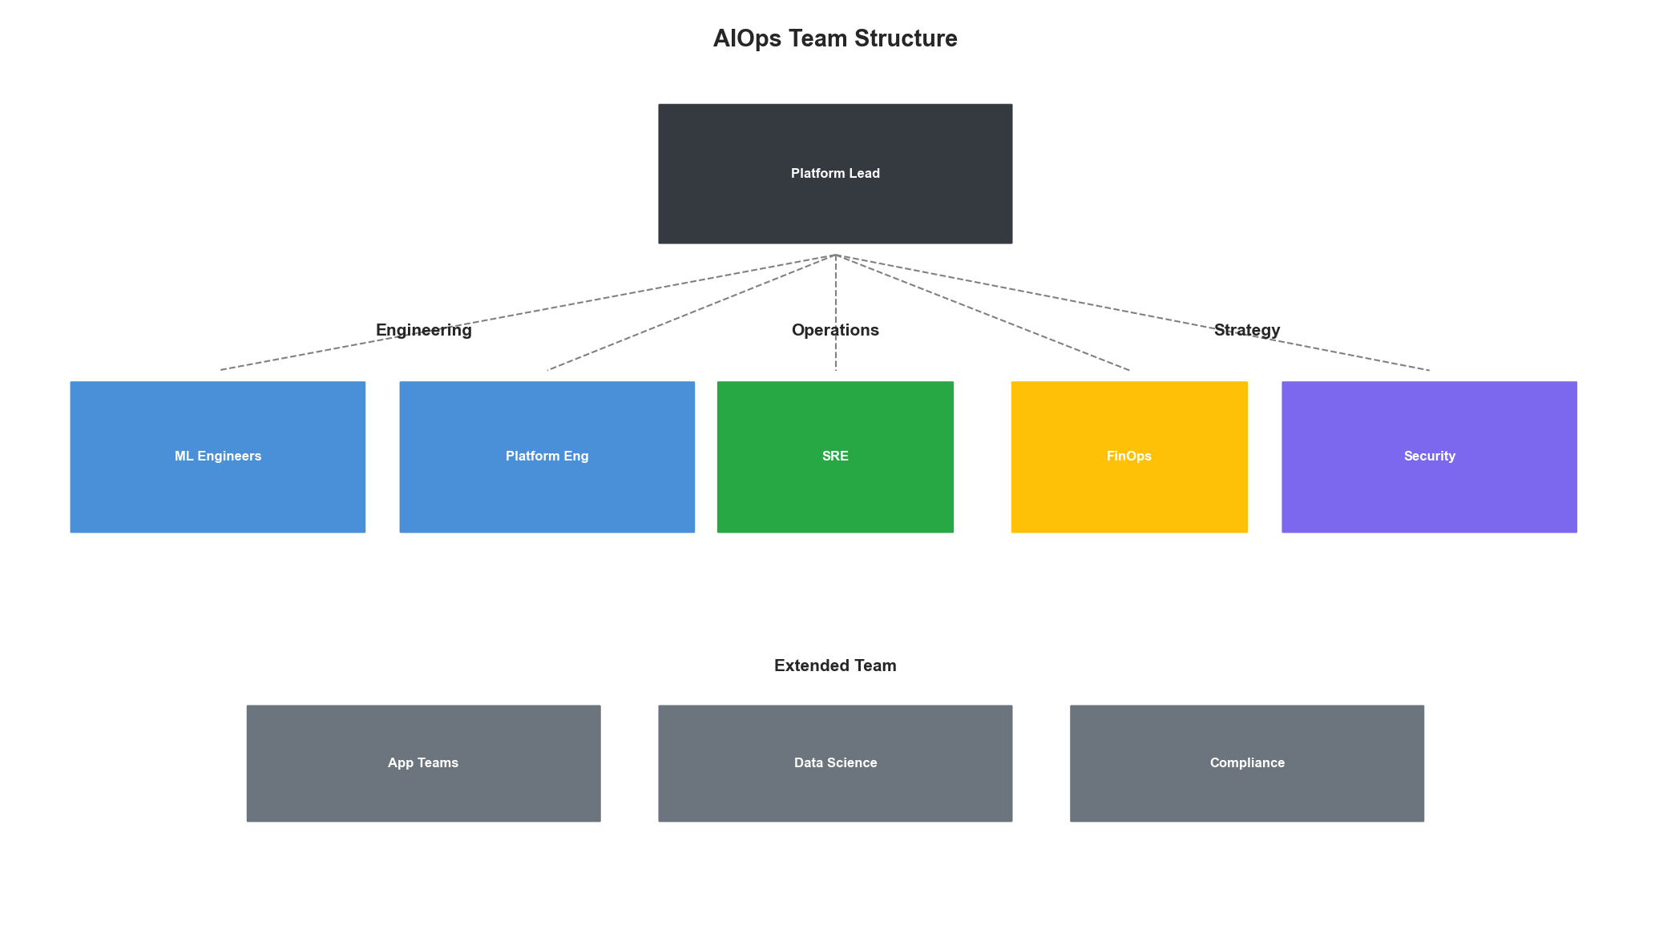
Team Structure

Success Metrics

KPI Framework
@dataclass
class KPI:
"""Key Performance Indicator definition."""
name: str
category: str
formula: str
target: str
measurement_frequency: str
data_source: str
class KPIFramework:
"""AIOps success metrics framework."""
def __init__(self):
self.kpis = self._define_kpis()
def _define_kpis(self) -> List[KPI]:
return [
# Operational KPIs
KPI("Mean Time to Detect (MTTD)", "operational",
"Time from incident start to detection",
"< 5 minutes", "per incident", "monitoring system"),
KPI("Mean Time to Resolve (MTTR)", "operational",
"Time from detection to resolution",
"< 30 minutes", "per incident", "incident management"),
KPI("Incident Volume", "operational",
"Number of incidents per period",
"Month-over-month reduction", "weekly", "incident management"),
KPI("Auto-Remediation Rate", "operational",
"Incidents auto-remediated / total incidents",
"> 50%", "weekly", "automation platform"),
# Cost KPIs
KPI("Infrastructure Cost", "financial",
"Total cloud/infrastructure spend",
"20% reduction from baseline", "monthly", "cloud billing"),
KPI("Cost per Transaction", "financial",
"Infrastructure cost / transaction volume",
"Continuous reduction", "monthly", "billing + metrics"),
KPI("Resource Utilization", "financial",
"Average CPU/memory utilization",
"60-80% average", "daily", "metrics platform"),
KPI("Waste Elimination", "financial",
"Cost of unused resources identified",
"> $100K annually", "monthly", "optimization platform"),
# Quality KPIs
KPI("Alert Accuracy", "quality",
"True positives / total alerts",
"> 90%", "weekly", "alerting system"),
KPI("Model Accuracy", "quality",
"Prediction accuracy across models",
"> 85%", "weekly", "ML platform"),
KPI("Recommendation Acceptance", "quality",
"Recommendations accepted / total",
"> 70%", "weekly", "automation platform"),
KPI("Customer Impact Incidents", "quality",
"Incidents affecting customers",
"Zero", "weekly", "incident management"),
# Team KPIs
KPI("Toil Reduction", "team",
"Time on manual repetitive tasks",
"50% reduction", "monthly", "time tracking"),
KPI("On-Call Pages", "team",
"Pages per on-call shift",
"< 2 per shift", "weekly", "paging system"),
KPI("Automation Confidence", "team",
"Team confidence in automation (survey)",
"> 80% positive", "quarterly", "surveys")
]
def get_dashboard_config(self) -> Dict:
"""Get dashboard configuration for KPIs."""
categories = {}
for kpi in self.kpis:
if kpi.category not in categories:
categories[kpi.category] = []
categories[kpi.category].append({
'name': kpi.name,
'target': kpi.target,
'frequency': kpi.measurement_frequency
})
return {
'categories': categories,
'refresh_schedule': {
'real_time': ['MTTD', 'MTTR', 'Alert Accuracy'],
'hourly': ['Resource Utilization', 'Auto-Remediation Rate'],
'daily': ['Cost per Transaction', 'Model Accuracy'],
'weekly': ['Incident Volume', 'Recommendation Acceptance']
}
}
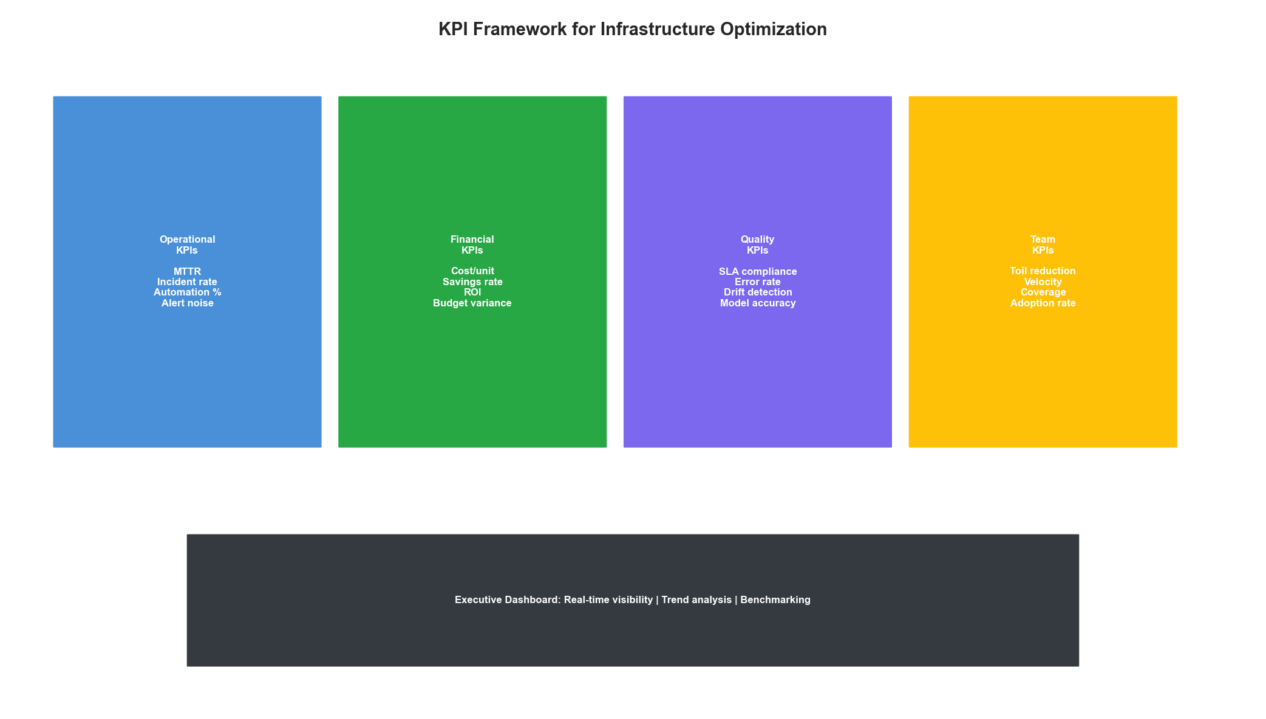
KPI Dashboard

Change Management

Adoption Strategy
class AdoptionStrategy:
"""Strategy for organizational adoption of AIOps."""
def __init__(self):
self.phases = [
{
'name': 'Awareness',
'activities': [
'Executive briefings on AIOps value',
'Success story sharing from industry',
'Pilot team identification',
'Initial training planning'
],
'stakeholders': ['Executives', 'IT Leadership', 'Pilot Teams']
},
{
'name': 'Understanding',
'activities': [
'Hands-on training sessions',
'Tool demonstrations',
'Process documentation',
'Q&A sessions'
],
'stakeholders': ['Operations Teams', 'Development Teams', 'Security']
},
{
'name': 'Acceptance',
'activities': [
'Pilot program execution',
'Quick wins celebration',
'Feedback collection',
'Process refinement'
],
'stakeholders': ['Pilot Teams', 'Adjacent Teams']
},
{
'name': 'Adoption',
'activities': [
'Broad rollout',
'Champion program',
'Advanced training',
'Best practice sharing'
],
'stakeholders': ['All IT Teams']
},
{
'name': 'Optimization',
'activities': [
'Continuous improvement',
'Innovation programs',
'Cross-team optimization',
'Industry contribution'
],
'stakeholders': ['Organization-wide']
}
]
def get_resistance_mitigation(self) -> List[Dict]:
"""Common resistance points and mitigation strategies."""
return [
{
'resistance': 'Fear of job loss',
'mitigation': 'Emphasize upskilling and new opportunities. '
'AIOps creates higher-value roles, not job elimination.'
},
{
'resistance': 'Distrust of automation',
'mitigation': 'Start with recommendations, not actions. '
'Build trust through transparency and gradual rollout.'
},
{
'resistance': 'Comfortable with current tools',
'mitigation': 'Show clear productivity gains. '
'Provide excellent training and support.'
},
{
'resistance': 'Concerns about reliability',
'mitigation': 'Implement strong safety controls. '
'Maintain human oversight until confidence builds.'
}
]

Key Takeaways
- Assess First: Understand current maturity before planning improvements
- Phase Implementation: Build foundation before automation
- Right-Size Team: Scale team to organization needs
- Measure Success: Define and track clear KPIs
- Manage Change: Address human factors as seriously as technology
Implementation success depends equally on technology, process, and people. Start small, demonstrate value, and expand based on proven results.

